**NAME: MSHAHZEB**

**ROLL: SP22-BSE-073**

**Fully Dressed UseCase:**

**Use Case: Post Job Listings**

**Use Case ID**: UC-001  
**Use Case Name**: Post Job Listings  
**Primary Actor**: Employer (or Admin)  
**Stakeholders and Interests**:

* **Employer**: Wants to post job listings to attract qualified candidates.
* **Job Seekers**: Interested in viewing job listings for potential employment opportunities.
* **System Administrator**: Ensures the job listing conforms to platform guidelines and policies.

**Preconditions**

1. Employer must be registered and logged into the system.
2. Employer has a verified company profile on the platform.

**Postconditions**

1. Job listing is successfully created and visible to job seekers.
2. Employer can manage (edit, deactivate, or delete) the job listing if needed.

**Main Success Scenario (Basic Flow)**

1. **Employer navigates to the "Post a Job" page**:  
   The system displays a job posting form.
2. **Employer enters job details**:
   * Job Title
   * Job Description
   * Required Skills and Qualifications
   * Job Type (e.g., Full-time, Part-time, Contract)
   * Salary Range
   * Location
   * Application Deadline
3. **Employer reviews job listing details**:  
   The system displays a preview of the job listing.
4. **Employer submits the job listing**:
   * The system validates the information (e.g., checks for mandatory fields, correct format).
5. **System confirms job listing creation**:
   * The job listing is saved in the database and marked as "Active."
   * The system sends a confirmation notification to the employer.
6. **System makes job listing available**:
   * The job listing is now visible to job seekers browsing available positions.

**Extensions (Alternate Flows)**

* **3a. Employer provides incomplete or invalid details**:
  + The system prompts the employer to correct the missing or invalid fields.
  + Employer corrects and resubmits the details.
* **5a. Job listing fails system validation**:
  + The system provides error messages detailing what needs to be corrected.
  + Employer makes the required changes and resubmits.

**Special Requirements**

* The job listing should have the option to auto-deactivate after the application deadline.
* Employers can select whether they want applications submitted directly on the platform or via an external link.

**Assumptions**

* Employers have the necessary permissions to post job listings.
* Job listings are only accessible to authenticated job seekers if the platform is private.

**Open Issues**

* Should employers be able to preview how the listing appears to job seekers before finalizing?
* Are there specific guidelines or moderation for content within job postings?

**SSD**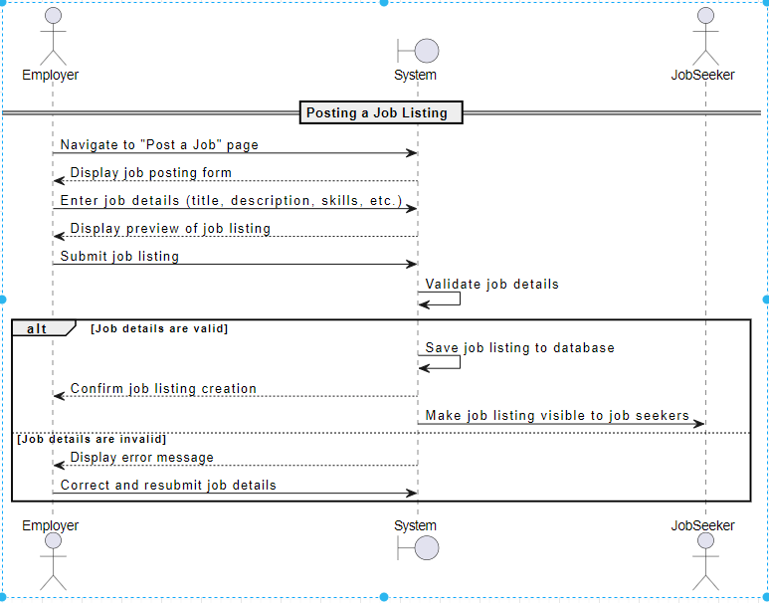

Communication Diagram

s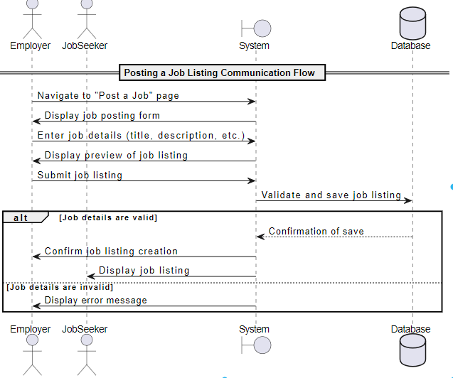

Package diagram

