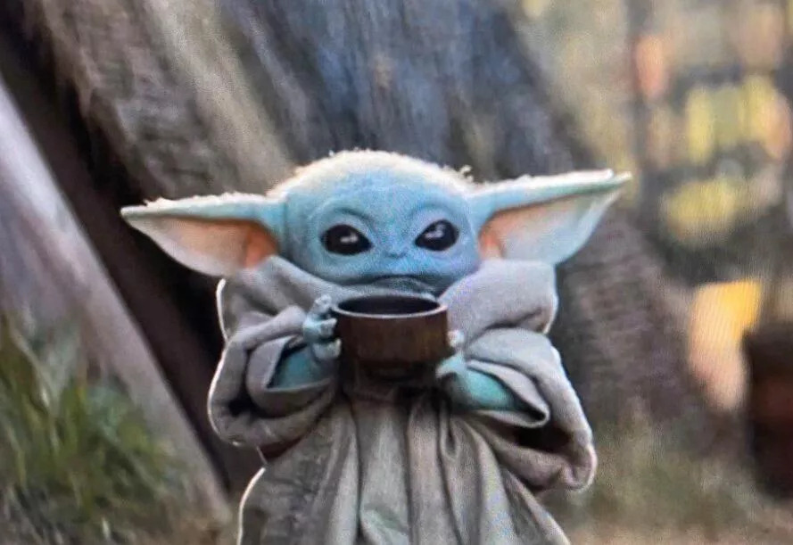

Grogu aka baby yoda | 1-877-7-MICKEY | babyyoda@gmail.com

# About Me

I am a character from the star wars disney+ original television series the mandalorian. i am an infant member of the same unnamed alien species as the star wars characters yoda and yaddle, with whom i shares a strong ability in the force.

# Education

**The Mandalorian***12 November 2019 - Current*Din Djarin Aka Mando  
Force levitate & Force heal

**Luke Skywalker***18 December 2020 - Current*The Force  
Levitation & Telepathy

# Work Experience

**Jedi Grand Master Yoda***2020 - Current*Ancient and shrouded in mystery.

**Bobba Fett***2019 - Current*Armored bounty hunter

# Skills

* **Force Levitate**
* **Force Choke**
* **Force Heal**
* **Telekinesis**