**Отчёт по Практическому занятию 11**

**Студента группы ПР-21 Шайдуллин Артём**

**Задание 1:**

С помощью класса enum задайте дни недели и цвета и используя вспомогательные функции,

выдайте значения на экран в виде строки и числа.

**Класс Days:**

*enum class* Days {  
 *MONDAY* {  
 *override fun* title() = "Понедельник";  
 *override val* day = 1;  
 *override fun* weekend() = *false*;  
 *override fun* toUpper() = title().*toUpperCase*();  
 *override fun* toLower() = title().*toLowerCase*();  
 *override fun* revers() = title().*reversed*();  
 },  
 *TUESDAY* {  
 *override fun* title() = "Вторник";  
 *override val* day = 2;  
 *override fun* weekend() = *false*;  
 *override fun* toUpper() = title().*toUpperCase*();  
 *override fun* toLower() = title().*toLowerCase*();  
 *override fun* revers() = title().*reversed*();  
 },  
 *WEDNESDAY* {  
 *override fun* title() = "Среда";  
 *override val* day = 3;  
 *override fun* weekend() = *false*;  
 *override fun* toUpper() = title().*toUpperCase*();  
 *override fun* toLower() = title().*toLowerCase*();  
 *override fun* revers() = title().*reversed*();  
 },  
 *THURSDAY* {  
 *override fun* title() = "Четврег";  
 *override val* day = 4;  
 *override fun* weekend() = *false*;  
 *override fun* toUpper() = title().*toUpperCase*();  
 *override fun* toLower() = title().*toLowerCase*();  
 *override fun* revers() = title().*reversed*();  
 },  
 *FRIDAY* {  
 *override fun* title() = "Пятница";  
 *override val* day = 5;  
 *override fun* weekend() = *false*;  
 *override fun* toUpper() = title().*toUpperCase*();  
 *override fun* toLower() = title().*toLowerCase*();  
 *override fun* revers() = title().*reversed*();  
 },  
 *SATURDAY* {  
 *override fun* title() = "Суббота";  
 *override val* day = 6;  
 *override fun* weekend() = *true*;  
 *override fun* toUpper() = title().*toUpperCase*();  
 *override fun* toLower() = title().*toLowerCase*();  
 *override fun* revers() = title().*reversed*();  
 },  
 *SUNDAY* {  
 *override fun* title() = "Воскресенье";  
 *override val* day = 7;  
 *override fun* weekend() = *true*;  
 *override fun* toUpper() = title().*toUpperCase*();  
 *override fun* toLower() = title().*toLowerCase*();  
 *override fun* revers() = title().*reversed*();  
 };  
  
 *abstract fun* title(): String;  
 *abstract val* day: Int;

**Класс Colors:**

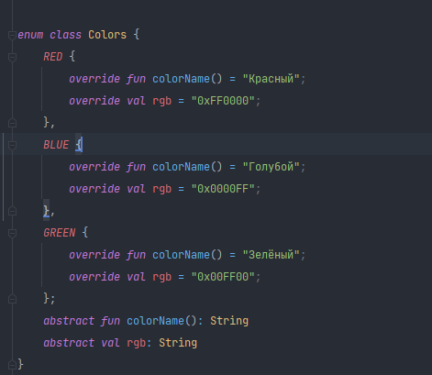

**Вывод данных:**

*fun* main() {  
 *// days enum  
  
 println*(Days.values().*asList*())  
  
 *val* monday = Days.*MONDAY*;  
 *println*(monday.title())  
 *println*(monday.ordinal)  
 *println*(monday.toUpper())  
 *println*(monday.toLower())  
 *println*(monday.revers())  
  
 *val* tuesday = Days.*TUESDAY*;  
 *println*(tuesday.title())  
 *println*(tuesday.ordinal)  
 *println*(tuesday.toUpper())  
 *println*(tuesday.toLower())  
 *println*(tuesday.revers())  
  
 *val* wednesday = Days.*WEDNESDAY*;  
 *println*(wednesday.title())  
 *println*(wednesday.ordinal)  
 *println*(wednesday.toUpper())  
 *println*(wednesday.toLower())  
 *println*(wednesday.revers())  
  
 *val* thursday = Days.*THURSDAY*;  
 *println*(thursday.title())  
 *println*(thursday.ordinal)  
 *println*(thursday.toUpper())  
 *println*(thursday.toLower())  
 *println*(thursday.revers())  
  
 *val* friday = Days.*FRIDAY*;  
 *println*(friday.title())  
 *println*(friday.ordinal)  
 *println*(friday.toUpper())  
 *println*(friday.toLower())  
 *println*(friday.revers())  
  
 *val* saturday = Days.*SATURDAY*;  
 *println*(saturday.title())  
 *println*(saturday.ordinal)  
 *println*(saturday.toUpper())  
 *println*(saturday.toLower())  
 *println*(saturday.revers())  
  
 *val* sunday = Days.*SUNDAY*;  
 *println*(sunday.title())  
 *println*(sunday.ordinal)  
 *println*(sunday.toUpper())  
 *println*(sunday.toLower())  
 *println*(sunday.revers())  
  
 *// days enum end  
  
 // colors enum  
  
 println*(Colors.values().*asList*())  
  
 *val* red = Colors.*RED  
 println*(red.name)  
 *println*(red.ordinal)  
  
 *val* blue = Colors.*BLUE  
 println*(blue.name)  
 *println*(blue.ordinal)  
  
 *val* green = Colors.*GREEN  
 println*(green.name)  
 *println*(green.ordinal)  
 *// colors enum end*}

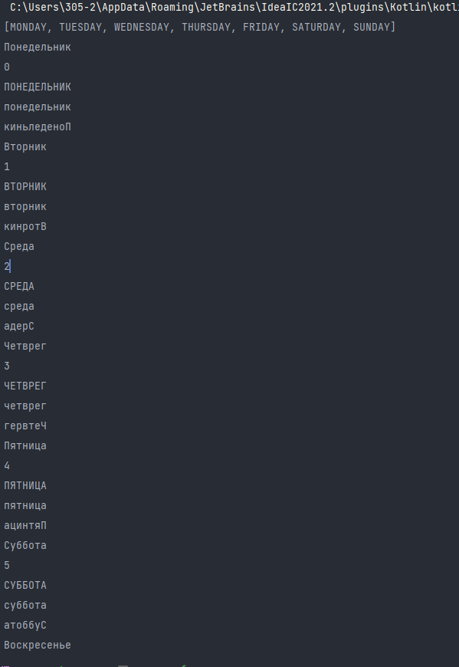

**Вывод: Благодаря этой работе я узнал, как использовать enum классы в kotlin.**