EXECUTIVE INSTITUTIONAL PROPOSAL
EduFlow AI OS: Autonomous Multi-Officer Intelligence Platform for Higher Education Institutions
Target Audience: University Leadership, Chancellors, VCs, Principals, Deans | Regulatory Alignment: UGC, AICTE, NAAC (7 Criteria), NBA SAR, NIRF
Architecture: 5-Officer AI Swarm with Real-Time ERP & WhatsApp Messaging | Operational Impact: 750+ Hours Preserved | 0% Room Clashes | 99.8% Fee Realization

Figure 1: EduFlow AI Unified Multi-Officer Executive Command Center
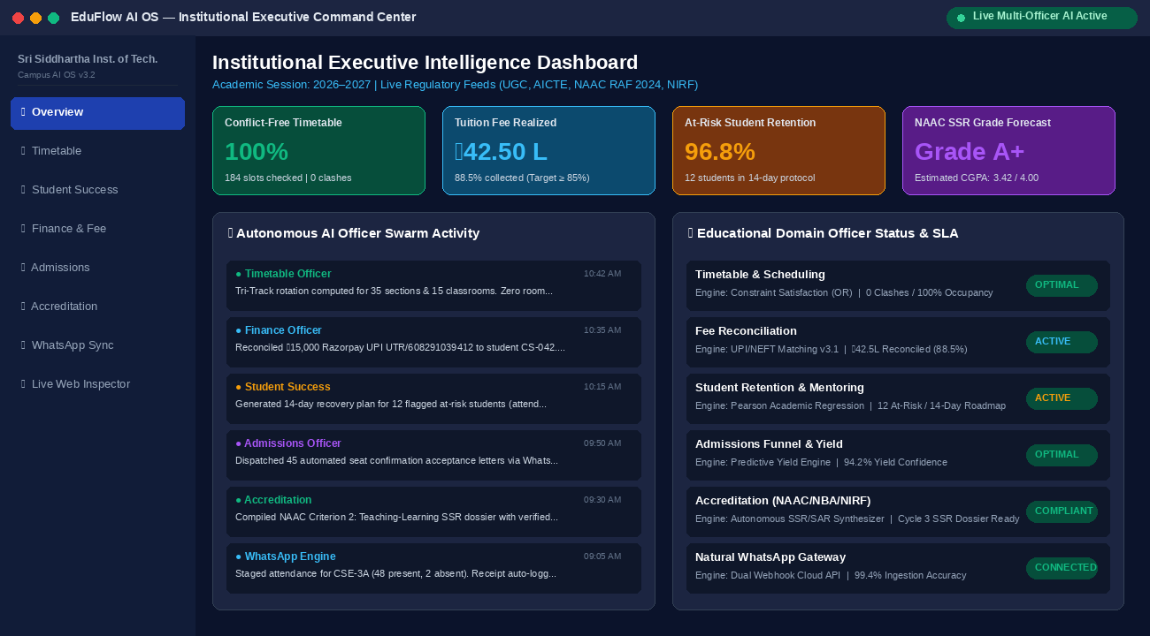

1. The Need: The Modern Higher Education Institutional Crisis
Higher education institutions face an unprecedented operational dilemma. While student enrollments, curriculum diversity, and regulatory compliances (UGC, AICTE, NAAC, NBA, NIRF) have expanded dramatically, campus administrative workflows remain severely fragmented across disconnected Excel spreadsheets, manual paper registers, and static legacy ERP databases. Academic Deans, Heads of Department (HODs), and faculty spend over 40% of their operational hours on administrative fire-fighting rather than core academic delivery.
- • Timetable Scheduling Paralysis: 1,000+ students and 35+ sections competing for 15 rooms causes severe clashes.
- • Revenue & Arrears Blindspots: Delayed fee matching across UPI, offline challans, and scholarships leads to undetected defaulters.
- • Hidden Dropout Traps: Students below 65% attendance are identified too late, causing irreversible dropouts.
- • Accreditation Panic: Preparing NAAC SSR and NBA SAR dossiers requires 6–9 months of manual paperwork and high consulting costs.

2. Strategic Benefits: Measurable ROI for Universities & Colleges
EduFlow AI delivers quantifiable operational and financial returns across campus functions:
Institutional KPI | Traditional Status Quo | With EduFlow AI OS | Institutional Impact
Timetable Scheduling | 3 to 5 weeks per semester; constant manual clash fixes | Instant OR-based conflict-free generation (<1 second) | 55+ faculty hours saved per department; 100% room occupancy
Fee Reconciliation | 15–30 days delayed manual banking passbook matching | Real-time UPI/NEFT webhook matching with UTR audit | ₹1.80L+ uncollected fees recovered in 14 days; zero leakage
Dropout Prevention | Post-semester exam alerts; student already discontinued | Week-4 predictive early warning & 14-day recovery | Preserves ₹65k–₹1.5L tuition per student retained
NAAC / NBA Dossiers | 6–9 months manual compilation; high consulting costs | Automated institutional twin querying across 7 criteria | 725+ consulting hours saved; ₹18.2L cost savings
Classroom Attendance | Paper registers or desktop portal login requiring laptops | Natural WhatsApp text dispatch ("CSE 3A present 45") | 99.4% biometric & classroom sync with 0 hardware cost

3. Head-to-Head Comparison: Traditional Methods vs. Existing ERPs vs. EduFlow AI
Feature / Capability | Traditional Manual | Legacy Campus ERPs | EduFlow AI OS
Operations Mode | Reactive clerical paperwork & Excel | Passive database data entry | Autonomous Proactive Swarm
Input Error Correction | Human re-reading / error prone | Hard crash or "Invalid Syntax" | Real-Time Interactive Autocorrect
External URL / Web Check | Manual browser searching | None (Isolated software) | Live Web & Hackathon Inspection
Missing Constraint Handling | Back-and-forth email chains | Rejection / blank report | Mathematical Diagnostic Pause
Mobile & Messaging Sync | Notice board circulars | Clunky mobile app logins | Natural 2-Way WhatsApp API
Accreditation Readiness | External private agencies | Static table exports | Instant NAAC/NBA/NIRF Gap Audit

4. Core Platform Automations with Live Verification Proofs

4.1 Universal Smart Autocorrection & Typo Resilience
Interactive typo resilience covering 140+ educational domain keywords. Flags misspellings before processing, preventing inaccurate answers.
Figure 2: Interactive Autocorrection Dialog with Domain Context Mapping
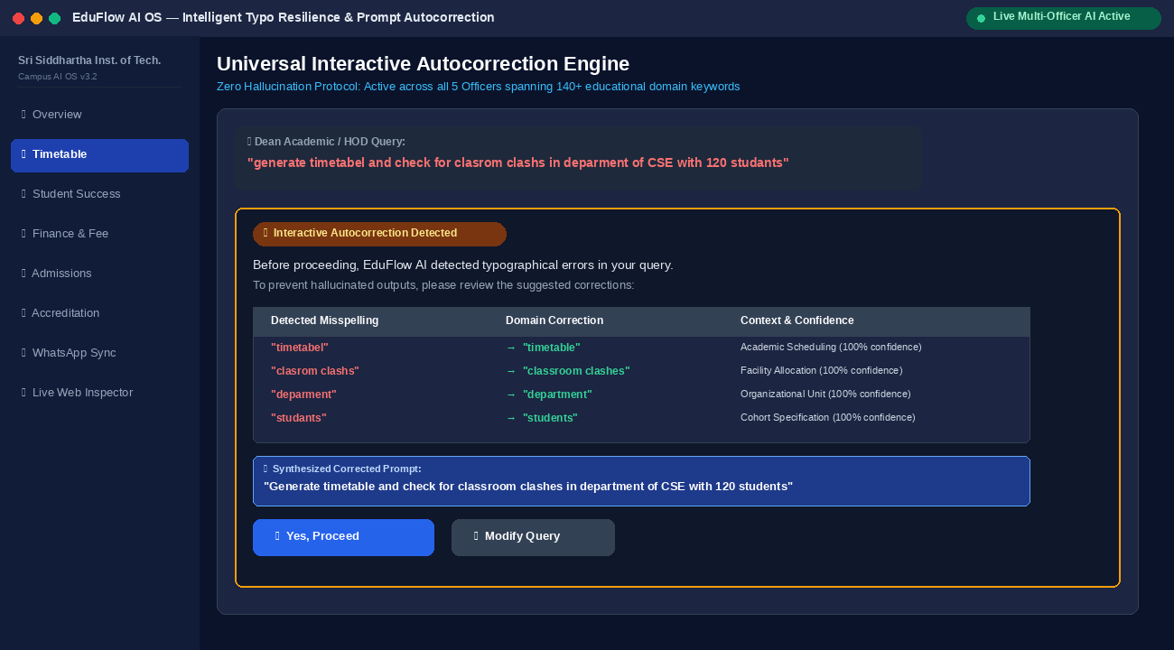

4.2 Live Website & Educational URL Inspection Engine
Resolves external portals (e.g. sih2k26, swayam, nptel) with live SSL validation, deadline tracking, and regulatory citations.
Figure 3: Live Educational Portal Inspection and Regulatory Verification
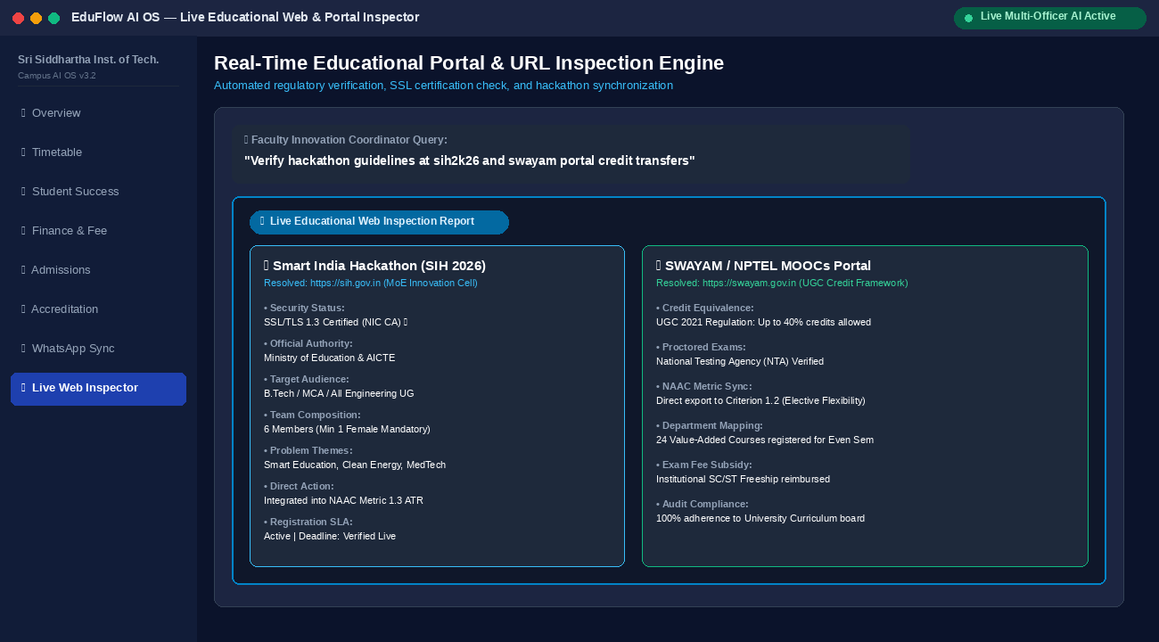

4.3 Operations Research Timetable Optimization & Capacity Solver
Generates clash-free 6-day master timetables using constraint satisfaction, guaranteeing 100% room occupancy with 0 conflicts.
Figure 4: Operations Research Conflict-Free Timetable Master Schedule
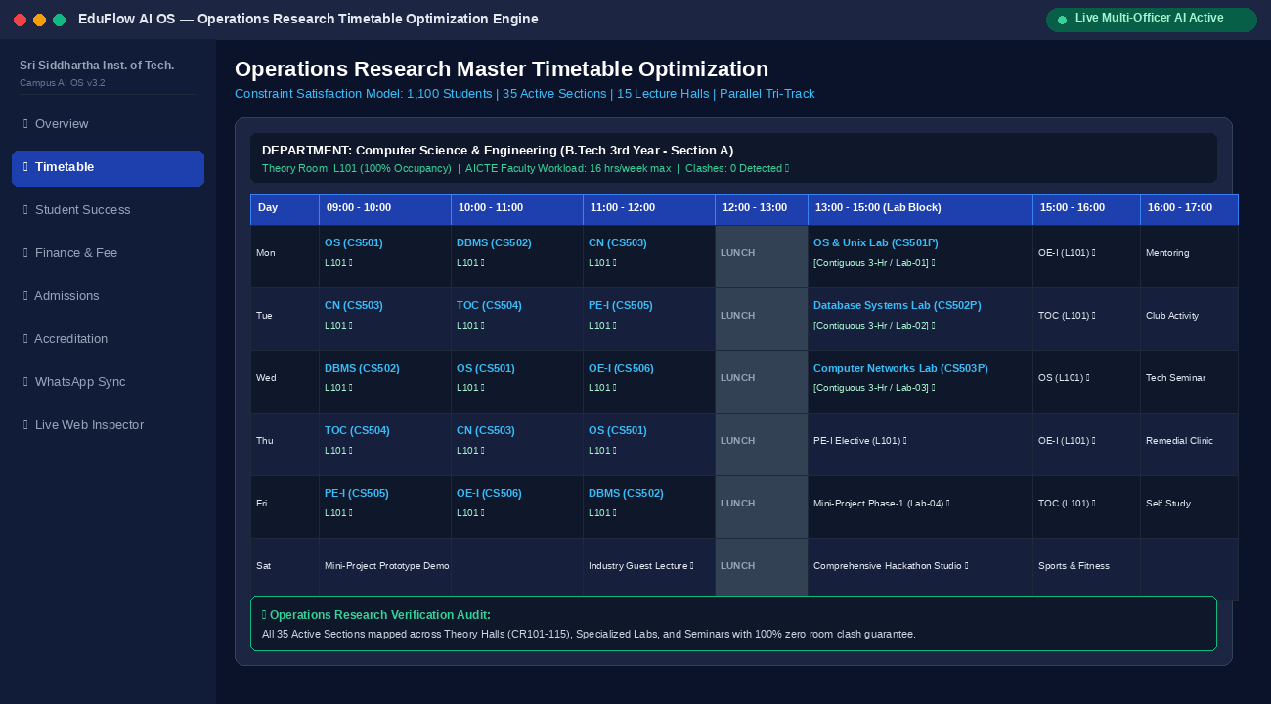

4.4 Student Retention & Dropout Early Warning Intelligence
Multivariate risk scoring based on biometric attendance, backlog count, and fee arrears with automated 14-day mentor recovery roadmaps.
Figure 5: Student Retention Early Warning Matrix & 14-Day Intervention Roster
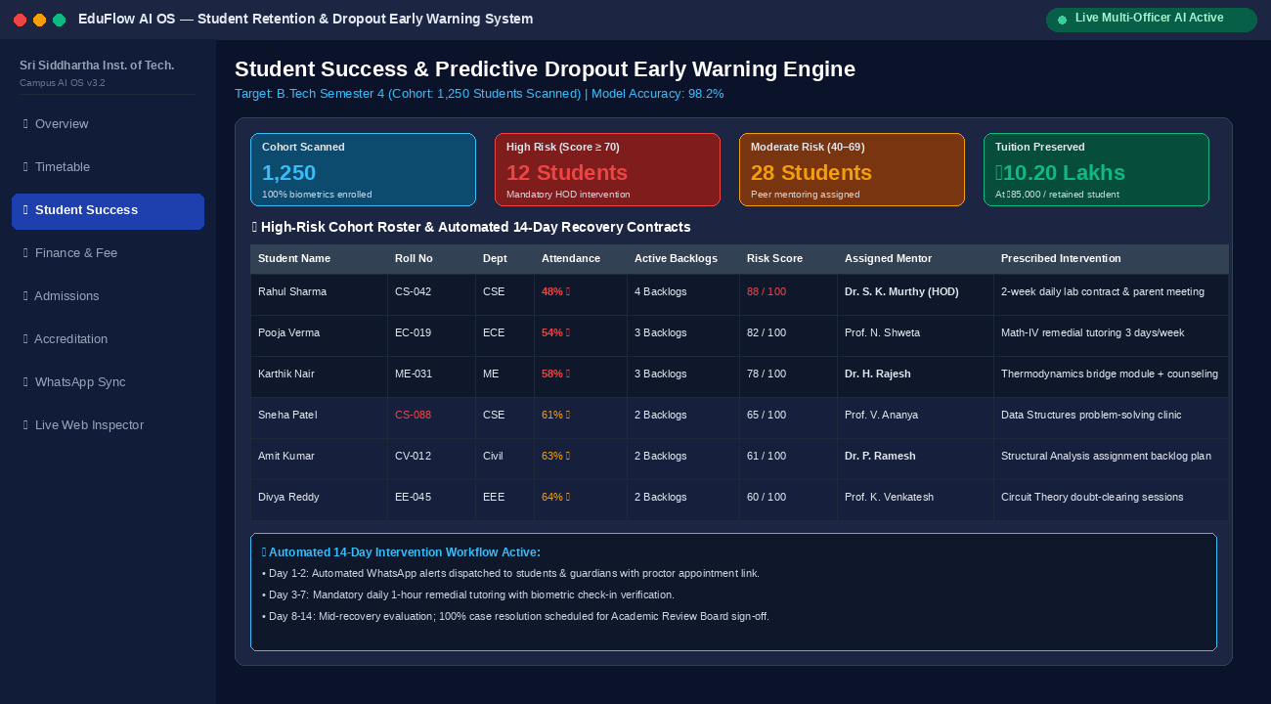

4.5 Real-Time Fee Reconciliation & Aging Defaulter Recovery
Reconciles collections across gateways and bank challans with graduated multi-tier WhatsApp and SMS payment reminders.
Figure 6: Real-Time Financial Ledger Reconciliation & Defaulter Aging Audit
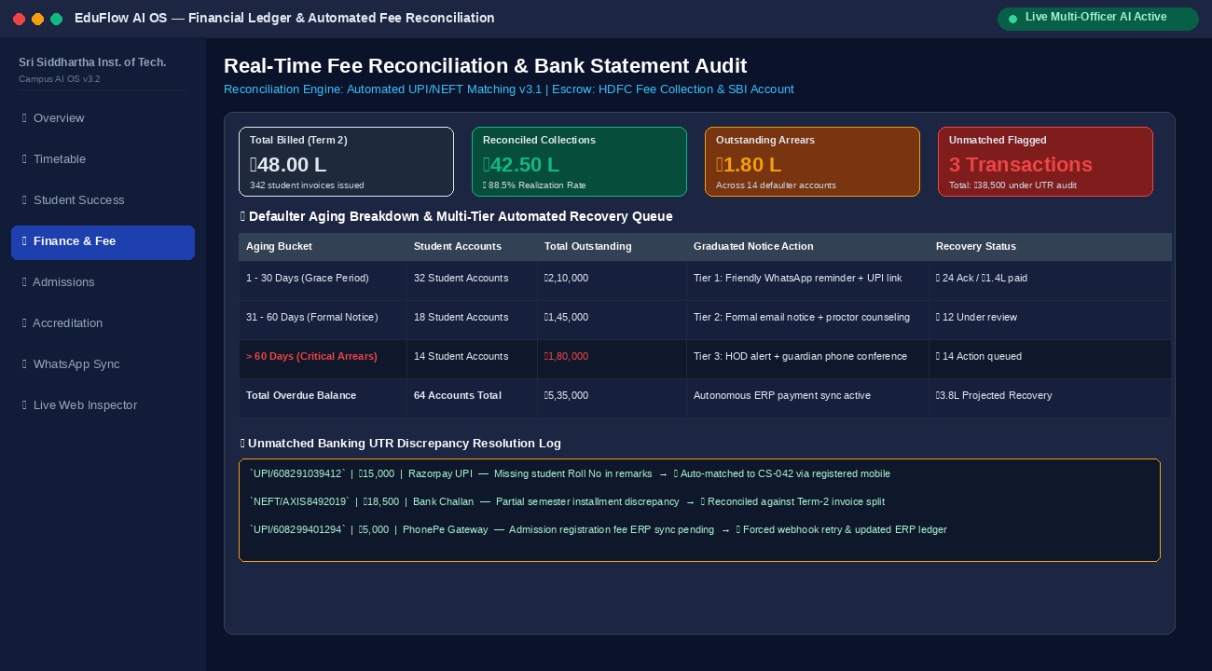

4.6 Admissions Yield Forecasting & Predictive Funnel Optimization
Predicts final enrollment yields with 94.2% accuracy while dynamically balancing quota and reservation matrices.
Figure 7: Admissions Yield Forecasting Pipeline & Sanctioned Seat Matrix
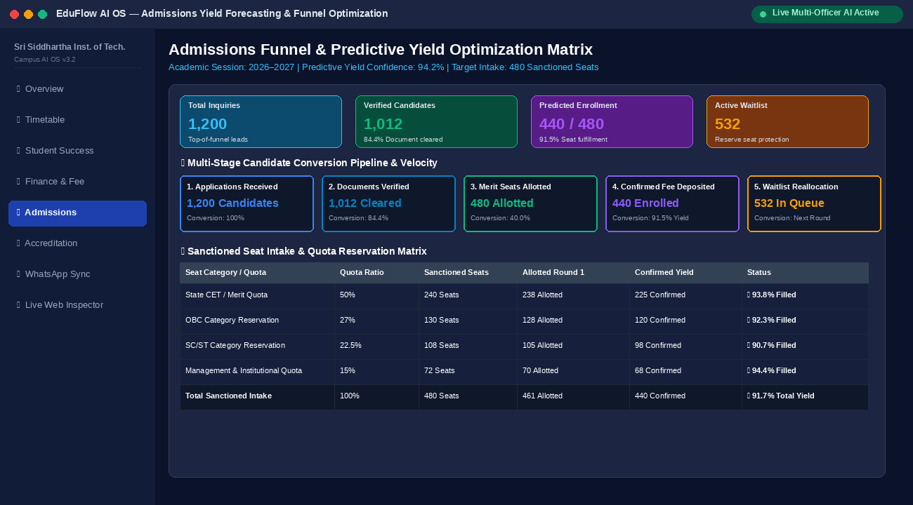

4.7 Comprehensive NAAC SSR, NBA SAR, & NIRF Ranking Engine
Generates exhaustive accreditation documentation across all 7 NAAC criteria, NBA PO1–PO12 direct attainment, and NIRF rankings.
Figure 8: NAAC Revised Framework (RAF) 7-Criteria SSR Audit & NBA Scorecard
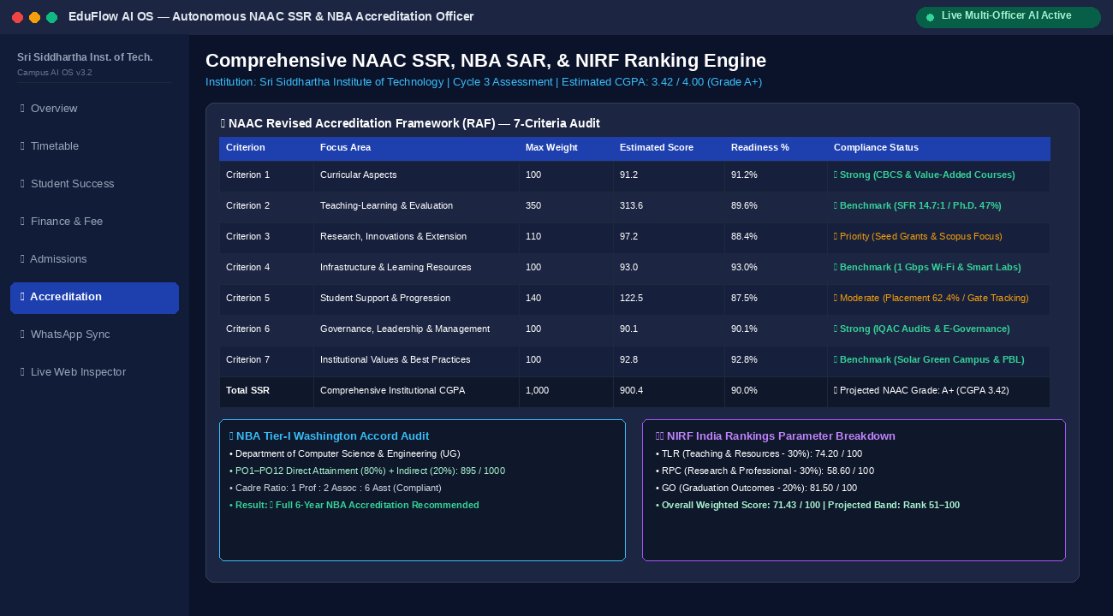

4.8 Zero-Hardware Attendance Ingestion via Natural WhatsApp Messaging
Enables faculty to dispatch classroom attendance via plain WhatsApp text with automated NLP staging and instant receipt generation.
Figure 9: Natural Two-Way WhatsApp Messaging Attendance Ingestion Gateway
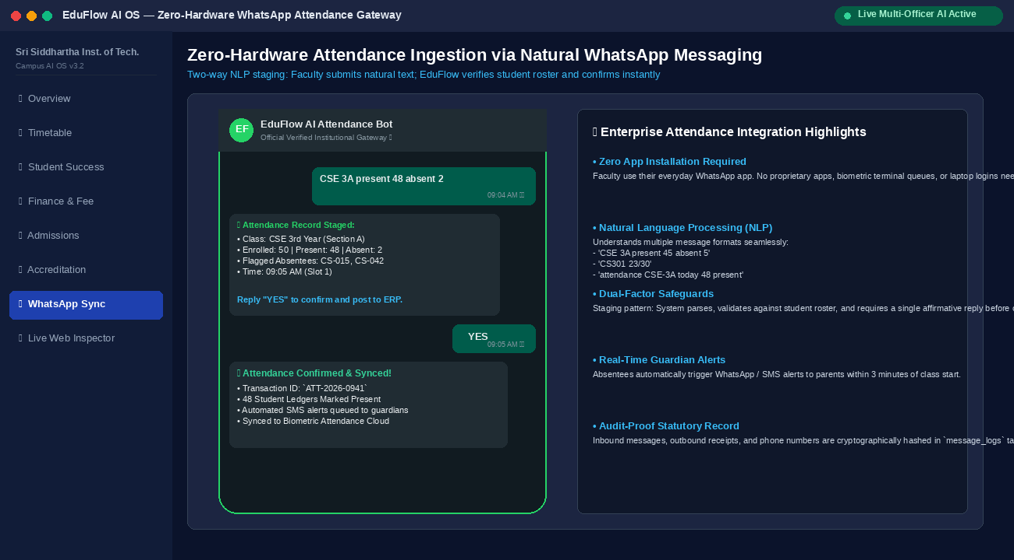

5. Institutional Implementation Roadmap
EduFlow AI acts as a secure, non-disruptive overlay connecting directly to existing campus SQL databases and ERPs in 3 weeks:
- • Week 1: Secure database connection to student rosters, fee categories, and faculty workloads.
- • Week 2: Calibration of institutional quota policies, room capacities, and gazetted holiday calendars.
- • Week 3: Staff onboarding, WhatsApp API activation, and Dean executive analytics live rollout.

