DAY1:
Project Title: Receipt and Invoice Digitizer – Overview Notes
1. Introduction
A Receipt and Invoice Digitizer is a software system that automatically extracts important information from scanned receipts and invoices using OCR (Optical Character Recognition) and stores the data in a structured digital format.
It helps businesses reduce manual data entry, minimize errors, and improve record management efficiency.

2. Problem Statement
Many businesses still manually enter receipt and invoice data into spreadsheets or accounting systems. This process:
- Is time-consuming
- Prone to human errors
- Difficult to track and manage at scale
- Requires physical storage space
The project aims to automate this process using intelligent document processing.

3. Objectives
- Extract key fields from receipts and invoices (Date, Vendor Name, Amount, GST, Invoice Number, etc.)
- Convert unstructured document images into structured digital data
- Store extracted data in a database
- Provide search, filter, and export functionality
- Reduce manual effort and improve accuracy

4. Key Features
Image Upload (JPG, PNG, PDF)
OCR-based Text Extraction
Automatic Field Detection
Data Validation
Database Storage
Download as Excel/CSV
User Authentication (Optional)

5. Technologies Used
Backend:
- Python
- Flask / FastAPI / Django
OCR Engine:
- Tesseract OCR
- OpenCV (for image preprocessing)
Database:
- MySQL / PostgreSQL / SQLite
Frontend:
- HTML, CSS, JavaScript
- Bootstrap (optional)

6. System Architecture
- User uploads receipt/invoice
- Image preprocessing (resize, grayscale, noise removal)
- OCR extracts text
- Text parsing & field extraction
- Data validation
- Store in database
- Display structured result

7. Workflow
Input → Image Processing → OCR → Text Cleaning → Field Extraction → Database Storage → Output Display

8. Expected Outcome
- Faster invoice processing
- Reduced human error
- Digital record maintenance
- Easy financial tracking
- Improved productivity

9. Future Enhancements
- AI-based smart field recognition using NLP
- Integration with accounting software
- Cloud storage support
- Mobile app version
- Multi-language receipt support

DAY2:
Github repo creations
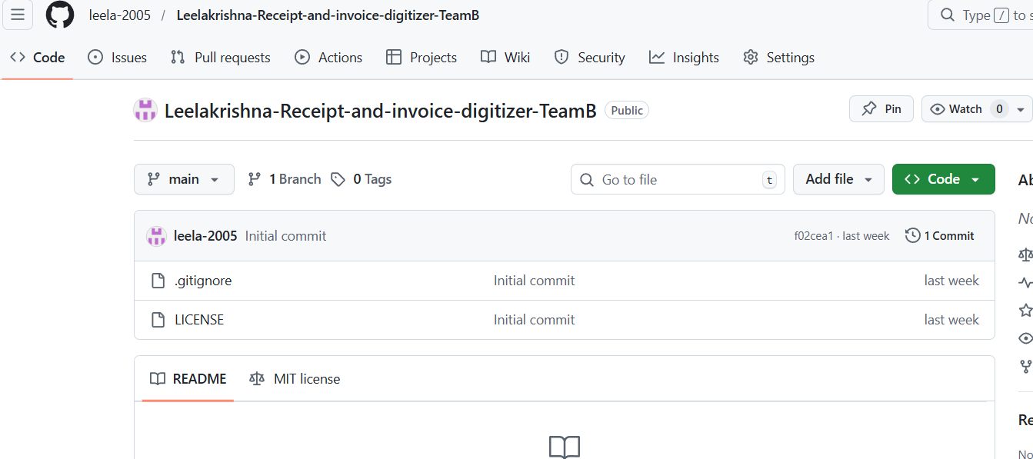

DAY 3:
---------------------------------------------
Git
A distributed version control system used to track changes in source code.
GitHub
A cloud-based platform used to host and manage Git repositories.
GitLab
A DevOps platform that provides Git repository hosting with CI/CD tools.
git add
Adds file changes to the staging area.
git add .
Stages all modified and new files in the current directory.
git add app.py
Stages only the app.py file.
git commit
Saves staged changes to the local repository with a message.
git push
Uploads local commits to a remote repository.
git clone
Creates a local copy of a remote Git repository.
git pull
Fetches and merges changes from a remote repository.
git fetch --all
Fetches all updates from all remote repositories without merging.
git branch
Lists all local branches.
git branch --all
Lists both local and remote branches.
git checkout
Switches to another branch.
git checkout -b
Creates a new branch and switches to it.
app.py / main.py
Python source files containing application logic
python -m venv leela
Creates a new Python virtual environment named leela.
shakthi/Scripts/activate
Activates the virtual environment so Python uses its isolated packages.
pip install -r requirements.txt
Installs all Python dependencies listed in the requirements.txt file.
python app.py
Runs the Python application file app.py.
DAY4:
Software Development Life Cycle (SDLC) is a step-by-step process followed to design, develop, test, deploy, and maintain software applications.

SDLC – Step by Step Process
- Requirement Analysis
- Planning
- Design
- Development
- Testing
- Deployment
- Maintenance

SDLC ROLES
1. Functional Consultant / Business Analyst
- Understands client requirements
- Converts business needs into documents

2. Developer / Programmer
- Converts functional requirements into technical logic
- Writes code
- Prepares POC (Proof of Concept)
- Implements logic at code level
- Performs Unit Testing

3. Tester / QA Team
- Tests the application for bugs and issues
- Verifies functionality, performance, and quality

Servers Used in SDLC
- Development Server – Code writing and initial testing
- Quality (QA) Server – Testing by QA team
- Production Server – Live application for users

4. Administration Team
- Manages servers, access, security, backups
- Handles deployment and system availability

5. Product / Project Management
- Plans project activities
- Monitors progress
- Controls timelines, cost, and resources

6. Sales and Marketing Team
- Promotes the product
- Handles client communication
- Collects market and customer feedback

7. Human Resource (HR) Team
- Hiring and onboarding
- Employee management
- Payroll and policies

8. Documentation Team
- Prepares user manuals
- Technical documentation
- System guides

9. Support Team
- Handles user issues after deployment
- Bug reporting and resolution
- Maintenance support

SDLC MODELS
1. Waterfall Model
- Sequential process
- One phase must finish before the next starts
- Suitable for fixed requirements

2. Agile Methodology
- Iterative and incremental approach
- Continuous feedback and improvement
- Faster delivery and flexibility

Agile Roles
1. Product Owner
- Defines product requirements
- Prioritizes features
- Acts as customer representative
2. Scrum Master
- Facilitates Agile process
- Removes blockers
- Ensures Scrum rules are followed
3. Development Team
- Developers, testers, designers
DAY5:
What is an API?
API (Application Programming Interface) allows:
- Frontend ↔ Backend communication
- Data exchange using HTTP requests
Simple Flow
- Frontend sends payload
- Backend receives payload
- Backend processes logic
- Backend sends response

Payload
- Payload = data sent from frontend to backend
- Mostly sent in POST request body
- Format: JSON
Example payload:
{
"username": "krishna",
"password": "12345"
}

API Request Types (HTTP Methods)
GET
- Fetch data
- No payload
GET /users

POST
- Send data
- Payload in body
POST /login

DELETE
- Remove data
DELETE /user/1

Flask API (Basics)
Required Imports
from flask import Flask, request, jsonify
What Each Means
- Flask → create application
- request → receive payload
- jsonify → send JSON response

Flask App Creation
app = Flask(__name__)

Flask API Example
from flask import Flask, request, jsonify

app = Flask(__name__)

@app.route("/login", methods=["POST"])
def login():
data = request.json # payload
username = data.get("username")
password = data.get("password")

if username == "admin" and password == "123":
return jsonify({"message": "Login success"})
else:
return jsonify({"message": "Invalid credentials"}), 401

if __name__ == "__main__":
app.run(debug=True)

FastAPI (Modern API Framework)
Why FastAPI?
- Very fast 🚀
- Async support
- Auto API docs
- Best for WebSockets & async

Import & App Creation
from fastapi import FastAPI

app = FastAPI()

FastAPI Example
from fastapi import FastAPI
from pydantic import BaseModel

app = FastAPI()

class Login(BaseModel):
username: str
password: str

@app.post("/login")
def login(data: Login):
if data.username == "admin" and data.password == "123":
return {"message": "Login success"}
return {"message": "Invalid credentials"}

Postman
Postman is a tool used to:
- Test APIs
- Send GET, POST, DELETE requests
- View responses
Used mainly by:
- Developers
- Testers
- QA teams

HTTPS Request
- Secure HTTP
- Data is encrypted
- Used in production APIs

WebSocket
- Two-way communication
- Real-time data
- Example: chat apps, live notifications

Async Functions
- Non-blocking
- Better performance
- FastAPI supports async natively
DAY6:
JWT (JSON Web Token)
JWT is a compact and secure way to send information between client and server as a signed token.
- Used mainly for Authentication and Authorization
- Common in stateless APIs
- Works well with REST APIs

Why JWT?
- Secure (signed using secret key)
- Fast (no DB lookup for every request)
- Compact (easy to send in headers)
- Stateless (server does not store session)

JWT Flow (Step-by-Step)
1️⃣ User Login
User sends:
- username
- password

2️⃣ Server Validates Credentials
- Checks username & password in database

3️⃣ Server Generates JWT
- Token contains user info (payload)
- Signed using a secret key

4️⃣ Client Stores Token
Stored in:
- localStorage
- or cookies

5️⃣ Client Sends Token in Header
Authorization: Bearer <JWT_TOKEN>

6️⃣ Server Verifies Token
- Valid token → access allowed
- Invalid/expired → access denied

JWT is Stateless API
- Server does not store session
- Every request contains token
- Server only verifies token signature

Installing JWT Library (Python)
pip install pyjwt

Import JWT
import jwt
import datetime

JWT Token Generation Example (Python)
import jwt
import datetime

SECRET_KEY = "mysecretkey"

payload = {
"user_id": 101,
"username": "shakthi",
"exp": datetime.datetime.utcnow() + datetime.timedelta(minutes=30)
}

token = jwt.encode(payload, SECRET_KEY, algorithm="HS256")

print(token)

SECRET_KEY
- Used to sign the token
- Must be kept secret

Payload
Contains user data:
"user_id"
"username"
exp (Expiration)
"exp": current_time + 30 minutes
- Token expires after 30 minutes
- Prevents misuse

Algorithm (HS256)
- HMAC SHA-256
- Symmetric encryption (same key to sign & verify)

Token Verification (Server Side)
decoded = jwt.decode(token, SECRET_KEY, algorithms=["HS256"])
print(decoded)
If token is:
- ❌ Expired → error
- ❌ Tampered → error
- ✅ Valid → access allowed

Where JWT is Used
- REST APIs
- Mobile apps
- Web apps (React, Angular, Django, Flask)
- Microservices

JWT vs Session (Quick Comparison)
JWT | Session
Stateless | Stateful
Stored in client | Stored in server
Scales well | Harder to scale
Faster | Slower

DAY7:
Assignment – 2
SQL Queries on JOINs and Operations

Sample Tables Used
Table 1: Students
CREATE TABLE students (
student_id INT,
name VARCHAR(50),
department VARCHAR(50)
);
INSERT INTO students VALUES
(1, 'Ravi', 'CSE'),
(2, 'Anu', 'ECE'),
(3, 'Kiran', 'ME');

Table 2: Marks
CREATE TABLE marks (
student_id INT,
marks INT
);
INSERT INTO marks VALUES
(1, 85),
(2, 90),
(4, 70);

1) INNER JOIN
👉 Returns only matching records from both tables.
SELECT students.name, marks.marks
FROM students
INNER JOIN marks
ON students.student_id = marks.student_id;
✅ Output: Ravi, Anu
❌ Kiran excluded (no marks)

2) LEFT JOIN
Returns all records from left table + matched records from right.
SELECT students.name, marks.marks
FROM students
LEFT JOIN marks
ON students.student_id = marks.student_id;
✅ All students shown
❌ Kiran → marks = NULL

3) RIGHT JOIN
Returns all records from right table + matched from left.
SELECT students.name, marks.marks
FROM students
RIGHT JOIN marks
ON students.student_id = marks.student_id;
✅ Student with marks shown
❌ student_id = 4 → name = NULL

4) CROSS JOIN
Returns Cartesian product.
SELECT students.name, marks.marks
FROM students
CROSS JOIN marks;
Rows = students × marks

5) JOIN with WHERE Condition
SELECT students.name, marks.marks
FROM students
INNER JOIN marks
ON students.student_id = marks.student_id
WHERE marks.marks > 80;

6) GROUP BY with JOIN
SELECT students.department, AVG(marks.marks) AS avg_marks
FROM students
INNER JOIN marks
ON students.student_id = marks.student_id
GROUP BY students.department;

7) HAVING Clause
Filters grouped data
SELECT students.department, COUNT(*)
FROM students
INNER JOIN marks
ON students.student_id = marks.student_id
GROUP BY students.department
HAVING COUNT(*) > 1;

8) IN Operator
SELECT * FROM students
WHERE student_id IN (1, 3);

9) BETWEEN Operator
SELECT * FROM marks
WHERE marks BETWEEN 80 AND 90;

10) LIKE Operator
SELECT * FROM students
WHERE name LIKE 'A%';
✔ Names starting with A

11) IS NULL
SELECT students.name
FROM students
LEFT JOIN marks
ON students.student_id = marks.student_id
WHERE marks.marks IS NULL;
✔ Students without marks

12)UNION
Removes duplicates
SELECT name FROM students
UNION
SELECT student_id FROM marks;

13) UNION ALL
Keeps duplicates
SELECT student_id FROM students
UNION ALL
SELECT student_id FROM marks;

14) INTERSECT (PostgreSQL)
SELECT student_id FROM students
INTERSECT
SELECT student_id FROM marks;
✔ Common student IDs

15) EXCEPT (PostgreSQL)
SELECT student_id FROM students
EXCEPT
SELECT student_id FROM marks;
✔ Students without marks
DAY8:
Why Hashing?
- Never store passwords directly in the database
- Convert password into a fixed, irreversible value
- You cannot convert hash back to original password
- Used for login verification
Using Bcrypt in Python
Install
pip install bcrypt
Example Code
import bcrypt

# Original password
password = "shakthi"

# Convert string to bytes
password_bytes = password.encode('utf-8')

# Generate salt
salt = bcrypt.gensalt()

# Create hashed password
hashed_password = bcrypt.hashpw(password_bytes, salt)

print("Hashed:", hashed_password)

# Verify password
check = bcrypt.checkpw(password_bytes, hashed_password)
print("Match:", check)

DAY9:
Built-in String Methods
1) strip()
Removes spaces from both sides
text = " shakthi "
print(text.strip())
Output:
shakthi

2)join()
word = ["I", "like", "python"]
result = " ".join(word)
print(result)
Output:
I like python

3) replace()
text = "I like Java"
print(text.replace("Java", "Python"))

4) startswith()
text = "Python"
print(text.startswith("Py")) # True

5) endswith()
print(text.endswith("on")) # True

6) find()
Returns index position
text = "Python"
print(text.find("th")) # 2

7) isdigit()
print("1235".isdigit()) # True

8) isalpha()
print("Python".isalpha()) # True

Dictionary Methods
data = {"name": "Shakthi", "age": 22}
Method | Description
get() | Get value safely
keys() | Returns all keys
values() | Returns all values
items() | Returns key-value pairs
update() | Update dictionary
pop() | Remove item
clear() | Remove all items
Example:
print(data.get("name"))
print(data.keys())

Set Operations
a = {1,2,3}
b = {2,3,4}
print(a.union(b)) # {1,2,3,4}
print(a.intersection(b)) # {2,3}
print(a.difference(b)) # {1}

File Methods
file = open("test.txt", "w")
file.write("Hello")
file.close()

General Purpose Functions
Function | Example
len() | len("Python")
range() | range(5)
print() | print()
type() | type(5)
id() | id(variable)
sorted() | sorted(list)
enumerate() | enumerate(list)
zip() | zip(list1, list2)
uuid | unique ID

Type Conversion
int("3") # 3
float("3.5") # 3.5
str(10) # "10"
list("abc") # ['a','b','c']
set([1,2,2]) # {1,2}
tuple([1,2]) # (1,2)

Mathematical Functions
abs(-12) # 12
sum([1,2]) # 3
min([1,2])
max([1,2])
pow(2,3) # 8
round(2.7) # 3

Functional Programming
1) map()
nums = [1,2,3]
result = list(map(lambda x: x*2, nums))
2) filter()
nums = [1,2,3,4]
result = list(filter(lambda x: x%2==0, nums))
3) reduce()
from functools import reduce

nums = [1,2,3]
result = reduce(lambda x,y: x+y, nums)

DAY13:
Class and object
Function | Purpose
getattr() | Get attribute value
setattr() | Set attribute value
hasattr() | Check attribute existence
delattr() | Delete attribute
isinstance() | Check object type
issubclass() | Check class inheritance
globals() | Show global variables
locals() | Show local variables
callable() | Check if callable
eval() | Evaluate expression string
exec() | Execute code string
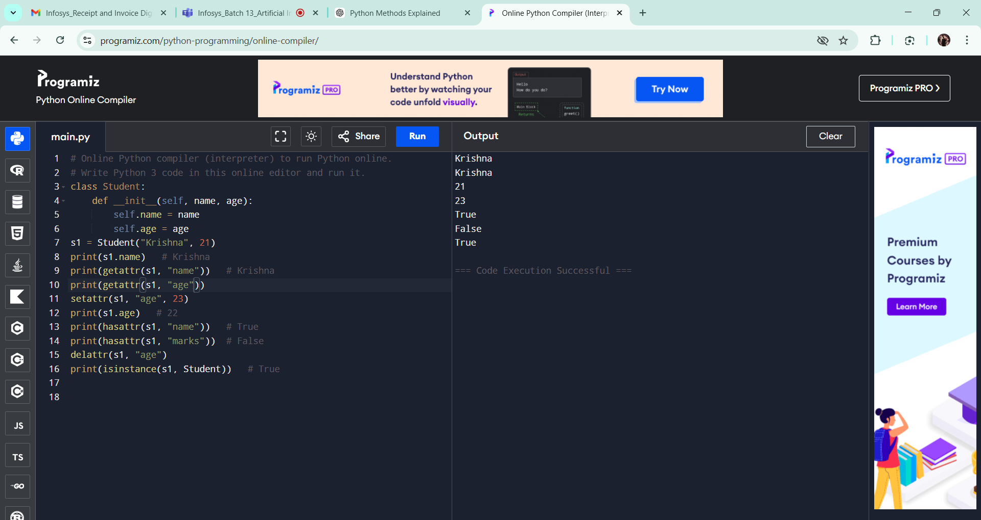

1. Exception Handling in Python
Exception handling is used to handle runtime errors without stopping the program.

🔹 try – except – finally
Syntax
try:
# risky code
except:
# error handling
finally:
# always executes

Example Program
try:
a = int(input("Enter number: "))
b = 10 / a
print(b)

except ZeroDivisionError:
print("Cannot divide by zero")

finally:
print("Program finished")
Output
Enter number: 0
Cannot divide by zero
Program finished
finally always runs (error or no error).

2. del() Function
del() removes a variable or object from memory.
Example
x = 10
print(x)

del x
# print(x) → Error (deleted)

3. Garbage Collection (GC)
Python automatically removes unused objects from memory.
This process is called:
👉 Garbage Collection
Library:
import gc

🔹 gc.collect()
Forces Python to clean unused memory manually.
Example
import gc

a = [1, 2, 3]
del a

gc.collect() # cleanup memory
print("Garbage collected")

🔹 What is GC?
GC = Garbage Collector
Purpose:
- Free memory
- Remove unused objects
- Improve performance

4. enumerate() Concept
enumerate() gives index + value while looping.

Without enumerate
fruits = ["apple", "banana", "mango"]

for i in range(len(fruits)):
print(i, fruits[i])

With enumerate (Better way)
fruits = ["apple", "banana", "mango"]

for index, value in enumerate(fruits):
print(index, value)
Output
0 apple
1 banana
2 mango

Simple Program (Assignment Example)
students = ["Ravi", "Kiran", "Anu"]

for roll, name in enumerate(students, start=1):
print("Roll:", roll, "Name:", name)

5. isinstance() Function
Checks whether a variable belongs to a specific data type.

Syntax
isinstance(object, datatype)

Example
x = 10

print(isinstance(x, int)) # True
print(isinstance(x, str)) # False

Practical Example
value = "Hello"

if isinstance(value, str):
print("It is a string")
else:
print("Not a string")

Quick Revision Table ⭐
Concept | Meaning
try | risky code block
except | handles error
finally | always executes
del() | deletes object
gc | garbage collector module
gc.collect() | manual memory cleanup
enumerate() | index + value loop
isinstance() | checks data type

ASSIGNMENT3:
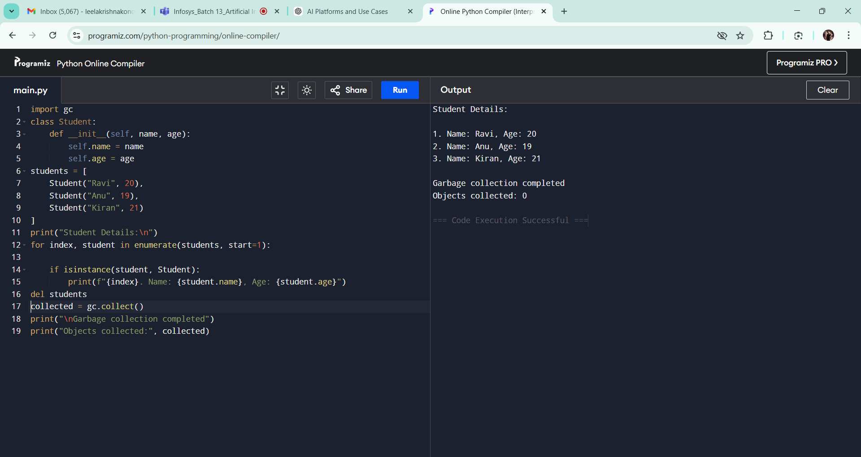

DAY14:
1. Programmed & Pre-trained AI (Specific Use Cases)
These are AI systems trained already and used for particular tasks.
Examples
Use Case | Example
Chatbot | ChatGPT, Gemini
Image Generation | DALL·E, Midjourney
Video Generation | Sora, Runway
Prediction | ML models (forecasting, classification)
These models are pre-trained using huge datasets and then used via APIs.

2. Major AI Platforms / Companies
🔹 Google
- Gemini → LLM model
- Google AI Studio → Developer platform
- Supports:
  - Chat
  - Image understanding
  - Coding
  - Multimodal AI

🔹 OpenAI
- GPT Models (GPT-4o, GPT-4o-mini)
- OpenAI Platform
- APIs for:
  - Chatbot
  - Image generation
  - Speech
  - Embeddings
Used through API key.

🔹 Groq
- Groq LLM inference platform
- Very fast responses
- Supports models like:
  - Llama
  - Mixtral
Website for API keys:
https://console.groq.com/keys

🔹 Microsoft
- Copilot
- Azure OpenAI Service
Azure OpenAI = Enterprise version of OpenAI models.
Used by companies for:
- secure deployment
- enterprise apps
- large-scale production

3. LLM vs AI Platform
LLM | AI Platform
Model only | Full development environment
Example: GPT | OpenAI Platform
Text generation | API + deployment tools
Brain | Complete system

4. AI Development Platforms
Platform | Purpose
Google AI Studio | Test Gemini models
OpenAI Platform | Build AI apps
Groq Cloud | Fast inference
Azure OpenAI | Enterprise production

5. Production Ready or Not?
Platform | Production Ready
OpenAI | Yes
Azure OpenAI | Enterprise level
Google Gemini | Yes
Groq | Fast inference production
Production Ready means:
- scalable
- secure
- stable APIs
- monitoring support

6. Pricing Concepts (Rate)
AI APIs charge using:
🔹 Tokens
Token ≈ word pieces.
Example:
Hello world → ~2 tokens
You pay for:
- input tokens
- output tokens

🔹 Token Limit
Maximum tokens per request.
Example:
- GPT-4o mini → large context window
- determines response size + memory

7. Example OpenAI API Code (Python)
response = client.chat.completions.create(
model="gpt-4o-mini",
messages=messages,
temperature=0.7,
max_tokens=500
)
Meaning
Parameter | Meaning
model | AI model used
messages | conversation input
temperature | creativity level
max_tokens | response length limit

8. API Key Concept
API key = secret password to access AI model.
Example:
OpenAI API Key
Groq API Key
Never share publicly.

9. Using OpenAI API in Android Studio
Steps
1️⃣ Create OpenAI account
2️⃣ Generate API key
3️⃣ Add dependency (Retrofit/HTTP client)
4️⃣ Call OpenAI endpoint using REST API
Example (simplified):
POST https://api.openai.com/v1/chat/completions
Authorization: Bearer YOUR_API_KEY

10. Simple Architecture
Android App
↓
Backend / API Call
↓
OpenAI / Gemini / Groq
↓
AI Response
↓
App Display
DAY15:
🔹 Positive & Negative (Sentiment Analysis)
Sentiment Analysis means identifying emotion or opinion in text.
Sentence | Sentiment
This movie is amazing | Positive 🙂
This product is bad | Negative 🙁
Used in:
- Chatbots
- Reviews analysis
- Social media monitoring

NLTK (Natural Language Toolkit)
NLTK is a Python library used for text processing and NLP tasks.
Full form: Natural Language Toolkit
Installation
pip install nltk
Import
import nltk
Download datasets
nltk.download('all')
(Downloads all required NLP resources)

7 Main Features of NLTK

1) Tokenization
Breaking sentence into words.
Example:
NLP is interesting
Output:
["NLP", "is", "interesting"]
Code
from nltk.tokenize import word_tokenize

text = "NLP is interesting"
tokens = word_tokenize(text)
print(tokens)

2) Stop Word Removal
Removing common words that do not add meaning.
Examples:
is, the, am, are, was
Code
from nltk.corpus import stopwords

stop_words = set(stopwords.words('english'))

3) Stemming
Reducing words to root form (may not be real word).
Word | Stem
playing | play
better | bet
Code
from nltk.stem import PorterStemmer

stemmer = PorterStemmer()
stemmer.stem("playing")

4) Lemmatization
Converts word into meaningful base word.
Word | Lemma
better | good
running | run
Code
from nltk.stem import WordNetLemmatizer

lemmatizer = WordNetLemmatizer()
lemmatizer.lemmatize("better", pos='a')
More accurate than stemming.

5) POS Tagging (Part of Speech)
Identifies grammar role of words.
Word | POS
Run | Verb
Apple | Noun
Code
from nltk.tokenize import word_tokenize
import nltk

text = "NLP is interesting"
tokens = word_tokenize(text)

nltk.pos_tag(tokens)

6) NER (Named Entity Recognition)
Identifies names in text.
Examples:
- Person
- Location
- Organization
Sentence:
Ravi works at Google in India.
Output:
- Ravi → Person
- Google → Organization
- India → Location
Download resources
nltk.download('words')
nltk.download('maxent_ne_chunker')

7) Text Processing / Text Preprocessing
Preparing text before machine learning.
Steps:
- Lowercase conversion
- Remove punctuation
- Tokenization
- Stopword removal
- Stemming/Lemmatization

Text Preprocessing Example
import nltk
from nltk.tokenize import word_tokenize
from nltk.corpus import stopwords

text = "NLP is very interesting and useful."

tokens = word_tokenize(text.lower())

filtered = [w for w in tokens if w not in stopwords.words('english')]

print(filtered)
Output:
['nlp', 'interesting', 'useful']

Quick Difference (Important ⭐)
Stemming | Lemmatization
Faster | More accurate
Cuts words | Understands meaning
bet | good

Simple NLP Pipeline
Text
↓
Tokenization
↓
Stopword Removal
↓
Stemming/Lemmatization
↓
POS Tagging
↓
NER
↓
Model Training

ASSIGNMENT4:
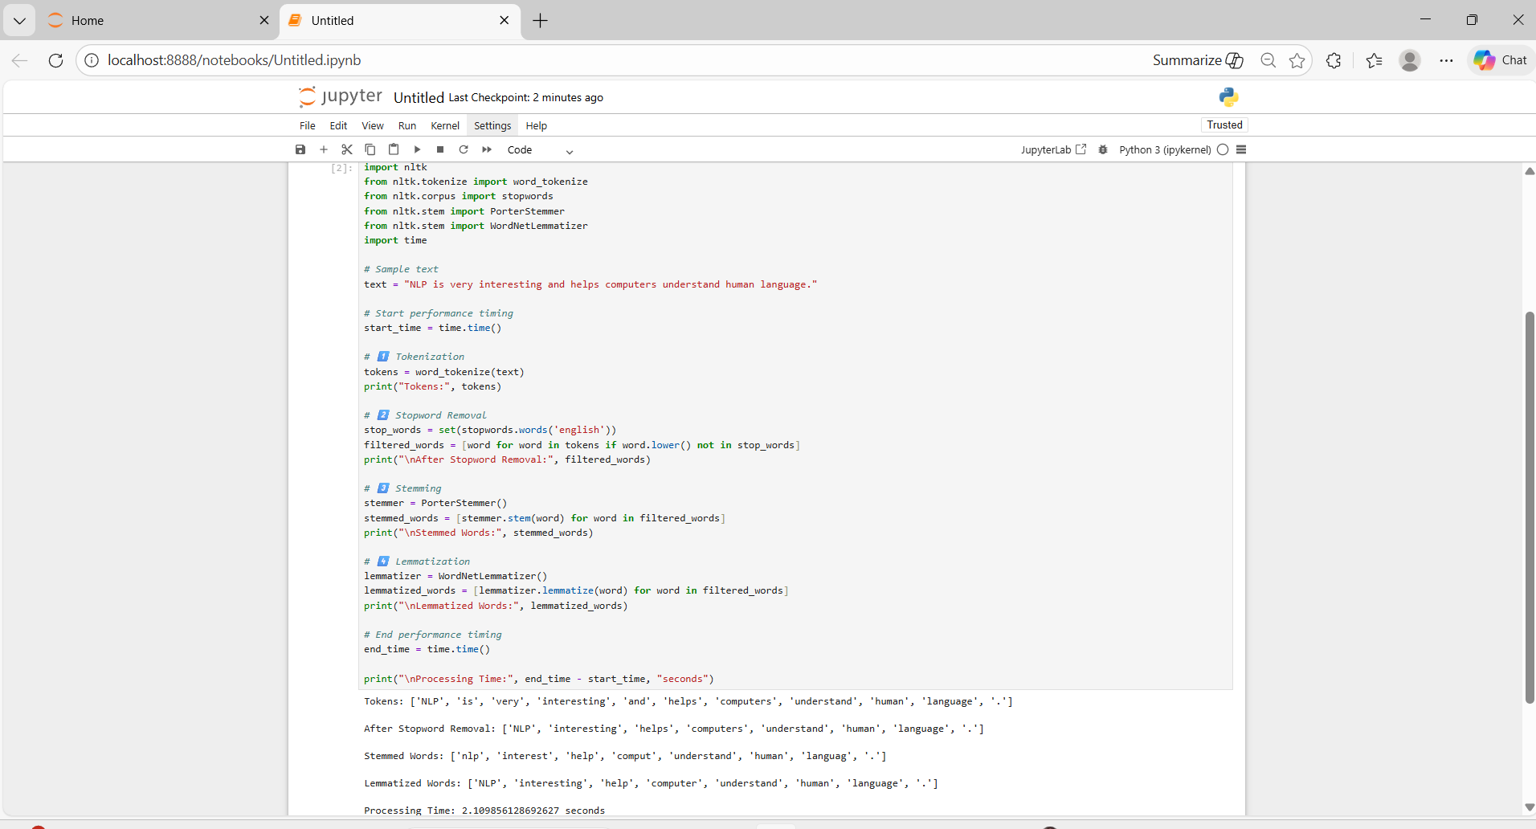

DAY16:
1. Machine Learning (ML)
- Machine Learning is a subset of Artificial Intelligence (AI).
- It allows computers to learn from data instead of being explicitly programmed.
- The system improves its performance automatically using datasets.
Simple meaning:
Computer learns patterns from data and makes predictions or decisions.

2. Relationship Between AI and ML
- Artificial Intelligence (AI) → Making machines intelligent.
- Machine Learning (ML) → Method used inside AI to learn from data.
Artificial Intelligence
↓
Machine Learning
↓
Deep Learning

3. Types of Machine Learning
1. Supervised Learning
- Model learns using labeled data (input + correct output).
- Used for prediction tasks.
Types:
- Regression
  - Predicts continuous values.
  - Example: House price prediction.
- Classification
  - Predicts categories or classes.
  - Example: Spam or Not Spam email.

2. Unsupervised Learning
- Model learns from unlabeled data.
- Finds hidden patterns automatically.
Type:
- Clustering
  - Groups similar data together.
  - Example: Customer segmentation.

3. Reinforcement Learning
- Model learns by trial and error.
- Gets rewards or penalties based on actions.
Example:
- Game playing AI
- Robot navigation

4. Important ML Concepts
🔹 Embedding
- Converts data (text, images, etc.) into numerical vectors.
- Helps machines understand similarity between items.

🔹 Overfitting
- Model learns training data too perfectly.
- Performs well on training data but poorly on new data.
Problem: Memorization instead of learning.

🔹 Underfitting
- Model is too simple.
- Cannot learn patterns properly.
Problem: Poor performance everywhere.

5. Regression Algorithms
🔹 Linear Regression
- Predicts continuous values using a straight-line relationship.
- Example: Predict salary based on experience.

🔹 Logistic Regression
- Used for classification problems.
- Output is probability (0 or 1).
Example:
- Disease prediction (Yes/No)

6. Decision Tree
- Tree-like model used for classification or regression.
- Makes decisions using conditions.
Example:
Is age > 18?
Yes → Adult
No → Minor

7. Scikit-learn (Sklearn)
- Python library for Machine Learning.
- Provides ready-to-use ML algorithms.
Used for:
- Regression
- Classification
- Clustering
- Model evaluation
sklearn and scikit-learn are the same.

8. OCR (Optical Character Recognition)
- Technology that converts images → text.
Example:
- Reading text from scanned documents or photos.

9. Popular OCR Models / Libraries
🔹 PaddleOCR
- Powerful OCR by Baidu.
- Supports many languages.
- High accuracy.

🔹 Pytesseract
- Python wrapper for Tesseract OCR.
- Open-source and widely used.

🔹 DocTR
- Deep learning-based OCR.
- Good for document understanding.

🔹 Surya OCR
- Advanced OCR model for structured documents.

🔹 EasyOCR
- Simple and easy-to-use OCR library.
- Supports multiple languages.

DAY17:
Implementing Pytesseract

DAY18:
Do assignments and documention

KNN
K-Means
Clustering algorithm
Cluster = groups of similar data points
K = number of clusters (ex: K = 4)
Centroid = center point of cluster
Euclidean distance
Steps:
- Choose the K value
- Initialize centroids
- Assign each data point to nearest centroid
- Calculate Euclidean distance
- Recalculate centroid
- Repeat until convergence
WCSS = Within Cluster Sum of Squares
Elbow Method → used to find optimal K value
Unsupervised learning → no labeled data
Python
from sklearn.cluster import KMeans

KNN (K-Nearest Neighbors)
Supervised learning
Used for:
• Classification
• Regression
Steps:
- Choose K value
- Calculate distance
- Find K nearest neighbors
- Majority voting
Manhattan Distance
|x2 − x1| + |y2 − y1|
Python
from sklearn.neighbors import KNeighborsClassifier

DAY 21
Backpropagation
Used in neural networks
Gradient Descent
Used to minimize loss function
Epoch = one complete training cycle
Training process:
Forward propagation → prediction
Backpropagation → error calculation
Gradient descent → weight update
Implementation:
KNN using Python
K-Means using Python

