Project Documentation

Day 1 - Project Introduction
The session began with a formal introduction to our mentor, who explained their role in guiding and supporting us throughout the project. Each team member introduced themselves, sharing: Their academic background ,Technical skills and areas of interest.
This introduction helped in:
- Understanding each other’s strengths and skill sets
- Creating a comfortable and open communication environment
We discussed about the project title and gave a brief introduction about the project. We understood the problem statement and the objectives of the project.

Day 2 - GitHub Repository
We learned how to create a GitHub account and how to create a new repository. We also learned how to clone a repository to the local system using git clone command.
MY personal repository: https://github.com/srushtiy05/Srushti_Receipt_invoice_digitilizer_team_b
My team B repository:
github link: https://github.com/Shaik-Ayisha/Receipt-and-Invoice-Digitizer-_Team_B.git

Day 3 - Git, GitHub and GitLab
We learned the difference between git, Github and Gitlab.
Git is a version control system.
Github and Gitlab are platforms used to host Git repositories.

Git Commands Learned
1. git clone: Used to copy a repository.
2. git add . : Adds all files to staging area.
3. git add filename: Adds specific file.
4. git commit -m: Saves changes with message.
5. git push: Pushes changes to remote repository.
6. git pull: Fetches and merges changes.
7. git fetch --all: Fetches all changes without merging.
8. git branch: Lists branches.
9. git checkout -b: Creates and switches branch.

Virtual Environment
We learned about creating a virtual environment using python -m venv.
Activate it using scripts/activate and deactivate to exit.

Upcoming Topic
Tomorrow we will learn FastAPI and Flask API to create backend endpoints.

Day 4 – SDLC & Agile Methodology
In today’s session, we discussed the Software Development Life Cycle (SDLC) and Agile methodology in detail.SDLC is a structured process used to design, develop, test, deploy, and maintain software. We learned about the key roles involved:
1.Functional Consultant / Business Analyst gathers business and project requirements and prepares the Functional Specification Document (FSD).
2.Developers prepare the Technical Specification Document (TSD) based on FSD, implement the code, and perform unit testing.
3.Testers / QA team create test scripts, execute testing, and record test results.
4.Administration (IT) team manages servers, databases, and system infrastructure.
5.Product / Project Management plans, monitors, and controls the project.
6.Sales & Marketing promote the product and convert customers.
7.HR manages recruitment and employee-related activities.
8.Documentation & Support teams handle documentation and post-deployment support.
We also discussed the three main servers:
•Development Server
•Quality (QA) Server
•Production Server
Agile methodology, which follows an iterative and collaborative approach with steps like design, development, implementation, review, and monitoring.
Agile mainly has three roles:
•Product Owner – handles requirements, priorities, and planning
Scrum Master – monitors the process and guides the team
•Development Team – designs, develops, tests, and deploys the product
Overall, today’s session focused on understanding roles, responsibilities, and workflows in both traditional SDLC and Agile methodology.

Day 5 – API
the session focused on understanding APIs and backend development using Python. The discussion was mainly around APIs, Flask, FastAPI, request–response flow, and hands-on practice.

API Understanding
API stands for Application Programming Interface. An API is used for communication between frontend and backend. The frontend sends input data to the backend, and the backend processes the data and sends a response back to the frontend.

Payload
Payload refers to the input entered by the user. This input is sent from the frontend to the backend through an API. The backend receives the payload, processes it, and sends back the response.

HTTP Methods
The HTTP methods discussed were GET, POST, and DELETE.
GET method is used to fetch data from the backend.
POST method is used to send data from the frontend to the backend for processing.
DELETE method is used to delete data from the backend.

Flask API
Flask is a Python library used to build APIs. It is a simple and basic framework suitable for beginner-level API developers. Flask is used to create backend endpoints.
In Flask, the application is initialized using app = Flask(__name__). app is a variable name and __name__ represents the current Python file.
Routes in Flask are created using app.route(). The HTTP methods such as GET and POST are passed inside the parentheses as parameters.

FastAPI
FastAPI is another Python framework used to build APIs. The FastAPI application is initialized using app = FastAPI(). In FastAPI, HTTP methods are defined directly using decorators like @app.get() and @app.post().
Prefix and Endpoint
Prefix represents the project name and remains the same for all endpoints in a project. Each endpoint has a separate name based on its functionality.

Postman Tool
Postman is a tool used to test APIs. It is used to send GET and POST requests and to check the responses returned by the backend.

HTTP Request vs WebSocket
In HTTP requests, the frontend sends a request to the backend and receives the entire response at once. In WebSocket-based communication, the connection remains open and responses are sent continuously. ChatGPT was discussed as an example of WebSocket-based communication.

Localhost and HTTPS
During local development, APIs run on HTTP using localhost. HTTPS is not required during local development and is only needed after deployment.

Virtual Environment
A virtual environment is created to manage project dependencies. It is created using python -m venv venv and activated before installing Flask or FastAPI.

Assignment 1
Assignment 1 was given during the session. to create a Python program using either Flask or FastAPI. The assignment objective is to connect Python using Flask or FastAPI and create a basic working API.
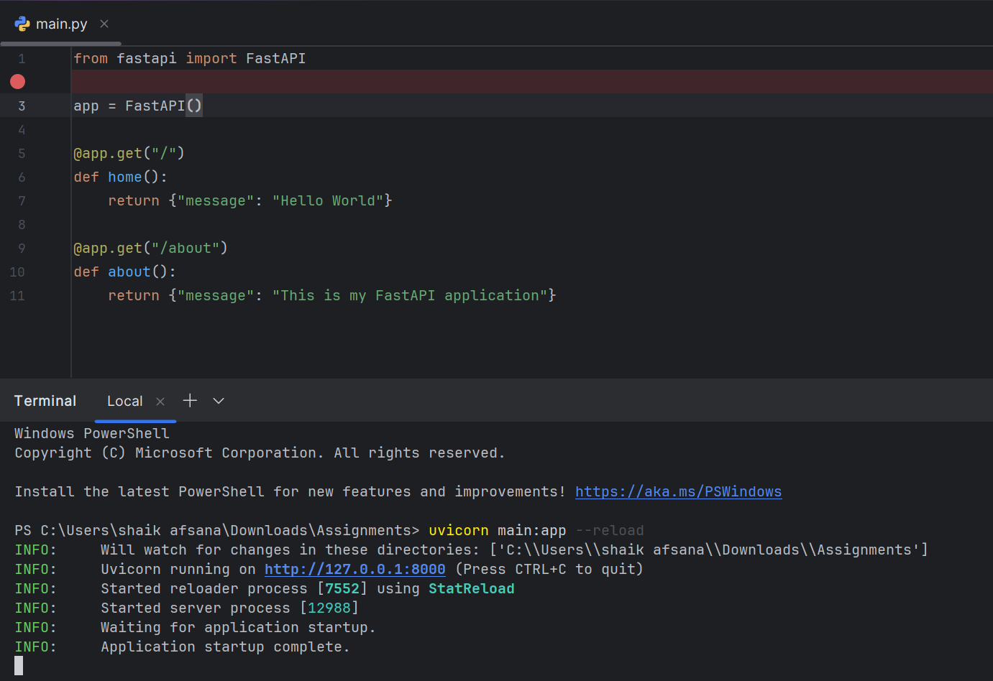

Use of AI Tools Anti-Gravity, provided by Google, was discussed as an AI tool that provides access to Gemini models.

DAY-6: milestone responsiblity
Day 6 focused on understanding project structure, frontend and backend responsibilities, milestone expectations, and documentation requirements. UI development and clear explanation of project flow are the main focus
Frontend Developer Responsible for UI screens such as Login page ,Dashboard using React ,HTML, CSS, JavaScript , No backend connection required at this stage.
PPT Instructions
Individual PPT : Explain your role ,technologies used ,Screens parts developed
Group PPT: Project overview, Milestone wise progress, Team member names & contributions ,each member must present their part
Repository Instructions
To Work on individual repository for now
Group repository can be updated Code integration will be done in later stages

DAY-7: SQL – JWT – BACKEND DEVELOPMENT

INTRODUCTION TO SQL
Structured Query Language (SQL) is a standard programming language used to manage and manipulate data stored in relational databases.
SQL is an essential skill for backend development because applications require data storage, retrieval, and modification.
SQL allows developers to:
Store large amounts of structured data
- Retrieve specific data efficiently
- Update existing data
- Delete unwanted data securely
SQL works with database management systems such as MySQL, PostgreSQL, and SQLite.
These databases are widely used in web applications, enterprise systems, and backend servers.
CRUD OPERATIONS
CRUD stands for Create, Read, Update, and Delete.
These are the four fundamental operations performed on data in any database-driven application.
Create: Used to insert new records into a database.
Read: Used to retrieve or display data stored in tables.
Update: Used to modify existing data without deleting it.
Delete: Used to remove data from tables when it is no longer required.
Every backend system heavily relies on CRUD operations to function correctly.

CORE SQL COMMANDS
CREATE: The CREATE command is used to define new database tables. It specifies the structure of the table, including column names and data types.
INSERT: The INSERT command is used to add new rows of data into a table.
SELECT: The SELECT command retrieves data from one or more tables.
It is the most frequently used SQL command.
UPDATE: The UPDATE command modifies existing rows.
It must be used carefully with conditions to avoid updating all records.
DELETE: The DELETE command removes specific rows from a table using conditions.

DROP, TRUNCATE, AND DELETE (DIFFERENCES)
DROP:
The DROP command removes the entire table from the database.
Both the table structure and its data are permanently deleted.
TRUNCATE:
The TRUNCATE command deletes all records from a table but keeps the table structure intact.
It is faster than DELETE and cannot be rolled back.
DELETE:
The DELETE command removes selected rows based on a condition.
The table structure remains unchanged.
SQL OPERATORS
SQL operators are used to perform operations on data.
Comparison Operators:
These operators compare two values and return results based on conditions.
Logical Operators:
AND, OR, and NOT are used to combine multiple conditions in queries.
IN Operator: The IN operator checks whether a value matches any value in a given list.
BETWEEN Operator: The BETWEEN operator filters records within a specified range.
LIKE Operator: The LIKE operator is used for pattern matching in text data.
IS NULL Operator: Used to check whether a column contains NULL values.
PATTERN MATCHING USING LIKE
Pattern matching helps search text-based data :'A%':
Matches values starting with the letter A :'%A':
Matches values ending with the letter A. :'%A%':
Matches values containing the letter A anywhere.
This is useful for filtering names, emails, or text data.
AGGREGATE FUNCTIONS
Aggregate functions perform calculations on multiple rows and return a single value.
MIN(): Returns the smallest value in a column.
MAX(): Returns the largest value.
AVG(): Calculates the average of values.
COUNT(): Counts the total number of records.
These functions are commonly used for reports and analysis.
ORDER BY: Used to sort query results in ascending or descending order.
GROUP BY: Groups rows having the same values.
It is used along with aggregate functions to summarize data.
HAVING CLAUSE :The HAVING clause is used to filter grouped data.It works only with GROUP BY and aggregate functions.
WHERE filters individual rows, while HAVING filters groups.

SET OPERATORS
UNION: Combines results of two queries and removes duplicates.
UNION ALL: Combines results and keeps duplicates.
INTERSECT: Returns records common to both queries.
EXCEPT: Returns records present in the first query but not in the second.

SQL JOINS
INNER JOIN: Returns only matching records from both tables.
LEFT JOIN: Returns all records from the left table and matching records from the right table.
RIGHT JOIN: Returns all records from the right table and matching records from the left table.
FULL JOIN: Returns all records from both tables.
CROSS JOIN: Returns all possible combinations of records.
ASSIGNMENT 2 – SQL QUERIES ON JOIN AND OPERATION
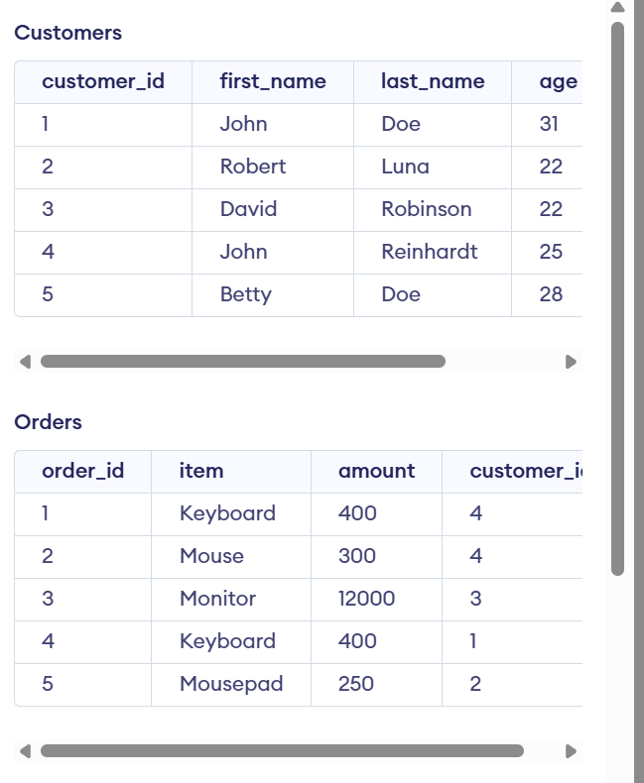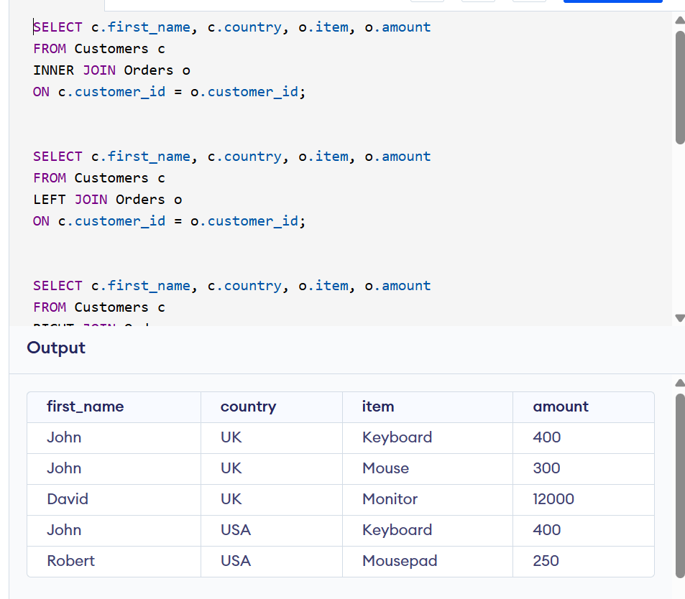
Inner join
This shows only customers who placed orders
SELECT c.first_name, c.country, o.item, o.amount
FROM Customers c
INNER JOIN Orders o
ON c.customer_id = o.customer_id;
LEFT JOIN
SELECT c.first_name, c.country, o.item, o.amount
FROM Customers c
LEFT JOIN Orders o
ON c.customer_id = o.customer_id;
All customers appears no order -item & amount will be NULL
RIGHT JOIN
SELECT c.first_name, c.country, o.item, o.amount
FROM Customers c
RIGHT JOIN Orders o
ON c.customer_id = o.customer_id;
JOIN 3 Tables (Customers + Orders + Shippings)
SELECT c.first_name, o.item, o.amount, s.status
FROM Customers c
INNER JOIN Orders o
ON c.customer_id = o.customer_id
INNER JOIN Shippings s
ON c.customer_id = s.customer_id;
Total Amount Spent by Each Customer
SELECT c.first_name, SUM(o.amount) AS total_spent
FROM Customers c
INNER JOIN Orders o
ON c.customer_id = o.customer_id
GROUP BY c.first_name;

INTRODUCTION TO JWT
JSON Web Token (JWT) is a compact and secure method for transmitting information between a client and server.
JWT is widely used for authentication and authorization in backend applications.

STATELESS API CONCEPT
JWT works with stateless APIs.In stateless architecture, the server does not store session information.The client stores the token and sends it with every request.
JWT STRUCTURE
JWT consists of three parts:
Header: Contains the token type and encryption algorithm.
Payload: Contains user information such as user ID and username.
Signature: Ensures the integrity and authenticity of the token.

JWT AUTHENTICATION FLOW
User logs in using credentials.
Server validates credentials.
JWT token is generated upon successful validation.
Token is stored on the client side.
Client sends token in request headers.
Server verifies token validity.
Access is granted or denied.

JWT SECURITY
JWT tokens are sensitive.They must be transmitted using HTTPS. secret keys must be protected.
Tokens must include expiry time.
JWT IN PYTHON : PyJWT is a Python library used to create and verify JWT tokens.
Installation:
pip install PyJWT
Imports:
import jwt
import datetime
The jwt.encode() function is used to generate secure tokens.
JWT VS OAUTH
JWT:
Used for authentication.
Lightweight and stateless.
OAuth:
Authorization framework.
Used for third-party logins like Google or GitHub.
Flask and FastAPI are used to build backend APIs.
Databases and JWT are integrated for secure systems.
HASH ,HTML and CSS will be covered in future classes.

Day 9 Documentation
File handling, Built-in functions, and functional programming in python
1. File Handling
File handling allows Python to read from and write to external files such as .txt or .csv files.
- Common File Methods:
open() - Opens a file in specified mode (read, write, append).
read() - Reads entire file content.
readline() - Reads one line at a time.
readlines() - Reads all lines and returns as a list.
write() - Writes content to file.
close() - Closes file and frees memory.

2. Object Related Functions
type() - Returns the data type of a variable.
id() - Returns the unique memory address of an object.
UUID - Generates a globally unique identifier using uuid module.

3. General Utility Functions
len() - Returns length of iterable.
range() - Generates sequence of numbers.
sorted() - Returns a new sorted list.
enumerate() - Returns index-value pairs.
zip() - Combines multiple iterables element-wise.
join() - Joins list of strings into single string.
sum() - Returns sum of all elements.
min() - Returns minimum value.
max() - Returns maximum value.
pow() - Returns power of a number.

4. Conversion Functions
Conversion functions are used to convert one data type to another.
int() - Converts value to integer.
float() - Converts value to float.
str() - Converts value to string.
list() - Converts iterable to list.
tuple() - Converts iterable to tuple.
set() - Converts iterable to set.

5. Functional Programming Concepts
map() - Applies a function to every element in an iterable.
filter() - Filters elements based on condition.
reduce() - Reduces iterable to single value

DAY 10 AND 11- MILESTONE 1

DAY 12
Day 12 focused on advanced Python built-in functions related to Object-Oriented Programming, scope management, dynamic execution, memory management, and exception handling..

1. Class and Object Built-in Methods

getattr()
The getattr() function is used to retrieve the value of an attribute from an object dynamically. It is especially useful when attribute names are not fixed and need to be accessed programmatically. This function improves flexibility in dynamic programming environments.

setattr()
The setattr() function is used to assign or update the value of an attribute in an object dynamically. It allows modification of object properties at runtime without directly accessing them using dot notation. This function supports scalable and modular code development.

hasattr()
The hasattr() function checks whether a specific attribute exists within an object. It returns a Boolean value and helps prevent runtime errors by verifying attribute availability before access.

isinstance()
The isinstance() function checks whether an object belongs to a specified class. It supports object validation, type checking, and inheritance-based verification. This function ensures that operations are performed on appropriate object types.

issubclass()
The issubclass() function verifies whether one class is a subclass of another class. It is used to validate class hierarchy and inheritance relationships. Proper understanding of parent and child class relationships is necessary when using this function.

2. Miscellaneous Functions

globals()
The globals() function returns a dictionary containing all global variables defined in the current program scope. It is useful in large programs where tracking global variables manually becomes difficult. This function supports scope inspection and debugging.

locals()
The locals() function returns a dictionary containing all local variables within a specific scope such as a function. It helps in understanding variable accessibility and supports debugging within confined scopes.

callable()
The callable() function checks whether an object can be invoked as a function. It returns a Boolean value and ensures that an object is executable before calling it. This function supports modular and reusable programming practices.

eval()
The eval() function evaluates a single Python expression provided as a string and returns the result. It performs dynamic expression evaluation and is commonly used in controlled execution environments.

exec()
The exec() function executes dynamically created Python code blocks. Unlike eval(), it can execute multiple statements. It is useful for dynamic execution and debugging but must be used carefully.

3. Exception Handling

try
The try block contains code that may potentially raise an error during execution. It allows the programmer to define sections of code that need monitoring for exceptions.

except
The except block handles errors that occur within the try block. It prevents abrupt termination of the program and ensures graceful error handling.

finally
The finally block executes regardless of whether an exception occurs or not. It is typically used for cleanup operations such as releasing resources or closing connections.

4. Memory Management

del Statement
The del statement is used to delete variables or object references from memory. It removes the reference to an object, and if no references remain, Python frees the memory automatically.

Garbage Collection - gc.collect()
Python provides a gc (Garbage Collection) library to manage unused memory. The gc.collect() function forces garbage collection and frees memory occupied by unreachable objects. This mechanism improves memory efficiency in large-scale and long-running applications.

ASSIGNMENT 3
• Understand the enumerate() function and its concept.
• Practice the isinstance() function and analyze class relationships.
• Develop Python code using the gc library for memory management.
Assignment 3
Enumerate()
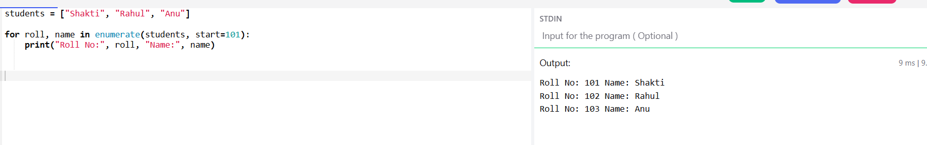

ISINSTANCE()
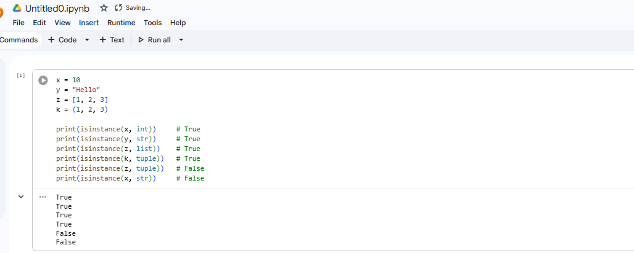

GC LIBRARY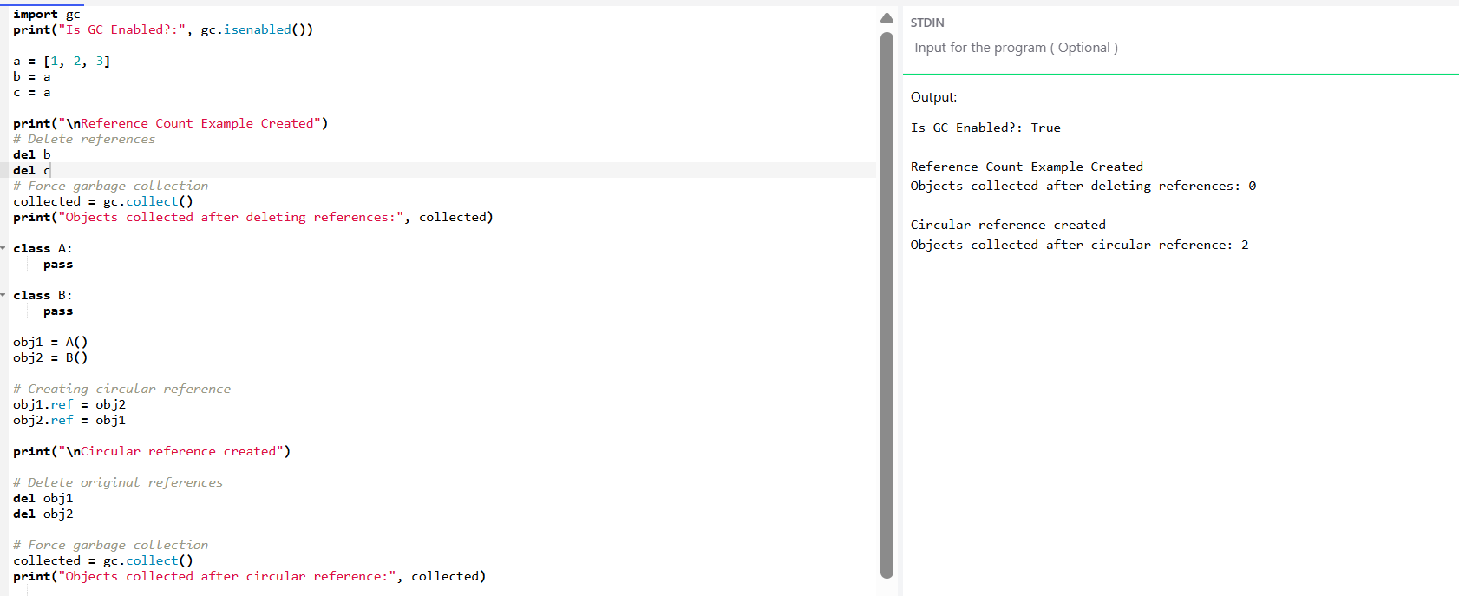

shows how Python uses the gc library to manage memory and clean unused objects, especially circular references, using gc.collect().
DAY 14- AI MODELS
AI Models & LLM Session Documentation
AI Models
Pre-trained systems developed using Machine Learning and Deep Learning to perform tasks such as chat, prediction, image/video generation, and automation.
2. Prediction Concept
AI works on probability-based prediction. Models predict the most likely output based on patterns learned during training.
Natural Language Processing (NLP)
A branch of AI that enables machines to understand and process human language using techniques like tokenization, classification, and sentiment analysis.
4. Large Language Models (LLMs)
Deep learning models trained on massive text datasets to understand, generate, and reason over language.
5. NLP vs LLM
NLP is the field of study.
LLM is a powerful model built using NLP techniques.
OCR vs NLP vs LLM
OCR extracts text from images.
NLP understands and processes text.
LLM understands, generates, and performs reasoning.
AI Platforms & Providers
Companies like OpenAI, Google, Meta, and xAI provide AI models via platforms that include UI and API access.
8. API Key Generation
API keys are secret credentials used to access AI models programmatically.
They must be stored securely and never shared publicly.
Rate LimitTime-based restriction controlling how many API requests can be sent within a specific time window.
Token Limit Request-based limit controlling how many tokens (input + output) can be processed in a single request.

11. Billing & Usage Most platforms charge based on token usage.
Free tiers provide limited credits; paid plans increase limits and access.

Chat Completion Structure
Includes:
- Model selection
- System message
- User message
- Assistant response
- Parameters (temperature, max tokens)

13. Temperature Parameter
Controls output randomness.
Low temperature → stable and factual.
High temperature → creative and varied.
14. Document Chatbot
Reads documents, converts them into embeddings, retrieves relevant information, and answers user queries accurately.
15. Vision vs Extraction Models
Vision models process images.
Extraction models (OCR-based) extract text from images.

16. Production Readiness
Before deployment, ensure:
- Security
- Authentication
- Scalability
- Stable performance
Enterprise systems require controlled and secure responses.
Staying updated with AI news, new LLM releases, and market trends is essential for professional growth.

DAY 15 NLP

1. NLP (Natural Language Processing)
NLP is a branch of Artificial Intelligence that enables computers to understand, interpret, and process human language (text or speech).

2. Positive and Negative (Sentiment Analysis)
Sentiment Analysis is used to classify text into Positive, Negative, or Neutral categories based on emotional tone.

3. NLTK (Natural Language Toolkit)
NLTK is a Python library used for performing NLP tasks.
Installation: pip install nltk
Import: import nltk
Download Data: nltk.download('all')

4. NLTK Main Key Features
- Tokenization
- Stop Word Removal
- Stemming
- Lemmatization
- POS Tagging
- Named Entity Recognition (NER)
- Text Processing / Preprocessing

5. Tokenization
Tokenization is the process of breaking text into smaller units such as words or sentences.
Import: from nltk.tokenize import word_tokenize

6. Stop Word Removal
Stop word removal eliminates commonly used words that do not add significant meaning.
Import: from nltk.corpus import stopwords

7. Stemming
Stemming reduces words to their root form, which may not always be a meaningful word.
Import: from nltk.stem import PorterStemmer

8. Lemmatization
Lemmatization reduces words to their dictionary base form and is more accurate than stemming.
Import: from nltk.stem import WordNetLemmatizer

9. POS (Part of Speech) Tagging
POS Tagging identifies the grammatical role of words in a sentence, such as noun, verb, adjective, or adverb.

10. Named Entity Recognition (NER)
NER identifies named entities such as Person, Location, and Organization within text.
Required Downloads:
- nltk.download('words')
- nltk.download('maxent_ne_chunker')

11. Text Processing
Text Processing involves cleaning and manipulating text data for analysis.

12. Text Preprocessing
Text Preprocessing includes steps such as lowercasing, tokenization, stop word removal, stemming, lemmatization, and removing punctuation before applying machine learning models.

Assignment 4
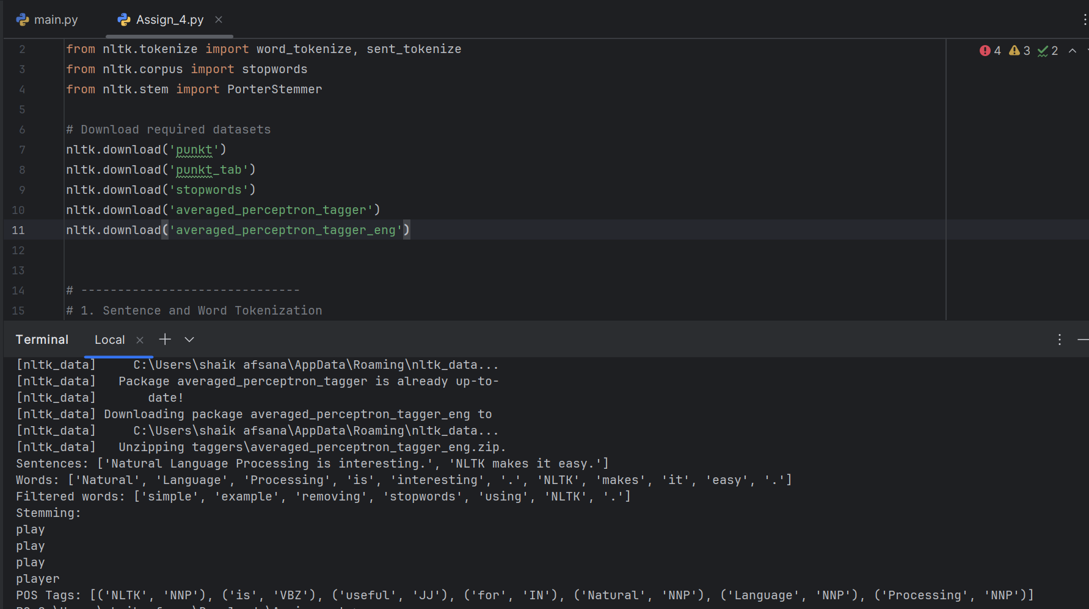
DAY16. Machine Learning (ML)
Machine Learning is a subset of Artificial Intelligence (AI).
•It allows computers to learn from data instead of being explicitly programmed.
•The system improves its performance automatically using datasets.
Simple meaning:Computer learns patterns from data and makes predictions or decisions.
________________________________________
2. Relationship Between AI and ML
•Artificial Intelligence (AI) → Making machines intelligent.
•Machine Learning (ML) → Method used inside AI to learn from data.
Artificial Intelligence
↓
Machine Learning
↓
Deep Learning
3. Types of Machine Learning
1. Supervised Learning
•Model learns using labeled data (input + correct output).
•Used for prediction tasks.
Types:
•Regression
oPredicts continuous values.
oExample: House price prediction.
Classification
oPredicts categories or classes.
oExample: Spam or Not Spam email.
2. Unsupervised Learning
•Model learns from unlabeled data.
•Finds hidden patterns automatically.
Type:
•Clustering
oGroups similar data together.
oExample: Customer segmentation.
3. Reinforcement Learning
•Model learns by trial and error.
•Gets rewards or penalties based on actions.
Example:
•Game playing AI
•Robot navigation
4. Important ML Concepts
🔹 Embedding
•Converts data (text, images, etc.) into numerical vectors.
•Helps machines understand similarity between items.
🔹 Overfitting
•Model learns training data too perfectly.
•Performs well on training data but poorly on new data.
Problem: Memorization instead of learning.
🔹 Underfitting
•Model is too simple.
•Cannot learn patterns properly.
Problem: Poor performance everywhere.
5. Regression Algorithms
🔹 Linear Regression
•Predicts continuous values using a straight-line relationship.
•Example: Predict salary based on experience.
🔹 Logistic Regression
•Used for classification problems.
Output is probability (0 or 1).
Example:
•Disease prediction (Yes/No)
6. Decision Tree
• Tree-like model used for classification or regression.
• Makes decisions using conditions.
7. Scikit-learn (Sklearn)
• Python library for Machine Learning.
• Provides ready-to-use ML algorithms.
Used for:
• Regression
• Classification
• Clustering
• Model evaluation
sklearn and scikit-learn are the same.
8. OCR (Optical Character Recognition)
• Technology that converts images → text.
Example:
• Reading text from scanned documents or photos.
9. Popular OCR Models / Libraries
🔹 PaddleOCR
• Powerful OCR by Baidu.
• Supports many languages.
• High accuracy.
🔹 Pytesseract
• Python wrapper for Tesseract OCR.
• Open-source and widely used.
__
🔹 DocTR
• Deep learning-based OCR.
• Good for document understanding.
🔹 Surya OCR
🔹 EasyOCR
• Simple and easy-to-use OCR library.
• Supports multiple languages.
DAY 17 OCR IMPLEMENT
To perform Optical Character Recognition (OCR) using Tesseract OCR in Python and extract text from images.
. Environment Setup
conda create -p venv python=3.13
conda activate venv
3. Install Required Libraries
pip install pytesseract pillow
4. Install Tesseract OCR Engine
Download and install Tesseract from UB Mannheim installer.
Default Path: C:\Program Files\Tesseract-OCR
5. Verify Installation
tesseract --version
6. Set System PATH (If Required)
Add the following path to Environment Variables:
C:\Program Files\Tesseract-OCR
8. Direct Path Configuration in Python
pytesseract.pytesseract.tesseract_cmd = r'C:\Program Files\Tesseract-OCR\tesseract.exe'
9. Final Working Code
import pytesseract
from PIL import Image
pytesseract.pytesseract.tesseract_cmd = r"C:\Program Files\Tesseract-OCR\tesseract.exe"
image = Image.open("15474.jpg")
text = pytesseract.image_to_string(image)
print(text)

DAY 18 Machine Learning (conti)
1. K-Means Clustering
Type: Unsupervised Learning Algorithm
Purpose: Clustering (Grouping similar data points)
Concept of Clustering
Clustering means grouping similar data points together.
Intra-cluster distance (within same cluster) should be MINIMUM.
Inter-cluster distance (between different clusters) should be MAXIMUM.
K Value
K represents the number of clusters to be formed.
Example: If K = 3, then 3 distinct clusters must be created.
Centroid
Centroid is the center point of a particular cluster.
Centroid Formula (Mean of cluster points):
μ = ( Σx / n , Σy / n )
Euclidean Distance
Used to calculate distance between two data points.
Formula:
d = √((x2 - x1)^2 + (y2 - y1)^2)
Within Cluster Sum of Squares (WCSS)
WCSS measures how tightly the clusters are packed.
Small WCSS → Tightly packed cluster.
Large WCSS → Spread out cluster.
What is WCSS?
WCSS = Sum of squared distances between:
- Each data point
- And its corresponding centroid
Inside the SAME cluster.
Tightly packed cluster → Low WCSS
Spread cluster → High WCSS

Mathematical Formula:
J = Σ(i=1 to K) Σ(x ∈ Ci) ||x - μi||^2
K-Means Algorithm Steps
1. Choose K value.
2. Initialize K centroids randomly.
3. Calculate Euclidean distance between each data point and centroids.
4. Assign data points to nearest centroid (Cluster Assignment).
5. Recalculate centroids as mean of assigned points.
6. Compute WCSS.
7. Repeat steps 3–6 until convergence.
Convergence
Convergence occurs when centroids no longer move or maximum iterations are reached.
Elbow Method (Selecting Optimal K)
1. Run K-Means for different K values (1,2,3,...).
2. Calculate WCSS for each K.
3. Plot K vs WCSS graph.
4. The 'elbow point' indicates optimal K.
Assumptions
• Clusters are spherical in shape.
• Clusters are of similar size.
• Distance metric used is Euclidean distance.
Limitations
• Need to choose K manually.
• Sensitive to initial centroid selection.
• Sensitive to outliers.
• Not suitable for non-spherical clusters.
1.11 Python Implementation (sklearn)
from sklearn.cluster import KMeans
kmeans = KMeans(n_clusters=3)
kmeans.fit(X)
kmeans.predict(X)
K-Means can also be implemented manually by calculating distances and updating centroids.
2. K-Nearest Neighbors (KNN)
Type: Supervised Learning Algorithm
Purpose: Classification and Regression
Similar data points exist closer to each other.
K Value
K represents number of nearest neighbors.
Distance Metrics
Euclidean Distance: d = √((x2 - x1)^2 + (y2 - y1)^2)
Manhattan Distance: d = |x2 - x1| + |y2 - y1|
Steps of KNN
1. Choose K value.
2. Calculate distance between test point and all training points.
3. Select K nearest neighbors.
4. For Classification → Majority Voting.
5. For Regression → Average of K neighbor values.
Overfitting and Underfitting
Small K → Overfitting.
Large K → Underfitting.
Moderate K is recommended.
Feature Scaling
Normalization or Standardization is required because KNN is distance-based.
Lazy Learner
KNN has no explicit training phase; it stores entire dataset.
Prediction time is slower compared to other algorithms.
Manual Implementation
Calculate distances manually → Sort → Pick K nearest → Apply voting or averaging.
3. Backpropagation Algorithm
Type: Supervised Learning (Neural Networks)
Purpose: Minimize error and update weights using Gradient Descent.
3.1 Steps of Backpropagation
1. Forward Propagation (Input → Hidden → Output).
2. Compute Error.
Error = Actual Output - Predicted Output
3. Backward Propagation (Using Chain Rule).
4. Update Weights.
3.2 Weight Update Formula
W_new = W_old - (η × ∂L/∂W)
Where η = Learning Rate and ∂L/∂W = Gradient of Loss w.r.t Weight.
Backpropagation minimizes the loss function using Gradient Descent.

