

Celebal Summer Internship 2026
Week 5 Task: Understand Spark fundamentals and perform data cleaning, transformation, and aggregation using DataFrames
By : Shaik Faizan Ahmed
Roll No : 23B81A05L3
College : CVR COLLEGE OF ENGINEERING

Dataset Description
A synthetic sales dataset containing 1,000 records was created for this assignment to demonstrate various Apache Spark DataFrame operations. The dataset represents sales transactions collected from multiple stores across different regions and includes customer information, product details, transaction information, and revenue data.
The dataset contains the following attributes:
Column Name | Description
user_id | Unique identifier for each user
transaction_date | Date of the sales transaction
region | Region where the transaction occurred (North, South, East, West)
product_category | Category of the purchased product
sale_amount | Total sale amount for the transaction
city | City where the transaction took place
age | Age of the customer
subscription | Customer subscription type (Premium or Basic)
price | Price of the purchased product
status | Transaction status
email | Customer email address
username | Customer username
raw_timestamp | Timestamp of the transaction before schema conversion
store_id | Unique identifier of the store
revenue | Revenue generated from the transaction

The dataset intentionally includes duplicate records, null values, and inconsistent data to demonstrate data cleaning, filtering, aggregation, schema modification, and pipeline creation using Apache Spark DataFrames.

Step 1: Understand Limitations of MapReduce and Advantages of Spark
Objective
To understand the limitations of the MapReduce programming model and learn the advantages of Apache Spark, including in-memory processing and faster execution.
Steps Performed
- Opened a Databricks notebook to start the Apache Spark assignment.
- Studied the limitations of the MapReduce programming model.
- Learned that MapReduce stores intermediate results on disk after every processing stage.
- Understood that disk-based processing increases execution time for large datasets.
- Studied the advantages of Apache Spark over MapReduce.
- Learned that Spark performs in-memory processing, reducing disk I/O.
- Understood that Spark provides faster execution for iterative data processing, machine learning, and real-time analytics.
- Compared the processing approach of MapReduce and Spark.
Output:
The concepts of MapReduce and Apache Spark were successfully studied. Spark's in-memory processing, faster execution, and efficient handling of large datasets were identified as major advantages over the traditional MapReduce framework.
Screenshot 1
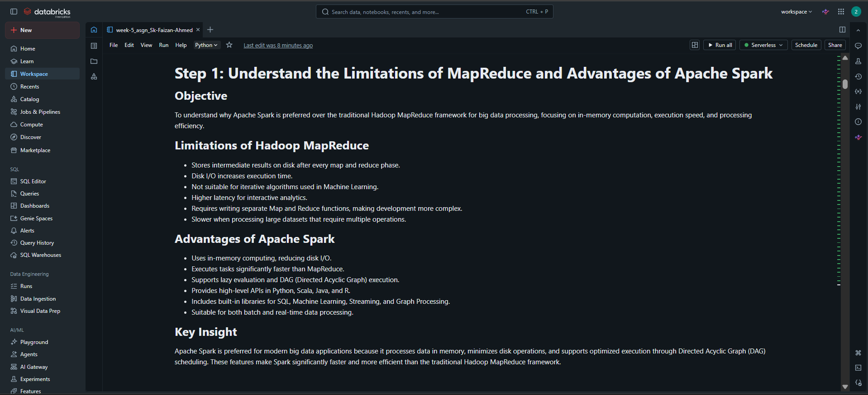
Caption: Understanding the limitations of MapReduce and the advantages of Apache Spark.
What I Learned
I learned that MapReduce performs disk-based processing, which increases execution time because intermediate results are written to storage after each stage. I also learned that Apache Spark keeps intermediate data in memory whenever possible, making data processing much faster and more suitable for iterative algorithms, analytics, and real-time applications.

Step 2: Learn Spark DataFrame Concepts and Immutability
Objective
To understand Spark DataFrame concepts by exploring the dataset and demonstrating DataFrame immutability using PySpark.
Code 1: Displaying the Dataset
display(df)
Output:
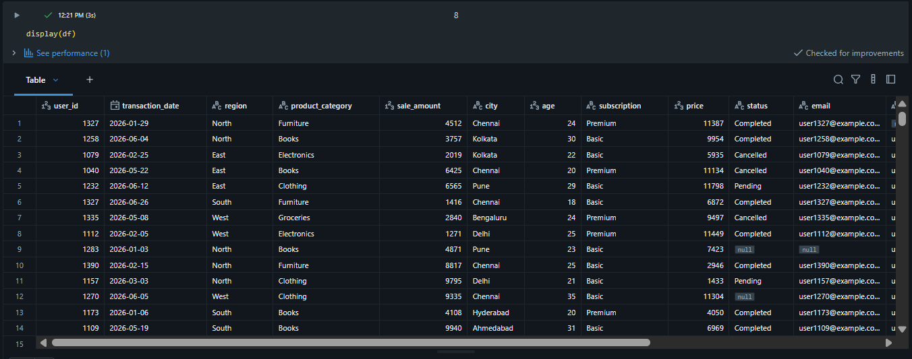
Code 2: Displaying the Schema
df.printSchema()
Output:
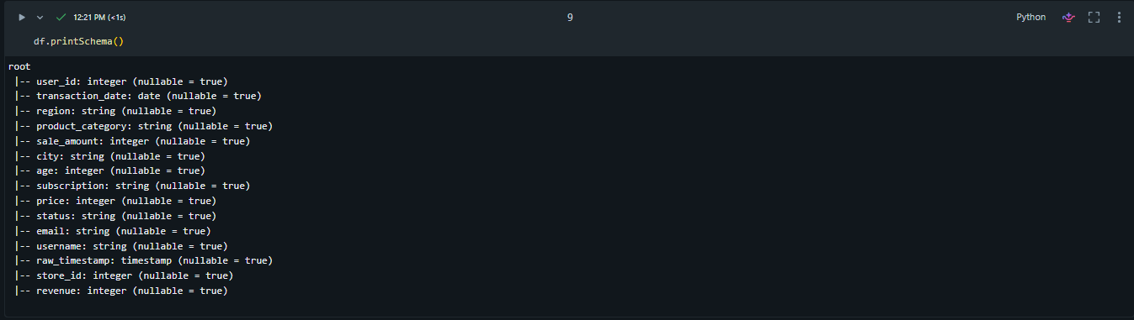
Code 3: Counting Rows and Columns
print("Total Rows:", df.count())
print("Total Columns:", len(df.columns))
Output:
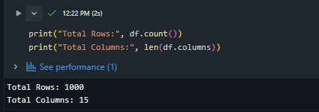
Code 4: Displaying Column Names
print(df.columns)
Output:
Code 5: Displaying Data Types
print(df.dtypes)
Output:
Code 6: Displaying Summary Statistics
df.describe().show()
Output:
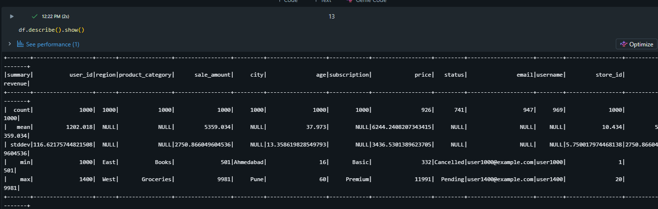
Code 7: Demonstrating DataFrame Immutability
filtered_df = df.filter(df.region == "West")

print("Original Rows:", df.count())
print("Filtered Rows:", filtered_df.count())
Output:
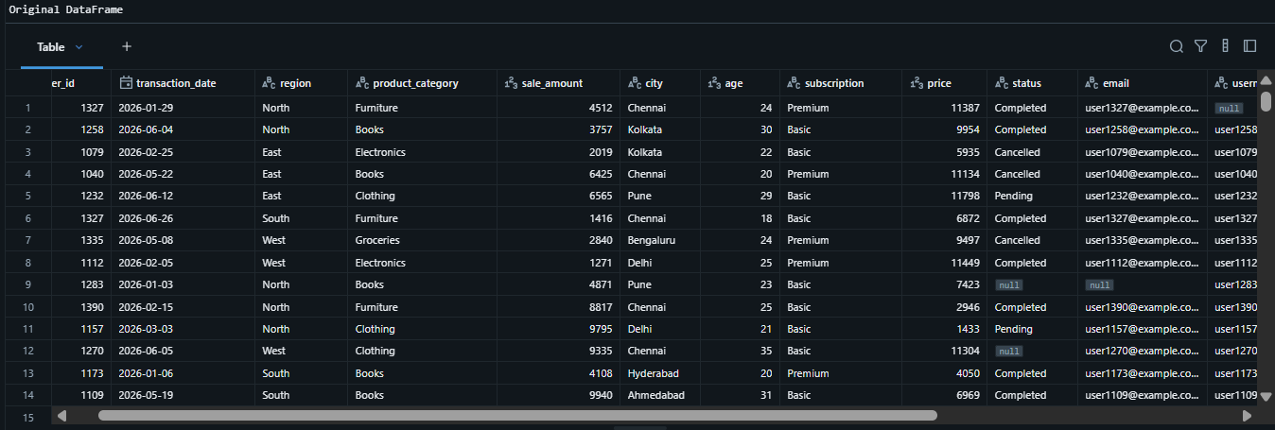
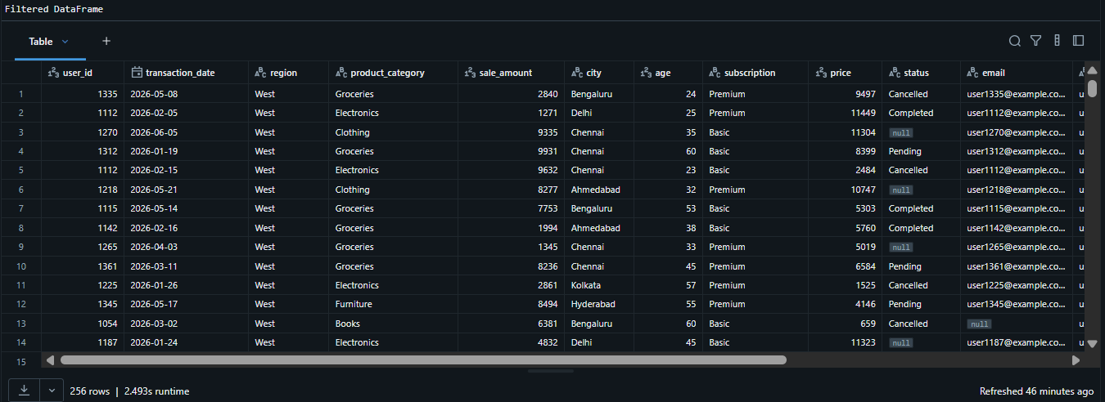
Code 8: Verifying the Original DataFrame is Unchanged
# Verifying the original DataFrame is unchanged

print("Original Rows:", df.count())
print("Filtered Rows:", filtered_df.count())
Output:
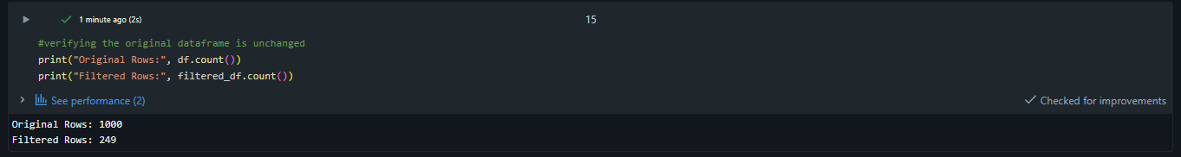
What I Learned
I learned that Spark DataFrames provide a structured way to store and process data using rows and columns with predefined schemas. I also learned that DataFrames are immutable, meaning every transformation creates a new DataFrame instead of modifying the existing one. This makes Spark more reliable and allows it to optimize the execution of transformations.

Step 3: Perform Data Cleaning Operations
Objective
To improve the quality of the dataset by removing duplicate records and handling missing values before performing further analysis.
Code 1: Checking Duplicate Records
total_rows = df.count()
unique_rows = df.dropDuplicates().count()
print("Total Records:", total_rows)
print("Unique Records:", unique_rows)
print("Duplicate Records:", total_rows - unique_rows)
Output:
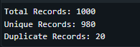
Code 2: Removing Duplicate Records
df_clean = df.dropDuplicates(["user_id", "transaction_date"])
Output:
Code 3: Verifying Duplicate Removal
print("Rows Before Cleaning:", df.count())
print("Rows After Removing Duplicates:", df_clean.count())
Output:

Code 4: Checking Null Values
from pyspark.sql.functions import col, count, when
df_clean.select([
count(when(col(c).isNull(), c)).alias(c)
for c in df_clean.columns
]).show()
Output:
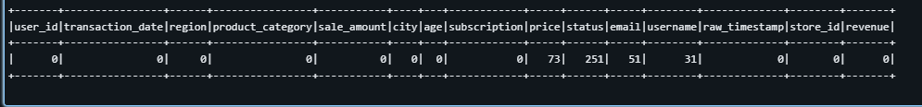
Code 5: Filling Null Values
df_clean = df_clean.fillna({
"price": 0,
"status": "Unknown"
})
Output:
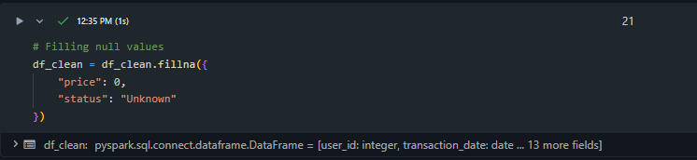Code 6: Verifying Null Values
df_clean.select(
count(when(col("price").isNull(), True)).alias("price_nulls"),
count(when(col("status").isNull(), True)).alias("status_nulls")
).show()
Output:
Code 7: Displaying the Cleaned Dataset
display(df_clean)
Output:
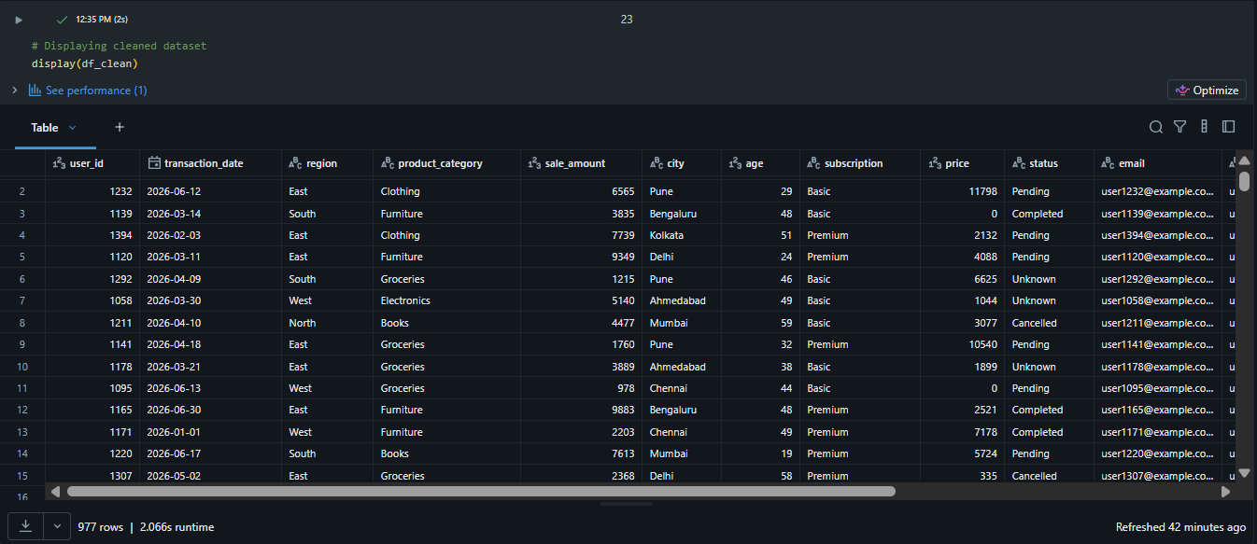
What I Learned
I learned how to improve the quality of a dataset by removing duplicate records and handling missing values. I also learned that Spark provides built-in functions such as dropDuplicates() and fillna() to efficiently clean data before performing analysis. Cleaning the data ensures that further transformations and aggregations produce accurate and reliable results.
Step 4: Apply Filtering Conditions on Datasets
Objective
To filter the dataset based on different conditions such as age, subscription type, product category, and region for targeted data analysis.
Code 1: Filtering Records by Age
# Filtering records by age
age_filter = df_clean.filter(
col("age").between(18, 30)
)
display(age_filter)
Output:
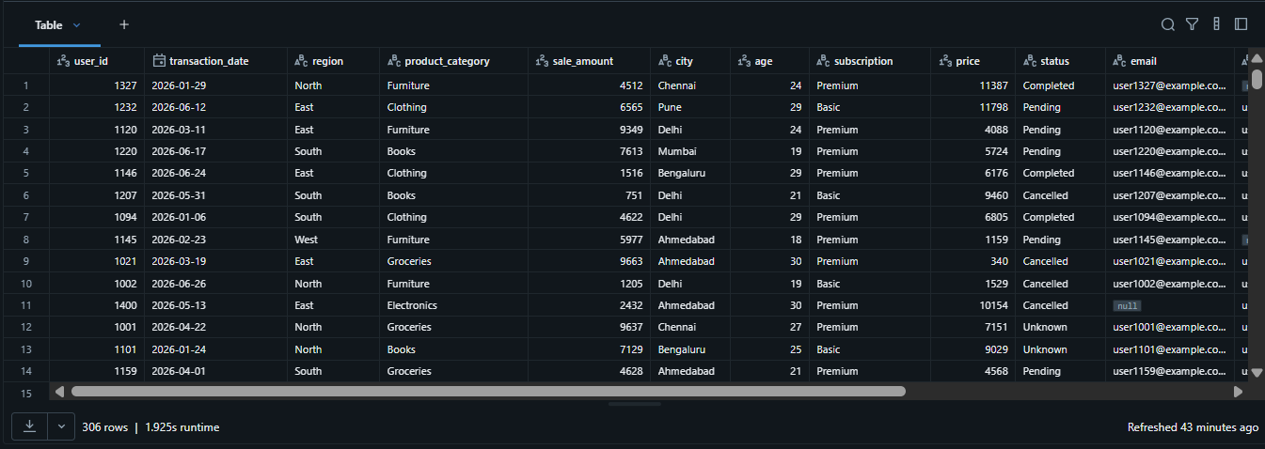Code 2: Filtering Premium Subscribers
premium_filter = df_clean.filter(
col("subscription") == "Premium"
)
display(premium_filter)
Output:
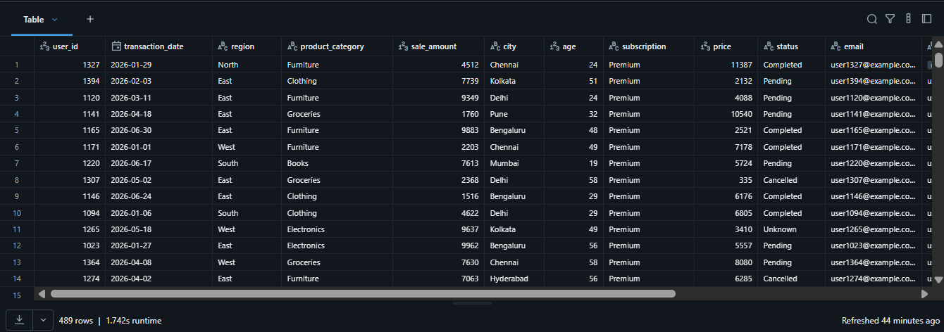

Code 3: Filtering West Region Records
west_filter = df_clean.filter(
col("region") == "West")
display(west_filter)
Output:
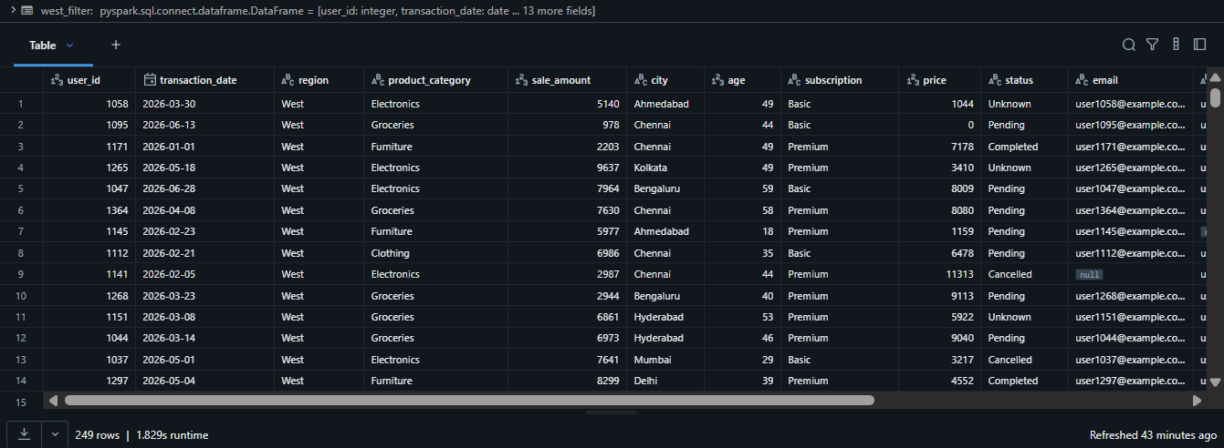Code 4: Filtering Electronics Category
electronics_filter = df_clean.filter(
col("product_category") == "Electronics"
)
display(electronics_filter)
Output:
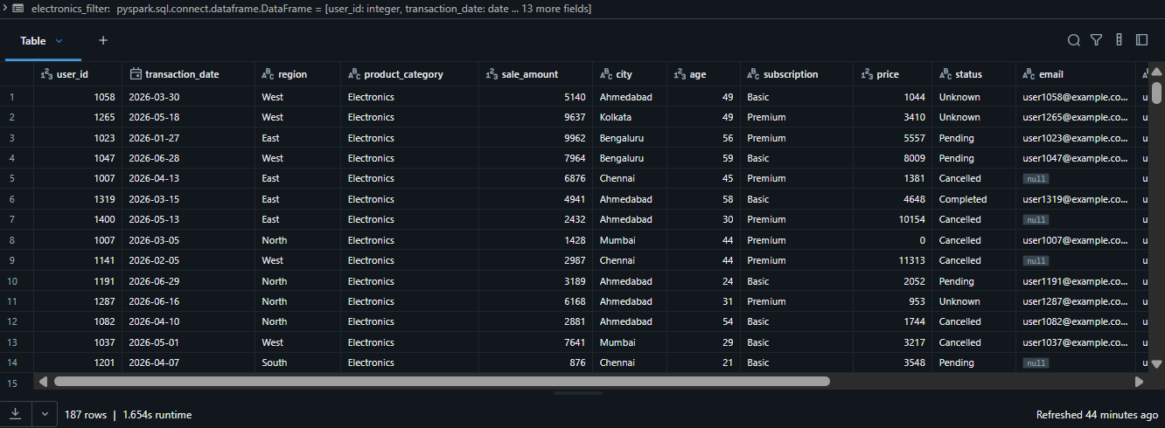Code 5: Applying Multiple Filter Conditions
filtered_data = df_clean.filter(
(col("age").between(18, 30)) &
(col("subscription") == "Premium") &
(col("region") == "West")
)
display(filtered_data)
Output:
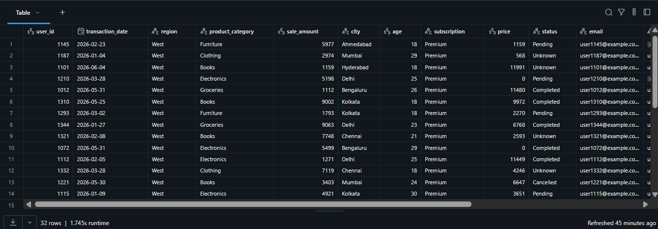Code 6: Counting Filtered Records
# Counting filtered records
print("Age Filter:", age_filter.count())
print("Premium Subscribers:", premium_filter.count())
print("West Region:", west_filter.count())
print("Electronics Category:", electronics_filter.count())
print("Combined Filter:", filtered_data.count())
Output:
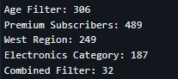
What I Learned
I learned how to filter data using different conditions in Spark DataFrames. I also learned that multiple conditions can be combined using logical operators to retrieve specific records. Filtering helps focus on relevant subsets of data, making analysis more efficient and meaningful.

Step 5: Use Aggregation Functions
Objective
To perform aggregation operations on the dataset using Spark functions such as count, sum, average, minimum, and maximum.
Code 1: Counting Total Records
# Counting total records
df_clean.select(
count("*").alias("Total Records")
).show()
Output:
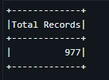
Code 2: Calculating Total Sales
# Calculating total sales
df_clean.select(
sum("sale_amount").alias("Total Sales")
).show()
Output:
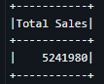
Code 3: Calculating Average Sales
# Calculating average sales
df_clean.select(
avg("sale_amount").alias("Average Sales")
).show()
Output:
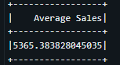

Code 4: Finding Minimum and Maximum Sales
# Finding minimum and maximum sales
df_clean.select(
min("sale_amount").alias("Minimum Sales"),
max("sale_amount").alias("Maximum Sales")
).show()
Output:
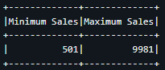
Code 5: Calculating Multiple Aggregations
# Calculating multiple aggregations
df_clean.select(
count("*").alias("Total Records"),
sum("sale_amount").alias("Total Sales"),
avg("sale_amount").alias("Average Sales"),
min("sale_amount").alias("Minimum Sales"),
max("sale_amount").alias("Maximum Sales")
).show()
Output:
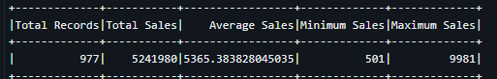
What I Learned
I learned how to use Spark aggregation functions to summarize large datasets. Functions such as count(), sum(), avg(), min(), and max() help generate meaningful statistics that can be used to analyze business data and support decision-making.

Step 6: Group Data Using groupBy() and Apply Conditions on Aggregated Results
Objective
To group the dataset using different columns and perform aggregation operations to analyze summarized information.
Code 1: Counting Records by City
# Counting records by city
city_count = df_clean.groupBy("city").count()
display(city_count)
Output:
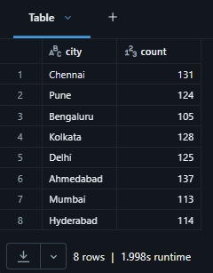
Code 2: Filtering Cities with More Than 100 Records
# Filtering cities with more than 100 records
popular_cities = city_count.filter(
col("count") > 100
)
display(popular_cities)
Output:
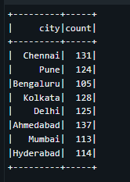

Code 3: Calculating Average Sales by Product Category
# Calculating average sales by product category
category_sales = df_clean.groupBy("product_category").agg(
avg("sale_amount").alias("Average Sales")
)
display(category_sales)
Output:
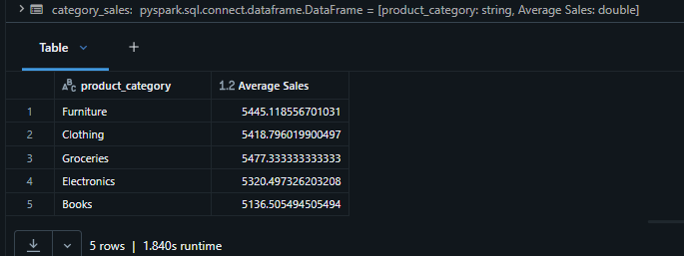
Code 4: Calculating Total Revenue by Store
# Calculating total revenue by store
store_revenue = df_clean.groupBy("store_id").agg(
sum("revenue").alias("Total Revenue")
)
display(store_revenue)
Output:
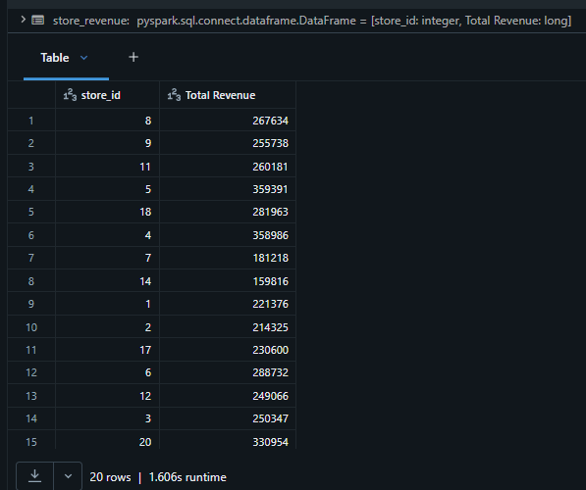
Code 5: Calculating Total Sales by Region
# Calculating total sales by region
region_sales = df_clean.groupBy("region").agg(
sum("sale_amount").alias("Total Sales")
)
display(region_sales)
Output:
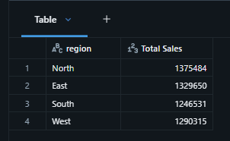
Code 6: Performing Multiple Aggregations
# Performing multiple aggregations
summary = df_clean.groupBy("product_category").agg(
count("*").alias("Total Products"),
sum("sale_amount").alias("Total Sales"),
avg("sale_amount").alias("Average Sales"),
min("sale_amount").alias("Minimum Sales"),
max("sale_amount").alias("Maximum Sales")
)
display(summary)
Output:
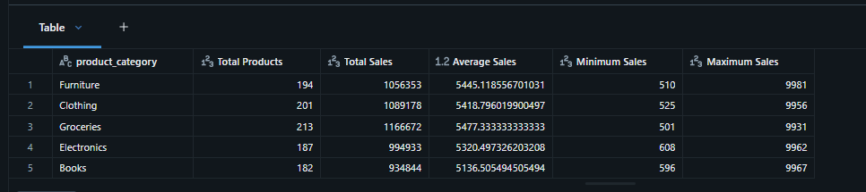
What I Learned
I learned how to group data using the groupBy() function and apply aggregation functions to each group. This helped me summarize the dataset based on different categories such as city, product category, store, and region. I also learned how grouped data provides meaningful insights that are useful for data analysis and reporting.

Step 7: Understand Wide Transformations and Shuffle Operations
Objective
To understand wide transformations and shuffle operations by performing grouping and aggregation on the dataset.
Code 1: Grouping Data by Store
# Grouping data by store
store_summary = df_clean.groupBy("store_id").agg(
sum("revenue").alias("Total Revenue")
)
display(store_summary)
Output:
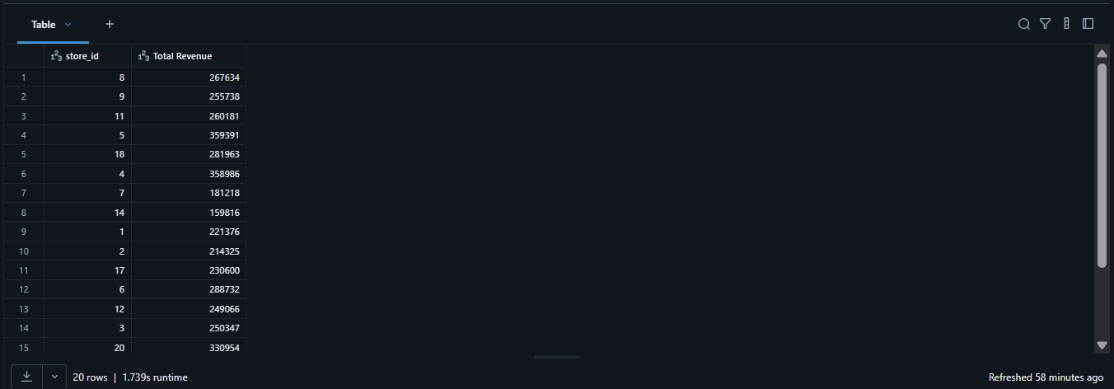Code 2: Grouping Data by Region
# Grouping data by region
region_summary = df_clean.groupBy("region").agg(
avg("sale_amount").alias("Average Sales")
)
display(region_summary)
Output:
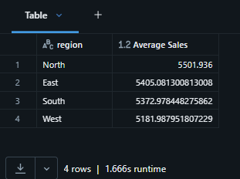
Code 3: Displaying the Execution Plan
# Displaying the execution plan
store_summary.explain()
Output:
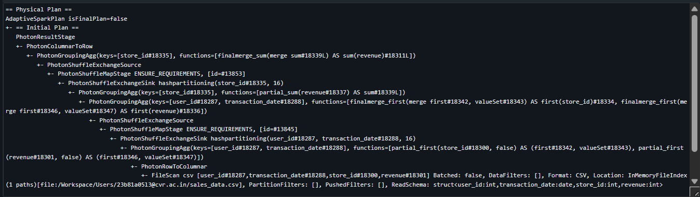Code 4: Performing a Narrow Transformation
# Filtering records
filtered_df = df_clean.filter(
col("region") == "West"
)
display(filtered_df)
Output:
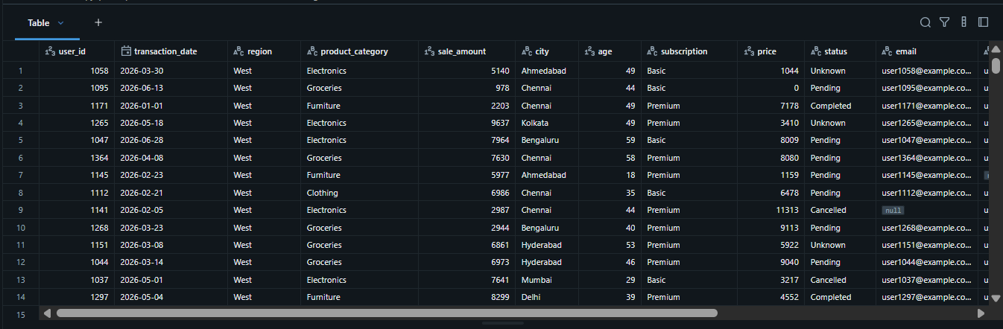What I Learned
I learned that operations such as groupBy() are wide transformations because Spark redistributes data across partitions through a shuffle operation before performing the aggregation. I also learned that filtering is a narrow transformation since each partition processes its own data without exchanging data with other partitions. Understanding these transformations helps in writing more efficient Spark applications.

Step 8: Modify Schema (Casting, Renaming Columns)
Objective
To modify the DataFrame schema by changing the data type of a column and renaming the column for better readability.
Code 1: Displaying the Current Schema
df_clean.printSchema()
Output:
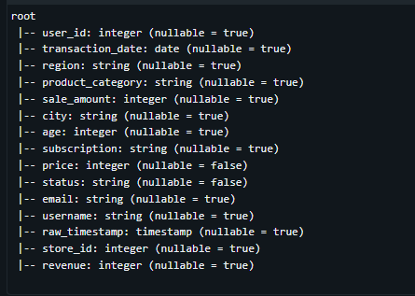
Code 2: Casting the Timestamp Column
# Casting raw_timestamp to TimestampType
from pyspark.sql.functions import col
df_clean = df_clean.withColumn(
"raw_timestamp",
col("raw_timestamp").cast("timestamp")
)
Output:
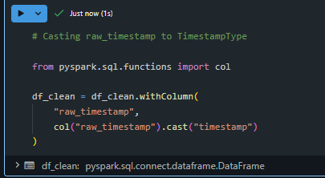
Code 3: Renaming the Column
# Renaming raw_timestamp column
df_clean = df_clean.withColumnRenamed(
"raw_timestamp",
"event_time"
)
Output:
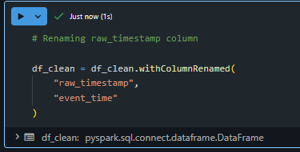
Code 4: Displaying the Updated Schema
df_clean.printSchema()
Output:
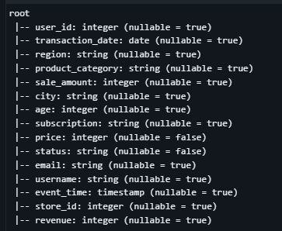
Code 5: Displaying the Updated Dataset
# Displaying updated dataset
display(df_clean)
Output:
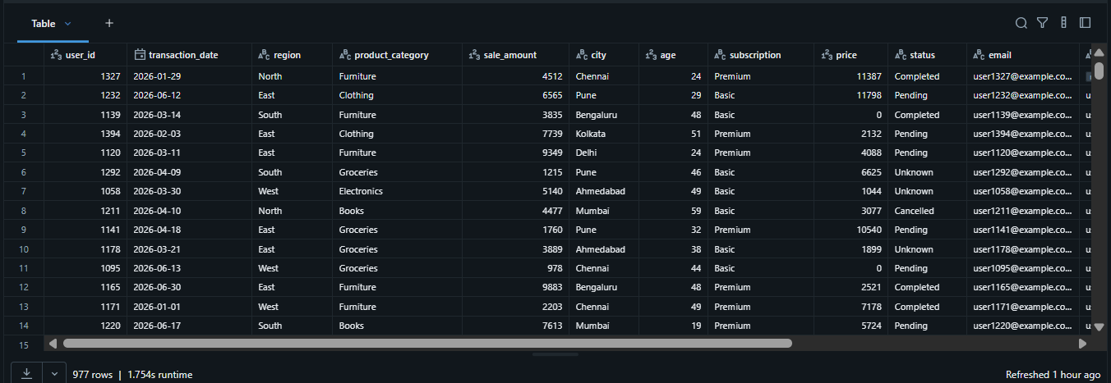What I Learned
I learned how to modify the schema of a Spark DataFrame by changing the data type of a column and renaming columns using Spark transformation functions. I also learned that schema modification improves data consistency and makes the dataset easier to understand and analyze.

Step 9: Handle Inconsistent Data (Nulls, Empty Values, Schema Issues)
Objective
To identify and handle inconsistent data by removing records with null email values and empty usernames, ensuring the dataset is clean and reliable for further analysis.
Code 1: Checking Remaining Null Values
# Checking remaining null values
df_clean.select(
count(when(col("email").isNull(), True)).alias("email_nulls"),
count(when(col("username").isNull(), True)).alias("username_nulls")
).show()
Output:
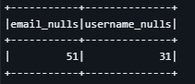
Code 2: Checking Empty Usernames
empty_username_count = df_clean.filter(
trim(col("username")) == ""
).count()
print("Empty Usernames:", empty_username_count)
Output:
Code 3: Removing Null Email Records
df_clean = df_clean.filter(
col("email").isNotNull()
)
Output:
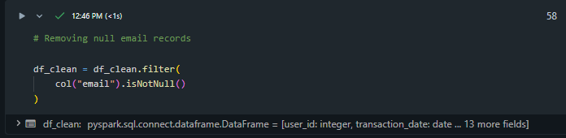

Code 4: Removing Empty Username Records
# Removing empty username records
df_clean = df_clean.filter(
trim(col("username")) != ""
)
Output:
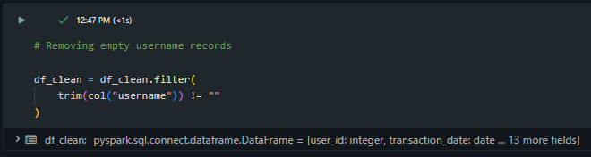
Code 5: Checking remaining null values
df_clean.select(
count(when(col("email").isNull(), True)).alias("email_nulls"),
count(when(col("username").isNull(), True)).alias("username_nulls")
).show()
Output:
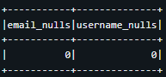
Code 6: Displaying the Cleaned Dataset
# Displaying cleaned dataset
display(df_clean)
Output:
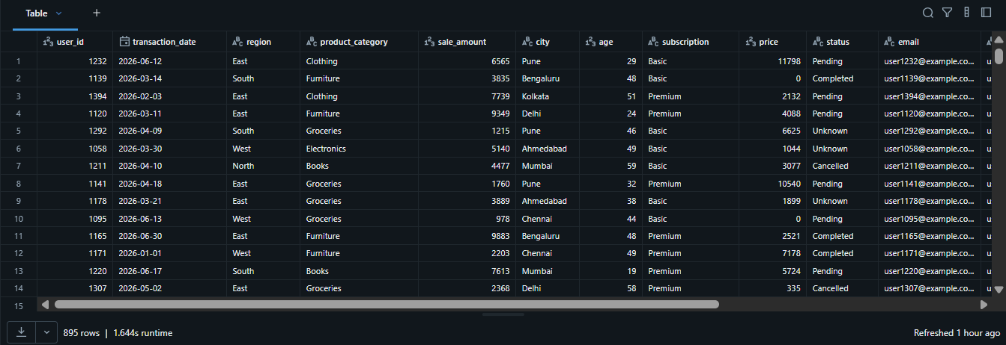

Code 7: Displaying the Updated Schema
# Displaying updated schema
df_clean.printSchema()
Output:
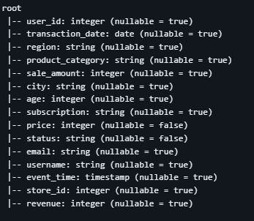
What I Learned
I learned how to identify and remove inconsistent records from a Spark DataFrame. By removing records with null email values and empty usernames, I ensured that the dataset became more reliable for further processing and analysis. I also learned that validating data quality is an important step before performing analytics or building data pipelines.

Step 10: Build a Complete Data Processing Pipeline
Objective
To build a complete Spark data processing pipeline by combining data cleaning, transformation, and aggregation operations into a single workflow.
Code 1: Building the Data Processing Pipeline
pipeline_df = (
df
.dropDuplicates(["user_id", "transaction_date"])
.fillna({
"price": 0,
"status": "Unknown"
})
.filter(col("email").isNotNull())
.filter(trim(col("username")) != "")
.withColumn(
"raw_timestamp",
col("raw_timestamp").cast("timestamp")
)
.withColumnRenamed(
"raw_timestamp",
"event_time"
)
.groupBy("store_id")
.agg(
count("*").alias("Total Transactions"),
sum("revenue").alias("Total Revenue"),
avg("sale_amount").alias("Average Sales")
)
.orderBy("store_id")
)
Output:
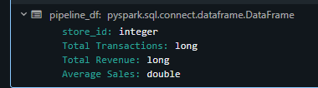
Code 2: Displaying the Pipeline Result
# Displaying pipeline result
display(pipeline_df)
Output:
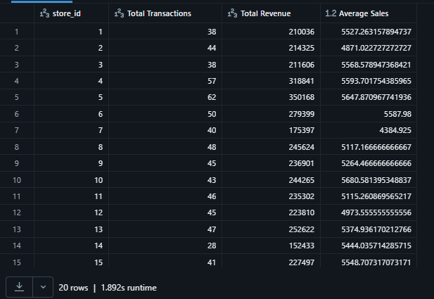
Code 3: Displaying the Pipeline Schema
# Displaying pipeline schema
pipeline_df.printSchema()
Output:
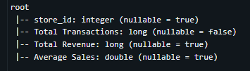
Code 4: Counting Final Records
# Counting final records
print("Total Stores:", pipeline_df.count())
Output:
What I Learned
I learned how to combine multiple Spark transformations into a single data processing pipeline. By chaining operations such as removing duplicates, handling missing values, filtering inconsistent records, modifying the schema, and performing aggregations, I was able to process the raw dataset and generate meaningful summarized results. This demonstrated how Spark efficiently executes multiple transformations to build scalable data processing workflows.

Overall Observation
During this assignment, I explored the fundamental concepts of Apache Spark and implemented various data processing operations using Spark DataFrames in Databricks. I learned how to load and inspect datasets, understand DataFrame immutability, clean data by removing duplicates and handling missing values, and apply filtering conditions to extract relevant records. I also performed aggregation and grouping operations to generate meaningful summaries from the dataset. In addition, I modified the DataFrame schema, handled inconsistent data, and built a complete data processing pipeline by combining multiple transformations. The assignment demonstrated how Spark efficiently processes large datasets through its DataFrame API and optimized execution model.

Conclusion
This assignment provided practical experience with Apache Spark and PySpark for large-scale data processing. By performing data cleaning, filtering, aggregation, grouping, schema modification, and pipeline creation, I gained a better understanding of Spark's capabilities and workflow. I also learned how Spark DataFrames simplify data processing while supporting efficient execution through transformations and actions. Overall, this assignment strengthened my understanding of Spark fundamentals and demonstrated how Apache Spark can be used to build efficient and scalable data processing applications.

