

Celebal Summer Internship 2026
Week 5 Task: Understand Spark fundamentals and perform data cleaning, transformation, and aggregation using DataFrames
By : Shaik Faizan Ahmed
Roll No : 23B81A05L3
College : CVR COLLEGE OF ENGINEERING

Q1. What are the key limitations of traditional MapReduce that make Spark a preferred choice for modern big data processing?
Answer
Traditional MapReduce is a disk-based processing framework where intermediate results are written to disk after every Map and Reduce stage. This repeated disk I/O increases execution time, especially when processing large datasets or iterative applications.
The key limitations of MapReduce are:
- High disk I/O due to repeated reading and writing of intermediate data.
- Slower execution compared to modern processing frameworks.
- Poor performance for iterative algorithms such as machine learning.
- Higher latency, making it unsuitable for real-time analytics.
- More complex programming model requiring separate Map and Reduce functions.
- Limited support for interactive data processing.
Apache Spark overcomes these limitations by using in-memory computing, which stores intermediate data in memory whenever possible. This significantly reduces disk operations and improves execution speed. Spark also provides simple APIs, supports multiple programming languages, and offers built-in libraries for SQL, streaming, machine learning, and graph processing.

Q2. Explain how Spark uses In-Memory Computing to speed up iterative machine learning algorithms compared to disk-based systems.
Answer
Apache Spark uses in-memory computing, which means it stores intermediate data in memory (RAM) instead of writing it to disk after every processing stage. This significantly reduces the time spent on disk read and write operations.
In iterative machine learning algorithms, the same dataset is processed multiple times to improve the model. In traditional disk-based systems such as MapReduce, the dataset is read from disk during every iteration, which increases execution time.
Spark overcomes this limitation by keeping the data in memory across multiple iterations. Since the data is readily available in RAM, Spark can repeatedly access it without performing expensive disk operations. This results in much faster execution and improved performance for machine learning, graph processing, and other iterative workloads.

Advantages of In-Memory Computing
- Reduces disk I/O operations.
- Speeds up iterative computations.
- Improves the performance of machine learning algorithms.
- Supports faster interactive data analysis.
- Enables efficient processing of large datasets.

Q3. Write a code snippet to remove all duplicate rows from a DataFrame based on a specific set of columns: user_id and transaction_date.
Solution
The dropDuplicates() function is used to remove duplicate records based on the specified columns. In this example, duplicate rows are identified using the user_id and transaction_date columns.
Code
# Removing duplicate records
df_clean = df.dropDuplicates(["user_id", "transaction_date"])
display(df_clean)
Output
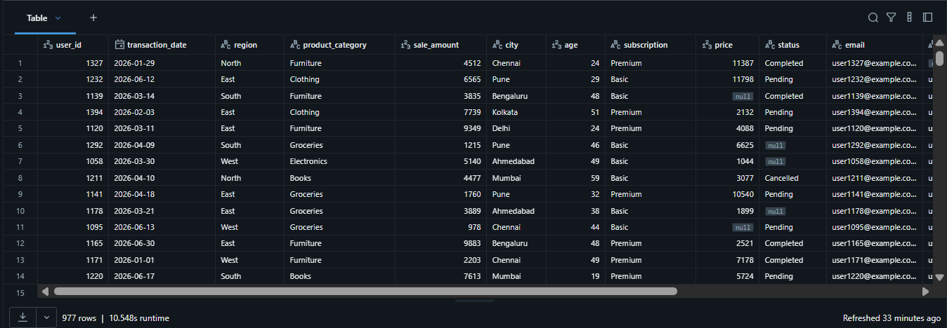
# Verifying duplicate removal
print("Rows Before Cleaning:", df.count())
print("Rows After Removing Duplicates:", df_clean.count())
Output
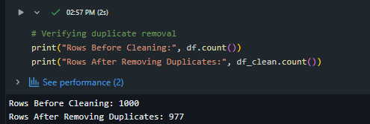

Q4. Given a DataFrame df_sales, write a query to filter for rows where the region is 'West' and then group by product_category to find the average sale_amount.
Solution
The dataset is first filtered to include only the records where the region is West. The filtered data is then grouped by product_category, and the average sale_amount is calculated using the avg() function.
Code 1: Filtering the West Region
# Filtering West region
west_sales = df.filter(
col("region") == "West"
)
Code 2: Grouping by Product Category and Calculating Average Sale Amount
# Calculating average sale amount
average_sales = west_sales.groupBy("product_category").agg(
avg("sale_amount").alias("Average Sale Amount")
)
display(average_sales)
Output
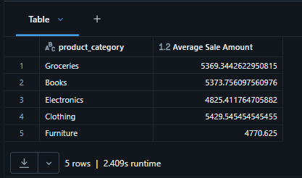

Q5. What is the difference between .na.drop() and .na.fill()? Provide a code example of filling null values in a status column with the string 'Unknown'.
Answer
Spark provides different methods to handle missing values in a DataFrame.
- .na.drop() removes rows that contain null values.
- .na.fill() replaces null values with a specified value without removing any rows.
The choice depends on the dataset. If preserving all records is important, .na.fill() is preferred. If incomplete records are not useful, .na.drop() can be used to remove them.
Solution
The following code replaces all null values in the status column with the string "Unknown".
Code 1: Filling Null Values in the Status Column
df_status = df.na.fill({
"status": "Unknown"
})
display(df_status)
Output
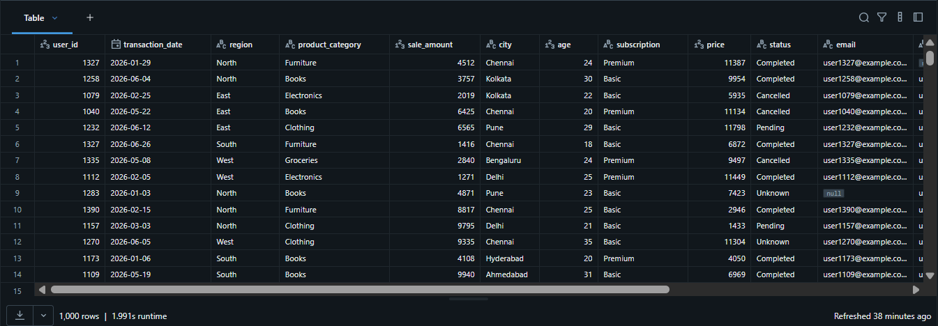Code 2: Verifying Null Values
from pyspark.sql.functions import col, count, when
df_status.select(
count(when(col("status").isNull(), True)).alias("Status Nulls")
).show()
Output
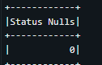
Q6. Write a query to find the total count of records for each city in a DataFrame, but only for cities where the count is greater than 100.
Solution
The dataset is grouped by the city column to calculate the total number of records for each city. The grouped result is then filtered to display only those cities where the total count is greater than 100.
Code
# Counting records by city
city_count = df.groupBy("city").count()
popular_cities = city_count.filter(
col("count") > 100
)
display(popular_cities)
Output
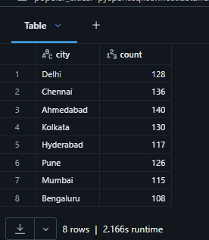

Q7. How does the immutability of Spark DataFrames affect how you perform "data cleaning" steps like dropping columns or renaming them?
Answer
Spark DataFrames are immutable, which means they cannot be modified after they are created. Whenever a data cleaning operation such as dropping a column, renaming a column, or filtering records is performed, Spark creates a new DataFrame instead of modifying the existing one.
For example, when a column is renamed using withColumnRenamed() or removed using drop(), the original DataFrame remains unchanged. The result must be stored in a new DataFrame or assigned back to the same variable.
Example
df_new = df.withColumnRenamed("raw_timestamp", "event_time")
In this example, df_new contains the updated column name, while the original df DataFrame remains unchanged.
Advantages of DataFrame Immutability
- Prevents accidental modification of the original dataset.
- Makes data processing more reliable and consistent.
- Allows Spark to optimize execution using lazy evaluation.
- Supports fault tolerance and efficient parallel processing.
Conclusion
DataFrame immutability ensures that every transformation creates a new DataFrame, making Spark applications safer, more reliable, and easier to optimize.
Q8. Write a Spark command to filter a dataset for rows where the age is between 18 and 30 (inclusive) and the subscription is 'Premium'.
Solution
The following query filters the dataset to display only those records where the customer's age is between 18 and 30 (inclusive) and the subscription type is Premium.
Code
premium_users = df.filter(
(col("age").between(18, 30)) &
(col("subscription") == "Premium")
)
display(premium_users)
Output
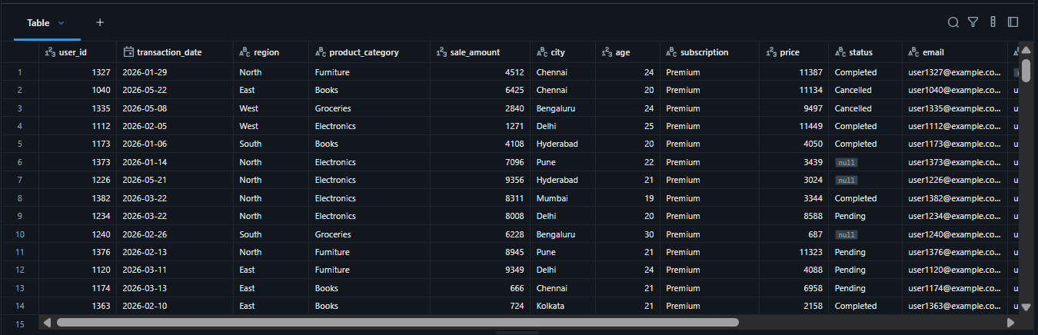

Q9. When cleaning a dataset, why is it often better to handle null values before performing mathematical aggregations like sum() or avg()?
Answer
Handling null values before performing mathematical aggregations is important because missing values can affect the accuracy and reliability of the results. If null values are ignored or left untreated, aggregation functions may produce incorrect or misleading outputs.
For example, when calculating the average of a column, rows containing null values may be excluded from the calculation, which can change the final result. Similarly, null values can affect other calculations and lead to inconsistent analysis.
By handling null values before applying aggregation functions, the dataset becomes more complete and reliable, resulting in accurate analytical results.
Benefits of Handling Null Values First
- Improves the accuracy of aggregation results.
- Prevents unexpected or misleading calculations.
- Ensures consistent and reliable data analysis.
- Improves overall data quality before processing.
Conclusion
Handling null values before performing mathematical operations helps produce accurate and reliable analytical results, making the dataset suitable for further processing and decision-making.
Q10. Write the code to revise a column named raw_timestamp by casting it to a TimestampType and renaming it to event_time.
Solution
The following code converts the raw_timestamp column to the TimestampType data type and then renames the column to event_time.
Code 1: Casting the raw_timestamp Column
# Casting raw_timestamp to TimestampType
from pyspark.sql.types import TimestampType
df_timestamp = df.withColumn(
"raw_timestamp",
col("raw_timestamp").cast(TimestampType())
)

Code 2: Renaming the Column
# Renaming raw_timestamp column
df_timestamp = df_timestamp.withColumnRenamed(
"raw_timestamp",
"event_time"
)
display(df_timestamp)
Output
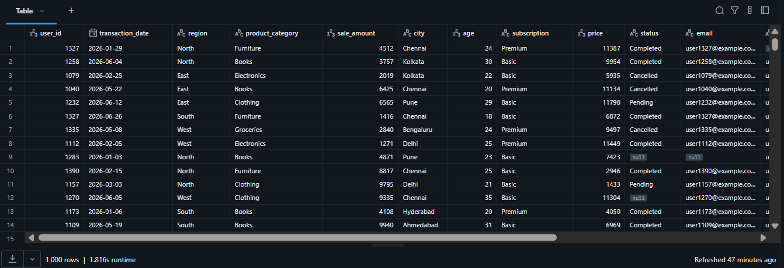Code 3: Displaying the Updated Schema
# Displaying updated schema
df_timestamp.printSchema()
Output
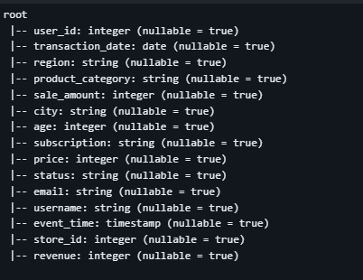

Q11. Explain the "Shuffle" process that occurs during a grouping operation. Why is it considered a wide transformation?
Answer
A shuffle is the process in Apache Spark where data is redistributed across different partitions during operations such as groupBy(), join(), and orderBy().
During a grouping operation, records with the same key may exist in different partitions. Spark moves these records to the same partition before performing the aggregation. This movement of data between partitions is known as a shuffle.
A shuffle is considered a wide transformation because data from multiple input partitions is combined to produce the output. Unlike narrow transformations, wide transformations require data to be exchanged between partitions, which increases execution time.
Characteristics of Shuffle Operations
- Redistributes data across partitions.
- Occurs during operations such as groupBy(), join(), and orderBy().
- Requires network communication between partitions.
- Uses additional memory and disk resources.
- Takes more time than narrow transformations.
Conclusion
Shuffle operations are essential for grouping and aggregation tasks, but they are more expensive because Spark must move data across partitions before processing. Therefore, operations such as groupBy() are classified as wide transformations.

Q12. Write a code snippet that identifies and removes rows where the email column contains null values OR the username is an empty string.
Solution
The following code first identifies records where the email column contains null values or the username column is empty. These inconsistent records are then removed to improve the quality of the dataset.
Code 1: Identifying Inconsistent Records
invalid_records = df.filter(
(col("email").isNull()) |
(trim(col("username")) == "")
)
display(invalid_records)
Output
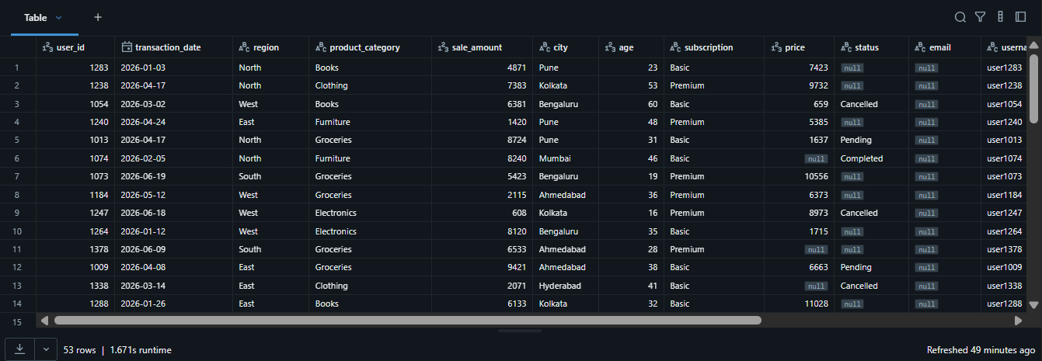Code 2: Removing Inconsistent Records
# Removing inconsistent records
clean_df = df.filter(
col("email").isNotNull()
).filter(
trim(col("username")) != ""
)
display(clean_df)
Output
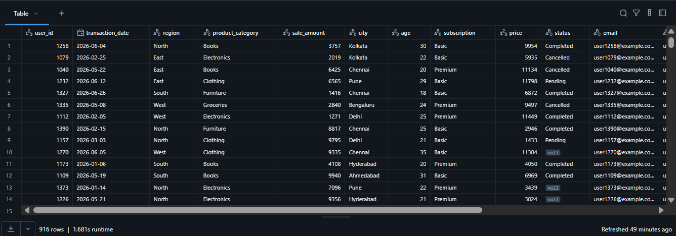Code 3: Verifying the Cleaned Dataset
# Verifying the cleaned dataset

print("Rows Before Cleaning:", df.count())
print("Rows After Cleaning:", clean_df.count())
Output


Q13. How do you use the .agg() function to calculate multiple statistics at once, such as the min, max, and mean of the price column?
Solution
The .agg() function allows multiple aggregation operations to be performed in a single query. In this example, the minimum, maximum, and average values of the price column are calculated together.
Code
# Calculating multiple statistics using agg()

price_summary = df.agg(
min("price").alias("Minimum Price"),
max("price").alias("Maximum Price"),
avg("price").alias("Average Price")
)

display(price_summary)
Output


Q14. In the context of cleaning a dataset, what is the risk of using inferSchema=true when your source data contains messy or inconsistent date formats?
Answer
The inferSchema=true option allows Spark to automatically detect the data type of each column while loading a dataset. Although this makes data loading easier, it may infer incorrect data types when the dataset contains inconsistent or messy date formats.
For example, if some records use the format YYYY-MM-DD while others use DD/MM/YYYY, Spark may interpret the entire column as a string instead of a date or timestamp. This can lead to problems when filtering, sorting, or performing date-based calculations.

Risks of Using inferSchema=true
- Incorrect data type detection.
- Date columns may be loaded as strings.
- Errors during filtering and date calculations.
- Inconsistent results during data analysis.
- Additional data cleaning may be required before processing.
Best Practice
When working with important date or timestamp columns, it is recommended to define the schema explicitly or convert the column to the required data type after loading the dataset using functions such as cast() or to_timestamp().
Conclusion
While inferSchema=true simplifies the data loading process, inconsistent date formats can lead to incorrect schema inference. Therefore, validating or explicitly defining the schema is recommended when working with messy datasets.

Q15. Write a final processing pipeline that:
- Filters out duplicates.
- Fills null prices with 0.
- Groups by store_id to calculate total revenue.
Solution
The following Spark pipeline combines multiple DataFrame transformations into a single workflow. It removes duplicate records, replaces null values in the price column with 0, and groups the dataset by store_id to calculate the total revenue generated by each store.
Code 1: Building the Processing Pipeline
# Building the processing pipeline
pipeline_df = (
df
.dropDuplicates(["user_id", "transaction_date"])
.fillna({
"price": 0
})
.groupBy("store_id")
.agg(
sum("revenue").alias("Total Revenue")
)
.orderBy("store_id")
)
display(pipeline_df)
Output
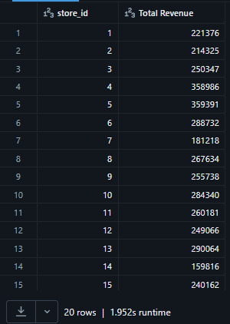
Code 2: Displaying the Pipeline Schema
pipeline_df.printSchema()
Output
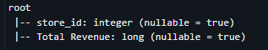
Code 3: Counting Total Stores
print("Total Stores:", pipeline_df.count())
Output

Overall Observation
This assignment provided practical experience in using Apache Spark DataFrames for data processing and analysis. Various DataFrame operations such as filtering, grouping, aggregation, duplicate removal, null value handling, schema modification, and data transformation were implemented using PySpark in Databricks. The assignment also improved the understanding of important Spark concepts including DataFrame immutability, in-memory computing, and shuffle operations. By combining theoretical concepts with practical implementation, the assignment demonstrated how Spark efficiently processes large datasets for big data applications.

Conclusion
This assignment successfully demonstrated the use of Apache Spark for performing data cleaning, transformation, and aggregation tasks on a large dataset. The practical implementation of Spark DataFrame operations helped in understanding how Spark handles distributed data processing efficiently. Overall, the assignment strengthened the understanding of Spark fundamentals and provided hands-on experience with PySpark and Databricks for building reliable and efficient data processing workflows.

