

Celebal Summer Internship 2026
Week 3 Task: Use Subqueries, CTEs, and Window Functions to analyze sales data from the Superstore dataset.
By : Shaik Faizan Ahmed
Roll No : 23B81A05L3
College : CVR COLLEGE OF ENGINEERING

Step 1: Setup Data
1. Import the Superstore Dataset into superstore_raw
The Superstore dataset was imported into MySQL Workbench and stored in the table named superstore_raw. This table served as the source table for all subsequent analysis.
Output
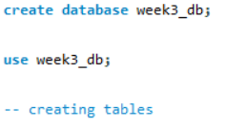
2. Create Tables
The following tables were created from the raw dataset:
- Customers B) orders C) products
Query
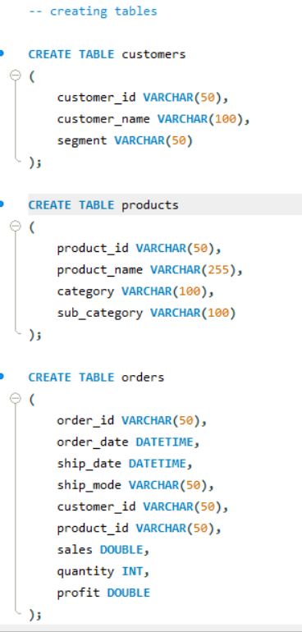
Observation
I learned how to organize raw data into separate tables based on customers, products, and orders.

3. Insert Data Using SELECT DISTINCT
Query
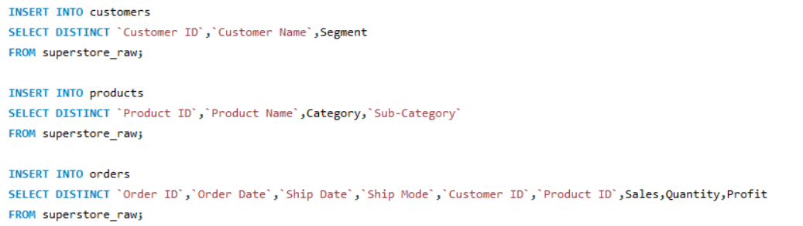Observation
I learned how to populate normalized tables from a raw dataset using SELECT DISTINCT while removing duplicate records.

Step 2: Perform Required Queries
Query 1: Find All Orders Where Sales Are Greater Than the Average Sales (Subquery)
Query
SELECT * FROM orders WHERE sales>(SELECT AVG(sales) FROM orders);
Output
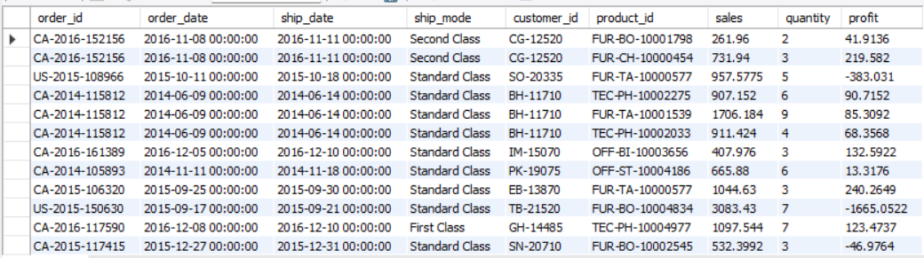
Explanation
This query returns all orders whose sales value is greater than the average sales value across all orders.
Brief Insight
The result highlights high-value orders that perform better than the average transaction.
Query 2: Find the Highest Sales Order for Each Customer (Subquery)
Query
SELECT * FROM orders o
WHERE sales=( SELECT MAX(sales) FROM orders
WHERE customer_id=o.customer_id );
Output
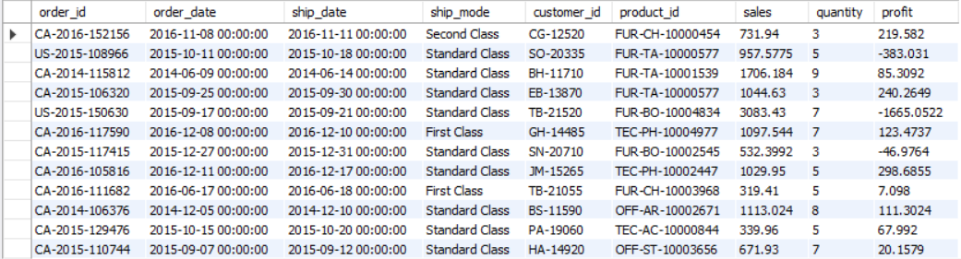Explanation
This query identifies the highest sales order placed by each customer.
Brief Insight
The result helps identify the most valuable transaction made by every customer.
Query 3: Calculate Total Sales for Each Customer (CTE)
Query
WITH cs AS(
SELECT customer_id,SUM(sales) as total_sales
FROM orders
GROUP BY customer_id
)
SELECT * FROM cs;
Output
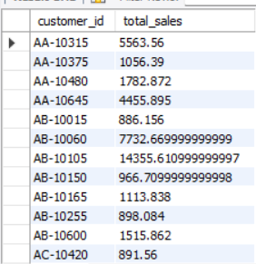
Explanation
This query calculates the total sales generated by each customer by summing the sales of all their orders.
Brief Insight
The result provides a customer-wise sales summary and helps identify high-value customers.

Query 4: Find Customers Whose Total Sales Are Above Average (CTE + Subquery)
Query
WITH cs AS(
SELECT customer_id,SUM(sales) as total_sales
FROM orders
GROUP BY customer_id
)
SELECT * FROM cs WHERE total_sales>(SELECT AVG(total_sales) FROM cs);
Output
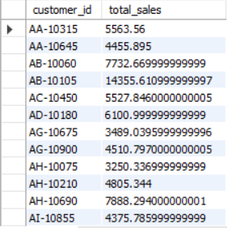
Explanation
This query filters customers whose total sales exceed the average customer sales.
Brief Insight
The result highlights customers who contribute more revenue than the average customer.

Query 5: Rank All Customers Based on Total Sales (Window Function)
Query
WITH cs AS(
SELECT customer_id,SUM(sales) total_sales
FROM orders
GROUP BY customer_id
)
SELECT customer_id,total_sales,
RANK() OVER(ORDER BY total_sales DESC) sales_rank
FROM cs;
Output
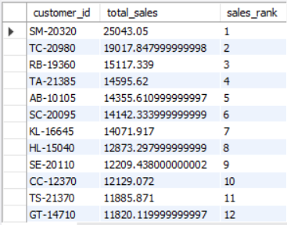
Explanation
This query ranks customers according to their total sales in descending order.
Brief Insight
The result helps identify the best-performing customers based on revenue.

Query 6: Assign Row Numbers to Each Order Within a Customer (Window Function + PARTITION BY)
Query
SELECT customer_id,order_id,sales,
ROW_NUMBER() OVER(PARTITION BY customer_id ORDER BY sales DESC) row_num
FROM orders;
Output
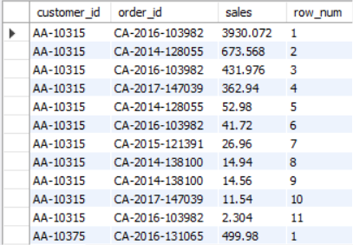
Explanation
This query assigns a unique row number to every order within each customer group.
Brief Insight
The result makes it easy to identify the highest and lowest orders for each customer.
Query 7: Display Top 3 Customers Based on Total Sales (Window Function)
Query
WITH cs AS(
SELECT customer_id,SUM(sales) total_sales
FROM orders
GROUP BY customer_id
)
SELECT *
FROM(
SELECT customer_id,total_sales,
RANK() OVER(ORDER BY total_sales DESC) rnk
FROM cs
) t
WHERE rnk<=3;
Output
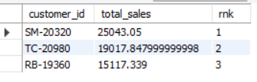
Explanation
This query ranks customers by total sales and displays the top three ranked customers.
Brief Insight
The result identifies the highest revenue-generating customers in the dataset.

Observation
I learned how Subqueries, CTEs, and Window Functions can be used to perform advanced analysis on sales data. I also noticed that these techniques help answer business questions more efficiently than simple SQL queries.

Step 3: Final Combined Query
Display Customer Name, Total Sales, and Rank (JOIN + CTE + Window Function)
Query
WITH cs AS(
SELECT customer_id,SUM(sales) as total_sales
FROM orders
GROUP BY customer_id
)
SELECT c.customer_name,cs.total_sales,
RANK() OVER(ORDER BY cs.total_sales DESC) as customer_rank
FROM cs
JOIN customers c
ON cs.customer_id=c.customer_id
ORDER BY customer_rank;
Output
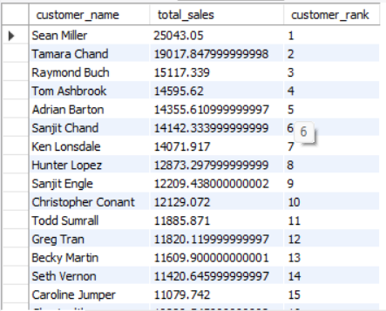
Explanation
The CTE calculates total sales for each customer. The JOIN operation is used to retrieve customer names from the customers table, and the RANK() window function assigns a rank based on total sales.
Brief Insight
The result provides a ranked list of customers and helps identify the top-performing customers based on revenue contribution.
Observation
I learned how multiple SQL concepts can be combined within a single query to generate meaningful business insights and customer rankings.
Mini Project: Customer Sales Insights
Question 1: Who Are the Top 5 Customers?
Query
SELECT * FROM(
SELECT customer_id,SUM(sales) as total_sales
FROM orders
GROUP BY customer_id
)t
ORDER BY total_sales DESC
LIMIT 5;
Output
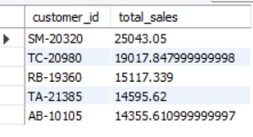
Explanation
This query calculates total sales for each customer and displays the top 5 customers with the highest sales.
Brief Insight
These customers contribute the largest share of revenue and can be considered high-value customers.

Question 2: Who Are the Bottom 5 Customers?
Query
SELECT * FROM(
SELECT customer_id,SUM(sales) as total_sales
FROM orders
GROUP BY customer_id
)t
ORDER BY total_sales
LIMIT 5;

Output
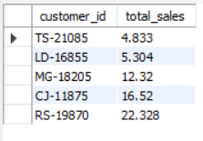
Explanation
This query identifies the customers with the lowest total sales.
Brief Insight
These customers contribute the least revenue and may require additional engagement strategies.

Question 3: Which Customers Made Only One Order?
Query
SELECT customer_id,COUNT(DISTINCT order_id) as total_orders
FROM orders
GROUP BY customer_id
HAVING COUNT(DISTINCT order_id)=1;
Output
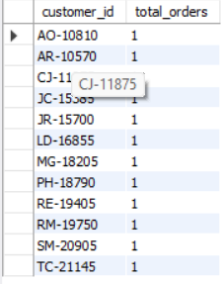
Explanation
This query finds customers who have placed exactly one order.
Brief Insight
The result helps identify customers who may not have returned after their first purchase.

Question 4: Which Customers Have Above-Average Sales?
Query
WITH cs AS(
SELECT customer_id,SUM(sales) total_sales
FROM orders
GROUP BY customer_id
)
SELECT * FROM cs WHERE total_sales>(SELECT AVG(total_sales) FROM cs);
Output
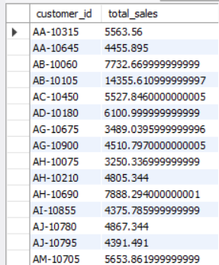
Explanation
This query identifies customers whose total sales exceed the average customer sales.
Brief Insight
These customers contribute more revenue than the average customer and represent important business assets.
Question 5: What Is the Highest Order Value Per Customer?
Query
SELECT customer_id,MAX(sales) as highest_order FROM orders GROUP BY customer_id;
Output
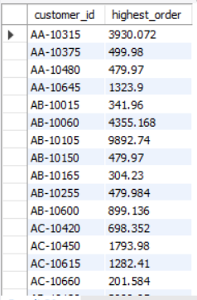
Explanation
This query returns the highest sales value recorded for each customer.
Brief Insight
The result highlights the largest transaction completed by every customer.

Final Observation
I learned how SQL can be used to solve practical business problems using Subqueries, CTEs, Window Functions, and JOIN operations. I also observed that customer sales data can be analyzed effectively to identify top customers, low-performing customers, purchasing patterns, and high-value transactions.

Final Insights
- Customer sales were not evenly distributed, as a small group of customers generated significantly higher sales than the rest.
- Ranking customers based on total sales helped identify the most valuable customers who contribute the highest revenue.
- Several customers had total sales above the overall average, indicating strong purchasing activity and business value.
- The analysis revealed customers who placed only a single order, highlighting potential opportunities for customer retention and engagement.
- The highest-order-value analysis showed that some customers made significantly larger purchases than others.
- Subqueries were useful for comparing individual records against aggregate values such as averages and maximum sales.
- CTEs simplified complex aggregation queries and made customer-level analysis easier to perform and understand.
- Window Functions provided advanced analytical capabilities such as ranking customers and assigning row numbers within customer groups.
- Combining JOINs, CTEs, and Window Functions helped generate a complete customer performance report with sales totals and rankings.
- Overall, SQL proved to be an effective tool for transforming raw sales data into meaningful business insights and decision-making information.

Conclusion
This assignment provided hands-on experience in using advanced SQL concepts such as Subqueries, CTEs, Window Functions, and JOINs. These techniques helped analyze sales data, generate customer insights, and answer business-oriented questions effectively.

