

Celebal Excellence Internship 2026
Project - Smart Fraud detection pipeline

By: Shaik Faizan Ahmed
StudentId: CT_CSI_DE_641
College Roll No: 23B81A05L3
College: CVR COLLEGE OF ENGINEERING

Abstract
Large number of transactions take place every day at financial organizations; therefore, manual fraud detection becomes difficult and infeasible at such scales. In this assignment, we have implemented a scalable fraud detection pipeline by means of PySpark, Spark SQL, and Delta Lake on Databricks, according to the Medallion Architecture for ingestion, cleaning, and analysis of account, transactions, and fraud-watch list data. In addition to the core requirement of binary fraud classification, the implemented pipeline has introduced a tiered risk approach of three levels - confirmed fraud, suspicious, and normal, with the help of combining the watch-lists with other indicators like large international transaction, risky KYC, thus helping to detect early the risk accounts which need checking before committing any fraud. The implemented solution is intended to operate efficiently not only in local but also in Databricks environment by means of one-time setup of configuration and produce thirteen different outputs such as transaction level report, account risk report, merchant risk report, etc. With regard to the test data set consisting of 200 transactions from 50 accounts, 26 transactions have been classified as confirmed fraud, and 62 as suspicious.
Keywords: Fraud Detection, PySpark, Spark SQL, Delta Lake, Databricks, Medallion Architecture, Data Engineering, Risk Classification

Table of Contents
Abstract 2
Problem Statement 4
Objectives 5
Dataset Description 6
Accounts Dataset 6
Transactions Dataset 6
Fraud Watchlist 6
Technology Stack 7
Architecture 7
Project Structure and File Descriptions 8
Configuration and Environments 9
Methodology 10
schemas.py 10
Explanation 11
bronze.py 12
Explanation 14
silver.py 14
Explanation 18
gold.py 18
Explanation 22
data_quality.py 23
Explanation 24
reporting.py 25
Explanation 31
Results 32
Conclusion 39

Problem Statement

A lot of transactions are being processed by financial organizations on a day-to-day basis. It is thus challenging to perform manual identification of fraud. This project uses a data pipeline which detects fraudulent activities with the use of technologies such as PySpark, Spark SQL, and Databricks. This data pipeline uses a Medallion Architecture where the raw data in CSV format (account, transactions, and fraud watchlist) will be initially stored in the Bronze Layer. Data cleaning (dealing with null values and type casting) and data enrichment (joins between datasets through account_id) will then be performed in the Silver layer. In the Gold layer, fraud detection will be performed through matching transactions against the fraud watchlist where a classification as either fraud or normal will be assigned. Insights in terms of total transactions, total frauds, and fraud per account will be generated from the system.

Note: While the base requirement specifies a binary "fraud" / "normal" classification driven purely by watchlist matching, this project extends that logic by also flagging "suspicious" transactions — those not yet confirmed on the watchlist but carrying independent risk signals such as unusually large international transfers or an unresolved KYC status. This enables earlier review of at-risk accounts before fraud is formally confirmed, more closely reflecting how fraud detection systems operate in practice. Full details are provided in the Methodology section.

Objectives

- To ingest raw account, transaction, and fraud watchlist data into a structured Bronze layer using enforced schemas.
- To clean and enrich the data in the Silver layer by handling nulls, correcting types, and joining transactions with account details.
- To classify transactions in the Gold layer using a layered risk model that identifies confirmed fraud, flags suspicious activity, and separates normal transactions.
- To generate a comprehensive set of aggregated insights, including fraud trends by branch, account type, city, merchant, and time period.
- To support execution in both local and Databricks environments through a single configuration file, without requiring code changes.
- To validate the fraud detection logic and reporting functions through automated tests.

Dataset Description

Accounts Dataset
Field | Description
account_id | Unique identifier for each account
customer_name | Full name of the account holder
account_type | Type of account (Savings / Current / etc.)
credit_limit | Maximum credit allowed on the account
branch | Branch where the account is registered
opening_date | Date the account was opened
kyc_status | KYC verification status of the account (verified, pending, rejected, expired)

Transactions Dataset
Field | Description
txn_id | Unique identifier for each transaction
account_id | Account linked to this transaction
txn_date | Date on which the transaction occurred
amount | Transaction amount in currency units
merchant | Name of the merchant involved
city | City where the transaction took place
is_international | Whether the transaction was international

Fraud Watchlist
Field | Description
account_id | Account flagged for suspected fraud
fraud_type | Category/type of fraud detected
flagged_date | Date on which the account was flagged

Technology Stack
Technology | Purpose
Python | Core programming language for scripting and orchestration
PySpark | Distributed data processing framework
Spark SQL | SQL-based querying on distributed datasets
Databricks | Cloud platform for running Spark workloads
Delta Lake | Storage layer providing ACID transactions on data lakes
YAML (pipeline_config.yaml) | Centralized configuration for paths, thresholds, and environment switching
pytest | Automated testing of fraud classification and reporting logic

Architecture

The pipeline follows a Medallion Architecture with three structured layers:

Layer | Component | Description
Source | CSV Files | Raw input data files for accounts, transactions, and fraud watchlist
Bronze | Delta Tables (Raw) | Ingested raw data stored in Delta format without transformation
Silver | Clean + Join + Enrich | Cleansed data with null handling, type casting, and table joins
Gold | Fraud Detection Output | Final output with fraud flags, counts, and business insights

Source Data (CSV Files)
↓
Bronze Layer (Raw Data — Delta Tables)
↓
Silver Layer (Clean + Join + Enrich)
↓
Gold Layer (Fraud Detection + Final Output)

The pipeline is designed to run identically in both local and Databricks environments. A single configuration file controls which set of paths is used, so the same codebase produces the same layered output regardless of where it runs.

Project Structure and File Descriptions
Folder or File | Description
data/raw/ | Raw source CSVs: accounts.csv, transactions.csv, known_fraud_accounts.csv
notebooks | Databricks notebooks mirroring the pipeline stages, meant to run on a live cluster
src/schemas.py | Defines explicit schemas for all three source CSVs, enforced during ingestion
src/bronze.py | Reads raw CSVs with enforced schemas, tags rows with ingestion metadata, writes to Delta as the raw layer
src/silver.py | Cleans and enriches data: casts dates, imputes missing credit limits, fills missing merchants, deduplicates transactions, joins accounts and transactions, flags orphan transactions
src/gold.py | Applies the layered fraud risk classification, builds account and branch level summary tables, writes the final Gold Delta tables
src/data_quality.py | Generates an audit report summarizing nulls found, duplicates removed, and orphan transactions identified
src/reporting.py | Builds and exports the full set of Gold layer insight reports, including trend, segment, and top-account views
tests/ | Automated tests covering fraud classification logic and reporting functions
config/pipeline_config.yaml | Central configuration for source paths, table paths, thresholds, and the local/Databricks environment switch
outputs/ | Generated reports and exported insights, described in the Results section
run_pipeline.py | Single entry point that runs the full pipeline locally, from ingestion through report generation

Notebooks in order:
01_bronze_ingestion.py handles raw ingestion.
02_silver_cleaning_enrichment.py handles cleaning, enrichment, and the data quality report.
03_gold_fraud_detection.py handles fraud classification and all insight report generation.

Configuration and Environments
The pipeline is designed to run without any code changes between a local machine and a Databricks cluster. A single setting at the top of pipeline_config.yaml controls this:
environment: local
Setting this value to either local or databricks determines which set of paths the pipeline uses for reading source data, writing Delta tables, and exporting reports. Every path in the configuration file has a matching entry for both environments.

Local | Databricks
Source CSVs are read from data/raw/ | Source CSVs are read from a Databricks Volume path
Delta tables are written to a delta/ folder | Delta tables are written to the same Volume, under a delta/ subfolder
Reports are exported to an outputs/ folder | Reports are exported to the same Volume, under an outputs/ subfolder

This approach avoids hardcoding paths inside the pipeline logic itself, so the same source files (schemas, bronze.py, silver.py, gold.py, reporting.py) run unchanged in either setting.

Methodology
This section documents every source file in the pipeline. For each file, the complete code is shown, followed by an explanation of what it does and the reasoning behind the key design decisions.

schemas.py
This file defines an explicit schema for each of the three source CSVs, so that Bronze ingestion does not rely on Spark's automatic schema inference.
Full code:
from pyspark.sql.types import (
StructType,
StructField,
StringType,
DoubleType,
)

# Dates stay as strings here, we cast them properly in the silver layer.

# accounts.csv
ACCOUNTS_SCHEMA = StructType([
StructField("account_id", StringType(), nullable=False),
StructField("customer_name", StringType(), nullable=True),
StructField("account_type", StringType(), nullable=True),
StructField("opening_date", StringType(), nullable=True),
StructField("branch", StringType(), nullable=True),
StructField("kyc_status", StringType(), nullable=True),
StructField("credit_limit", DoubleType(), nullable=True),
])

# transactions.csv
TRANSACTIONS_SCHEMA = StructType([
StructField("txn_id", StringType(), nullable=False),
StructField("account_id", StringType(), nullable=False),
StructField("txn_date", StringType(), nullable=True),
StructField("txn_type", StringType(), nullable=True),
StructField("amount", DoubleType(), nullable=True),
StructField("merchant", StringType(), nullable=True),
StructField("city", StringType(), nullable=True),
StructField("is_international", StringType(), nullable=True),
])

# known_fraud_accounts.csv
FRAUD_WATCHLIST_SCHEMA = StructType([
StructField("account_id", StringType(), nullable=False),
StructField("fraud_type", StringType(), nullable=True),
StructField("flagged_date", StringType(), nullable=True),
])

SCHEMA_REGISTRY = {
"accounts": ACCOUNTS_SCHEMA,
"transactions": TRANSACTIONS_SCHEMA,
"fraud_watchlist": FRAUD_WATCHLIST_SCHEMA,
}

Explanation
- Each dataset (accounts, transactions, fraud watchlist) has its own StructType, listing every column name and type exactly as it should appear after reading the CSV.
- Schema inference is intentionally avoided. Letting Spark guess column types means reading a sample of the file first, which is slower, and it can silently misjudge a column's type if the sample happens to look different from the rest of the file. Defining the schema explicitly makes ingestion both faster and predictable.
- Date columns (opening_date, txn_date, flagged_date) are deliberately typed as StringType here rather than DateType. Raw CSV date formats can be inconsistent or malformed, and casting them immediately during ingestion would silently convert any unparseable value to null before the data has even been inspected. Keeping them as text at this stage and casting them explicitly in the Silver layer keeps that conversion visible and controlled.
- SCHEMA_REGISTRY maps each dataset name to its schema, so the rest of the codebase (bronze.py) can look up the correct schema generically by name instead of writing separate read logic for each of the three files.

bronze.py
This file implements the Bronze layer: reading the raw CSV files and writing them into Delta format without any transformation.
Full code:
import os
import yaml
from pyspark.sql import SparkSession, DataFrame
from pyspark.sql import functions as F

from schemas import SCHEMA_REGISTRY

def load_config(config_path: str = "config/pipeline_config.yaml") -> dict:
with open(config_path, "r") as f:
return yaml.safe_load(f)

def read_source_csv(spark: SparkSession, dataset_name: str, config: dict) -> DataFrame:
"""Reads a raw CSV with its enforced schema and tags it with bronze metadata."""
path_key = {
"accounts": "accounts_path",
"transactions": "transactions_path",
"fraud_watchlist": "fraud_watchlist_path",
}[dataset_name]

env = config["environment"]
source_path = config["source"][env][path_key]
schema = SCHEMA_REGISTRY[dataset_name]

df = (
spark.read
.option("header", True)
.schema(schema)
.csv(source_path)
)

df = df.withColumn("ingestion_timestamp", F.current_timestamp()) \
.withColumn("source_file", F.lit(os.path.basename(source_path)))

return df

def write_bronze_table(df: DataFrame, dataset_name: str, config: dict) -> str:
table_key = {
"accounts": "accounts",
"transactions": "transactions",
"fraud_watchlist": "fraud_watchlist",
}[dataset_name]

env = config["environment"]
table_name = config["tables"]["bronze"][table_key]
path_prefix = config["tables"]["bronze"]["path_prefix"][env]
output_path = f"{path_prefix}/{table_name}"

df.write.format("delta").mode("overwrite").save(output_path)

return output_path

def run_bronze_ingestion(spark: SparkSession, config_path: str = "config/pipeline_config.yaml") -> dict:
"""Runs bronze ingestion for all 3 datasets using an existing SparkSession."""
config = load_config(config_path)

results = {}
for dataset_name in ["accounts", "transactions", "fraud_watchlist"]:
df = read_source_csv(spark, dataset_name, config)
output_path = write_bronze_table(df, dataset_name, config)
results[dataset_name] = {
"row_count": df.count(),
"output_path": output_path,
}
print(f"[bronze] {dataset_name}: {results[dataset_name]['row_count']} rows -> {output_path}")

return results

if __name__ == "__main__":
# standalone/local run (not needed on Databricks, spark is already provided there)
spark = SparkSession.builder.appName("SmartFraudDetection_Bronze").getOrCreate()
run_bronze_ingestion(spark)

Explanation
- load_config reads pipeline_config.yaml once per call, so every path used anywhere in this file comes from configuration rather than being hardcoded.
- read_source_csv looks up the correct source path for the current environment (local or databricks), applies the matching schema from schemas.py, and reads the CSV with headers enabled.
- Every row is tagged with an ingestion_timestamp and a source_file column. This is added purely for traceability, so that if a question ever comes up about when or from which file a row was ingested, that information is already attached to the data instead of needing separate logs.
- write_bronze_table writes using mode('overwrite'). Bronze in this project is treated as the latest raw snapshot of the source files, not an append-only history, so each run replaces the previous Bronze table rather than accumulating duplicate ingestions.
- run_bronze_ingestion loops over all three dataset names and calls the same read/write functions for each, rather than writing three near-identical ingestion functions. This keeps the ingestion logic in one place, so a change (for example, adding a new metadata column) only needs to be made once.

silver.py
This file implements the Silver layer: cleaning the raw Bronze data and enriching transactions with account details.
Full code:
import yaml
from pyspark.sql import SparkSession, DataFrame
from pyspark.sql import functions as F
from pyspark.sql.window import Window

def load_config(config_path: str = "config/pipeline_config.yaml") -> dict:
with open(config_path, "r") as f:
return yaml.safe_load(f)

def read_bronze_table(spark: SparkSession, dataset_name: str, config: dict) -> DataFrame:
table_key = {
"accounts": "accounts",
"transactions": "transactions",
"fraud_watchlist": "fraud_watchlist",
}[dataset_name]

env = config["environment"]
table_name = config["tables"]["bronze"][table_key]
path_prefix = config["tables"]["bronze"]["path_prefix"][env]
path = f"{path_prefix}/{table_name}"

return spark.read.format("delta").load(path)

def clean_accounts(df: DataFrame) -> DataFrame:
"""Casts dates, imputes missing credit_limit with the median for that account_type."""
df = df.withColumn("opening_date", F.to_date("opening_date", "yyyy-MM-dd"))

median_by_type = df.groupBy("account_type").agg(
F.expr("percentile_approx(credit_limit, 0.5)").alias("median_credit_limit")
)

df = df.join(median_by_type, on="account_type", how="left")
df = df.withColumn(
"credit_limit",
F.when(F.col("credit_limit").isNull(), F.col("median_credit_limit")).otherwise(F.col("credit_limit"))
).drop("median_credit_limit")

return df

def clean_transactions(df: DataFrame, config: dict) -> DataFrame:
"""Casts dates/types, fills missing merchant, dedupes on txn_id."""
merchant_fill = config["silver"]["null_handling"]["merchant"]

df = df.withColumn("txn_date", F.to_date("txn_date", "yyyy-MM-dd"))
df = df.withColumn("is_international", F.when(F.col("is_international") == "yes", True).otherwise(False))
df = df.withColumn(
"merchant",
F.when(F.col("merchant").isNull(), F.lit(merchant_fill)).otherwise(F.col("merchant"))
)

if config["silver"]["drop_duplicate_txn_ids"]:
window = Window.partitionBy("txn_id").orderBy(F.col("ingestion_timestamp").desc())
df = df.withColumn("_row_num", F.row_number().over(window)) \
.filter(F.col("_row_num") == 1) \
.drop("_row_num")

return df

def enrich_transactions(txn_df: DataFrame, acc_df: DataFrame, config: dict) -> DataFrame:
"""Left-joins transactions to accounts, flagging transactions whose account_id has no match."""
acc_cols = acc_df.select(
"account_id", "customer_name", "account_type", "branch", "kyc_status", "credit_limit"
)

joined = txn_df.join(acc_cols, on="account_id", how="left")

if config["silver"]["flag_orphan_transactions"]:
joined = joined.withColumn("is_orphan_transaction", F.col("customer_name").isNull())

return joined

def write_silver_table(df: DataFrame, config: dict) -> str:
env = config["environment"]
table_name = config["tables"]["silver"]["enriched_transactions"]
path_prefix = config["tables"]["silver"]["path_prefix"][env]
output_path = f"{path_prefix}/{table_name}"

df.write.format("delta").mode("overwrite").save(output_path)

return output_path

def run_silver_processing(spark: SparkSession, config_path: str = "config/pipeline_config.yaml") -> dict:
config = load_config(config_path)

accounts = read_bronze_table(spark, "accounts", config)
transactions = read_bronze_table(spark, "transactions", config)

accounts_clean = clean_accounts(accounts)
transactions_clean = clean_transactions(transactions, config)

enriched = enrich_transactions(transactions_clean, accounts_clean, config)
output_path = write_silver_table(enriched, config)

orphan_count = enriched.filter(F.col("is_orphan_transaction") == True).count()
total_count = enriched.count()

print(f"[silver] enriched transactions: {total_count} rows -> {output_path}")
print(f"[silver] orphan transactions flagged: {orphan_count}")

return {
"row_count": total_count,
"orphan_count": orphan_count,
"output_path": output_path,
}

if __name__ == "__main__":
spark = SparkSession.builder.appName("SmartFraudDetection_Silver").getOrCreate()
run_silver_processing(spark)

Explanation
- read_bronze_table reads a given Bronze Delta table back in, using the same environment-aware path pattern as bronze.py.
- clean_accounts casts opening_date into a real date type, then imputes any missing credit_limit using the median credit limit for that specific account_type, rather than a single global median. Credit limits vary meaningfully between account types (for example, Current accounts typically carry higher limits than Savings accounts), so filling a missing value with a type-specific median keeps the imputed value realistic instead of pulling it toward an unrelated overall average.
- clean_transactions casts txn_date, converts the raw is_international value (stored as a yes/no style string in the source CSV) into an actual boolean column, and fills missing merchant values with a configurable placeholder instead of leaving them null. Converting is_international to boolean here is necessary because Gold's fraud logic later evaluates it with a boolean comparison.
- Duplicate transaction records are removed using a window function: rows are partitioned by txn_id and ordered by ingestion_timestamp descending, keeping only the first row per partition (the most recently ingested one). This approach was chosen over a simple dropDuplicates() because it lets the pipeline decide which duplicate to keep (the newest) rather than an arbitrary one.
- enrich_transactions left-joins transactions to the cleaned accounts on account_id. A left join is used deliberately instead of an inner join: if an inner join were used, any transaction whose account_id had no matching account would be silently dropped, which would understate the total transaction volume and hide a data quality problem. Instead, such transactions are kept and flagged as is_orphan_transaction, so they remain visible and can be investigated rather than disappearing.

gold.py
This file implements the Gold layer: classifying each transaction's fraud risk and building the summary tables that get persisted as the final Delta tables.
Full code:
import yaml
from pyspark.sql import SparkSession, DataFrame
from pyspark.sql import functions as F

def load_config(config_path: str = "config/pipeline_config.yaml") -> dict:
with open(config_path, "r") as f:
return yaml.safe_load(f)

def read_silver_table(spark: SparkSession, config: dict) -> DataFrame:
env = config["environment"]
table_name = config["tables"]["silver"]["enriched_transactions"]
path_prefix = config["tables"]["silver"]["path_prefix"][env]
path = f"{path_prefix}/{table_name}"
return spark.read.format("delta").load(path)

def read_bronze_fraud_watchlist(spark: SparkSession, config: dict) -> DataFrame:
env = config["environment"]
table_name = config["tables"]["bronze"]["fraud_watchlist"]
path_prefix = config["tables"]["bronze"]["path_prefix"][env]
path = f"{path_prefix}/{table_name}"
return spark.read.format("delta").load(path)

def apply_fraud_flags(txn_df: DataFrame, fraud_watchlist_df: DataFrame, config: dict) -> DataFrame:
"""Adds is_watchlisted, is_high_value_international, is_pending_kyc_risk, and fraud_risk_level."""

# confirmed fraud: account appears in the watchlist
watchlist_accounts = fraud_watchlist_df.select("account_id", "fraud_type").distinct()
df = txn_df.join(watchlist_accounts, on="account_id", how="left")
df = df.withColumn("is_watchlisted", F.col("fraud_type").isNotNull())

# high value + international: amount above the configured percentile, and international
percentile = config["gold"]["high_value_percentile"]
threshold = df.approxQuantile("amount", [percentile], 0.01)[0]
df = df.withColumn(
"is_high_value_international",
(F.col("is_international") == True) & (F.col("amount") >= F.lit(threshold))
)

# pending/rejected/expired KYC on the account
risky_statuses = config["gold"]["risky_kyc_statuses"]
df = df.withColumn("is_pending_kyc_risk", F.col("kyc_status").isin(risky_statuses))

# combined risk level
df = df.withColumn(
"fraud_risk_level",
F.when(F.col("is_watchlisted"), F.lit("confirmed_fraud"))
.when(F.col("is_high_value_international") | F.col("is_pending_kyc_risk"), F.lit("suspicious"))
.otherwise(F.lit("normal"))
)

return df, threshold

def build_fraud_summary(df: DataFrame) -> DataFrame:
"""Aggregated fraud rate by branch, account_type, city, and merchant."""
return (
df.groupBy("branch", "account_type")
.agg(
F.count("*").alias("total_transactions"),
F.sum(F.when(F.col("fraud_risk_level") == "confirmed_fraud", 1).otherwise(0)).alias("confirmed_fraud_count"),
F.sum(F.when(F.col("fraud_risk_level") == "suspicious", 1).otherwise(0)).alias("suspicious_count"),
)
.withColumn(
"fraud_rate_pct",
F.round((F.col("confirmed_fraud_count") + F.col("suspicious_count")) / F.col("total_transactions") * 100, 2)
)
.orderBy(F.col("fraud_rate_pct").desc())
)

def build_account_level_breakdown(df: DataFrame) -> DataFrame:
"""Per-account fraud transaction counts, for accounts with at least one flagged transaction."""
return (
df.filter(F.col("fraud_risk_level") != "normal")
.groupBy("account_id", "customer_name", "fraud_risk_level")
.agg(F.count("*").alias("flagged_transaction_count"), F.sum("amount").alias("total_flagged_amount"))
.orderBy(F.col("total_flagged_amount").desc())
)

def write_gold_tables(fraud_df: DataFrame, summary_df: DataFrame, config: dict) -> dict:
env = config["environment"]
path_prefix = config["tables"]["gold"]["path_prefix"][env]

fraud_path = f"{path_prefix}/{config['tables']['gold']['fraud_transactions']}"
summary_path = f"{path_prefix}/{config['tables']['gold']['fraud_summary']}"

fraud_df.write.format("delta").mode("overwrite").save(fraud_path)
summary_df.write.format("delta").mode("overwrite").save(summary_path)

return {"fraud_transactions_path": fraud_path, "fraud_summary_path": summary_path}

def run_gold_processing(spark: SparkSession, config_path: str = "config/pipeline_config.yaml") -> dict:
config = load_config(config_path)

enriched = read_silver_table(spark, config)
watchlist = read_bronze_fraud_watchlist(spark, config)

fraud_df, threshold = apply_fraud_flags(enriched, watchlist, config)
summary_df = build_fraud_summary(fraud_df)

paths = write_gold_tables(fraud_df, summary_df, config)

counts = fraud_df.groupBy("fraud_risk_level").count().collect()
counts_dict = {row["fraud_risk_level"]: row["count"] for row in counts}

print(f"[gold] high-value threshold (amount >= {round(threshold, 2)})")
print(f"[gold] risk level counts: {counts_dict}")
print(f"[gold] fraud_transactions -> {paths['fraud_transactions_path']}")
print(f"[gold] fraud_summary -> {paths['fraud_summary_path']}")

return {
"threshold": threshold,
"risk_level_counts": counts_dict,
**paths,
}

if __name__ == "__main__":
spark = SparkSession.builder.appName("SmartFraudDetection_Gold").getOrCreate()
run_gold_processing(spark)

Explanation
- apply_fraud_flags is the core function of the entire pipeline. It joins the enriched transactions against the fraud watchlist to determine is_watchlisted, computes a high-value threshold using approxQuantile at a configurable percentile, and flags accounts with a risky KYC status.
- approxQuantile is used instead of an exact quantile calculation because computing an exact percentile requires sorting or fully scanning the entire dataset, which becomes expensive at scale. approxQuantile accepts a small, configurable error margin (set to 0.01 here) in exchange for being far cheaper to compute, which is the standard tradeoff made in distributed data processing when working with large transaction volumes.
- The final fraud_risk_level is assigned using a when/otherwise chain where the watchlist check is evaluated first. This ordering is intentional: if an account is genuinely on the fraud watchlist, that is treated as a stronger and more certain signal than either of the other two heuristics, so it always takes priority over being merely marked suspicious.
- build_fraud_summary aggregates the classified transactions by branch and account_type, calculating a fraud_rate_pct so branches or account types with unusually high fraud activity can be identified at a glance.
- build_account_level_breakdown filters out normal transactions before grouping, so the resulting table only lists accounts that actually have at least one flagged transaction, rather than including every account in the dataset.
- write_gold_tables saves both the classified transaction-level data and the summary table as Delta tables, using overwrite mode so that a later run reflects the current run's results rather than another dataset.

data_quality.py
This file generates an audit report describing what the Bronze and Silver layers actually found and fixed in the raw data. It is separate from the fraud detection logic itself.
Full code:
import os
import yaml
from pyspark.sql import SparkSession, DataFrame
from pyspark.sql import functions as F

def load_config(config_path: str = "config/pipeline_config.yaml") -> dict:
with open(config_path, "r") as f:
return yaml.safe_load(f)

def generate_data_quality_report(
spark: SparkSession,
bronze_accounts: DataFrame,
bronze_transactions: DataFrame,
silver_enriched: DataFrame,
config: dict,
) -> str:
"""Builds a markdown summary of what the pipeline actually found/fixed."""

total_accounts = bronze_accounts.count()
total_transactions = bronze_transactions.count()

null_credit_limit = bronze_accounts.filter(F.col("credit_limit").isNull()).count()
null_merchant = bronze_transactions.filter(F.col("merchant").isNull()).count()

distinct_txn_ids = bronze_transactions.select("txn_id").distinct().count()
duplicate_txn_ids_removed = total_transactions - distinct_txn_ids

silver_row_count = silver_enriched.count()
orphan_count = silver_enriched.filter(F.col("is_orphan_transaction") == True).count()

lines = [
"# Data Quality Report",
"",
"Generated automatically by the pipeline. Summarizes what Bronze/Silver found and fixed.",
"",
"## Source Row Counts",
f"- Accounts: {total_accounts}",
f"- Transactions: {total_transactions}",
"",
"## Nulls Found in Bronze (before cleaning)",
f"- Missing \`credit_limit\`: {null_credit_limit} accounts",
f"- Missing \`merchant\`: {null_merchant} transactions",
"",
"## Duplicates",
f"- Duplicate \`txn_id\` rows removed: {duplicate_txn_ids_removed}",
"",
"## Silver Layer Result",
f"- Enriched transaction rows: {silver_row_count}",
f"- Orphan transactions (account_id not found in accounts.csv): {orphan_count}",
"",
]

report_text = "\n".join(lines)

env = config["environment"]
output_path = config["output"][env]["data_quality_report_path"]
os.makedirs(os.path.dirname(output_path), exist_ok=True)
with open(output_path, "w") as f:
f.write(report_text)

return report_text

Explanation
- generate_data_quality_report counts how many accounts had a missing credit_limit and how many transactions had a missing merchant, before any cleaning was applied, by inspecting the raw Bronze tables directly.
- Duplicate transactions removed is calculated as the difference between the total row count and the count of distinct txn_id values in Bronze. This gives a concrete number for how many rows Silver's deduplication step actually removed, rather than just stating that deduplication happened.
- The report also captures the final Silver row count and the number of orphan transactions flagged, so the effect of the account join in silver.py is visible in one place.
- This logic is kept in its own file, separate from gold.py, because it answers a different question than fraud classification does. Fraud classification asks whether a transaction looks risky; this file asks whether the data itself was clean going into that classification. Keeping the two concerns apart makes each function single-purpose and easier to reason about independently.
- The report is written as markdown to a path resolved from config['output'][environment], so it lands in the correct location whether the pipeline is running locally or on Databricks.

reporting.py
This file turns the classified Gold dataset into the full set of business-facing reports, and exports each of them as a file in the outputs directory.
Full code:
import os
import yaml
from pyspark.sql import DataFrame
from pyspark.sql import functions as F

def load_config(config_path: str = "config/pipeline_config.yaml") -> dict:
with open(config_path, "r") as f:
return yaml.safe_load(f)

def get_output_paths(config: dict) -> dict:
"""Resolves the local/databricks output path block based on config['environment']."""
env = config["environment"]
return config["output"][env]

def build_fraud_type_breakdown(fraud_df: DataFrame) -> DataFrame:
"""Transaction count, total amount, and distinct accounts per known fraud_type."""
return (
fraud_df.filter(F.col("fraud_type").isNotNull())
.groupBy("fraud_type")
.agg(
F.count("*").alias("transaction_count"),
F.round(F.sum("amount"), 2).alias("total_amount"),
F.countDistinct("account_id").alias("distinct_accounts"),
)
.orderBy(F.col("transaction_count").desc())
)

def build_monthly_fraud_trend(fraud_df: DataFrame) -> DataFrame:
"""Total / confirmed_fraud / suspicious counts by transaction month."""
return (
fraud_df.withColumn("txn_month", F.date_format("txn_date", "yyyy-MM"))
.groupBy("txn_month")
.agg(
F.count("*").alias("total_transactions"),
F.sum(F.when(F.col("fraud_risk_level") == "confirmed_fraud", 1).otherwise(0)).alias("confirmed_fraud_count"),
F.sum(F.when(F.col("fraud_risk_level") == "suspicious", 1).otherwise(0)).alias("suspicious_count"),
)
.orderBy("txn_month")
)

def build_city_fraud_breakdown(fraud_df: DataFrame) -> DataFrame:
"""Fraud rate by transaction city."""
return (
fraud_df.groupBy("city")
.agg(
F.count("*").alias("total_transactions"),
F.sum(F.when(F.col("fraud_risk_level") == "confirmed_fraud", 1).otherwise(0)).alias("confirmed_fraud_count"),
F.sum(F.when(F.col("fraud_risk_level") == "suspicious", 1).otherwise(0)).alias("suspicious_count"),
)
.withColumn(
"fraud_rate_pct",
F.round((F.col("confirmed_fraud_count") + F.col("suspicious_count")) / F.col("total_transactions") * 100, 2)
)
.orderBy(F.col("fraud_rate_pct").desc())
)

def build_top_flagged_accounts(account_breakdown_df: DataFrame, top_n: int = 10) -> DataFrame:
"""Top N accounts by total flagged amount (expects gold.build_account_level_breakdown output)."""
return account_breakdown_df.orderBy(F.col("total_flagged_amount").desc()).limit(top_n)

def build_top_flagged_merchants(fraud_df: DataFrame, top_n: int = 10) -> DataFrame:
"""Top N merchants by count of flagged (non-normal) transactions."""
return (
fraud_df.filter(F.col("fraud_risk_level") != "normal")
.groupBy("merchant")
.agg(
F.count("*").alias("flagged_transaction_count"),
F.round(F.sum("amount"), 2).alias("total_flagged_amount"),
)
.orderBy(F.col("flagged_transaction_count").desc())
.limit(top_n)
)

def build_kyc_risk_breakdown(fraud_df: DataFrame) -> DataFrame:
"""Transaction and fraud counts by account KYC status."""
return (
fraud_df.groupBy("kyc_status")
.agg(
F.count("*").alias("total_transactions"),
F.sum(F.when(F.col("fraud_risk_level") == "confirmed_fraud", 1).otherwise(0)).alias("confirmed_fraud_count"),
F.sum(F.when(F.col("fraud_risk_level") == "suspicious", 1).otherwise(0)).alias("suspicious_count"),
)
.withColumn(
"fraud_rate_pct",
F.round((F.col("confirmed_fraud_count") + F.col("suspicious_count")) / F.col("total_transactions") * 100, 2)
)
.orderBy(F.col("fraud_rate_pct").desc())
)

def build_international_domestic_split(fraud_df: DataFrame) -> DataFrame:
"""Transaction count and fraud rate comparison between international and domestic transactions."""
return (
fraud_df.groupBy("is_international")
.agg(
F.count("*").alias("total_transactions"),
F.sum(F.when(F.col("fraud_risk_level") == "confirmed_fraud", 1).otherwise(0)).alias("confirmed_fraud_count"),
F.sum(F.when(F.col("fraud_risk_level") == "suspicious", 1).otherwise(0)).alias("suspicious_count"),
)
.withColumn(
"fraud_rate_pct",
F.round((F.col("confirmed_fraud_count") + F.col("suspicious_count")) / F.col("total_transactions") * 100, 2)
)
)

def build_risk_level_counts(fraud_df: DataFrame) -> DataFrame:
"""Transaction count and share of total per fraud_risk_level (normal/suspicious/confirmed_fraud)."""
total = fraud_df.count()
return (
fraud_df.groupBy("fraud_risk_level")
.agg(F.count("*").alias("transaction_count"))
.withColumn("pct_of_total", F.round(F.col("transaction_count") / F.lit(total) * 100, 2))
.orderBy(F.col("transaction_count").desc())
)

def generate_overall_summary_report(fraud_df: DataFrame, threshold: float, config: dict) -> str:
"""Markdown summary of total transactions and risk-level breakdown for the whole Gold dataset."""
total = fraud_df.count()
counts = {row["fraud_risk_level"]: row["count"] for row in fraud_df.groupBy("fraud_risk_level").count().collect()}

confirmed = counts.get("confirmed_fraud", 0)
suspicious = counts.get("suspicious", 0)
normal = counts.get("normal", 0)

def pct(part: int) -> float:
return round(part / total * 100, 2) if total else 0.0

lines = [
"# Overall Fraud Summary",
"",
"Generated automatically by the Gold layer. Totals across all processed transactions.",
"",
"## Totals",
f"- Total Transactions: {total}",
f"- Confirmed Fraud: {confirmed} ({pct(confirmed)}%)",
f"- Suspicious: {suspicious} ({pct(suspicious)}%)",
f"- Normal: {normal} ({pct(normal)}%)",
"",
"## Thresholds Used",
f"- High-value percentile: {config['gold']['high_value_percentile']}",
f"- High-value amount threshold: {round(threshold, 2)}",
f"- Risky KYC statuses: {', '.join(config['gold']['risky_kyc_statuses'])}",
"",
]

report_text = "\n".join(lines)

output_path = get_output_paths(config)["overall_summary_path"]
os.makedirs(os.path.dirname(output_path), exist_ok=True)
with open(output_path, "w") as f:
f.write(report_text)

return report_text

def export_all_reports(fraud_df: DataFrame, account_breakdown_df: DataFrame, threshold: float, config: dict) -> dict:
"""Builds every Gold-layer insight report and writes it to outputs/."""
top_n = config["output"].get("top_n_flagged", 10)
output_paths = get_output_paths(config)

reports = {
"fraud_type_breakdown": build_fraud_type_breakdown(fraud_df),
"monthly_fraud_trend": build_monthly_fraud_trend(fraud_df),
"city_fraud_breakdown": build_city_fraud_breakdown(fraud_df),
"top_flagged_accounts": build_top_flagged_accounts(account_breakdown_df, top_n),
"top_flagged_merchants": build_top_flagged_merchants(fraud_df, top_n),
"kyc_risk_breakdown": build_kyc_risk_breakdown(fraud_df),
"international_vs_domestic": build_international_domestic_split(fraud_df),
"account_breakdown_full": account_breakdown_df,
"risk_level_counts": build_risk_level_counts(fraud_df),
}

path_keys = {
"fraud_type_breakdown": "fraud_type_breakdown_path",
"monthly_fraud_trend": "monthly_fraud_trend_path",
"city_fraud_breakdown": "city_fraud_breakdown_path",
"top_flagged_accounts": "top_flagged_accounts_path",
"top_flagged_merchants": "top_flagged_merchants_path",
"kyc_risk_breakdown": "kyc_risk_breakdown_path",
"international_vs_domestic": "international_domestic_split_path",
"account_breakdown_full": "account_breakdown_full_path",
"risk_level_counts": "risk_level_counts_path",
}

written_paths = {}
for name, df in reports.items():
output_path = output_paths[path_keys[name]]
os.makedirs(os.path.dirname(output_path), exist_ok=True)
df.toPandas().to_csv(output_path, index=False)
written_paths[name] = output_path
print(f"[reporting] {name} -> {output_path}")

summary_text = generate_overall_summary_report(fraud_df, threshold, config)
written_paths["overall_summary"] = output_paths["overall_summary_path"]
print(f"[reporting] overall_summary -> {written_paths['overall_summary']}")

return written_paths

Explanation
- get_output_paths resolves the correct block of output file paths (local or databricks) based on the environment setting in the configuration file, so every export function in this file can call it instead of repeating that lookup.
- Each build_* function follows the same underlying pattern: group the classified transactions by a relevant dimension (fraud type, month, city, KYC status, international flag, merchant, or account), then aggregate counts, amounts, or a fraud rate for that dimension. Keeping every function to this same shape made the set of reports straightforward to extend, since a new report is typically just a new groupBy and aggregation, not a new pattern.
- build_top_flagged_accounts and build_top_flagged_merchants both filter down to non-normal transactions before ranking, so the top-N results only ever surface accounts or merchants that actually have flagged activity.
- generate_overall_summary_report assembles the overall transaction and risk-level totals into a readable markdown document, including the thresholds that were actually used for that run. A local pct() helper guards against dividing by zero if the dataset were ever empty.
- export_all_reports loops over a dictionary of report name to DataFrame, and for each one converts it to a pandas DataFrame before writing it to CSV with toPandas().to_csv(). This is deliberate: Spark's native DataFrame writer produces a folder containing multiple partition files rather than one clean CSV, which is not useful for a report meant to be opened directly in Excel or a text editor. Since each of these aggregated report tables is small, converting to pandas first is a safe and simple way to produce a single flat file.
- os.makedirs(..., exist_ok=True) is called before every write, so the correct output folder is created automatically on the very first run, whether that is a local outputs/ folder or a Databricks Volume path that may not exist yet.

Results

1. Pipeline Run Overview
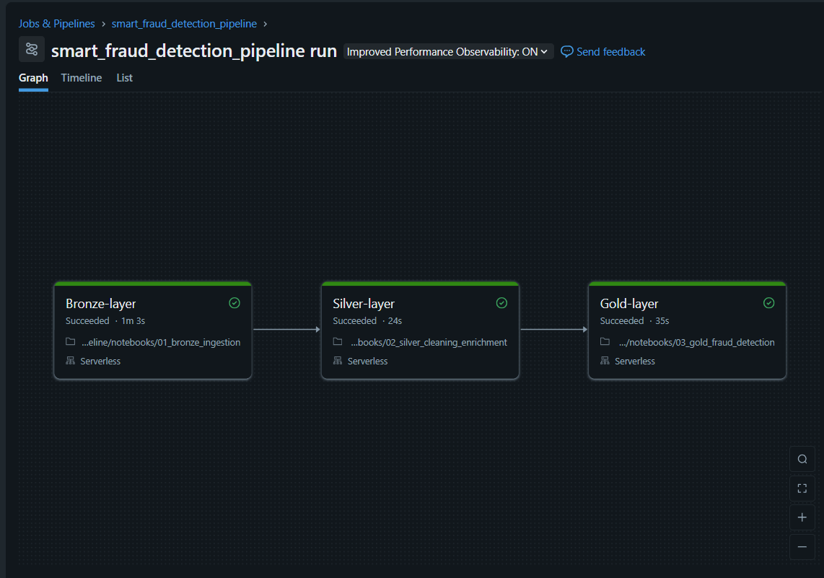
The pipeline was executed as a Databricks Job (smart_fraud_detection_pipeline) on serverless compute, running three sequential tasks: Bronze-layer (1m 3s), Silver-layer (24s), Gold-layer (35s) — a total runtime of roughly 2 minutes across 50 accounts and 200 transaction records, with all three tasks succeeding.

2. Bronze Layer — Raw Ingestion
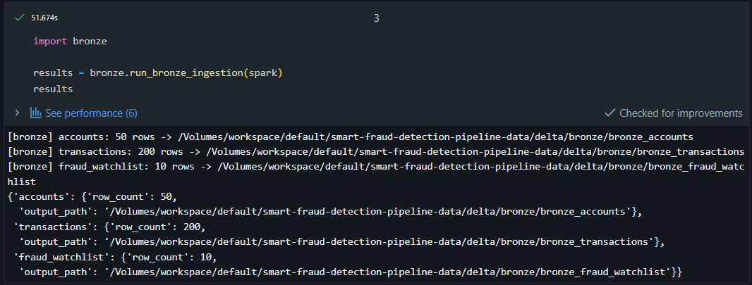
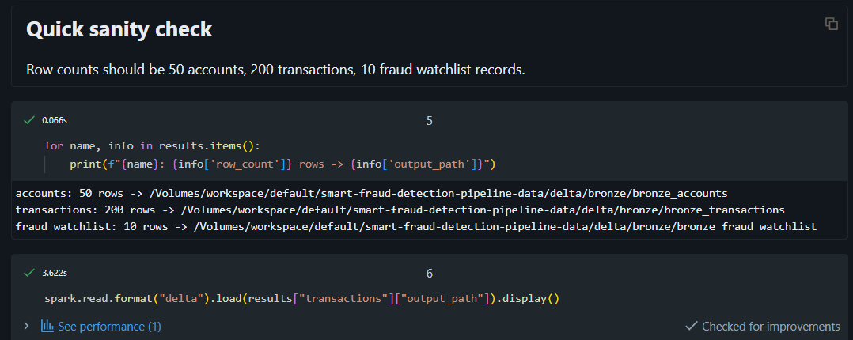
Bronze ingestion read all three source files with enforced schemas and wrote them to Delta without transformation: 50 account rows, 200 transaction rows, and 10 fraud watchlist records, each landing at its respective path under delta/bronze/.
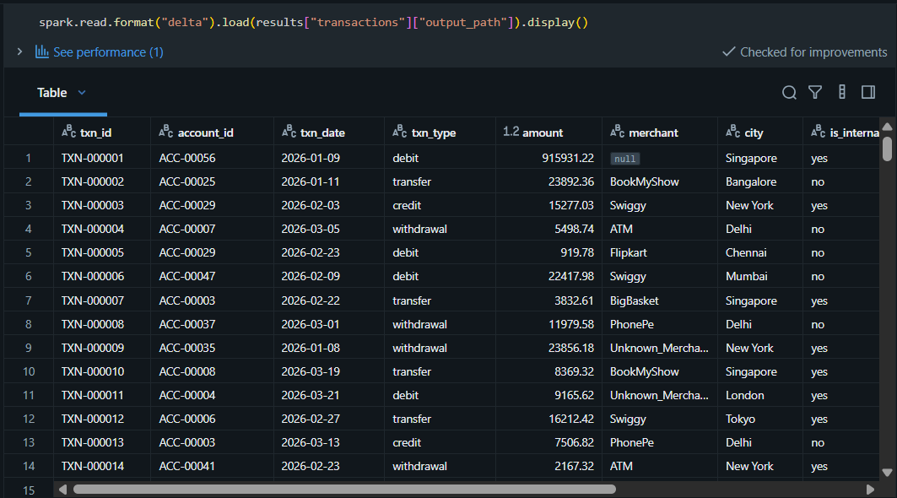
This is the raw, unmodified transactions table.

3. Data Quality Findings
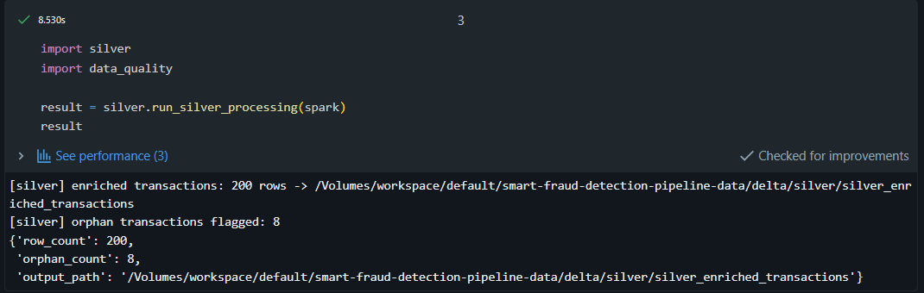
Before cleaning, Bronze ingestion surfaced 9 accounts (18%) missing credit_limit, 7 transactions (3.5%) missing merchant, and 0 duplicate txn_id rows. All 200 transaction rows were retained through Silver — none were silently dropped. Missing credit limits were imputed with the account-type median, missing merchants were filled with a placeholder, and 8 orphan transactions (4%, account_id with no matching account) were kept and explicitly flagged rather than removed.
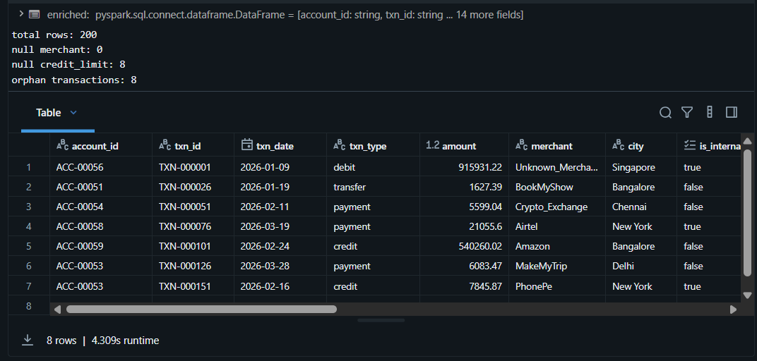
This is the same transactions table after Silver cleaning — TXN-000001's merchant now shows Unknown_Mercha... instead of null, confirming the cleaning step worked. Note the inline stats here show null credit_limit: 8, not 9 — this is expected, since the account-level median imputation successfully fills every matched account's credit limit, and the only rows still null are the 8 orphan transactions, which have no account to join against at all.
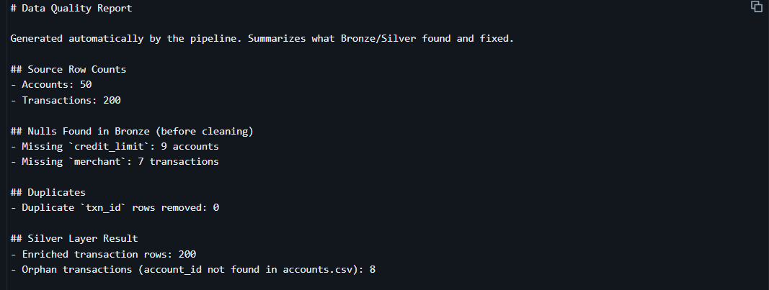

4. Fraud Classification Overview
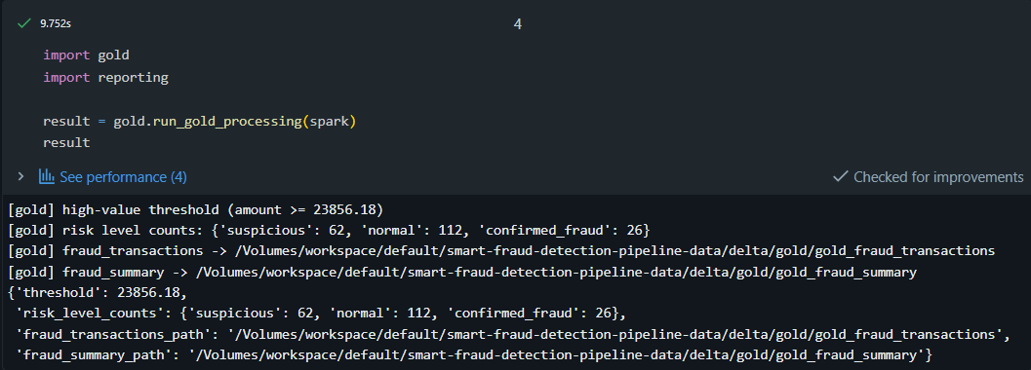

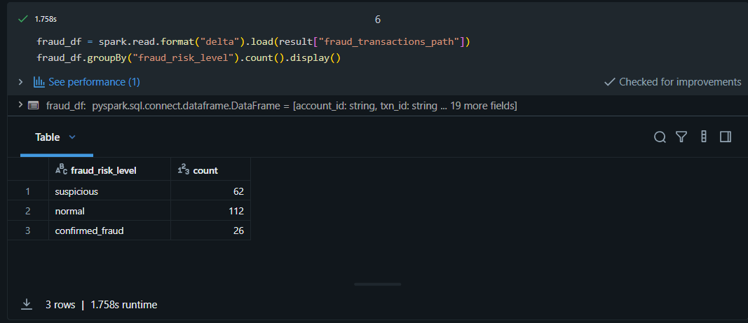
Gold processing computed a high-value threshold of ₹23,856.18 (90th percentile via approxQuantile) and classified all 200 transactions: 26 confirmed fraud (13.0%), 62 suspicious (31.0%), and 112 normal (56.0%). Nearly 44% of all transactions triggered at least one risk signal.

5. Fraud by Branch and Account Type
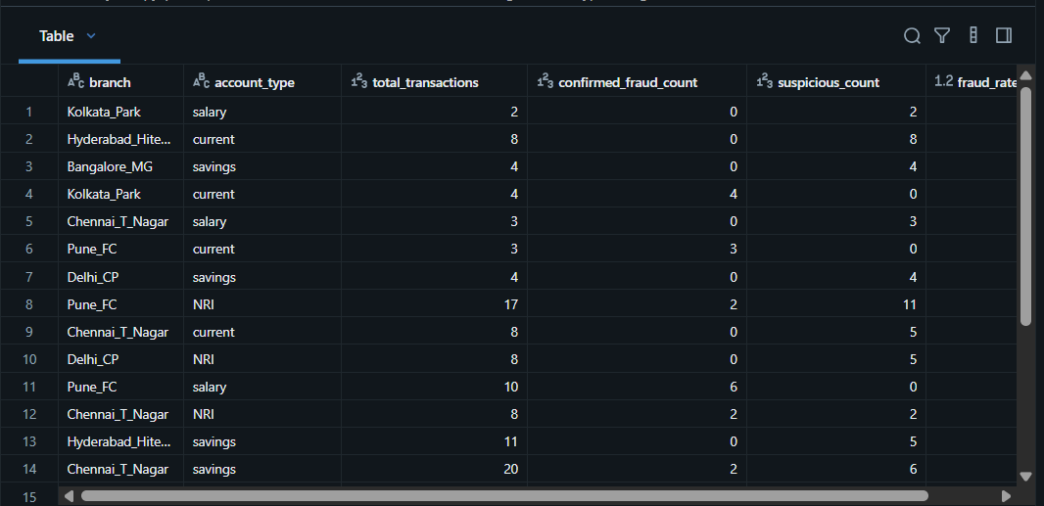
Fraud concentration varied sharply by branch and account type. Among higher-volume segments, Pune_FC/NRI stands out at 76.47% across 17 transactions — the largest high-risk segment by volume — followed by Chennai_T_Nagar/savings at 40.0% across 20 transactions and Bangalore_MG/current at 25.0% across 16 transactions. Several smaller segments (3-8 transactions each, including Chennai_T_Nagar/salary, Hyderabad_Hitech/current, and Kolkata_Park/current) show 100% fraud rates, but these should be read cautiously given the small sample sizes rather than treated as reliable signals on their own.
6. Top Flagged Accounts (Full Breakdown)
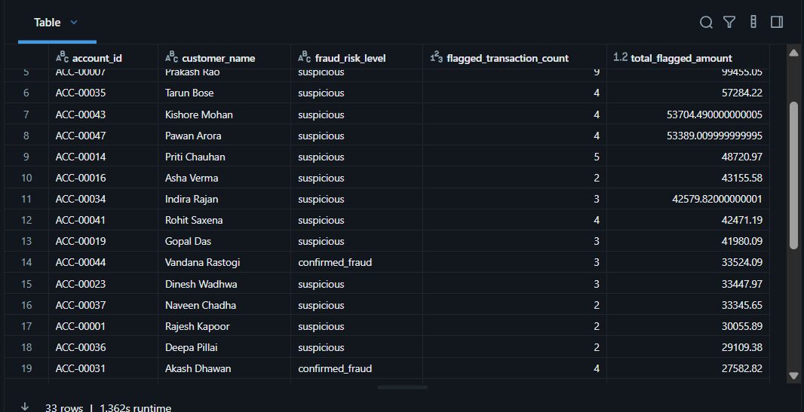
Across all accounts with at least one flagged transaction, 33 accounts appear in the full breakdown - the majority (28 of 33) classified as suspicious, with 5 as confirmed fraud.

7. Fraud Type Breakdown
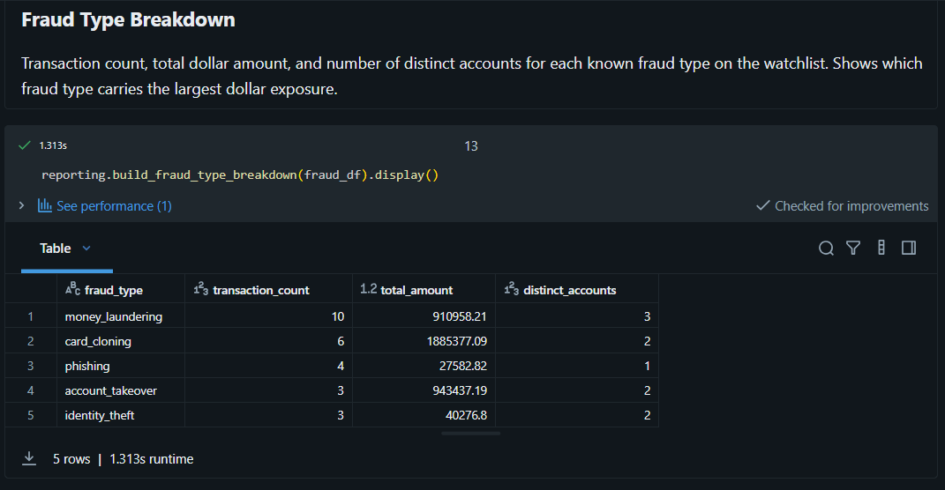
Card cloning carries the largest dollar exposure at ₹18.85 lakh despite only 6 transactions across 2 accounts, more than money laundering's ₹9.1 lakh across 10 transactions and 3 accounts — driven by a small number of very high-value transactions. Phishing shows the smallest footprint, with just 4 transactions totaling ₹27,582.82 tied to a single account.

8. Trend Over Time
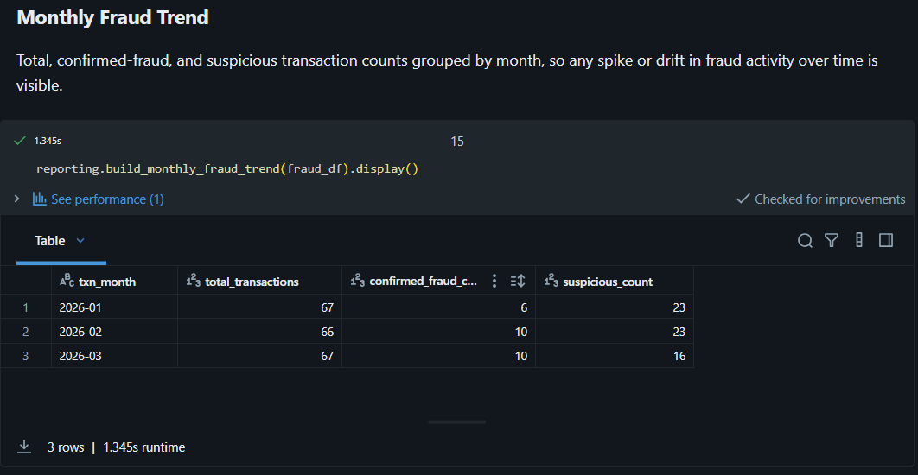
Confirmed fraud counts nearly doubled from January (6) to February and March (10 each), while suspicious-transaction counts declined slightly over the same period (23 → 23 → 16). Transaction volume stayed roughly flat month over month (~66-67), so this reflects a genuine shift in risk composition rather than simply more transactions being processed.
9. Geographic Breakdown

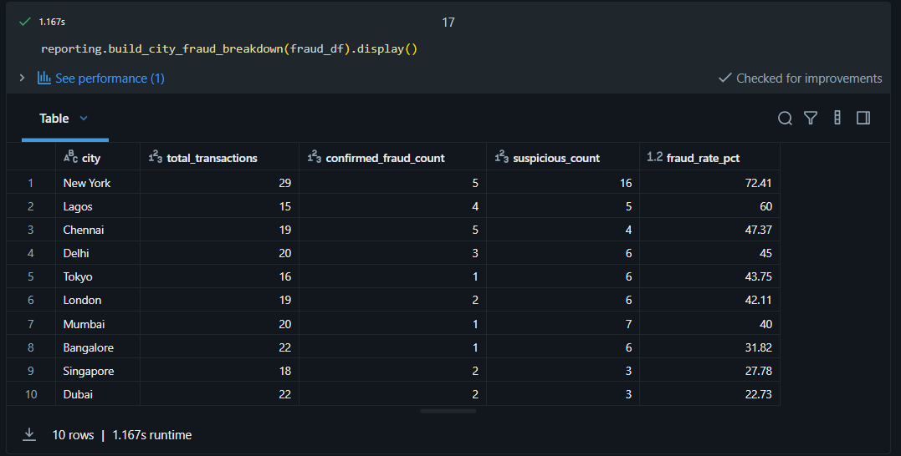
New York is both the highest-volume city (29 transactions) and the highest fraud rate (72.41%) — not a small-sample artifact. Lagos follows at 60.0% on 15 transactions. At the low end, Dubai (22.73%) and Singapore (27.78%) show the lowest fraud rates despite comparable transaction volumes.

10. KYC Risk Correlation
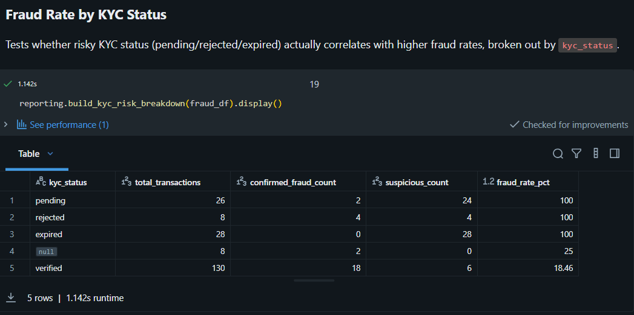
This is the strongest signal in the dataset: every transaction tied to an account with a non-verified KYC status — pending, rejected, or expired — was flagged as either suspicious or confirmed fraud, a 100% rate across all three categories, compared to 18.46% for verified accounts. This directly confirms the assumption built into the Gold layer's risk logic.

11. International vs. Domestic Transactions
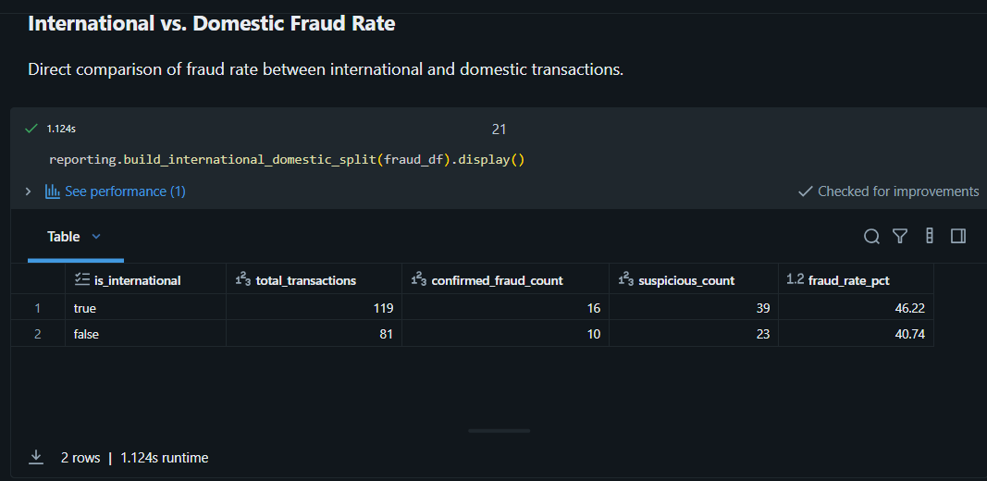
International transactions show a fraud rate of 46.22% versus 40.74% for domestic — a real but modest gap of about 5.5 percentage points, notably smaller than the KYC or geography signals above.
12. Top 10 Flagged Accounts and Merchants
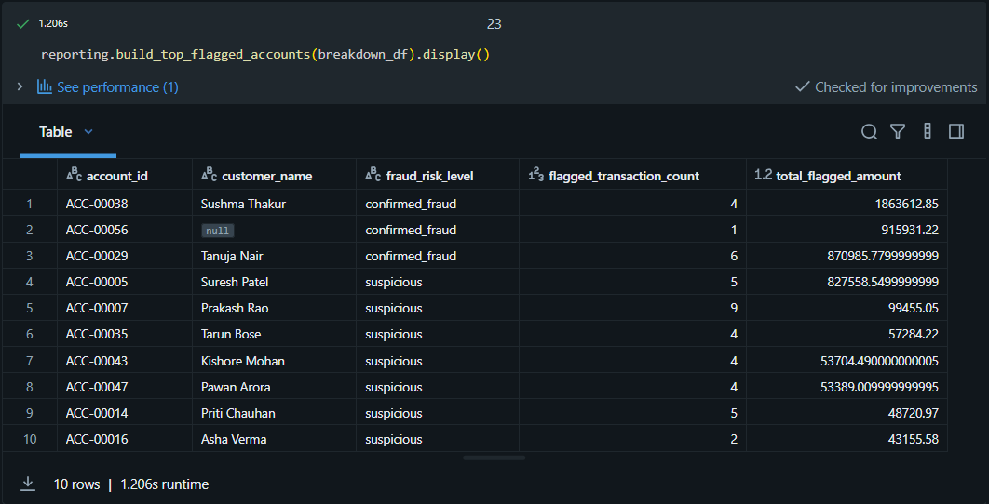
The top 3 accounts — ACC-00038, ACC-00056, and ACC-00029, all confirmed fraud — total roughly ₹36.5 lakh in flagged value, more than the remaining 7 accounts in the top 10 combined. ACC-00056 has no customer name on record, worth a data quality follow-up outside this pipeline.
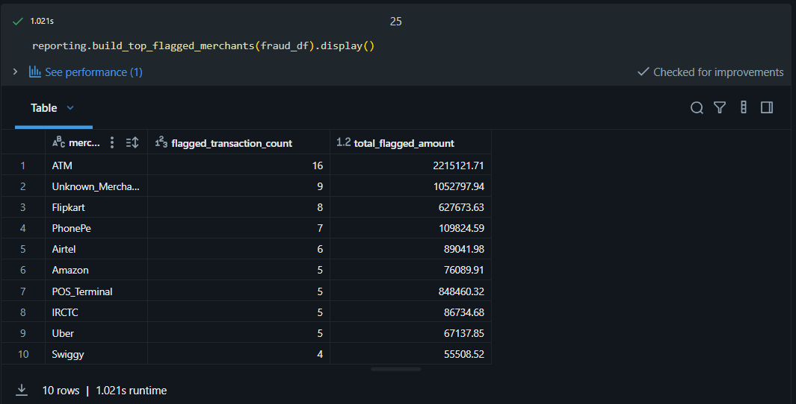
ATM transactions are both the most frequent (16) and highest-value (₹22.15 lakh) flagged merchant category. Unknown_Merchant follows in second place with 9 flagged transactions — a mix of transactions with genuinely missing merchant data filled by Silver, and pre-existing "Unknown_Merchant" labels already present in the raw source data.
13. Export Confirmation
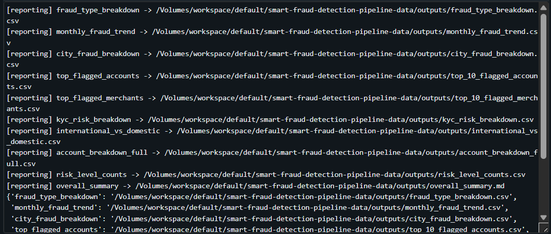
All reports above were persisted as individual CSVs, plus the markdown overall summary, to the outputs/ volume, confirming the full report set matches what's shown inline in the notebook.

Conclusion

This project built a fraud detection pipeline that ingests raw banking data, cleans and enriches it, and classifies transactions by fraud risk, using a Bronze, Silver, Gold architecture that keeps each stage's responsibility clear and every downstream number traceable back to its source.
The original problem statement asked for a pipeline to detect fraud using the known fraud watchlist, which the is_watchlisted check in the Gold layer directly satisfies. Rather than stopping there, the pipeline was extended to also flag transactions that show signs of risk without appearing on the watchlist at all. Two additional heuristics were added: transactions that are both high-value and international, and transactions tied to accounts with an unresolved KYC status (pending, rejected, or expired). These are classified separately as suspicious, distinct from confirmed_fraud, so the two signal types are never conflated.
Across the 200 transactions processed in this run, the pipeline classified 26 as confirmed fraud from the watchlist and 62 as suspicious from these additional heuristics, meaning nearly 44% of all activity triggered at least one risk signal. That suspicious count is more than double the confirmed fraud count, showing that a large share of the risk in this dataset would have gone completely undetected if the pipeline only checked against the known fraud list as originally scoped. The results also confirmed that KYC status is the strongest predictor of fraud in this dataset, with non-verified accounts flagged at a far higher rate than verified ones, and that fraud value is concentrated in a small number of high-value accounts rather than spread evenly across the dataset.
Throughout the pipeline, no transaction was silently dropped, and every data quality issue, from missing values to orphaned records, was handled deliberately and made visible rather than hidden. The result is a set of fraud reports that a reviewer can trust: complete, explainable, and reproducible across both local and Databricks environments.

