Exploratory Data Analysis (EDA) Summary
Report Template

1. Introduction
[The Delinquency prediction to detect the bad or criminal records in the credit card income of employees and students in USA. The dataset contains the data of total 6 months and each month is divided into a individual column in dataset.]

2. Dataset Overview
This section summarizes the dataset, including the number of records, key variables, and data types. It also highlights any anomalies, duplicates, or inconsistencies observed during the initial review.
Key dataset attributes:
- Number of records: [500 rows and 19 columns]
- Key variables: [Customer ID : A unique identifier assigned to each customer,
Age : The age of the customer in years,
Income : The annual gross income of the customer,
Credit Score : The creditworthiness of the customer (typically between 300–850),
Credit Utilization : The percentage of the available credit limit that the customer is currently using,
Missed Payments : The total number of payments the customer has failed to make,
Loan Balance : The current outstanding balance on the customer's loan,
Delinquent Account : A binary indicator where '1' signifies a delinquent account and '0' signifies a healthy account,
Employment Status : The current job status (e.g., Employed, Self-employed, Unemployed, Retired),
Account Tenure : The duration (likely in months or years) for which the account has been active,
Credit Card Type : The tier or category of the credit card (e.g., Platinum, Gold, Business, Student),
Location : The geographic city or region where the customer resides,
Month_1 to Month_6 : Historical payment status for each of the last six months (e.g., On-time, Late, Missed).]
- Data types: [Categorical(identifier, Binary, Nominal, Ordinal),
Numerical(Discrete, Continuous).]

3. Missing Data Analysis
Identifying and addressing missing data is critical to ensuring model accuracy. This section outlines missing values in the dataset, the approach taken to handle them, and justifications for the chosen method.
Key missing data findings:
- Variables with missing values: [Income has 39 null values, Credit Score has 2 null values, Loan Balance has 29 null values]
- Missing data treatment: [Deletion.]

4. Key Findings and Risk Indicators
This section identifies trends and patterns that may indicate risk factors for delinquency. Feature relationships and statistical correlations are explored to uncover insights relevant to predictive modeling.
Key findings:
- Correlations observed between key variables: [There is NO correlation between variables as the below image shows.]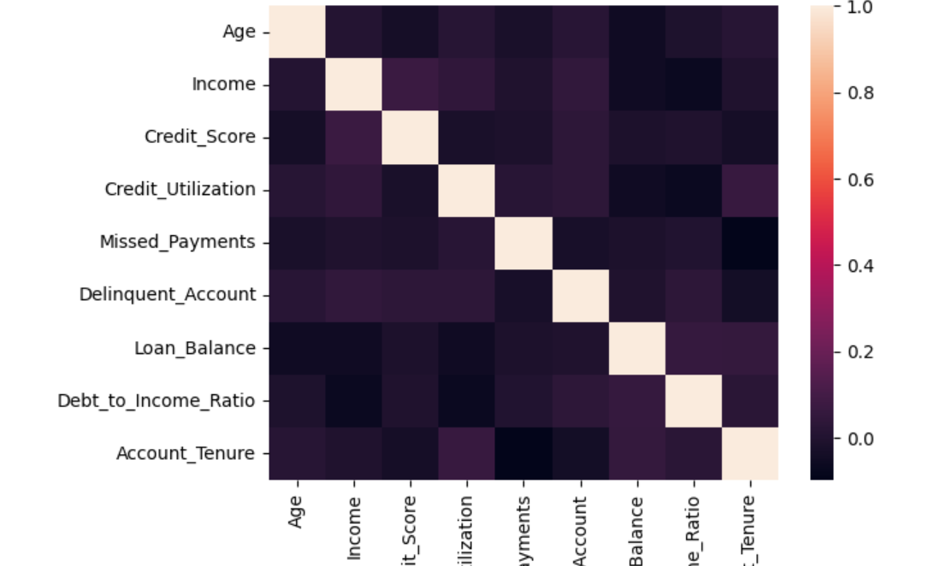
- Unexpected anomalies: [We need to encode the categorical data for the better solutions and analysis for the better delinquency prediction.]

5. AI & GenAI Usage
Generative AI tools were used to summarize the dataset, impute missing data, and detect patterns. This section documents AI-generated insights and the prompts used to obtain results.
Example AI prompts used:
-'Analise the Dataset to find the key variables and suggest the key features to keep and drop from the dataset.'
- 'Suggest an imputation strategy for missing income values based on industry best practices.'
- ‘Find the dependent or predicting variable from the dataset which needs to be targeted in prediction.’

6. Conclusion & Next Steps
[-Using the Encoding techniques like ‘Ordinal/One Hot Encoder’ to change the categorical into Numeric and start predicting by using SKLearn library.
-The Delinquent Account in dataset is target.
-It has only two values 0 and 1 .
-The Logistic Regression is the best fit model for this dataset and prediction.
-But, There is a huge bias in this data , There are 420 zero’s(No) and only 80 one’s(Yes) in column, So we need to standardize the data in Delinquent Account. ]

