**Week 8: Pipeline Creation using script and Installation of Docker**

1. Evaluation of Jenkins pipeline.
2. **WORKING ON BUILD TRIGGERS FOR LAST JENKINS PIPILINE**
3. Hands-on practice on creation of scripted Jenkins pipeline.
4. Installation of Docker Desktop and creating account in DockerHUb.
5. Take the screenshots for above task

Procedure

**General :**

Description :- provide the description of the project

Build triggers: here we can provide with build triggers of you choice

**Advance project option**:

Definition:

Choose pipeline script

**Here code for pipeline -script**

Copy the code there

-------------------------------------------------------------------------------------------------------------------------

pipeline {

agent any

tools{

maven 'Maven'

git 'GIT_HOME'

}

stages {

stage('git repo & clean') {

steps {

//bat "rmdir /s /q maven_java"

bat "git clone https://github.com/ArunGarimella04/maven_java.git"

bat "mvn clean -f maven_java"

}

}

stage('install') {

steps {

bat "mvn install -f maven_java" //project name

}

}

stage('test') {

steps {

bat "mvn test -f maven_java"

}

}

stage('package') {

steps {

bat "mvn package -f maven_java"

}

}

}

}

**Steps to create a Build Trigger for Jenkins pipeline:**

1. Create a Jenkins Pipeline.

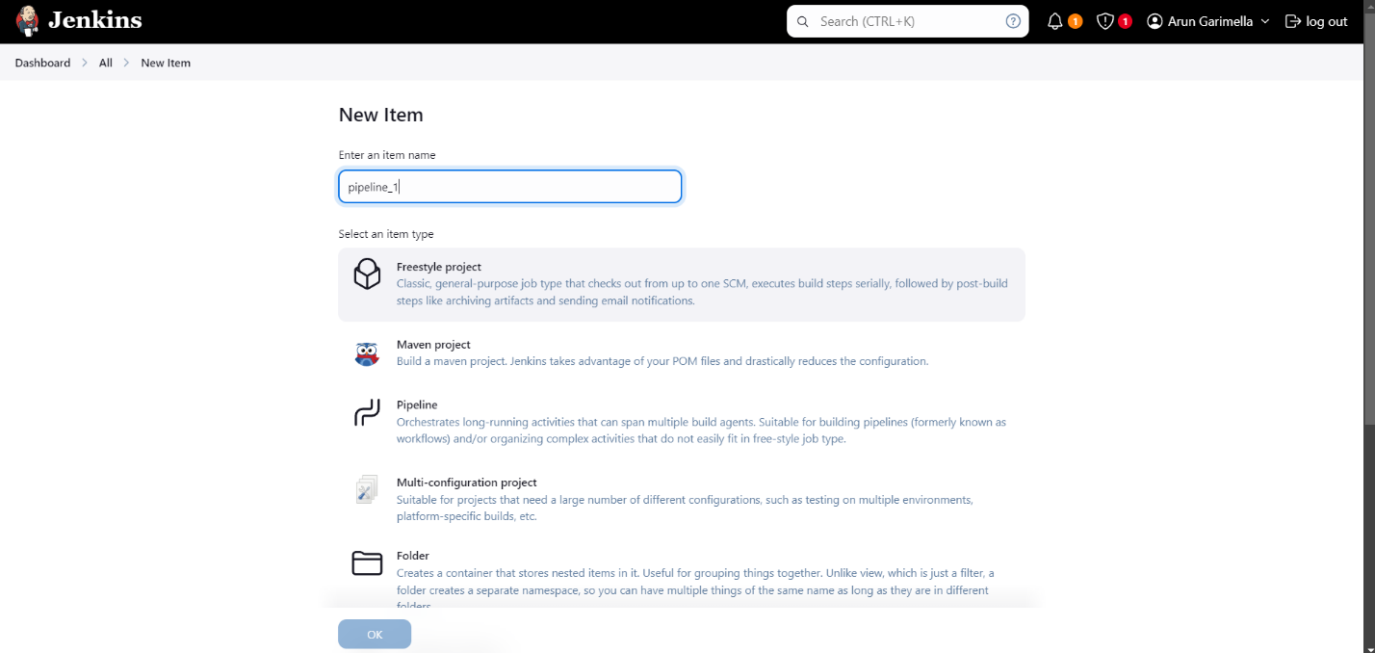

2. Select “Build periodically” in Build Triggers section and type “H/15 * * * *” in the description.

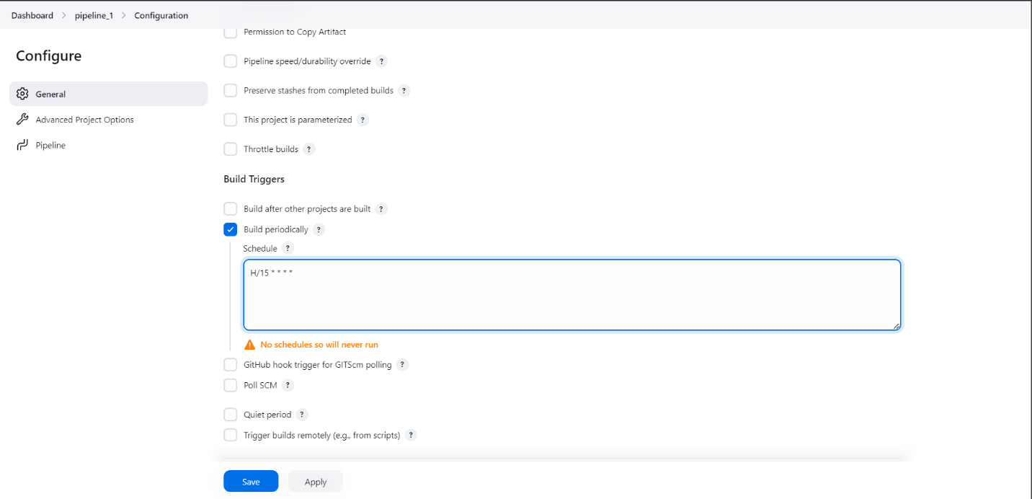

3. Add your pipeline script in the Pipeline definition section.

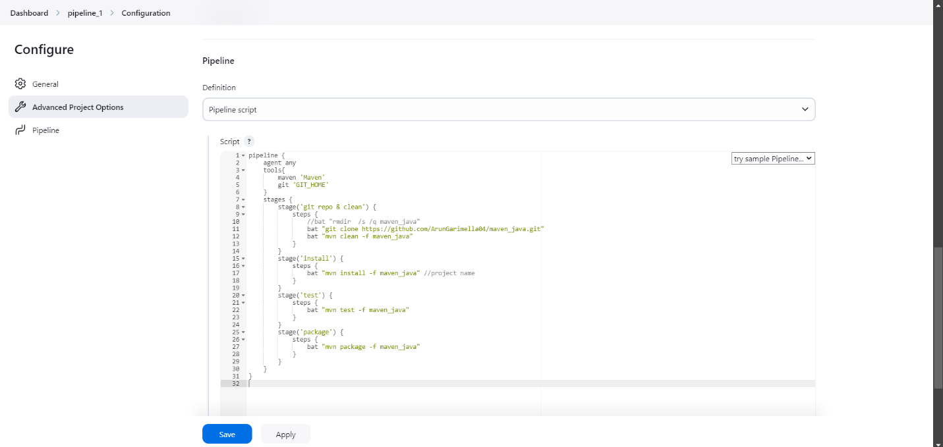

4. Click on Build Now option and wait for the build to complete.

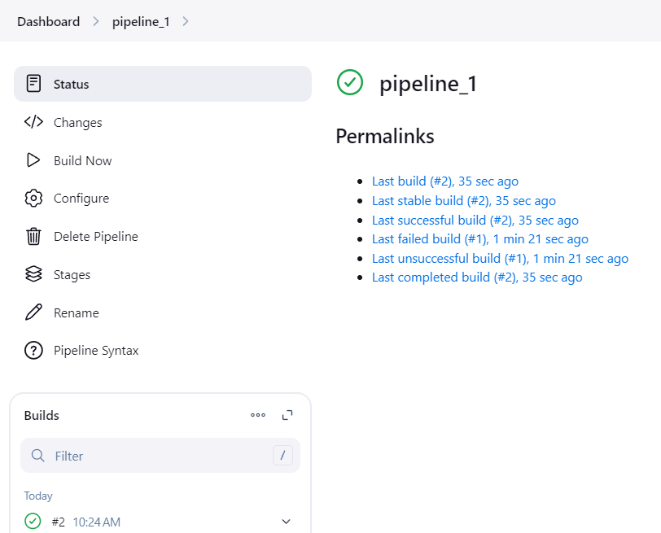

5. You will see a “BUILD SUCCESS” output in the Console Output.

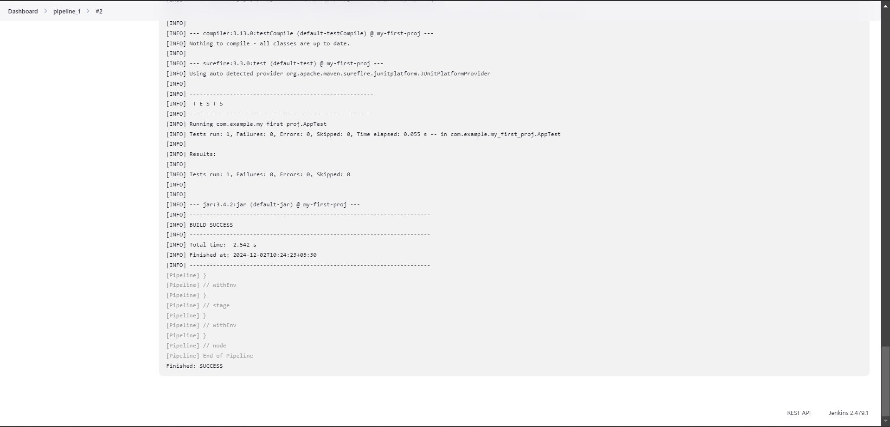

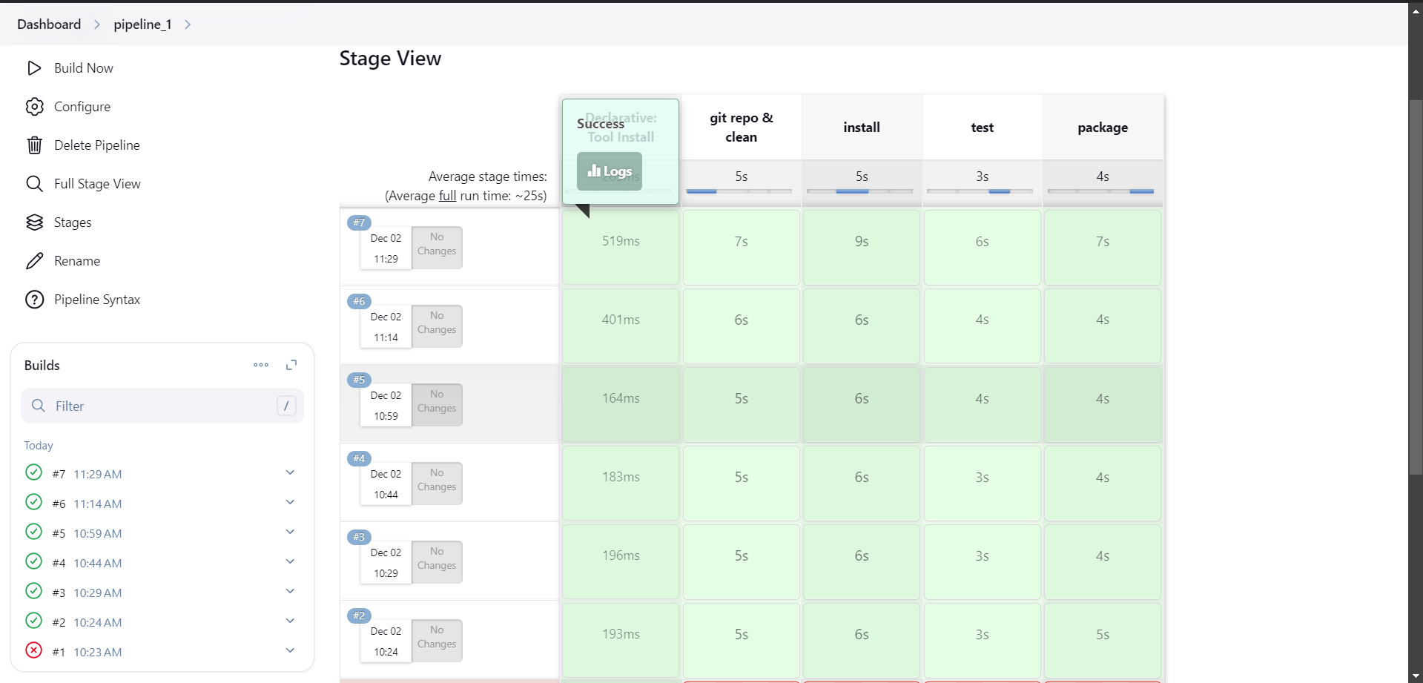

**Steps to create a Build Trigger for maven Web project using poll SCM:**

1. Select an existing maven web build project and go to configure.
2. Select poll SCM option from “BUILD TRIGGERS”.
3. Type “H/2 * * * *” in the description.

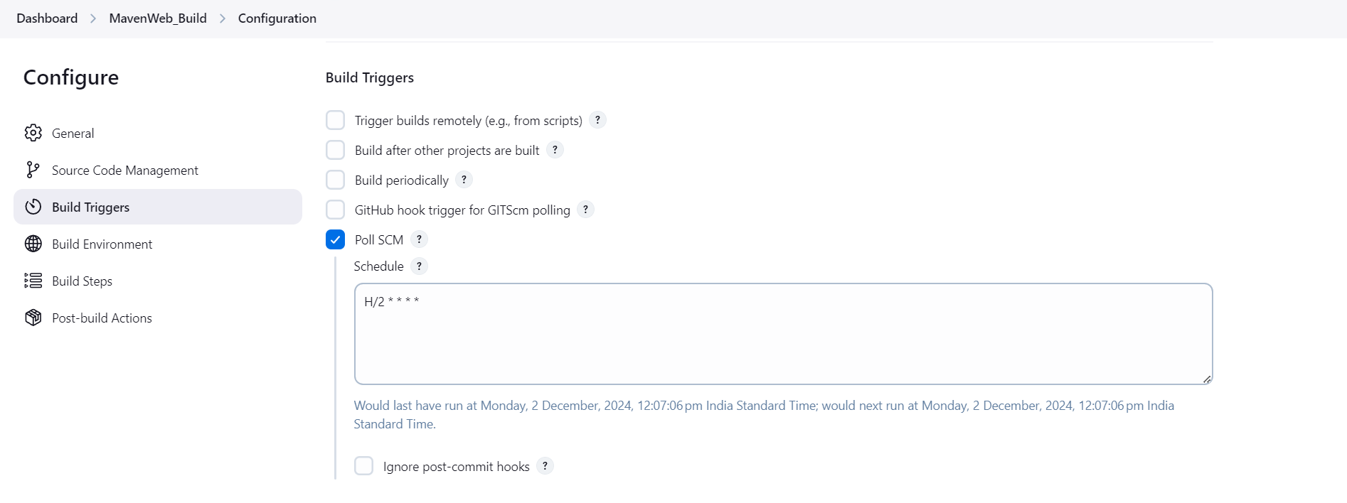

1. Click on Build now.

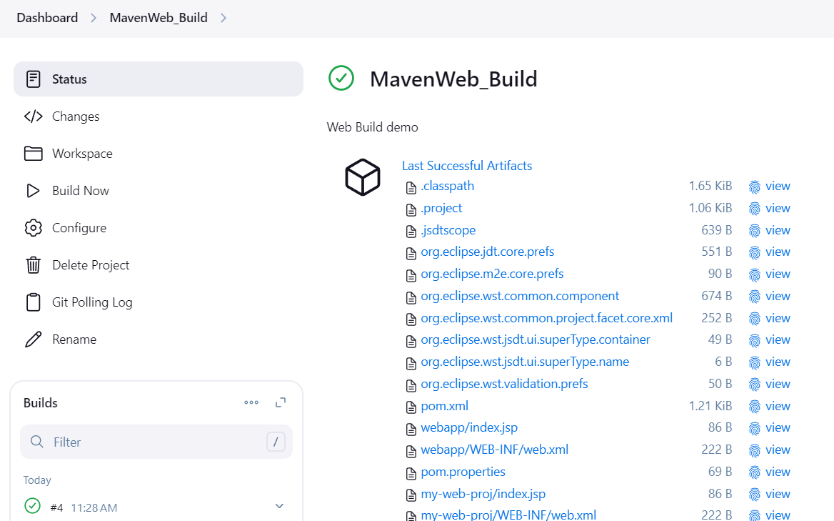

1. Open tomcat server and click on “/Webpath” in “manager app” and look for output.

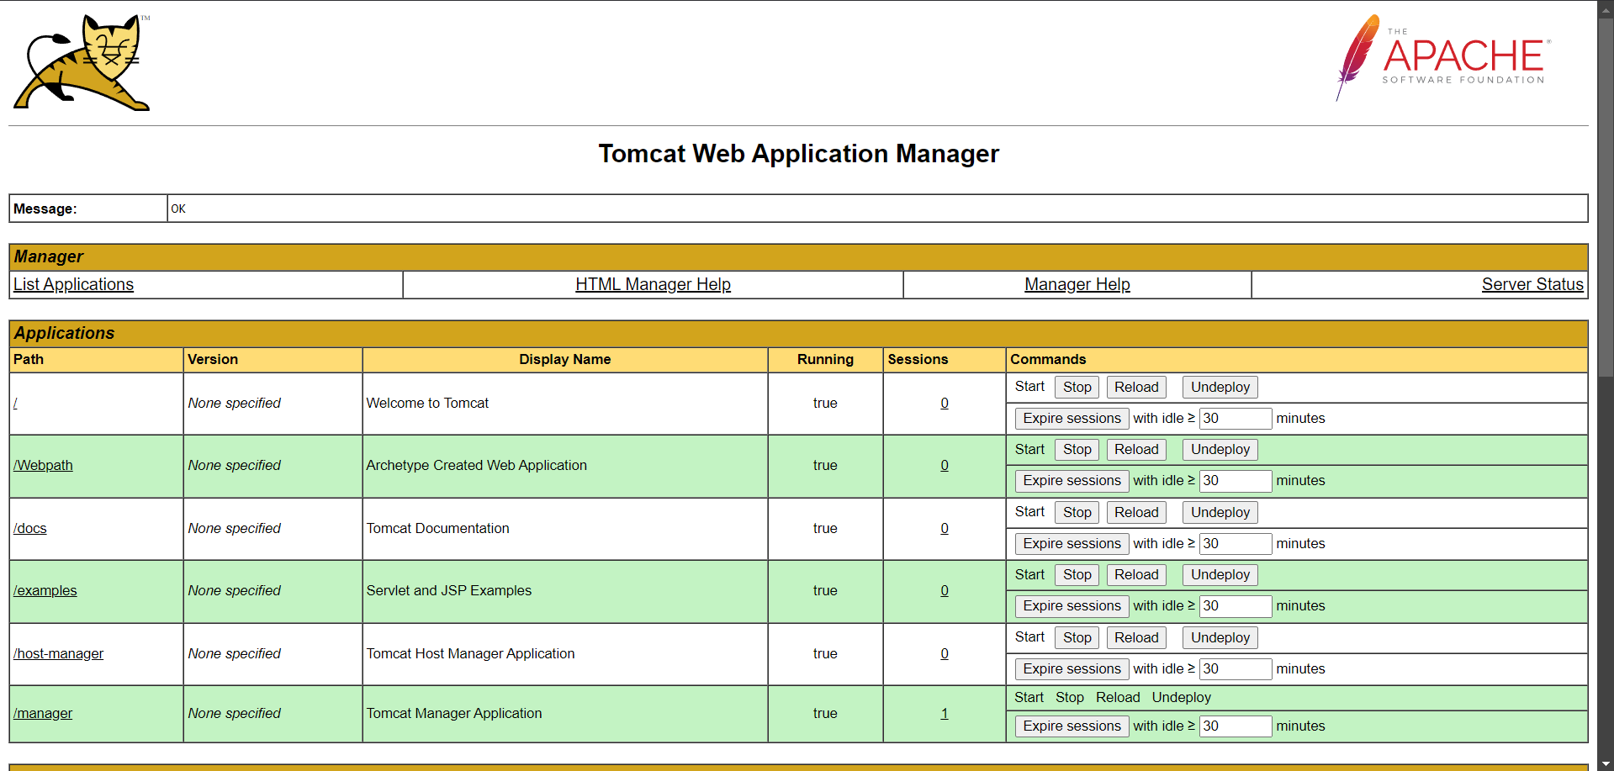

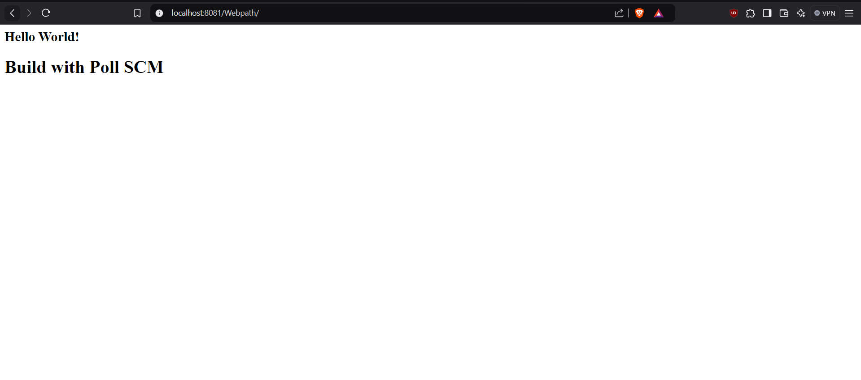

1. You have successfully created a maven project with poll SCM.

**Installation of Docker for Desktop and DockerHUB account creation:**

1. Go to <https://www.docker.com> and download Docker for your Operating System.

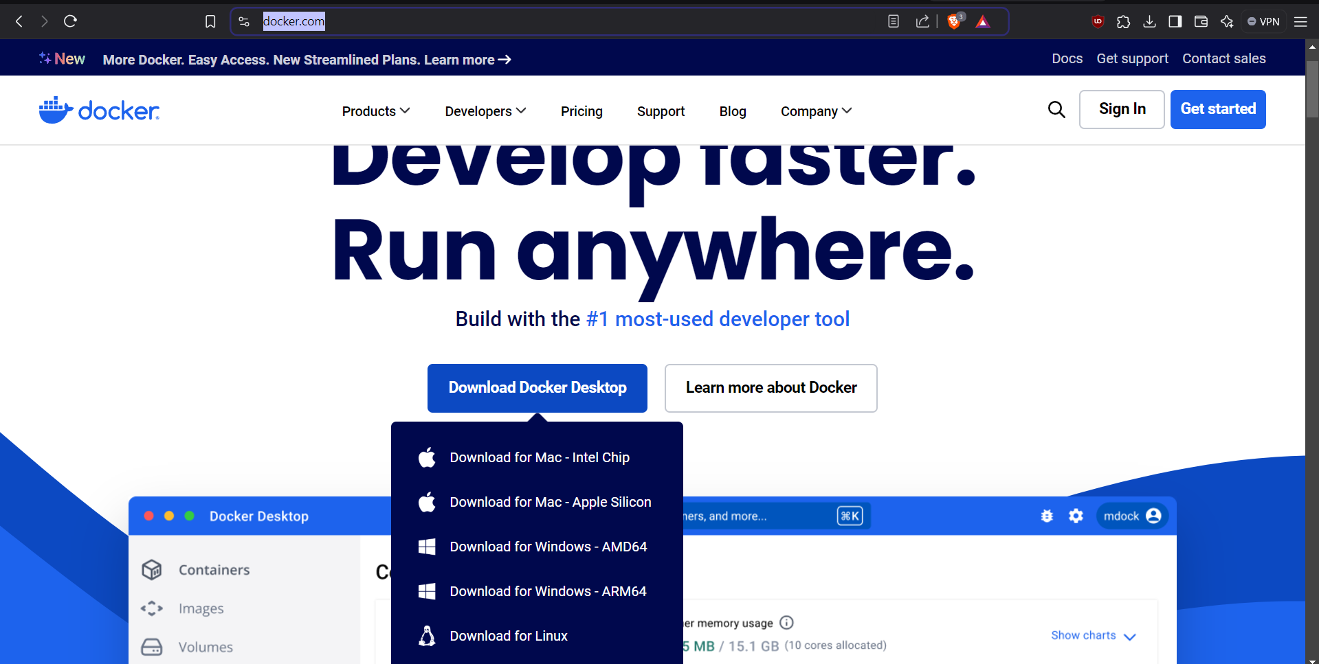

1. Run the downloaded docker installation executable.

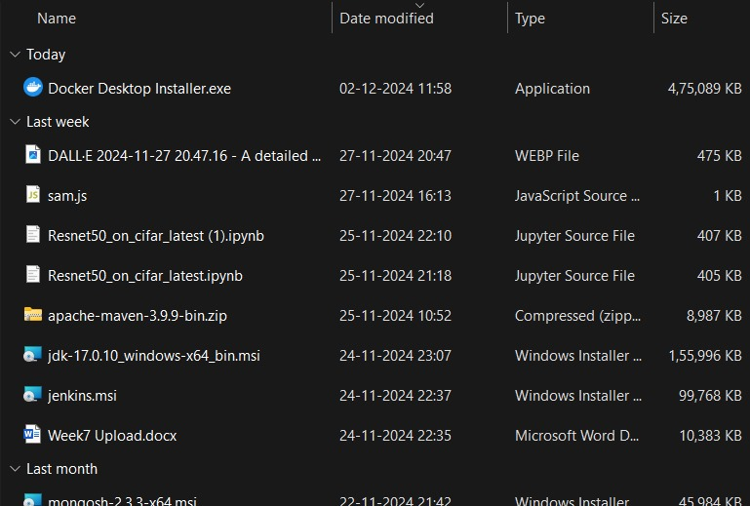

1. Click on “OK” in the configuration window.

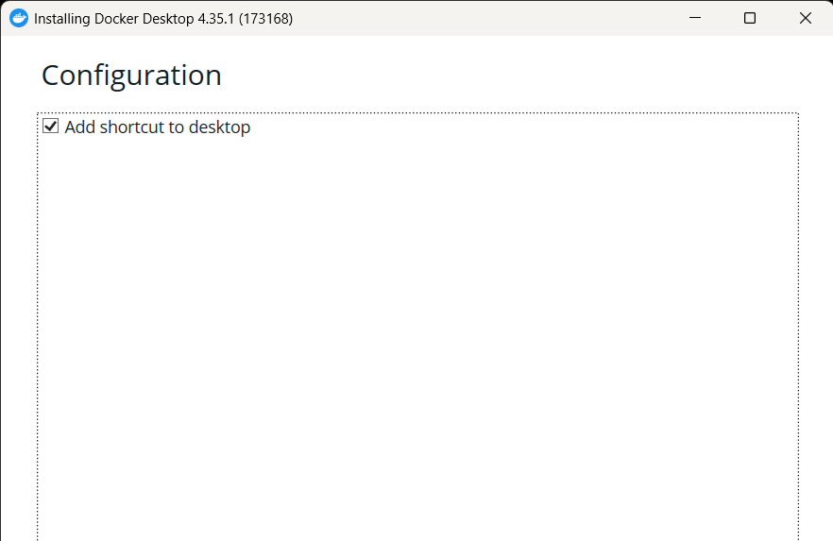

1. Wait for Docker to finish installing.

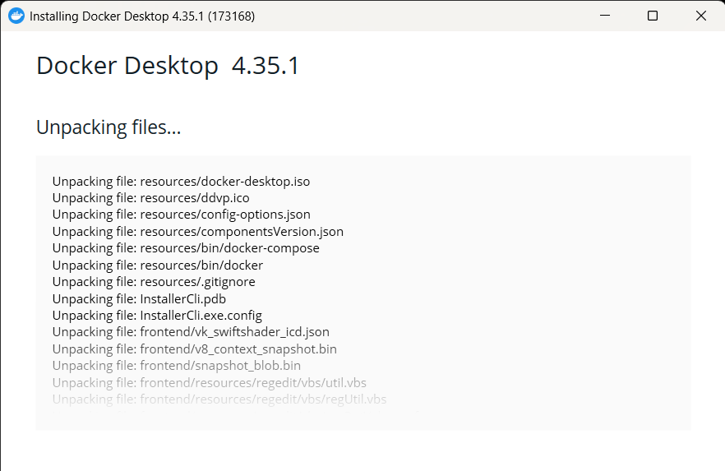

1. Click on “Close and Restart”.

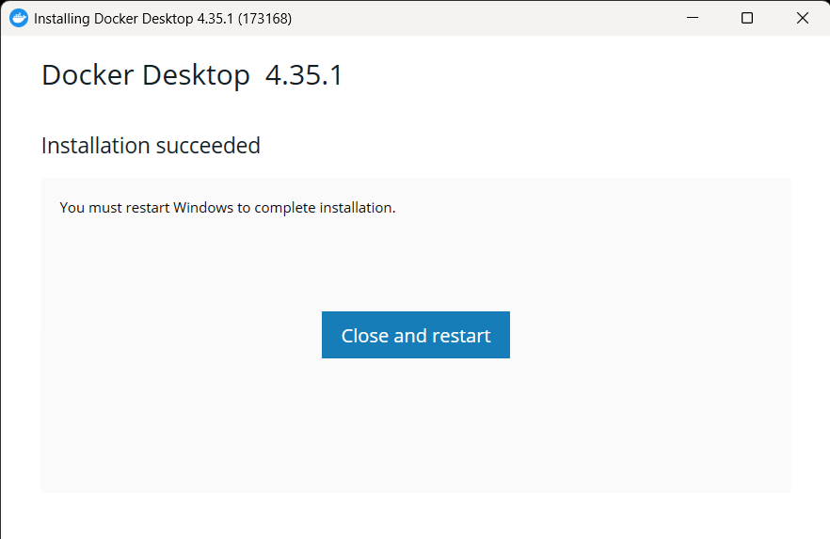

1. After restarting select “Accept”

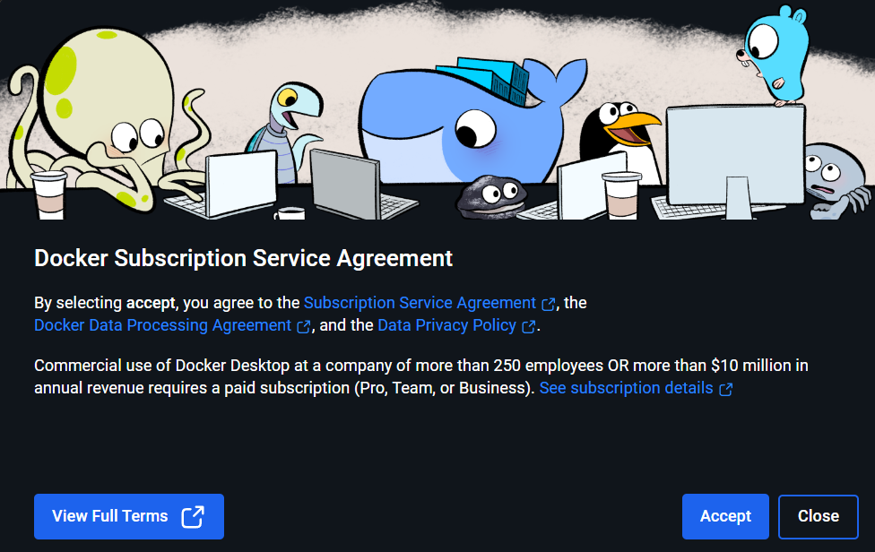

1. Create a Docker account and sign in.

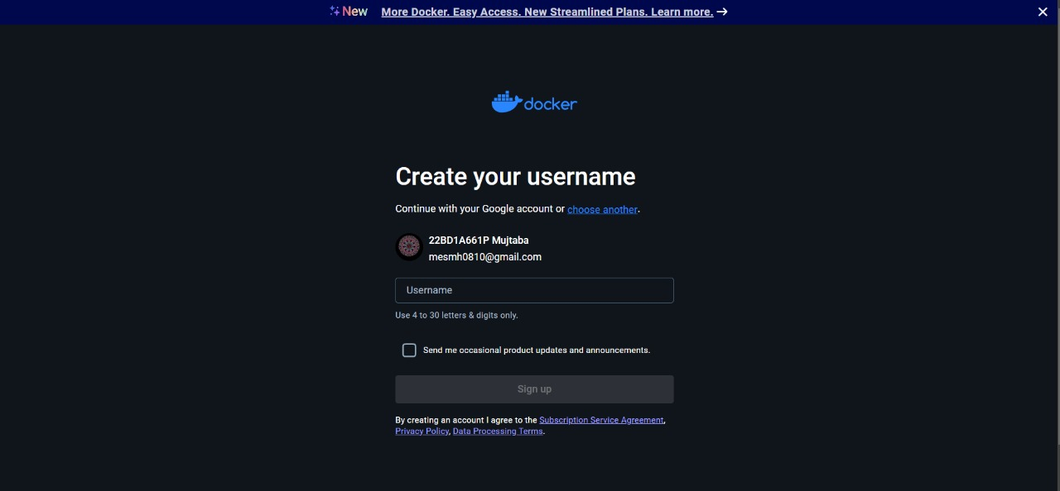

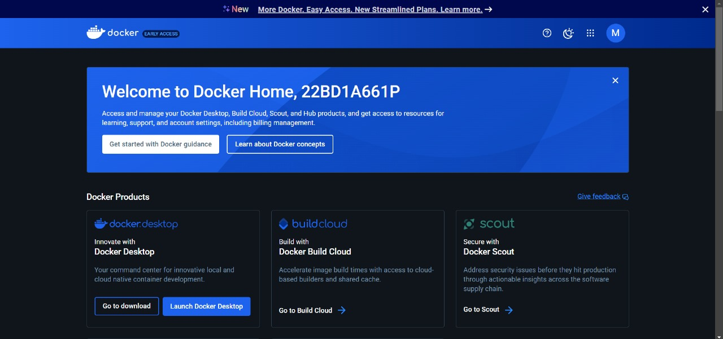

1. You have successfully created a docker hub account.