Week 9: Creation of images and container ..pushing them into dockerhub
- Evaluation of previous experiments.
- Hands-on practice on docker for pulling image, creation of container ,running container, pushing it into docker hub, creation of image using the docker file.
- Creating images using DockerFile and pushing the created image into DockerHub.
- Upload the screenshots for above task and provide the link for docker hub

- Installation of the docker( Follow the installation PPT and download the docker)
- Sign In into Docker Hub
- Click on personal-> continue with free
- Go to gmail and verify your account
- Once logged into the DockerHub,there are no containers and Images in Docker Hub
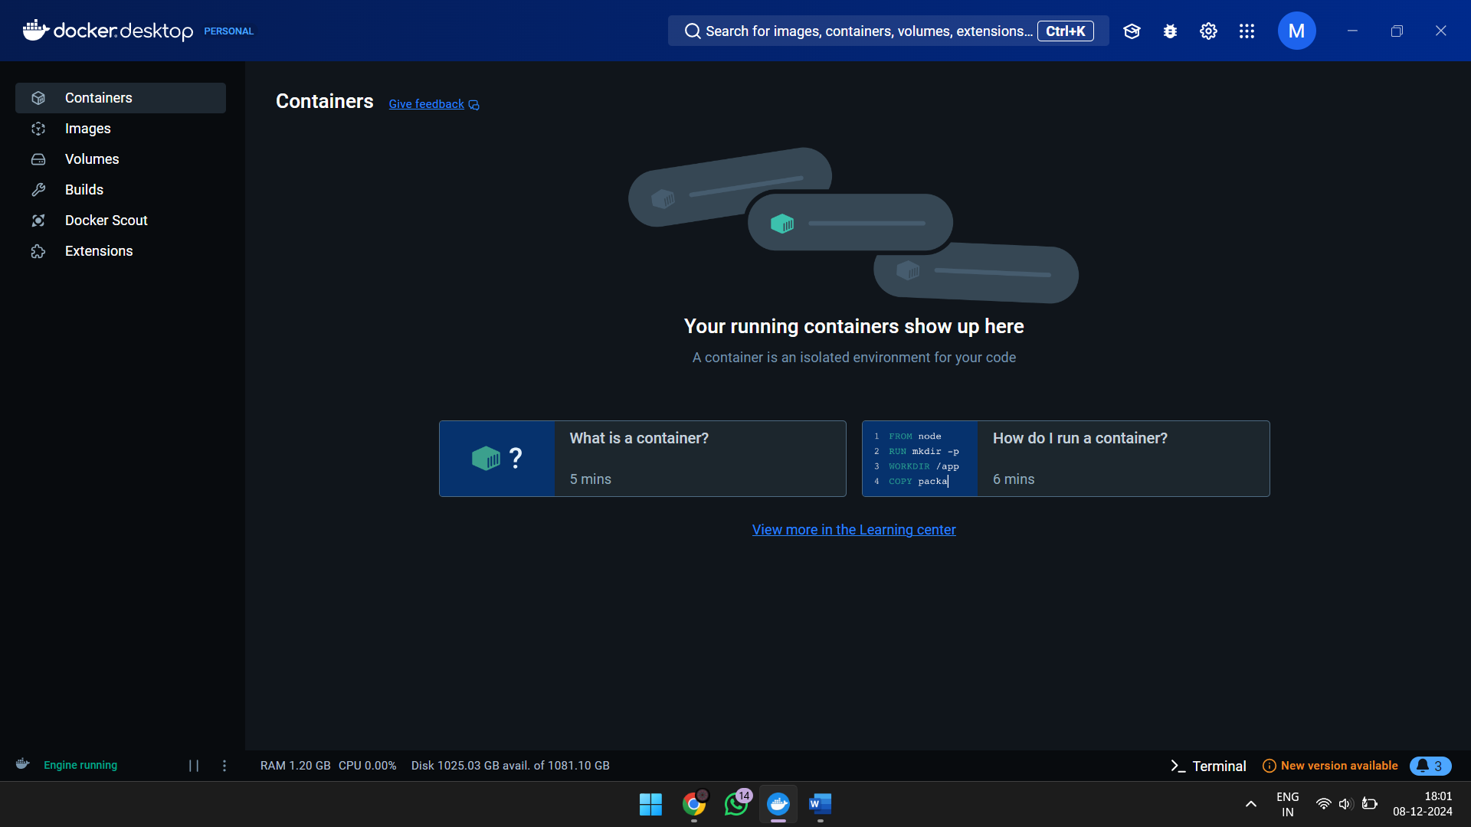
- Create a folder on desktop as”Docker”
- Check Docker Version
docker –version
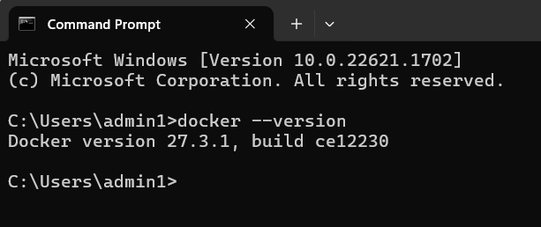
- RUN image HELLO-WORLD IMAGE
docker run hello-world
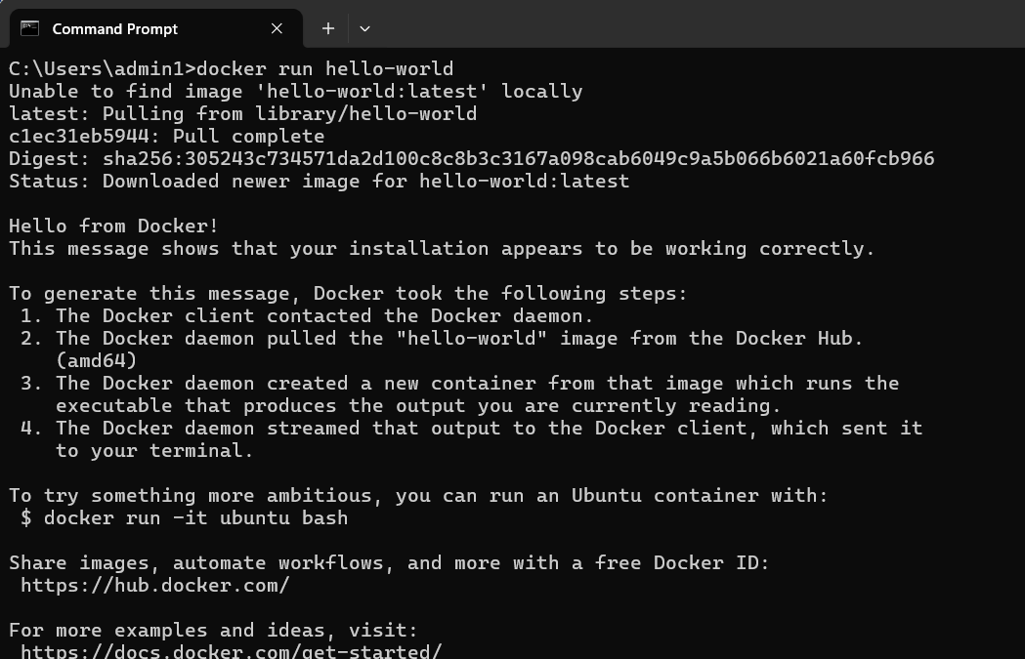
- CHECK IMAGES
docker images
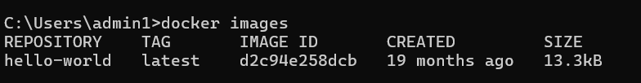
- Pull Ubuntu Image from Docker Hub
docker pull ubuntu
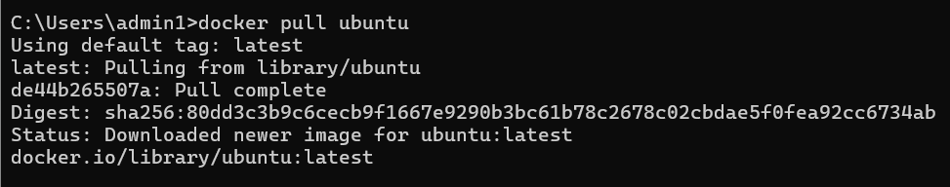
- Run the image as docker container
docker run -it -d ubuntu

- Check the all running and stopped containers
docker ps –a
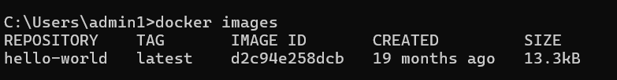

- During the execution of the container Ubuntu ->
copy the container ID
- To accessing/executing a running container (ubuntu)
docker exec -it 1c6072756052 bash
- Give echo message in the running container
root@1c6072756052:/# echo Welcome to docker demo
Welcome to docker demo
- Exit from the running container
root@1c6072756052:/# exit
exit
PS C:\Users>
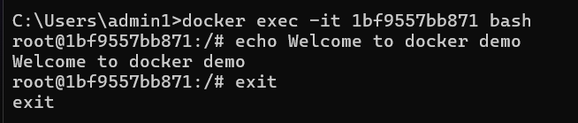
- To stop the running container
docker stop containerID
PS C:\Users > docker stop 1c6072756052
1c6072756052
PS C:\Users >
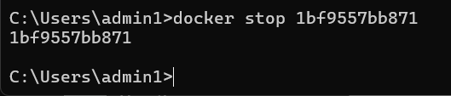
- run ubuntu with echo
docker run –it ubantu bash root@1c6072756052:/# echo Bhargavi
Bhargavi
root@1c6072756052:/#
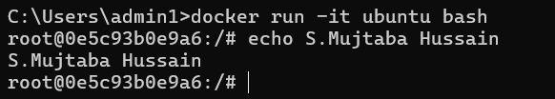
- Pull the ubuntu image from the docker repository and run it as a container that will provide all the features of ubuntu
$ docker search ubuntu displays public images in ubuntu
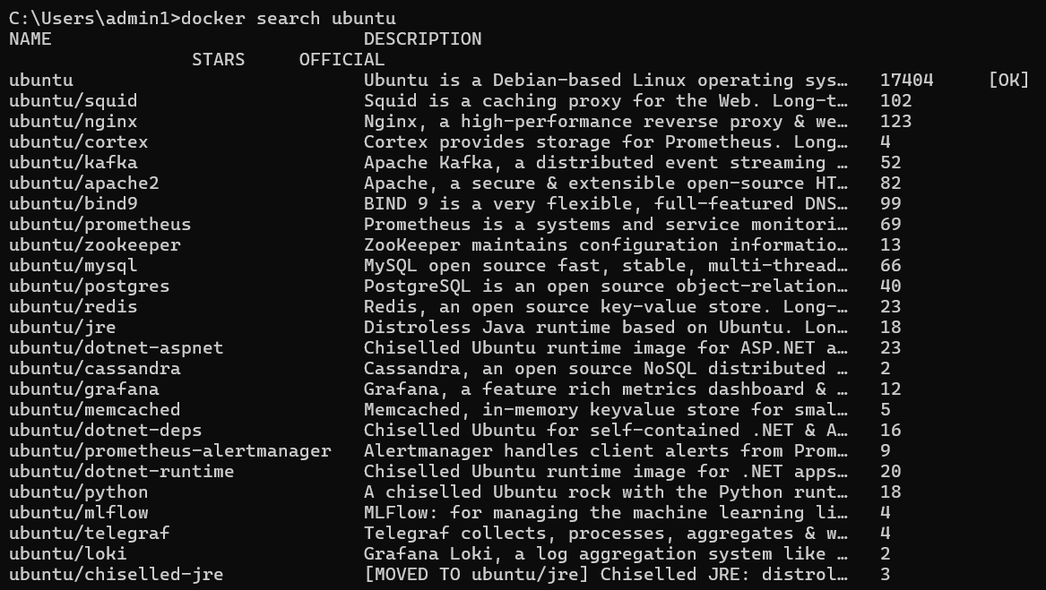
- Pushing the image from local repository to docker hub
- Step1:create dockerhub account
- Step2:login using dochub
- PS C:\Users > docker login
- Username:<< >> ( here give user name)
- Password:<< >> ( here give user password)
Login Succeeded
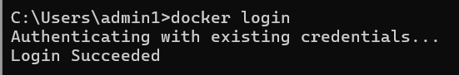

- Restart image
$docker start containerID used to restart the container if it has stopped due to application crash or if error occurred
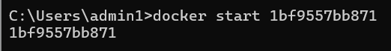

Creating Docker Image using Docker File
- Create two files, one file Dockerfile without extension and the other app.js (.js file contains Javascript code for execution on webpages)
a)Creating a sample javascript file
Type the following commands
$ Vi app.js
Console.log(“Docker Image using Docker File”)
Press Esc-> :wq-> to save and exit
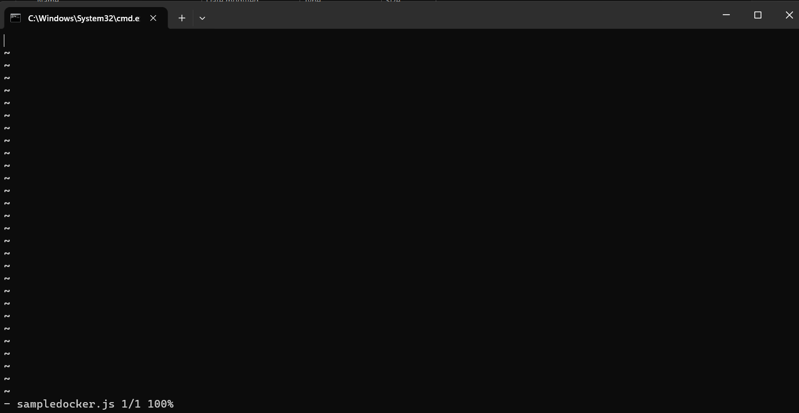

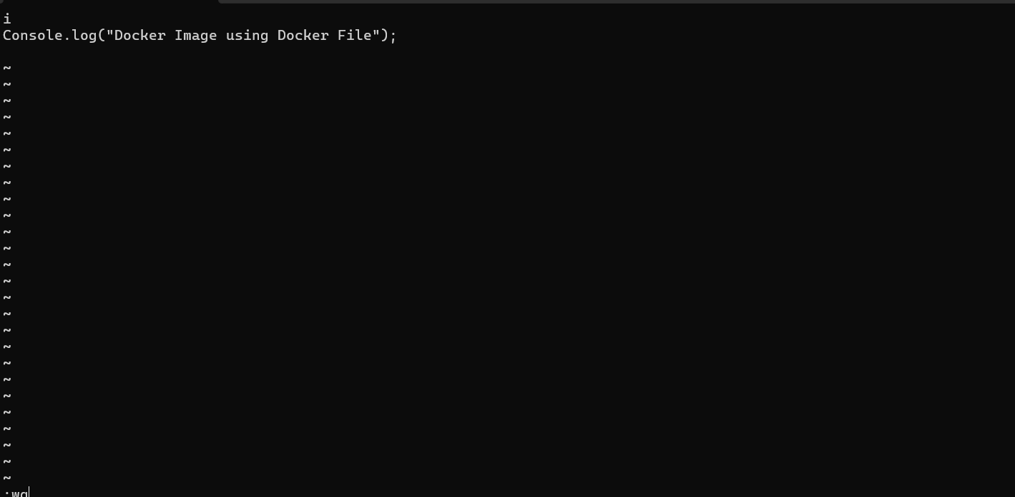

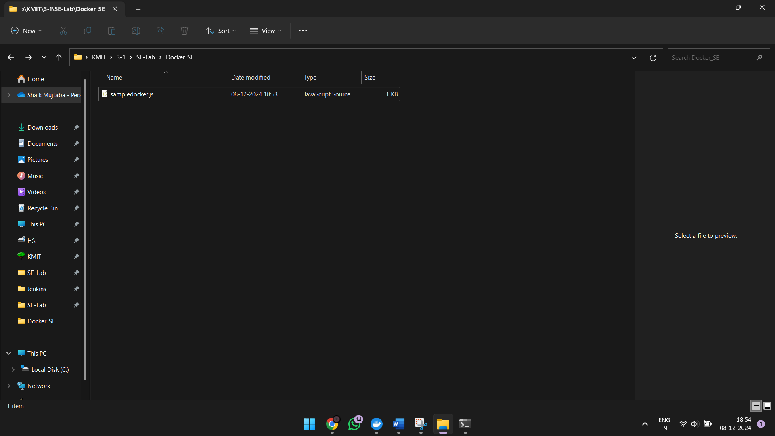

b)Creating Docker Image using Docker File
- Type the following commands
- Node app.js will execute app.js file in node
$ Vi dockerfile
#getting base image alpine
From node :alpine
WORKDIR / bhargavikumbham
COPY . /bhargavikumbham
CMD node app.js
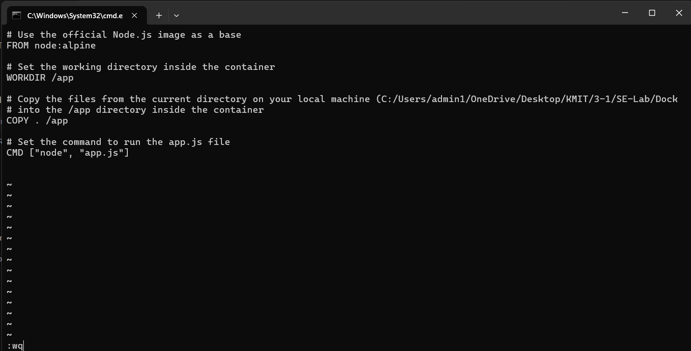
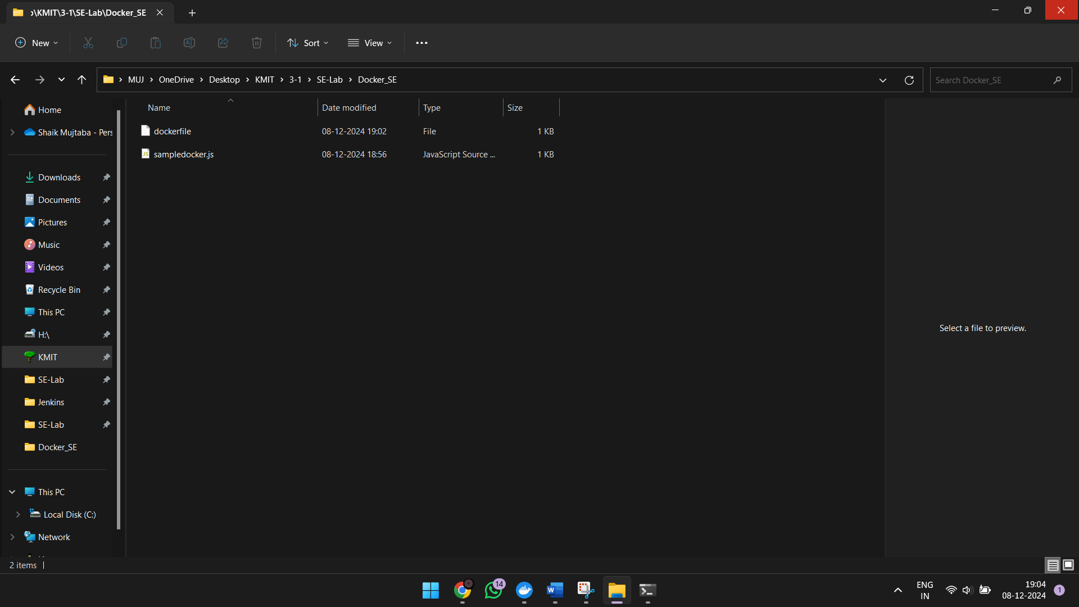
- Press Esc-> :wq-> to save and exit

$ docker build –t myimage
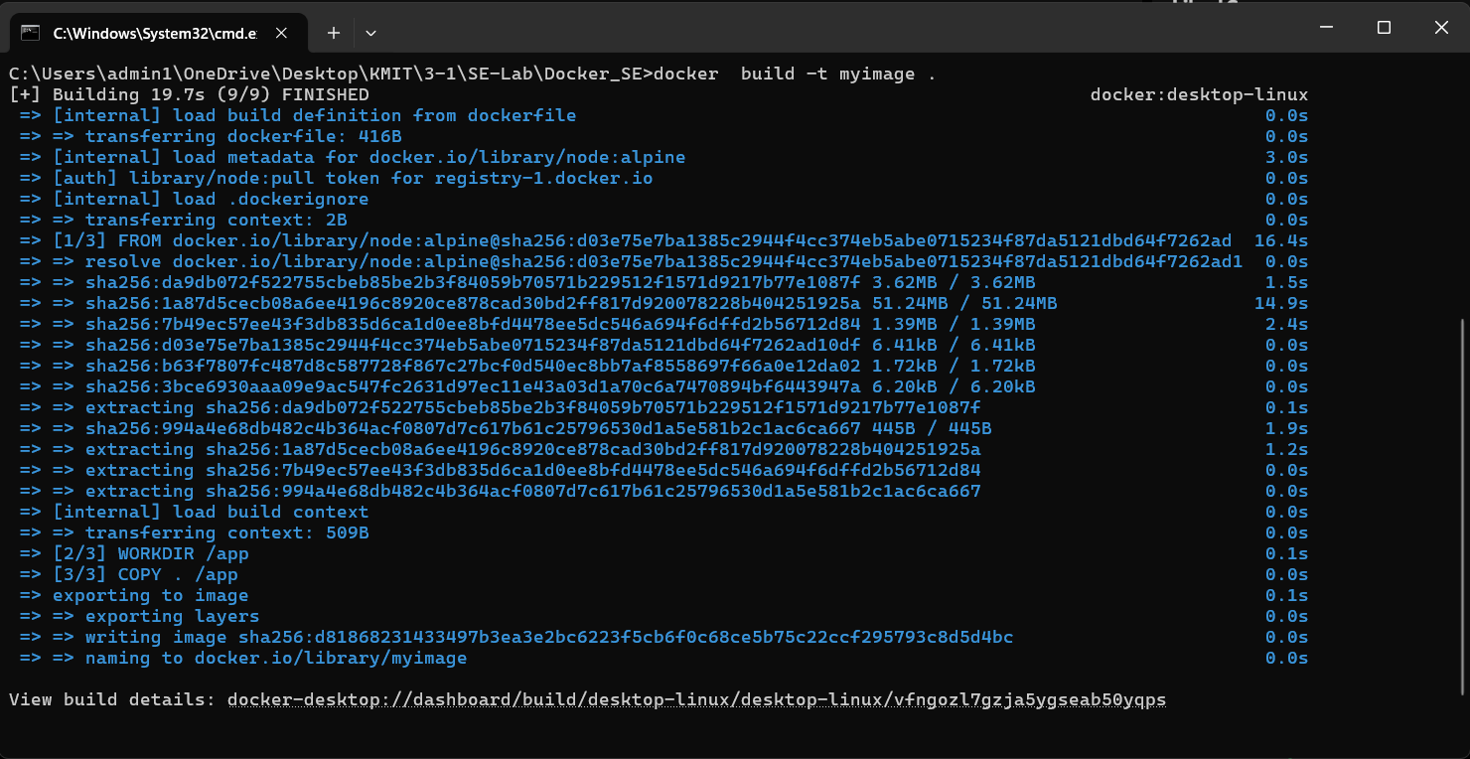

$ docker images
myimage will display here
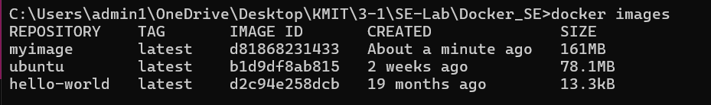
- Go to docker desktop-> local-> check myimage will exist-> click on run
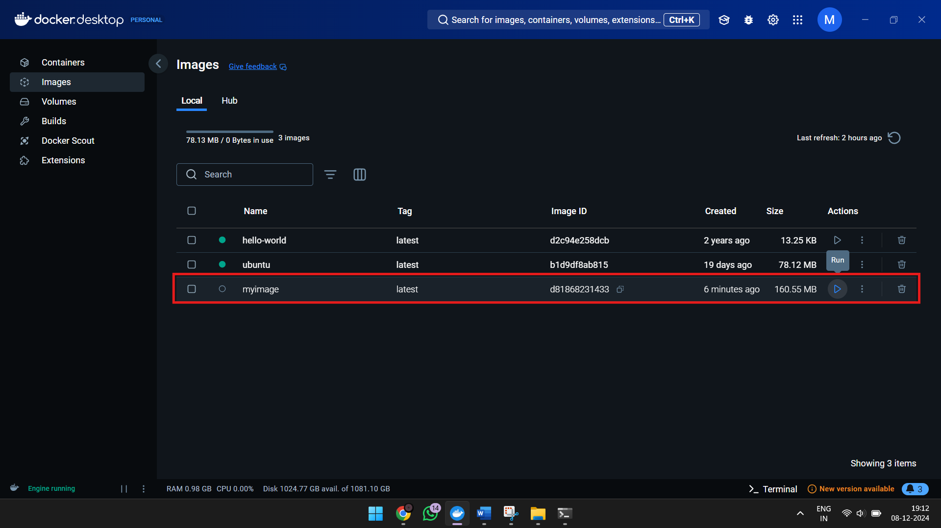

- Diplays the console output as “Docker Image using Docker File”
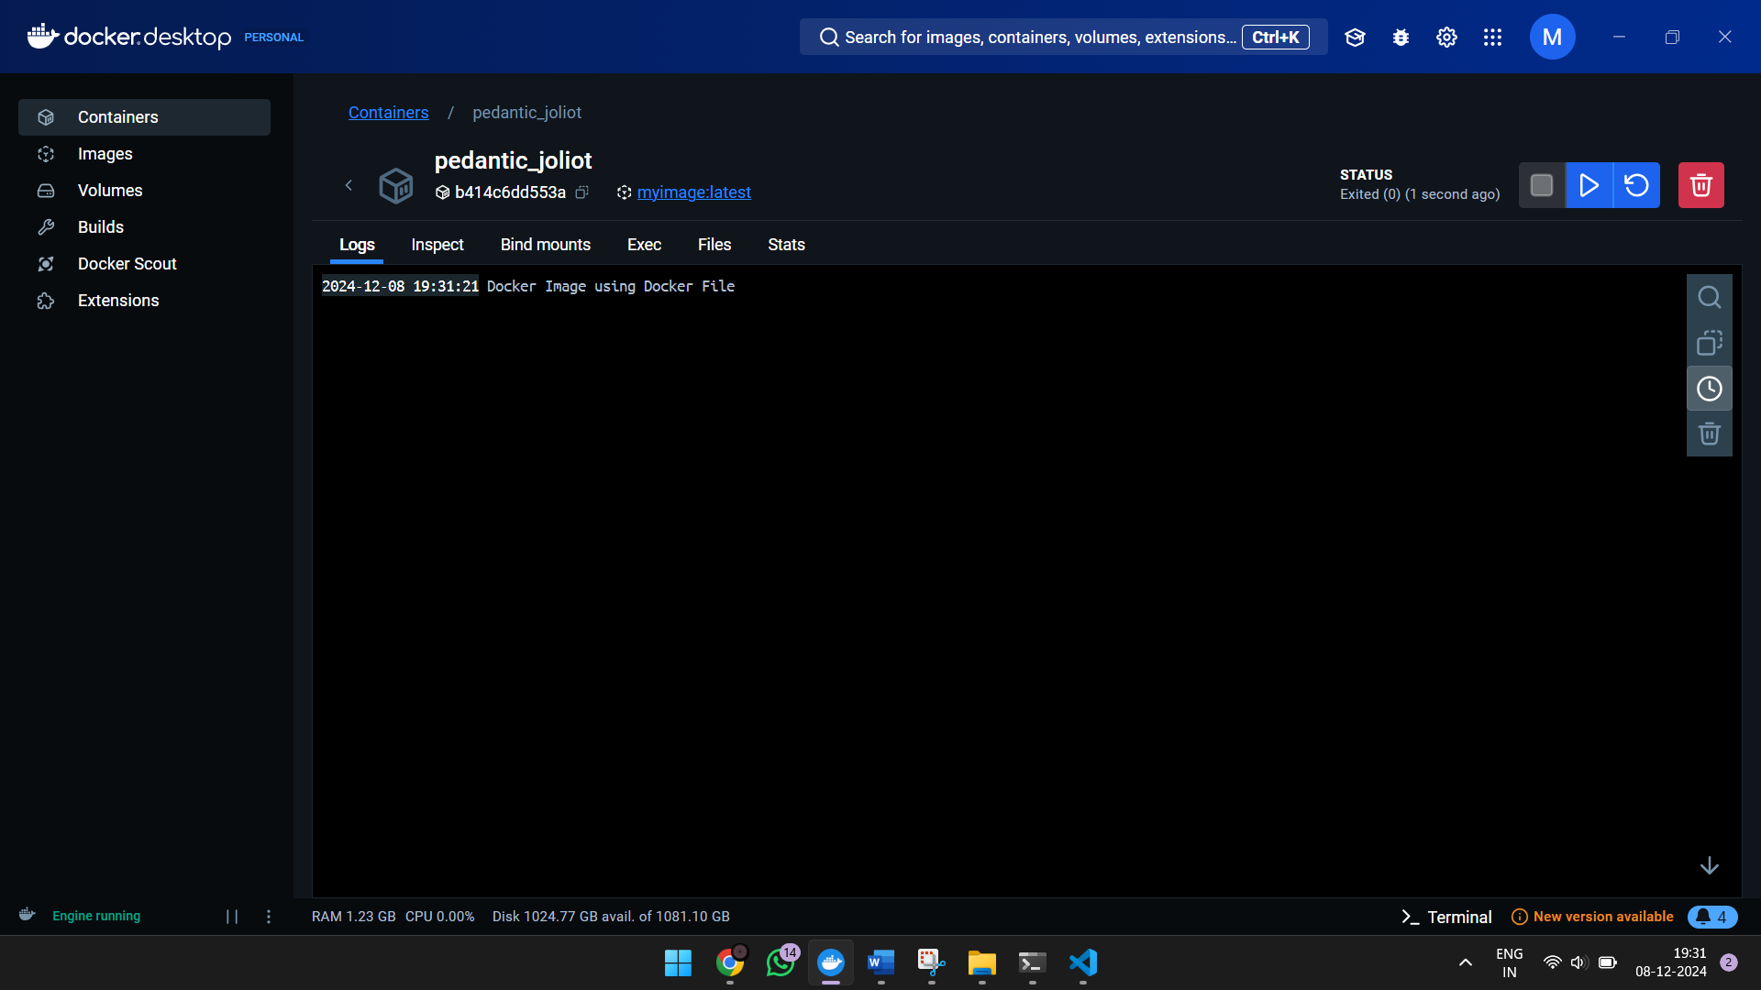
- $ docker tag myimage bhargavikumbham/myimage
- $ docker push bhargavikumbham/myimage
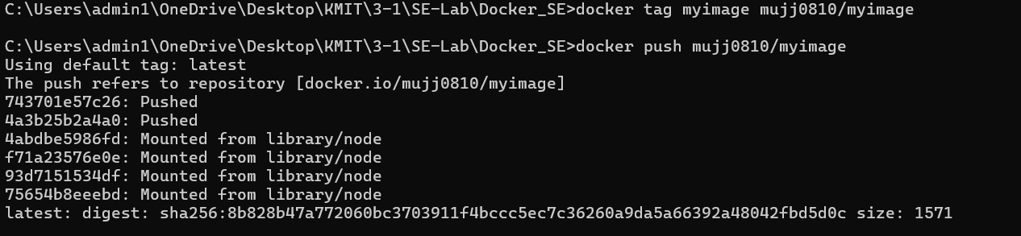
- Go to desktop docker and check under the specified directory myimage will display
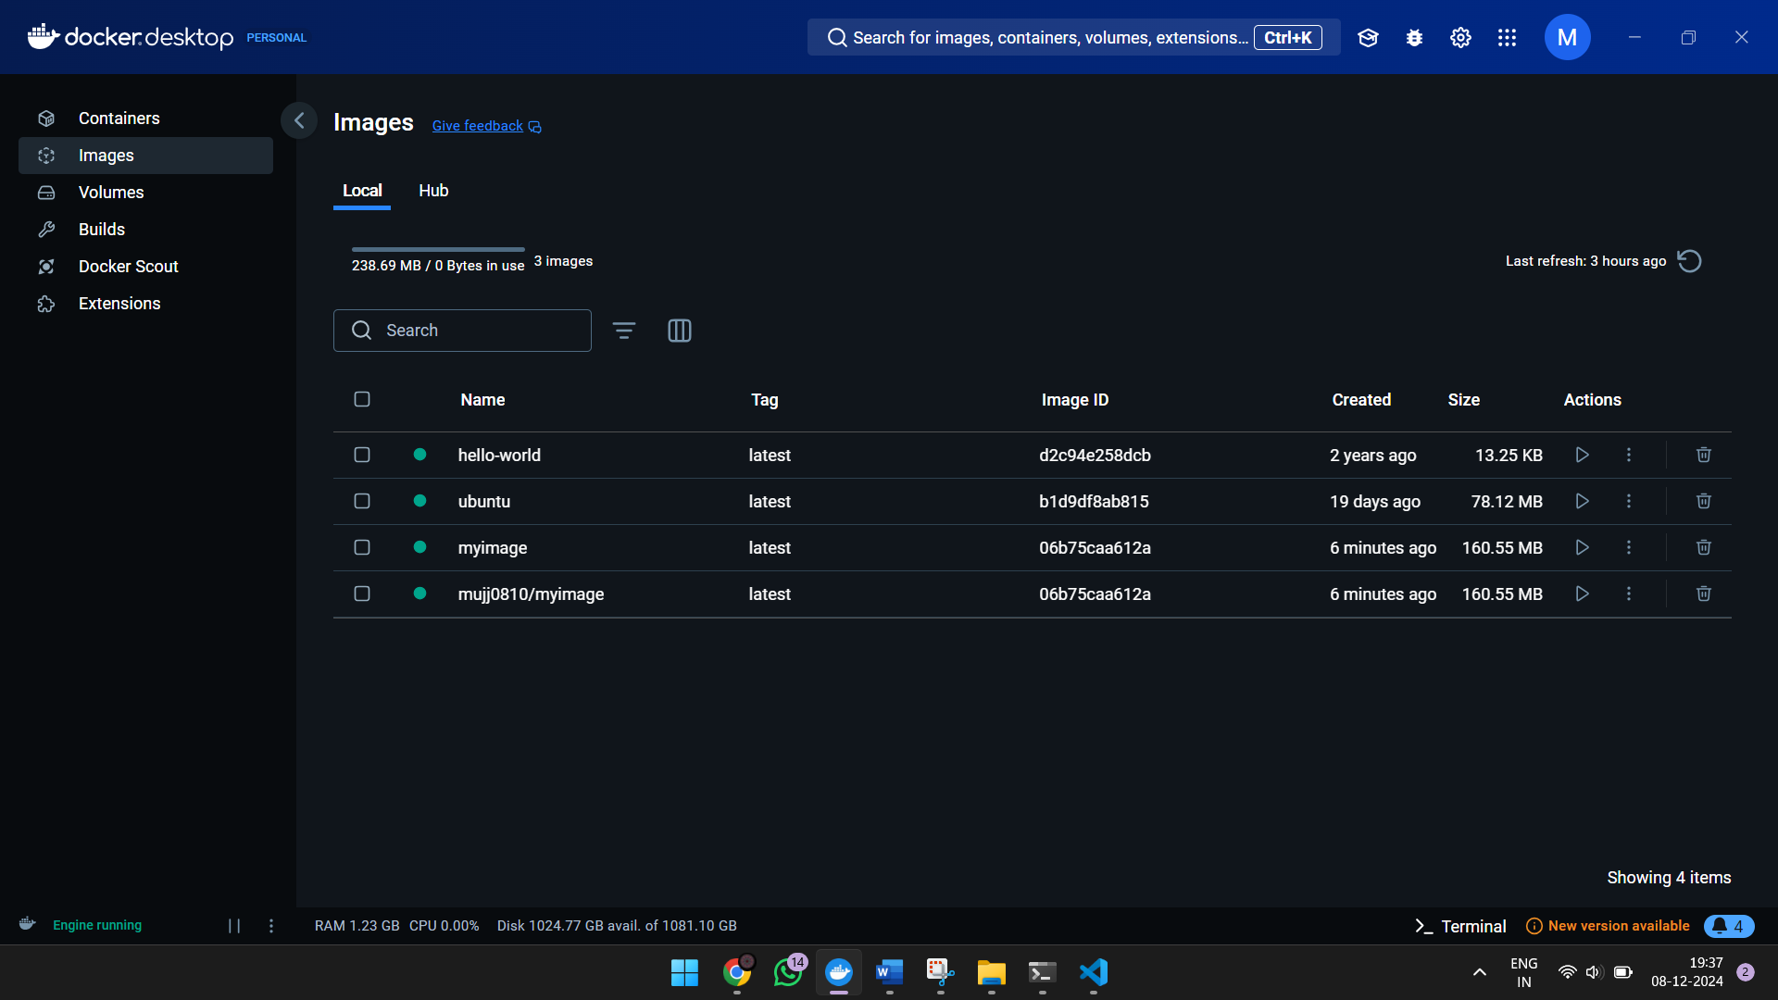
- $ docker logout

How to push images from local rep to docker hub rep

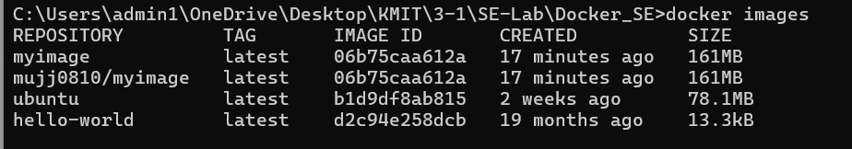
- How to push images from local rep to docker hub rep
Step1:create dockerhub account
Step2:login using dochub
- PS C:\Users > docker login
- Username:<< >> ( here give user name)
- Password:<< >> ( here give user password)
- Login Succeeded
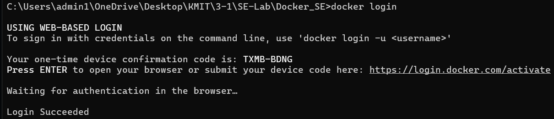
- To restart image
- $docker start containerID used to restart the container if it has stopped due to application crash or if error occurred
- Working with container in interactive mode
- docker container exec -it containerID
- Troubleshooting containers using logs $docker logs 505174ea315 Helps to see what’s going on in container
- Creating same image with different version in one application
- docker run redis:latest
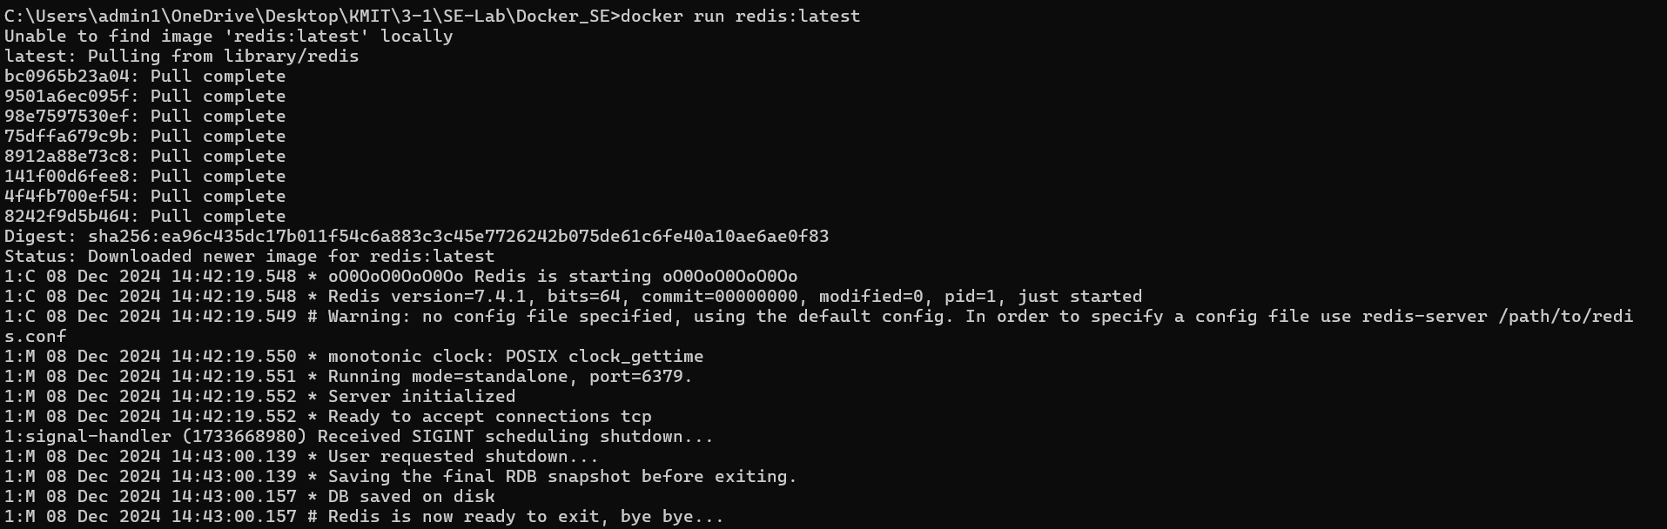
- docker run redis:5.0
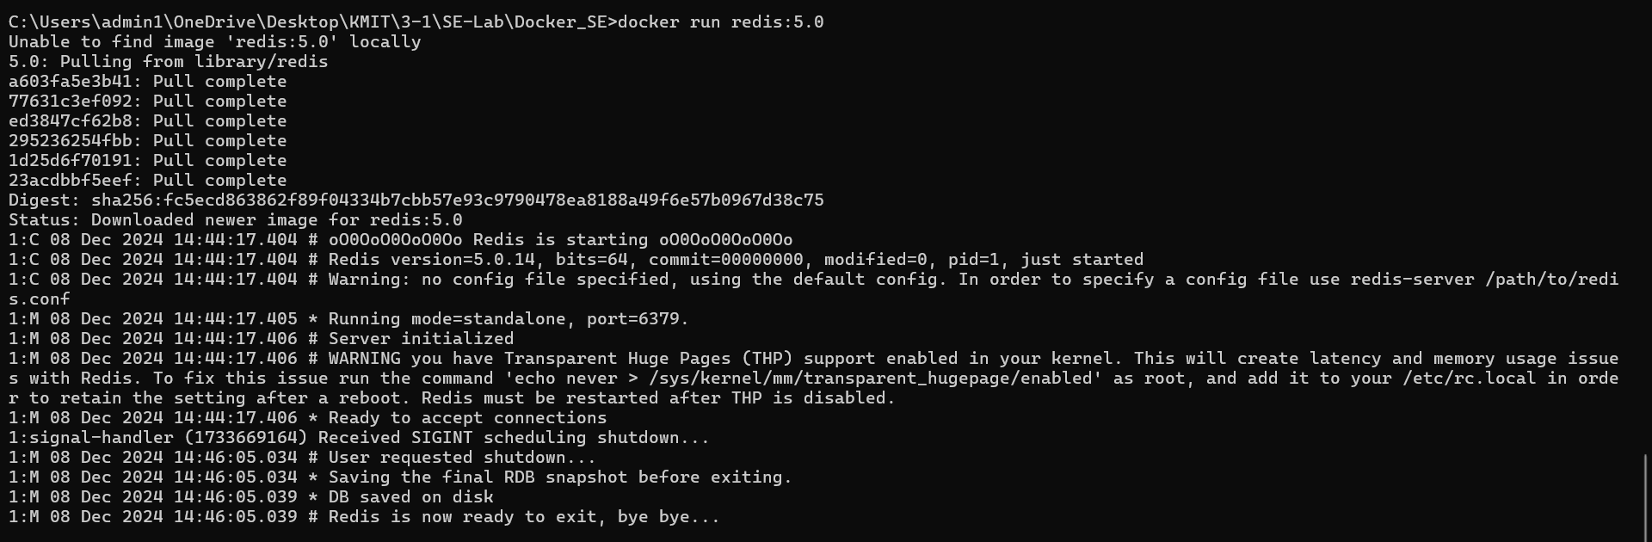
- Here two redis image
