Anomaly Detection in Crowds

Problem Statement
By utilizing a combination of statistical and machine learning techniques, we will build a model that can effectively distinguish between normal and anomalous behavior patterns in Smartphone usage. This model can be used for various purposes, such as detecting suspicious activities, identifying potential hazards, or even understanding crowd dynamics better.

Objective
The objective of this case study is to develop a model.

Data Parameters and Understanding
I have collected data from multiple sources, including IEEE Xplore, Kaggle, Acm digital library and publicly available datasets. The dataset comprises features related to Smartphone usage, such as accelerometer and application usage.
Dataset Description
- Features : the dataset contains various features, including timestamp, sensor readings, network-related metrics and labels indicating normal and anomalous behavior.
- Data types : Most features are numerical ( continuous or discrete).

Exploratory Data Analysis (EDA)
I have computed descriptive statistics for each feature.
Initial insights are Network traffic patterns vary across users and time.
Visualizations
- Box plot :
I visualized the distribution of readings, highlighted potential outliers.
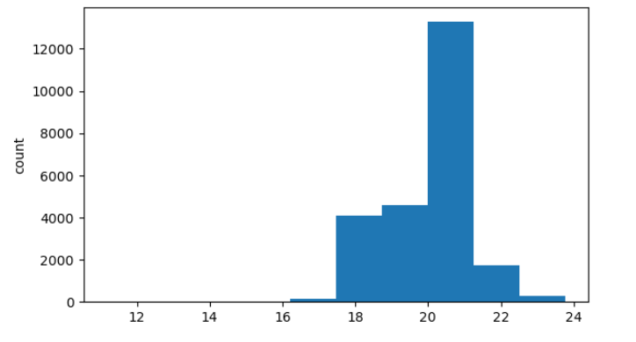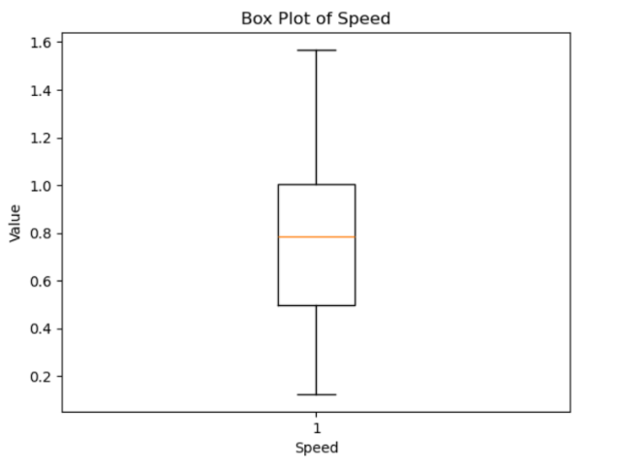

- Univariate Analysis (histograms)
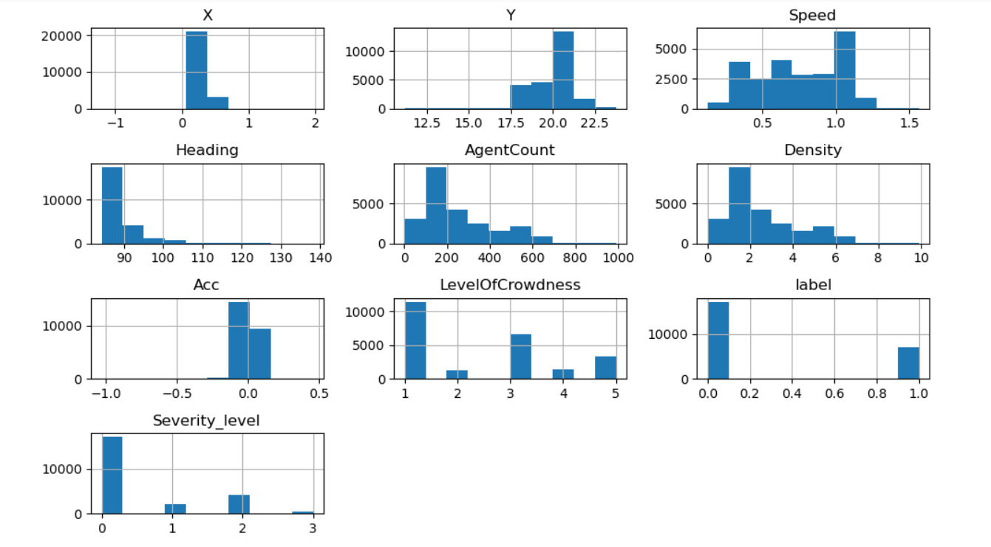

- Univariate Analysis (Boxplots)
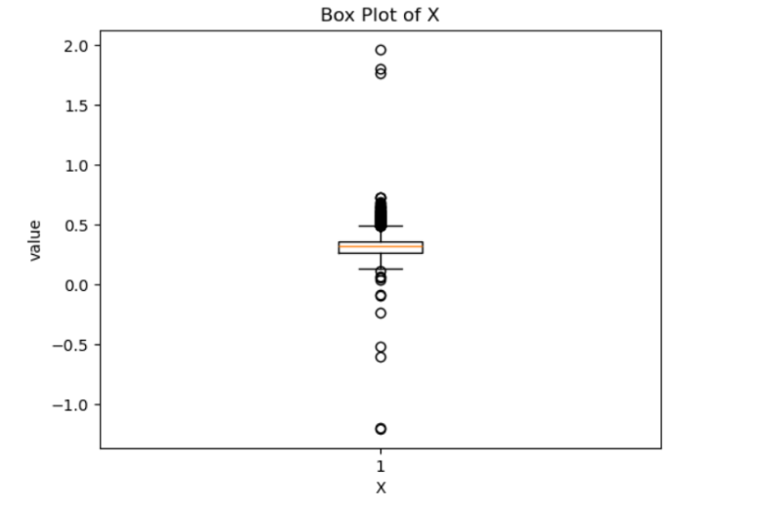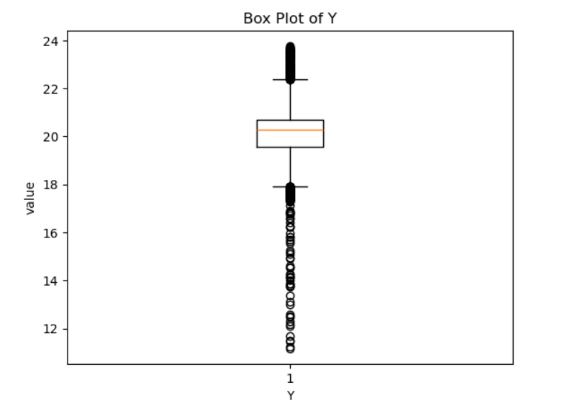
Bloxplot of x Boxplot of y

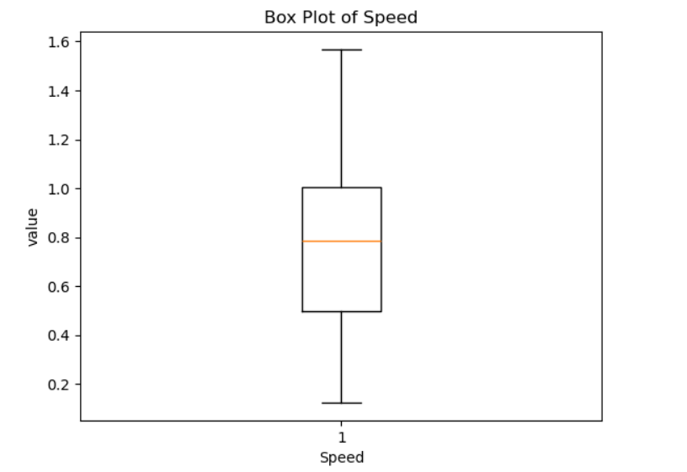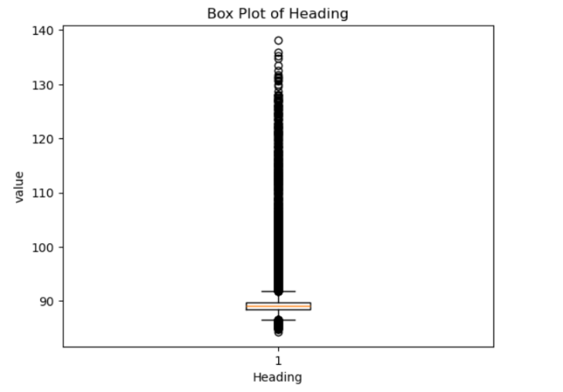
Boxplot of speed Boxplot of Heading

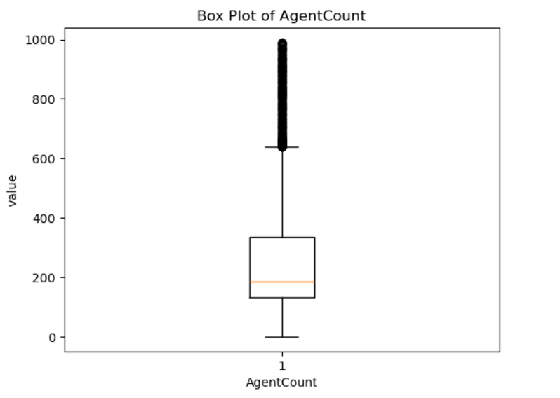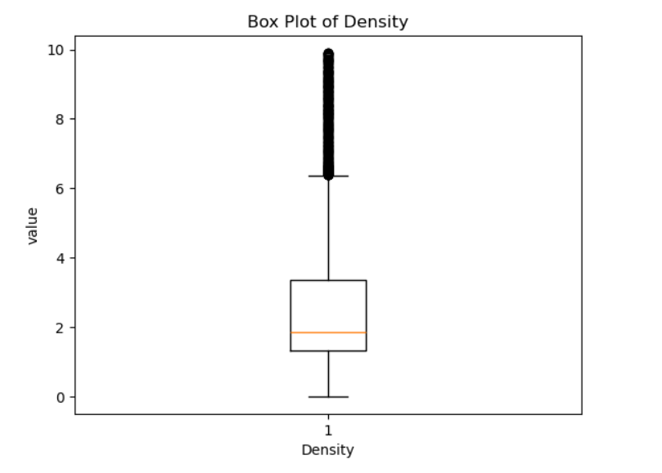
Boxplot of AgentCount Bloxplot of Density

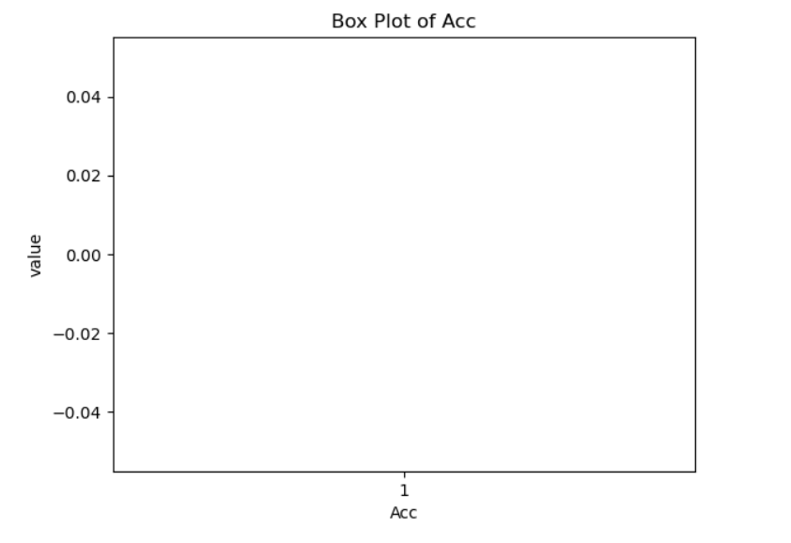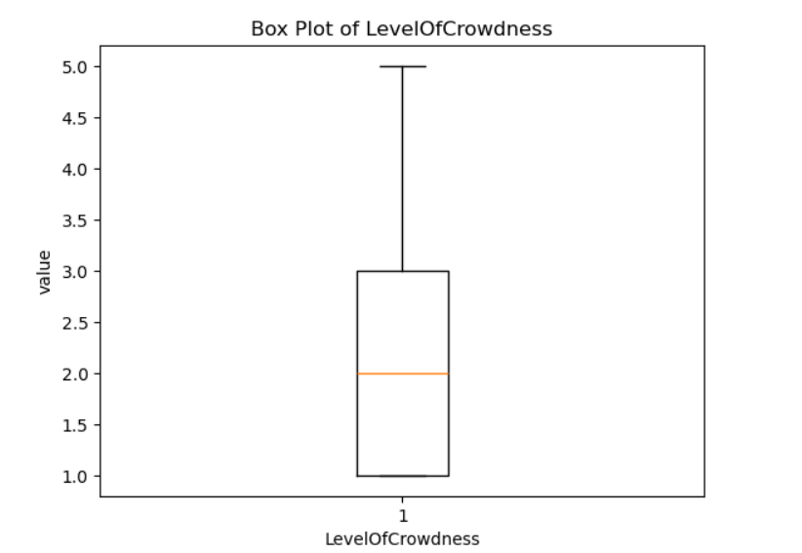
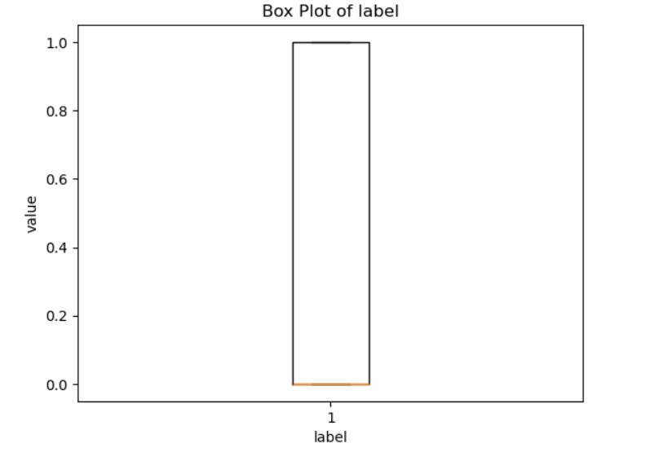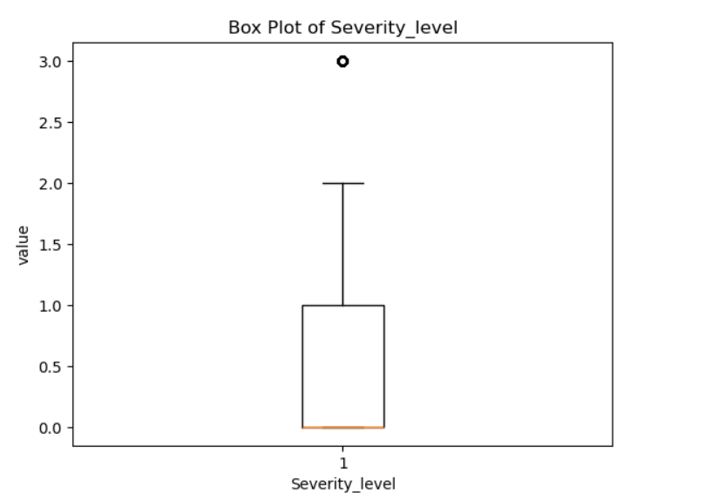
Boxplot of Label Boxplot of Severity level

- Bivariate Analysis(scatterplots)

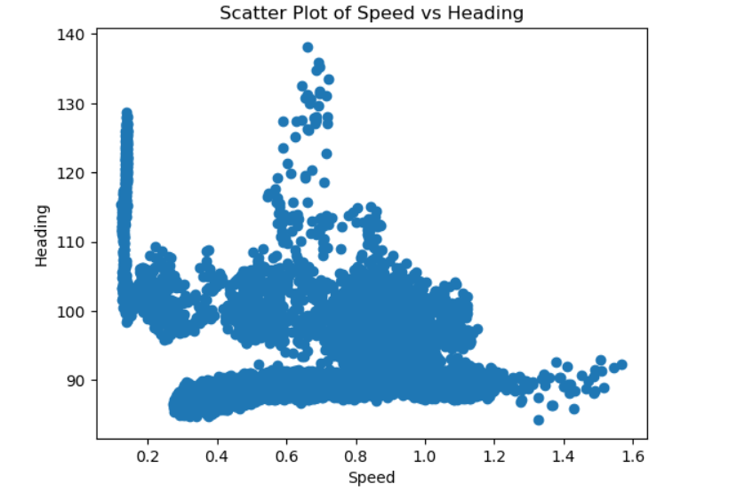
Data preprocessing
Handling missing values
We imputed missing values using mean or median.
No significant impact on overall dataset.
Outliers Treatment
Detected Outliers using box plots.
Decided to keep them for now, as they might represent genuine anomalies.
Feature Engineering
Derived network-related features.
In this we explored Smartphone using data, performed EDA, and prepared the dataset for modeling.
Candidate Anomaly Detection Algorithms
1.Cortical Learning Algorithms based on the Hierarchical Temporal Memory (CLA-based HTM)
Objective:
To implement a CLA-based HTM model for anomaly detection in time-series data from smartphone usage.
Model Implementation:
- Trained HTM model on preprocessed data.
- Evaluated model performance using standard metrics

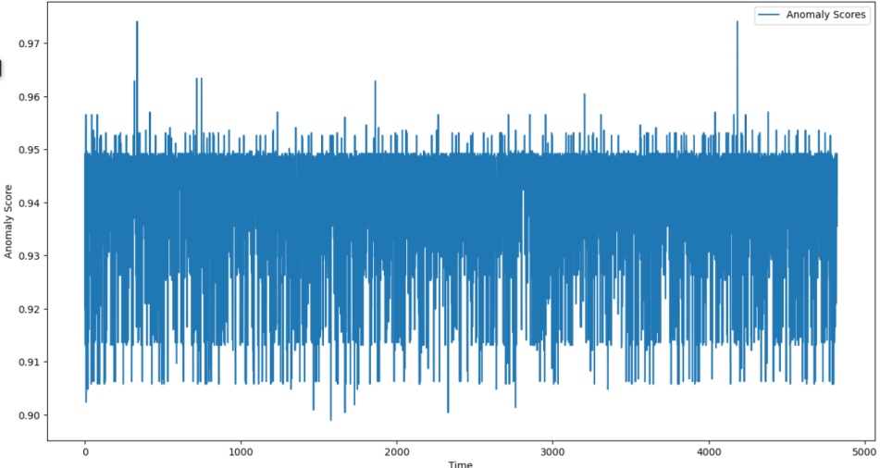

K-Nearest Neighbour (KNN)
Objective:
To implement a KNN model for detecting anomalous smartphone usage patterns.
Model Implementation:
- Applied KNN algorithm on the dataset.
- Tuned hyperparameters for optimal performance.
- Evaluated using appropriate metrics.
Output Analysis :
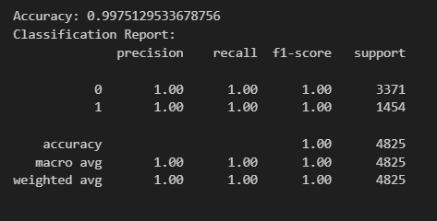

Local Outlier Probability (LoOP)
Objective:
To implement a LoOP model to identify anomalies in the smartphone usage dataset.
Model Implementation:
- Implemented LoOP algorithm.
- Assessed model performance with standard evaluation metric.
Output Analysis:
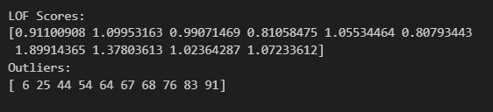
Influence Outlier (IO)
Objective:
To apply the IO algorithm to detect anomalies in smartphone usage data.
Model Implementation:
- Applied the IO algorithm.
- Evaluated the model using standard performance metrics.
Output Analysis:
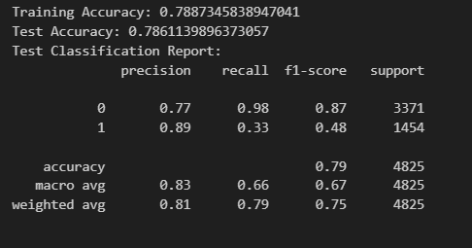
Summary and Analysis
I had implemented three different detection techniques (KNN, LOP, IO) to identify anomalous behavior pattern in a dataset.
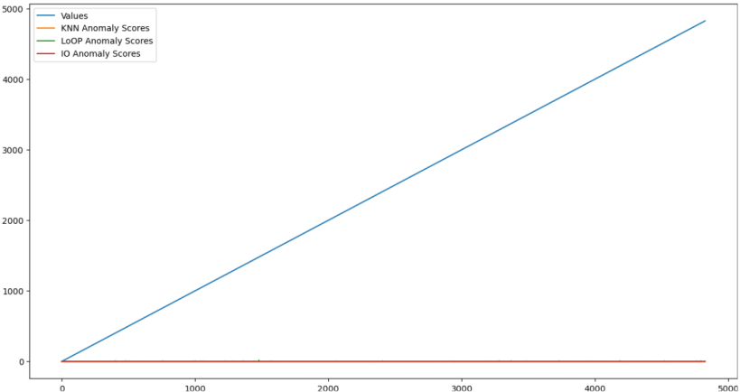
Reference link : https://github.com/Shaik-Sam/Smartphone-Dataset-for-Anomaly-Detection-in-Crowds.git

