Name: Sk. Seema Kousar

Project: Historical Places of India

Batch no: June batch

Github link: <https://github.com/Shaik-Seema-Kousar/Class_Project.git>

Output:

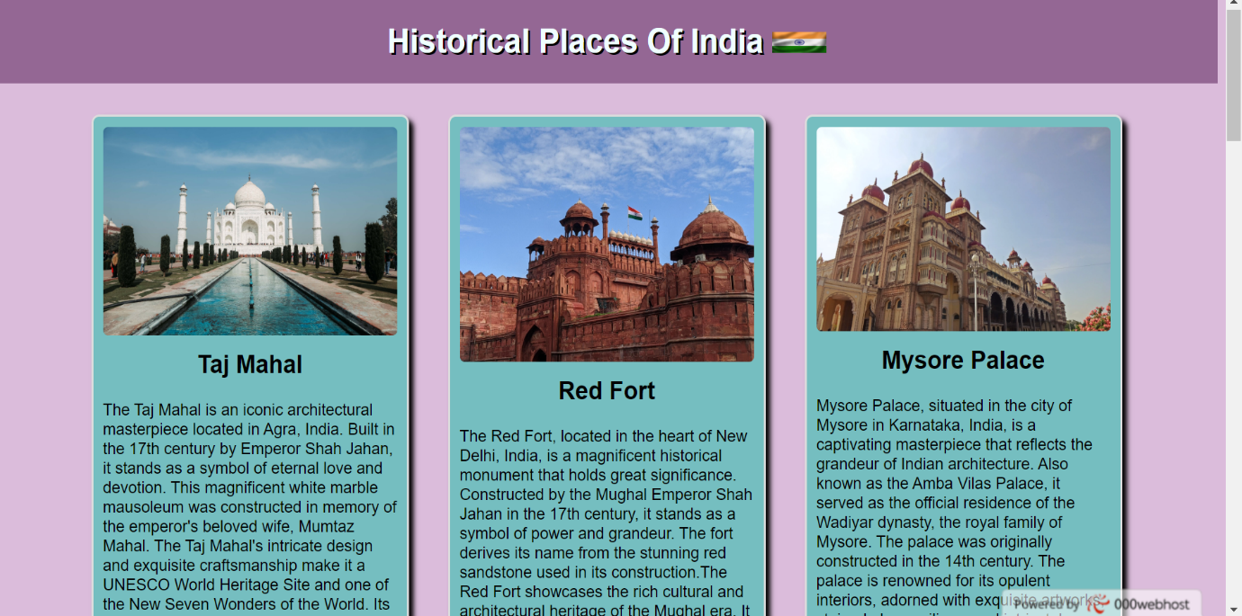

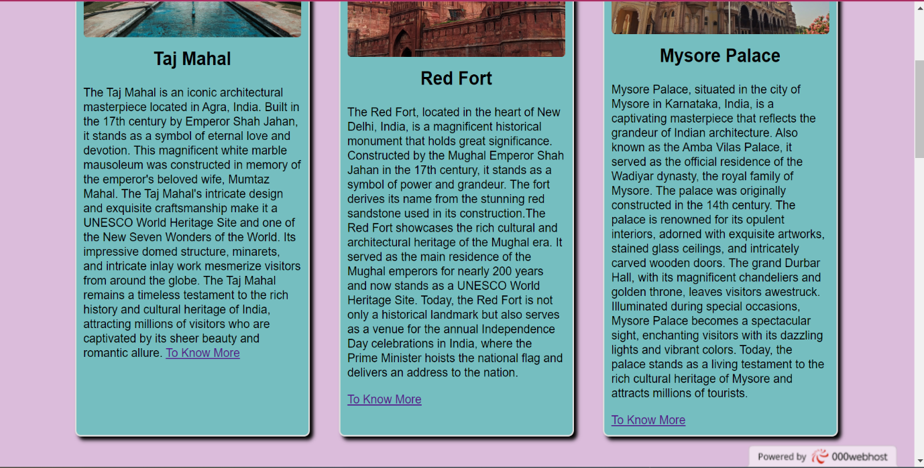

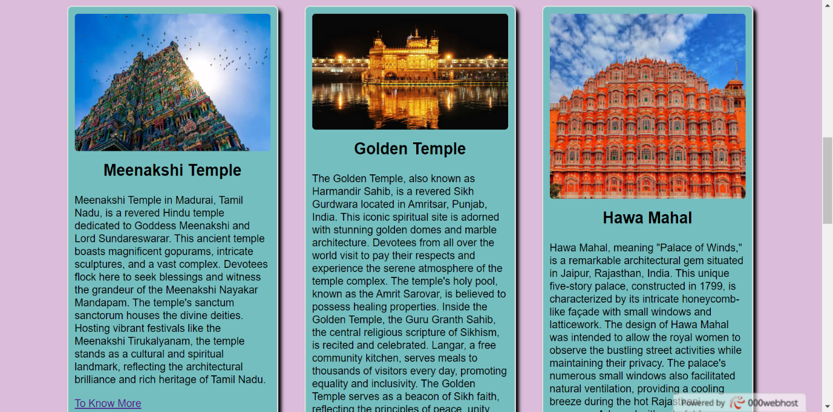

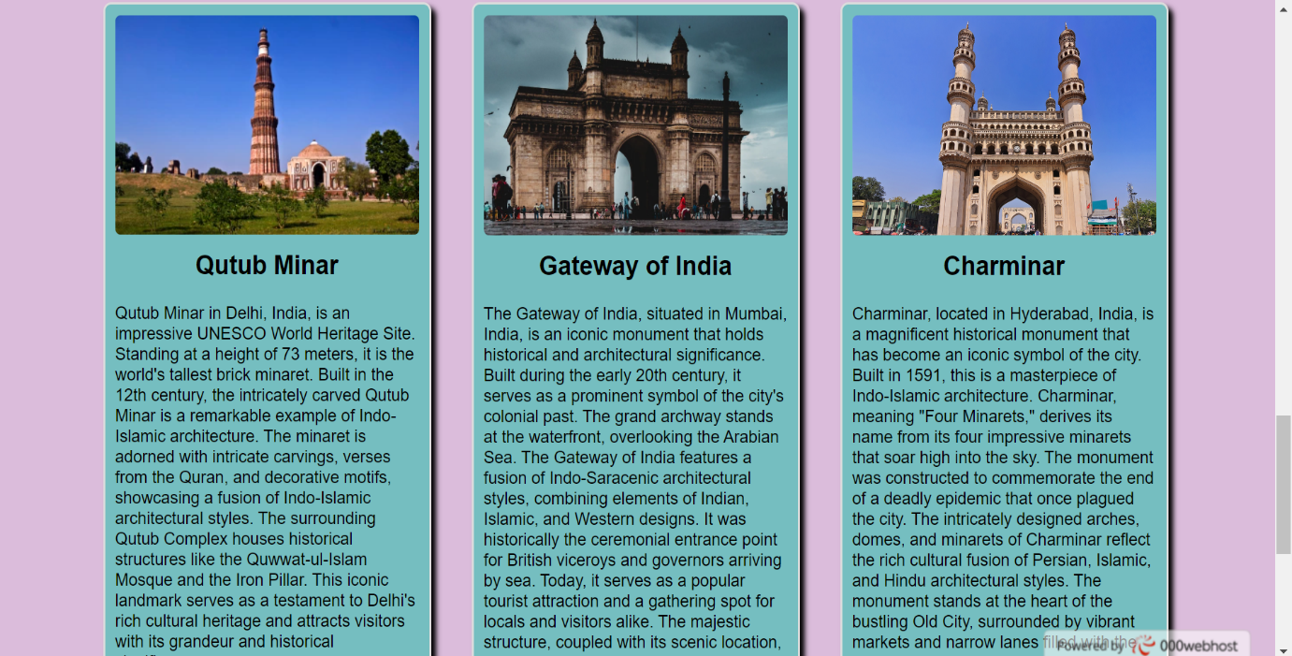

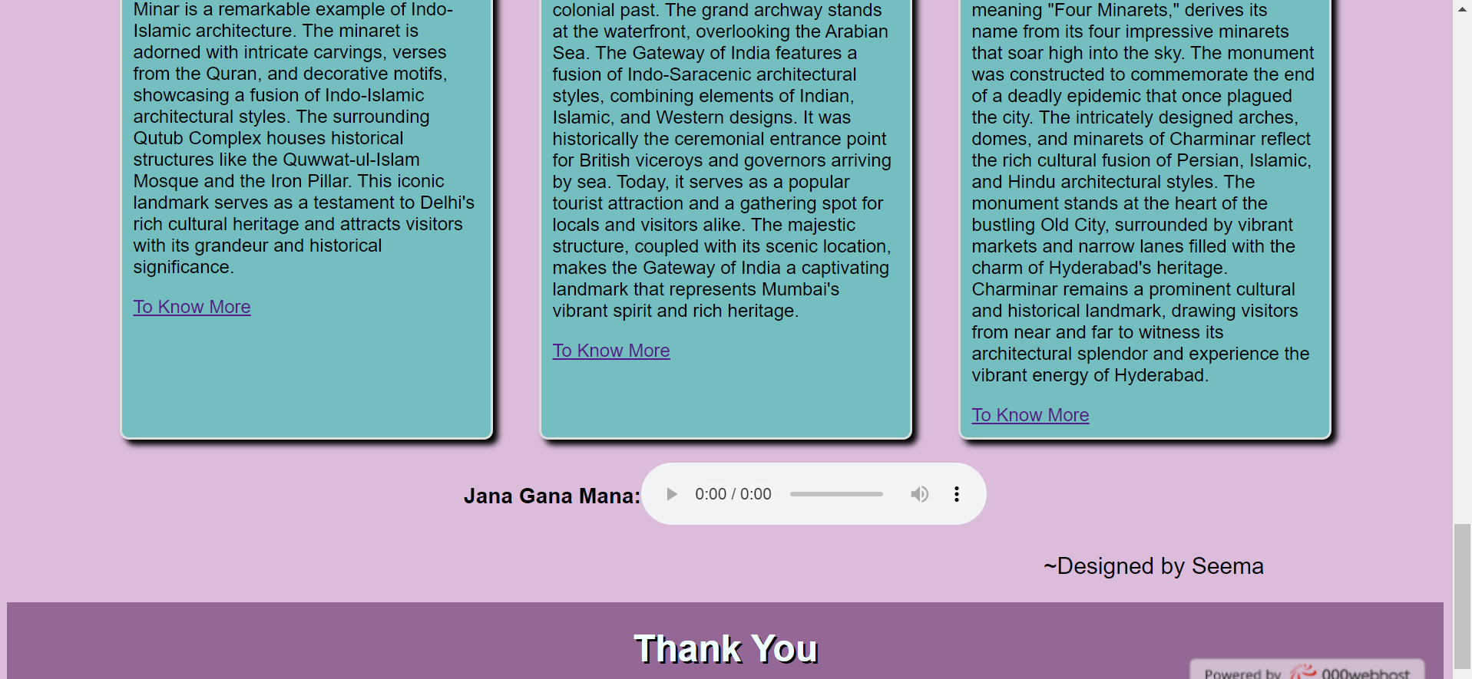

Webpage link: <https://shiyawasedaaa.000webhostapp.com/>