From Strategy to Dashboard: An End-to-End Business Intelligence Study
Organization: Monzo Bank
Author: Siddik Shaik

Table of Contents
Task 1: Strategy and Decision Types 4
Question (a) 4
Question (b) 4
Question (c) 4
Question (d) 4
Task 2: BI Architecture 5
Question (1) 5
Question (2) 6
Question (3) 6
Question (4) 6
Task 3: BI Metrics 7
Task 4: Value Proposition 7
Question (i) 7
Question (ii) 8
Question (iii) 9
Task 5: BI Strategy 10
Question (i) 10
Question (ii) 10
Task 6: Dashboard Design 11
Dashboard Design Proposal Essay 11
Dashboard Objectives and Audience 12
Key Metrics and Visual Design 12
Justification of Design Choices 13
Conclusion 13
Deliverables 14
References 15

Task 1: Strategy and Decision Types

Question (a): What’s Morrison’s strategy?
The strategy of Morrisons is to enhance the digital reach and access by means of strategic partnerships. Through teaming up with Amazon, Morrisons will aim at increasing customer convenience, increasing service quality and competitive advantage in the grocery store market. The plan utilizes its differentiated value proposition of fresh, high-quality, hand-prepared food out of Market Street as the means of attracting both new and long-term customers. It also contributes to growth through the incorporation of e-commerce and the use of conventional food stores, hence addressing the shifting consumer trends especially, the growing requirement of online grocery shopping and delivery (Morrisons, 2020).

Question (b): What strategic decision did it make with Amazon? Consider Structured and Unstructured

decision types
Morrisons took the strategic move of collaborating with Amazon to enable it to have same-day delivery of the grocery through Amazon platform. This unplanned judgment boasted of long-term consequences and ambiguity, market growth and digitalization. Nevertheless, certain aspects of the implementation were organized, including logistics merging, price harmonization, and geographical expansion beginning with Leeds (Morrisons, 2020). This ambivalent business step will expand the visibility, take advantage of the technology and delivery capabilities of Amazon, and will put Morrisons in a better position to contend in the online grocery market, particularly in the aftermath of the pandemic e-commerce boom.

Question (c): What tactical decisions did Morrison make as a company to achieve the goals and

objectives set by its strategy? Consider Structured and Unstructured decision type
Morrisons has made a number of tactical choices to favor the partnership with Amazon. Organized choices were made on the scope of products (e.g., Market Street and The Best range), how to set prices in line with in-store discounts, and to organize delivery schedules with Amazon Flex (Morrisons, 2020). Unstructured aspects entailed predicting demand, modifying the offers to suit the regional tastes, and rearranging the operations in stores to accept online orders. Such operational decisions were needed to keep customers satisfied, operational efficiency and delivery on the promise of delivering fast and fresh groceries responsive to the Morrisons value-based approach to their market.

Question (d): What day-to-day operational decisions needed to be made to operate this partnership?

Consider Structured and Unstructured decision type
Structured decisions included order picking decisions by Morrisons employees, slotting of a delivery timetable, and inventory management. These were needed so that the fulfillment and stock accuracy was done in time. Unstructured decisions involved decision making problems with regard to deliveries, customer service, and changing fluctuations in demand on the fly. Operation employees had to cooperate with Amazon flex courier service, include in-store logistics and assure the quality of products to online customers. These moves allowed moving on with the collaboration without interruption and keeping Morrisons brand promise of freshness and convenience (Morrisons, 2020).

Task 2: BI Architecture

Question (1): Propose/Identify/Develop an adequate diagram that illustrates the existing BI

Architecture of your organization.
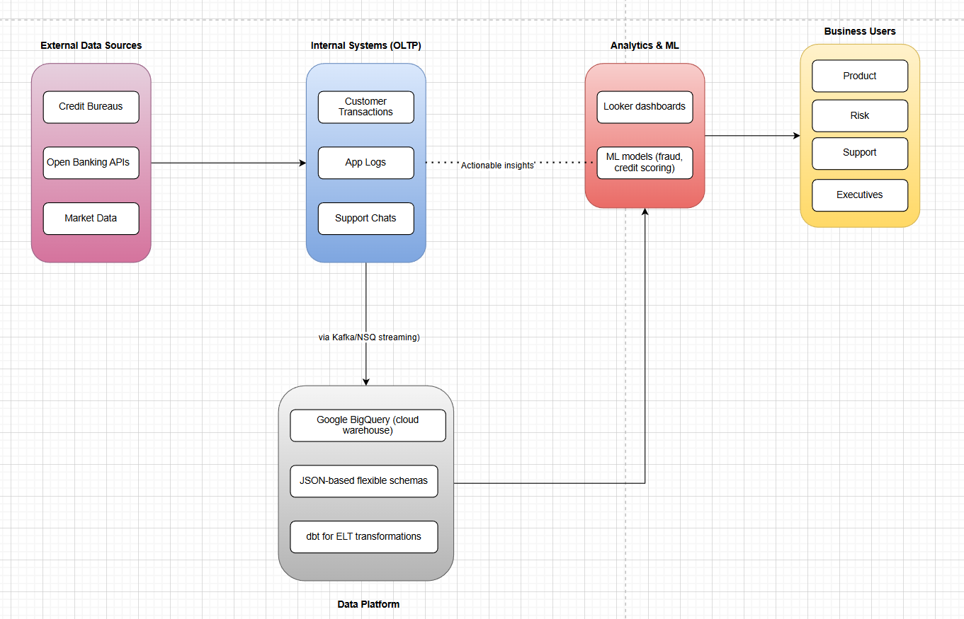
Figure 1: Monzo Bank: Business Intelligence Architecture Overview
(Developed in Draw.io)
The diagram titled “Monzo Bank – Business Intelligence Architecture Overview” showcases a modular, real-time BI architecture tailored for digital banking. It has external data feeds and integration with Market Data, Open Banking APIs, and Credit Bureaus, and integrates with internal OLTP system records of Customer Transactions, App Logs, and Support Chats. They are consumed via Kafka/NSQ to Google Big Query, a fitted data warehouse on cloud with JSON-based adaptable schemas and dbt to establish logic of transformation. Thereupon, Looker dashboard and ML models (e.g., fraud detection, credit scoring) provide data to business people in Product, Risk, Support, and Executive teams.

Question (2): Indicate/explain the Data sources (internal and external data)? Think of the existing

management support systems (OLTP
Monzo’s BI ecosystem integrates both internal and external data sources to support robust, near-real-time analysis.
- Internal data includes:
  - Customer Transactions from its banking platform.
  - App Logs, providing insights into feature usage and performance.
  - Support Chats, which are mined for service quality and customer sentiment.
- External data includes:
  - Credit Bureaus for financial health and risk assessment.
  - Open Banking APIs to retrieve transaction data across other institutions.
  - Market Data for macroeconomic indicators and financial benchmarking.

Question (3): Will your organization consider unstructured data as a data source? – Why, explain?
Yes, Monzo considers unstructured data a valuable asset in its BI framework.
- Support chats, which are analyzed using NLP to extract insights on customer pain points.
- App reviews and social media comments, which offer sentiment analysis and product feedback.
- Open-ended survey responses, which provide rich contextual data.
The unstructured data is beneficial in improving customer insights, facilitating preventive services, and inputting in real-time insights via machine learning models (e.g., churn prediction or fraud alerts). With unstructured data being a digital-first bank, this allows Monzo to be an agile and customer-oriented bank in terms of making decisions.

Question (4): Justify your choices made in the BI Architecture design – based on business needs and

trends in industry (e.g., Cloud computing, data Lakehouses, agility – refer to the

reading on the Six shifts to create a game-changing data architecture
The BI architecture at Monzo is consistent with McKinsey Six Shifts of modern data infrastructure through a cloud-native design implementation based on Google Big Query to scale and perform. Instant data ingestion applications Kafka/NSQ real-time tools enable instant data ingestion in critical applications like in fraud detection. The schemas which are flexible and are based on JSON enable agile data processing, such as unstructured inputs. The decoupled design is easily scalable and can be developed fast, and accessed at a business domain scale. Transparency and self-service analytics are supported by such APIs and ELT tools as dbt and Looker. Such an arrangement correlates with the vision of Monzo to become fast, compliance, personalized, and innovative in a competitive digital banking environment (Castro et al. 2020).

Task 3: BI Metrics
Amazon will need to use business intelligence (BI) metrics to facilitate data-driven decision-making when it comes to making a big acquisition such as Morrisons. These metrics are under three critical categories, including Profitability, Revenue, and Risk. As Benson (2021) and Brahm et al. (2018) support, the following analysis explains how the strategic decisions of Amazon can be informed by each of the types of metrics.
Profitability Metrics
One of the key issues of profitability arises in the methods Amazon will analyze Morrisons. The COVID-19 pandemic impacted Morrisons sales positively, but it also reduced its profits because of the upsurge in the cost of operations including logistics and safety precautions (Benson, 2021). It suggests that the gross profit margin, EBITDA, and the operating margin are very vital indicators to study the financial standing of the company in the long-run. The report by the Bain and Company (Brahm et al., 2018) recommends that Amazon also use profitability by customer segment, product category, and location. This granularity shows what aspects of the business are the most value creating and may be used to understand that cost efficiencies or cost synergies are possible after acquisition. An example is to reform segments in low margin or high turnover and scale high margin segments.
Revenue Metrics
Amazon should also assess the performance of the top line, based on revenue growth rate, like-to-like sales and average transaction value of the Morrisons stores and online outlets. Although revenue is not the only measure of success, it is the indicator of the market interest and price performance. Another metric that Amazon should take into account is customer lifetime value (CLTV) and customer acquisition cost (CAC). Such measures can play a key role in networking the costs of acquiring a new customer and the value which they can offer in the long run, which is essential to align these measures with data-driven approaches to customers at Amazon. Moreover, the acquisition of Morrisons by Amazon should consider the potential of omnichannel revenue, such as how the physical outlets would facilitate the delivery and collection network of Amazon. Any possible cross-selling or larger basket sizes (particularly through Amazon Fresh or Prime Now) has to also be included in the revenue estimates as well.
Risk Metrics
Risk is a significant concern, and Amazon must conduct a rigorous due diligence process to uncover potential threats. Key risk metrics include:
- Operational risk: Store-level variability, labor relations (especially in light of ongoing warehouse-related scrutiny), and supplier dependency all need to be measured and tracked.
- Integration risk: The cultural and technological alignment between Morrisons and Amazon’s digital ecosystem must be evaluated. Compatibility in systems and leadership style can significantly affect the success of the merger.
- Reputational risk: Media concerns about labor conditions may be amplified if Morrisons’ brand is linked too closely to Amazon’s public image. Metrics like Net Promoter Score (NPS) and employee satisfaction are useful indicators of brand health and customer loyalty.
- Supply chain risk: Amazon should also examine inventory turnover, stockout rates, and delivery accuracy to ensure reliability an area Bain also flags as key to managing operational performance (Brahm et al., 2018).

Task 4: Value Proposition

Question (i): Identify (with examples) the value proposition/s of Alpen Hotel.
Alpen Hotel Grooming aims to position itself as a premium hospitality brand in Singapore, offering exceptional guest experiences. Its core value propositions include:
- Personalised Guest Services
- High-Quality Facilities and Amenities
- Strong Brand Reputation in the Luxury Market
Example: To provide the individual experience, Alpen will also utilise historical stay information to provide personal room environments, including past preferred room temperature, type of pillows to use or minibar options. As an example, when a regular guest had ordered gluten-free breakfast and late check-out options in the past, the preferences would be automatically recorded and ready to be drawn up when the guest comes. Nevertheless, data analytics practices at Alpen are not yet fully implemented because of the issue of privacy and insufficient data knowledge within the company (Wee et al., 2019).

Question (ii): Propose BI/D&A approaches based on the value propositions identified for

Alpen Hotel.
To align with its customer-centric approach, Alpen Hotel should implement the following Business Intelligence and Data & Analytics (BI/D&A) strategies:
- CRM-Focused Analytics: Use a Customer Relationship Management (CRM) system integrated with analytics to understand booking behaviour, preferences, and feedback.
  - Example: If a guest books spa services frequently, offer targeted discounts or early booking access to spa packages via email.
- Data Integration Across Departments: Create a central data warehouse that consolidates guest information from front desk, housekeeping, dining, and marketing departments.
  - Example: If a guest checks in early, the housekeeping team is alerted via a dashboard to prioritise room preparation, ensuring a seamless experience.
- Real-Time Dashboards: Provide operational staff with live dashboards that show guest check-ins, room service usage, and special requests.
  - Example: A concierge can see real-time data indicating a guest’s birthday and arrange for a surprise welcome gift.
- Customer Segmentation: Apply clustering algorithms to segment customers based on value, preferences, and behaviour.
  - Example: Segment high-value corporate travellers and tailor loyalty perks such as free meeting room hours or executive lounge access.

Question (iii): Identify and provide examples of any three (3) types (descriptive, diagnostic,

predictive, prescriptive) of analytics that Alpen Hotel could apply to its

business problem
- Descriptive Analytics: Analyses historical data to summarise trends and patterns.
  - Example: Alpen can assess past occupancy rates during festive periods like Chinese New Year to prepare marketing campaigns and staffing plans accordingly.
- Predictive Analytics: Uses historical data to forecast future behaviour.
  - Example: By analysing booking patterns, Alpen can predict which guests are likely to return and send personalised rebooking offers a week after checkout.
- Prescriptive Analytics: Recommends actions based on predictions and constraints.
  - Example: An AI-driven pricing tool could suggest increasing weekend room rates by 15% during Formula One race weekend, optimising RevPAR while maintaining occupancy.

Task 5: BI Strategy

Question (i): Brocchi, C., Brown, B., Machado, J. & Neiman, M. (2016). Using Agile to

Accelerate your Data Transformation. McKinsey & Company
Implementing a successful Business Intelligence (BI) strategy requires attention to several key factors:
- Business-Driven Approach: BI strategy should be in line with the definite business purposes. The values of use cases should be ranked, and data requirements aligned to it. This is to ensure that the BI projects produce tangible measures rather than technical success (Brocchi et al. 2016).
- Agile Development: By implementing agile concepts to BI, it is possible to deliver value faster because of the iterative development, MVPs (Minimum Viable Products), and continuous feedback. This also promotes innovation with risk management.
- Cross-Functional Teams: The success of BI depends on the co-operation of IT and business units. To reduce this gap and guarantee the collective ownership of data results, Agile scrum teams consisting of data scientists, engineers, and business users are helpful (Brocchi et al. 2016).
- Modern Data Architecture: Scalability, agility and cost-effectiveness is facilitated by cloud-native data platforms (e.g., data lakes or lake houses). They should be able to support the structured and unstructured data and enable real-time analytics (Brocchi et al. 2016).
- Governance and Metrics: Good data controls, versioning and KPIs are essential. Agile sprints should be integrated with performance tracking as they are considered to be aligned with the business needs and have an incremental nature (Brocchi et al. 2016).
- Fail-Fast Culture: A data-driven organization should foster experimentation, tolerate failure, and learn from it. Rewarding “intelligent failure” helps reduce fear and supports innovation.

Question (ii)
Shell offers a real-world example of how these factors translate into large-scale success:
- Business Alignment & Use Cases: The analytics process of Shell started with clear-cut business issues. One of such projects has been a successful early project to predict the optimum stock levels and the reorder point of the spare parts. The team provided assurance of value delivery through the identification of the user, business process they had an influence on and financial result. This was a clear delineation of alignment that was key to the stakeholder buy-in (Databricks, 2021).
- Agile & MVPs: Shell emphasizes “failing fast,” scale solutions by quickly testing solution values by using MVPs. Dan Jeavons, the VP of Digital Innovation, emphasizes that Shell manages to focus on experimentation to learn early and not to over-engineer a solution that has not been tested (Databricks, 2021).
- Cross-Functional Teams: Shell formed agility-based teams based on a common cause. Data labs consisted of data artists, engineers, and business leaders. These groups enjoyed decision-making authority and were given the power to resolve domain-related issues (Databricks, 2021).
- Data Architecture & Cloud Platforms: Shell was an early adopter of cloud. Shell brings together time-based data from different locations into one cloud system, built using Delta Lake. This setup lets them run the same types of searches across all their operations, helping avoid problems that often happen with older, more complex data processing methods (Databricks, 2021).
- Cultural Shift & Learning from Failure: Shell promotes a culture where taking smart risks is supported. When projects don’t succeed but lead to useful lessons, they are still valued. This mindset has made experimentation routine and helped build a strong and adaptable data-driven environment.
- Governance and Scale: To handle its growing operations and prevent isolated data systems, Shell created the Shell Sensor Intelligence Platform (SSIP). This platform sets common data standards for all locations, while still giving teams room to build their own solutions on top of it (Databricks, 2021).

Deliverables of an Effective BI Strategy
For a BI strategy to be actionable, it must include clear deliverables. These typically include:
Deliverable | Description
BI Roadmap | Timeline of short- and long-term initiatives, aligned with business goals.
Use Case Registry | Prioritized list of data use cases with expected ROI, owners, and deadlines.
Data Architecture Blueprint | Technical diagrams outlining infrastructure (e.g. cloud platforms, ETL, dashboards).
KPI Framework | List of metrics that will measure business impact of BI projects.
Governance Model | Policies for data quality, access, compliance, and version control.
Training Plan | Upskilling plan for staff in data literacy, tools, and agile BI practices.
Dashboards & Reports | Visualization tools built to support decision-making for different user levels.

Task 6: Dashboard Design

Dashboard Design Proposal Essay
1. Introduction
The​‍​‌‍​‍‌​‍​‌‍​‍‌ main purpose of the dashboard is to support data-driven decision-making that is aligned with Monzo's digital-first strategy and focus on innovation (Gecko board, 2023). This proposal introduces a dashboard idea created for Monzo Bank in the UK. The dashboard will display the essential metrics that show the expansion of Monzo, the satisfaction of customers, the performance of the company, and the level of ​‍​‌‍​‍‌​‍​‌‍​‍‌risks.
2. Dashboard Objectives and Audience
This​‍​‌‍​‍‌​‍​‌‍​‍‌ dashboard is a product of Monzo and is intended for the bank's product managers, customer support leaders, and senior executives. It reveals the current state of the most vital areas like customer activity, revenue patterns, customer feedback, and fraud monitoring (Moriarty, 2019). The dashboard is a powerful tool that allows teams to use the information not only for strategic decision-making but also for daily operational management when they unite all the data in one place (Gecko board, ​‍​‌‍​‍‌​‍​‌‍​‍‌2023).
3. Key Metrics and Visual Design
The following KPIs are included:
- Active Users (Millions): Line chart to show consistent user growth.
- Annual Revenue (£M): Column chart illustrating financial performance.
- Customer Support Tickets: Area chart to monitor support demand trends.
- NPS Score: Line chart to assess customer satisfaction.
- Fraud Rate (%): Line or bar chart to visualize risk and fraud effectiveness.
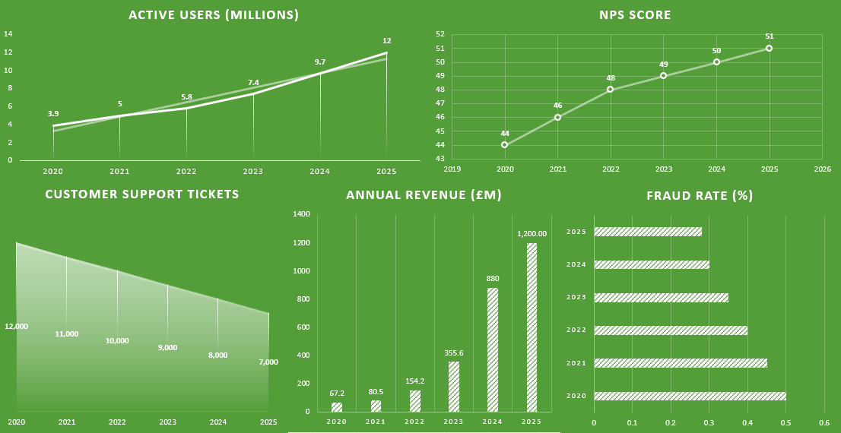
Figure 2: Dashboard
(Developed in MS Excel)
4. Justification of Design Choices
- Purpose-first design ensures relevance for all users.
- Minimalist visual elements improve readability.
- Contextual metrics (e.g., NPS over time) help in interpreting results.
- Consistent format and color-coding support cognitive ease.
- Grouping metrics (like Users and Revenue) provides coherence.
- User-friendly structure places high-priority data (like revenue) in the top-left, reflecting visual hierarchy principles.
5. Conclusion
Monzo​‍​‌‍​‍‌​‍​‌‍​‍‌ uses the dashboard as a one-stop shop for keeping track of the customer experience, the company's financial performance, and the efficiency of its operations. The dashboard is turned into a practical instrument that helps Monzo accomplish its goal and expand as a leading digital bank, by employing effective data-visualization techniques and being committed to the insights that can lead to actual ​‍​‌‍​‍‌​‍​‌‍​‍‌decisions.

References
Benson, M. (2021) ‘If Amazon buys Morrisons, it could be a win for consumers and a major threat to other supermarkets’, The Conversation, 22 June. Available at: https://theconversation.com/if-amazon-buys-morrisons-it-could-be-a-win-for-consumers-and-a-major-threat-to-other-supermarkets-163189
Brahm, C., Kovac, M. & Guarraia, P. (2018) How to Measure the Metrics that Matter. Bain & Company Insights, 7 December. Available at: https://www.bain.com/insights/how-to-measure-the-metrics-that-matter/
Castro, A., Machado, J., Roggendorf, M. & Soller, H. (2020) How to build a data architecture to drive innovation—today and tomorrow. McKinsey & Company. Available at: https://www.mckinsey.com/capabilities/mckinsey-digital/our-insights/how-to-build-a-data-architecture-to-drive-innovation-today-and-tomorrow
Databricks (2021) Failing fast with data science and ML | Champions of Data + AI | Episode 11. YouTube video, 31 August. Available at: https://www.youtube.com/watch?v=SeMwj8dSne8&t=891s
Geckoboard (2022) 12 dashboard design tips for better data visualization. YouTube video, 4 April. Available at: https://www.youtube.com/watch?v=t3cAUt7sOQg
Geckoboard. (2023) Design and build a great dashboard. 1 January. Available at: https://www.geckoboard.com/best-practice/dashboard-design/
Moriarty, T. (2019) ‘10 Principles for Building Effective Dashboards’. Medium (Eyeful). 21 January. Available at: https://medium.com/eyeful/10-principles-for-building-effective-dashboards-1f1bddceda0e
Morrisons (2020) Morrisons is now on Amazon.co.uk – Same-day grocery delivery FREE with Prime. 19 August. Available at: https://www.morrisons-corporate.com/media-centre/corporate-news/morrisons-is-now-on-amazon.co.uk/
Wee, T., Perdana, A. & Remy, D. (2019) ‘Data analytics dilemma at Alpen Hotel’, Journal of Information Technology Teaching Cases, 9(2), pp. 58-63. https://journals.sagepub.com/doi/abs/10.1177/2043886919870543

