Programs on Patterns

1. Right-Angled Triangle (Stars)

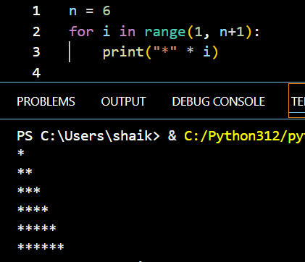

1. Pyramid Pattern

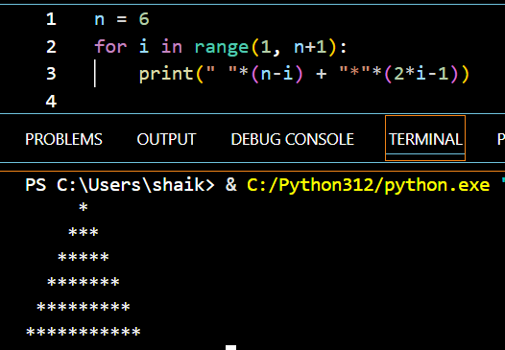

1. Inverted Pyramid

1. Square pattern

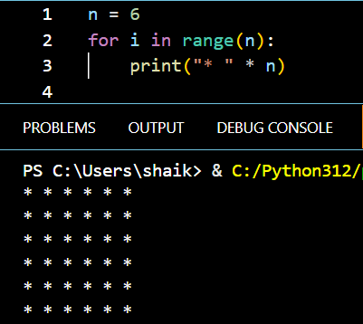

1. Hollow Square

