String Functions

# Programs Using String Functions:

1. Case Conversion:

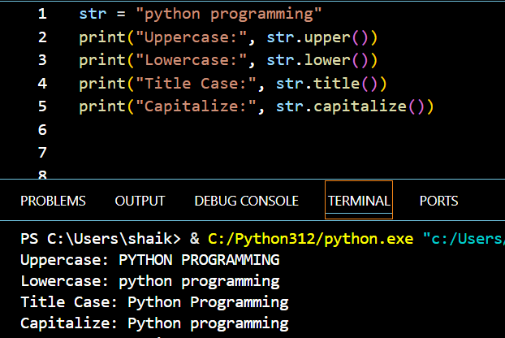

1. Program to count alphabets, digits, and special characters in a string

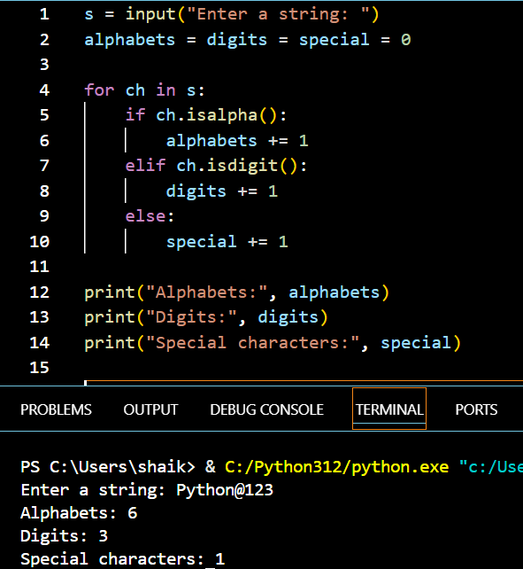

1. Splitting & Joining

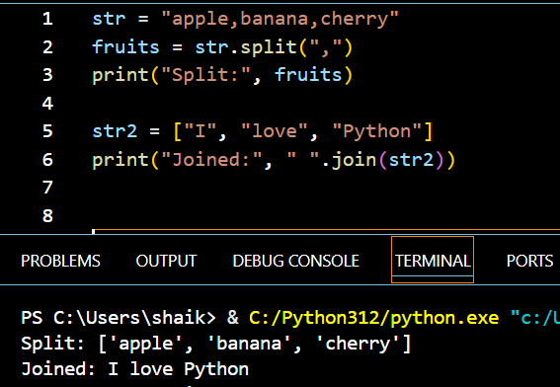

1. Encoding

