Date:03-9-2025

1. Check whether the given number is prime number or not.

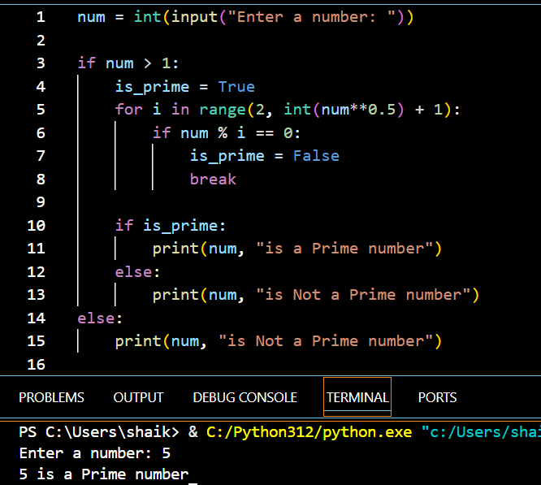

1. Check whether the given string is palindrome or not.

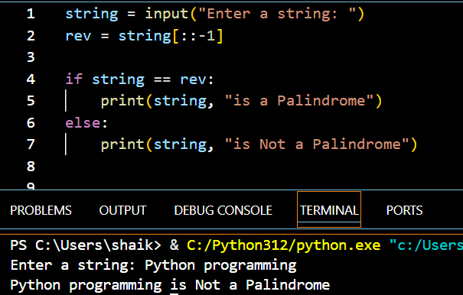

3. Check whether the given number is armstrong number or not.

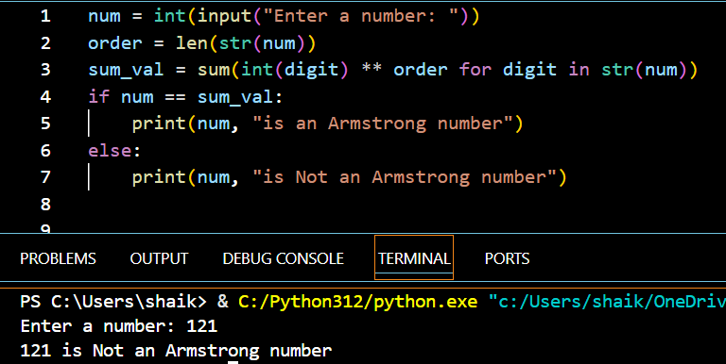

1. Check whether the given number is strong or not.

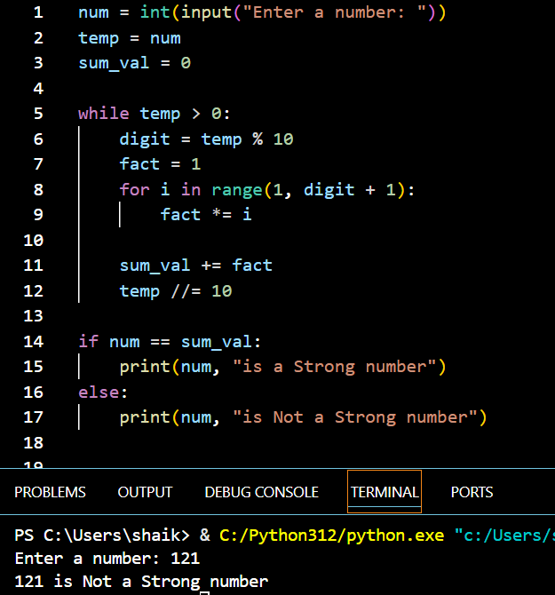

1. Fibonacci series upto nth term.

