Date: 04-9-2025

1. Print factorial of a number.

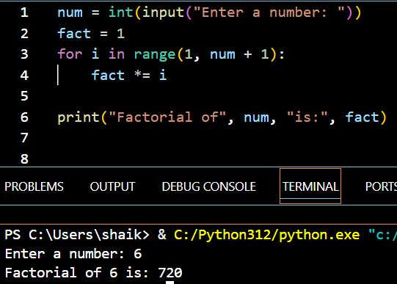

1. Factors of a number.

1. Check the number is Perfect Number.

1. Check the given number is perfect square or not.

1. Check the given number is harshad number or not

