Practice:

1. **Check if a Number is Positive and Negative in Python**

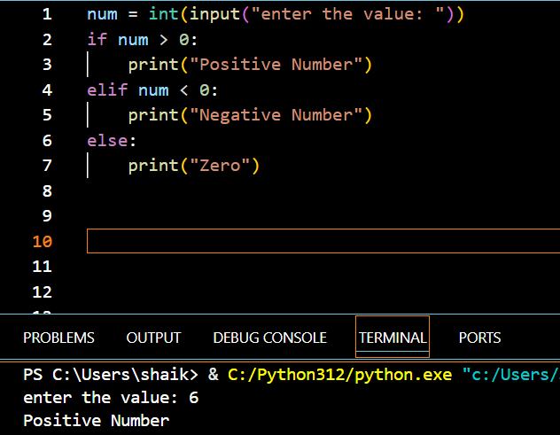

1. **Check Whether a Number is Even or Odd in Python**

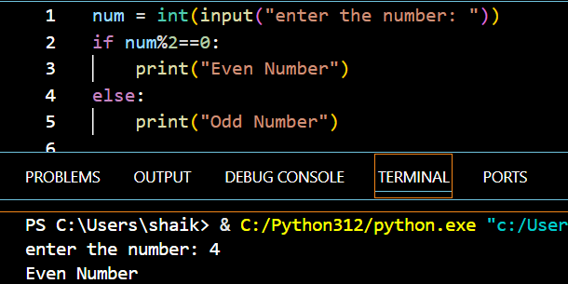

1. 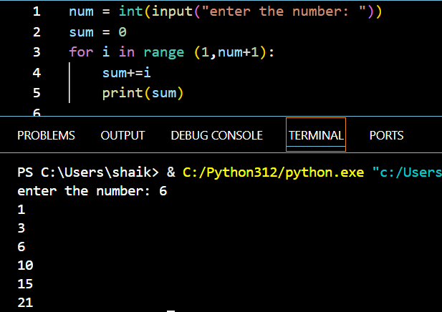**Find the Sum of the First N Natural Numbers in Python**