Practice:

1. **Find the Sum of N Natural Numbers**

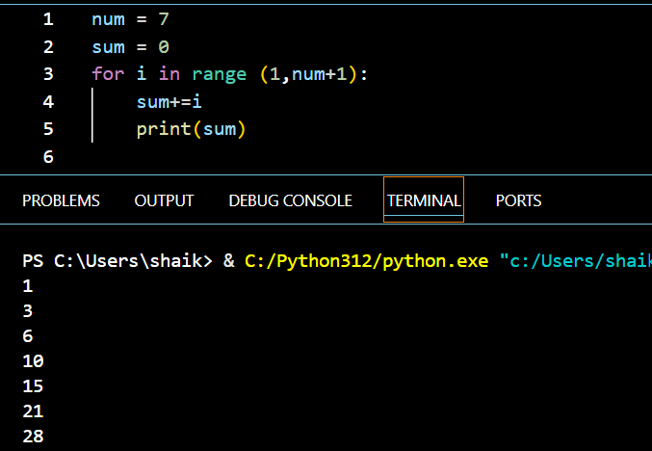

1. **Find the Sum of the Numbers in a Given Interval in Python Language**

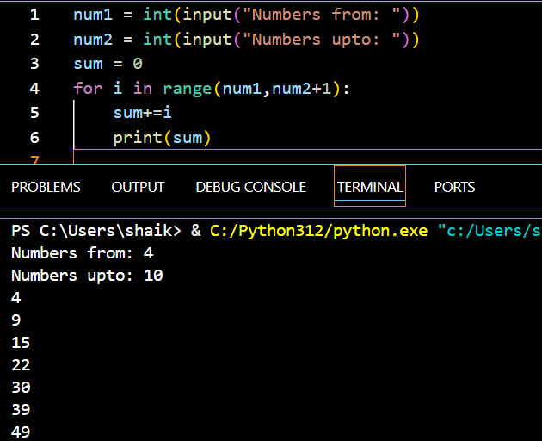

1. **Find the Greatest of Two Numbers in Python**

