Practice:

1. **Find the Greatest of the Three Numbers in Python Language**

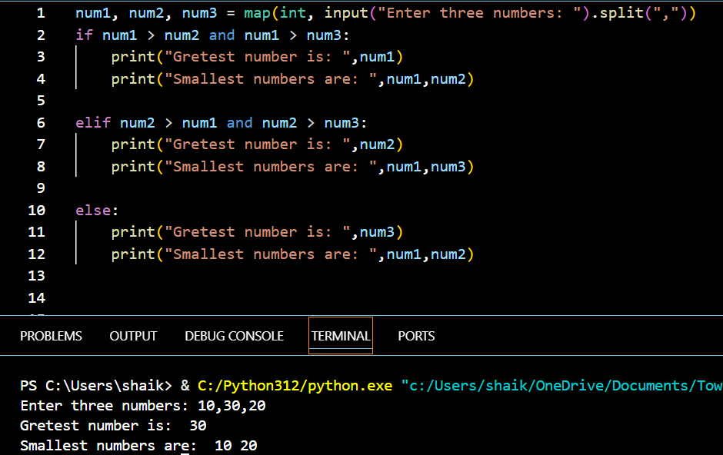

1. **Check Whether a Year is a Leap Year or Not in Python**

1. **Check Whether a Number is a Prime or Not**

