Practice:

1. Find the Reverse of a Number

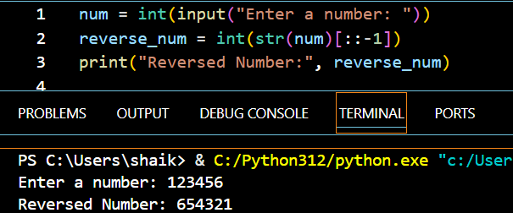

1. Check Whether or Not the Number is a Palindrome

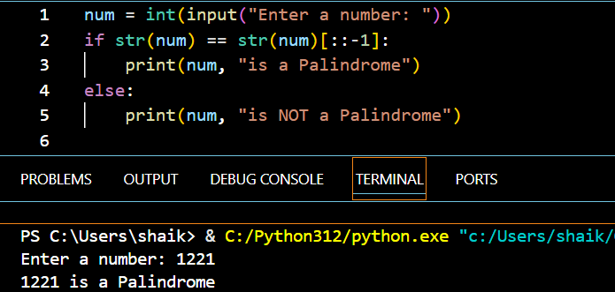

1. Check Whether a Given Number is an Armstrong Number or Not

