Practice:

1. Find the Armstrong Numbers in a given Range

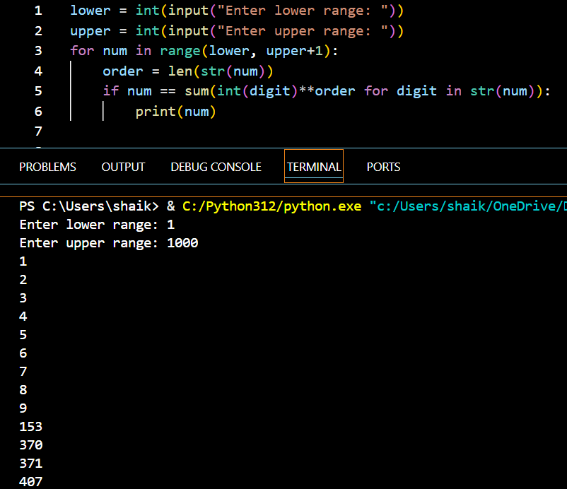

1. Find the Fibonacci Series up to Nth Term

1. Find the Nth Term of the Fibonacci Series

