**Task-2 Report**

**1. Task Description**Provide a clear and concise description of the task performed, including the primary goal and functionality implemented (e.g., authentication, role-based access, protected routes).

**2. Screenshot of Output**

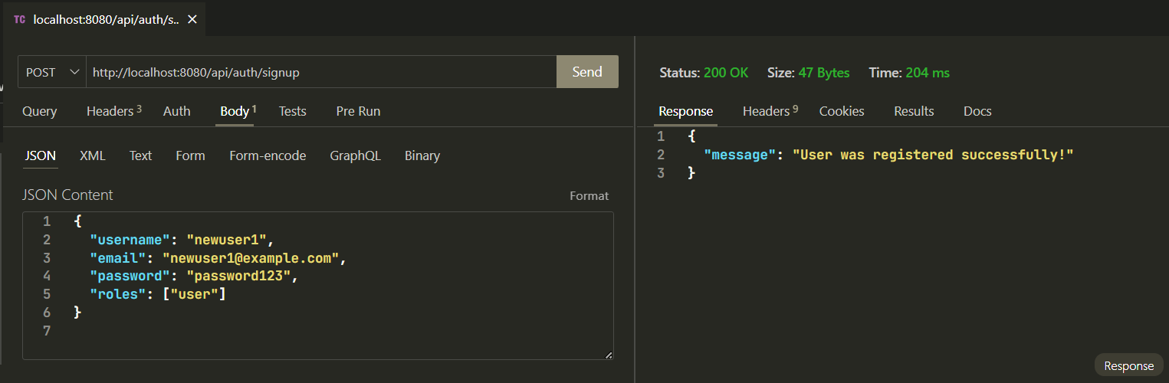

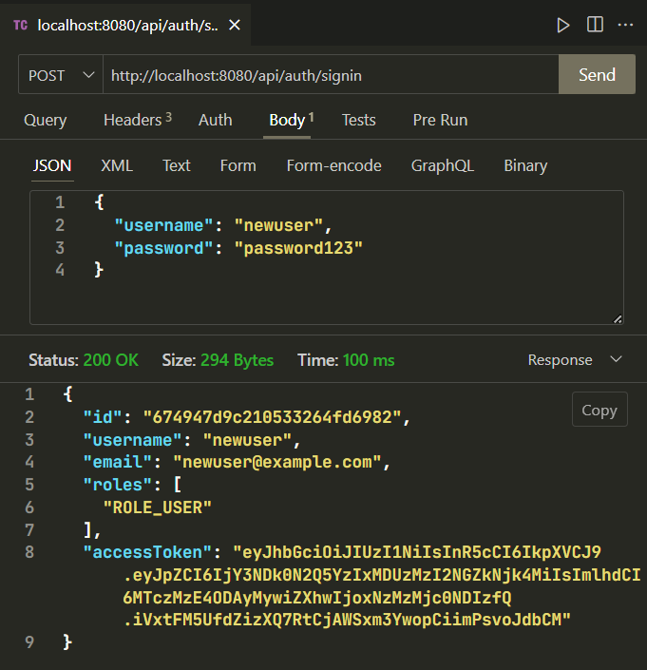

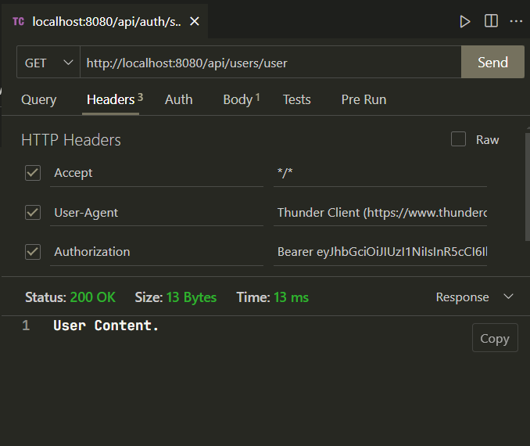

**3. Widgets/Algorithms Used**

* JWT Authentication: For generating and verifying secure tokens.
* Middleware: Used for verifying tokens and controlling access to routes based on roles.
* MongoDB: For storing user and role data.
* Express.js: Framework used for building RESTful APIs.