**Task 3 Report**

**1. Add Task Description**

The React Weather App is a web application that allows users to search for the current weather conditions of any city worldwide. It fetches and displays real-time weather data, including temperature and weather description, using the SheCodes Weather API. The project demonstrates the use of React.js for dynamic UI rendering and API integration.

**2. Attach Screenshot of Output**

Below is an example of how the app interface might look, with a search bar and weather information displayed dynamically.

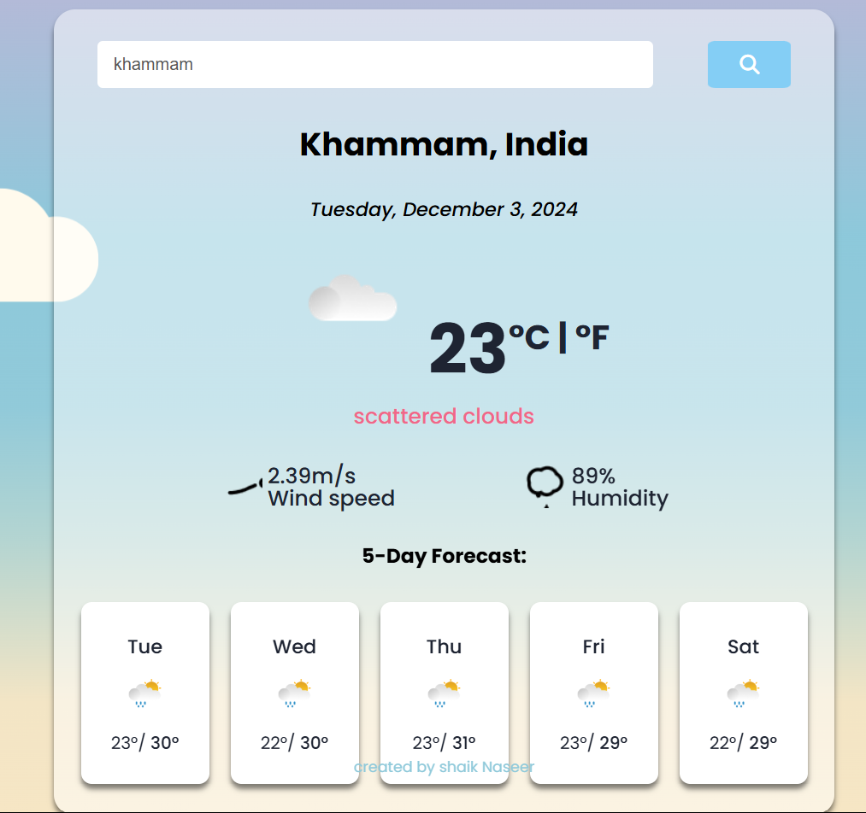

**3. Widgets/Components Used**

1. **Search Bar**:
   * Allows users to input a city name for weather search.
   * Triggers an API request upon submission.
2. **Weather Display Section**:
   * Dynamically updates to show:
     + Current temperature.
     + Weather description.
     + A weather icon for visual representation.

**Algorithm**

1. **Search Handling**:
   * Captures the user’s city input.
   * Sends an API request to fetch weather data.
2. **API Integration**:
   * Utilizes the **SheCodes Weather API**.
   * Parses JSON response to extract relevant weather details.
3. **Dynamic Rendering**:
   * Updates the UI components (temperature, description, and icon) based on the API response.
   * Uses React state to manage and reflect changes in real-time.