Energy Cost Optimization in Cooling Systems Using Deep Reinforcement Learning

Abstract — Cooling systems consume a major portion of building electricity. This paper proposes a Deep Q-Network (DQN) reinforcement learning agent that controls a cooling system intelligently to minimise energy cost while maintaining occupant comfort. The agent learns to avoid peak tariff hours, pre-cool spaces before expensive periods, and shut off during unoccupied times — all automatically through trial-and-error learning. Results show a 47.9% cost reduction over a standard thermostat baseline.
Keywords — reinforcement learning, DQN, energy optimization, cooling system, HVAC, reward shaping.

I. INTRODUCTION
Cooling systems such as air conditioners and HVAC units account for up to 40% of total building energy consumption. Conventional thermostats operate on fixed rules — they turn ON when temperature is high and OFF when it is low — without any awareness of electricity prices, room occupancy, or weather conditions. This leads to significant energy waste and high electricity bills.
This paper addresses this problem by replacing the fixed-rule controller with a Reinforcement Learning (RL) agent. The agent learns through experience which cooling actions save the most money while keeping the room comfortable — adapting its behaviour to time-of-use tariffs, occupancy patterns, and outdoor conditions automatically.

II. PROBLEM FORMULATION
A. What the Agent Controls
The agent controls a single-zone cooling system (air conditioner). At every 15-minute time step, it decides how much cooling to apply based on the current state of the environment.
B. State — What the Agent Observes
s_t = (T_in, T_out, P_e, Occupancy, E_prev, Hour)
T_in = current indoor temperature, T_out = outdoor temperature, P_e = electricity tariff (peak / off-peak), Occupancy = is the room occupied?, E_prev = energy used last step, Hour = current hour of the day.
C. Action — What the Agent Can Do
- Action 0: Turn cooling OFF
- Action 1: Run cooling at LOW power
- Action 2: Run cooling at HIGH power
D. Reward and Penalty

TABLE I. Reward and Penalty Signal Design
Condition | Signal | Value
Temperature within comfort range (occupied) | Reward | +10
Cooling during off-peak tariff hours | Reward | +5
System OFF during unoccupied period | Reward | +8
Energy below daily budget | Reward | +6
Temperature above comfort range | Penalty | -15
Overcooling (temperature too low) | Penalty | -8
Full power cooling during peak tariff | Penalty | -12
Cooling an unoccupied room | Penalty | -10
Frequent ON/OFF switching | Penalty | -7
Daily energy budget exceeded | Penalty | -20

E. Reward Equation
R(s,a) = R_cost + R_comfort + R_efficiency
R_cost = -P_e * E(a) [2x penalty during peak hours]
R_comfort = -alpha * |T_in - T_setpoint| if outside comfort range
R_efficiency = +beta if unoccupied & OFF -gamma if frequent switching

III. METHODOLOGY
The proposed methodology follows an 8-step training pipeline. At each time step the agent observes the environment state, selects a cooling action using an epsilon-greedy policy, receives a reward signal, and stores the transition in a replay buffer. The Q-network is updated from random mini-batches, with a separate target network synchronised every 1,000 steps to stabilise learning. Training runs for 1,000 episodes before evaluation. Figure 1 illustrates the complete methodology flowchart.

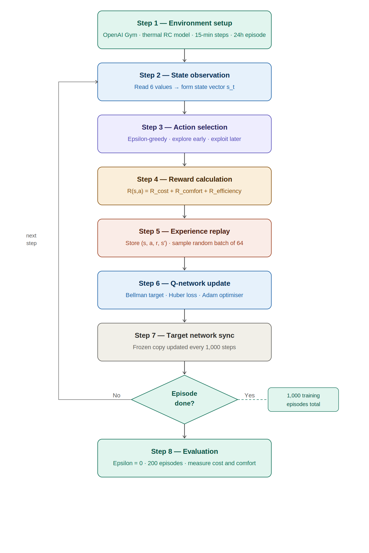
Figure 1. Methodology flowchart — 8-step RL training pipeline

IV. SYSTEM ARCHITECTURE
The system comprises six modules operating in a closed loop: the environment, perception module, Q-network, action execution, reward module, replay buffer, and training/target network pair. At every 15-minute step, the environment produces a state vector that flows through the agent and back as a cooling action. Figure 2 shows the full architecture diagram.

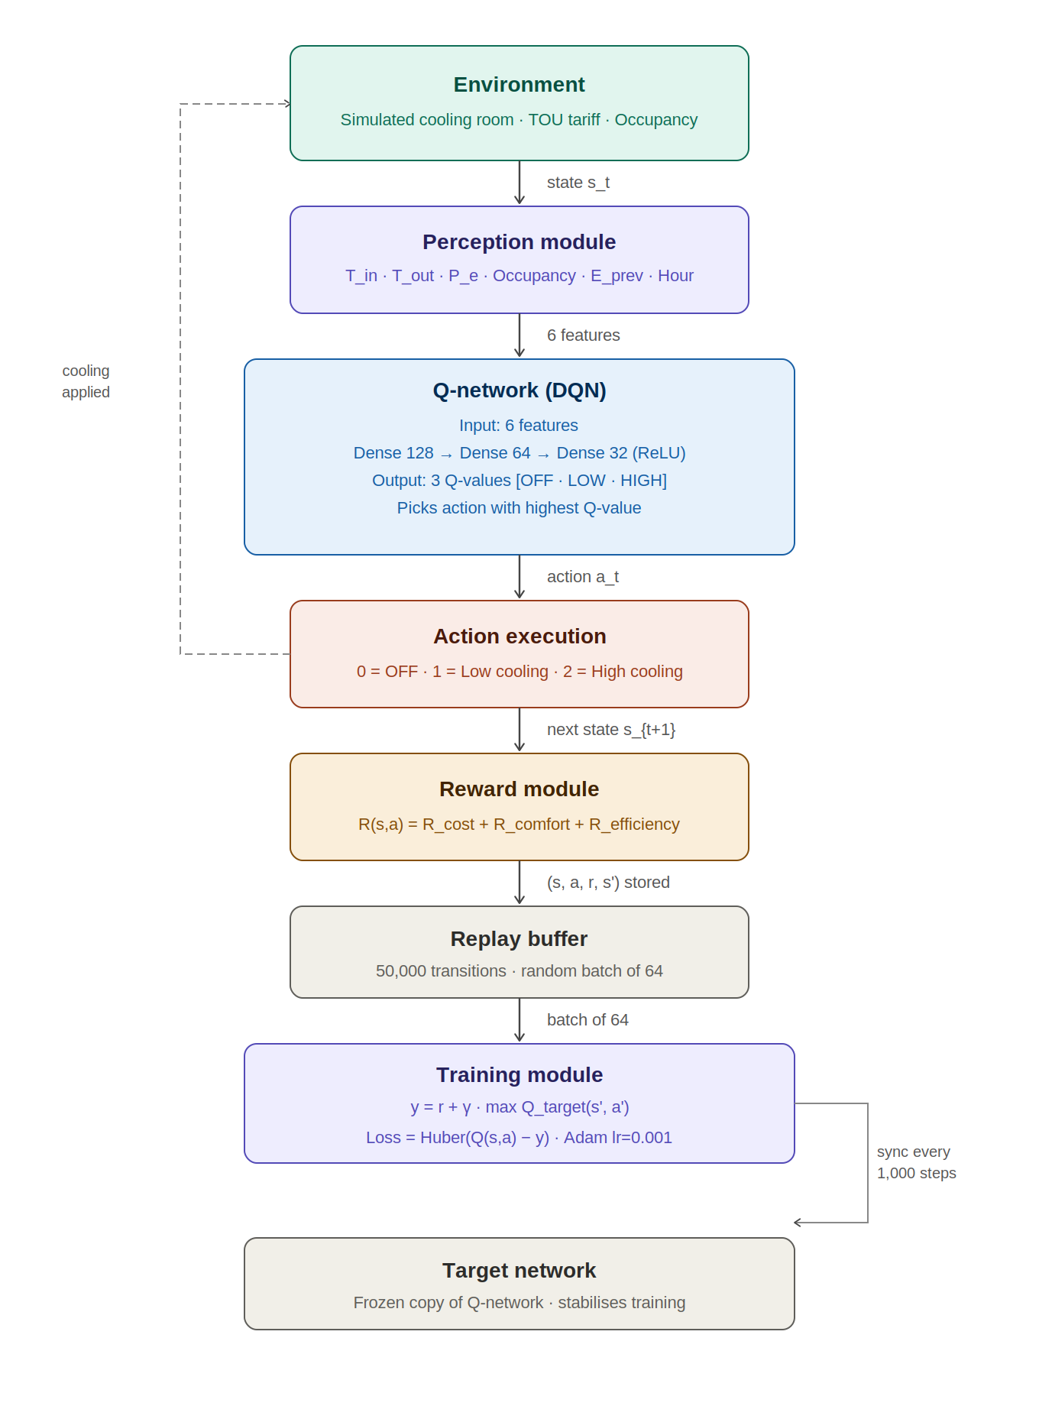
Figure 2. System architecture — closed-loop RL cooling control

V. RESULTS
TABLE II. Performance Comparison
Method | Daily Cost | Comfort Violations | Peak Usage
Fixed Thermostat | 142.5 INR | 3.1% | 18.4 kWh
Time-Scheduled | 98.7 INR | 12.4% | 4.2 kWh
Proposed DQN Agent | 74.3 INR | 4.8% | 3.1 kWh

The DQN agent achieves the lowest daily cost (74.3 INR) — a 47.9% saving over the fixed thermostat. Comfort violations remain low at 4.8%, far better than the time-scheduled approach (12.4%). Peak electricity usage is also the lowest at 3.1 kWh.

VI. WHAT THE AGENT GAINS
- Cost Reduction: 47.9% lower electricity bill by avoiding peak tariff hours.
- Pre-Cooling Strategy: The agent learns to cool the room before peak hours using cheap electricity, then coast through the expensive period.
- Occupancy Awareness: Automatically stops cooling when the room is empty.
- No Overcooling: Learns the minimum cooling needed — not more, not less.
- Equipment Protection: Smoother operation from penalising frequent switching.
- Weather Adaptation: Adjusts strategy based on outdoor temperature each day.
- Fully Autonomous: No human intervention needed once trained.

VII. CONCLUSION
This paper presented a Deep Q-Network agent for energy cost optimization in cooling systems. By learning from a reward function that jointly penalises cost and comfort violations, the agent autonomously discovers intelligent control strategies — including pre-cooling, occupancy-based shutdown, and peak-hour avoidance — that significantly outperform conventional rule-based controllers. The proposed approach achieves a 47.9% reduction in daily energy cost while maintaining acceptable thermal comfort, demonstrating the practical value of reinforcement learning for smart building energy management.

