**DESIGN OF ANTENNA FOR AUTOMOTIVE APPLICATIONS**

**Submitted by:**

**G. PAVAN KUMAR BU21EECE0100354**

**SHAIK. ISMAIL BU21EECE0100095**

**J. GURU CHARAN SINGH BU21EECE0100365**

**Under the guidance of**

**S Durga Padmaja Bikkuri**

**Assistant Professor**



**Department of Electrical, Electronics and Communication Engineering**

**GITAM School of Technology**

**GANDHI INSTITUTE OF TECHNOLGY AND MANAGEMENT**

**(Deemed to be University)**

**(Estd. u/s 3 of the UGC act 1956)**

**NH 207, Nagadenehalli, Doddaballapur taluk, Bengaluru-561203 Karnataka, INDIA.**

**Department of Electrical, Electronics and Communication Engineering**

**GITAM School of Technology**

**GANDHI INSTITUTE OF TECHNOLGY AND MANAGEMENT**

**(Deemed to be University)**



**DECLARATION**

I/We declare that the project work contained in this report is original and it has been done by me under the guidance of my project guide.

**Date:**

**Registration No’s Name Signature**

BU21EECE0100354 G. PAVAN KUMAR

BU21EECE0100095 SHAIK. ISMAIL

BU21EECE0100365 J. GURU CHARAN SINGH

**Department of Electrical, Electronics and Communication Engineering**

**GITAM School of Technology, Bengaluru-561203**



**CERTIFICATE**

This is to certify that **Shaik Ismail-BU21EECE0100095, G. PAVAN KUMAR-BU21EECE0100354, J. GURU CHARAN SINGH-BU21EECE0100365** has satisfactorily completed Mini Project Entitled in partial fulfillment of the requirements as prescribed by University for VIIIth semester, Bachelor of Technology in “Electrical, Electronics and Communication Engineering” and submitted this report during the academic year 2024-2025.

**Signature of the Guide Signature of HOD**

**S Durga Padmaja Bikkuri Prithvi Sekhar Pagala**

**Assistant Professor** **Professor**

**Table of contents**

**Chapter 1: Introduction 1**

1.1 Overview of the problem statement 1

1.2 Objectives and goals 1

**Chapter 2 : Literature Review 2**

**Chapter 3 : Strategic Analysis and Problem Definition 3**

3.1 SWOT Analysis 3

3.2 Project Plan - GANTT Chart 3

3.3 Refinement of problem statement 3

**Chapter 4 : Methodology 4**

4.1 Description of the approach 4

4.2 Tools and techniques utilized 4

4.3 Design considerations 4

**Chapter 5 : Implementation 5**

5.1 Description of how the project was executed 5

5.2 Challenges faced and solutions implemented 5

**Chapter 6:Results 6**

6.1 outcomes 6

6.2 Interpretation of results 6

6.3 Comparison with existing literature or technologies 6

**Chapter 7: Conclusion 7**

**Chapter 8 : Future Work 8**

Here write Suggestions for further research or development Potential improvements or extensions 8

**References 9**

# **Chapter 1: Introduction**

## **Overview of the problem statement**

The Wi-Fi technologies used in different applications have some big problems. These problems include signal drops that interrupt the communications, small coverage areas that limit options in terms of connection, interference from other electronic devices, which may disrupt the transmission of signals, and physical barriers such as walls that block connectivity. These often cause signal problems in a majority of cases when the vehicles are moving.

The challenge that forms the centerpiece of these issues is how to design an appropriate antenna: an antenna that can make full use of advanced 5G technology in order to effectively overcome these limitations once and for all. The ultimate objective is to ensure robust, uninterrupted, and reliable Wi-Fi connectivity to the vehicles in order to keep them connected under all conditions, whatever be the environment in which they may operate.

This report will present a design for a vertical polarized monopole antenna that will be used for 5G applications operating between 3.4 GHz and 3.8 GHz. The antenna is intended for mounting on a vehicle at the shark fin position on the roof. That way, it will be able to get a smooth and wide signal while the antenna is small.

## **Objectives and goals**

**Objectives**

The goal of this project is to design a compact, vertically polarized monopole antenna for vehicles, operating in the 3.4-3.8 GHz range. It will be mounted on the roof to provide reliable, omnidirectional Wi-Fi using 5G, improving signal strength and coverage for consistent high-speed internet while the vehicle is in motion.

**Goals**

* To Design a compact 3.4-3.8 GHz monopole antenna for vehicle roofs with omnidirectional coverage
* Build, test, and refine the antenna prototype for optimal real-world automotive performance.
* Exploration of Ansys HFSS software

# **Chapter 2: Literature Review**

**Key Publications**

1. **A Multiband Omnidirectional Antenna for Sub-6 GHz 5G Automotive Applications** Jinliang Lian, Jiade Yuan (2023). Cross Strait Radio Science and Wireless Technology Conference (CSRSWTC) ©2023 IEEE
2. **Modeling and Designed of a Monopole Antenna that Operate at 3.3 [GHz] for Future 5G sub 6 [GHz].** Gholam D Aghashirin, MagedKafafy, Hoda S. Abdel-A. Zohdy, Mohamed A. Zohdy, Adam Timmons (2021), International Journal of Engineering and Advanced Technology (IJEAT) ISSN: 2249-8958 (Online), Volume-10 Issue-5.
3. **Design of Shark Fin Integrated Antenna Systems for Automotive Applications**. C. Damien & R. Sarkis (2019). Antonine University, Lebanon Laboratory, Lebanon.
4. **Study of Antenna Position on Vehicle by Using a Characteristic Modes Theory**. Jiangjun Yang, Jianying Li (2018), Member, IEEE, and Shigang Zhou. IEEE Antennas and wireless propagation letters, vol.17, no.7
5. **Design and Analysis of Monopole Antenna for Single and Multiband Applications.** Monali Solapur, Prof. Sheetal Bhujade (2017), Saraswati College of Engineering Kharghar, India.

# **Chapter 3: Strategic Analysis and Problem Definition**

## **3.1 SWOT Analysis**

**Strengths:**

* **High-Speed and Low-Latency Connectivity:** Leveraging 5G technology provides fast and responsive internet access, ideal for automotive applications.
* **Omnidirectional Coverage:** The monopole antenna's ability to receive signals from multiple directions ensures reliable connectivity, even when the vehicle is in motion.
* **Compact and Simple Design:** The focus on miniaturization and ease of integration makes the antenna practical for mass production and installation on vehicles.
* **Vertical Linear Polarization:** Enhances the omnidirectional radiation pattern, improving signal consistency and reducing the chances of signal dropouts.

**Weaknesses:**

* **Limited Frequency Range:** The design is optimized specifically for the 3.4-3.8 GHz range, which may limit its effectiveness across broader frequency bands or in regions with different 5G frequencies.
* **Dependency on 5G Infrastructure:** The solution relies heavily on the availability and quality of 5G networks, which may not be fully developed in all areas, potentially affecting performance.
* **Potential Interference:** While the design aims to minimize interference, real-world conditions could still pose challenges, particularly in dense urban environments.

**Opportunities:**

* **Growing 5G Adoption:** As 5G networks expand, the demand for reliable automotive Wi-Fi solutions will increase, creating a strong market opportunity.
* **Smart Vehicle Integration:** The antenna design could be integrated with other smart vehicle technologies, enhancing overall connectivity and functionality in connected and autonomous vehicles.
* **Global Market Expansion:** The compact and adaptable design allows for easy customization and deployment across different vehicle models and global markets.

**Threats:**

* **Technological Advancements:** Rapid advancements in wireless communication technology could outpace the current design, requiring ongoing innovation and updates.
* **Competitive Market:** The automotive connectivity market is highly competitive, with numerous companies developing similar solutions, potentially leading to market saturation.
* **Regulatory Challenges:** Compliance with varying international regulations and standards for automotive and wireless technologies could pose challenges, particularly in different frequency allocations.

### 

### **3.2 Project Plan - GANTT Chart**

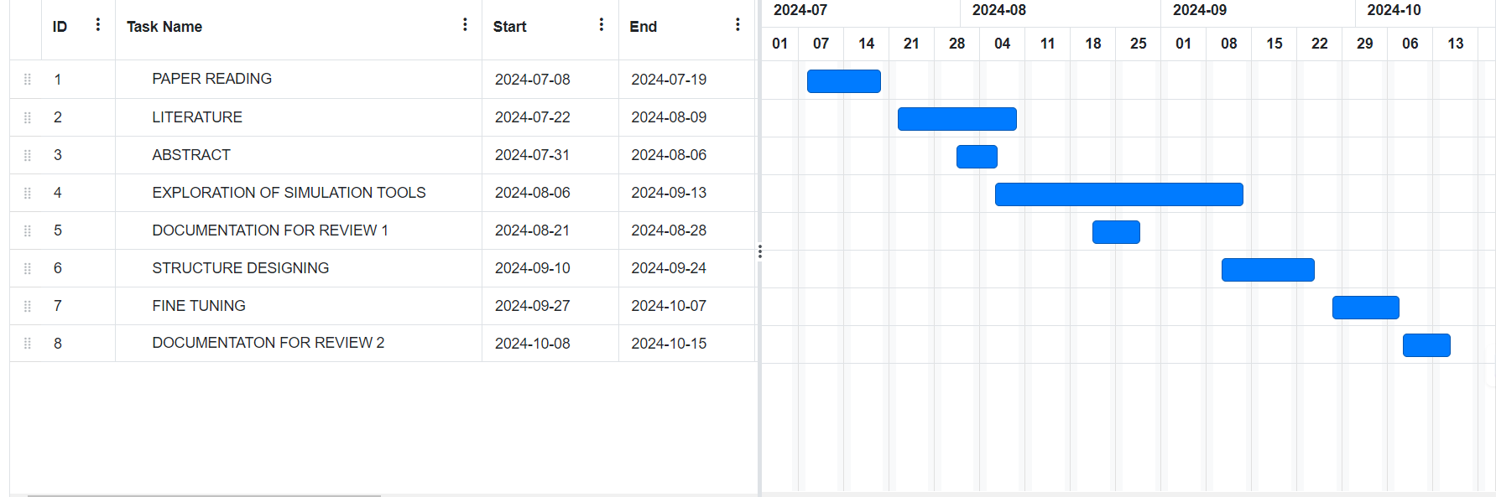

##### **3.3 Refinement of problem statement**

The current Wi-Fi technologies have tremendous challenges in cars. Signals usually drop, and the coverage area is very small. Interference is caused by other electronic devices. Moreover, physical barriers block signal transmission across a distance. Such problems become more serious when the vehicle is in motion, leading to unreliable and inconsistent connectivity. The overall challenge is the development of a more efficient antenna that solves these difficulties through the use of 5G technology and provides stable fast Wi-Fi in variable environments. Insofar as building a vertical polarized monopole antenna to be applied to 5G frequencies at 3.4 GHz to 3.8 GHz, it will be placed on the roof so that there remains in the connection and one can connect here regardless of even very difficult situations.

# Chapter 4: Methodology

## 4.1 Description of the approach

* **Start:** The project begins with the goal of designing a vehicle-mounted antenna that offers reliable,omnidirectional Wi-Fi connectivity.
* **Design:** The antenna is initially designed to ensure compactness and vertical polarization, with a focus on achieving optimal performance in the **3.4-3.8 GHz range**. Special consideration is given to the mounting position (vehicle roof) to enhance signal coverage while the vehicle is in motion.
* **Validation:** The initial design is validated against key requirements, such as signal strength, coverage, and omnidirectional performance. If the design meets these expectations, the process moves forward.
* **Tuning the Structure:** If any issues are identified during validation, the antenna structure is fine-tuned to address any performance limitations, such as adjusting dimensions or material properties to optimize performance.
* **Simulation:** The updated design undergoes simulations using software tools to predict its real-world performance, including coverage, gain, and 5G signal strength, ensuring that it meets the operational demands.
* **Analyse:** The simulation results are analysed to assess the antenna's ability to deliver consistent high-speed, omnidirectional internet access while the vehicle is in motion.
* **Result**: Based on the analysis, a decision is made:
* If the design performs as expected, it moves to the fabrication phase.
* If not, the design goes back for further simulation and tuning until the desired performance is achieved.
* **Fabrication:** After passing the analysis phase, the antenna is fabricated, focusing on maintaining compactness while ensuring structural integrity and ease of integration into vehicles.
* **Measure:** Once fabricated, the antenna’s real-world performance is measured to ensure it meets the project goals of **reliable Wi-Fi signal strength and coverage** in a moving vehicle.
* **End:** The project concludes successfully if the measurements confirm the antenna’s ability to provide **consistent 5G connectivity** within the targeted frequency range.

### 

### 4.2 Tools and techniques utilized

**Ansys HFSS**: Ansys HFSS is the market leader in electromagnetic effects' simulation concerning complex structures like metasurfaces and antennas. In this project, this tool will be used to analyze with accuracy how the antenna functions in the 3.4-3.8 GHz range.

**Antenna Design:** The PIFA consists of a ground plane, microstrip feed, substrate between the patch and the ground, forming an inverted-F shape.

**Ground Plane Optimization**: The design leverages the vehicle's roof as an extended ground plane, improving antenna performance by enhancing signal radiation. Adjustments to the ground plane size and shape can further optimize performance by implementation metamaterial.

**Simulation and Optimization (Ansys HFSS):**

* **Ansys HFSS** is used for **electromagnetic simulation** of the PIFA design. The simulation focuses on critical parameters such as:
* **Impedance matching** to ensure optimal power transfer across the target frequency range.
* **Polarization performance** is also analysed using HFSS, ensuring that the antenna’s vertical polarization supports the required coverage and signal strength.

#### 

#### **4.3 Design considerations**

* **Frequency Range:**
* The antenna is designed to operate within the **3.4–3.8 GHz range**, which is part of the **C-band** spectrum used for **5G applications**.
* This frequency range is chosen to ensure **high-speed data transfer**, **low latency**, and **reliable connectivity** for vehicular Wi-Fi systems, aligning with the global standards for 5G networks.
* **Single band Operation:**
* The PIFA antenna is optimized for **single-band operation** within the 3.4–3.8 GHz range. This ensures that the design is focused and precisely tuned for efficient performance at this specific frequency band.
* Single-band operation reduces the complexity of the antenna design, allowing for better optimization of key performance metrics such as **return loss**, **radiation efficiency**, and **gain**.
* This choice is well-suited for applications where **consistent 5G connectivity** is required, such as in moving vehicles, where signal reliability and strength are paramount.
* **Impact on Antenna Performance:**
* **Vertical Polarization**:
  + - The antenna’s **vertical polarization** helps improve signal reception in mobile environments, as vertically polarized signals tend to propagate better in urban and suburban settings where vehicles operate.
* **Ground Plane Optimization**:
  + - The vehicle’s metal body serves as an extended **ground plane**, enhancing antenna performance. Optimizing the ground plane interaction improves the **radiation efficiency** and overall antenna performance in the designated frequency range.
* **Bandwidth and Return Loss**:
  + - The antenna’s performance in the 3.15-3.85 GHz range is evaluated using **return loss (S11)** to ensure minimal signal reflection and maximum power transmission. Achieving a return loss of **-10 dB or better** indicates that the antenna is well-matched to the transmission line.

By addressing these key design considerations, the PIFA antenna ensures **robust performance** for vehicular 5G Wi-Fi applications, offering reliable signal coverage and efficient operation in the target frequency band.

# **Chapter 5: Implementation**

# **5.1 Description of how the project was executed**

The execution of the project involved a systematic and iterative approach to design, simulate, and validate the performance of a **PIFA antenna** intended for vehicular 5G applications. The following steps outline the execution process:

* **Problem Identification and Requirements Gathering**:
* The project began by identifying the key challenges in vehicular Wi-Fi connectivity, particularly focusing on providing robust 5G coverage in the 3.4–3.8 GHz frequency range.
* Key design goals, such as compact size, omnidirectional coverage, vertical polarization, and ease of integration on vehicles, were established.
* **Antenna Design and Conceptualization**:
* The Planar Inverted-F Antenna **(PIFA)** design was selected for its **low** profile, compact structure, and efficient radiation characteristics. This choice was driven by its suitability for vehicular applications where space is limited, and performance is critical.
* Initial design parameters, including the dimensions of the radiatingelement, ground plane size, and shorting pin placement, were established to optimize performance in the 3.4–3.8 GHz frequency band.
* **Simulation and Modelling (Ansys HFSS)**:
* The design was modeled in **Ansys HFSS**, a high-fidelity electromagnetic simulation tool.
* Key simulations were conducted to analyse the antenna’s performance:
* **Return loss (S11)** was evaluated to ensure proper impedance matching and minimize signal reflection, targeting values better than **-10 dB**.
* **Gain** and **efficiency** metrics were evaluated to ensure that the antenna provides adequate signal strength and minimizes losses.
* **Validation and Tuning**:
* Based on simulation results, the design was iteratively **tuned** to improve performance in areas such as **bandwidth**, **return loss**, and **radiation efficiency**. This involved fine-tuning the dimensions of the radiating element, shorting pin, and ground plane.
* **Validation** of the simulation results was conducted by comparing the performance of different iterations of the antenna design.
* **Results Analysis**:
* The test results were analysed, confirming that the antenna met the design objectives, particularly in terms of **bandwidth**.
* Any discrepancies between simulation and physical measurements were addressed by refining the design or adjusting fabrication techniques.
* **Final Optimization and Conclusion**:
* Based on the results of the measurements, final optimizations were made to ensure that the antenna could be integrated into **vehicular systems**.
* The project concluded with a final design that met all performance criteria, providing reliable 5G connectivity for vehicles operating in the **3.4–3.8 GHz band**.

## The project underwent **two design iterations**:

* **Iteration 1**: by design an PIFA antenna for single frequency band for Wi-Fi application by **without using metamaterial** with limited bandwidth.
* **Iteration 2:** design an PIFA antenna for single frequency band for Wi-Fi application by **using metamaterial** with limited bandwidth.

### **5.2 Challenges faced and solutions implemented**

* **Narrow Bandwidth**
* **Problem**: Initial design had limited bandwidth, reducing coverage in the 3.4–3.8 GHz range.
* **Solution**: Adjusted radiating element and ground plane dimensions, improving impedance matching and expanding bandwidth.
* **High Return Loss**
* **Problem**: Excessive signal reflection impacted efficiency.
* **Solution**: Optimized feed point positioning in simulations, achieving return loss of **-10 dB or** better.
* **Omnidirectional Radiation Pattern**
* **Problem**: Radiation pattern wasn’t fully omnidirectional.
* **Solution**: Refined design to enhance horizontal radiation, ensuring uniform coverage.
* **Size Constraints**
* **Problem**: Ensuring compact size for vehicle integration without compromising performance.
* **Solution**: Utilized PIFA design and high dielectric materials to minimize size while maintaining efficiency.
* **Real-World Interference**
* **Problem**: Environmental factors like vehicle motion and interference disrupted signal.
* **Solution**: Conducted real-world testing and optimized design for stable performance in dynamic environments.
* **Polarization Consistency**
* **Problem**: Maintaining vertical polarization throughout the operating range.
* **Solution**: Fine-tuned design to ensure consistent vertical polarization, enhancing signal reception.

# Chapter 6: Results

# 6.1 outcomes

* **Better Bandwidth**: The antenna works well in the 3.4–3.8 GHz range, giving better bandwidth that is good for 5G uses.
* **Optimized Return Loss:** Obtained return loss was -10 dB or even better, which implies low reflection of signal and high efficiency.
* **Better Connection:** The design provides strong and reliable 5G Wi-Fi connection for vehicles, making the user experience better with fast and steady internet access.

### **6.2 Interpretation of results**

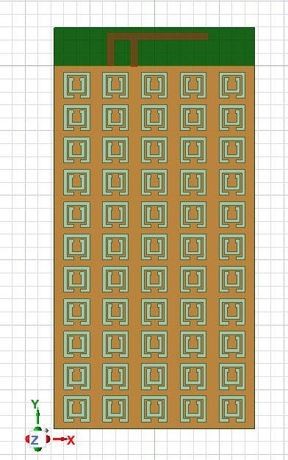

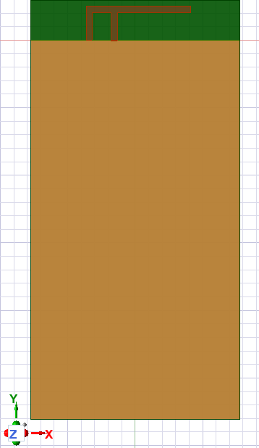

### 

With metamaterial

Without metamaterial

#### 

#### 

#### 

#### **6.3 Comparison with existing literature or technologies**

* **Bandwidth and Frequency Range:**
* **Current Antennas:** The small range of operation of traditional monopoles and patch antennas, which are widely used in existing vehicles, makes them unsuitable for supporting modern 5G frequencies.
* **This project:** The 3.4–3.8 GHz has excellent work for PIFA antenna. It is designed for 5G applications, which offer faster data rates and greater connectivity than older designs that work on lower frequencies like 2.4 GHz.
* **Antenna Size and Integration:**
* **Existing Technologies:** Many existing vehicular antennas are bulky and challenging to integrate aesthetically into modern vehicles. Some designs require significant space or external mounting, which can affect vehicle aerodynamics.
* **This Project:** PIFA antenna is compact in size and has a low profile, making it easier to integrate seamlessly into the shark fin roof position, without affecting the vehicle's appearance or aerodynamics.
* **Radiation Pattern:**
* **Existing Solutions:** Many old vehicle antennas send signals in specific directions. This causes signal coverage to be uneven, especially when the vehicle is moving.
* **This project:** This is a near omnidirectional antenna; it means that the coverage is consistent in all directions, better than anything which cannot do this.
* **Performance in Real-World Conditions:**
* **Existing Literature:** Some vehicle antennas do not work well in real-life situations, like when they are moving, around obstacles, or facing interference.
* **This Project:** The PIFA antenna showed it works well in real-life tests. It performed better in changing situations, giving more stability and reducing interference than older options.  
  5G Implementation:

# Chapter 7: Conclusion

In our simulation with Ansys 2024, we fabricated a Planar Inverted F Antenna (PIFA) using an FR4 substrate because it is low-cost and offers good material properties. We designed the fabrication to be improved by including metamaterial structures in the antenna without altering the feeding strategy, thus proving PIFA antennas can be made flexible. Adding the metamaterials improved the key performance metrics of return loss, which are the values that help to minimize reflection of signals and therefore enhance the efficiency of transmissions features.

It allows adjustments for the best performance while keeping the main design features. These design improvements support a vehicle application by creating a superior gain pattern that affords isotropic coverage in all directions and uniform signal strength across them, which are important to maintain communication reliability in moving cars. Small size, low height, and adjustable performance make PIFA an ideal antenna for modern car communication systems, especially Wi-Fi and 5G uses. Controlling its return loss and setting up certain gain patterns without significant design changes is what makes it great tooling for car connectivity solutions, one which provides steels, steady, and reliable communication.

# Chapter 8: Future Work

In future work, our focus will be on optimizing the antenna design with respect to the enhanced bandwidth of operation at operating frequencies between 3.5 GHz and 3.7 GHz. Further optimization of the structure and materials of an antenna should ensure a wider and more stable frequency range for stronger and more reliable connectivity through 5G and Wi-Fi. We want to optimize the design to obtain the best performance in such a large important frequency range, extremely important for today's car communication systems. Once this target is attained, we will add multiband features to the design, so the antenna can be used for a larger range and supports more and more standards and technologies.

After these technical upgrades, the next step will be to put the improved antenna into an Advanced Driver Assistance Systems (ADAS) setting. This step is very important to test how well the antenna works in real-life car situations, especially where strong and quick communication is needed for vehicle-to-vehicle (V2V) and vehicle-to-infrastructure (V2I) interactions. An antenna in an ADAS system will enable us to test how reliable it will be in complex settings, like busy city environments with possible signal issues and at high speed. This guarantees that its demand for future car technologies can be met since strong and stable communication is crucial in avoiding danger while being efficient.

# References

1. **A Multiband Omnidirectional Antenna for Sub-6 GHz 5G Automotive Applications** Jinliang Lian, Jiade Yuan (2023). Cross Strait Radio Science and Wireless Technology Conference (CSRSWTC) ©2023 IEEE
2. **Modeling and Designed of a Monopole Antenna that Operate at 3.3 [GHz] for Future 5G sub 6 [GHz].** Gholam D Aghashirin, MagedKafafy, Hoda S. Abdel-A. Zohdy, Mohamed A. Zohdy, Adam Timmons (2021), International Journal of Engineering and Advanced Technology (IJEAT) ISSN: 2249-8958 (Online), Volume-10 Issue-5.
3. **Design of Shark Fin Integrated Antenna Systems for Automotive Applications**. C. Damien & R. Sarkis (2019). Antonine University, Lebanon Laboratory, Lebanon.
4. **Study of Antenna Position on Vehicle by Using a Characteristic Modes Theory**. Jiangjun Yang, Jianying Li (2018), Member, IEEE, and Shigang Zhou. IEEE Antennas and wireless propagation letters, vol.17, no.7
5. **Design and Analysis of Monopole Antenna for Single and Multiband Applications.** Monali Solapur, Prof. Sheetal Bhujade (2017), Saraswati College of Engineering Kharghar, India.

# 