**Challenge task 1**

1. Launch one ec2 instance using amazon linux 2.
2. Install Docker
3. Install jenkins
4. Install apache
5. Install nginx
6. Install Apache Tomcat

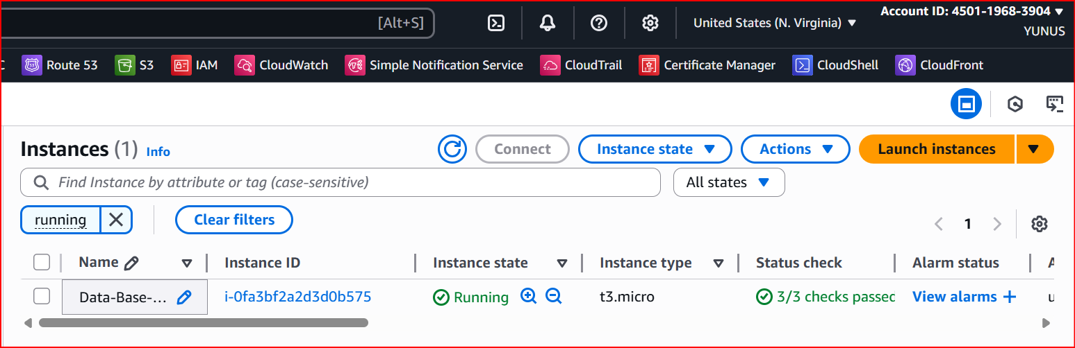

Connect the instance SSH

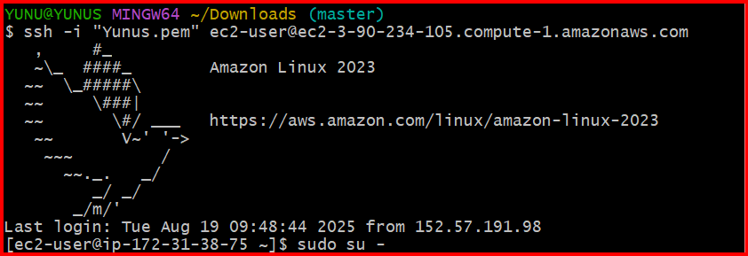

Sudo yum update

Install docker Sudo yum install -y docker)

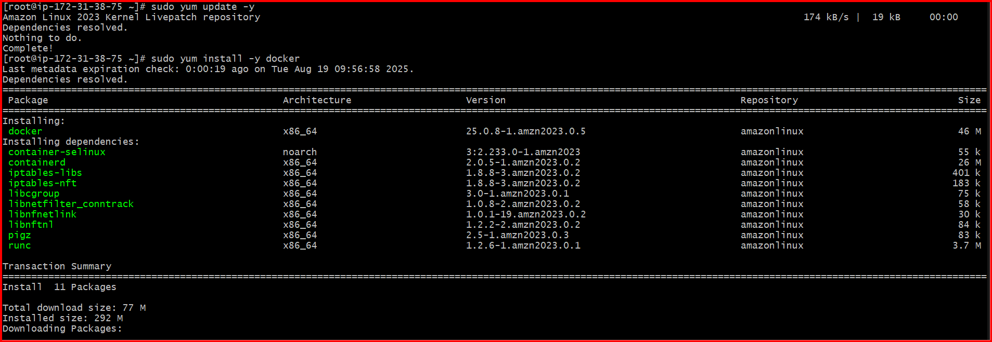

sudo systemctl enable docker

sudo systemctl start docker

sudo systemctl status docker

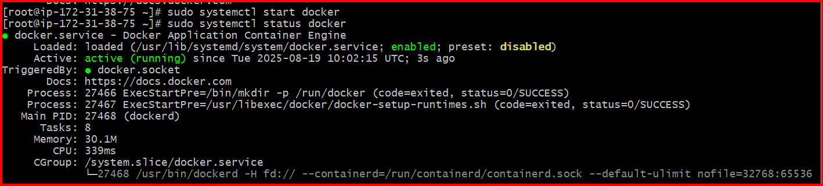

Install java

sudo yum install -y java-17-amazon-corretto

check the version java –version

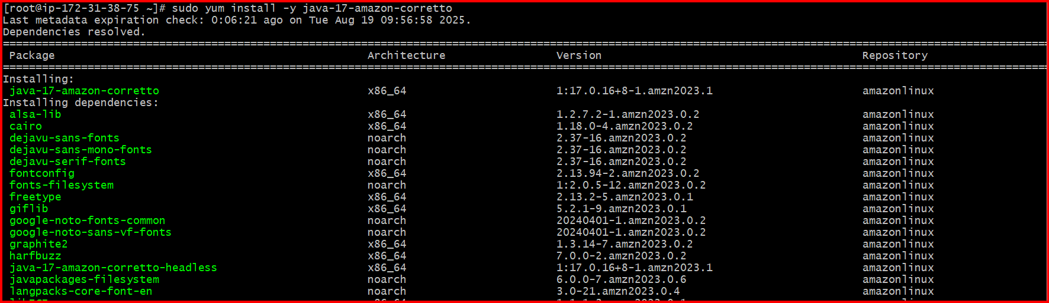

**Jenkins repository** to your system by downloading its repo file into

sudo wget -O /etc/yum.repos.d/jenkins.repo \https://pkg.jenkins.io/redhat-stable/jenkins.repo

sudo rpm --import <https://pkg.jenkins.io/redhat-stable/jenkins.io-2023.key>

sudo yum install -y jenkins

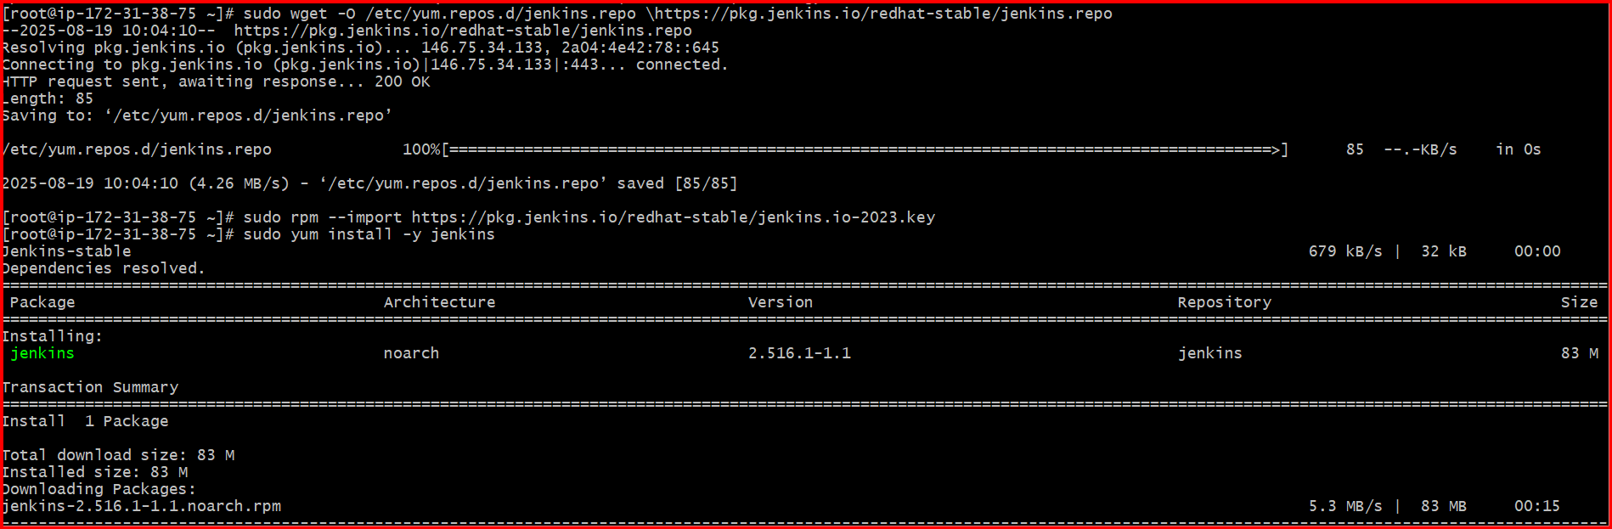

sudo systemctl enable jenkins

sudo systemctl start Jenkins

sudo systemctl stop jenkins

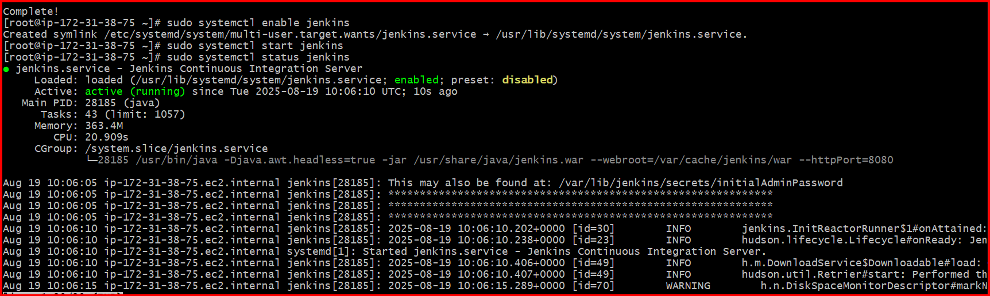

Go to browser check the with publich id:8080

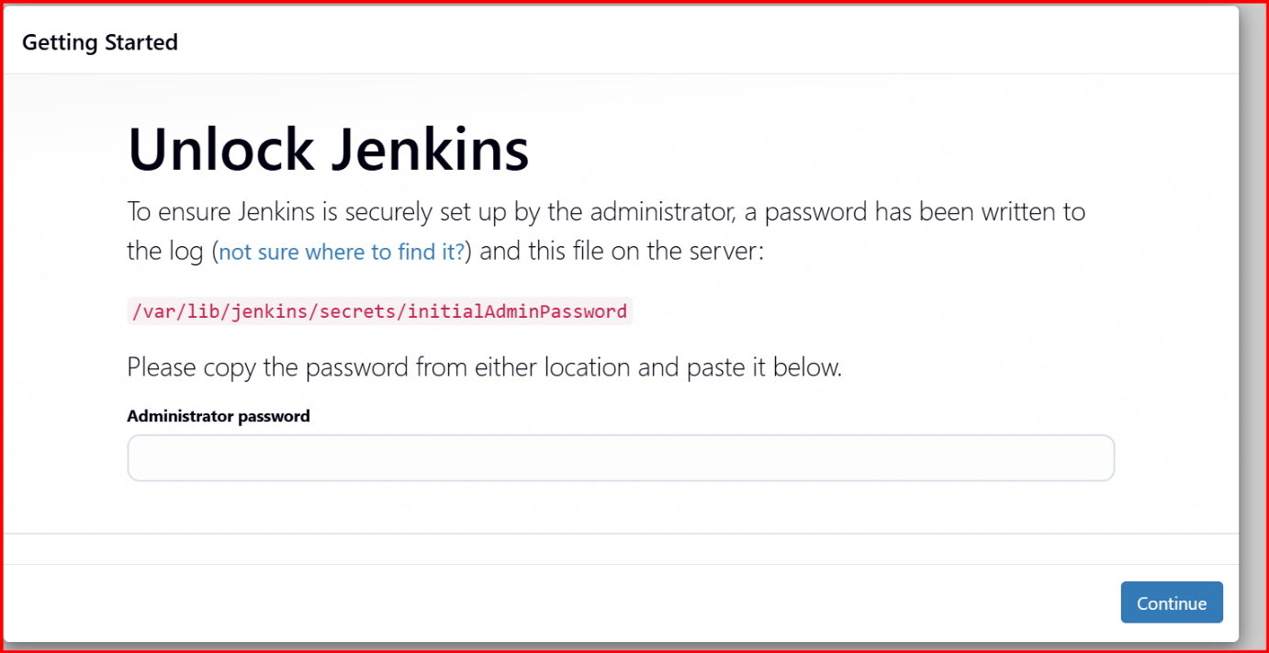

Cat and /var/lib/Jenkins/secrets/initialAdminPassword

This will show the Password (past and continue)

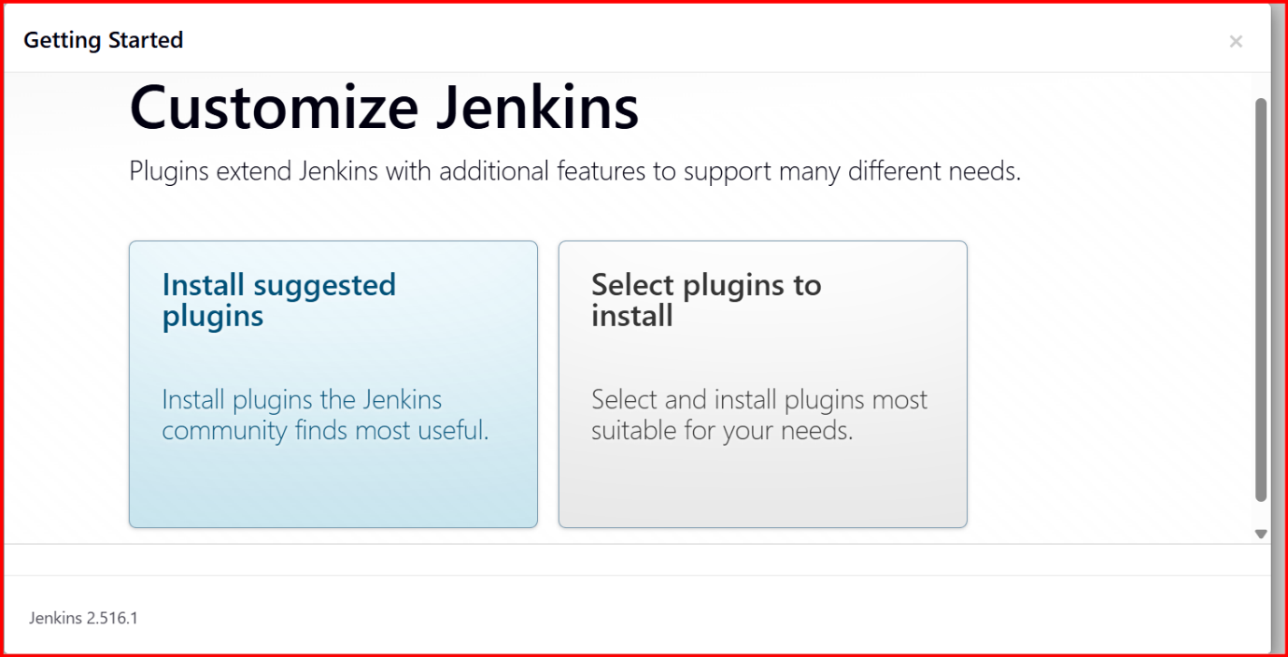

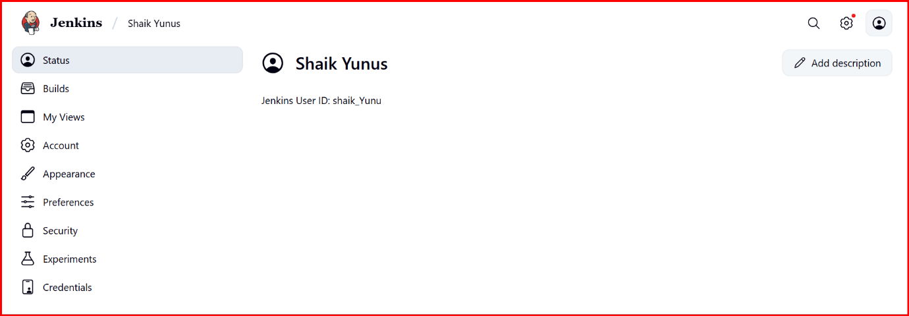

**Install apache**

sudo yum install -y httpd

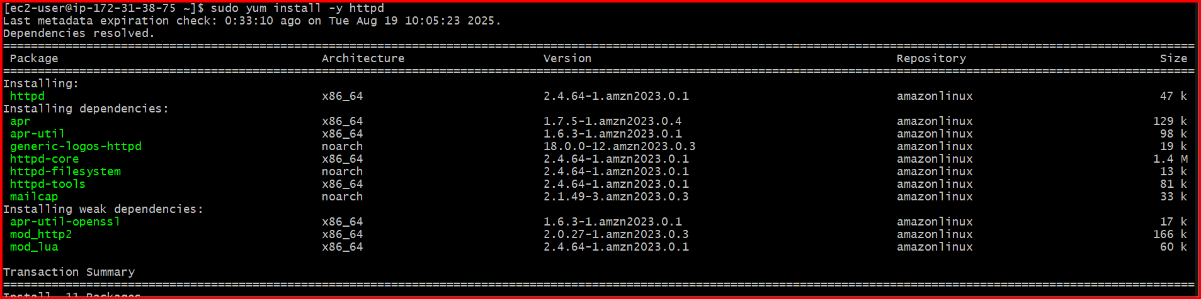

sudo systemctl start httpd

sudo systemctl enable httpd

sudo systemctl status httpd

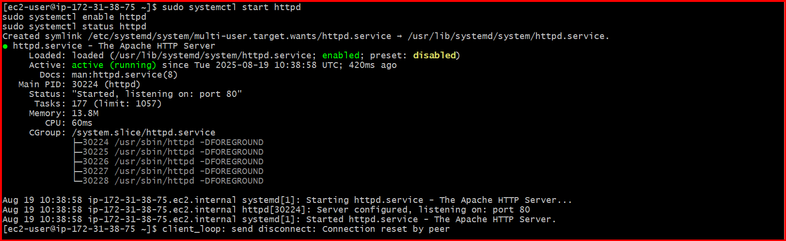

Check with public id in browser

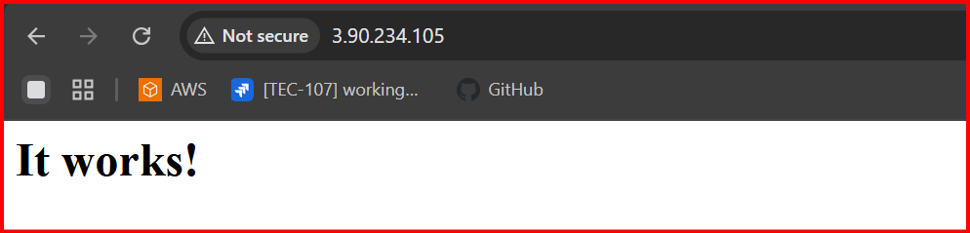

**Install nginx**

sudo yum install -y nginx

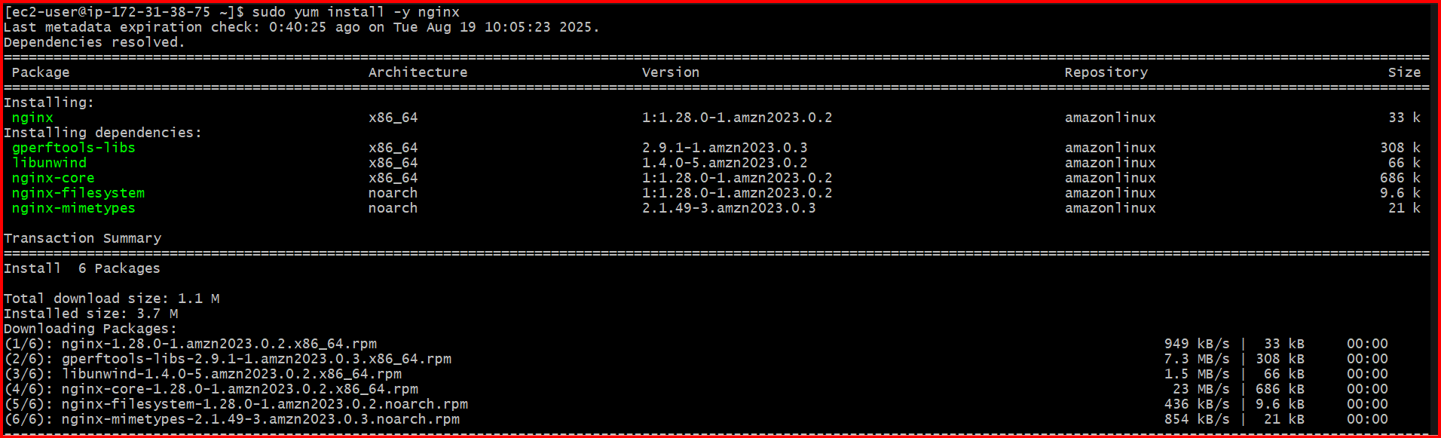

sudo systemctl start nginx

sudo systemctl enable nginx

sudo systemctl status nginx

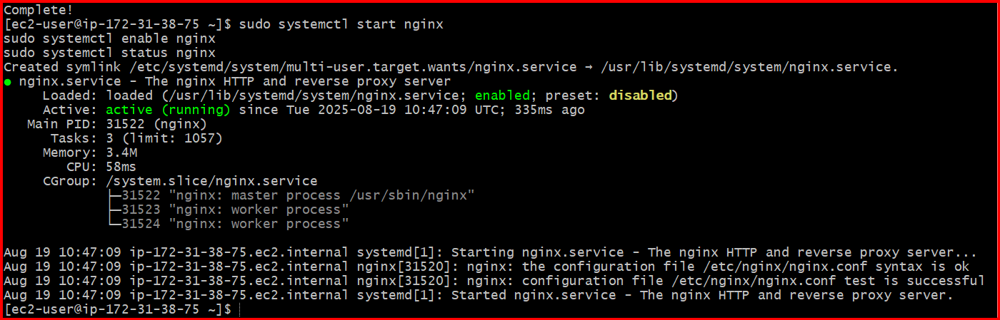

**Check in Browser**

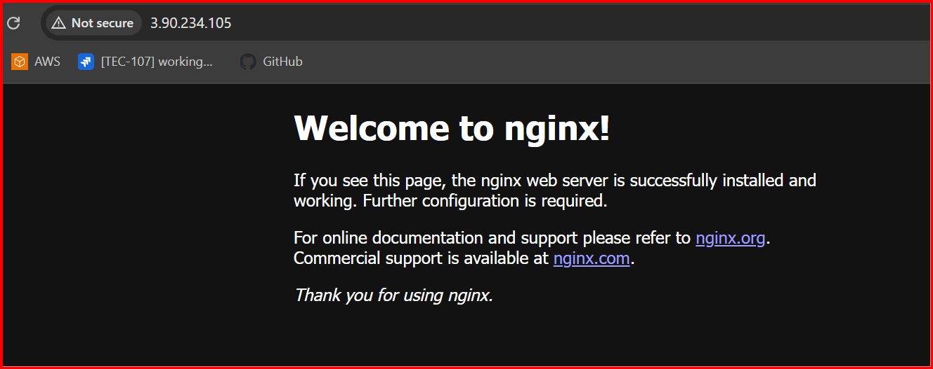

**Install Apache Tomcat**

**cd /opt**

**sudo wget tomcat link**

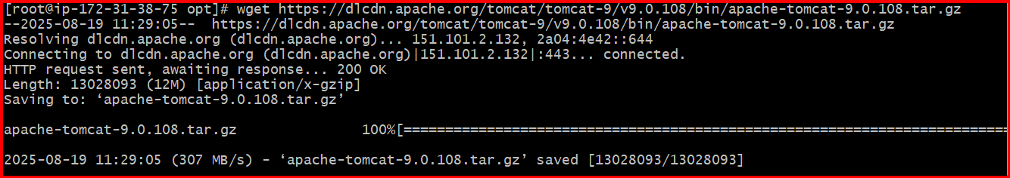

**sudo tar xvf apache-tomcat-9/v9.0.108.tar.gz**

