**JENKINS TASK-1**

**1) Install Jenkins and run Jenkins on port number 8081.  
2) Secure Jenkins server  
3) Create users called DevOps, testing in Jenkins with Limited access.  
4) Configure labels and restrict the jobs to execute based on label only.  
5) Create Three sample jobs using the below URL.**

**1.Run Ec2 Instance**

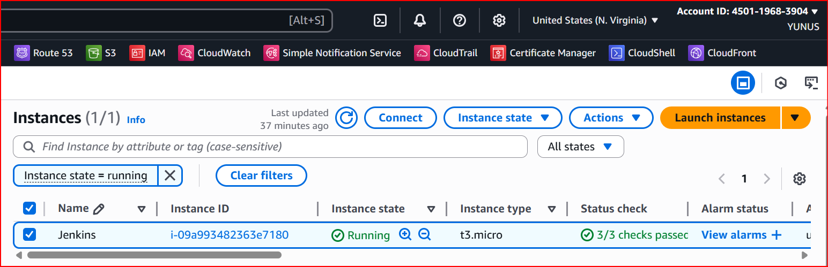

**Download Jenkins and Java**

1. **sudo wget -O /etc/yum.repos.d/jenkins.repo \https://pkg.jenkins.io/redhat-stable/jenkins.repo**
2. **sudo dnf install -y java-17-amazon-corretto**
3. **java -version**
4. **Yum install Jenkins**
5. **Systemctl start Jenkins**
6. **Systemctl status Jenkins**

**Check with IP address port 8080 is working or not**

**Change the Port number to 8081**

1. **Now go to → sudo vi /usr/lib/systemd/system/jenkins.service**
2. **Update → Environment="JENKINS_PORT=8081"**
3. **sudo systemctl daemon-reexec**
4. **sudo systemctl daemon-reload**
5. **sudo systemctl restart jenkins**

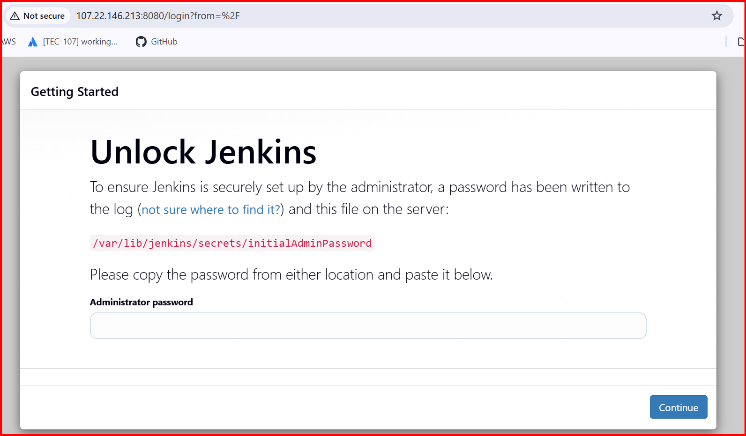

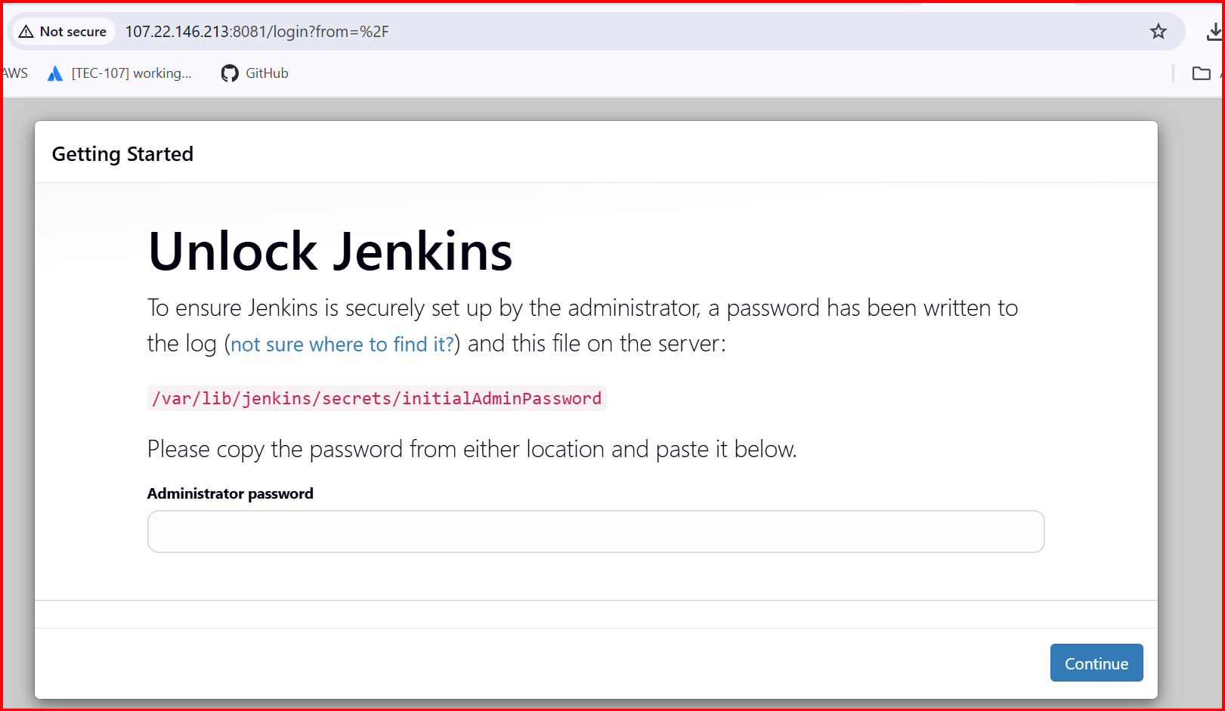

**2. Secure Jenkins server**

**Cat /var/lib/Jenkins/secrets/intialAdminPassword**

**Shows the password**

**Copy and Past in browser**

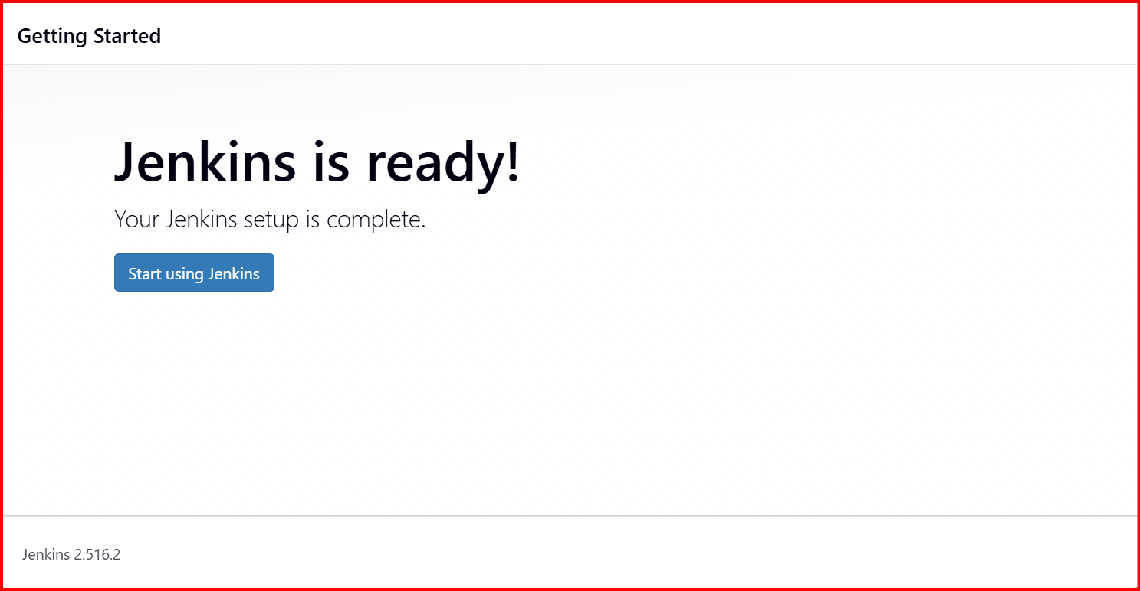

**User profile 🡪 Settings 🡪 Change Password**

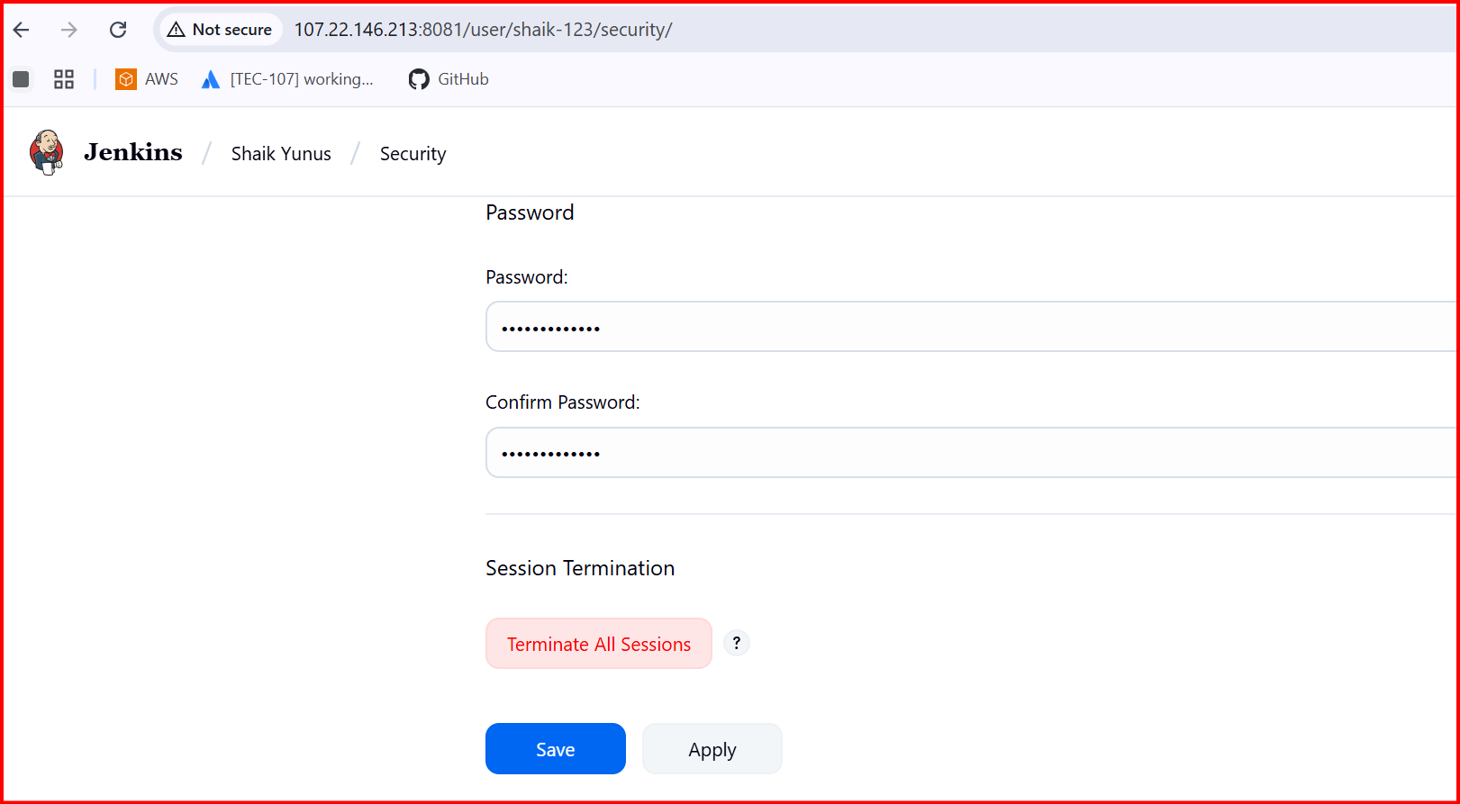

**3.Create users called DevOps, testing in Jenkins with Limited access**

**Install plugins**

**Role based plugins**

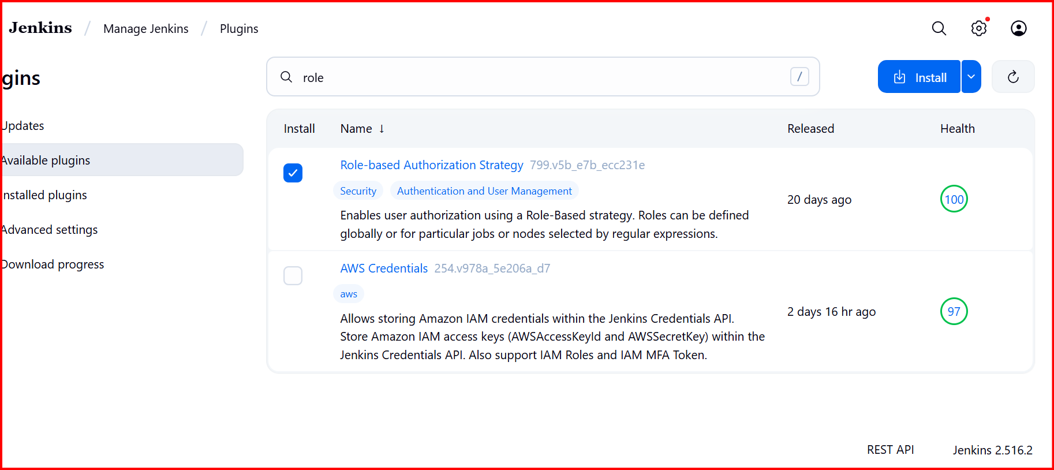

**Create User🡪 Devops**

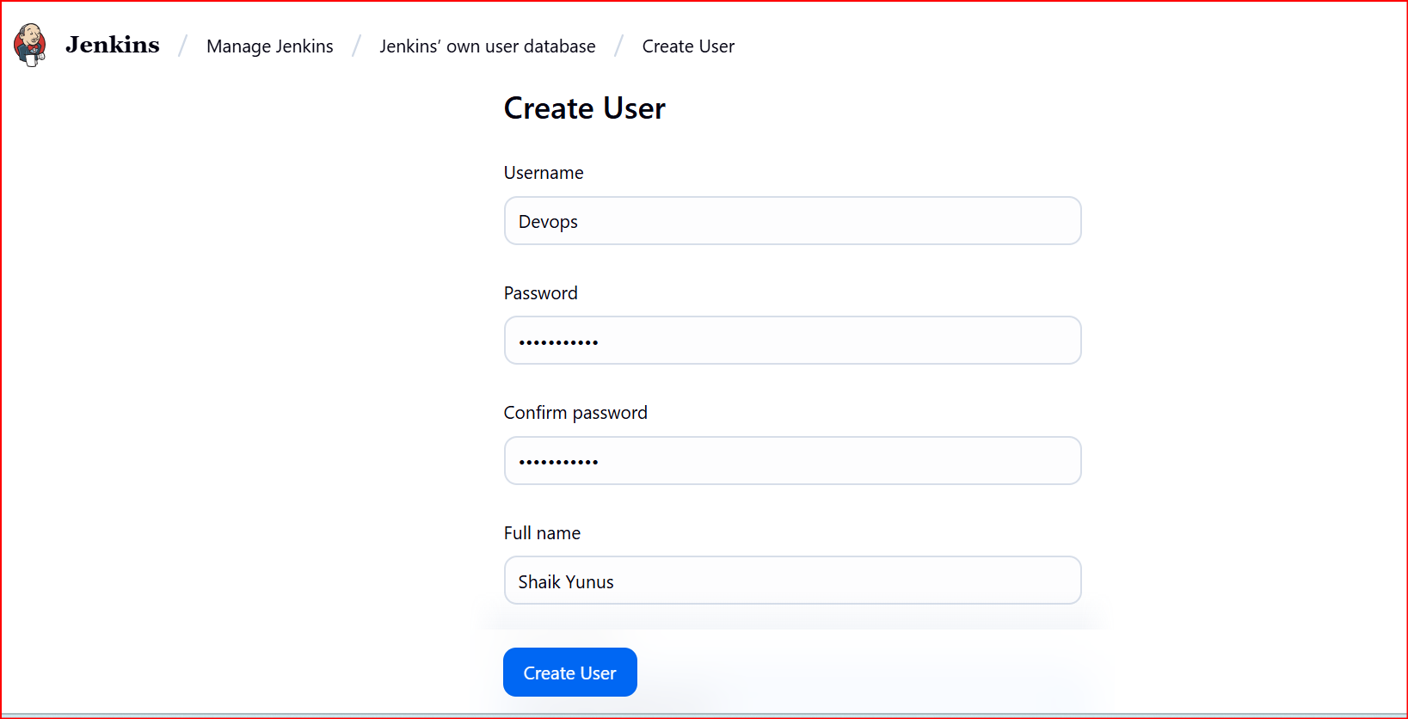

**Manage Jenkies 🡪 Authorization 🡪 Project Based Metrics Authorization Strategy**

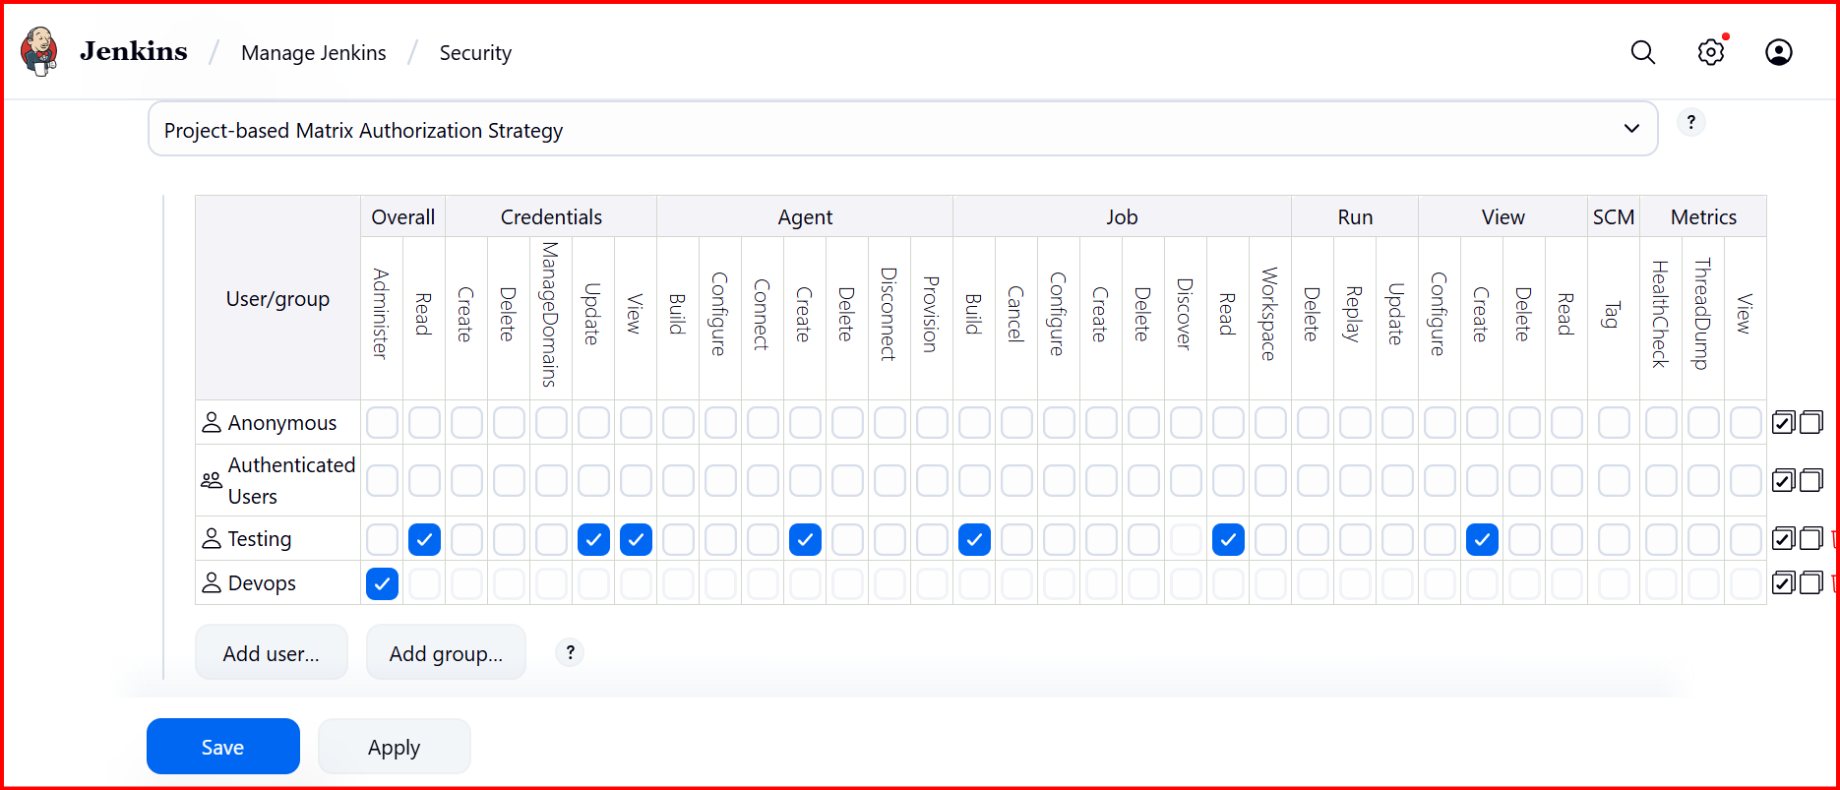

**4.Configure labels and restrict the jobs to execute based on label only.**

**Git Install 🡪 Yum install git**

**Manage Jenkins🡪 system🡪 Lables 🡪 Master🡪 Save**

**Create First-Job 🡪 New-Iteam name🡪 Free style project🡪 master 🡪Select git 🡪 URL**

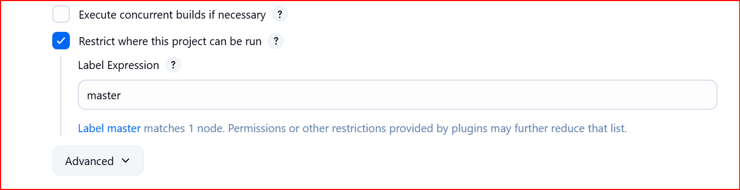

**Note: Disk space is below threshold of 1GB only 451.39 MB out of 455.89 MB left on/temp**

**Create a new tmp directory:  
sudo mkdir -p /var/lib/jenkins/tmp**

**sudo chown -R jenkins:jenkins /var/lib/jenkins/tmp**

**Add below temp file → sudo systemctl edit jenkins**

**[Service]**

**Environment="JAVA_OPTS=-Djava.io.tmpdir=/var/lib/jenkins/tmp"**

**Then reload**

**sudo systemctl daemon-reload**

**sudo systemctl restart jenkins**

**Install Bit bucket**

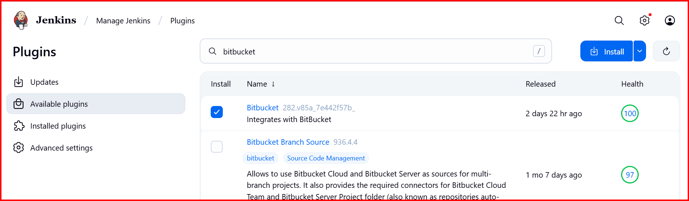

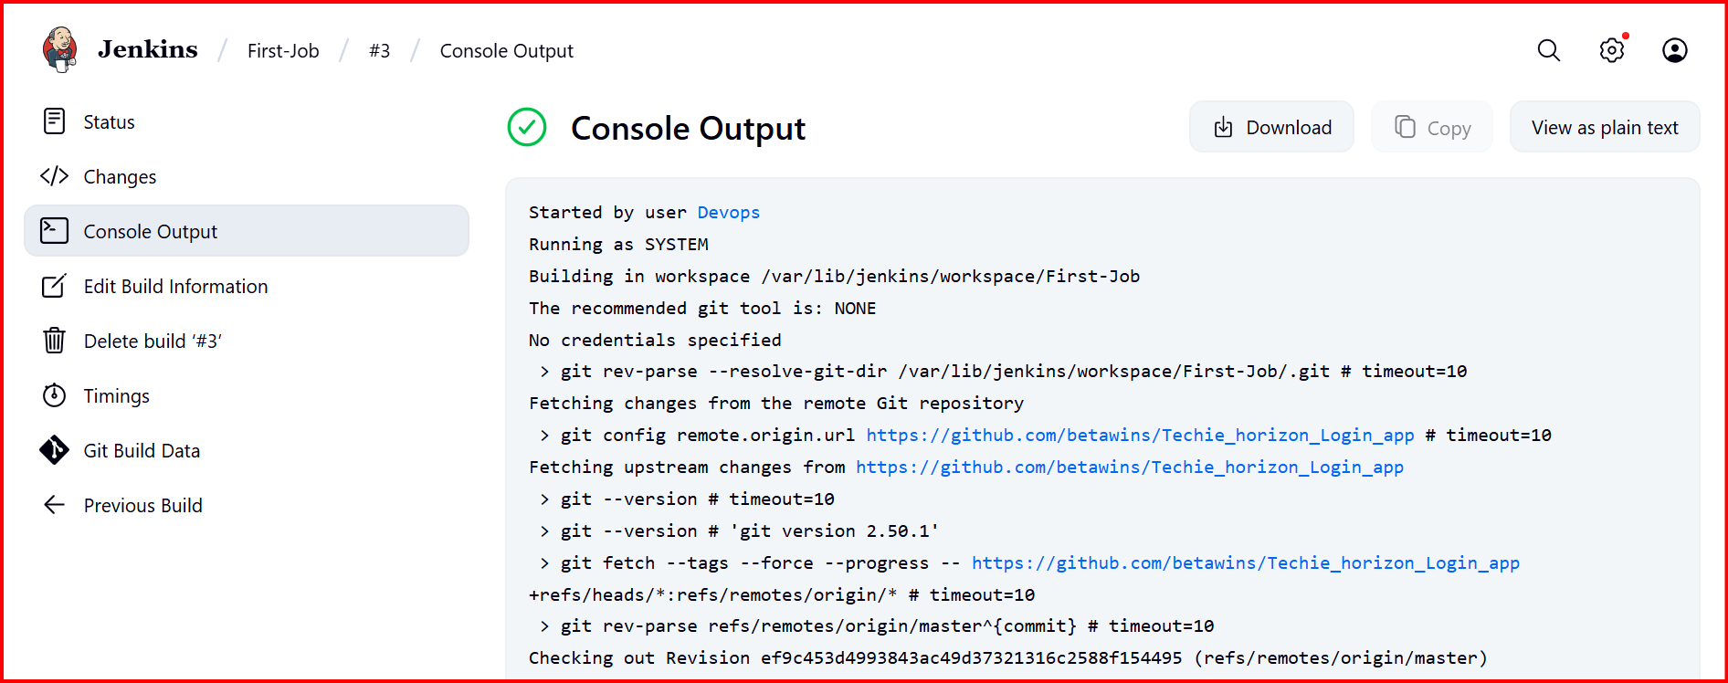

**5.Create Three sample jobs using the below URL.**

[**https://github.com/betawins/Techie_horizon_Login_app.git**](https://github.com/betawins/Techie_horizon_Login_app.git)

**Create 3 different jobs with master lable and use the git URL**

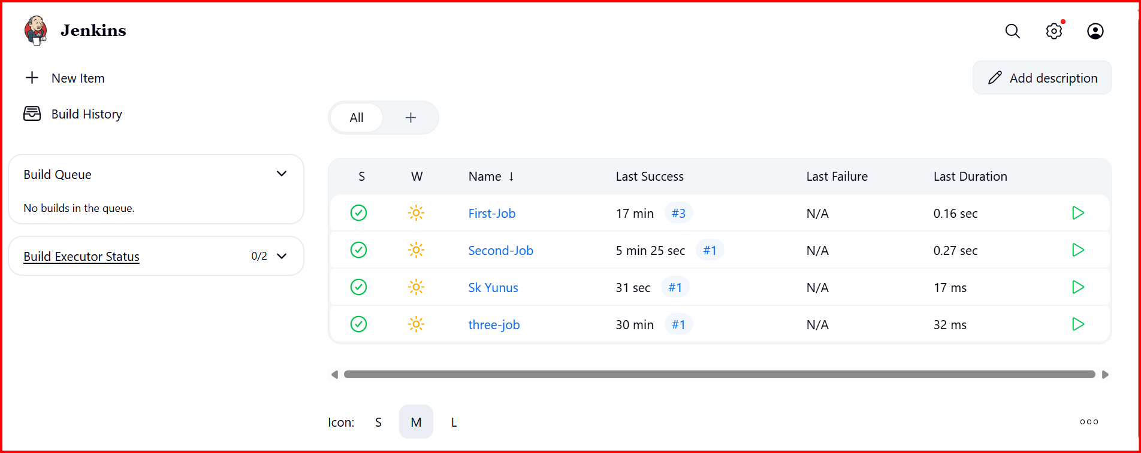

**6.Create one Jenkins job using git hub Private repository.**

**Go to Manage Jenkins 🡪 credentials 🡪 username should be Git username 🡪 Password**

**You should create a token🡪 git 🡪 Setting 🡪 Developer settings 🡪Personal access tokens🡪 classic 🡪 new token classic 🡪 Name 🡪 Enable repo 🡪 generate token**

**Password should be appeared 🡪 copy and paste this password in Jenkins and Save**

**Create one private repo in git hub**

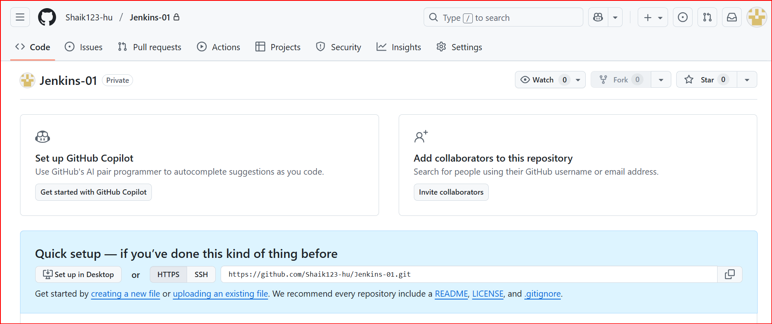

**Create job in Jenkins and give the git url and credentials and create**

**Bulid**

