**TASK QUESTIONS**

1. Create user with name Techie and provide sudo access to user.

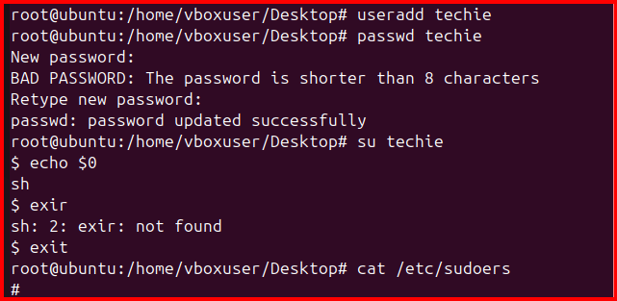



1. Navigate to the home directory.

Tild command is used for home directory

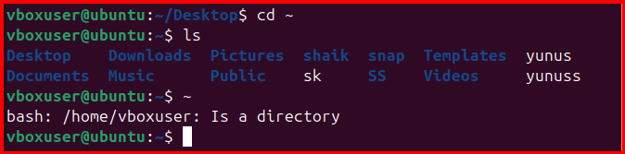

1. Create a new directory.
2. List the contents of a directory.
3. Change the current directory.
4. Create a new empty file
5. View the contents of a file.

Mkdir command is used for new directory

ls command is used for list the contents

cd command is used for change current directory

touch command is used for create the empty file

Vi command file is to edit the content

Cat command is displaying the edit content

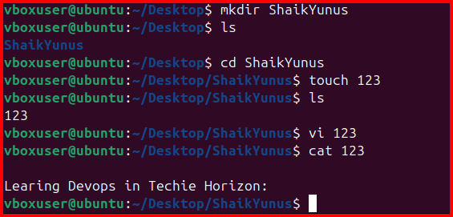

8. Copy a file to another location.

9. Move a file to another location.

Mv = move command

Cp = copy command

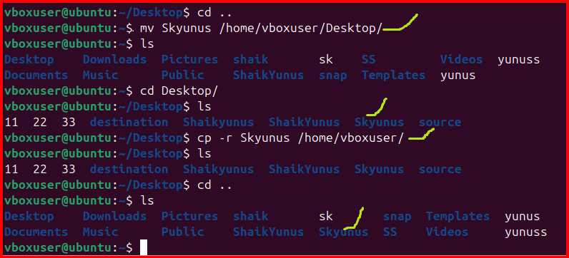

**10. Rename a file.**

**11. Delete a file.**

**Mv old file name new file name**

**rm file nameUpdate the system packages**

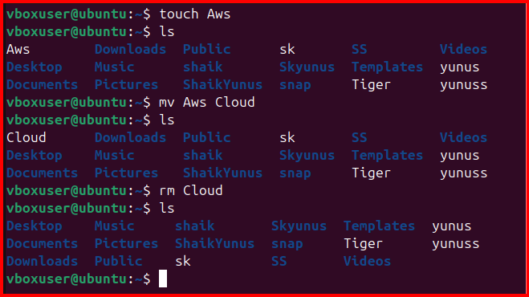

**12.** **Grant or revoke permissions on a file or directory.**

**Chmod permissions filename**

**R=4,w=2,x=1**

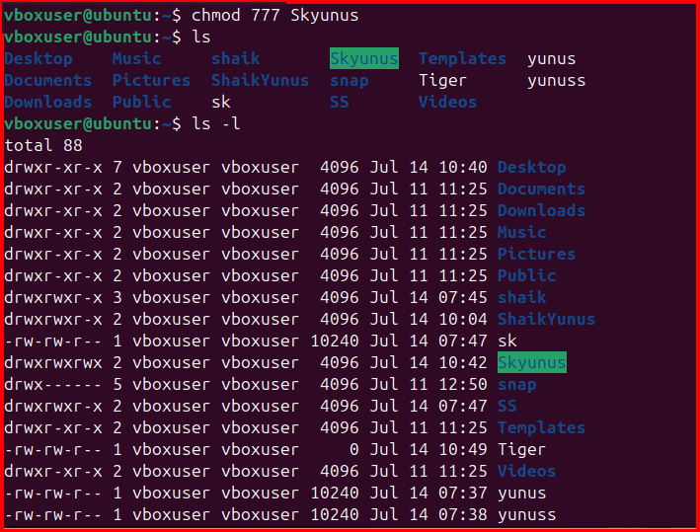

**13.** **View the current date and time.**

**Data command**

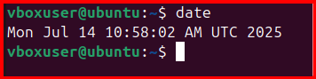

**14.** **Check the system uptime.**

**Uptime:** **Show how long the system has been running**

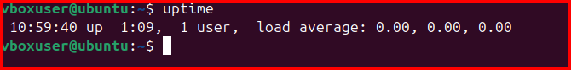

**15.** **View the running processes.**

**List of running services/process**

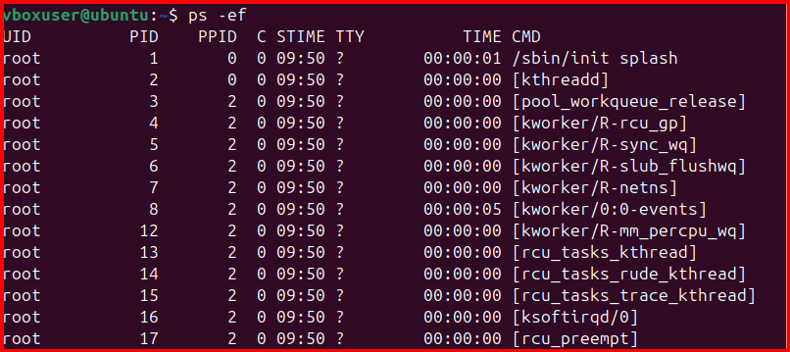

**16.** **Kill a running process**

**Kill -9 PID**

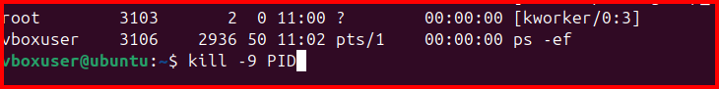

**17.Install a package using the package manager**

**Apt install git**

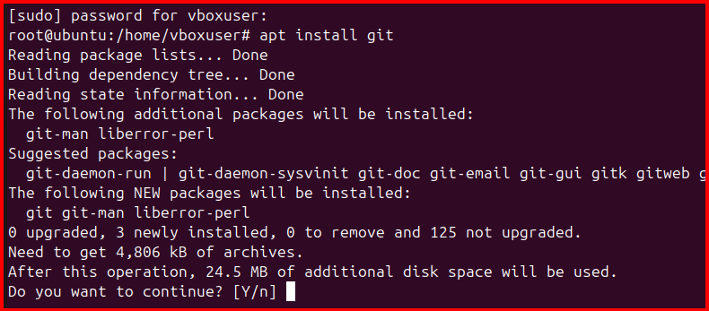

**18.** **Update the system packages.**

**Sudo apt update is the command for update the system package**

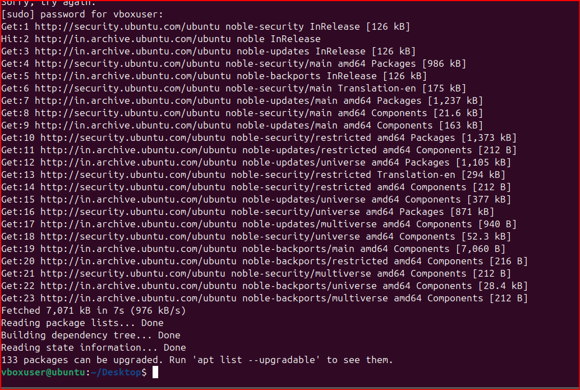

**19.Create a symbolic link.**

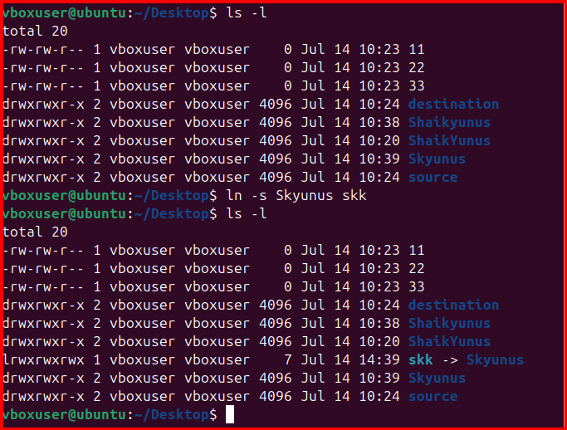

**20.Search for files using the find command.**

**Find -name filename**

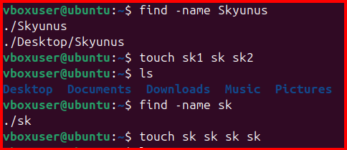

**21.** **Compress and decompress files using tar.**

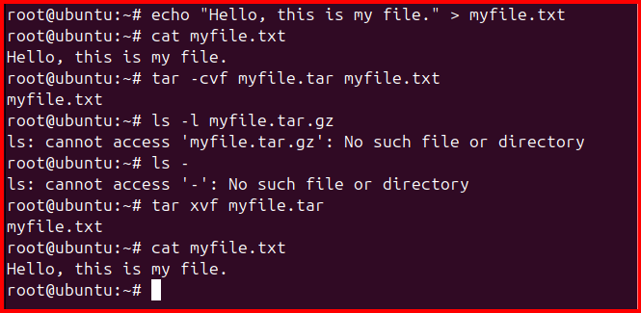

**22.Monitor system resources with top or htop.**

**Top to check the system utilisation**

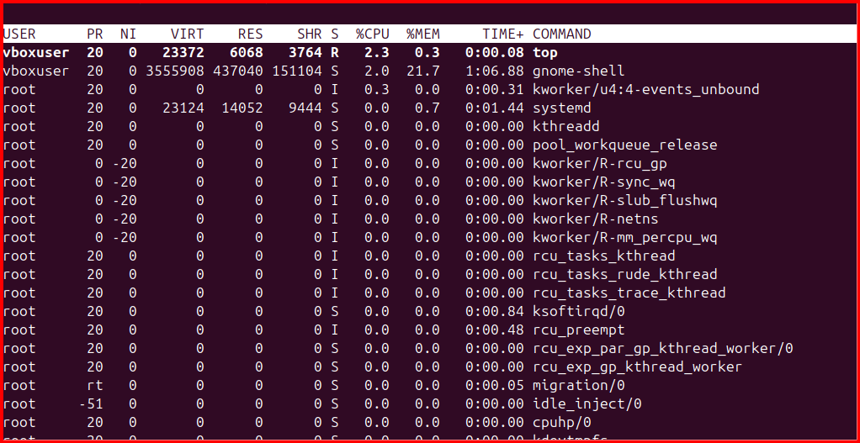

**23. Create and manage user groups.**

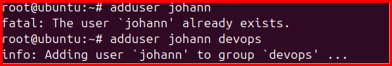

**24.Set up SSH password less authentication.**

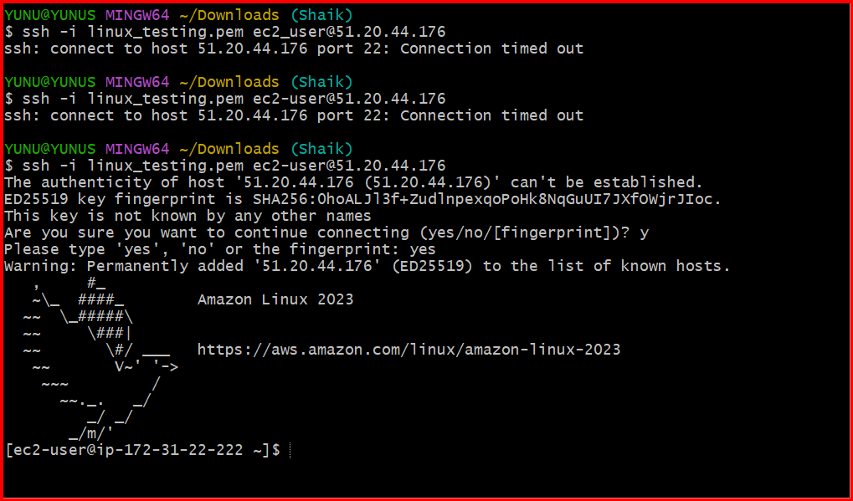

**25.Monitor log files using tail or grep.**

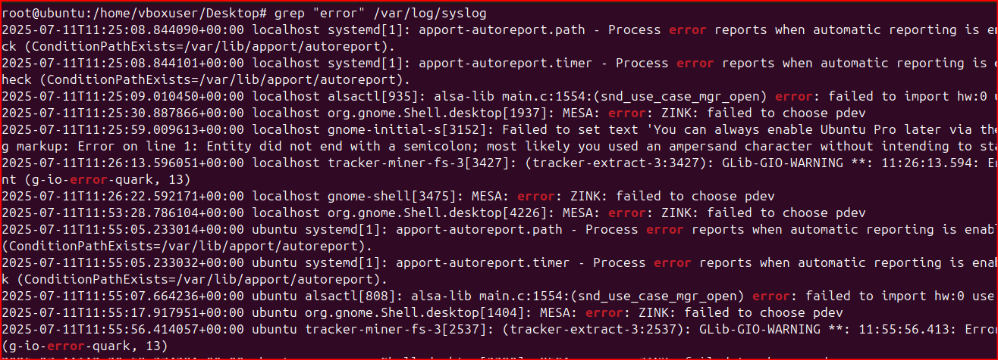

**26.Set up a web server (e.g., Apache or Nginx)**

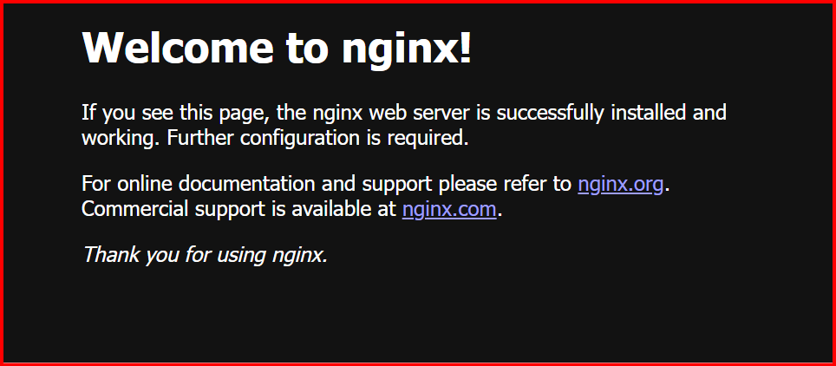

**27. Configure and secure a MySQL Database.**



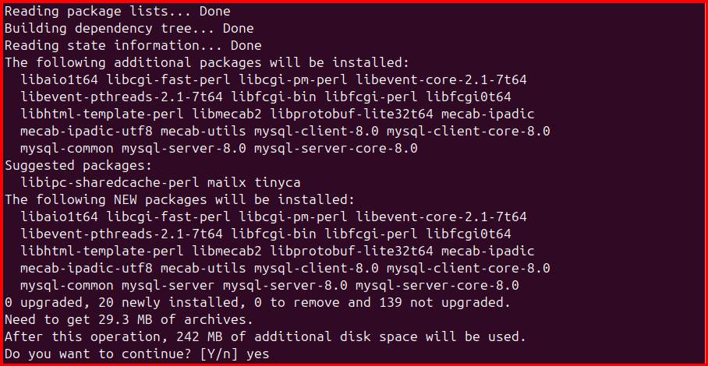

**28.Set up a Application Server (e.g.,Apache Tomcat).**

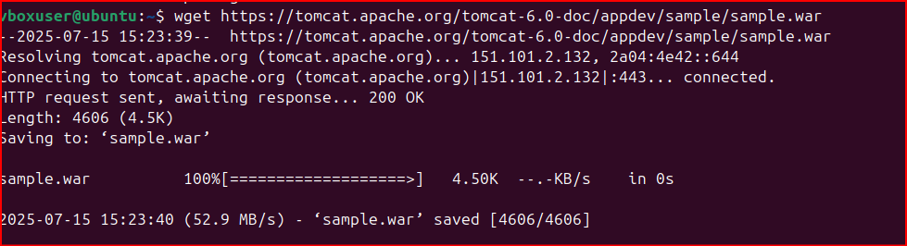

**29.** **create a service file for Apache Tomcat.(Should execute by using systemtctl command).**

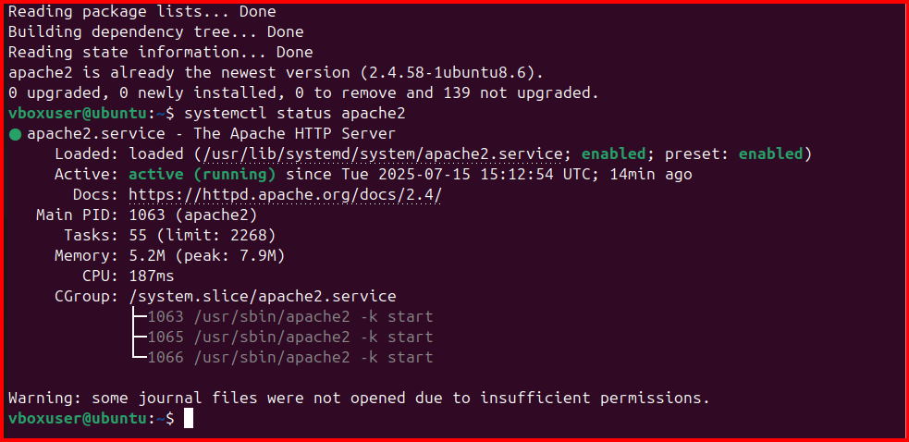

**30.Print specific columns from a delimited file.**

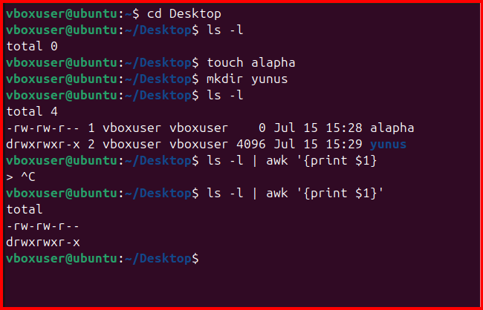

**31.Filter and print lines based on a specific pattern or condition.**

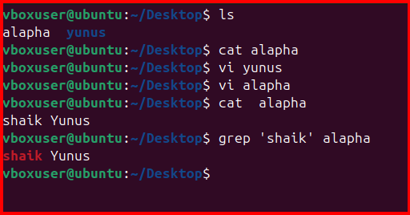

**32.Calculate and print the average, sum, or other statistics of a column.**

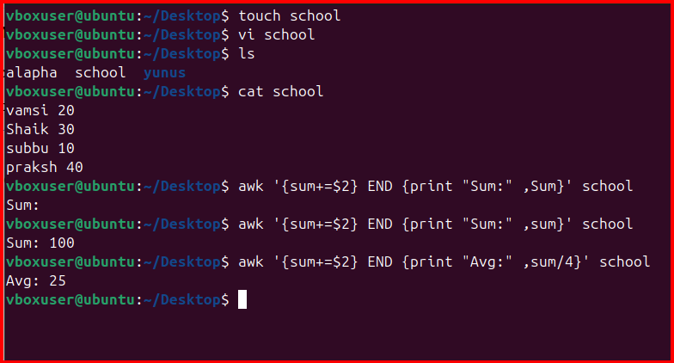

**33.** **Perform string manipulation, such as extracting substrings or changing case.**

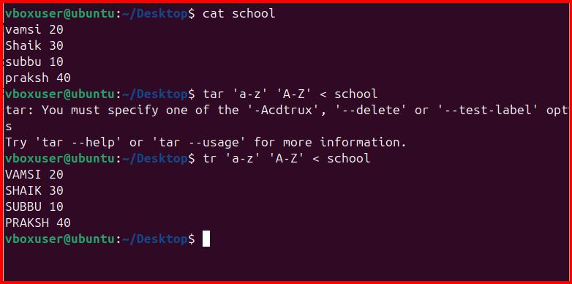

**34.Count the occurrences of a specific pattern in a file.**

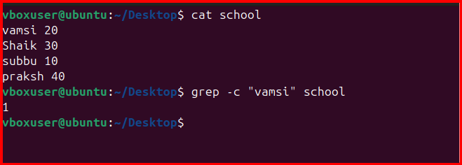

**35.** **Sort lines based on a specific field or column.**

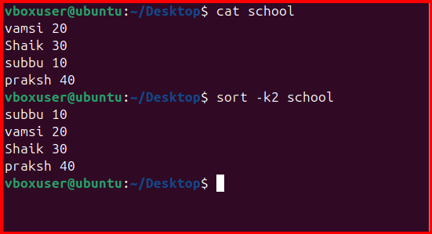

**36.** **Merge multiple files based on a common field or column.**

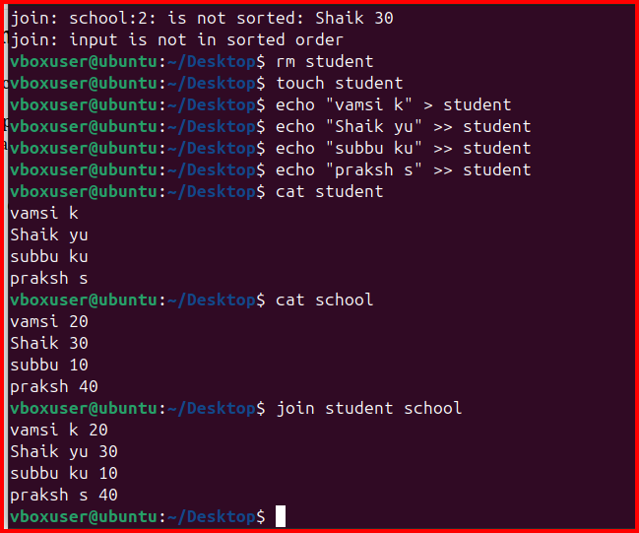

**37.Substitute text in a file using search and replace.**

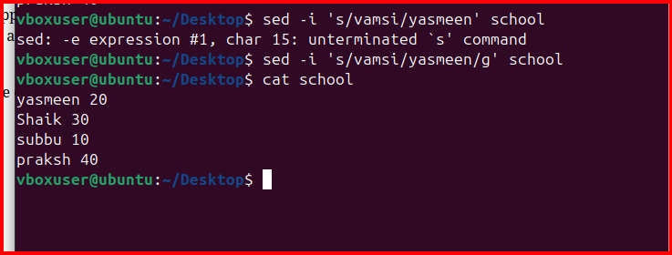

**38.Delete specific lines based on a pattern or line number.**

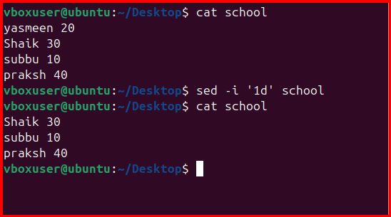

**39.Append or insert text before or after a specific pattern or line.**

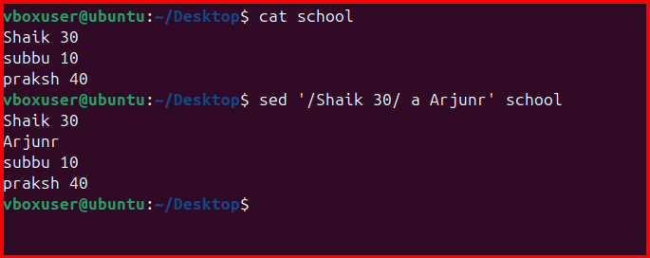

**40.Print only specific lines from a file.**

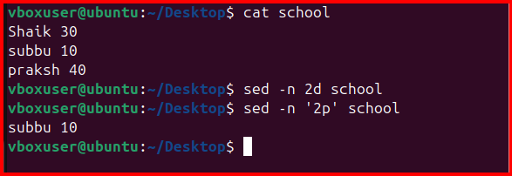

**41.** **Copy file from linux to windows machine**

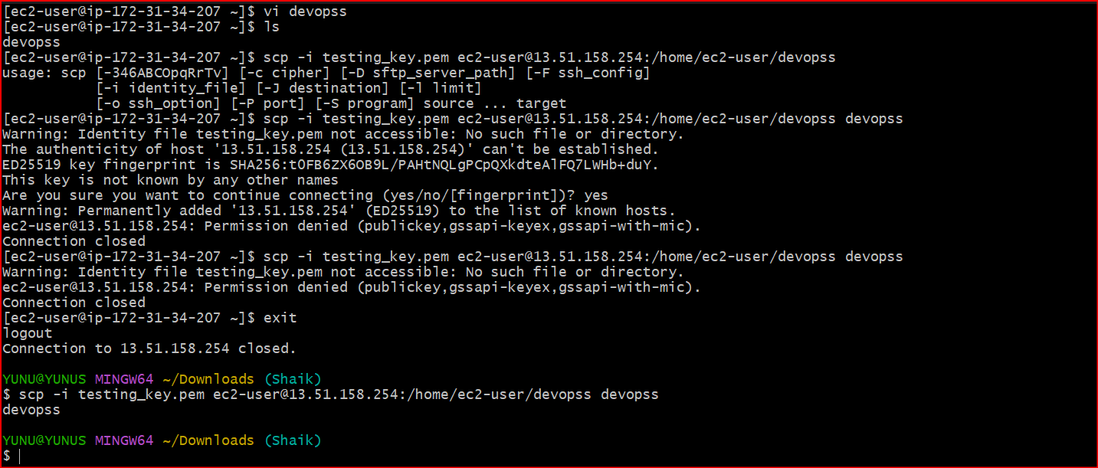

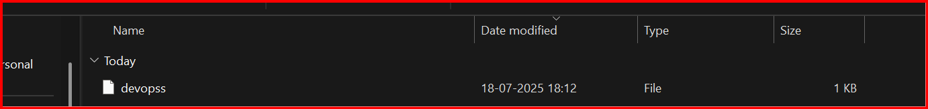

**42. use cases for AWK and 5 use cases for sed.**







