**S3-Task**

1. **Create s3 bucket and upload some objects to s3.**

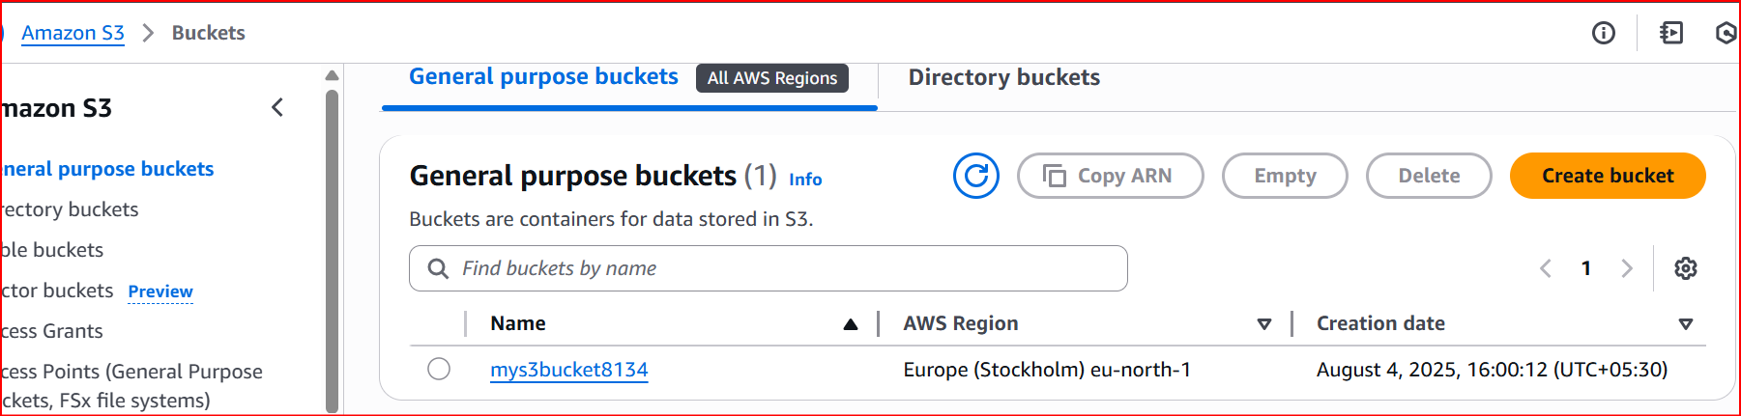

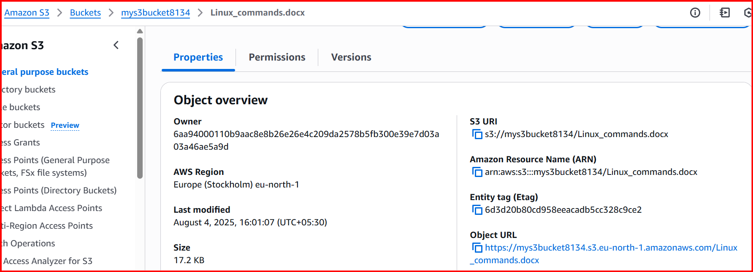

**2.** **Deploy static website in s3 bucket.**

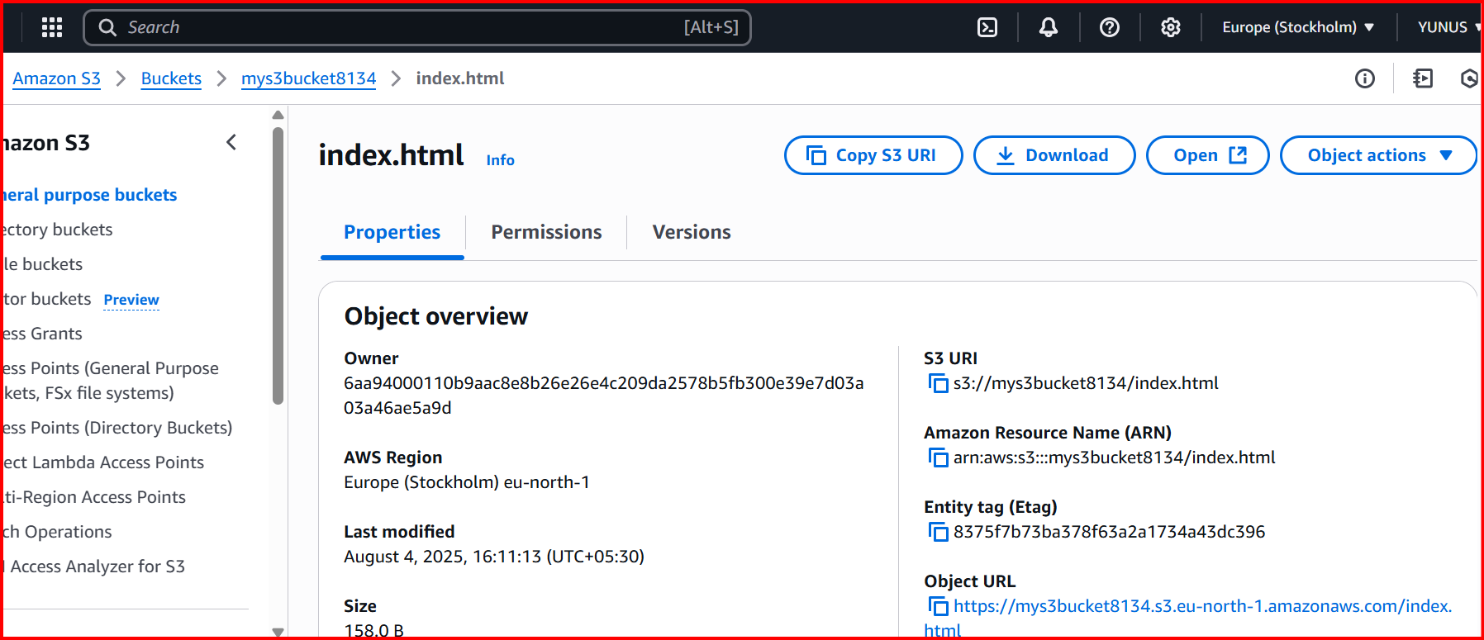

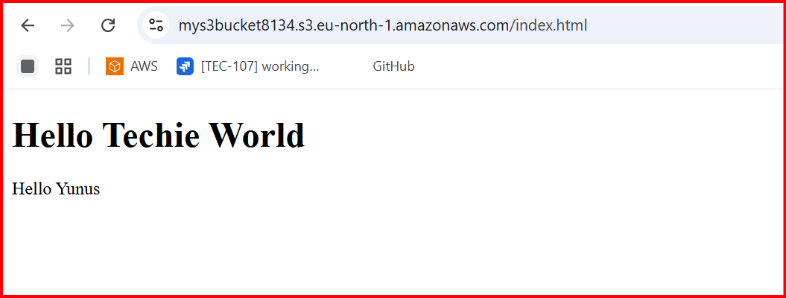

**3.Enable cross region replication on s3 buckets.**

**Source:**

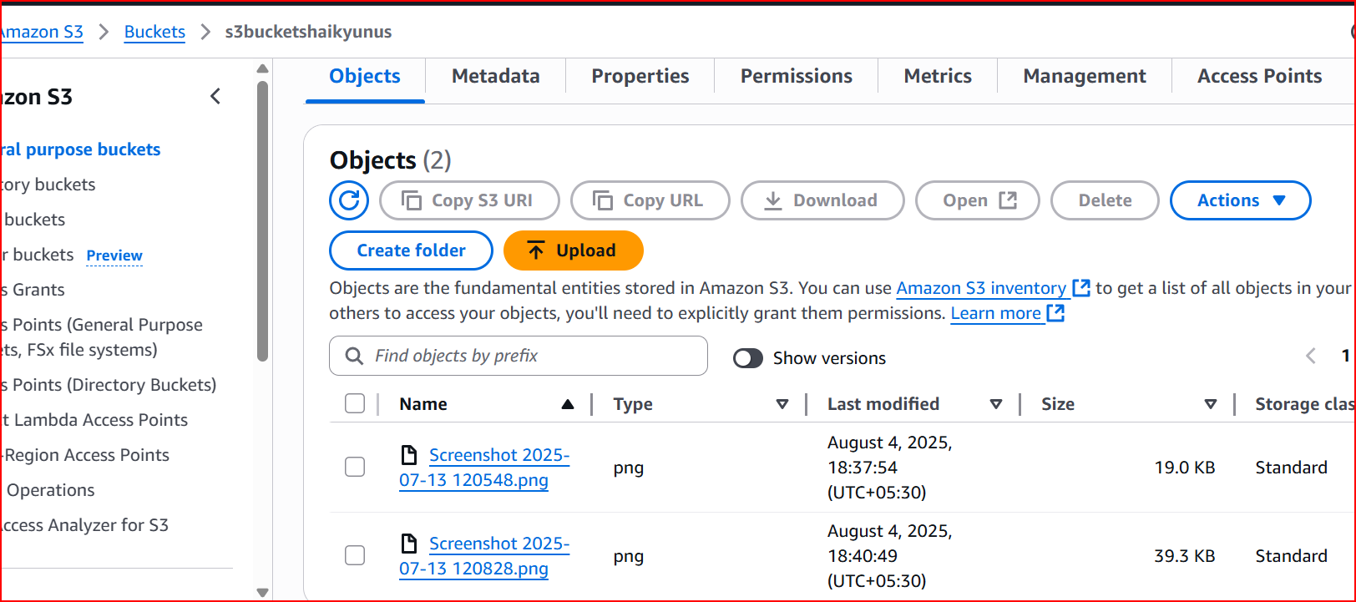

**Destination:**

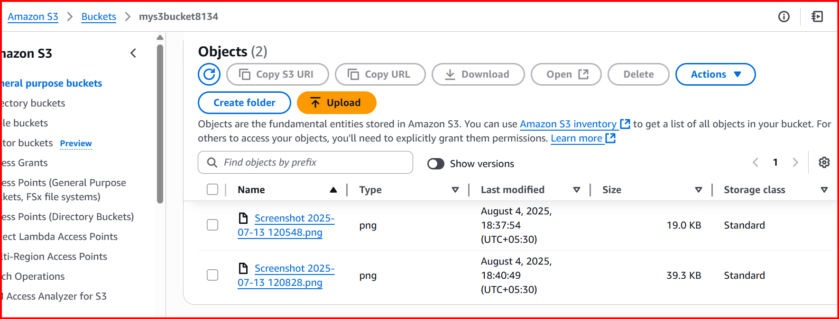

**4.** **Configure bucket policy,only Admin user can see the objects of s3 bucket.**

**User:**

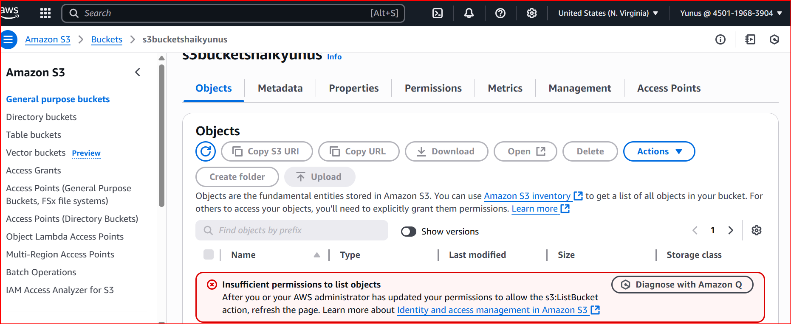

**Admin:**

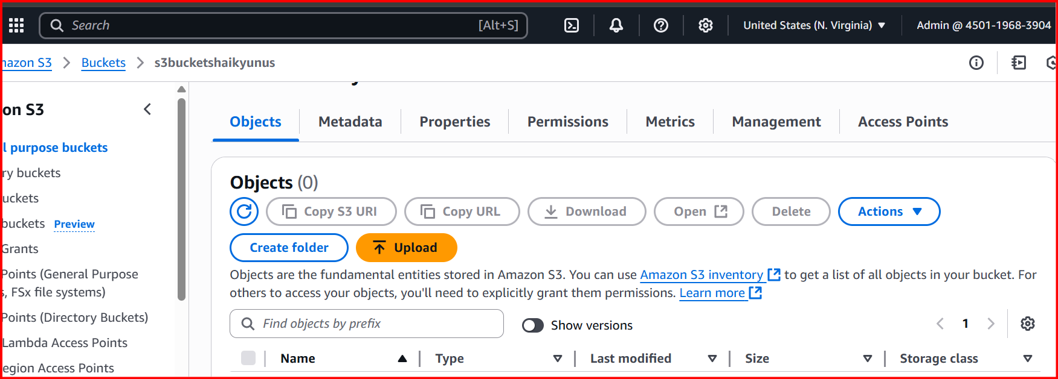

**5.** **Setup lifecycle policies to automatically transition or delete objects based on specific criteria.**

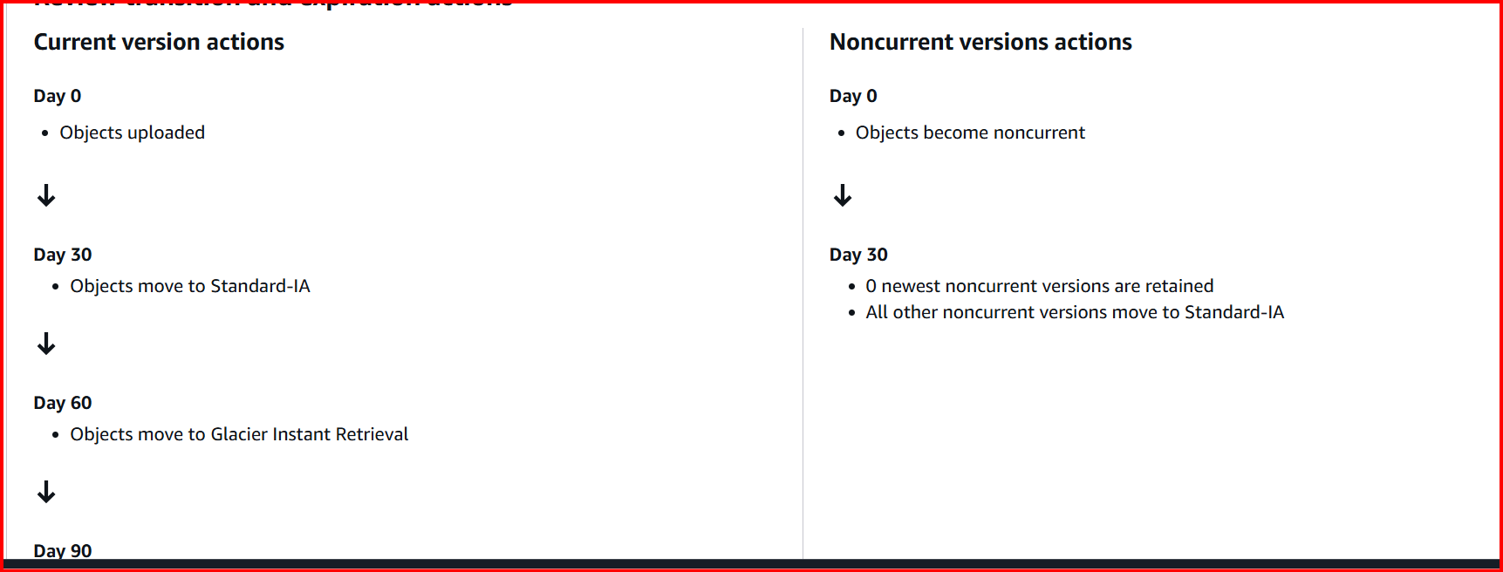 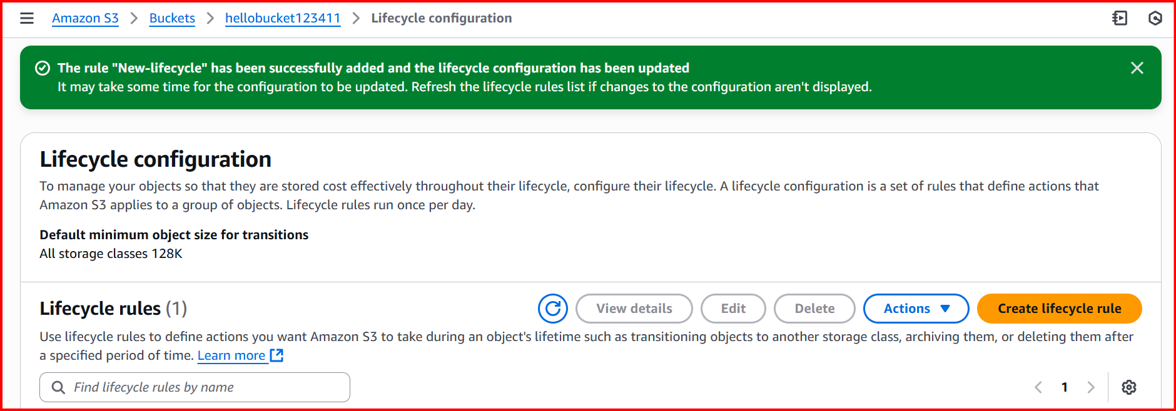

**6.** **Push some objects in s3 using AWS CLI.**

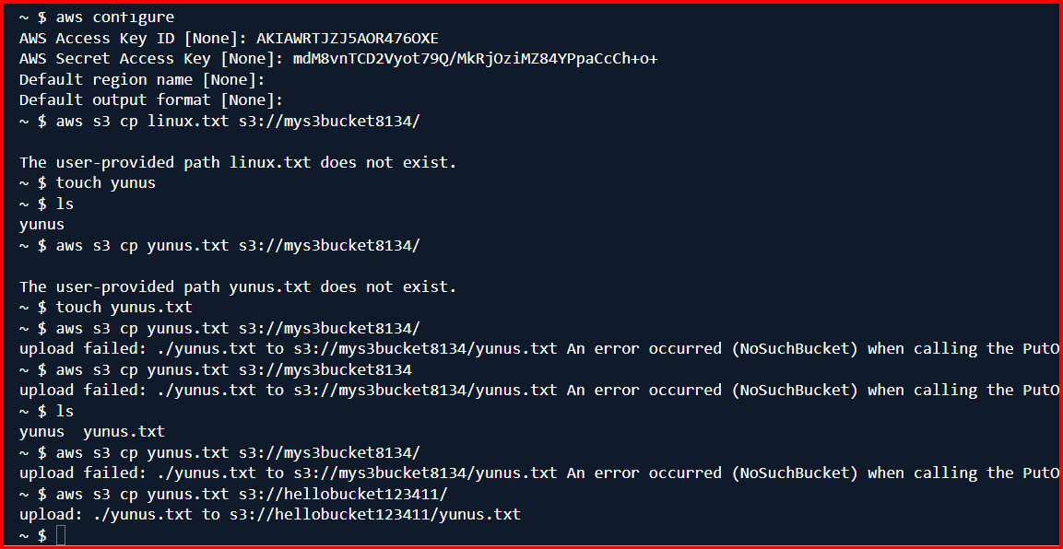

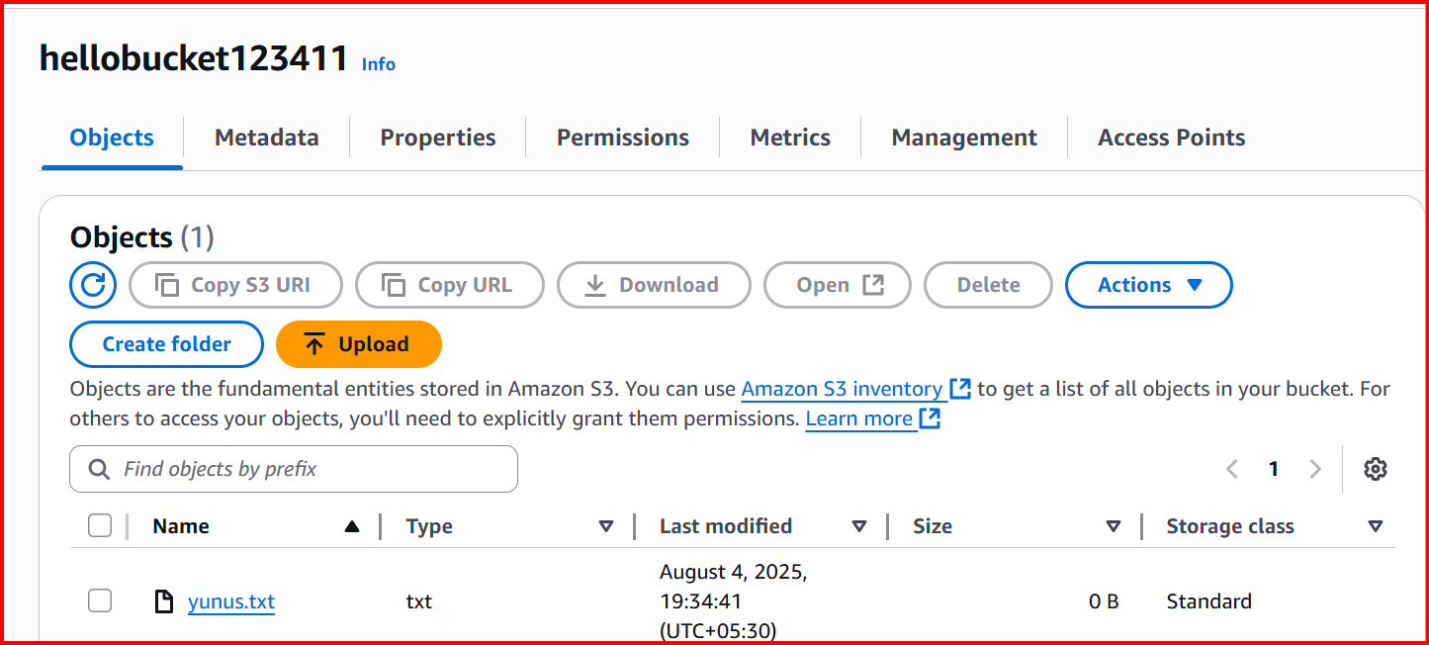

**7.** **Write a bash script to create s3 bucket.**

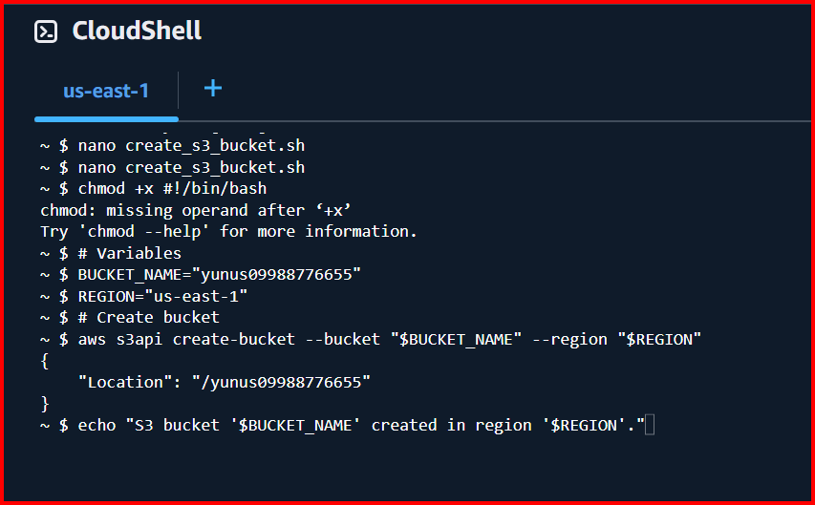

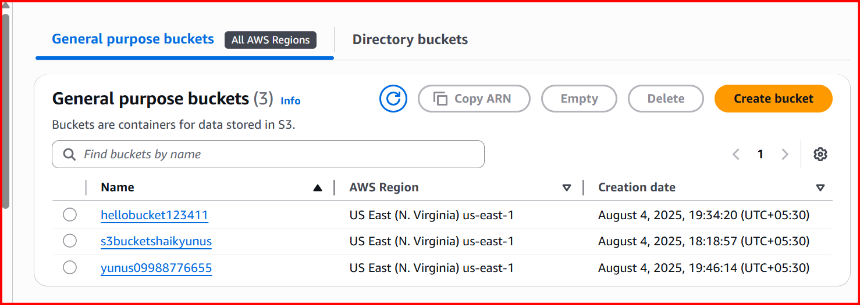

**8.Upload one 1 gb of file to s3 using cli.**

