1.To check a Swap Two Numbers

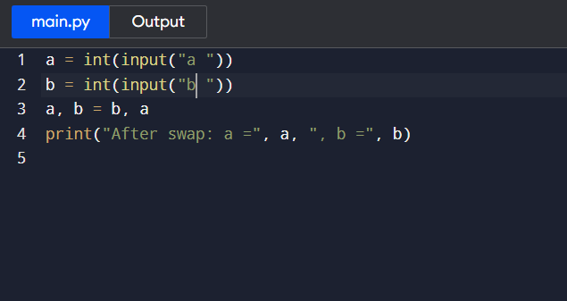

2.Find Largest of Three Numbers

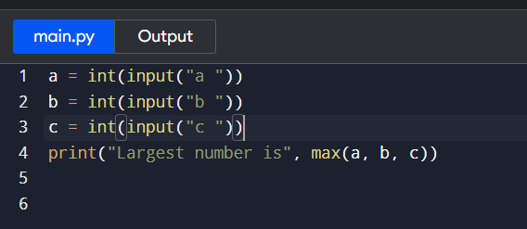

3.Multiplication Table

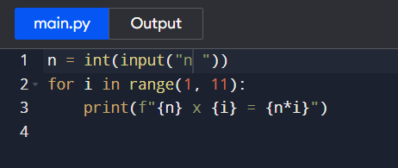

4.Count Digits in a Number

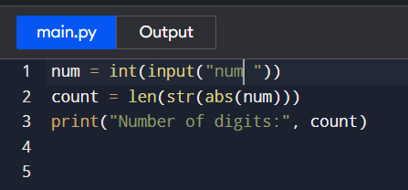

5. Sum of Digits

