1.Palindrome String

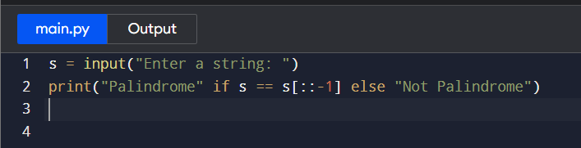

2.Count Vowels in String

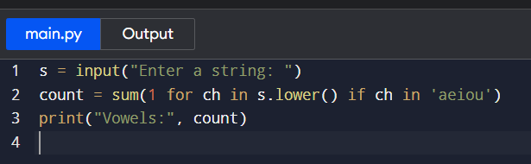

3. Armstrong Numbers in Range

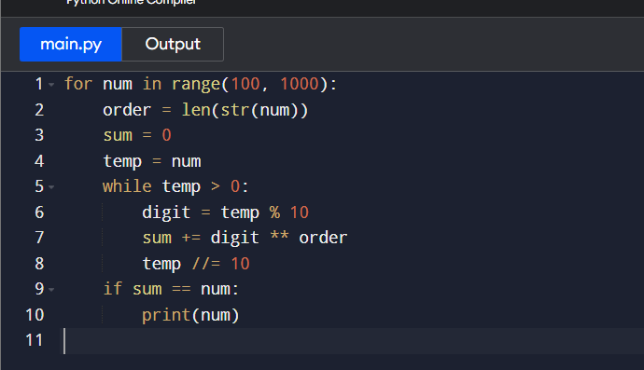

4. Prime Numbers in Range

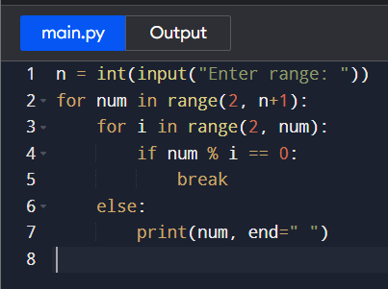

5. Sum of Natural Numbers

