A
Mini Project Report
On
Dynamic Data Visualization Dashboard for Blood Bank Management using Python
Submitted to DR.K.V.SUBBA REDDY INSTITUTE OF TECHNOLOGY
In Partial Fulfillment of the requirements for the Award of Degree of
BACHELOR OF TECHNOLOGY IN
COMPUTER SCIENCE AND ENGINEERING (AIML/AI)
Submitted By
______________ ____________
______________ ____________
______________ ____________
Under the Esteemed guidance of
Dr. B. MAHESH
Associate Professor, Department of CSE
Department of CSE (AI & AIML)
DR.K.V.SUBBA REDDY INSTITUTE OF TECHNOLOGY
UGC AUTONOMOUS
(Approved by AICTE, NEW DELHI, Affiliated to JNTUA, Anantapur)
2026-2027

DR.K.V.SUBBA REDDY INSTITUTE OF TECHNOLOGY
UGC AUTONOMOUS
(Accredited by NBA, Approved by AICTE NEW DELHI, Affiliated to JNTUA, Anantapur)
Department of CSE (AI/AIML)
CERTIFICATE
This is to certify that the project entitled “Dynamic Data Visualization Dashboard for Blood Bank Management using Python” is a bonafide work carried out by
______________ ____________
______________ ____________
______________ ____________
in partial fulfillment of the requirement for the award of the degree of BACHELOR OF TECHNOLOGY in CSE (AI/AIML) from Dr.K.V.Subba Reddy Institute of Technology, Kurnool, under our guidance and supervision.
The results presented in this Mini project have been verified and are found to be satisfactory. The results embodied in this Mini project have not been submitted to any other university for the award of any other degree or diploma.

Guide Head of the Department
DECLARATION
This is to certify that the work reported in the present Mini project entitled “Dynamic Data Visualization Dashboard for Blood Bank Management using Python” is a record of bonafide work done by us in the Department of CSE (AI/AIML), Dr.K.V.Subba Reddy Institute of Technology, Kurnool. The reports are based on the project work done entirely by us and not copied from any other source.
We submit our project for further development by any interested students who share similar interests to improve the project in the future.
The results embodied in this Mini project report have not been submitted to any other University or Institute for the award of any degree or diploma to the best of our knowledge and belief.
ACKNOWLEDGMENT
We are extremely grateful to Dr. K Sree Latha, Principal and H. Ateeq Ahmed, HOD, Department of CSE (AI/AIML), Dr.K.V.Subba Reddy Institute of Technology for their constant support. We are extremely thankful to Dr. B. Mahesh, Associate Professor, Department of CSE, Internal Guide, for his constant guidance, encouragement and moral support throughout the project.
We will be failing in duty if we do not acknowledge with grateful thanks to the authors of the references and other literatures referred in this Project.
We express our thanks to all staff members and friends for all the help and coordination extended in bringing out this project successfully in time.
Finally, we are very much thankful to our parents who guided us for every step.
INDEX / TABLE OF CONTENTS
1. Abstract
2. Introduction
2.1 Background
2.2 Motivation
2.3 Problem Statement
2.4 Objectives of the Project
2.5 Scope of the Project
3. Literature Survey / Existing System
3.1 Existing Data Visualization Tools
3.2 Limitations of Existing System
3.3 Proposed System
4. Technologies and Tools Used
4.1 Python
4.2 Streamlit
4.3 Pandas
4.4 NumPy
4.5 Plotly
5. System Requirements
5.1 Hardware Requirements
5.2 Software Requirements
6. Dataset Description
6.1 Dataset Sources
6.2 Dataset Attributes
6.3 Data Types
6.4 Data Preprocessing
6.5 Data Cleaning
7. Implementation
7.1 Project Structure
7.2 Data Loading
7.3 Data Preprocessing
7.4 Visualization Development
7.5 Streamlit Interface
7.6 Interactive Filters
7.7 Dashboard Integration
8. Data Visualization
8.1 Collection Trend Charts
8.2 State-wise Comparison
8.3 Seasonality Charts
8.4 Blood Group Visualization
8.5 Safety and Discard Charts
8.6 Donor Profile Charts
8.7 Blood Bank Directory Charts
9. Results and Discussion
9.1 Dashboard Charts
9.2 Visualization Results
9.3 Analysis of Results
9.4 Key Insights
10. Advantages and Limitations
11. Conclusion
12. Future Enhancement
13. References
14. Appendix
A. Source Code
B. Dataset Notes
C. Additional Screenshots

GitHub Repository: https://github.com/ShaikAdnan001/blood-bank-dashboard
Live Dashboard: https://blood-bank-dashboard-okg7dmhrjxccv8wmcq84ee.streamlit.app/

1. ABSTRACT
The India Blood Bank Management Dashboard is a data-visualization project that explores blood collection, voluntary and replacement donation, blood-group distribution, transfusion-transmissible infection (TTI) discards, donor profiles and the blood bank network of 30 Indian states and union territories over the years 2010 to 2020. The application brings five linked CSV datasets into one interactive web interface so that a user can filter by year range, region and state, compare categories, inspect seasonal patterns and read key indicators such as the demand gap, discard rate and voluntary donation share.
The dashboard is written in Python. Streamlit provides the web interface and interactive controls, Pandas prepares and aggregates the data, and Plotly Express produces the interactive charts. The interface is organised into eight tabs: Overview, States, Seasonality, Blood groups, Safety & discards, Donors, Blood banks and Data. An important point is that the data used in this project is simulated. It was produced by the script generate_blood_bank_data.py with a fixed random seed, loosely calibrated to publicly reported national trends, and it must not be presented as official statistics. The project therefore demonstrates the visualization workflow and dashboard design rather than reporting real national figures.
Keywords: Data visualization, blood bank management, blood donation, Streamlit, Plotly, Pandas, Python, interactive dashboard, simulated data.

2. INTRODUCTION

2.1 Background
Blood donation and supply in India. Blood cannot be manufactured; it can only come from donors, and it has a short shelf life. A country therefore needs a steady stream of donations, licensed blood banks to test, process and store the units, and a hospital network that can draw on that stock when patients need it. In India this system is regulated and monitored by bodies such as the National AIDS Control Organisation (NACO), the National Blood Transfusion Council (NBTC) and the Central Drugs Standard Control Organisation (CDSCO) under the Ministry of Health and Family Welfare. Each of them reports different aspects of the system: how many units are collected, how many blood banks are licensed, and how much blood is voluntarily donated.
Voluntary and replacement donation. A voluntary donor gives blood without any specific patient in mind, while a replacement donor gives because a relative or friend of a patient has been asked to replace the units used. A high share of voluntary donation is considered healthier for a blood system because it makes the supply more stable and is associated with safer blood. For this reason the share of voluntary donation is one of the most closely watched indicators and is shown prominently in the dashboard.
Supply, demand and the demand gap. The estimated requirement for blood in a state depends on its population. When the units actually collected are smaller than the estimated requirement, the difference is called the demand gap. A dashboard that places collection, requirement and issue figures side by side makes it easy to see whether the gap is narrowing or widening over time and which states are most affected.
Safety, discards and components. Every unit is screened for transfusion-transmissible infections such as HIV, hepatitis B, hepatitis C, syphilis and malaria. Units that test positive, and units that expire before use, are discarded. The discard rate and the proportion of blood that is separated into components (red cells, plasma and platelets) are therefore useful measures of the quality of a blood bank network.
Data visualization and dashboards. Data visualization is the practice of representing data with bars, lines, points, areas, colours and sizes so that patterns, comparisons and unusual values can be seen quickly. A table of 330 state-year rows is hard to read, but the same data drawn as a ranked bar chart or a heatmap shows the leading states and the trends at once. A dashboard collects such charts and the headline figures on one screen, and interactive controls such as sliders and drop-down lists let the user change what is shown instead of reading a fixed report.
The Python data stack. In a Streamlit application the script is re-run whenever a control changes, so every figure and chart is recalculated from the selected data. Caching is used so that the CSV files are not reloaded on every interaction. Pandas provides the DataFrame structure used to load, filter and aggregate the data, and Plotly produces charts with hover details, zooming and panning. Together they allow a complete data application to be written in a single Python file and run in a web browser.

2.2 Motivation
Blood is needed every day for surgery, childbirth, accidents and the treatment of diseases such as thalassemia and cancer, yet shortages are widely reported. Students and the public rarely get a chance to look at how collection, demand and safety indicators change over time and differ between states. This project aims to make such information easier to explore through interactive charts instead of requiring users to compare many separate tables.
For computer science and AI students the project is also a practical exercise in the full data-visualization workflow: designing a dataset, preparing and cleaning it, choosing suitable chart types, and presenting the result in an interactive application. Because real state-wise records in a consistent format were not available for the whole period, a simulated dataset was designed so that the dashboard could be built and tested end to end, and every page of the dashboard states clearly that the data is simulated.

2.3 Problem Statement
Blood bank related information is scattered across reports, portals and files in different formats, and the raw tables are large and difficult to compare by eye. Static charts cannot be filtered by year, region or state, and it is easy to misread simulated or sample data as official statistics.
The problem has three parts. First, the information about collection, donors, blood groups, safety and the blood bank network is spread over several tables. Second, those tables are too large to read directly and cannot be explored interactively. Third, the data must be clearly identified as simulated so that nobody mistakes the figures for official counts. This project addresses all three: it brings five datasets into one interface, provides interactive charts and filters, and keeps a simulated-data note visible in the dashboard.

2.4 Objectives of the Project
- Visualize yearly blood collection, estimated requirement and units issued for the selected states between 2010 and 2020.
- Compare states and regions using ranked bar charts, a scatter plot and a heatmap of voluntary donation.
- Show the monthly pattern of collection and issue, and the closing blood stock over time.
- Present blood-group distribution, TTI-positive units, discard rates and component separation.
- Profile the donors in a 25,000-record sample by age, gender, donation type, venue, first-time status and hemoglobin level.
- Summarise the blood bank network by category and available facilities.
- Provide filters, headline indicators and downloadable tables, and document the data origin and its limitations.

2.5 Scope of the Project
The project is an educational data-visualization dashboard. Its features and findings match the code and datasets in the GitHub repository. Within this scope, the dashboard covers 30 states and union territories grouped into six regions, eleven years (2010–2020), 330 state-year records, 3,960 monthly records, 2,640 blood-group records, a sample of 25,000 donor records and a directory of 3,107 blood banks, presented on eight tabs.
The following are outside the scope: reporting official or audited national blood-collection statistics, predicting future shortages or collections, managing the day-to-day operations of an individual blood bank (donor registration, stock entry, requests), and drawing medical or policy conclusions from the simulated figures.

3. LITERATURE SURVEY / EXISTING SYSTEM

3.1 Existing Data Visualization Tools
Spreadsheets and charting libraries can create visual summaries from tabular data. Business-intelligence platforms provide interactive dashboards with filters and drill-down, and Python libraries such as Matplotlib, Seaborn, Plotly and Streamlit allow customised analysis within a code-based workflow. Government and health agencies publish annual reports and portal data on blood collection, blood banks and transfusion services, and electronic blood bank management systems exist to record donors, units and stock inside individual institutions.

3.2 Limitations of Existing System
- Information may be spread across multiple reports, websites and file formats, and is often published as static tables or PDF documents.
- Static charts make filtering by year, region or state, and comparing subsets, inconvenient.
- Operational blood bank software is designed for record keeping inside one institution and does not provide a state-wise analytical overview.
- Commercial dashboard products may be unnecessary or costly for a small academic prototype.
- Different sources may use different time periods, definitions and coverage, which makes direct comparison difficult.

3.3 Proposed System
The India Blood Bank Management Dashboard proposes a Streamlit-based application that presents five related datasets with interactive filters and Plotly visualizations. A sidebar lets the user restrict the year range, regions and states; headline indicators update with the selection; and eight tabs organise the charts by theme. Data tables can be viewed and downloaded as CSV files. The simulated nature of the data is stated in the sidebar and on the donor page.

4. TECHNOLOGIES AND TOOLS USED

4.1 Python
Python is used for the application logic, the data preparation and the dataset generator. Its readable syntax and large ecosystem of data libraries make it a common choice for data-visualization projects.

4.2 Streamlit
Streamlit turns a Python script into a web application. The dashboard uses its page configuration, sidebar, sliders and multi-select controls, metric cards, tabs, columns, data tables, download button, caching decorator (@st.cache_data) and message functions such as st.warning, st.error and st.info. The application is deployed on Streamlit Community Cloud.

4.3 Pandas
Pandas loads the CSV files into DataFrames and performs the filtering (boolean masks with between and isin), aggregation (groupby with sum and mean), reshaping (melt and pivot_table) and ranking (nlargest and sort_values) used for every chart.

4.4 NumPy
NumPy is used in the data-generation script (generate_blood_bank_data.py) for the seeded random number generator, random choices, normal distributions and array operations that produce the simulated data. The dashboard file app.py does not import NumPy directly, although it is installed as a dependency of Pandas.

4.5 Plotly
Plotly Express is the visualization library imported and used by app.py. It provides line, area, bar, scatter, pie, histogram, box and heatmap (imshow) charts with hover details, zooming, panning and legend toggling. The standard-library module pathlib is used to locate the data files next to the application.

5. SYSTEM REQUIREMENTS

5.1 Hardware Requirements
- Laptop or desktop computer with a modern processor.
- 4 GB RAM or more recommended (the largest file, donors_sample.csv, is about 2 MB).
- Enough storage for Python, the project files and the five CSV datasets.
- Internet access to open the deployed dashboard or to install the Python packages.

5.2 Software Requirements
- Python 3 and pip.
- Streamlit, Pandas and Plotly (listed for installation through requirements.txt).
- NumPy, only if the data-generation script is re-run.
- A code editor such as Visual Studio Code and a modern web browser.
Typical launch command: python -m streamlit run app.py (the dashboard opens at http://localhost:8501). To regenerate the datasets: python generate_blood_bank_data.py.

6. DATASET DESCRIPTION
The dashboard loads five CSV files. All five are created by the script generate_blood_bank_data.py and are therefore simulated data, not official records. The table below gives the size of each file; the sub-sections that follow explain the origin, every attribute, the data types and the preparation steps in simple terms.
File | What it contains | Rows | Columns | Used on tab
state_year_summary.csv | State × year indicators: banks, donations, requirement, issue, discards, TTI results, component separation | 330 (30 states × 11 years) | 23 | Overview, States, Safety, Blood banks
monthly_collection.csv | State × year × month collection, issue and closing stock | 3,960 | 6 | Seasonality
blood_group_summary.csv | State × year × blood group collection and issue | 2,640 (330 × 8 groups) | 5 | Blood groups
donors_sample.csv | Donor-level donation records (simulated sample) | 25,000 | 12 | Donors
blood_banks_directory.csv | Master list of individual blood banks in 2020 | 3,107 | 6 | Blood banks

In total the dashboard works with 330 + 3,960 + 2,640 + 25,000 + 3,107 = 34,737 records. The 30 states and union territories belong to six regions: North (9), South (6), Northeast (6), East (4), West (3) and Central (2). No cell in any of the five files is empty.

6.1 Dataset Sources
No real record-level data is downloaded from any website. The datasets are synthetic and were generated by the project script with a fixed random seed (42), so the same files can be recreated at any time. The generator is loosely calibrated to publicly reported national trends published by NACO, NBTC, CDSCO and the Ministry of Health and Family Welfare: roughly 2,400 to 3,300 licensed blood banks, about 8 to 13 million units collected per year, and a rising share of voluntary donation. The calibration is approximate and the generated figures must not be quoted as official statistics.
The main assumptions built into the generator are summarised below. Patterns seen in the charts are largely a consequence of these assumptions.
Quantity | How it is simulated
States and population | 30 states/UTs with an approximate population weight in millions and a region; each has a base voluntary-donation share for 2010
Blood banks | Starting number proportional to population, growing by about 3.2% per year with small random variation
Units collected | Per-1,000-population rate starting near 7.0 and rising by 0.30 per year, multiplied by a persistent state factor (0.8–1.2); Northeast states ×0.8; year 2020 ×0.82 to represent a COVID-19 dip
Voluntary share | Base share + 1.8 percentage points per year + noise, capped at 97%; reduced by 4 points in 2020
Estimated requirement | Population × (11.5 + 0.08 × years since 2010) units per 1,000 people
Units issued | 88–95% of units collected
Discards | TTI rate falling from about 2.2% by roughly 0.12 points per year; expiry discards 1.5–4.5% of collection, slowly reducing
TTI infections | Each infection is a random fraction of TTI discards (e.g. hepatitis B 30–40%, HIV 4–8%)
Component separation | About 18% in 2010 rising by 4.2 points per year (capped at 95%)
Seasonality | Monthly factors from 0.90 (June) to 1.08 (October) with ±5% noise
Blood groups | Approximate Indian ABO/Rh distribution (O+ 36.5%, B+ 32.5%, A+ 22.5%, AB+ 7.5%, Rh-negative groups together about 1%)
Donors | 25,000 records; age ~ Normal(31, 9) limited to 18–65; 90% male; hemoglobin Normal(14.6, 1.1) for men and Normal(13.2, 1.0) for women
Blood bank directory | One row per licensed bank in 2020, with random category, licence year (1995–2019), component facility (55%) and apheresis (12%)

6.2 Dataset Attributes
Each file is a table in which every row is one record and every column is one attribute.
(a) state_year_summary.csv — one row per state per year (330 rows, 23 columns)
Attribute (column) | Meaning in simple words | Type
state, region, year | State/UT name, its region, and the calendar year (2010–2020) | Text, Text, Integer
population_millions | Approximate population of the state in millions | Number
licensed_blood_banks | Number of licensed blood banks in that year | Integer
govt_blood_banks | How many of those banks are government-run | Integer
voluntary_units, replacement_units | Units collected from voluntary and from replacement donors | Integer
total_units_collected | Total units collected (voluntary + replacement) | Integer
voluntary_donation_pct | Voluntary units as a percentage of total | Number
estimated_requirement_units | Estimated number of units the state needs in the year | Integer
units_issued | Units supplied to hospitals | Integer
units_discarded_tti, units_discarded_expiry | Units discarded because of infection results, or because they expired | Integer
hiv_positive, hbv_positive, hcv_positive, syphilis_positive, malaria_positive | TTI-positive units by infection (HIV, hepatitis B, hepatitis C, syphilis, malaria) | Integer
component_separation_pct | Percentage of blood separated into components | Number
collection_per_1000_pop | Units collected per 1,000 population (derived) | Number
demand_gap_units | Estimated requirement minus units collected (derived) | Integer
discard_rate_pct | TTI + expiry discards as a percentage of collection (derived) | Number
(b) monthly_collection.csv — one row per state, year and month (3,960 rows, 6 columns)
Attribute (column) | Meaning in simple words | Type
state, year, month | State/UT, year and month number (1–12) | Text, Integer, Integer
units_collected, units_issued | Units collected and issued in that month | Integer
closing_stock_units | Units remaining in stock at the end of the month | Integer
(c) blood_group_summary.csv — one row per state, year and blood group (2,640 rows, 5 columns)
Attribute (column) | Meaning in simple words | Type
state, year | State/UT and year | Text, Integer
blood_group | One of O+, B+, A+, AB+, O−, B−, A−, AB− | Text
units_collected, units_issued | Units collected and issued for that blood group | Integer
(d) donors_sample.csv — one row per donation (25,000 rows, 12 columns)
Attribute (column) | Meaning in simple words | Type
donor_id | Unique ID such as D100000 | Text
donation_date, year | Date of donation and its year | Date, Integer
state | State/UT of the donation | Text
age, gender | Donor age (18–65) and gender (Male/Female) | Integer, Text
blood_group | Blood group of the donor | Text
donation_type | Voluntary or Replacement | Text
hemoglobin_g_dl | Hemoglobin level in grams per decilitre | Number
first_time_donor, tti_reactive | Whether the donor is a first-time donor; whether the sample was TTI reactive | True/False
donation_venue | Blood Bank, Camp or Hospital | Text
(e) blood_banks_directory.csv — one row per blood bank (3,107 rows, 6 columns)
Attribute (column) | Meaning in simple words | Type
blood_bank_id, state | Unique ID such as BB00001 and the state/UT | Text
category | Government, Private, NGO/Charitable or Red Cross | Text
licence_year | Year the licence was issued (1995–2019) | Integer
has_component_facility, has_apheresis | Whether the bank can separate components, and whether it has apheresis | True/False

6.3 Data Types
Data type | Columns | How it is used
Text (string) | state, region, blood_group, donation_type, donation_venue, category, IDs | Labels on axes, legends, colour groups, filters and pie-chart names
Numeric (whole / decimal) | All unit counts, percentages, population, age, hemoglobin, year, month | Bar lengths, line heights, bubble sizes, colour scales, totals and sliders
Date | donation_date | Read as a date type when donors_sample.csv is loaded
Boolean | first_time_donor, tti_reactive, has_component_facility, has_apheresis | Grouping (first-time vs repeat) and averaging to percentages

6.4 Data Preprocessing
The following preparation steps are performed by the application each time it runs:
- The five CSV files are read into Pandas DataFrames inside one function decorated with @st.cache_data, so they are not reloaded on every click.
- donation_date is parsed as a date while reading donors_sample.csv (parse_dates).
- The sidebar selections (year range, regions, states) are turned into boolean masks and applied to copies of the four main tables, giving f_sy, f_mo, f_gr and f_dn; the original tables are never modified.
- The state list offered in the sidebar is limited to the regions chosen, so the filters stay consistent.
- Yearly totals are produced with groupby(...).sum(), and monthly averages with groupby("month").mean().
- Wide tables are reshaped with melt() so several measures can be drawn as separate coloured lines or bars, and with pivot_table()/pivot() to build heatmaps (state × year and year × month).
- States are ranked with nlargest() and sort_values() to prepare the top-15 charts.
- Percentages and growth figures shown in the headline cards (percentage change from the previous year, voluntary share, discard rate) are calculated at run time.
- Derived columns collection_per_1000_pop, demand_gap_units and discard_rate_pct are created once when the data is generated.

6.5 Data Cleaning
- The generated files contain no missing values (0 empty cells in the state-year, monthly and donor tables), so no imputation is needed.
- If any CSV file is missing, the application shows the message “Missing data file … Put all CSV files next to app.py” and stops instead of crashing.
- If no state is selected in the sidebar, a warning is shown and the application stops until at least one state is chosen.
- The donor page shows “No donor records for this selection” when the filters leave no donor rows.
- Divisions are protected: the year-on-year change is shown only when the previous-year value is not zero, and the voluntary and discard percentages divide by max(total, 1).
- The datasets are simulated; the dashboard says so in the sidebar and on the donor page.
Important limitation: the data is simulated. No figure in this report or in the dashboard is an official statistic, and the patterns reflect the assumptions of the generator.

7. IMPLEMENTATION

7.1 Project Structure
The complete dashboard is a single Streamlit file, app.py, kept in the same folder as the data files. The repository contains the following files:
File | Purpose
app.py | Streamlit application: data loading, filters, headline indicators, tabs and all charts
generate_blood_bank_data.py | Script that creates the five simulated CSV files (seed 42)
state_year_summary.csv | State × year indicators (330 rows)
monthly_collection.csv | Monthly collection, issue and stock (3,960 rows)
blood_group_summary.csv | Blood-group collection and issue (2,640 rows)
donors_sample.csv | Simulated donor sample (25,000 rows)
blood_banks_directory.csv | Blood bank master list (3,107 rows)
requirements.txt | List of Python packages needed to run the application

7.2 Data Loading
The function load() reads the five CSV files from the folder of app.py using pathlib and returns five DataFrames. It is wrapped in a try/except block: if a file cannot be found, a clear error message is displayed and execution stops with st.stop(). The @st.cache_data decorator ensures the files are read only once per session.

7.3 Data Preprocessing
After loading, the sidebar values are used to create the filtered tables f_sy, f_mo, f_gr and f_dn. The latest selected year (last_year) and the year before it (prev_year) are determined from the filtered state-year table so that the headline cards always refer to the end of the chosen period. Only the preprocessing steps listed in Section 6.4 are performed in the code.

7.4 Visualization Development
Charts were selected according to the question being asked: line charts for trends over time, area and stacked bar charts for composition, horizontal bar charts for rankings, a scatter plot for the relationship between two numeric variables (with size and colour carrying extra information), heatmaps for two-dimensional patterns such as state × year, pie (donut) charts for shares, a histogram and box plot for distributions, and a table for detailed records. A common red-based colour list (RED) gives all charts a consistent look suited to the subject.

7.5 Streamlit Interface
The page is set to wide layout with a blood-drop icon. A sidebar holds the filters. The main area shows the title, a caption that repeats the selected period and number of states, five metric cards, one caption line for the discard rate, and eight tabs. Charts are arranged in two-column rows with st.columns(2) and drawn with use_container_width=True so they fill the available width.

7.6 Interactive Filters
Control | Location | Effect
Year range slider (2010–2020) | Sidebar | Restricts every table and chart to the chosen years
Region multi-select | Sidebar | Restricts the data to the chosen regions and updates the state list
State / UT multi-select | Sidebar | Restricts the data to the chosen states; at least one must be selected
Year to compare slider | States tab | Chooses the single year used in the ranking charts and scatter plot
Table selector | Data tab | Chooses which filtered table to view and download

When any filter is changed, the script re-runs and all metric cards, charts and tables on every tab are recalculated from the new selection.

7.7 Dashboard Integration
The dashboard connects data loading, filtering, headline indicators, charts and downloads in one workflow: load → filter → summarise → visualise → download. The five metric cards show units collected in the last selected year (with the percentage change from the previous year), voluntary donation percentage, number of licensed blood banks, units issued and the demand gap. The data tab allows the filtered state-year, monthly, blood-group or donor table to be viewed and downloaded as a CSV file.

8. DATA VISUALIZATION

8.1 Collection Trend Charts (Overview tab)
A line chart compares total units collected, estimated requirement and units issued year by year. An area chart splits donations into voluntary and replacement units, and a stacked bar chart shows units collected by region for each year.

8.2 State-wise Comparison (States tab)
For a chosen year the tab shows the top 15 states by units collected, the top 15 by units per 1,000 population, a scatter plot of voluntary share against collection rate (bubble size = units collected, colour = region), the 15 largest demand gaps, and a heatmap of voluntary donation percentage by state and year.

8.3 Seasonality Charts (Seasonality tab)
A line chart gives the average monthly collection and issue, a year × month heatmap shows total collection, and a line chart tracks the closing blood stock over time.

8.4 Blood Group Visualization (Blood groups tab)
A donut chart gives each blood group’s share of collections, a grouped bar chart compares units collected and issued by group, and a line chart shows collections by blood group over time.

8.5 Safety and Discard Charts (Safety & discards tab)
A stacked bar chart shows TTI-positive units by infection, a line chart shows the overall discard rate (TTI plus expiry), and a second line chart shows the average component separation percentage.

8.6 Donor Profile Charts (Donors tab)
The tab contains a histogram of donor age by gender, stacked bars of donation type by year, a donut chart of donation venue, grouped bars of first-time versus repeat donors by gender, and a box plot of hemoglobin level by gender.

8.7 Blood Bank Directory Charts (Blood banks tab)
A donut chart shows blood banks by category, a horizontal bar chart shows the states with the most blood banks, a grouped bar chart shows the percentage of banks with a component facility and with apheresis in each category, and a line chart shows licensed blood banks over time.

9. RESULTS AND DISCUSSION

9.1 Dashboard Charts
The figures below reproduce the charts of each dashboard tab at the default filter setting (years 2010–2020, all 30 states/UTs, all regions) using the five CSV files of the project. In the running application the same charts are interactive: the user can hover over a point or bar for exact values, zoom, pan and toggle legend entries, and the sidebar filters change every chart.
Overview tab
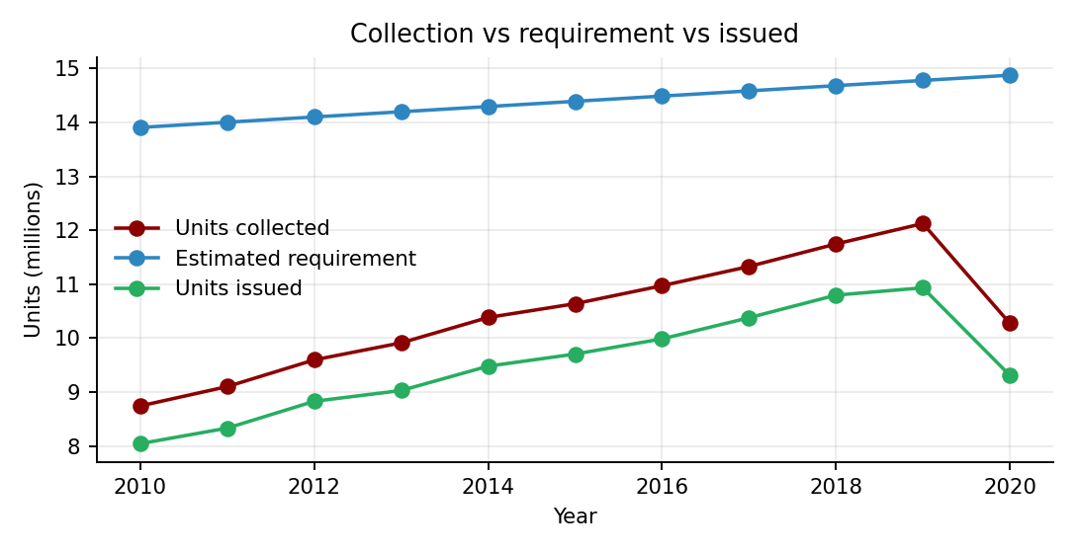
Figure 1: Overview: total units collected, estimated requirement and units issued, 2010–2020 (all states).
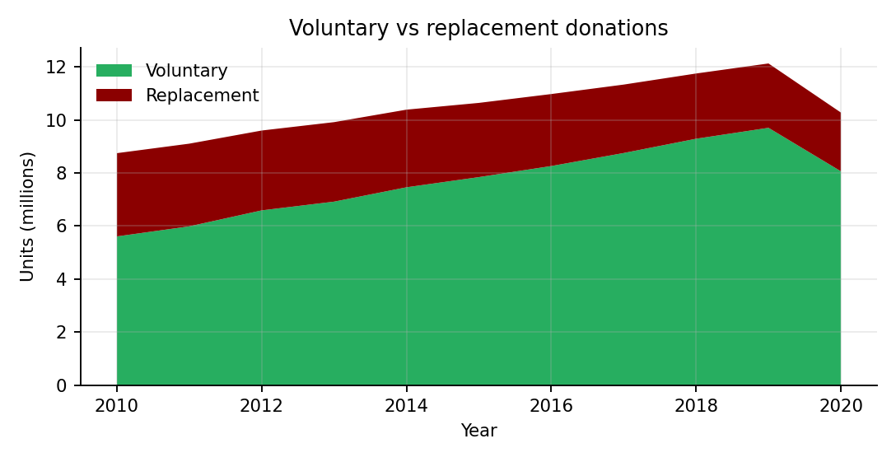
Figure 2: Overview: voluntary versus replacement donations.
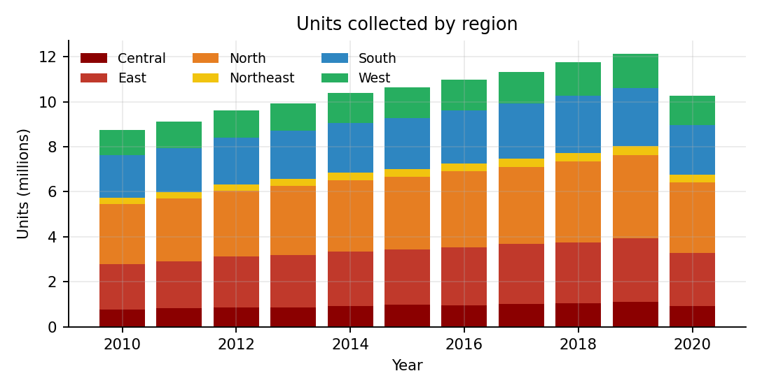
Figure 3: Overview: units collected by region and year.
States tab
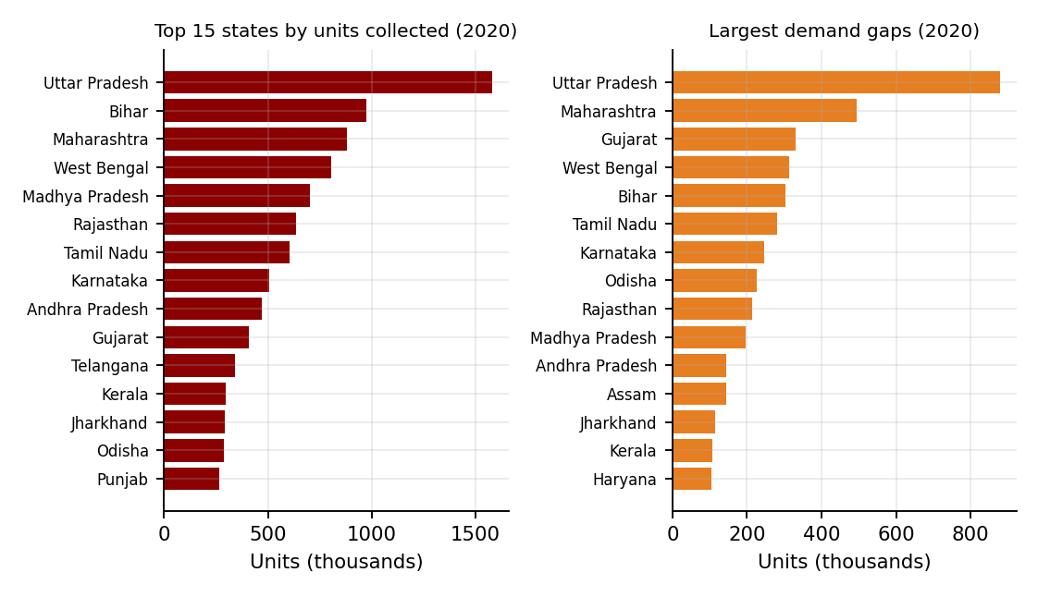
Figure 4: States: top 15 states by units collected and the 15 largest demand gaps (2020).
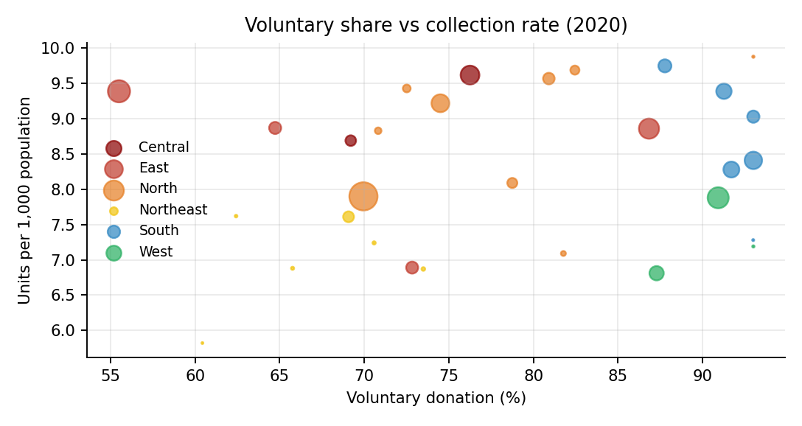
Figure 5: States: voluntary donation share versus collection rate per 1,000 population (2020; bubble size = units collected).
Seasonality tab
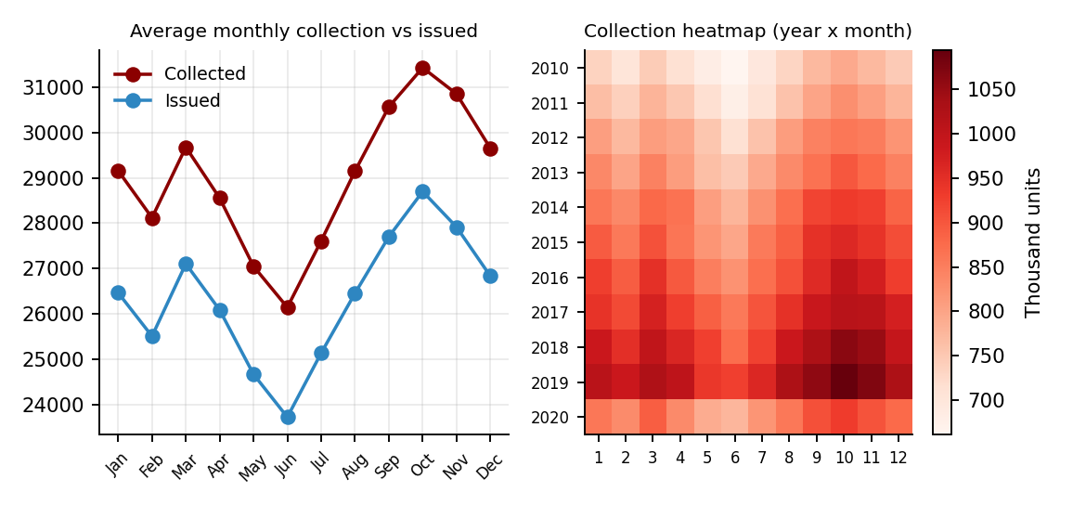
Figure 6: Seasonality: average monthly collection and issue, and year × month collection heatmap.
Blood groups tab
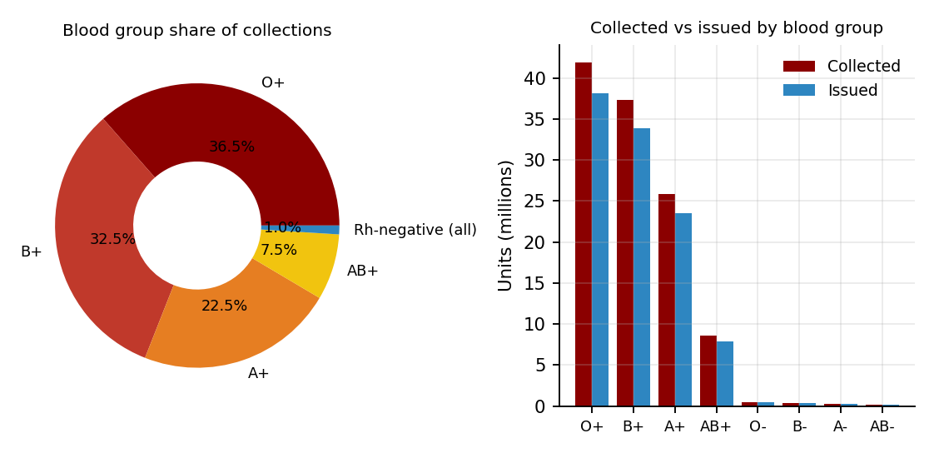
Figure 7: Blood groups: share of collections and units collected versus issued by group.
Safety & discards tab
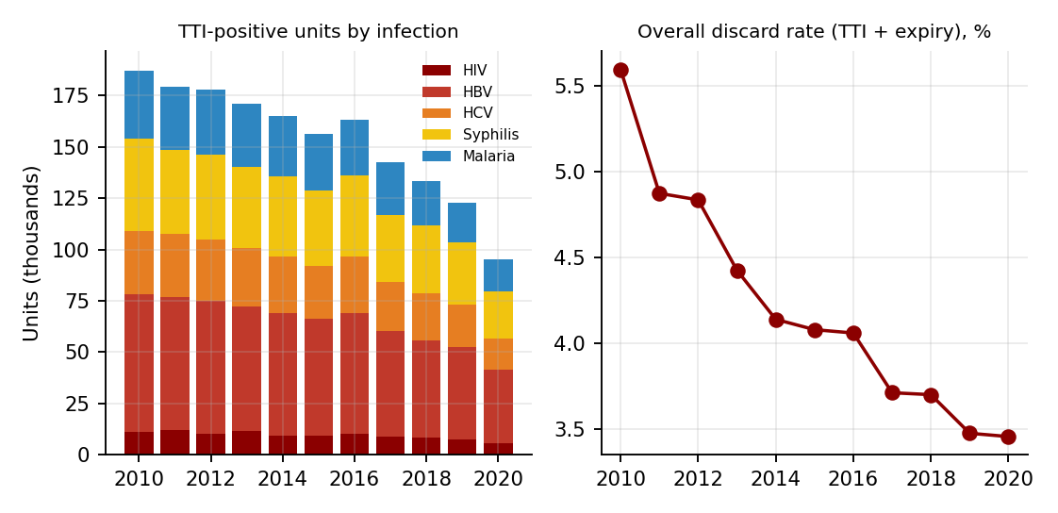
Figure 8: Safety: TTI-positive units by infection and overall discard rate (TTI + expiry).
Donors tab
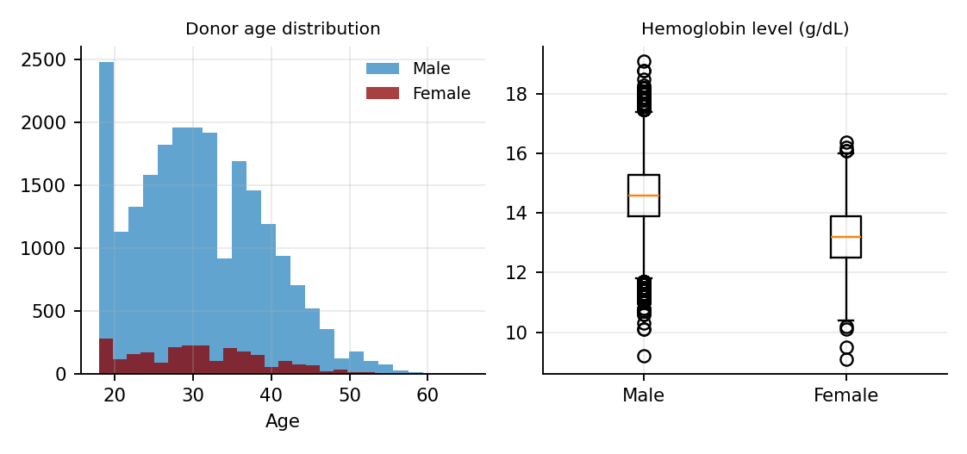
Figure 9: Donors: age distribution by gender and hemoglobin level (25,000-record simulated sample).
Blood banks tab
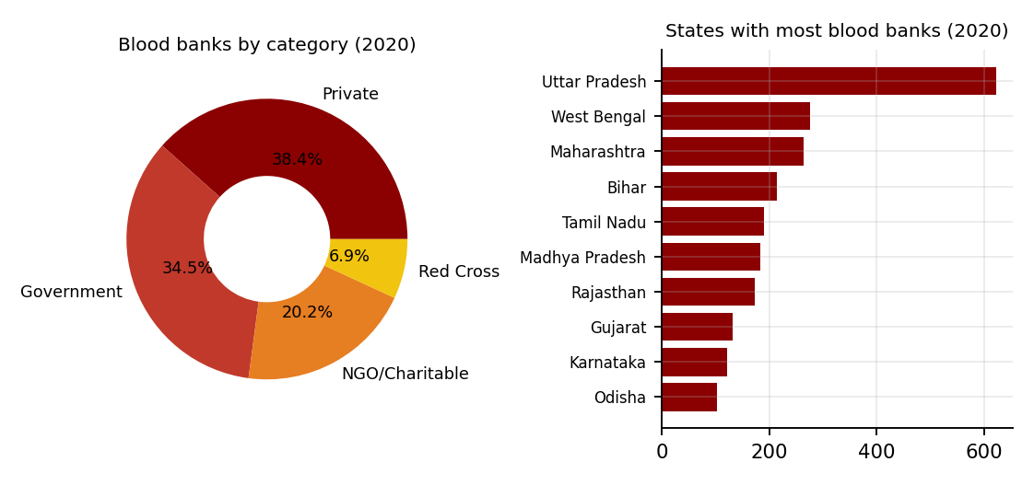
Figure 10: Blood banks: category share and the ten states with the most blood banks (2020).

9.2 Visualization Results
The current implementation produces the following visual elements. Each chart is drawn with Plotly Express.
Tab | Visualization | Chart type | Fields used
Header | Headline indicators | Metric cards | total_units_collected (with change vs previous year), voluntary_units, licensed_blood_banks, units_issued, demand_gap_units
Overview | Collection vs requirement vs issued | Line | year; total_units_collected, estimated_requirement_units, units_issued
Overview | Voluntary vs replacement | Area | year; voluntary_units, replacement_units
Overview | Units collected by region | Stacked bar | year, region, total_units_collected
States | Top 15 states; per 1,000 population | Horizontal bar | state; total_units_collected; collection_per_1000_pop
States | Voluntary share vs collection rate | Bubble (scatter) | x: voluntary_donation_pct, y: collection_per_1000_pop, size: units, colour: region
States | Largest demand gaps | Horizontal bar | state; demand_gap_units
States | Voluntary % by state and year | Heatmap | state × year; voluntary_donation_pct
Seasonality | Average monthly collection vs issued | Line | month; units_collected, units_issued
Seasonality | Collection heatmap; closing stock | Heatmap; line | year × month; closing_stock_units
Blood groups | Share; collected vs issued; trend | Donut; grouped bar; line | blood_group; units_collected, units_issued; year
Safety & discards | TTI-positive units; discard rate; component separation | Stacked bar; line; line | hiv/hbv/hcv/syphilis/malaria_positive; discards; component_separation_pct
Donors | Age, donation type, venue, first-time, hemoglobin | Histogram, stacked bar, donut, grouped bar, box | age, gender, donation_type, donation_venue, first_time_donor, hemoglobin_g_dl
Blood banks | Category, top states, facilities, growth | Donut, bar, grouped bar, line | category, state, has_component_facility, has_apheresis, licensed_blood_banks
Data | Filtered tables | Table + download | State-year, monthly, blood-group or donor columns

Interactive filters. The sidebar has a year-range slider (2010–2020), a region selector and a state/UT selector. The States tab has its own year slider. All charts and tables update when a filter is changed.

9.3 Analysis of Results
All values below are read from the simulated datasets with every state and year selected. They describe the generated data and not the real blood supply of India.
Collection and requirement. Total units collected across the 30 states rose from about 8.75 million in 2010 to about 12.12 million in 2019, an increase of roughly 39%, and then fell to about 10.28 million in 2020, a drop of about 15.3% from 2019. The fall in 2020 comes from the COVID-19 reduction built into the simulation. The estimated requirement grew more slowly, from about 13.9 million to about 14.9 million units, so the demand gap narrowed from about 5.16 million units in 2010 to about 2.65 million in 2019 and widened again to about 4.60 million in 2020. Units issued stayed at 88–95% of units collected; they were about 8.05 million in 2010, 10.93 million in 2019 and 9.31 million in 2020.
Voluntary donation. The voluntary share of all units increased steadily from 64.1% in 2010 to 80.0% in 2019 and dipped to 78.5% in 2020. Correspondingly, replacement donations decreased from about 3.14 million units in 2010 to about 2.21 million in 2020. At state level, Tamil Nadu, Kerala and Goa reached the 93% level in 2020, while Bihar had the lowest voluntary share at 55.5%.
States and regions. In 2020 the largest collections were in Uttar Pradesh (about 1.58 million units), Bihar (0.98 million), Maharashtra (0.88 million), West Bengal (0.81 million) and Madhya Pradesh (0.70 million). These are the most populous states, so the ranking by total units mostly follows population. Per 1,000 population the picture is different: Chandigarh (9.88), Telangana (9.75), Delhi (9.69), Madhya Pradesh (9.62) and Punjab (9.57) lead, while Arunachal Pradesh (5.82), Gujarat (6.81) and Tripura (6.87) are lowest. The largest demand gaps in 2020 are in Uttar Pradesh (about 0.88 million units), Maharashtra (0.50 million), Gujarat (0.33 million), West Bengal (0.31 million) and Bihar (0.30 million). By region, the North collected the most in 2020 (about 3.12 million units), followed by the East (2.37 million) and the South (2.23 million); the Northeast collected the least (0.33 million).
Seasonality. Collection follows a seasonal pattern: it is highest in October (about 8% above the monthly average) and in September and November, and lowest in June (about 10% below average) and May. The closing stock chart reflects the same cycle. Because the monthly factors are part of the generator, the pattern shows how the chart type reveals seasonality rather than a measured real-world effect.
Blood groups. O+ makes up 36.5% of collections, followed by B+ (32.5%), A+ (22.5%) and AB+ (7.5%). The four Rh-negative groups together account for only about 1% (O− 0.40%, B− 0.30%, A− 0.20%, AB− 0.10%). Because these groups are so rare, they are the ones most likely to run short when a patient needs them. Units issued follow the same proportions as units collected.
Safety and quality. The overall discard rate (TTI plus expiry) fell from 5.6% in 2010 to 3.5% in 2019 and 2020. TTI-positive units decreased for every infection: for example hepatitis B from about 66,800 to 35,600 units, syphilis from 44,800 to 22,600, malaria from 33,400 to 15,600, hepatitis C from 30,900 to 15,300 and HIV from 11,200 to 5,900 between 2010 and 2020. Hepatitis B contributes the largest share of positive units. Average component separation rose from about 17% in 2010 to about 61% in 2020.
Donors. In the 25,000-record sample the average donor is about 31 years old (median 30, range 18–65). About 90% of donors are male and 10% female. Voluntary donations make up 75.4% of the sample and 55.3% of donors are first-time donors. Half of the donations (50.0%) take place in camps, 35.1% in blood banks and 14.8% in hospitals. Median hemoglobin is 14.6 g/dL for men and 13.2 g/dL for women, and about 1.1% of samples are TTI reactive.
Blood bank network. The number of licensed blood banks grew from 2,364 in 2010 to 3,107 in 2020. In the 2020 directory 38.4% of banks are private (1,193), 34.5% government (1,072), 20.2% NGO/charitable (628) and 6.9% Red Cross (214). About 54–58% of banks in each category have a component facility and 11–13% have apheresis. Uttar Pradesh has the most banks (622), followed by West Bengal (276), Maharashtra (264), Bihar (215) and Tamil Nadu (191).

9.4 Key Insights
- The simulated national collection grows by about 39% between 2010 and 2019 and then drops about 15% in 2020; the 2020 dip is a deliberate COVID-19 assumption in the generator.
- The demand gap shrinks from 5.2 million units (2010) to 2.7 million (2019) and widens again to 4.6 million in 2020, showing how quickly a shock can undo several years of progress.
- Voluntary donation rises from 64.1% to 80.0% by 2019; replacement donations decline in absolute terms.
- Ranking by total units follows population, but ranking per 1,000 population gives a different order, so both views are needed to compare states fairly.
- Collection peaks in the autumn months and is lowest in mid-year, so planning of donation camps could focus on May–July.
- O+ and B+ account for about 69% of collections, whereas the four Rh-negative groups together account for about 1%.
- Discard rates and TTI-positive units decline over the period while component separation rises, indicating an improving system in the simulation.
- All figures come from simulated data created by generate_blood_bank_data.py and are not official statistics.

10. ADVANTAGES AND LIMITATIONS

10.1 Advantages
- Combines collection, demand, safety, donor and blood bank perspectives in one interface.
- Interactive filters and charts make state, region and year comparisons easy to explore.
- Headline indicators update automatically with the chosen filters.
- Data tables can be inspected and downloaded as CSV files.
- Built entirely with free, widely used Python tools and deployed on the web, so it can be opened from any browser.
- The dataset is reproducible because the generator uses a fixed random seed.

10.2 Limitations
- The data is simulated; the dashboard is a demonstration of visualization techniques and does not report official statistics.
- Patterns in the charts (growth rates, the 2020 dip, seasonality, group shares) are built into the generator and therefore cannot be used to draw real-world conclusions.
- The donor charts use a 25,000-record sample, not national counts.
- The blood bank directory shows only the 2020 situation, and the generator allots each bank to a category at random.
- The dashboard does not manage live operations such as donor registration, stock entry or hospital requests.
- Results depend on the quality of the data and on the features implemented in the application.

11. CONCLUSION
The India Blood Bank Management Dashboard demonstrates how a set of related tables can be turned into an interactive, easy-to-read application using Python, Streamlit, Pandas and Plotly. By organising five datasets into eight tabs with common filters, it allows users to follow collection trends, compare states, study seasonality, examine blood-group distribution, review safety indicators, profile donors and inspect the blood bank network. Because the datasets are simulated, the project’s value lies in the design of the dashboard and the visualization workflow; conclusions should remain limited to what the data and the current implementation support.

12. FUTURE ENHANCEMENT
- Replace the simulated files with official, properly sourced data (for example from NACO, NBTC and state blood transfusion councils) and record the source, release date and licence of every file.
- Add a choropleth map of India so that state values can be seen geographically.
- Add forecasting of collection and demand with confidence intervals, clearly labelled as estimates.
- Add district-level data and blood-group availability for each blood bank so that users can locate needed blood.
- Add donor registration, reminders and stock-alert features backed by a database.
- Add downloadable PDF summaries, a data dictionary page and user authentication for administrators.

13. REFERENCES
- Project GitHub Repository — https://github.com/ShaikAdnan001/blood-bank-dashboard
- Deployed dashboard — https://blood-bank-dashboard-okg7dmhrjxccv8wmcq84ee.streamlit.app/
- National AIDS Control Organisation (NACO), India — blood safety and blood bank information.
- National Blood Transfusion Council (NBTC), India — national blood policy and guidelines.
- Central Drugs Standard Control Organisation (CDSCO), India — licensing of blood banks.
- Ministry of Health and Family Welfare, Government of India — public health reports.
- Streamlit Documentation — https://docs.streamlit.io
- Pandas Documentation — https://pandas.pydata.org/docs
- Plotly Python Documentation — https://plotly.com/python
- NumPy Documentation — https://numpy.org/doc

14. APPENDIX

A. Source Code
GitHub repository: https://github.com/ShaikAdnan001/blood-bank-dashboard
The dashboard is written as a single Streamlit file, app.py, in the same folder as the five data files. Libraries used: streamlit, pandas and plotly (plotly.express), plus the standard-library module pathlib. To run: pip install streamlit pandas plotly, then python -m streamlit run app.py from the project folder.
Complete source code (app.py)
"""
India Blood Bank Management Dashboard (2010-2020)
Run: streamlit run app.py
Needs the 5 CSV files in the same folder as this file.
Data is SIMULATED - see generate_blood_bank_data.py.
"""
from pathlib import Path
import pandas as pd
import plotly.express as px
import streamlit as st

st.set_page_config(page_title="India Blood Bank Dashboard", page_icon="🩸", layout="wide")
BASE = Path(__file__).parent
RED = ["#8B0000", "#C0392B", "#E67E22", "#F1C40F", "#2E86C1", "#27AE60", "#8E44AD", "#7F8C8D"]

@st.cache_data
def load():
sy = pd.read_csv(BASE / "state_year_summary.csv")
monthly = pd.read_csv(BASE / "monthly_collection.csv")
groups = pd.read_csv(BASE / "blood_group_summary.csv")
donors = pd.read_csv(BASE / "donors_sample.csv", parse_dates=["donation_date"])
banks = pd.read_csv(BASE / "blood_banks_directory.csv")
return sy, monthly, groups, donors, banks

try:
sy, monthly, groups, donors, banks = load()
except FileNotFoundError as e:
st.error(f"Missing data file: {e.filename}. Put all CSV files next to app.py.")
st.stop()

# ------------------------------------------------------------------ sidebar
st.sidebar.title("🩸 Filters")
yr_min, yr_max = st.sidebar.slider("Year range", 2010, 2020, (2010, 2020))
regions = st.sidebar.multiselect("Region", sorted(sy.region.unique()),
default=sorted(sy.region.unique()))
state_pool = sorted(sy[sy.region.isin(regions)].state.unique())
states = st.sidebar.multiselect("State / UT", state_pool, default=state_pool)
st.sidebar.caption("Simulated data for a visualization project - not official statistics.")
if not states:
st.warning("Select at least one state in the sidebar.")
st.stop()

f_sy = sy[sy.year.between(yr_min, yr_max) & sy.state.isin(states)]
f_mo = monthly[monthly.year.between(yr_min, yr_max) & monthly.state.isin(states)]
f_gr = groups[groups.year.between(yr_min, yr_max) & groups.state.isin(states)]
f_dn = donors[donors.year.between(yr_min, yr_max) & donors.state.isin(states)]
last_year = f_sy.year.max()
prev_year = last_year - 1

# ------------------------------------------------------------------- header
st.title("India Blood Bank Management Dashboard")
st.caption(f"Years {yr_min}-{yr_max} | {len(states)} states/UTs selected")

def total(df, col, year):
return int(df[df.year == year][col].sum())

cur, prev = total(f_sy, "total_units_collected", last_year), total(f_sy, "total_units_collected", prev_year)
delta = f"{(cur - prev) / prev * 100:+.1f}% vs {prev_year}" if prev else None
vol_pct = f_sy[f_sy.year == last_year].voluntary_units.sum() / max(cur, 1) * 100
banks_now = total(f_sy, "licensed_blood_banks", last_year)
issued = total(f_sy, "units_issued", last_year)
gap = total(f_sy, "demand_gap_units", last_year)
disc = (total(f_sy, "units_discarded_tti", last_year) + total(f_sy, "units_discarded_expiry", last_year)) / max(cur, 1) * 100

c1, c2, c3, c4, c5 = st.columns(5)
c1.metric(f"Units collected ({last_year})", f"{cur:,}", delta)
c2.metric("Voluntary donation", f"{vol_pct:.1f}%")
c3.metric("Licensed blood banks", f"{banks_now:,}")
c4.metric("Units issued", f"{issued:,}")
c5.metric("Demand gap (units)", f"{gap:,}", help="Estimated requirement minus units collected")
st.caption(f"Discard rate (TTI + expiry) in {last_year}: {disc:.1f}%")

tabs = st.tabs(["📈 Overview", "🗺️ States", "📅 Seasonality", "🅰️ Blood groups",
"🧪 Safety & discards", "🧑 Donors", "🏥 Blood banks", "📄 Data"])

# ----------------------------------------------------------------- overview
with tabs[0]:
nat = f_sy.groupby("year", as_index=False)[
["total_units_collected", "voluntary_units", "replacement_units",
"estimated_requirement_units", "units_issued"]].sum()
a, b = st.columns(2)
fig = px.line(nat.melt("year", ["total_units_collected", "estimated_requirement_units", "units_issued"],
var_name="metric", value_name="units"),
x="year", y="units", color="metric", markers=True,
title="Collection vs requirement vs issued", color_discrete_sequence=RED)
a.plotly_chart(fig, use_container_width=True)
fig = px.area(nat.melt("year", ["voluntary_units", "replacement_units"],
var_name="donation type", value_name="units"),
x="year", y="units", color="donation type",
title="Voluntary vs replacement donations", color_discrete_sequence=[RED[5], RED[0]])
b.plotly_chart(fig, use_container_width=True)
reg = f_sy.groupby(["year", "region"], as_index=False).total_units_collected.sum()
st.plotly_chart(px.bar(reg, x="year", y="total_units_collected", color="region",
title="Units collected by region", color_discrete_sequence=RED),
use_container_width=True)

# ------------------------------------------------------------------- states
with tabs[1]:
yr = st.slider("Year to compare", int(yr_min), int(yr_max), int(yr_max), key="state_year")
cy = f_sy[f_sy.year == yr]
a, b = st.columns(2)
top = cy.nlargest(15, "total_units_collected").sort_values("total_units_collected")
a.plotly_chart(px.bar(top, x="total_units_collected", y="state", orientation="h",
title=f"Top 15 states by units collected ({yr})",
color_discrete_sequence=[RED[0]]), use_container_width=True)
pc = cy.sort_values("collection_per_1000_pop").tail(15)
b.plotly_chart(px.bar(pc, x="collection_per_1000_pop", y="state", orientation="h",
title=f"Units per 1,000 population ({yr})",
color_discrete_sequence=[RED[4]]), use_container_width=True)
a, b = st.columns(2)
a.plotly_chart(px.scatter(cy, x="voluntary_donation_pct", y="collection_per_1000_pop",
size="total_units_collected", color="region", hover_name="state",
title=f"Voluntary share vs collection rate ({yr})",
color_discrete_sequence=RED), use_container_width=True)
gp = cy.sort_values("demand_gap_units").tail(15)
b.plotly_chart(px.bar(gp, x="demand_gap_units", y="state", orientation="h",
title=f"Largest demand gaps ({yr})",
color_discrete_sequence=[RED[2]]), use_container_width=True)
heat = f_sy.pivot_table(index="state", columns="year", values="voluntary_donation_pct")
st.plotly_chart(px.imshow(heat, aspect="auto", color_continuous_scale="Reds",
title="Voluntary donation % by state and year"),
use_container_width=True)

# -------------------------------------------------------------- seasonality
with tabs[2]:
mon = f_mo.groupby("month", as_index=False)[["units_collected", "units_issued"]].mean()
mon["month name"] = pd.to_datetime(mon.month, format="%m").dt.strftime("%b")
a, b = st.columns(2)
a.plotly_chart(px.line(mon.melt(["month", "month name"], ["units_collected", "units_issued"],
var_name="metric", value_name="avg units"),
x="month name", y="avg units", color="metric", markers=True,
title="Average monthly collection vs issued (selected states)",
color_discrete_sequence=RED), use_container_width=True)
hm = f_mo.groupby(["year", "month"], as_index=False).units_collected.sum() \
.pivot(index="year", columns="month", values="units_collected")
b.plotly_chart(px.imshow(hm, aspect="auto", color_continuous_scale="Reds",
title="Collection heatmap (year x month)"),
use_container_width=True)
stock = f_mo.groupby(["year", "month"], as_index=False).closing_stock_units.sum()
stock["date"] = pd.to_datetime(dict(year=stock.year, month=stock.month, day=1))
st.plotly_chart(px.line(stock, x="date", y="closing_stock_units",
title="Closing blood stock over time", color_discrete_sequence=[RED[0]]),
use_container_width=True)

# ------------------------------------------------------------- blood groups
with tabs[3]:
gtot = f_gr.groupby("blood_group", as_index=False)[["units_collected", "units_issued"]].sum()
a, b = st.columns(2)
a.plotly_chart(px.pie(gtot, names="blood_group", values="units_collected", hole=.45,
title="Blood group share of collections",
color_discrete_sequence=RED), use_container_width=True)
b.plotly_chart(px.bar(gtot.melt("blood_group", var_name="metric", value_name="units"),
x="blood_group", y="units", color="metric", barmode="group",
title="Collected vs issued by blood group",
color_discrete_sequence=[RED[0], RED[4]]), use_container_width=True)
gy = f_gr.groupby(["year", "blood_group"], as_index=False).units_collected.sum()
st.plotly_chart(px.line(gy, x="year", y="units_collected", color="blood_group", markers=True,
title="Collections by blood group over time",
color_discrete_sequence=RED), use_container_width=True)

# ------------------------------------------------------------------- safety
with tabs[4]:
tti = f_sy.groupby("year", as_index=False)[
["hiv_positive", "hbv_positive", "hcv_positive", "syphilis_positive", "malaria_positive"]].sum()
a, b = st.columns(2)
a.plotly_chart(px.bar(tti.melt("year", var_name="infection", value_name="units"),
x="year", y="units", color="infection",
title="TTI-positive units by infection",
color_discrete_sequence=RED), use_container_width=True)
dr = f_sy.groupby("year", as_index=False)[["units_discarded_tti", "units_discarded_expiry",
"total_units_collected"]].sum()
dr["discard rate %"] = (dr.units_discarded_tti + dr.units_discarded_expiry) / dr.total_units_collected * 100
b.plotly_chart(px.line(dr, x="year", y="discard rate %", markers=True,
title="Overall discard rate (TTI + expiry)",
color_discrete_sequence=[RED[0]]), use_container_width=True)
comp = f_sy.groupby("year", as_index=False).component_separation_pct.mean()
st.plotly_chart(px.line(comp, x="year", y="component_separation_pct", markers=True,
title="Average component separation % across selected states",
color_discrete_sequence=[RED[5]]), use_container_width=True)

# ------------------------------------------------------------------- donors
with tabs[5]:
if f_dn.empty:
st.info("No donor records for this selection.")
else:
a, b = st.columns(2)
a.plotly_chart(px.histogram(f_dn, x="age", nbins=25, color="gender",
title="Donor age distribution",
color_discrete_sequence=[RED[4], RED[0]]), use_container_width=True)
dt = f_dn.groupby(["year", "donation_type"], as_index=False).size()
b.plotly_chart(px.bar(dt, x="year", y="size", color="donation_type", barmode="stack",
title="Donation type by year (sample)",
color_discrete_sequence=[RED[5], RED[0]]), use_container_width=True)
a, b = st.columns(2)
a.plotly_chart(px.pie(f_dn, names="donation_venue", hole=.4, title="Where donors give",
color_discrete_sequence=RED), use_container_width=True)
a2 = f_dn.groupby(["gender", "first_time_donor"], as_index=False).size()
b.plotly_chart(px.bar(a2, x="gender", y="size", color="first_time_donor", barmode="group",
title="First-time vs repeat donors by gender",
color_discrete_sequence=[RED[4], RED[0]]), use_container_width=True)
st.plotly_chart(px.box(f_dn, x="gender", y="hemoglobin_g_dl", color="gender",
title="Hemoglobin level (g/dL)",
color_discrete_sequence=[RED[4], RED[0]]), use_container_width=True)
st.caption("Donor charts use a 25,000-record simulated sample, not full national counts.")

# -------------------------------------------------------------------- banks
with tabs[6]:
bk = banks[banks.state.isin(states)]
a, b = st.columns(2)
a.plotly_chart(px.pie(bk, names="category", hole=.45, title="Blood banks by category (2020)",
color_discrete_sequence=RED), use_container_width=True)
bc = bk.groupby("state", as_index=False).size().nlargest(15, "size").sort_values("size")
b.plotly_chart(px.bar(bc, x="size", y="state", orientation="h",
title="States with most blood banks (2020)",
color_discrete_sequence=[RED[0]]), use_container_width=True)
fac = bk.groupby("category", as_index=False)[["has_component_facility", "has_apheresis"]].mean()
fac[["has_component_facility", "has_apheresis"]] *= 100
st.plotly_chart(px.bar(fac.melt("category", var_name="facility", value_name="% of banks"),
x="category", y="% of banks", color="facility", barmode="group",
title="Facility availability by category",
color_discrete_sequence=[RED[0], RED[4]]), use_container_width=True)
growth = f_sy.groupby("year", as_index=False).licensed_blood_banks.sum()
st.plotly_chart(px.line(growth, x="year", y="licensed_blood_banks", markers=True,
title="Licensed blood banks over time",
color_discrete_sequence=[RED[0]]), use_container_width=True)

# --------------------------------------------------------------------- data
with tabs[7]:
choice = st.selectbox("Table", ["State-year summary", "Monthly collection",
"Blood group summary", "Donor sample"])
table = {"State-year summary": f_sy, "Monthly collection": f_mo,
"Blood group summary": f_gr, "Donor sample": f_dn}[choice]
st.dataframe(table, use_container_width=True, height=450)
st.download_button("Download filtered data (CSV)", table.to_csv(index=False).encode("utf-8"),
file_name=f"{choice.lower().replace(' ', '_')}.csv", mime="text/csv")

B. Dataset Notes
File | Rows × columns | Origin | Known limitations
state_year_summary.csv | 330 × 23 | Generated | Simulated; state-level patterns follow generator assumptions
monthly_collection.csv | 3,960 × 6 | Generated | Seasonal factors and noise are assumptions
blood_group_summary.csv | 2,640 × 5 | Generated | Group shares fixed to an approximate Indian distribution
donors_sample.csv | 25,000 × 12 | Generated | Sample, not national counts; 90% male by design
blood_banks_directory.csv | 3,107 × 6 | Generated | 2020 only; category and facilities assigned at random

All files were created by generate_blood_bank_data.py (NumPy random generator, seed 42). Row and column counts above were obtained by running that script.

C. Additional Screenshots
Additional screenshots of the running application (for example the Data tab and the dashboard with a narrowed year range or a single region selected) can be added here, with each figure labelled clearly.

