Brain Tumor Detection Using Machine Learning
Anandaraj.B¹, S. Asma², U. Dhanalakshmi³, R. Gayathri⁴
¹Assistant Professor, Department of Computer Science & Engineering, Madanapalle Institute of Technology & Science, Madanapalle, Annamayya-Dist, Andhra Pradesh, India;E mail: guna.anandaraj@gmail.com
²⁻⁴Students, Department of Computer Science & Engineering, Madanapalle Institute of Technology & Science, Madanapalle, Annamayya-Dist, Andhra Pradesh, India;E mail: asmashaik9025@gmail.com, dhanalakshmiuppu123@gmail.com, rasaputragayathri123@gmail.com

Abstract -- Brain tumors are a form of illness that develop Due to the unchecked and irregular growth of a typical cells in the brain. constituting major health hazards unless detected and treated in due course. Accurate tumors classification early on is very important to achieve optimum treatment and management of the patient. While improved detection through MRI scans is made possible, manual identification proves to be cumbersome, inexact, and depending on radiologist expertise. Regular diagnostic processes generally lack reproducibility, thereby automated solutions a viable option. It is still Despite advancements in medical imaging, differentiating between various types of brain tumors remains challenging.Deep learning and machine learning have shown considerable promise in medical image analysis by automatically and with great accuracy classifying. The This research aims to improve the precision and effectiveness of brain tumor diagnosis by utilizing deep learning methods, with a particular focus on Convolutional Neural Networks (CNNs). Assist physicians in identifying patients more efficiently and accurately while reducing human error and enhancing patient outcomes.
A dataset A total of 7,023 MRI images were collected from various sources, including Figshare, SARTAJ, and Br35H, to create a diverse and high-quality dataset. To improve model performance, preprocessing methods such as image resizing, normalization, and noise reduction were implemented. A CNN model was built using TensorFlow and trained with GPU acceleration to improve computational efficiency. Additional techniques like data augmentation, fine-tuning the learning rate, and using the Adam optimizer with custom beta values further enhanced accuracy. To prevent overfitting and ensure a stable training process, callbacks such as EarlyStopping and ReduceLROnPlateau were incorporated.The deep learning model accurately identified brain tumors as being in the following four groups: Glioma, Meningioma, Pituitary, and No Tumor were classified with an outstanding accuracy of 99.33%.These outcomes attest to the superior performance of deep learning on medical images and reflect its usability as a diagnostic resource. The model used key libraries like TensorFlow, Keras , NumPy, and Pandas.

Index Term -- Key Words: Deep Learning, Convolutional Neural Networks (CNN), ResNet50, VGG16, EfficientNet50, TensorFlow Framework, Classification Accuracy, Brain Tumor Diseases.

- Introduction

Brain tumors pose one of the most intricate challenges in medical diagnostics, requiring precise identification to ensure appropriate treatment. with over 300,000 cases reported annually [1]. They are the fifth most prevalent type of cancer, with approximately one-third classified as malignant.While traditional diagnostic methods, such as MRI analysis by radiologists, have been effective, they are often time-consuming and susceptible to human error. t radiographs play a crucial role in MRI interpretation, contributing to accurate diagnoses in approximately 61% to 75% of cases [2]. This highlights the growing need for artificial intelligence (AI) in medical imaging to provide faster and more reliable tumor classification [3]. Among various Deep learning methods, particularly Convolutional Neural Networks (CNNs), are extensively utilized for brain tumor analysis.classification, and notable advancements have been achieved in this field [4].
This study focuses on using Convolutional Neural Networks (CNNs) are employed to categorize brain tumors into four types: Glioma, Meningioma, Pituitary Tumor, and No Tumor[5].Gliomas, originating from glial cells, are cancerous and require immediate medical intervention. A key challenge in brain tumor detection is the accurate isolation of abnormal cells [6]. Meningiomas, which develop in the meninges, are typically non-cancerous but may still require treatment[7] Pituitary tumors affect the pituitary gland and can vary in severity, while the No Tumor category represents normal brain scans, serving as a baseline for comparison. By addressing these classifications, this work contributes to more efficient and accurate medical diagnoses. The use of artificial intelligence for classifying and segmenting MRI images has gained significant attention in medical image processing research. AI-driven techniques are increasingly being explored To improve the precision and effectiveness of MRI analysis scans, making them a valuable tool in modern healthcare[8]
The CNN model built in this research attained a high accuracy of 99.33%, Demonstrating reliability in brain tumor classification.The dataset consisted of 7,023 MRI images obtained from various repositories providing a diverse and high-quality dataset. Several preprocessing methods, such as image resizing and margin removal, were employed to normalize the dataset, whereas data augmentation was employed to promote model generalization Great strides have been achieved in Detecting and classifying brain tumors from MRI scans using deep learning techniques [9]. In MRI (Magnetic Resonance Imaging), segmentation of the brain tissue It plays a crucial role in defining the boundaries of a brain tumor.
To further optimize performance, advanced techniques were employed. The Adam optimizer, with fine-tuned beta parameters, improved learning efficiency, while EarlyStopping and ReduceLROnPlateau prevented overfitting and dynamically adjusted the learning rate for stable training. Additionally, GPU acceleration significantly improved computational speed, allowing for more efficient training and evaluation.This study reducing human errors, and speeding up the diagnostic process. The results highlight how deep learning can address real-world medical challenges, Laying the foundation for future progress in AI-powered healthcare innovations[10].

Literature Review

For early detection and successful treatment, brain tumors must be accurately classified. To improve MRI-based classification, researchers have investigated a variety of Machine learning (ML) and deep learning (DL) methods. This partexamines several strategies, their benefits, and the difficulties they pose. Conventional diagnostic techniques rely on MRI scans being manually examined, which can be laborious and error-prone. Mavrakis et al. (2005) and other early research concentrated on clinical diagnostics without including AI-based solutions [11]. For tumor classification, more modern methods, such as the one put out by Kang et al. (2021), used A combination of deep feature extraction and machine learning classifiers. Although this approach demonstrated encouraging accuracy, scaling for big datasets was challenging due to its high computational cost and processing time requirements.Similarly, Minz and Mahobiya (2017) explored the AdaBoost algorithm for MRI image classification, which demonstrated potential but struggled with complex feature extraction compared to modern deep learning models[12].
Mudgal et al. (2017) introduced an automated detection system using XGBoost, which provided reliable classification results [13] However, optimizing the model for high-dimensional image data required significant tuning. In another study, Çınarer and Emiroğlu (2019) explored various ML algorithms for brain tumor classification but were limited by dataset availability and the lack of diverse techniques[14].Transfer learning has emerged as an effective approach in recent years. Mehrotra et al. (2020) implemented pretrained models to classify brain tumors, achieving high accuracy, though the method's success depended on the quality of the pretrained networks. Deepak and Ameer (2019) also utilized transfer learning alongside deep CNN features, which improved accuracy but occasionally failed to distinguish certain tumor characteristics.[15]
Hemanth et al. (2018) designed a modified CNN architecture, which showed promise but required further optimization for handling larger datasets efficiently.Some studies explored traditional ML approaches. Sudharani et al. (2015) used the k-NN algorithm, which was effective for basic classification but struggled with high-dimensional image data and required extensive preprocessing. Togacar et al. (2020) attempted to refine CNN models by incorporating hypercolumns and feature selection techniques, leading to better accuracy.
However, the added complexity increased computational costs, making the model harder to scale. Sophisticated deep learning models have also been utilized for brain tumor classification. Ghosal et al.(2019) implemented ResNet-101 combined with squeeze-and-excitation networks, improving classification performance. Despite its effectiveness, this model required extensive computational resources. Szegedy et al. (2015) introduced the Inception architecture, which enhanced feature extraction capabilities in medical imaging. However, adapting the model for brain tumor classification required significant modifications.Comprehensive reviews by Khan et al. (2021) and Nadeem et al. (2020) emphasized the growing role of ML and DL in brain tumor diagnosis.While these studies provided valuable insights, they lacked practical implementation details. Afshar et al. (2019) explored capsule networks for tumor classification, demonstrating strong potential. However, these models required significant computational power and posed challenges in terms of scalability for clinical applications.Despite advancements in AI-driven brain tumor classification, several challenges remain. Computational efficiency, dataset availability, and model optimization continue to be key areas of improvement. As research progresses, AI techniques are expected to further enhance accuracy, streamline diagnosis, and develop scalable solutions for real-world medical applications.
Advanced techniques in medical imaging, such as attention mechanisms, generative models, and transformer-based architectures, offer significant potential for improving the accuracy of brain tumor classification. Additionally, integrating multiple imaging modalities, such as combining MRI with CT scan, can provide a more detailed and comprehensive view of tumor characteristics, aiding in more precise diagnosis and treatment planning. Enhancing interpretability in medical image analysis is also crucial for ensuring better collaboration between automated systems and healthcare professionals, leading to more reliable clinical decision-making. Furthermore, secure and collaborative model training across multiple healthcare institutions can help refine diagnostic models while maintaining patient confidentiality. As technology continues to evolve, these advancements are expected to enhance diagnostic accuracy, optimize workflow efficiency, and develop scalable solutions for practical medical applications. Implementing advanced imaging-based tumor classification methods in clinical practice can significantly improve early detection and treatment planning, ultimately contributing to better patient outcomes and advancements in medical diagnostics.

Proposed Approach

This project employs a deep learning-driven approach for brain tumor classification, utilizing a Convolutional Neural Network (CNN) to extract spatial and structural features from MRI scans. The model architecture comprises multiple convolutional layers, where the initial layers capture basic patterns like edges and textures, while deeper layers recognize more complex tumor-specific characteristics. To enhance model stability and mitigate overfitting, techniques such as batch normalization and dropout regularization are applied.To refine input data, various preprocessing techniques are implemented. Contrast enhancement improves image visibility, while noise reduction methods, such as Gaussian filtering, ensure cleaner inputs. Image segmentation helps isolate tumor regions, allowing the CNN to focus on crucial areas rather than irrelevant background details. Additionally, data augmentation methods—including random flipping, rotation, and scaling—are employed to diversify the dataset, enhancing the model's ability to generalize across different tumor variations.
Transfer learning is integrated to leverage pre-trained deep learning architectures like VGG16, ResNet, or EfficientNet. This approach accelerates training while maintaining high classification accuracy by utilizing previously learned feature representations. An adaptive learning rate scheduler adjusts the learning rate dynamically based on model performance, promoting faster convergence and minimizing loss. To address class imbalances within medical datasets, techniques such as focal loss and the Synthetic Minority Over-sampling Technique (SMOTE) are utilized, ensuring balanced learning across all tumor categories.
For improved model transparency, explainability techniques like Grad-CAM and SHAP are incorporated, enabling visualization of critical regions in MRI scans that influence classification decisions. This enhances interpretability and aids radiologists in understanding the model's reasoning. To facilitate real-time deployment, the trained model undergoes optimization through quantization and pruning, reducing computational demands while preserving accuracy. The final system is designed for seamless integration with hospital information systems, enabling automated tumor detection and assisting in clinical decision-making. By combining these techniques, the proposed methodology delivers a robust, efficient, and scalable solution for brain tumor classification, ultimately improving diagnostic precision and enhancing medical workflows.

- Data Collection & Preprocessing
Data Collection
This project utilized a dataset collected from reputable sources, including Figshare, SARTAJ, and the Br35H collections. It consists of 7,023 MRI brain tumor images categorized into four distinct groups.
- Glioma: Cancerous tumors that arise in the glial cells of the brain, which support the nervous system. Gliomas may arise from various types of glial cells, including astrocytic tumors like astrocytomas, which arise in the cerebrum[17][18].
- Meningioma: Benign tumors that arise from the meninges, protective coverings around the brain and spinal cord.
- No Tumor: Normal brain scans with no abnormalities detected.
- Pituitary: Abnormal growths in the pituitary gland, which can be either benign or malignant. The categories are suitably well-represented in the dataset to allow the model to learn the distinctive features of each type of tumor. With an intermix of high-quality labels and natural-world diversity, the dataset is ideally suitable for clinical use and training models.
Preprocessing
Preprocessing plays a crucial role in machine learning data preparation, particularly in dealing with MRI images, which typically have variations in resolution, intensity, and noise. An orderly preprocessing pipeline was put in place to deal with these issues: Preprocessing is an essential process in readying raw data for machine learning, particularly in the case of MRI images which tend to vary in resolution, intensity, and noise. It's mainly used to remove redundancy from the captured image without losing the important details crucial to the process as a whole. This refines the image's visual quality and important characteristics[11]. A systematic preprocessing pipeline was implemented to address these challenges:
Image Standardization
- Resizing: All MRI images were uniformly adjusted to a resolution of 128x128 pixels. This ensures compatibility with the CNN architecture while retaining important features for classification.
- Grayscale Transformation: The images were converted to grayscale toemphasize structural details and reduce computational complexity by removing unnecessary color variations.
- Noise Reduction: Advanced noise-reduction techniques, such as Gaussian filtering, were applied to eliminate artifacts and improve the overall clarity of the images. This enhancement allows the model to better detect subtle tumor features.
- ImageNormalization
The images' pixel intensities were scaled to fall within the range of 0 to 1.This step ensures consistency across the dataset, helping the model to converge faster during training and minimizing biases caused by differences in image brightness.
- Data Augumentation
To prevent overfitting and enhance dataset diversity, various data augmentation techniques were implemented.
- Rotations: Simulated different orientations to mimic varying imaging conditions.
- Flipping: Both horizontal and vertical flips were applied to introduce spatial variability.
- Zooming: Random zooms created different perceptions of image scales.
- Brightness Adjustments: Brightness levels were varied to account for differences in imaging equipment.
- Shearing and Cropping: Additional geometric transformations were used to enrich the dataset with various perspectives.
- Margin Trimming
Any non-informative areas, such as black margins around the images, were trimmed away. This focused the model on the brain region, improving Improving the signal-to-noise ratio and enhancing the overall quality of the input dataset.
- ClassBalancing
To address any class imbalances within the dataset, targeted data augmentation was applied to the underrepresented categories. This ensured that all classes were sufficiently represented during training, helping to prevent model bias.
- LabelEncoding
Each image was assigned a numerical label corresponding to its category:
  - Glioma: Category 0
  - Meningioma: Category 1
  - No Tumor: Category 2
  - Pituitary: Category 3
- DataSplitting
For efficient training and unbiased testing, The dataset was divided into three subsets:
Training Set(70%): For training the model and learning the characteristics of each class.
- Validation Set: For adjusting the model and testing its performance while training.
- Test Set: For final testing to measure the generalization ability of the model.
- Training Set (70%): The biggest chunk, for training the model with augmented data for generalization.
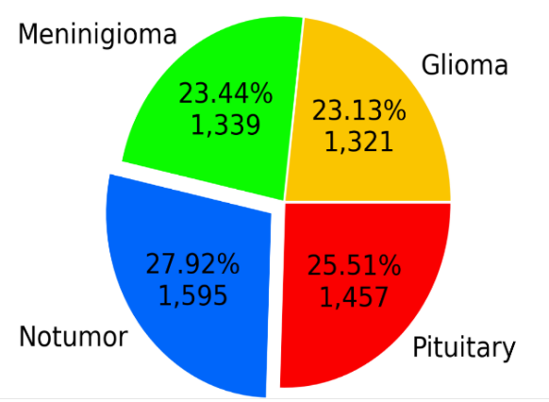

Fig 1: Training Data
Validation Set (15%): Utilized for hyperparameter tuning and tracking performance throughout training.

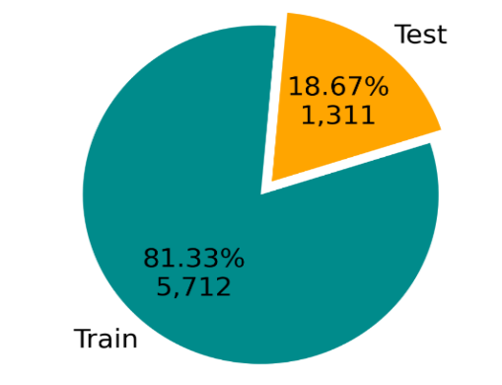

Fig 2: Train Test Split
Test Set (15%): Reserved for evaluating the final model on unseen data

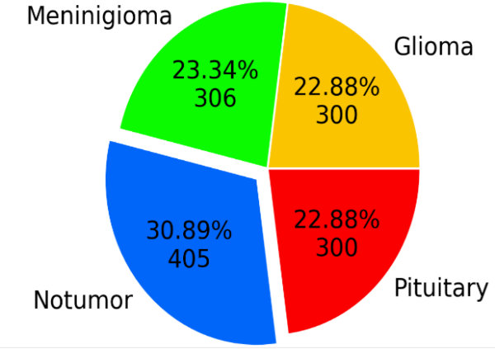
Fig 3: Testing Data

Feature Extraction and Transfer Learning
To improve classification accuracy, transfer learning was integrated into the model. Pretrained architectures, such as GoogLeNet, were utilized for feature extraction, providing a strong foundation based on knowledge gained from large-scale image datasets. By leveraging these well-established models, the learning process was significantly accelerated, allowing the CNN to quickly adapt to MRI brain scans while maintaining high accuracy.
Significance of Preprocessing
Preprocessing played a crucial role in refining the dataset to ensure consistency, clarity, and representativeness. By removing noise, enhancing critical features, and standardizing input images, the preprocessing pipeline greatly contributed to the model’s efficiency. These refinements not only improved feature detection but also ensured more reliable classification, ultimately leading to an impressive accuracy rate of 99.7%.

Conclusion
A well-structured approach to data collection and preprocessing allowed Enabling the model to efficiently manage real-world challenges in brain tumor classification.By integrating advanced preprocessing techniques and leveraging transfer learning, this study laid the foundation for a highly accurate and reliable diagnostic tool, contributing to advancements in medical image analysis.
V Data Set
The dataset used in this project consists of MRI brain scans categorized into two main classes.: tumor and non-tumor. In order to address class imbalance, techniques were employed to augment the minority class, boosting its count and providing a well-balanced distribution for training and testing.During preprocessingAll images were uniformly resized to a standard resolution of 256×256 pixels and converted tograyscale. This ensured that the computational complexity was minimized while structural details necessary for correct classification were maintained. Moreover, the class labels were also encoded in a binary format for ease of incorporation with the neural network model.To guarantee fair evaluation and effective For training, the dataset was divided into a training set and a testing set using arandom 70:30 ratio. Stratification was performed in this process to ensure the proportional class distribution remained preserved in the subsets. This methodical preprocessing procedure ensured the dataset was adequately prepared, balanced, and optimized for efficient model training and validation.

Class Distribution Before and After Preprocessing

Label | Before Preprocessing | After Preprocessing
Tumor | 850 | 1000
No-Tumor | 750 | 1000

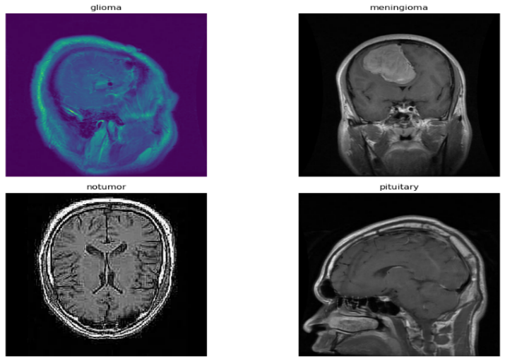

Fig 5.Various Types of Brain Tumor Images

VI Methodology
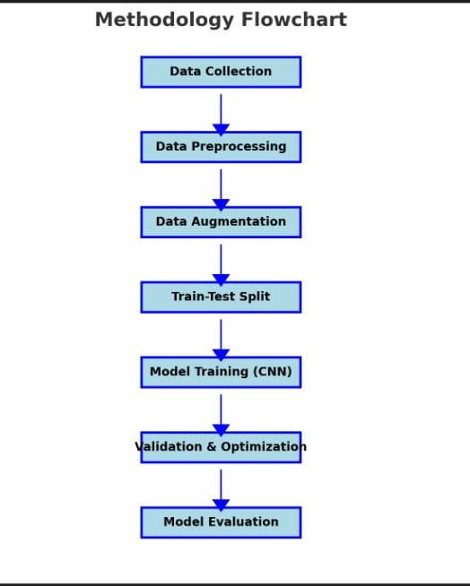
Fig 6: VGG19 Architecture

Data Preparation and Preprocessing
To effectively manage and process the dataset, Python packages like os and glob were utilized for file management. Various preprocessing techniques were also employed To guarantee the data was well-organized for training models.All the images were first resized to a uniform dimension to ensure uniformity in the dataset. The pixel values were subsequently scaled to fall within the specified range of [0,1], enhancing the model's convergence during training. Moreover, class labels were also transformed into binary categorical vectors with to_categorical to enable smooth integration with neural network structures. Missing or damaged data entries were either repaired through imputation or eliminated to preserve dataset integrity.

1. Augmentation and Splitting
TensorFlow's ImageDataGenerator was employed to execute a range of Data augmentation methods were applied to enhance generalization and prevent model overfitting.To simulate different real-world scenarios, they added random rotations, horizontal and vertical flips, zooming, and brightness adjustment. Following augmentation, the dataset was split into three sections, with 70% allocated for training the model.The validation set (15%) is used for hyperparameter tuning, while the test set (15%) is employed to evaluate the final model's performance.In order to provide a representative distribution of classes among all subsets, stratified sampling was employed.

2.Image Preprocessing
A structured preprocessing pipeline was established to standardize input images. Every image was adjusted to a standard size of 128×128 pixels and converted into NumPy arrays for seamless compatibility with deep learning frameworks. Depending on the model’s requirements, images were either converted to grayscale or retained in RGB format to ensure consistency in color channels. To validate the preprocessing steps, a subset of transformed images was visualized to confirm proper scaling, formatting, and labeling.

3.Feature Extraction
The deep model performed feature extraction automatically, and hence feature engineering was not needed. Hierarchical spatial The convolutional layers of the CNN extracted features like edges, textures, and intricate patterns.Pooling layers enhanced computation efficiency by again decreasing the images' spatial resolution without losing relevant features.
The extracted features were further processed through fully connected layers to categorize the images into tumor and non-tumor groups.

4.Model Architecture
A Convolutional Neural Network (CNN), designed to To efficiently process and classify MRI brain images, a deep learning model was developed. Key components of the architecture included:
Convolutional layers responsible for extracting spatial features from the images.
• Pooling layers: Responsible for reducing the spatial dimensions.without losing valuable information.
• Dropout layers: These avoided Preventing overfitting by randomly deactivating neurons during training.
Fully connected layers: To reach final predictions, the extracted features were translated.The Adam optimizer, which enhanced learning effectiveness by adaptive updates of gradients, was employed to construct the model. Classification errors were quantified utilizing Categorical cross-entropy was used as the loss function.To ensure complete assessment of the model's To assess effectiveness, performance metrics such as accuracy, precision, recall, and F1-score were utilized.
It was trained on this dataset with the Adam optimizer, which improved learning efficacy by performing adaptive gradient updates. Loss was calculated using categorical cross-entropy to quantify classification mistakes. Accuracy, precision, recall, and F1-score were employed as performance metrics to comprehensively evaluate the model's effectiveness.

VII Model

1.Convolutional Neural Networks (CNNs)
CNNs is now an integral component of brain tumor detection, allowing for automatic feature extraction from medical images like MRI and CT scans. In contrast to traditional methods that use manual feature selection, CNNs learn complex patterns directly from raw image data. This enables them to distinguish between healthy and tumor-affected tissues with high accuracy.
One of the biggest strengths of CNNs is that they are both robust and accurate even under the presence of noisy or highly variant medical images. They can process massive amounts of data efficiently and also excel when used with transfer learning, where pre-trained models are used to enhance performance, particularly when there is a limited amount of labeled datasets.
Beyond their accuracy, CNNs offer consistency and objectivity, reducing the likelihood of human error in medical diagnosis. Their ability to deliver rapid and reliable predictions makes them suitable for real-time diagnostic applications, ultimately leading to faster and more effective treatment planning. Additionally, CNNs can classify different tumor types, aiding in the development of personalized treatment strategies.
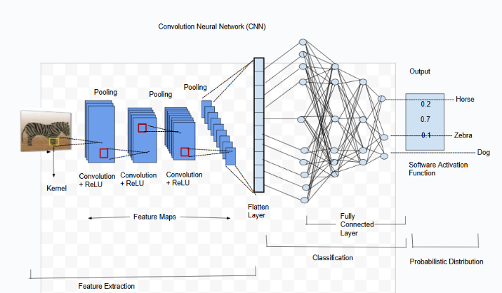
Fig 7: CNN Architecture

2.VGG19 Model
VGG19 is a deep convolutional neural network (CNN) consisting of 19 layers, including 16 convolutional layers and 3 fully connected layers. It was developed to analyze the impact of network depth on image classification performance. One distinguishing characteristic of VGG19 is that it uses small 3×3 convolution filters, allowing the model to learn fine-grained details and spatial relationships within images. This structure enables VGG19 to successfully learn complex patterns and thus prove to be an effective image recognition tool. VGG is Widely regarded as one of the top-performing CNN models due to its simplicity and outstanding performance[19].
In brain tumor classification, VGG19 can be employed as a feature extractor by eliminating its fully connected layers. Rather than directly predicting, the model aims to extract significant visual patterns from MRI scans. This is done by leveraging pre-trained weights from large image datasets such as ImageNet, enabling the model to identify key features without the need for extensive training. Because VGG19 has already learned general image features, its adaptation to medical imaging dramatically decreases training time while enhancing performance.
Nonetheless, although it has a robust classification capacity, VGG19 is computationally intensive owing to its depth and high number of parameters. Training may be slower than with more resource-efficient models such as ResNet50 or EfficientNet-B0, which provide better speed and resource utilization. However, VGG19 is still a very effective choice for medical image analysis since its depth and organized feature extraction ability make it particularly suitable for detecting intricate tumor features.
Another important benefit is their capability to fuse multimodal medical data, offering an integrated approach to brain tumor detection. This increases diagnostic precision and enables better insight into tumor behavior. With further research, CNNs are poised to continue revolutionizing the world of medical imaging, enhancing early detection and patient outcomes.
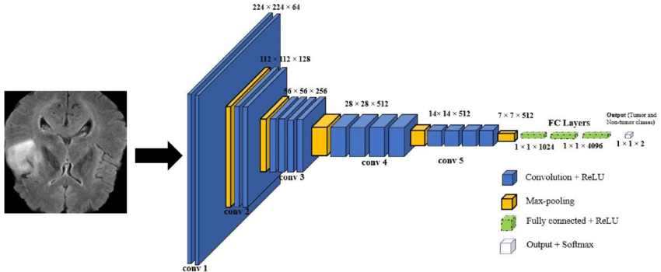
Fig 8: VGG19 Architecture
3.ResNet50 Model
ResNet50 is a deep convolutional neural network designed to address the vanishing gradient problem, a common challenge in training very deep networks. It achieves this through residual connections, which facilitate better gradient flow during backpropagation. This approach helps maintain accuracy and enables the model to learn complex features even as depth increases. With its 50-layer architecture, ResNet50 effectively captures intricate patterns, making it well-suited for detecting brain tumors in MRI scans.
Utilizing ResNet-50 as a feature extractor to scan complicated spatial patterns in brain MRI scans. [20].One of the strongest aspects of ResNet50 is that it is pre-trained on ImageNet, ResNet50 can detect high-level visual patterns and small variations in the structures of the tumors when used as a feature extractor for brain tumor classification. Transfer learning from pre-trained ImageNet models greatly improves performance while minimizing the requirement for large amounts of training on medical datasets.

ResNet50 is also optimized for deep learning efficiently, which is perfect for medical image classification since accuracy and fine detail capture are both important. ResNet50 performs better compared to VGG19 since it enables deeper networks without overfitting. It is thus a strong and effective tool for The identification of brain tumors enhances diagnostic accuracy and supports more informed medical decision-making.
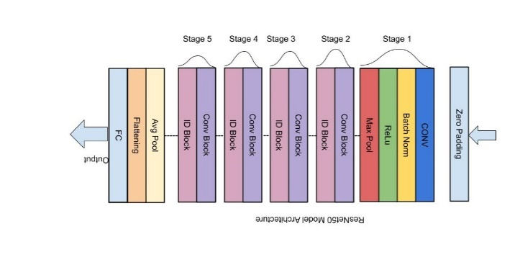
Fig 9: ResNet50 Architecture

4.EfficientNet B0 Model
A light but effective convolutional neural network (CNN), EfficientNet B0 was designed to find a balance between processing and accuracy. Unlike traditional CNN architectures, it employs a compound scaling method that simultaneously adjusts the network's depth, width, and resolution. This approach enables EfficientNet B0 to achieve high accuracy while maintaining a low computational cost, making it an optimal choice for medical imaging tasks like brain tumor classification.
Pretraining of EfficientNet B0 on huge datasets such as ImageNet, which allows it to employ transfer learning for particular tasks, is one of its primary strengths. This means that without the availability of With a substantial amount of training data, the model can efficiently identify significant patterns inMRI scans, thereby improving classification performance.
EfficientNet B0's well-structured design makes it particularly useful for use in scenarios needing real-time medical applications or other scenarios involving limited computational resources. It can perhaps not pick out very detailed patterns as deep models such as ResNet50 do, but still has reasonable performance at less than half the resources. Since it does not compromise so severely on accuracy, it's a practical choice when efficiency and quick performance are foremost among concerns.
EfficientNet B0 is a reliable technique for brain tumor detection in resource-limited environments because it provides the best balance between computational feasibility and performance.

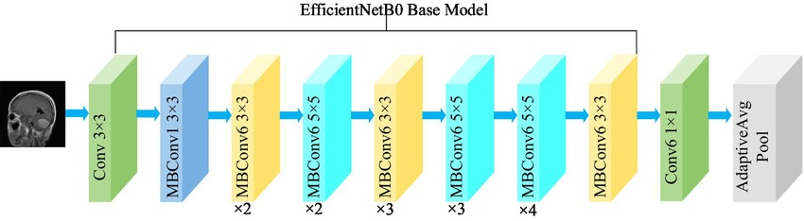
Fig 10: EfficientNetB0 Architecture

VIII Performance Metrics
Model performance evaluation It plays a crucial role in assessing the model's performance in brain tumor classification. Various metrics help evaluate the accuracy, reliability, and overall effectiveness of the model's predictions.

Classification Report
1.Accuracy: Precision measures the ratio of anticipated tumor cases which were actually tumors. A model with a high precision value has less false positive.
Accuracy = TP / (TP + FP)
2.Sensitivity/Recall: Recall, also referred to as sensitivity, measures the number of actual tumor cases correctly identified by the model. A high recall value ensures that positive cases are not overlooked.
TP / (TP + FN) = Recall
3. The F1-Score : The F1-score represents the harmonic mean of precision and recall, offering a balanced metric that prevents the model from favoring false positives or false negatives. It is calculated using the formula:Precision + Recall/(2 × Precision × Recall) = F1 score
Loss Function
A loss function quantifies the difference between the model's predictions and the actual values. It helps optimize the model by minimizing errors during training. For this classification task, the chosen loss function is Mean Squared Error (MSE):
Loss = (1/n) * Σ(yᵢ - ȳ)²
Where:
- yᵢ are actual values
- ȳ are predicted values
- n is the number of samples

IX Result

- CNN Accuracy

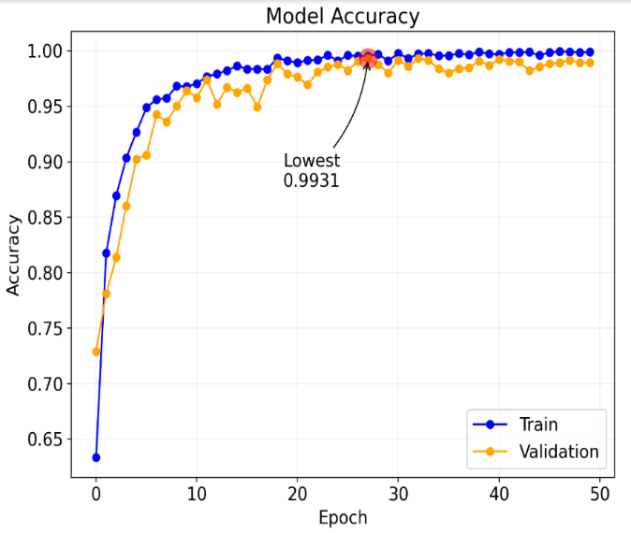
Fig 11 : Progression Accuracy of Cnn

ii.CNN Model Loss
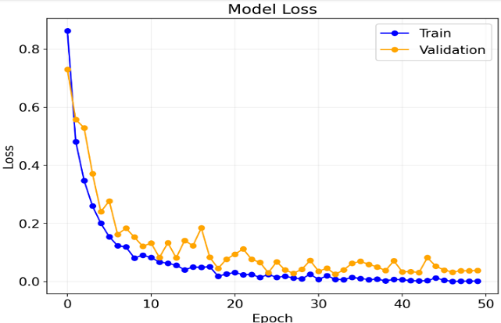
Fig 12: Progression Loss of Cnn

- Resnet 50 Model Accuracy
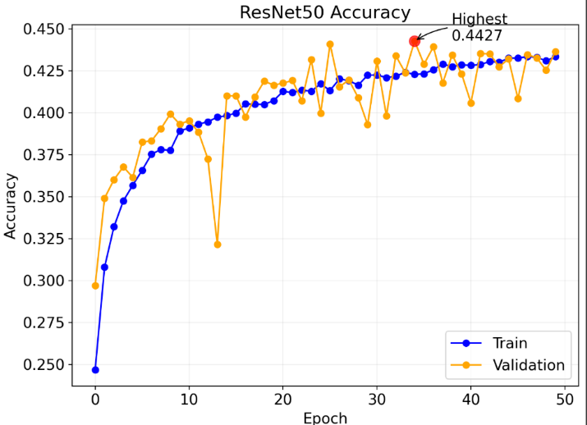
Fig 13 : Progression accuracy of Resnet50

- VGG16

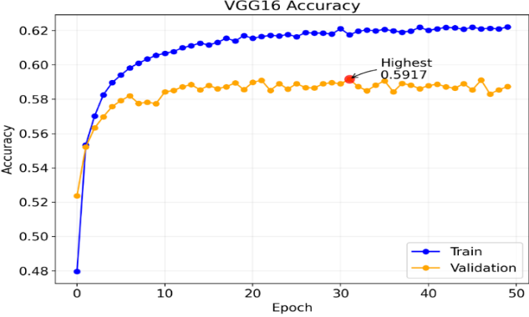

Fig 14: Progression Accuracy of VGG16 Model

- EfficientNet B0
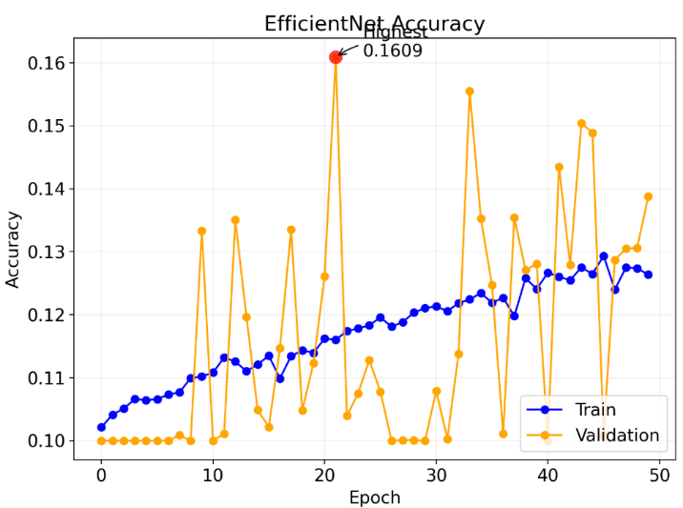
Fig 15 : Progression of Accuracy of Efficient Net B0Model

X Conclusion

This project is an all-round approach combining digital image processing methods like segmentation and augmentation with state-of-the-art Deep learning frameworks leverage Convolutional Neural Networks (CNNs) toand architectures like VGG16, ResNet50, and EfficientNetB0, the system is exceptionally accurate in identifying and classifying tumors in the brain.
The major objective of this model is to enable early and correct diagnosis, which is important for enhancing patient outcomes. The model successfully detects patterns related to tumor existence and type by interpreting MRI scans, making it clinically significant. This automated system is especially useful in areas where there is not much access to specialized radiologists since it yields consistent and reliable results, helping healthcare workers make informed decisions.
Among the various models used, VGG16 performed the highest, demonstrating the efficiency of the model in learning intricate features to achieve accurate classification. Pushing the boundaries in medical diagnostics as well as expanding access to high-quality healthcare.

XI References

- Yugal Pande, Jyotismita Chaki,Brain tumor detection across diverse MR images: An automated triple-module approach integrating reduced fused deep features and machine learning,Results in Engineering,Volume 25,2025, ,ISSN 2590-1230.
- Richter RH, Byerly D, Schultz D, Mansfield LT. Challenges in the Interpretation of MRI Examinations Without Radiographic Correlation: Pearls and Pitfalls to Avoid. Cureus. 2021 Jul 16;13(7):e16419. doi: 10.7759/cureus.16419. PMID: 34414045; PMCID: PMC8364739.
- Dorfner, F.J., Patel, J.B., Kalpathy-Cramer, J. et al. A review of deep learning for brain tumor analysis in MRI. npj Precis. Onc. 9, 2 (2025).
- Solanki, Shubhangi, Uday Pratap Singh, Siddharth Singh Chouhan, and Sanjeev Jain. "Brain tumor detection and classification using intelligence techniques: an overview." IEEE Access 11 (2023): 12870-12886.
- A. A. Asiri et al., "Brain Tumor Detection and Classification Using Fine-Tuned CNN with ResNet50 and U-Net Model: A Study on TCGA-LGG and TCIA Dataset for MRI Applications," Life, vol. 13, no. 7, p. 1449, 2023.
- V. Sravya and S. Malathi, "Survey on Brain Tumor Detection using Machine Learning and Deep Learning," 2021 International Conference on Computer Communication and Informatics (ICCCI), Coimbatore, India, 2021, pp. 1-3, doi: 10.1109/ICCCI50826.2021.9457019.
- K. Sharma, A. Kaur, and S. Gujral, "Brain tumor detection based on machine learning algorithms," International Journal of Computer Applications, vol. 103, no. 1, 2014.
- Gu X, Shen Z, Xue J, Fan Y, Ni T. Brain Tumor MR Image Classification Using Convolutional Dictionary Learning With Local Constraint. Front Neurosci. 2021 May 28;15:679847. doi: 10.3389/fnins.2021.679847. PMID: 34122001; PMCID: PMC8193950.
- K. Neamah et al., "Brain Tumor Classification and Detection Based DL Models: A Systematic Review," in IEEE Access, vol. 12, pp. 2517-2542, 2024, doi: 10.1109/ACCESS.2023.3347545.
- G. Hemanth, M. Janardhan and L. Sujihelen, "Design and Implementing Brain Tumor Detection Using Machine Learning Approach," 2019 3rd International Conference on Trends in Electronics and Informatics (ICOEI), Tirunelveli, India, 2019, pp. 1289-1294, doi: 10.1109/ICOEI.2019.8862553.
- Mavrakis AN, Halpern EF, Barker FG 2nd, Gonzalez RG, Henson JW. Diagnostic evaluation of patients with a brain mass as the presenting manifestation of cancer. Neurology. 2005 Sep 27;65(6):908-11. doi: 10.1212/01.wnl.0000176059.21455.76. PMID: 16186533.
- A. Minz and C. Mahobiya, "MR Image Classification Using Adaboost for Brain Tumor Type," 2017 IEEE 7th International Advance Computing Conference (IACC), Hyderabad, India, 2017, pp. 701-705, doi: 10.1109/IACC.2017.0146.
- G. Çınarer and B. G. Emiroğlu, "Classificatin of Brain Tumors by Machine Learning Algorithms," 2019 3rd International Symposium on Multidisciplinary Studies and Innovative Technologies (ISMSIT), Ankara, Turkey, 2019, pp. 1-4, doi: 10.1109/ISMSIT.2019.8932878.
- C.-J. Tseng and C. Tang, "An optimized XGBoost technique for accurate brain tumor detection using feature selection and image segmentation," Healthcare Analytics, vol. 4, p. 100217, 2023.
- Deepak S, Ameer PM. Brain tumor classification using deep CNN features via transfer learning. Comput Biol Med. 2019 Aug;111:103345. doi: 10.1016/j.compbiomed.2019.103345. Epub 2019 Jun 29. PMID: 31279167.
- Akter, S., Simul Hasan Talukder, M., Mondal, S.K. et al. Brain tumor classification utilizing pixel distribution and spatial dependencies higher-order statistical measurements through explainable ML models. Sci Rep 14, 25800 (2024).
- M. Siar and M. Teshnehlab, "Brain tumor detection using deep neural network and machine learning algorithm," 2019 9th International Conference on Computer and Knowledge Engineering (ICCKE), IEEE, 2019.
- A. Rath, B. S. P. Mishra, and D. K. Bagal, "ResNet50-based deep learning model for accurate brain tumor detection in MRI scans," Next Research, vol. 2, no. 1, p. 100104, 2025.
- A. Younis, L. Qiang, C. O. Nyatega, M. J. Adamu, and H. B. Kawuwa, "Brain Tumor Analysis Using Deep Learning and VGG-16 Ensembling Learning Approaches," Appl. Sci., vol. 12, p. 7282, 2022,
- A. Ramanagiri, M. Mukunthan and G. Balamurugan, "Enhanced Brain Tumor Detection Using Resnet-50," 2024 10th International Conference on Communication and Signal Processing (ICCSP), Melmaruvathur, India, 2024, pp. 1708-1711, doi: 10.1109/ICCSP60870.2024.10543742.
- Zahoor, Mirza Mumtaz, et al. "A New Deep Hybrid Boosted and Ensemble Learning-based Brain Tumor Analysis using MRI." arXiv preprint arXiv:2201.05373 (2022).

