**01-09-2025 Programs on patterns**

**Print a square pattern**

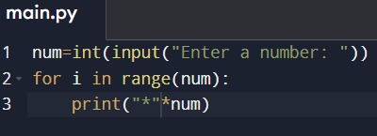

**Output:**

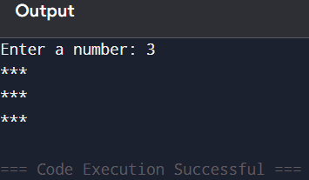

**Rhombus pattern**

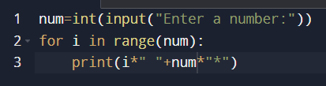

**Output:**

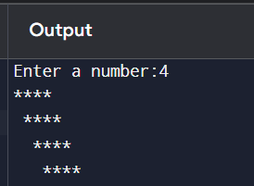

**Rectangular pattern**

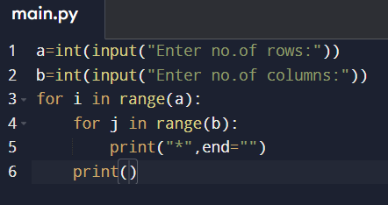

**Output:**

