**03-09-2025**

1. **Prime number**
2. **Palindrome**
3. **Armstrong**
4. **Strong**
5. **Fibonacci series**

**Prime number**

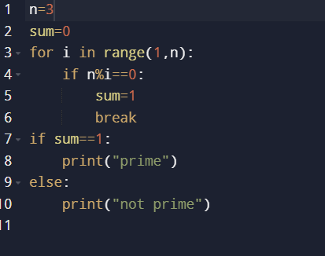

Output:



**Palindrome**

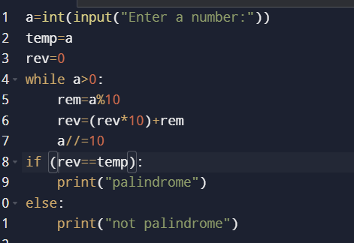

**Output:**

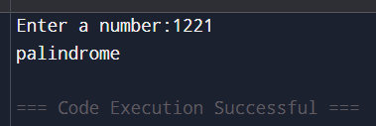

**Armstrong**

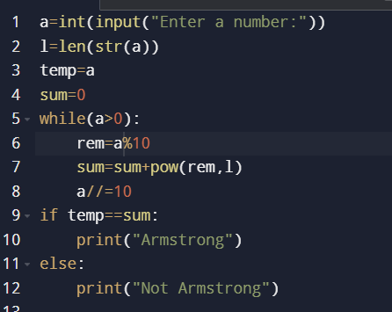

Output:

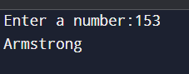

**Strong**

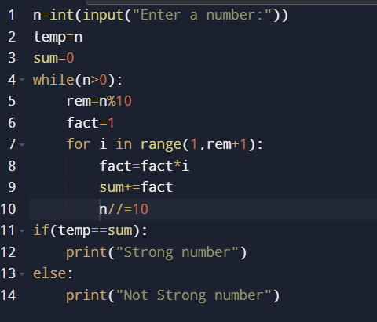

**Output:**

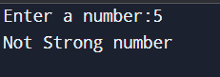

**Fibonacci series**

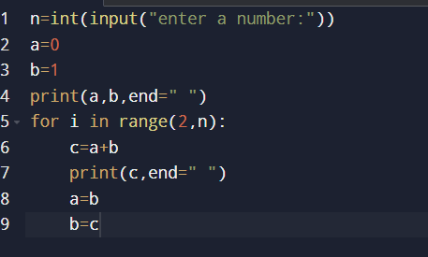

Output:

