**04-09-2025**

**1)Factorial number**

**2)Factors number**

**3)Perfect number**

**4)Perfect square**

**Factorial number**

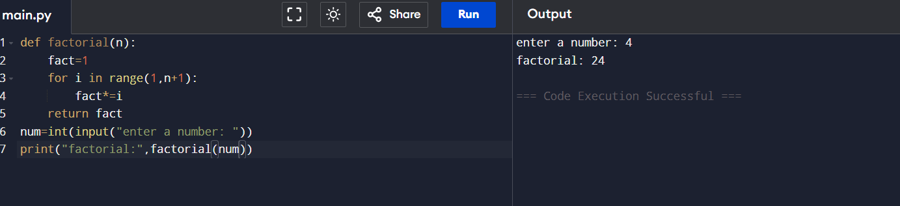

**Factors number**

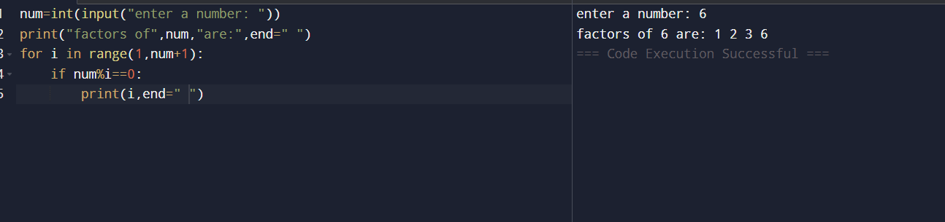

**Perfect number**

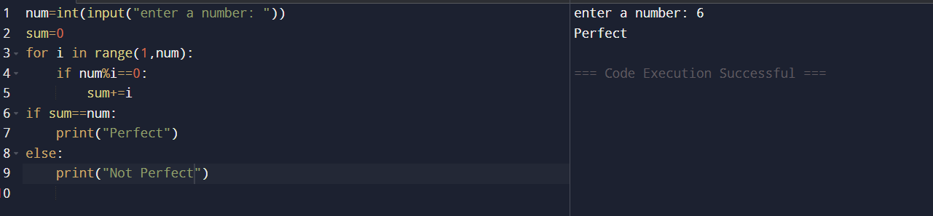

**Perfect square**

