**05-09-2025**

**1)Harshad number**

**2)Friendly number**

**3)Abundant number**

**4) strong number**

**5)Automorphic number**

**Harshad number**

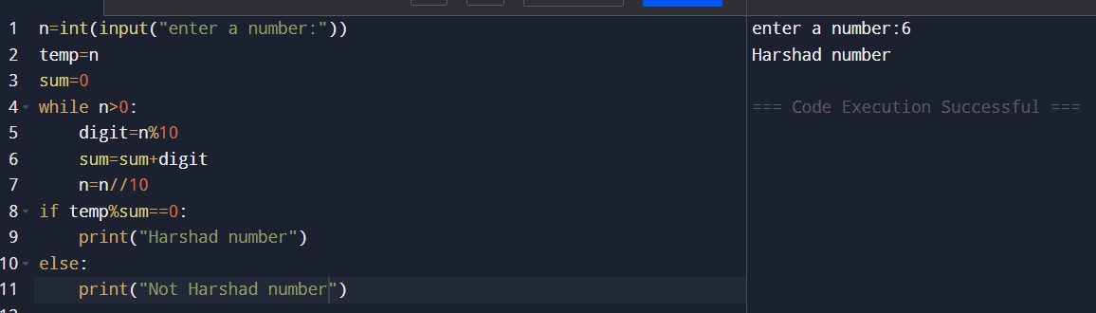

**Abundant number**

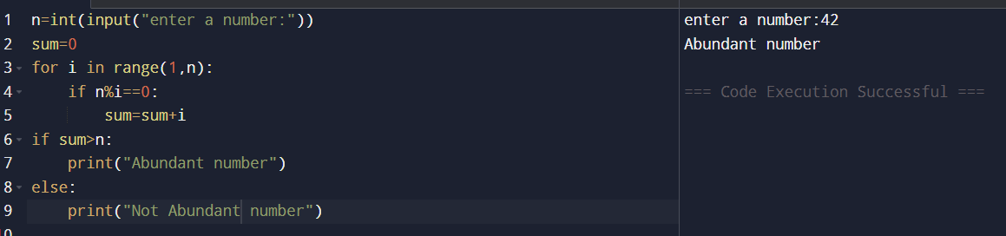

**strong number**

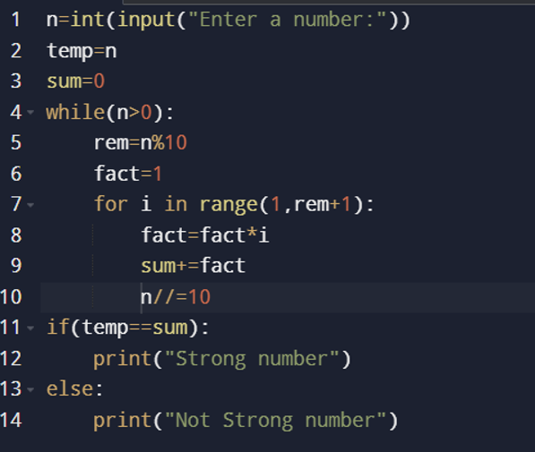

**Output:**

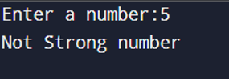

**Automorphic number**

