**Programs & Outputs**:

1.Check if a number is positive and negative in python

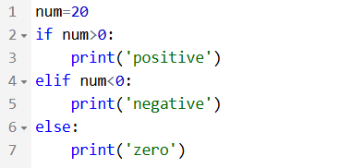

Output:



2.check whether a number is even or odd in python

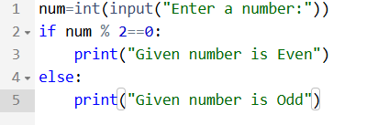

**Output:**



3.Find the sum of the first N natural numbers in python

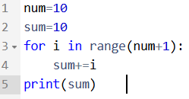

**Output:**

