**Practice : 21-08-2025**

**Programs & Outputs**

**Find the sum of N natural numbers**

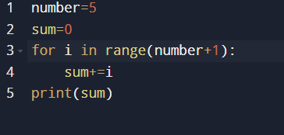

**Output:**

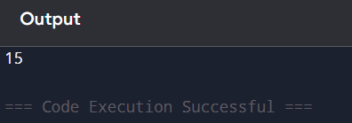

**Find the sum of numbers in a given range**

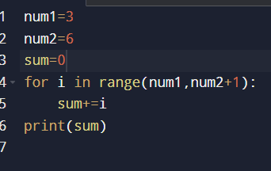

**Output:**

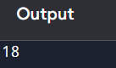

**Find the greatest number of two numbers**

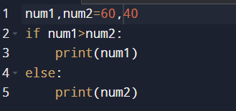

**Output:**

