**Practice :- 22-08-2025**

**Programs & Outputs**

**Find the greatest of three numbers**

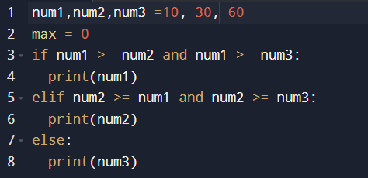

**Output:**

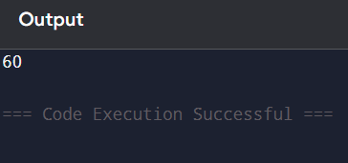

**Find the Leap year or Not**

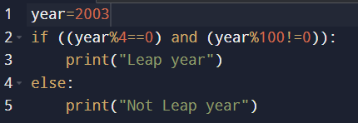

**Output:**

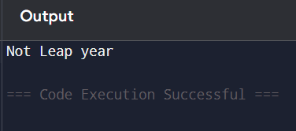

**Find the prime number or Not prime**

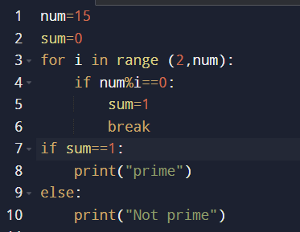

**Output:**

