Screenshot from VS Code FOR EXP:26
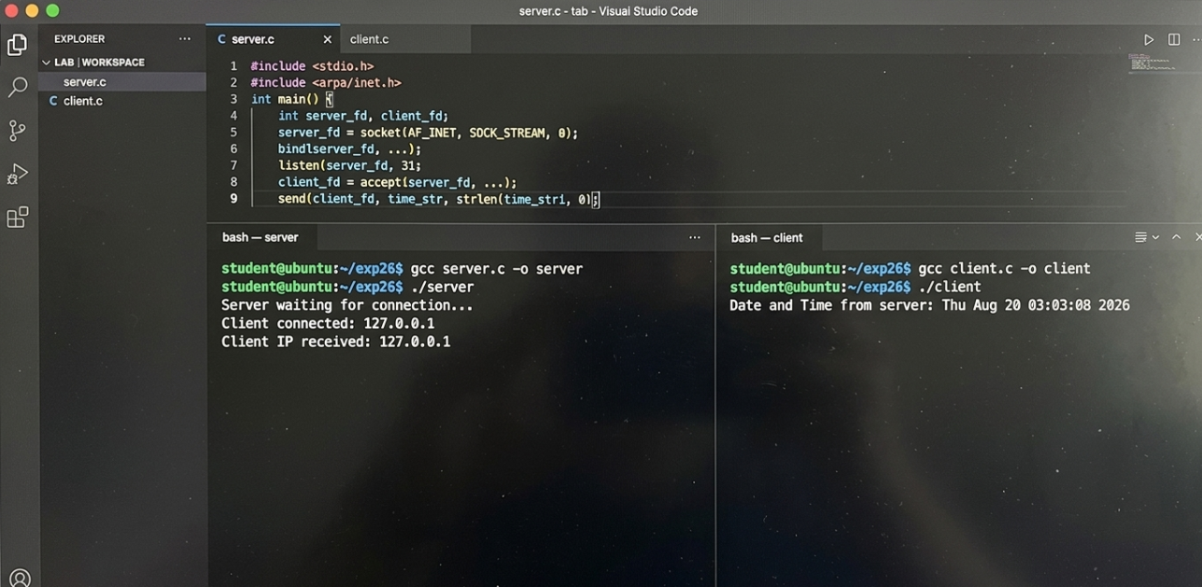
Screenshot from VS Code FOR EXP:27
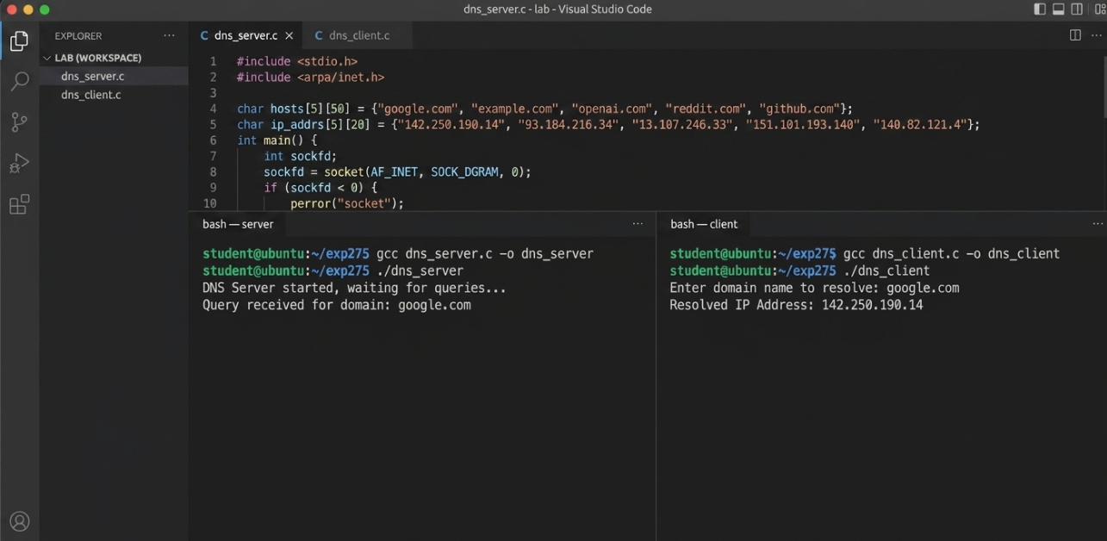

Screenshot from VS Code FOR EXP:28
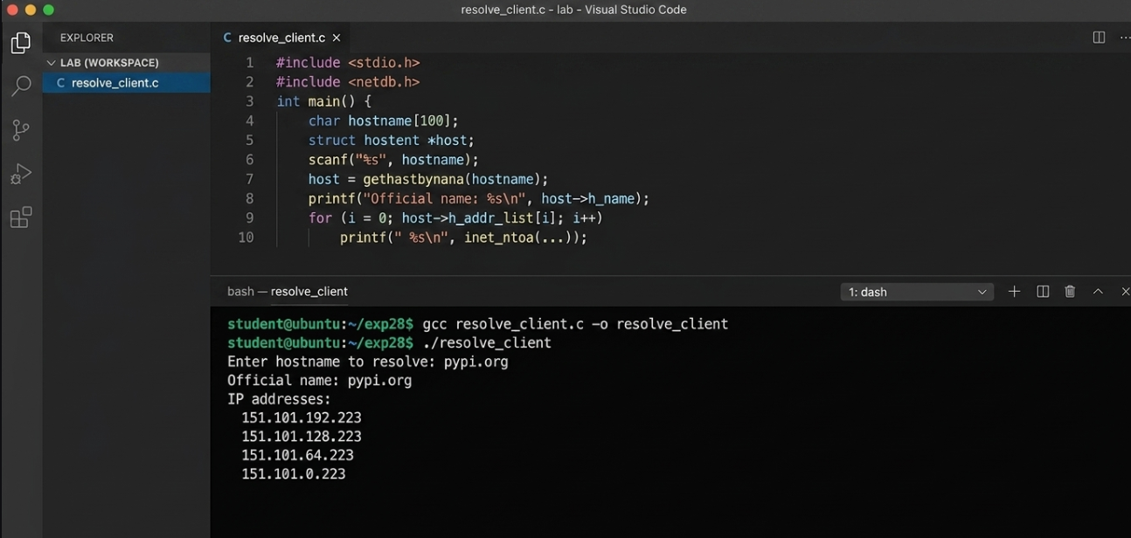
Screenshot from VS Code FOR EXP:29
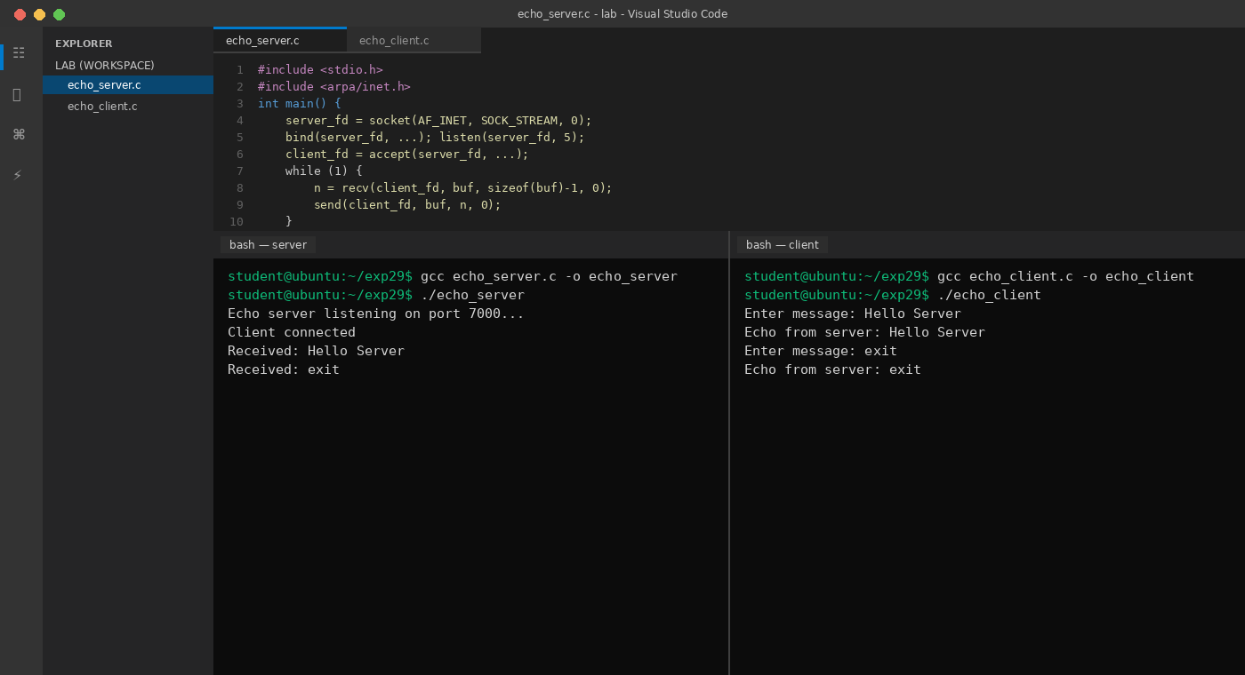

Screenshot from VS Code FOR EXP:30
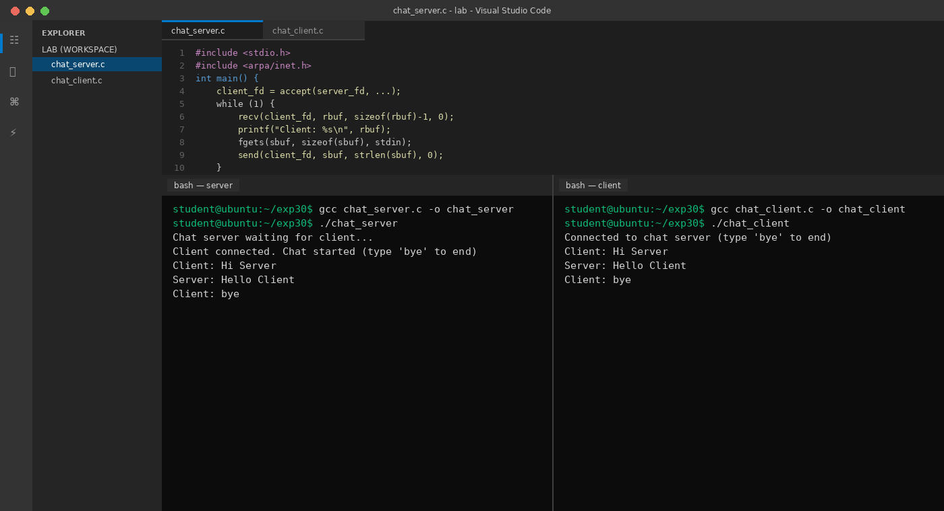
Screenshot from VS Code FOR EXP:31
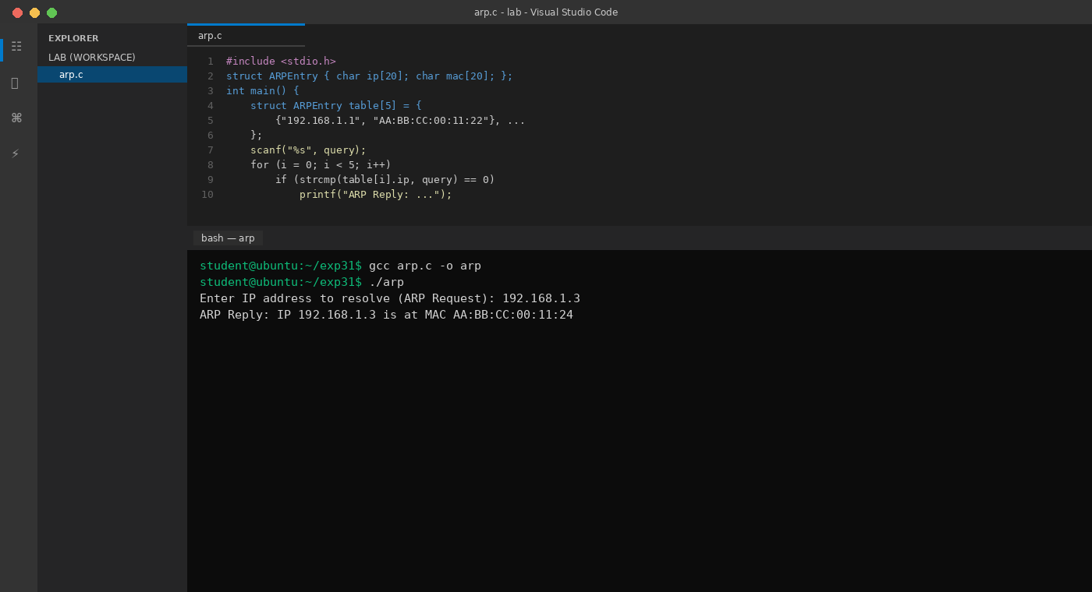

Screenshot from VS Code FOR EXP:32
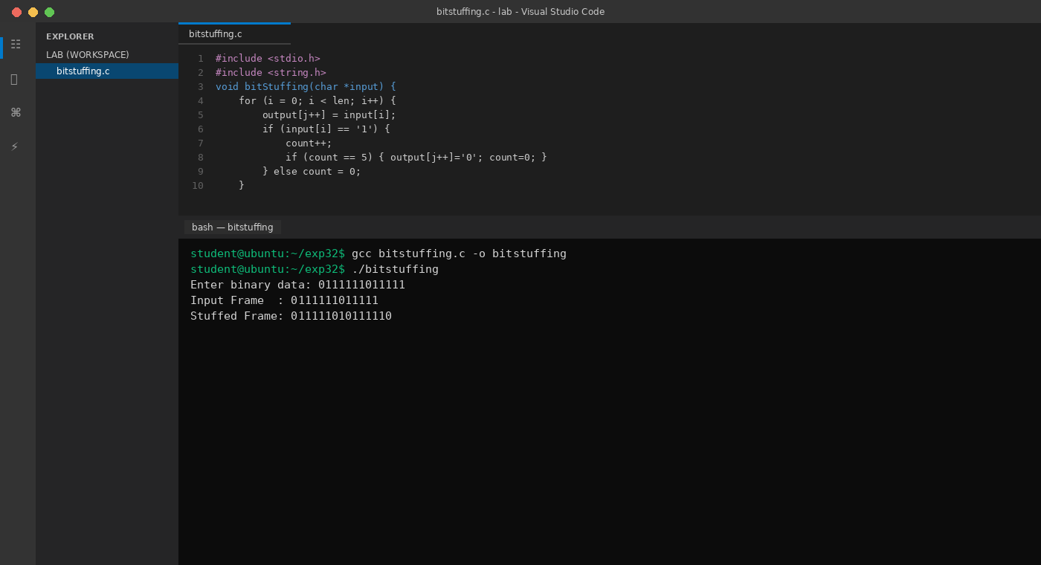

Screenshot from VS Code FOR EXP:33
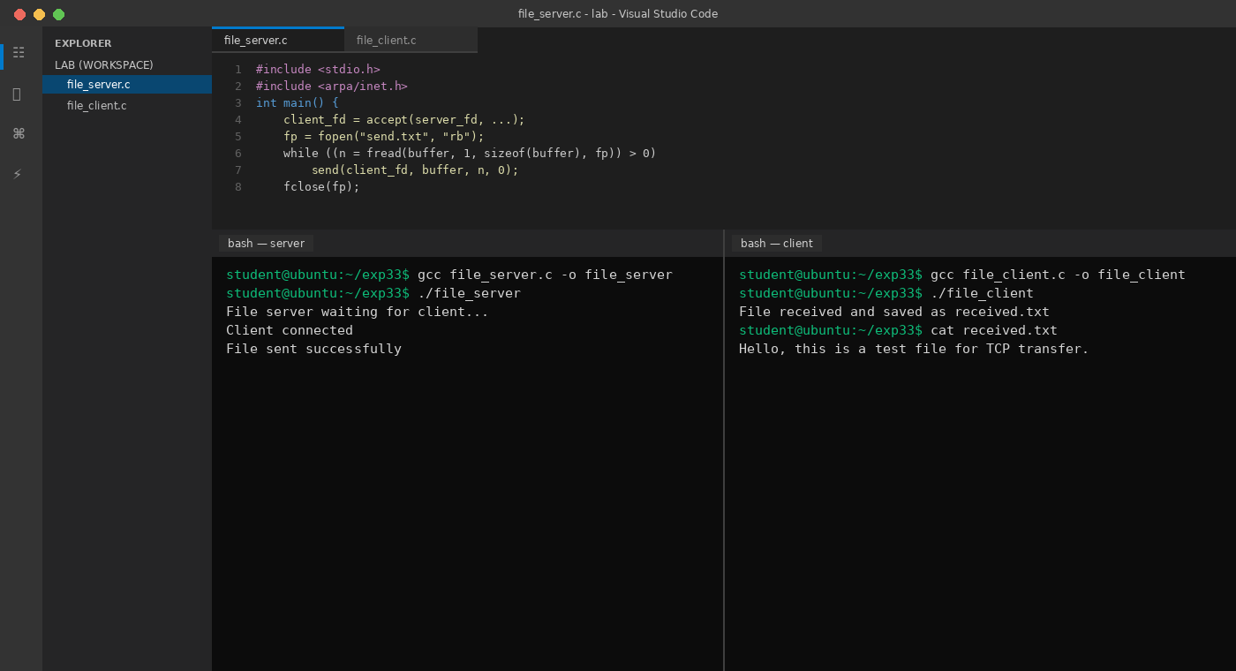
Screenshot from VS Code FOR EXP:34
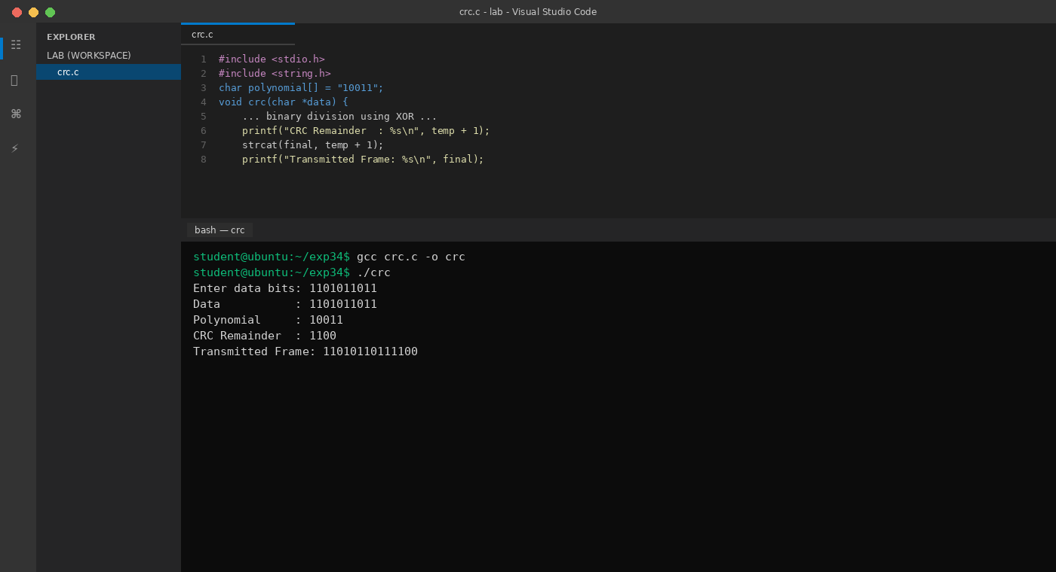
Screenshot from VS Code EXP:35
