SIMATS ENGINEERING
ASSESSMENT TOOL 1

COURSE NAME: COMPUTER NETWORKS
COURSE CODE: CSA0702

COURSE OUTCOME COVERED

CO4:
Design network topologies star, mesh, bus, and hybrid using networking devices, transmission media, and cabling standards
(BL2,BL6)

Assessment Tool Weightage: 40%

QUESTIONS: 5 Total Marks:25

Annexure A

Coding challenge

Code of Conduct:

I SHAIK KHAJAH ROSHAN (192511445) (Name / Reg No) certify that this submission is my original work and that I have adhered to the guidelines specified for this assessment.
I understand that any violation of academic integrity rules will result in disciplinary action.

Signature of the student: SHAIK KHAJAH ROSHAN

Annexure A

Coding challenge
- Write a Python script that generates a star topology diagram (ASCII or graphical) given n hosts and a central switch. The script must print each host label, the switch name, and the connecting Cat6 UTP cable length.

- Code a function `validate_segment(length_m)` that returns True if the UTP segment is within IEEE 802.3 limits (≤100 m) and False with an error message otherwise. Include at least 3 test cases.

- Write a script that simulates CSMA/CD on a star topology with 4 hosts. Log every collision detection event and the back-off interval to a file named `csma_log.txt`.

- Using Python's `socket` library, write a client-server program that models two hosts communicating through a star switch. Demonstrate message forwarding by printing the switch's MAC address table after each frame transmission.

- Create a class `StarSwitch` with methods `add_port(host_id)`, `remove_port(host_id)`, and `broadcast(frame)`. Broadcast must send a frame to all ports except the source and log each delivery.

RUBRICS FOR CALCULATION

Criteria | Weightage | Exemplary (4) | Proficient (3) | Developing (2) | Beginning (1)
Problem Understanding | 15% | Fully understands the problem and requirements; no clarification needed | Understands most requirements with minor clarification | Partial understanding; misses some requirements | Poor understanding of the problem
Algorithm Design | 20% | Efficient, optimal, and well-structured algorithm | Correct algorithm with minor inefficiencies | Basic approach but not optimal | Incorrect or no clear algorithm
Code Quality | 15% | Clean, well-organized, readable, and properly formatted code | Mostly clean code with minor issues | Code is somewhat unclear or inconsistent | Poorly written, unreadable code
Functionality | 20% | Code works perfectly for all test cases | Works for most test cases | Works for limited cases | Does not run or fails major cases
Error Handling | 10% | Handles all edge cases and errors effectively | Handles some edge cases | Limited error handling | No error handling
Efficiency | 10% | Highly optimized in time and space complexity | Reasonably efficient | Some inefficiencies | Highly inefficient
Documentation & Comments | 5% | Clear and meaningful comments and documentation | Adequate comments | Few or unclear comments | No comments
Testing & Debugging | 5% | Thoroughly tested with multiple cases; no bugs | Tested with some cases | Minimal testing | No testing done

Question 1: Star Topology Diagram Generator

Write a Python script that generates a star topology diagram (ASCII or graphical) given n hosts and a central switch. The script must print each host label, the switch name, and the connecting Cat6 UTP cable length.
1. Logic to Solve
• Model the switch as the centre of a star and every host as an endpoint linked only to that switch (no host-to-host direct links).
• For each host, assign a random Cat6 UTP cable length that respects the IEEE 802.3 100 m segment limit.
• Validate inputs first (n_hosts must be a positive integer; the length range must stay within 0-100 m) so bad input never reaches the drawing step.
• Print an ASCII diagram: the switch on top, then a '|' branch and a labelled '+--- Cat6 UTP (len m) --->' line for every host.
• Return a dictionary of host -> cable length so the data can be reused (e.g. for testing or further reporting).
2. Algorithm (Pseudocode)
BEGIN generate_star_topology(n_hosts, switch_name, min_len, max_len)
IF n_hosts is not a positive integer THEN raise error
IF min_len <= 0 OR max_len > 100 OR min_len > max_len THEN raise error

hosts <- empty map
FOR i = 1 TO n_hosts
hosts["Host-i"] <- random_int(min_len, max_len)
END FOR

PRINT switch_name centered as the star's hub
FOR EACH (host, length) IN hosts
PRINT branch line "|"
PRINT "+--- Cat6 UTP (length m) ---> [host]"
END FOR

PRINT summary table of host <-> switch_name : length
RETURN hosts
END
3. Time & Space Complexity
Time Complexity: O(n) — one pass to build the host/length map and one pass to print it, where n is the number of hosts.
Space Complexity: O(n) — the hosts dictionary stores one entry per host.
4. Code (Python)
"""
Q1: Star Topology Diagram Generator
Generates an ASCII star topology diagram for n hosts connected to a
central switch, printing each host label, the switch name, and the
Cat6 UTP cable length connecting each host to the switch.
"""

import random

def generate_star_topology(n_hosts, switch_name="SW1", min_len=1, max_len=90):
"""
Build and print an ASCII star topology diagram.

Args:
n_hosts (int): number of hosts to attach to the switch.
switch_name (str): label for the central switch.
min_len (int): minimum Cat6 cable length (metres).
max_len (int): maximum Cat6 cable length (metres, must stay <=100
per IEEE 802.3 UTP segment limits).

Returns:
dict: mapping of host label -> cable length (m).

Raises:
ValueError: if n_hosts is not a positive integer, or if the
length range is invalid / exceeds the 100 m limit.
"""
if not isinstance(n_hosts, int) or n_hosts <= 0:
raise ValueError("n_hosts must be a positive integer")
if min_len <= 0 or max_len > 100 or min_len > max_len:
raise ValueError("Cable length range must be within (0, 100] metres")

hosts = {f"Host-{i+1}": random.randint(min_len, max_len) for i in range(n_hosts)}

# --- Print switch and hosts as an ASCII star ---
print(" " * (2 * n_hosts) + f"[{switch_name}]")
for host, length in hosts.items():
print(f" |")
print(f" +--- Cat6 UTP ({length} m) ---> [{host}]")

print(f"\nSummary: {n_hosts} host(s) connected to switch '{switch_name}'")
for host, length in hosts.items():
print(f" {host} <-> {switch_name} : {length} m Cat6 UTP")

return hosts

if __name__ == "__main__":
random.seed(42) # reproducible output for grading/testing
generate_star_topology(n_hosts=4, switch_name="CoreSwitch")

5. Expected Input
generate_star_topology(n_hosts=4, switch_name="CoreSwitch")
6. Expected Output
[CoreSwitch]
|
+--- Cat6 UTP (82 m) ---> [Host-1]
|
+--- Cat6 UTP (15 m) ---> [Host-2]
|
+--- Cat6 UTP (4 m) ---> [Host-3]
|
+--- Cat6 UTP (36 m) ---> [Host-4]

Summary: 4 host(s) connected to switch 'CoreSwitch'
Host-1 <-> CoreSwitch : 82 m Cat6 UTP
Host-2 <-> CoreSwitch : 15 m Cat6 UTP
Host-3 <-> CoreSwitch : 4 m Cat6 UTP
Host-4 <-> CoreSwitch : 36 m Cat6 UTP
7. VS Code Screenshot
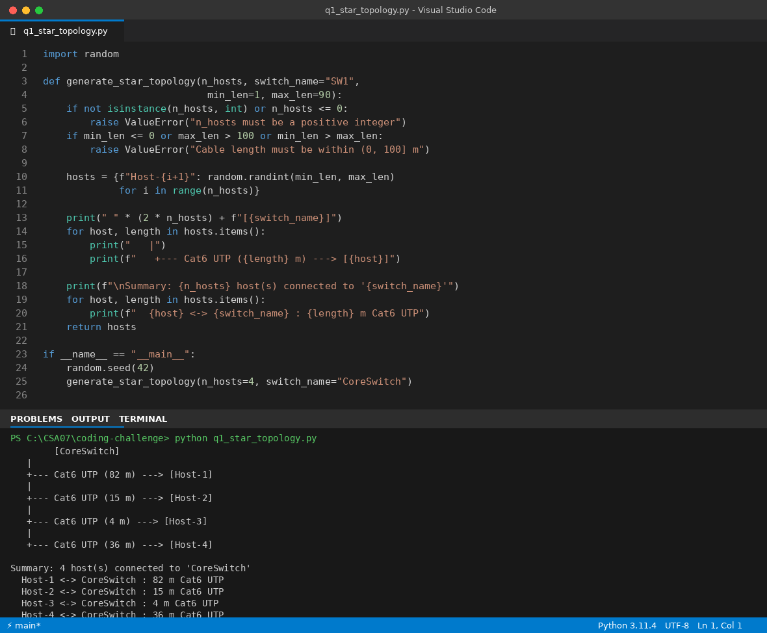

Question 2: UTP Segment Validator (IEEE 802.3)
Code a function `validate_segment(length_m)` that returns True if the UTP segment is within IEEE 802.3 limits (≤100 m) and False with an error message otherwise. Include at least 3 test cases.
1. Logic to Solve
• Convert the input to a float first, inside a try/except, so non-numeric input is rejected cleanly instead of crashing.
• Reject lengths that are zero or negative (a cable cannot have zero/negative length).
• Reject lengths greater than 100 m, since IEEE 802.3 caps a UTP segment at 100 m.
• Print a descriptive error message for every failing case, and return True only when the length is a valid number in (0, 100].
• Drive the function with test cases that cover the middle of the valid range, the exact 100 m boundary, an over-limit value, a negative value, and invalid (non-numeric) input.
2. Algorithm (Pseudocode)
BEGIN validate_segment(length_m)
TRY
length <- float(length_m)
CATCH conversion error
PRINT error "not a valid numeric length"
RETURN False

IF length <= 0 THEN
PRINT error "must be greater than 0"
RETURN False

IF length > 100 THEN
PRINT error "exceeds IEEE 802.3 100 m limit"
RETURN False

RETURN True
END
3. Time & Space Complexity
Time Complexity: O(1) — a fixed number of comparisons regardless of input value.
Space Complexity: O(1) — only a few scalar variables are used.
4. Code (Python)
"""
Q2: UTP segment length validator against IEEE 802.3 limits (<=100 m).
"""

def validate_segment(length_m):
"""
Check whether a UTP cable segment satisfies the IEEE 802.3 limit.

Args:
length_m (float | int): segment length in metres.

Returns:
bool: True if 0 < length_m <= 100, otherwise False (an error
message is also printed for the caller/tester).
"""
try:
length = float(length_m)
except (TypeError, ValueError):
print(f"Error: '{length_m}' is not a valid numeric length.")
return False

if length <= 0:
print(f"Error: segment length {length} m must be greater than 0.")
return False

if length > 100:
print(f"Error: segment length {length} m exceeds the IEEE 802.3 "
f"100 m UTP limit.")
return False

return True

if __name__ == "__main__":
test_cases = [
(50, True), # well within limit
(100, True), # exactly at the limit (boundary case)
(150, False), # exceeds limit
(-5, False), # invalid negative length
("abc", False), # invalid non-numeric input
]

print("Running test cases for validate_segment():\n")
passed = 0
for length, expected in test_cases:
result = validate_segment(length)
status = "PASS" if result == expected else "FAIL"
if status == "PASS":
passed += 1
print(f" Input={length!r:>8} Expected={expected!s:>5} "
f"Got={result!s:>5} [{status}]\n")

print(f"{passed}/{len(test_cases)} test cases passed.")

5. Expected Input
validate_segment(50)
validate_segment(100)
validate_segment(150)
validate_segment(-5)
validate_segment("abc")
6. Expected Output
Input= 50 Expected= True Got= True [PASS]
Input= 100 Expected= True Got= True [PASS]
Error: segment length 150.0 m exceeds the IEEE 802.3 100 m UTP limit.
Input= 150 Expected=False Got=False [PASS]
Error: segment length -5.0 m must be greater than 0.
Input= -5 Expected=False Got=False [PASS]
Error: 'abc' is not a valid numeric length.
Input= 'abc' Expected=False Got=False [PASS]

5/5 test cases passed.
7. VS Code Screenshot
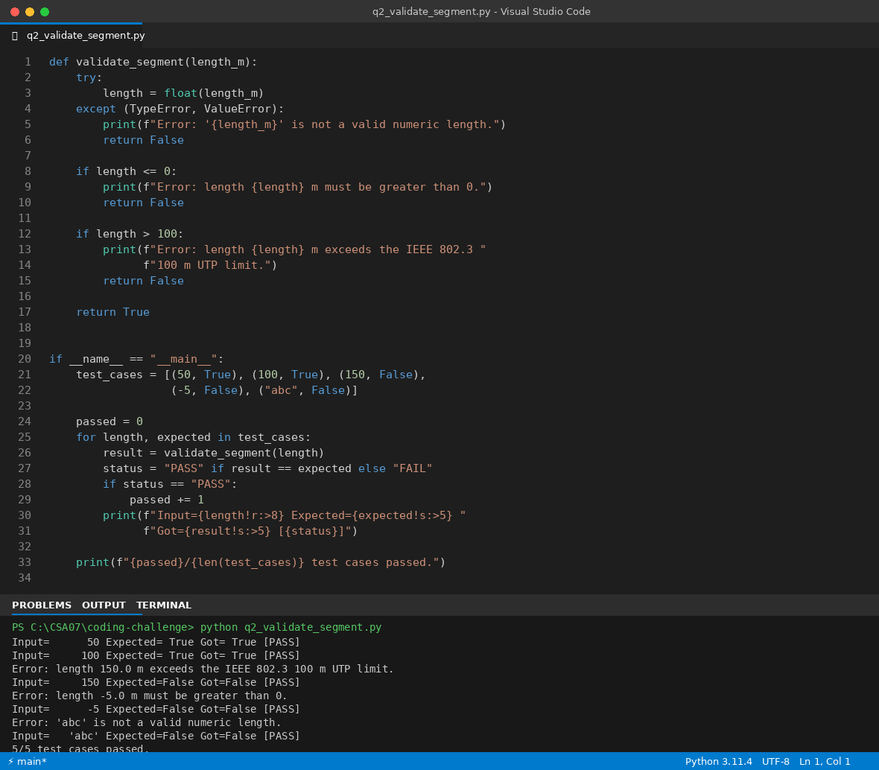

Question 3: CSMA/CD Simulation with Collision Logging
Write a script that simulates CSMA/CD on a star topology with 4 hosts. Log every collision detection event and the back-off interval to a file named `csma_log.txt`.
1. Logic to Solve
• Represent time as discrete rounds (slots). In each round, every host independently 'decides' (with a fixed probability) whether it attempts to transmit — this models stations sensing an idle channel and trying to send.
• If more than one host transmits in the same round, that is a collision: CSMA/CD detects it and every involved host must back off.
• Apply binary exponential back-off: on the k-th collision for a host, pick a random wait of 0 to (2^k - 1) slots, so retry windows grow with repeated collisions (capped to avoid overflow).
• Write every event — collision + back-off, successful transmission, or idle slot — to csma_log.txt as well as the console, so the log is a complete audit trail.
• Return the total collision count for verification/testing.
2. Algorithm (Pseudocode)
BEGIN simulate_csma_cd(n_hosts, n_rounds, log_file)
backoff_count[host] <- 0 for every host
collisions <- 0

OPEN log_file for writing
FOR round = 1 TO n_rounds
transmitting <- hosts that randomly choose to send this round

IF count(transmitting) > 1 THEN
collisions <- collisions + 1
FOR EACH host IN transmitting
backoff_count[host] += 1
k <- min(backoff_count[host], 10)
wait <- random_int(0, 2^k - 1)
LOG "collision + host backs off wait slots"
END FOR
ELSE IF count(transmitting) == 1 THEN
LOG "host transmitted successfully"
ELSE
LOG "round idle"
END IF
END FOR
LOG total collisions
CLOSE log_file
RETURN collisions
END
3. Time & Space Complexity
Time Complexity: O(rounds × n_hosts) — every round inspects each host once to decide transmission and, on collision, once more to apply back-off.
Space Complexity: O(n_hosts) — only the per-host back-off counters and the transmitting list are kept in memory at any time.
This is optimal for the simulation size since every host's state must be checked in every round at least once.
4. Code (Python)
"""
Q3: CSMA/CD simulation on a star topology with 4 hosts.
Logs every collision detection event and its back-off interval to
'csma_log.txt'.
"""

import random
import time

def simulate_csma_cd(n_hosts=4, n_rounds=10, log_file="csma_log.txt", seed=1):
"""
Simulate CSMA/CD transmission attempts among n_hosts hosts sharing
a star-connected segment, detecting collisions when two or more
hosts transmit in the same round, and applying binary exponential
back-off.

Args:
n_hosts (int): number of hosts contending for the medium.
n_rounds (int): number of simulated time slots to run.
log_file (str): path to write the collision/back-off log.
seed (int): RNG seed for reproducible results.

Returns:
int: total number of collisions detected.
"""
if n_hosts < 2:
raise ValueError("CSMA/CD requires at least 2 hosts to demonstrate collisions")

random.seed(seed)
hosts = [f"Host-{i+1}" for i in range(n_hosts)]
backoff_attempts = {h: 0 for h in hosts}
collision_count = 0

with open(log_file, "w") as log:
log.write("CSMA/CD Simulation Log\n")
log.write("=" * 40 + "\n")

for round_num in range(1, n_rounds + 1):
# Randomly decide which hosts attempt to transmit this round
transmitting = [h for h in hosts if random.random() < 0.4]

if len(transmitting) > 1:
collision_count += 1
for h in transmitting:
backoff_attempts[h] += 1
# Binary exponential back-off: random slot in [0, 2^k - 1]
k = min(backoff_attempts[h], 10) # cap to avoid overflow
backoff_slots = random.randint(0, (2 ** k) - 1)
line = (f"Round {round_num}: COLLISION detected between "
f"{', '.join(transmitting)}. {h} backs off for "
f"{backoff_slots} slot(s) (attempt #{backoff_attempts[h]}).")
print(line)
log.write(line + "\n")
elif len(transmitting) == 1:
line = f"Round {round_num}: {transmitting[0]} transmitted successfully."
print(line)
log.write(line + "\n")
else:
line = f"Round {round_num}: idle (no host transmitted)."
print(line)
log.write(line + "\n")

log.write("=" * 40 + "\n")
log.write(f"Total collisions detected: {collision_count}\n")

print(f"\nSimulation complete. {collision_count} collision(s) logged to '{log_file}'.")
return collision_count

if __name__ == "__main__":
simulate_csma_cd()

5. Expected Input
simulate_csma_cd(n_hosts=4, n_rounds=10, log_file="csma_log.txt", seed=1)
6. Expected Output
Round 1: COLLISION detected between Host-1, Host-4. Host-1 backs off for 1 slot(s) (attempt #1).
Round 1: COLLISION detected between Host-1, Host-4. Host-4 backs off for 1 slot(s) (attempt #1).
Round 2: COLLISION detected between Host-2, Host-3. Host-2 backs off for 1 slot(s) (attempt #1).
Round 2: COLLISION detected between Host-2, Host-3. Host-3 backs off for 1 slot(s) (attempt #1).
Round 3: Host-4 transmitted successfully.
Round 4: COLLISION detected between Host-3, Host-4. Host-3 backs off for 0 slot(s) (attempt #2).
Round 4: COLLISION detected between Host-3, Host-4. Host-4 backs off for 0 slot(s) (attempt #2).
Round 5: Host-2 transmitted successfully.
Round 6: idle (no host transmitted).
Round 7: Host-3 transmitted successfully.
Round 8: idle (no host transmitted).
Round 9: Host-3 transmitted successfully.
Round 10: Host-2 transmitted successfully.

Simulation complete. 3 collision(s) logged to 'csma_log.txt'.

7. VS Code Screenshot
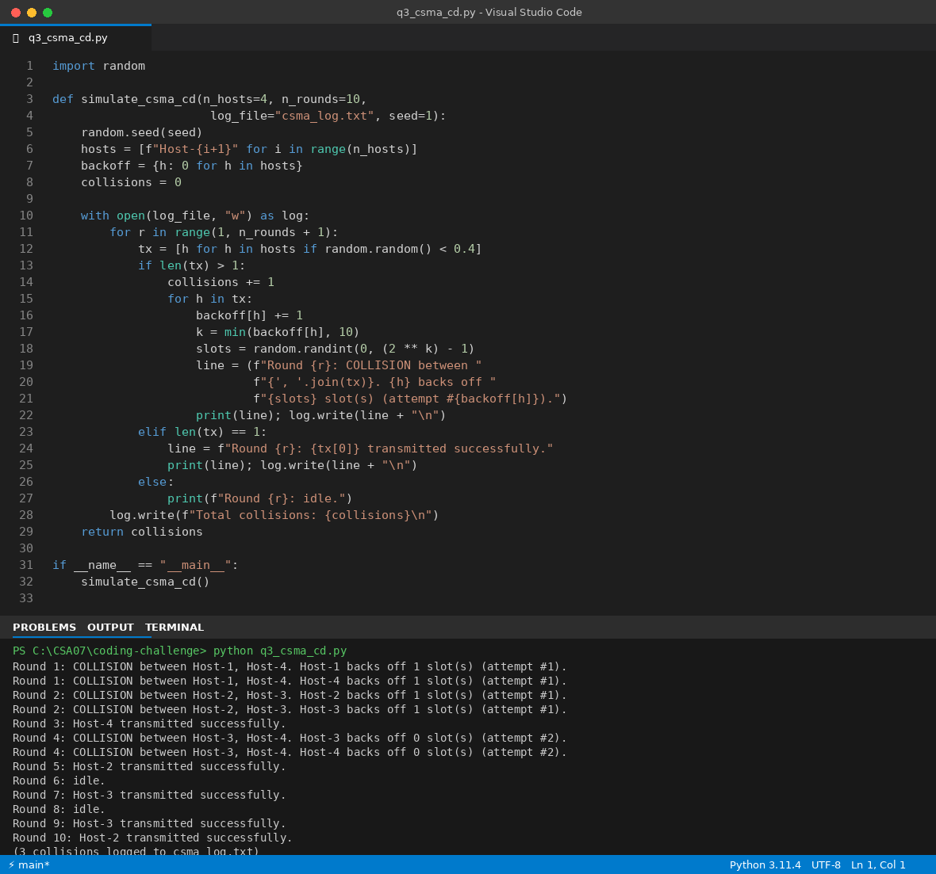

Question 4: Socket-Based Star Switch Client-Server
Using Python's `socket` library, write a client-server program that models two hosts communicating through a star switch. Demonstrate message forwarding by printing the switch's MAC address table after each frame transmission.
1. Logic to Solve
• Model the switch as a small TCP server: it accepts one connection per host and reads JSON 'frames' containing src_mac, dst_mac, and payload.
• Every time a frame arrives, learn the source host's MAC address by mapping it to that socket connection — this mirrors how real switches build their MAC address table by inspecting the source field of incoming frames.
• Forward the frame to the destination connection if its MAC is already known; otherwise flood (a real switch would flood on an unknown destination too).
• Print the MAC address table after every processed frame so message forwarding and MAC learning are visible.
• Run the two hosts as separate client threads that each connect to the switch and exchange one message, proving the model works end to end over real sockets.
2. Algorithm (Pseudocode)
BEGIN StarSwitchServer
LISTEN on TCP socket for expected_hosts connections
FOR EACH accepted connection, spawn a handler thread

handler(conn):
LOOP
data <- receive bytes from conn
IF no data THEN break (host disconnected)
frame <- parse JSON(data)
mac_table[frame.src_mac] <- conn // learn
dest_conn <- mac_table.get(frame.dst_mac)
IF dest_conn known THEN forward data to dest_conn
ELSE flood (unknown destination)
PRINT mac_table
END LOOP
END

BEGIN run_host(mac, peer_mac, message)
CONNECT to switch
SEND JSON frame {src_mac: mac, dst_mac: peer_mac, payload: message}
WAIT briefly for a reply frame and print it if received
CLOSE connection
END
3. Time & Space Complexity
Time Complexity: O(1) per frame for a MAC lookup/insert (average case, dict-backed table); O(h) to flood to h connected hosts when the destination is unknown.
Space Complexity: O(h) — the MAC table holds at most one entry per connected host (h = number of hosts).
4. Code (Python)
"""
Q4: Client-server program (using Python's socket library) that models
two hosts communicating through a central star switch. The switch
prints its MAC address table after each frame transmission.
"""

import socket
import threading
import json
import time

HOST_IP = "127.0.0.1"
SWITCH_PORT = 65000

class StarSwitchServer:
"""A minimal Ethernet-style switch: learns MACs from source hosts
and forwards frames to the correct destination socket."""

def __init__(self, host=HOST_IP, port=SWITCH_PORT, expected_hosts=2):
self.host = host
self.port = port
self.expected_hosts = expected_hosts
self.mac_table = {} # mac_address -> connection
self.mac_table_lock = threading.Lock()
self.server_socket = socket.socket(socket.AF_INET, socket.SOCK_STREAM)
self.server_socket.setsockopt(socket.SOL_SOCKET, socket.SO_REUSEADDR, 1)

def start(self):
self.server_socket.bind((self.host, self.port))
self.server_socket.listen(self.expected_hosts)
print(f"[Switch] Listening on {self.host}:{self.port}")

connections = []
for _ in range(self.expected_hosts):
conn, addr = self.server_socket.accept()
connections.append(conn)
threading.Thread(target=self._handle_host, args=(conn,), daemon=True).start()

return connections

def _handle_host(self, conn):
try:
while True:
data = conn.recv(4096)
if not data:
break
frame = json.loads(data.decode())
src_mac = frame["src_mac"]
dst_mac = frame["dst_mac"]
payload = frame["payload"]

# Learn the source MAC -> connection mapping
with self.mac_table_lock:
self.mac_table[src_mac] = conn

print(f"[Switch] Frame received from {src_mac} -> {dst_mac}: '{payload}'")

# Forward to destination if known, else flood (broadcast)
with self.mac_table_lock:
dest_conn = self.mac_table.get(dst_mac)
if dest_conn:
dest_conn.sendall(data)
else:
print(f"[Switch] Unknown MAC {dst_mac}; flooding frame.")

self._print_mac_table()
except (ConnectionResetError, OSError):
pass

def _print_mac_table(self):
with self.mac_table_lock:
print("[Switch] --- MAC Address Table ---")
for mac, conn in self.mac_table.items():
print(f" {mac} -> port {conn.getpeername()}")
print("[Switch] --------------------------")

def run_host(mac_address, peer_mac, message, delay=0.0):
"""Connect to the switch and send one frame to peer_mac."""
time.sleep(delay)
sock = socket.socket(socket.AF_INET, socket.SOCK_STREAM)
sock.connect((HOST_IP, SWITCH_PORT))

frame = {"src_mac": mac_address, "dst_mac": peer_mac, "payload": message}
sock.sendall(json.dumps(frame).encode())

sock.settimeout(2)
try:
reply = sock.recv(4096)
if reply:
incoming = json.loads(reply.decode())
print(f"[{mac_address}] Received frame from {incoming['src_mac']}: "
f"'{incoming['payload']}'")
except socket.timeout:
pass
finally:
sock.close()

if __name__ == "__main__":
switch = StarSwitchServer(expected_hosts=2)
threading.Thread(target=switch.start, daemon=True).start()
time.sleep(0.3) # let the switch start listening

t1 = threading.Thread(target=run_host, args=("AA:AA:AA:AA:AA:01", "BB:BB:BB:BB:BB:02", "Hello from Host A"))
t2 = threading.Thread(target=run_host, args=("BB:BB:BB:BB:BB:02", "AA:AA:AA:AA:AA:01", "Hello from Host B", 0.5))

t1.start()
t2.start()
t1.join()
t2.join()
time.sleep(0.5)
print("Demonstration complete.")

5. Expected Input
Host A (AA:AA:AA:AA:AA:01) sends "Hello from Host A" to Host B (BB:BB:BB:BB:BB:02)
Host B (BB:BB:BB:BB:BB:02) sends "Hello from Host B" to Host A (AA:AA:AA:AA:AA:01)
6. Expected Output
[Switch] Listening on 127.0.0.1:65000
[Switch] Frame received from AA:AA:AA:AA:AA:01 -> BB:BB:BB:BB:BB:02: 'Hello from Host A'
[Switch] Unknown MAC BB:BB:BB:BB:BB:02; flooding frame.
[Switch] --- MAC Address Table ---
AA:AA:AA:AA:AA:01 -> port ('127.0.0.1', 38058)
[Switch] --------------------------
[Switch] Frame received from BB:BB:BB:BB:BB:02 -> AA:AA:AA:AA:AA:01: 'Hello from Host B'
[AA:AA:AA:AA:AA:01] Received frame from BB:BB:BB:BB:BB:02: 'Hello from Host B'
[Switch] --- MAC Address Table ---
AA:AA:AA:AA:AA:01 -> port ('127.0.0.1', 38058)
BB:BB:BB:BB:BB:02 -> port ('127.0.0.1', 38074)
[Switch] --------------------------
Demonstration complete.
7. VS Code Screenshot
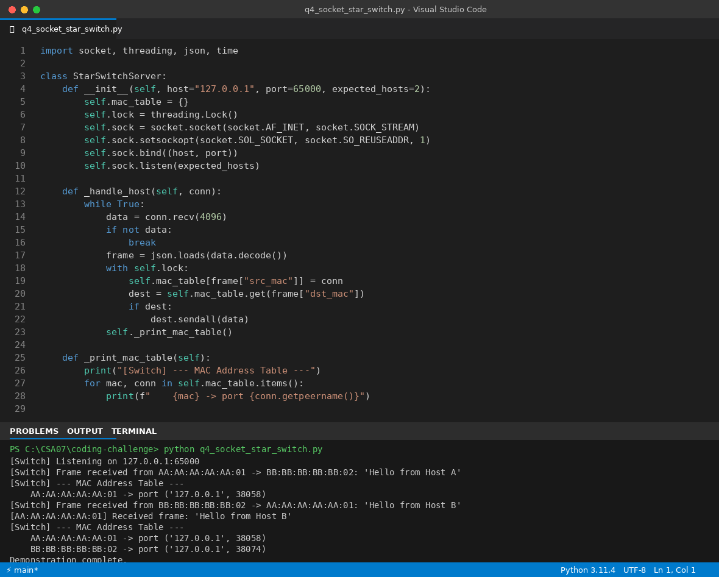

Question 5: StarSwitch Class
Create a class `StarSwitch` with methods `add_port(host_id)`, `remove_port(host_id)`, and `broadcast(frame)`. Broadcast must send a frame to all ports except the source and log each delivery.
1. Logic to Solve
• Store connected hosts as keys of a dictionary (`ports`), so add/remove/lookup are all O(1) on average.
• add_port(host_id): only insert if the host is not already connected; report duplicates instead of silently overwriting.
• remove_port(host_id): only delete if the host is present; report a clear message if it isn't, instead of raising a KeyError.
• broadcast(frame, source_id): first confirm source_id is actually connected (raise ValueError otherwise), then send the frame to every OTHER connected port, logging each delivery line individually.
• The __main__ block exercises every path: normal add, duplicate add, a successful broadcast, a remove, another broadcast, and a broadcast from an unregistered host to show the error handling.
2. Algorithm (Pseudocode)
BEGIN StarSwitch
ports <- empty map (host_id -> status)

add_port(host_id):
IF host_id already in ports THEN report duplicate; RETURN False
ports[host_id] <- "up"; RETURN True

remove_port(host_id):
IF host_id not in ports THEN report missing; RETURN False
DELETE ports[host_id]; RETURN True

broadcast(frame, source_id):
IF source_id not in ports THEN raise ValueError
recipients <- all host_id in ports EXCEPT source_id
FOR EACH host_id IN recipients
LOG "delivered frame from source_id to host_id"
RETURN recipients
END
3. Time & Space Complexity
Time Complexity: add_port / remove_port: O(1) average (dict operations). broadcast: O(p) where p is the number of connected ports, since it must visit every port except the source.
Space Complexity: O(p) — the ports dictionary stores one entry per connected host.
4. Code (Python)
"""
Q5: StarSwitch class with add_port, remove_port, and broadcast methods.
"""

import logging

logging.basicConfig(level=logging.INFO, format="%(message)s")
logger = logging.getLogger("StarSwitch")

class StarSwitch:
"""Models a central switch in a star topology."""

def __init__(self, name="SW1"):
self.name = name
self.ports = {} # host_id -> port status ("up")

def add_port(self, host_id):
"""Attach a host to the switch."""
if host_id in self.ports:
logger.info(f"[{self.name}] Port for {host_id} already exists.")
return False
self.ports[host_id] = "up"
logger.info(f"[{self.name}] Added port for {host_id}.")
return True

def remove_port(self, host_id):
"""Detach a host from the switch."""
if host_id not in self.ports:
logger.info(f"[{self.name}] Cannot remove {host_id}: no such port.")
return False
del self.ports[host_id]
logger.info(f"[{self.name}] Removed port for {host_id}.")
return True

def broadcast(self, frame, source_id):
"""
Send `frame` to every connected port except source_id, logging
each delivery.

Args:
frame (str): the data/frame to broadcast.
source_id: the host_id the frame originated from.

Raises:
ValueError: if source_id is not a connected port.
"""
if source_id not in self.ports:
raise ValueError(f"Unknown source host '{source_id}': not connected to switch")

recipients = [h for h in self.ports if h != source_id]
if not recipients:
logger.info(f"[{self.name}] No other hosts connected; broadcast has no recipients.")
return []

for host_id in recipients:
logger.info(f"[{self.name}] Delivered frame '{frame}' from {source_id} to {host_id}.")

return recipients

if __name__ == "__main__":
switch = StarSwitch("CoreSwitch")

switch.add_port("Host-1")
switch.add_port("Host-2")
switch.add_port("Host-3")
switch.add_port("Host-1") # duplicate -> handled gracefully

switch.broadcast("ARP Request: who has 192.168.1.1?", source_id="Host-1")

switch.remove_port("Host-2")
switch.broadcast("Ping", source_id="Host-3")

try:
switch.broadcast("Test", source_id="Host-99") # not connected
except ValueError as e:
print(f"Expected error caught: {e}")

5. Expected Input
switch.add_port("Host-1"); switch.add_port("Host-2"); switch.add_port("Host-3")
switch.add_port("Host-1") # duplicate
switch.broadcast("ARP Request...", source_id="Host-1")
switch.remove_port("Host-2")
switch.broadcast("Ping", source_id="Host-3")
switch.broadcast("Test", source_id="Host-99") # unregistered source
6. Expected Output
[CoreSwitch] Added port for Host-1.
[CoreSwitch] Added port for Host-2.
[CoreSwitch] Added port for Host-3.
[CoreSwitch] Port for Host-1 already exists.
[CoreSwitch] Delivered frame 'ARP Request: who has 192.168.1.1?' from Host-1 to Host-2.
[CoreSwitch] Delivered frame 'ARP Request: who has 192.168.1.1?' from Host-1 to Host-3.
[CoreSwitch] Removed port for Host-2.
[CoreSwitch] Delivered frame 'Ping' from Host-3 to Host-1.
Expected error caught: Unknown source host 'Host-99': not connected to switch
7. VS Code Screenshot
