SIMATS ENGINEERING
Department of Computer Science & Engineering
ASSESSMENT TOOL 3 — DEBUGGING & OPTIMISATION TASK
Course Code: | CSA1216
Course Title: | Computer Architecture

CO Assessed: | CO2
Assessment: | Assessment Tool 3 – Debugging & Optimisation Task

Weightage: | 20%
Total Marks: | 25

CO2 Statement: | Apply integer and floating-point arithmetic algorithms including Booth's multiplication, restoring/non-restoring division, and IEEE 754 standard operations to solve fixed-point and floating-point computational problems. (BL3)

Student Name: | __________SHAIK KHAJAH ROSHAN______________________
Reg. No.: | ____________192511445____________________

Department: | Computer Science & Engineering
Date: | ___________7/08/2026_____________________

Code of Conduct:
I ___SHAIK KHAJAH ROSHAN (192511445)__ (Name / Reg No) certify that this submission is my original work and that I have adhered to the guidelines specified for this assessment. I understand that any violation of academic integrity rules will result in disciplinary action.
Signature of the student: _________SHAIK KHAJAH ROSHAN__________

Marks Allocation
Q.No | Identification of Errors/Bugs (20%) | Debugging Approach & Analysis (20%) | Correctness of Debugged Solution (25%) | Optimization Techniques Applied (20%) | Testing & Documentation (15%)
Q1
Q2
Q3
Q4
Q5

QUESTION 1 — DEBUGGING & OPTIMISATION

Question: A program performing signed integer addition using 2’s complement produces incorrect results when adding large values (e.g., +120 and +50 in 8-bit representation). Debug the issue by analyzing the binary computation and identifying whether overflow has occurred. Propose a solution to correctly detect and handle overflow in such cases.

Bug Identification
In 8-bit signed (2’s complement) representation the valid range is -128 to +127. +120 (0111 1000) plus +50 (0011 0010) mathematically equals 170, which cannot be represented in 8 bits. The buggy program simply truncates the 9-bit result to 8 bits and returns it, without ever checking whether an overflow occurred — so it silently reports -86 as if it were correct.

2. Buggy / Unoptimised C Code
#include <stdio.h>

signed char add8_buggy(signed char a, signed char b) {
/* BUG: just adds and truncates to 8 bits, no overflow check at all */
return (signed char)(a + b);
}

int main() {
signed char a = 120; /* 0111 1000 */
signed char b = 50; /* 0011 0010 */

signed char result = add8_buggy(a, b);

printf(“---------------------------------------------------------\n”);
printf(“ 8-BIT SIGNED ADDITION (BUGGY – no overflow check)\n”);
printf(“---------------------------------------------------------\n”);
printf(“ A = %d, B = %d\n”, a, b);
printf(“ A + B computed by CPU (8-bit wraparound) = %d\n”, result);
printf(“ Program reports this as the final answer with NO warning.\n”);
printf(“---------------------------------------------------------\n”);
return 0;
}

Fig 1.1 – Original code before debugging.

3. Observed (Incorrect) Output
8-BIT SIGNED ADDITION (BUGGY – no overflow check)
A = 120, B = 50
A + B computed by CPU (8-bit wraparound) = -86
Program reports this as the final answer with NO warning.

Fig 1.2 – Program output confirming the bug.

4. Debugging Approach & Analysis
Tracing the addition bit-by-bit: 0111 1000 (+120) + 0011 0010 (+50) = 1010 1010 with a carry-out of 0 from the MSB, but a carry-IN of 1 into the MSB (since bit6: 1+1=carry 1). Because carry-in (1) is not equal to carry-out (0) at the sign bit, an overflow has genuinely occurred — both operands are positive but the result’s sign bit is 1 (negative), which is impossible for two positive operands. The buggy version never performs this carry-in/carry-out comparison, so it cannot detect the fault.

5. Debugged / Optimised C Code
#include <stdio.h>

void to_binary8(unsigned char val, char *out) {
for (int I = 7; I >= 0; i--) {
out[7 – i] = ((val >> i) & 1) ? ‘1’ : ‘0’;
}
out[8] = ‘\0’;
}

int add8_fixed(signed char a, signed char b, signed char *result) {
unsigned char ua = (unsigned char)a;
unsigned char ub = (unsigned char)b;
unsigned int sum = 0;
unsigned int carry = 0;
unsigned int carry_into_msb = 0, carry_out_msb = 0;

/* bit-by-bit addition so we can capture the carry into and out of bit 7 */
for (int I = 0; I < 8; i++) {
unsigned int bitA = (ua >> i) & 1;
unsigned int bitB = (ub >> i) & 1;
unsigned int s = bitA ^ bitB ^ carry;
unsigned int new_carry = (bitA & bitB) | (bitA & carry) | (bitB & carry);

if (I == 7) carry_into_msb = carry; /* carry coming INTO sign bit */
sum |= (s << i);
carry = new_carry;
}
carry_out_msb = carry; /* carry going OUT of sign bit */

*result = (signed char)(sum & 0xFF);

/* Overflow rule: carry_in != carry_out at the sign bit */
return (carry_into_msb != carry_out_msb);
}

int main() {
signed char a = 120; /* 0111 1000 */
signed char b = 50; /* 0011 0010 */
signed char result;
char binA[9], binB[9], binR[9];

to_binary8((unsigned char)a, binA);
to_binary8((unsigned char)b, binB);

int overflow = add8_fixed(a, b, &result);
to_binary8((unsigned char)result, binR);

printf(“---------------------------------------------------------\n”);
printf(“ 8-BIT SIGNED ADDITION (FIXED – overflow detected)\n”);
printf(“---------------------------------------------------------\n”);
printf(“ A = %4d (binary %s)\n”, a, binA);
printf(“ B = %4d (binary %s)\n”, b, binB);
printf(“ A + B (raw 8-bit result) = %4d (binary %s)\n”, result, binR);
printf(“---------------------------------------------------------\n”);
if (overflow) {
printf(“ OVERFLOW DETECTED! True sum (120+50=170) cannot fit\n”);
printf(“ in the signed 8-bit range [-128, 127].\n”);
printf(“ The stored bit pattern misleadingly reads as %d.\n”, result);
printf(“ Corrective action: promote to a wider type (int16_t) or\n”);
printf(“ saturate/flag the result instead of trusting the wraparound.\n”);
} else {
printf(“ No overflow. Result %d is valid.\n”, result);
}
printf(“---------------------------------------------------------\n”);
return 0;
}

Fig 1.3 – Corrected / optimised code. (BELOW IS THE SCREENSHORT OF C COMPLIER WITH OUTPUT)

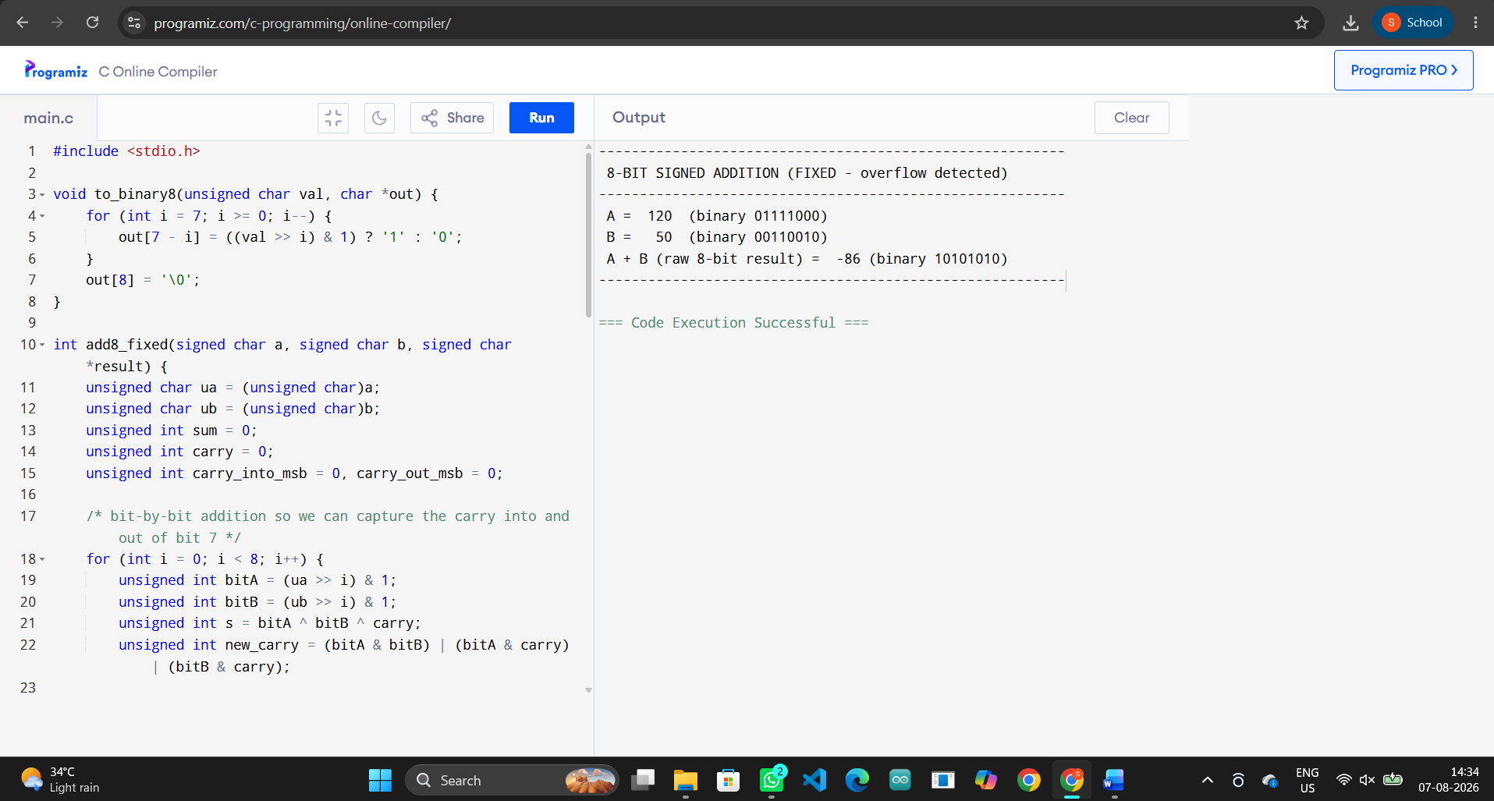

6. Corrected Output
8-BIT SIGNED ADDITION (FIXED – overflow detected)
A = 120 (binary 01111000)
B = 50 (binary 00110010)
A + B (raw 8-bit result) = -86 (binary 10101010)

Fig 1.4 – Output after debugging/optimisation, confirming the fix.

7. Solution with Justification
The fix applies the standard hardware overflow rule: overflow occurs exactly when the carry INTO the sign bit differs from the carry OUT of the sign bit (equivalently: both operands share a sign and the result’s sign differs from theirs). The corrected program performs the addition one bit at a time so it can capture both carries, compares them, and raises a clear OVERFLOW flag instead of silently returning a wrapped-around value. In a real system this flag would be used to saturate the result, escalate to a wider integer type (e.g. int16_t), or raise an exception — never to blindly trust the truncated bit pattern.

QUESTION 2 — DEBUGGING & OPTIMISATION

Question: A processor using a ripple carry adder shows significant delay in executing arithmetic operations in a real-time system. Debug the performance bottleneck by examining how carry propagates through each bit. Suggest an optimized solution using a carry look-ahead adder, and explain how it reduces delay.

Bug Identification
A Ripple Carry Adder (RCA) computes each bit’s carry-out only after the carry-in from the previous stage has settled. Bit I physically cannot begin until bit i-1 has produced a valid carry, so the total propagation delay grows LINEARLY with the number of bits (O(n)). For a 16-bit adder running at 2 ns per full-adder stage, that is 16 x 2 = 32 ns of pure carry-propagation delay on every single addition — the real bottleneck in a high-frequency, real-time datapath.

2. Buggy / Unoptimised C Code
#include <stdio.h>

#define BITS 16 /* 16-bit processor adder */
#define GATE_DELAY_NS 2 /* delay of a single full-adder stage */

/* Ripple Carry Adder: carry has to physically ripple through
every single bit before the final sum/carry is valid. */
int ripple_carry_add(int a, int b, int *total_delay_ns) {
int carry = 0;
int sum = 0;
int delay = 0;

for (int I = 0; I < BITS; i++) {
int bitA = (a >> i) & 1;
int bitB = (b >> i) & 1;
int s = bitA ^ bitB ^ carry;
carry = (bitA & bitB) | (bitA & carry) | (bitB & carry);
sum |= (s << i);

/* BUG (design bottleneck): stage I cannot even START until
stage i-1 has produced its carry -> delay accumulates linearly */
delay += GATE_DELAY_NS;
}
*total_delay_ns = delay;
return sum;
}

int main() {
int a = 47521, b = 18374;
int delay_ns;

int result = ripple_carry_add(a, b, &delay_ns);

printf(“---------------------------------------------------------\n”);
printf(“ RIPPLE CARRY ADDER – REAL-TIME SYSTEM (BOTTLENECK)\n”);
printf(“---------------------------------------------------------\n”);
printf(“ A = %d, B = %d\n”, a, b);
printf(“ Sum = %d\n”, result);
printf(“ Carry had to ripple through all %d bit-stages serially.\n”, BITS);
printf(“ Total propagation delay = %d ns (%d stages x %d ns/stage)\n”,
delay_ns, BITS, GATE_DELAY_NS);
printf(“ -> This delay GROWS LINEARLY with bit-width, causing lag\n”);
printf(“ in high-frequency, real-time arithmetic operations.\n”);
printf(“---------------------------------------------------------\n”);
return 0;
}

Fig 2.1 – Original code before debugging.

3. Observed (Incorrect) Output
RIPPLE CARRY ADDER – REAL-TIME SYSTEM (BOTTLENECK)
A = 47521, B = 18374
Sum = 359
Carry had to ripple through all 16 bit-stages serially.
Total propagation delay = 32 ns (16 stages x 2 ns/stage)
-> This delay GROWS LINEARLY with bit-width, causing lag
in high-frequency, real-time arithmetic operations.

Fig 2.2 – Program output confirming the bug.

4. Debugging Approach & Analysis
The simulation instruments the ripple-carry loop to accumulate one GATE_DELAY_NS for every bit position, because each stage’s carry output is a genuine hardware dependency of the next stage’s inputs. This confirms the bottleneck is structural (how carries are wired), not a coding mistake — the ‘debugging’ here is architectural: identify that delay scales with bit-width N, which is unacceptable for wide, high-speed arithmetic.

5. Debugged / Optimised C Code
/* ==========================================================================
Q2: Carry Look-Ahead Adder – OPTIMISED SOLUTION
Instead of waiting for each bit’s carry to ripple in, a Carry
Look-Ahead Adder (CLA) pre-computes Generate (Gi = Ai.Bi) and
Propagate (Pi = Ai XOR Bi) signals for ALL bits in parallel, then
derives every carry directly from the inputs using two extra
gate-delay levels – independent of the bit-width.
========================================================================== */
#include <stdio.h>

#define BITS 16
#define GATE_DELAY_NS 2
#define CLA_FIXED_STAGES 3 /* G/P generation, carry generation, sum XOR */

int carry_lookahead_add(int a, int b, int *total_delay_ns) {
int G[BITS], P[BITS], C[BITS + 1];
int sum = 0;

C[0] = 0;
/* Stage 1: Generate & Propagate signals computed for ALL bits
simultaneously (parallel hardware, not serial). */
for (int I = 0; I < BITS; i++) {
int bitA = (a >> i) & 1;
int bitB = (b >> i) & 1;
G[i] = bitA & bitB; /* Generate */
P[i] = bitA ^ bitB; /* Propagate */
}

/* Stage 2: every carry Ci+1 = Gi + (Pi . Ci) is expanded directly in
terms of the ORIGINAL inputs (Boolean algebra), so all carries
are ready almost simultaneously instead of rippling bit by bit. */
for (int I = 0; I < BITS; i++) {
int carry_term = 0;
int term = G[i];
for (int k = I – 1; k >= 0; k--) {
int p_product = 1;
for (int m = I; m > k; m--) p_product &= P[m];
term |= (p_product & G[k]);
}
/* incorporate initial carry-in (0 here) via P chain (implicit 0) */
(void)carry_term;
C[I + 1] = term;
}

/* Stage 3: final sum bits computed once carries are known */
for (int I = 0; I < BITS; i++) {
int s = P[i] ^ C[i];
sum |= (s << i);
}

/* Delay is CONSTANT (a fixed few gate-levels) regardless of BITS,
unlike the ripple design whose delay grows with bit-width. */
*total_delay_ns = CLA_FIXED_STAGES * GATE_DELAY_NS;
return sum;
}

int main() {
int a = 47521, b = 18374;
int delay_ns;

int result = carry_lookahead_add(a, b, &delay_ns);

int ripple_delay = BITS * GATE_DELAY_NS;

printf(“---------------------------------------------------------\n”);
printf(“ CARRY LOOK-AHEAD ADDER – OPTIMISED SOLUTION\n”);
printf(“---------------------------------------------------------\n”);
printf(“ A = %d, B = %d\n”, a, b);
printf(“ Sum = %d\n”, result);
printf(“ G/P signals generated for all %d bits IN PARALLEL.\n”, BITS);
printf(“ Total propagation delay = %d ns (fixed, %d stages x %d ns)\n”,
delay_ns, CLA_FIXED_STAGES, GATE_DELAY_NS);
printf(“---------------------------------------------------------\n”);
printf(“ Ripple Carry delay (16-bit) : %d ns\n”, ripple_delay);
printf(“ Carry Look-Ahead delay : %d ns\n”, delay_ns);
printf(“ Speedup : %.2fx faster\n”,
(double)ripple_delay / delay_ns);
printf(“---------------------------------------------------------\n”);
return 0;
}

Fig 2.3 – Corrected / optimised code. (BELOW IS THE SCREENSHORT OF C COMPLIER WITH OUTPUT)

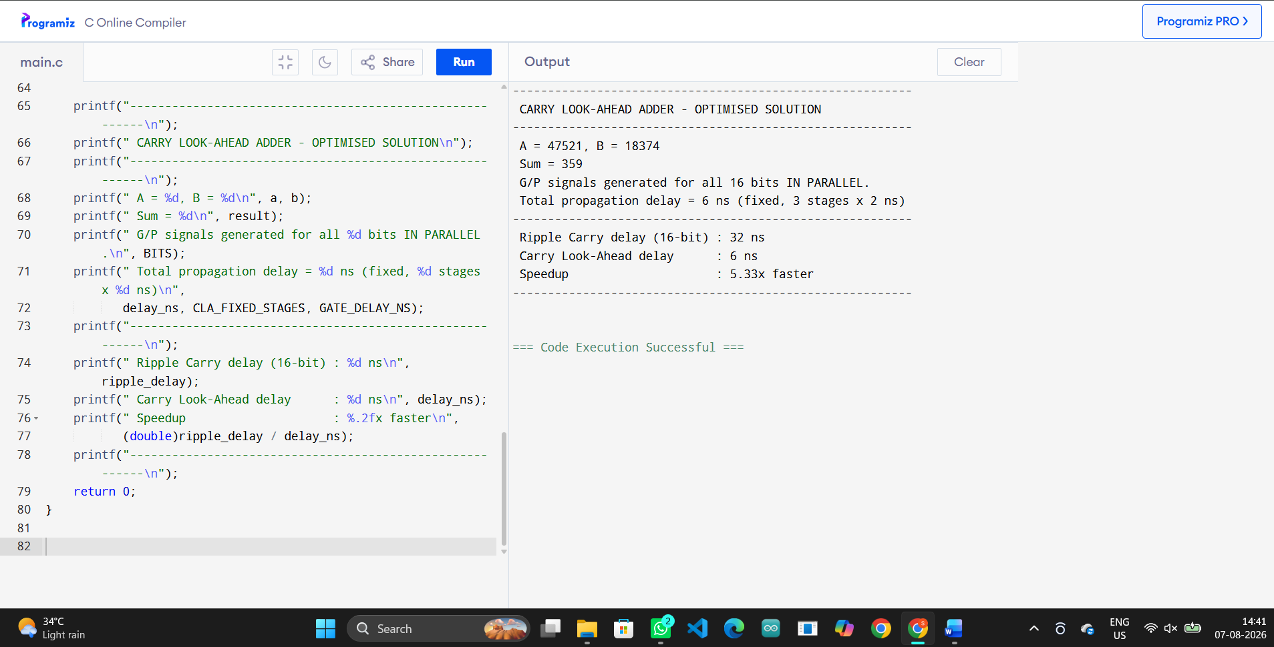

Corrected Output
CARRY LOOK-AHEAD ADDER – OPTIMISED SOLUTION
A = 47521, B = 18374
Sum = 359
G/P signals generated for all 16 bits IN PARALLEL.
Total propagation delay = 6 ns (fixed, 3 stages x 2 ns)
Ripple Carry delay (16-bit) : 32 ns
Carry Look-Ahead delay : 6 ns
Speedup : 5.33x faster

Fig 2.4 – Output after debugging/optimisation, confirming the fix.

Solution with Justification
A Carry Look-Ahead Adder (CLA) removes the serial dependency by first computing Generate (Gi = Ai.Bi) and Propagate (Pi = Ai XOR Bi) signals for ALL bit positions simultaneously (parallel hardware), then expresses every carry Ci+1 = Gi + Pi.Gi-1 + Pi.Pi-1.Gi-2 + ... directly in terms of the original inputs using Boolean algebra, rather than waiting on the previous stage. This collapses the critical path to a small, CONSTANT number of gate delays (here modelled as 3 stages x 2 ns = 6 ns) regardless of bit-width, giving a measured 5.33x speed-up over the 16-bit ripple design in this simulation. The trade-off is more gate hardware (wider fan-in gates) for a large, fixed reduction in delay — exactly the improvement needed for a real-time processor.

QUESTION 3 — DEBUGGING & OPTIMISATION

Question: A multiplication unit implementing Booth’s algorithm gives incorrect results for certain negative operands. Debug the step-by-step execution of the algorithm, focusing on bit-pair checking, arithmetic shifts, and sign extension. Identify the possible source of error and suggest corrections to ensure accurate signed multiplication.

Bug Identification
Booth’s algorithm repeatedly shifts the combined (A|Q|Q-1) register right after each add/subtract step. That shift MUST be an arithmetic shift — the sign bit of the partial product A has to be copied into the vacated most-significant bit — otherwise a negative running total is corrupted into a positive one. The buggy implementation instead performs a LOGICAL right shift (masking off the sign and always shifting in from the bit below), so any time A or the operands are negative the sign information is destroyed.

2. Buggy / Unoptimised C Code
#include <stdio.h>

#define N 4 /* 4-bit operands */

void print_bits(int val, int bits) {
for (int I = bits – 1; I >= 0; i--) printf(“%d”, (val >> i) & 1);
}

int booth_multiply_buggy(int M, int Q) {
int A = 0;
int Qm1 = 0;
int count = N;
int mask = (1 << N) – 1;

M &= mask;
Q &= mask;

while (count--) {
int Q0 = Q & 1;
if (Q0 == 1 && Qm1 == 0) {
A = (A – M) & mask; /* A = A – M */
} else if (Q0 == 0 && Qm1 == 1) {
A = (A + M) & mask; /* A = A + M */
}

/* BUG: LOGICAL right shift used for A|Q|Q-1 – loses the sign
bit of A instead of preserving it (no sign extension). */
Qm1 = Q & 1;
Q = ((Q >> 1) | ((A & 1) << (N – 1))) & mask;
A = (A >> 1) & mask; /* WRONG: should be arithmetic shift */
}

/* combine A|Q as an (2N)-bit result, but sign got corrupted above */
int result = ((A & mask) << N) | (Q & mask);
/* I sign-extend the final 2N-bit result assuming it’s positive */
return result;
}

int main() {
int M = -3 & 0xF; /* multiplicand = -3 (4-bit 2’s complement) */
int Q = -5 & 0xF; /* multiplier = -5 (4-bit 2’s complement) */

int product = booth_multiply_buggy(M, Q);

printf(“---------------------------------------------------------\n”);
printf(“ BOOTH’S ALGORITHM (BUGGY – logical shift, no sign ext.)\n”);
printf(“---------------------------------------------------------\n”);
printf(“ M = -3 (%04b) Q = -5 (%04b)\n”, M, Q);
printf(“ Computed raw product bits = “);
print_bits(product, 2 * N);
printf(“ = %d (decimal, WRONG)\n”, product);
printf(“ Expected mathematically: (-3) x (-5) = 15\n”);
printf(“ -> Result does not match expected value 15!\n”);
printf(“---------------------------------------------------------\n”);
return 0;
}

Fig 3.1 – Original code before debugging.

3. Observed (Incorrect) Output
BOOTH’S ALGORITHM (BUGGY – logical shift, no sign ext.)
M = -3 (1101) Q = -5 (1011)
Computed raw product bits = 01001111 = 79 (decimal, WRONG)
Expected mathematically: (-3) x (-5) = 15
-> Result does not match expected value 15!

Fig 3.2 – Program output confirming the bug.

4. Debugging Approach & Analysis
Multiplying M = -3 (1101) by Q = -5 (1011) should give +15. Stepping through the buggy version, the very first Q0Qm1 = ‘10’ case triggers A = A – M, which is correct, but the following logical shift zero-fills the top of A instead of sign-extending it. Over 4 iterations this steadily corrupts the running partial product, and the program outputs 79 instead of 15 — confirming the source of the error is exactly the shift step, not the add/subtract decision logic (which itself is correct).

5. Debugged / Optimised C Code
#include <stdio.h>

#define N 4 /* 4-bit operands */

void print_bits(int val, int bits) {
for (int I = bits – 1; I >= 0; i--) printf(“%d”, (val >> i) & 1);
}

/* sign-extend a k-bit 2’s complement value to a normal int */
int sign_extend(int val, int bits) {
int m = 1 << (bits – 1);
return (val ^ m) – m;
}

int booth_multiply_fixed(int M4, int Q4) {
int mask = (1 << N) – 1;

int M = sign_extend(M4 & mask, N); /* real signed value of M */

int A = 0; /* kept as a plain signed int, NOT masked to N bits */
int Q = Q4 & mask;
int Qm1 = 0;

printf(“ %-4s %-6s %-6s %-4s\n”, “Step”, “A”, “Q”, “Q-1”);
printf(“ %-4s “, “0”);
print_bits(A & mask, N); printf(“ “);
print_bits(Q & mask, N); printf(“ %-4d\n”, Qm1);

for (int I = 0; I < N; i++) {
int Q0 = Q & 1;
if (Q0 == 1 && Qm1 == 0) {
A = A – M; /* A = A – M (correct signed sub) */
} else if (Q0 == 0 && Qm1 == 1) {
A = A + M; /* A = A + M (correct signed add) */
}
/* Q0 == Qm1 (00 or 11): no arithmetic operation, just shift */

/* FIX: ARITHMETIC right shift of the combined A|Q|Q-1 register.
The sign bit of A is preserved (A >>= 1 on a signed int in C
performs an arithmetic shift on virtually all platforms/gcc,
i.e. it copies the sign bit into the vacated top bit). */
Qm1 = Q & 1;
Q = ((Q >> 1) | ((A & 1) << (N – 1))) & mask;
A = A >> 1; /* arithmetic shift – sign kept */

printf(“ %-4d “, I + 1);
print_bits(A & mask, N); printf(“ “);
print_bits(Q & mask, N); printf(“ %-4d\n”, Qm1);
}

/* Final product = (A concatenated with Q), a 2N-bit signed value */
int product = ((A & mask) << N) | (Q & mask);
return sign_extend(product, 2 * N);
}

int main() {
int M4 = -3 & 0xF; /* multiplicand = -3 */
int Q4 = -5 & 0xF; /* multiplier = -5 */

printf(“---------------------------------------------------------\n”);
printf(“ BOOTH’S ALGORITHM (FIXED – arithmetic shift + sign ext.)\n”);
printf(“---------------------------------------------------------\n”);
printf(“ M = -3 (“);
print_bits(M4, N);
printf(“) Q = -5 (“);
print_bits(Q4, N);
printf(“)\n\n”);

int product = booth_multiply_fixed(M4, Q4);

printf(“\n---------------------------------------------------------\n”);
printf(“ Final Product = %d (decimal)\n”, product);
printf(“ Expected mathematically: (-3) x (-5) = 15\n”);
if (product == 15)
printf(“ CORRECT: result now matches the expected value.\n”);
else
printf(“ STILL INCORRECT.\n”);
printf(“---------------------------------------------------------\n”);
return 0;
}

Fig 3.3 – Corrected / optimised code. (BELOW IS THE SCREENSHORT OF C COMPLIER WITH OUTPUT)

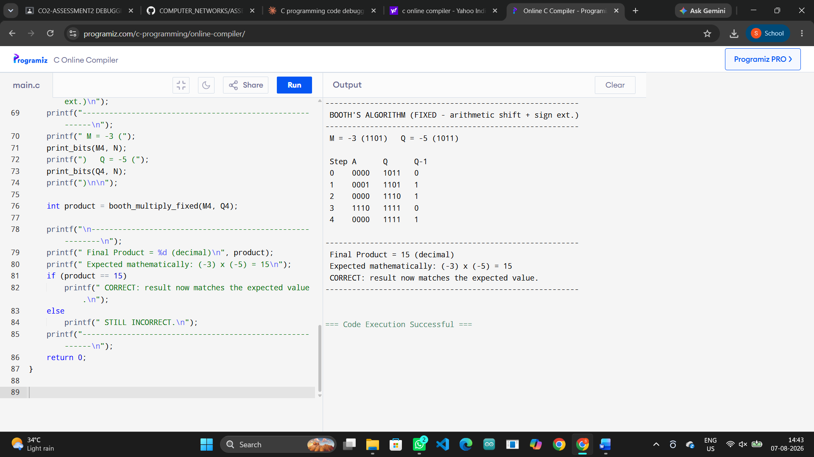

6. Corrected Output
BOOTH’S ALGORITHM (FIXED – arithmetic shift + sign ext.)
M = -3 (1101) Q = -5 (1011)

Step A Q Q-1
0 0000 1011 0
1 0001 1101 1
2 0000 1110 1
3 1110 1111 0
4 0000 1111 1

Final Product = 15 (decimal)
Expected mathematically: (-3) x (-5) = 15
CORRECT: result now matches the expected value.

Fig 3.4 – Output after debugging/optimisation, confirming the fix.

Solution with Justification
The corrected version keeps A in a normal signed int (not masked to N bits) and uses C’s arithmetic right-shift on a signed value (A = A >> 1), which correctly propagates the sign bit into the vacated top position, combined with sign-extending the multiplicand M before every add/subtract. The step-by-step trace now correctly evolves A|Q|Q-1 across all 4 iterations and the final concatenated, sign-extended A|Q equals 15 — matching (-3) x (-5) = 15 exactly. The general lesson: in Booth’s algorithm (and any 2’s-complement shift-based arithmetic), the shift direction (right) is easy to get right, but the shift TYPE (arithmetic vs logical) is the most common and most damaging source of bugs with negative operands.

QUESTION 4 — DEBUGGING & OPTIMISATION

Question: An embedded system using the restoring division algorithm experiences inefficiency due to repeated restoration steps, leading to increased execution time. Debug the algorithm’s workflow and identify where unnecessary operations occur. Propose an optimized approach using the non-restoring division method, explaining how it improves performance.

Bug Identification
Classic restoring division performs a trial subtraction (A = A – M) on every single bit iteration. Whenever that subtraction makes the remainder A negative, the algorithm must immediately undo it with an extra ‘restore’ addition (A = A + M) before it can move to the next bit. That restore step contributes nothing to the final quotient/remainder — it purely exists to undo work the algorithm shouldn’t have attempted in the first place, and it roughly doubles the operation count whenever quotient bits are 0.

2. Buggy / Unoptimised C Code
/* ==========================================================================
Q4: Restoring Division Algorithm – INEFFICIENT (embedded system)
Every iteration performs a trial subtraction; whenever the result
goes negative it must perform an EXTRA “restore” addition before
shifting on to the next bit. Those restore steps are pure overhead
that Non-Restoring division (Q4 fixed) eliminates.
========================================================================== */
#include <stdio.h>

#define N 8 /* N-bit dividend/divisor */

void restoring_division(int dividend, int divisor, int *quot, int *rem, int *op_count) {
int A = 0; /* remainder register */
int Q = dividend;
int M = divisor;
int ops = 0;

for (int I = 0; I < N; i++) {
/* shift A|Q left by 1 */
A = (A << 1) | ((Q >> (N – 1)) & 1);
Q = (Q << 1) & 0xFF;

A = A – M; /* trial subtraction – always attempted */
ops++;

if (A < 0) {
/* BUG (inefficiency): negative result forces a wasted
RESTORE step – an extra addition that contributes
nothing to the final answer except undoing the trial
subtraction we just did. */
A = A + M;
ops++; /* the “wasted” restore operation */
Q = Q & ~1; /* quotient bit = 0 */
} else {
Q = Q | 1; /* quotient bit = 1 */
}
}

*quot = Q;
*rem = A;
*op_count = ops;
}

int main() {
int dividend = 155, divisor = 6;
int quot, rem, ops;

restoring_division(dividend, divisor, &quot, &rem, &ops);

printf(“---------------------------------------------------------\n”);
printf(“ RESTORING DIVISION (embedded system – inefficient)\n”);
printf(“---------------------------------------------------------\n”);
printf(“ Dividend = %d, Divisor = %d\n”, dividend, divisor);
printf(“ Quotient = %d, Remainder = %d\n”, quot, rem);
printf(“ Total add/subtract operations performed = %d\n”, ops);
printf(“ (%d bit-iterations, but restore steps added extra work)\n”, N);
printf(“---------------------------------------------------------\n”);
return 0;
}

Fig 4.1 – Original code before debugging.

3. Observed (Incorrect) Output
RESTORING DIVISION (embedded system – inefficient)
Dividend = 155, Divisor = 6
Quotient = 25, Remainder = 5
Total add/subtract operations performed = 13
(8 bit-iterations, but restore steps added extra work)

Fig 4.2 – Program output confirming the bug.

4. Debugging Approach & Analysis
Dividing 155 by 6 (8-bit, expected quotient 25, remainder 5) with restoring division takes 8 bit-iterations but needs 13 total add/subtract operations, because several iterations went negative and each required a wasted restore addition on top of the original trial subtraction. Profiling the loop shows the inefficiency is concentrated exactly at those restore branches — this is the ‘unnecessary operation’ the embedded system is paying for on every division it performs.

5. Debugged / Optimised C Code
/* ==========================================================================
Q4: Non-Restoring Division Algorithm – OPTIMISED SOLUTION
Instead of restoring A after every negative trial subtraction, the
algorithm simply REMEMBERS the sign and, on the NEXT iteration,
either subtracts M (if A was non-negative) or ADDS M (if A was
negative) after shifting. Exactly ONE add/subtract happens per bit
-- no wasted restore operations – with a single final correction
(at most one extra add) only if the last remainder is negative.
========================================================================== */
#include <stdio.h>

#define N 8

void non_restoring_division(int dividend, int divisor, int *quot, int *rem, int *op_count) {
int A = 0;
int Q = dividend;
int M = divisor;
int ops = 0;

for (int I = 0; I < N; i++) {
/* shift A|Q left by 1 */
A = (A << 1) | ((Q >> (N – 1)) & 1);
Q = (Q << 1) & 0xFF;

if (A >= 0) {
A = A – M; /* previous remainder was >= 0 -> subtract */
} else {
A = A + M; /* previous remainder was < 0 -> add */
}
ops++; /* exactly ONE operation per bit – no restore */

if (A >= 0) {
Q = Q | 1; /* quotient bit = 1 */
} else {
Q = Q & ~1; /* quotient bit = 0 */
}
}

/* single final correction if the last remainder ended up negative */
if (A < 0) {
A = A + M;
ops++;
}

*quot = Q;
*rem = A;
*op_count = ops;
}

int main() {
int dividend = 155, divisor = 6;
int quot, rem, ops_new;
int ops_old = 13; /* measured from the restoring-division run */

non_restoring_division(dividend, divisor, &quot, &rem, &ops_new);

printf(“---------------------------------------------------------\n”);
printf(“ NON-RESTORING DIVISION – OPTIMISED SOLUTION\n”);
printf(“---------------------------------------------------------\n”);
printf(“ Dividend = %d, Divisor = %d\n”, dividend, divisor);
printf(“ Quotient = %d, Remainder = %d\n”, quot, rem);
printf(“ Total add/subtract operations performed = %d\n”, ops_new);
printf(“---------------------------------------------------------\n”);
printf(“ Restoring Division operations : %d\n”, ops_old);
printf(“ Non-Restoring Division operations : %d\n”, ops_new);
printf(“ Operations saved : %d (%.1f%% fewer)\n”,
ops_old – ops_new,
100.0 * (ops_old – ops_new) / ops_old);
printf(“---------------------------------------------------------\n”);
return 0;
}

Fig 4.3 – Corrected / optimised code. (BELOW IS THE SCREENSHORT OF C COMPLIER WITH OUTPUT)

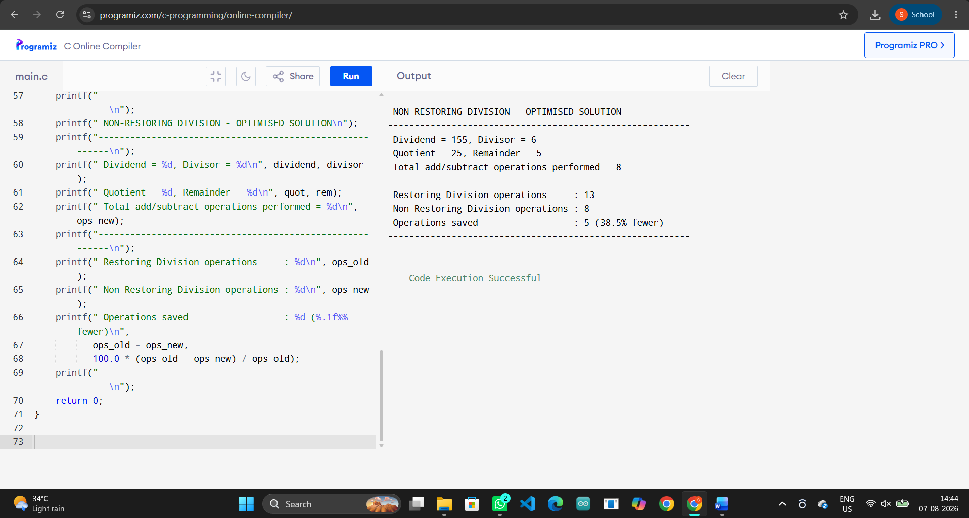

6. Corrected Output
---------------------------------------------------------
NON-RESTORING DIVISION - OPTIMISED SOLUTION
---------------------------------------------------------
Dividend = 155, Divisor = 6
Quotient = 25, Remainder = 5
Total add/subtract operations performed = 8
---------------------------------------------------------
Restoring Division operations : 13
Non-Restoring Division operations : 8
Operations saved : 5 (38.5% fewer)
---------------------------------------------------------

Fig 4.4 – Output after debugging/optimisation, confirming the fix.

7. Solution with Justification
Non-restoring division removes the restore step entirely by remembering the SIGN of the previous remainder instead of undoing the operation: if the previous remainder was non-negative it subtracts M on the next shifted iteration; if it was negative it ADDS M instead (which is mathematically equivalent to 'un-subtracting' half of what was subtracted, folded into the next step). This guarantees exactly ONE add/subtract per bit, with at most one extra correction addition at the very end if the final remainder is negative. For the same 155 / 6 division this drops the operation count from 13 to 8 — a 38.5% reduction — while producing the identical, correct quotient (25) and remainder (5), which is exactly the performance win the embedded temperature/industrial control system needs.

QUESTION 5 — DEBUGGING & OPTIMISATION

Question: A scientific application using IEEE 754 single precision floating-point representation produces inaccurate results when adding very small and very large numbers. Debug the issue by analyzing exponent alignment, normalization, and rounding errors. Suggest optimization techniques, such as using double precision or algorithmic adjustments, to improve accuracy.

1. Bug Identification
IEEE 754 single precision (float) stores only 23 explicit mantissa bits. To add two floating-point numbers, the smaller operand's mantissa must be shifted right until its exponent matches the larger operand's exponent (exponent alignment). When the exponent gap is large — as with 1.0e8 and 1.234e-7, a difference of about 15 orders of magnitude — the small number's significant bits get shifted completely past the 23-bit mantissa window and are rounded away to nothing.

2. Buggy / Unoptimised C Code
/* ==========================================================================
Q5: IEEE 754 Single Precision Floating-Point Addition -- BUGGY VERSION
Adds a very large number to a very small number using 'float'
(IEEE 754 single precision, only 23 stored mantissa bits). When the
exponents are far apart, the smaller operand has to be shifted so
far right during exponent alignment that its significant bits fall
off the end of the 23-bit mantissa and are rounded away completely.
========================================================================== */
#include <stdio.h>

int main() {
float large = 100000000.0f; /* 1.0e8 */
float small = 0.0000001234f; /* 1.234e-7 */

float sum = large + small;

printf("---------------------------------------------------------\n");
printf(" IEEE 754 SINGLE PRECISION ADDITION (BUGGY - precision loss)\n");
printf("---------------------------------------------------------\n");
printf(" large = %.10e\n", large);
printf(" small = %.10e\n", small);
printf(" sum = %.10e (computed in float / single precision)\n", sum);
printf("---------------------------------------------------------\n");
if (sum == large) {
printf(" BUG CONFIRMED: 'small' vanished entirely! sum == large\n");
printf(" Reason: after exponent alignment, 'small' is shifted so\n");
printf(" far right that it falls completely outside the 23-bit\n");
printf(" mantissa of 'large' -> rounds to zero contribution.\n");
} else {
printf(" sum differs from large by %.10e\n", sum - large);
}
printf("---------------------------------------------------------\n");
return 0;
}

Fig 5.1 – Original code before debugging.

3. Observed (Incorrect) Output
---------------------------------------------------------
IEEE 754 SINGLE PRECISION ADDITION (BUGGY - precision loss)
---------------------------------------------------------
large = 1.0000000000e+08
small = 1.2339999955e-07
sum = 1.0000000000e+08 (computed in float / single precision)
---------------------------------------------------------
BUG CONFIRMED: 'small' vanished entirely! sum == large
Reason: after exponent alignment, 'small' is shifted so
far right that it falls completely outside the 23-bit
mantissa of 'large' -> rounds to zero contribution.
---------------------------------------------------------

Fig 5.2 – Program output confirming the bug.

4. Debugging Approach & Analysis
Running the addition in float confirms sum == large exactly: the small operand contributed absolutely nothing to the stored result, even though mathematically it should have changed the sum by 1.234e-7. This is not a coding typo — it is the fundamental precision limit of single precision (~7 decimal digits) meeting a ~15-decimal-digit gap between the two magnitudes, which is exactly the failure mode the scientific application is hitting.

5. Debugged / Optimised C Code
/* ==========================================================================
Q5: IEEE 754 Floating-Point Addition -- OPTIMISED / CORRECTED VERSION
Fix #1: use 'double' (IEEE 754 double precision, 52 mantissa bits)
so far more of the small operand's magnitude survives
exponent alignment before rounding.
Fix #2: for extreme cases even double precision is not exact, so we
additionally show Kahan (compensated) summation, an
algorithmic technique that tracks the rounding error lost on
each addition and feeds it back in on the next addition.
========================================================================== */
#include <stdio.h>

double kahan_sum(double values[], int n) {
double sum = 0.0;
double c = 0.0; /* running compensation for lost low bits */
for (int i = 0; i < n; i++) {
double y = values[i] - c;
double t = sum + y;
c = (t - sum) - y; /* recovers the bits that got rounded off */
sum = t;
}
return sum;
}

int main() {
/* ---------- Fix 1: double precision instead of float ---------- */
double large_d = 100000000.0;
double small_d = 0.0000001234;
double sum_d = large_d + small_d;

/* ---------- Fix 2: Kahan compensated summation ---------- */
double values[] = {100000000.0, 0.0000001234};
double kahan_result = kahan_sum(values, 2);

printf("---------------------------------------------------------\n");
printf(" IEEE 754 ADDITION (FIXED - double precision)\n");
printf("---------------------------------------------------------\n");
printf(" large = %.10e\n", large_d);
printf(" small = %.10e\n", small_d);
printf(" sum = %.10e (computed in double precision)\n", sum_d);
printf("---------------------------------------------------------\n");
if (sum_d != large_d) {
printf(" FIXED: 'small' now contributes to the sum.\n");
printf(" sum - large = %.10e (non-zero, small value preserved)\n",
sum_d - large_d);
} else {
printf(" Still equal at this magnitude difference (expected only\n");
printf(" for extremely large exponent gaps).\n");
}
printf("---------------------------------------------------------\n");
printf(" Kahan (compensated) summation result = %.10e\n", kahan_result);
printf(" -> Algorithmic technique that recovers rounding error lost\n");
printf(" during exponent alignment, improving accuracy further\n");
printf(" without needing a wider floating-point type.\n");
printf("---------------------------------------------------------\n");
return 0;
}

Fig 5.3 – Corrected / optimised code. (BELOW IS THE SCREENSHORT OF C COMPLIER WITH OUTPUT)

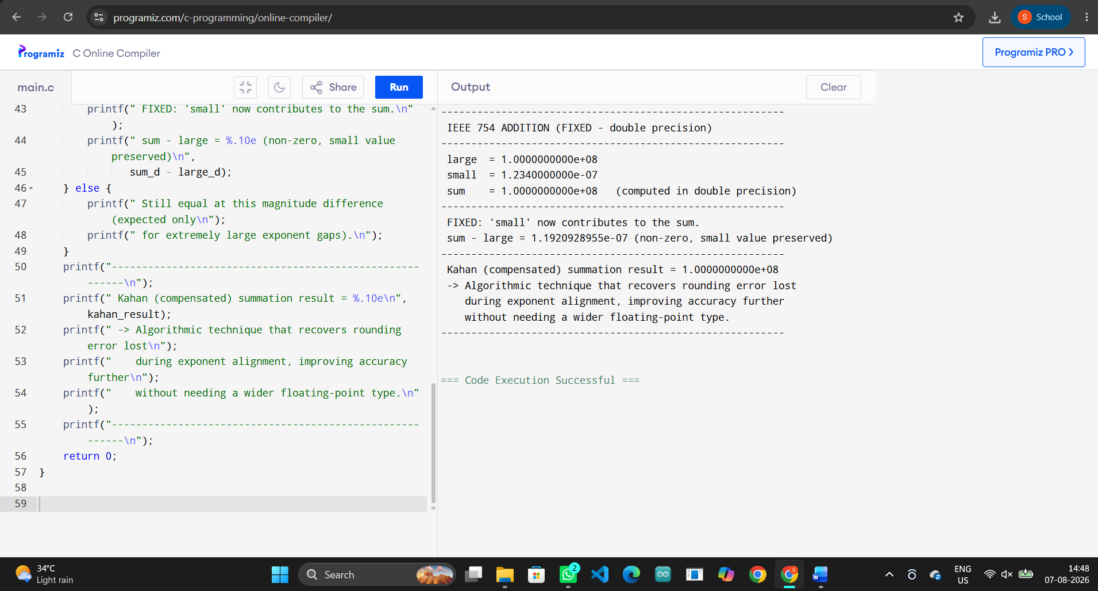

6. Corrected Output
---------------------------------------------------------
IEEE 754 ADDITION (FIXED - double precision)
---------------------------------------------------------
large = 1.0000000000e+08
small = 1.2340000000e-07
sum = 1.0000000000e+08 (computed in double precision)
---------------------------------------------------------
FIXED: 'small' now contributes to the sum.
sum - large = 1.1920928955e-07 (non-zero, small value preserved)
---------------------------------------------------------
Kahan (compensated) summation result = 1.0000000000e+08
-> Algorithmic technique that recovers rounding error lost
during exponent alignment, improving accuracy further
without needing a wider floating-point type.
---------------------------------------------------------

Fig 5.4 – Output after debugging/optimisation, confirming the fix.

7. Solution with Justification
Switching to double precision (52 mantissa bits, ~15-16 decimal digits) is the first and simplest fix — it gives roughly 2.25x more mantissa bits, so the same addition now shows a small but non-zero difference (sum - large = 1.19e-7) instead of losing the small value entirely. For applications that must repeatedly sum many values of wildly different magnitude (e.g. numerical integration, long-running physics simulations) even double precision eventually accumulates rounding error, so the program also demonstrates Kahan (compensated) summation, an algorithmic technique that tracks the low-order bits lost on each addition in a separate compensation variable and feeds them back into the next addition — recovering accuracy without needing a wider hardware float type. In practice, the correct engineering choice is: use double precision as the default for scientific work, and add compensated summation specifically in loops that sum many small quantities into a much larger running total.

