SIMATS ENGINEERING
ASSESSMENT TOOL 1
COURSE NAME: COMPUTER ARCHITECTURE COURSE CODE: CSA1216
COURSE OUTCOME COVERED
CO1: Analyze the functional units of a computer system including CPU, memory, bus structures, and I/O components by examining instruction execution cycles, addressing modes, and performance metrics such as CPI, clock cycles, and benchmarking (BL4)
Assessment Tool Weightage: 40%
QUESTIONS: 10 Total Marks: 50
ANNEXURE A
APPLICATION BASED QUESTIONS
Code of Conduct:
I _Shaik Khajah Roshan(192511445)_(Name / Reg No) certify that this submission is my original work and that I have adhered to the guidelines specified for this assessment. I understand that any violation of academic integrity rules will result in disciplinary action.
Signature of the student: _____Shaik Khajah Roshan________________
ANNEXURE A
1. A smart city surveillance system processes continuous video feeds from multiple cameras, where large volumes of data are transferred between I/O devices, memory, and CPU. During peak hours, the system experiences lag and delayed response in threat detection. Analyze how the interaction between CPU, memory, and I/O contributes to this issue, and explain how different bus structures (single-bus vs multi-bus) and improvements in instruction execution cycle can enhance system performance.
2. A real-time stock trading application running on a processor executes millions of instructions per second, but users report delays in transaction processing during high load. The system has a high CPI due to frequent memory access and branch instructions. Examine how the fetch–decode–execute cycle impacts execution time in this scenario, and propose methods to reduce CPI and improve overall CPU performance using suitable architectural enhancements.
3. An embedded system based on an 8085 microprocessor is used in an industrial temperature control unit, where sensors provide input and actuators respond accordingly. However, incorrect temperature readings are occasionally processed due to improper use of addressing modes in the program. Discuss how different addressing modes influence data access, identify possible causes of such errors, and suggest how the instruction set of 8085 can be effectively used to ensure accurate and reliable operation.
4. A computing system uses an 8086 microprocessor with segmented memory for executing multiple programs simultaneously, but it encounters issues like incorrect data access and stack overflow errors. Evaluate how segmentation (code, data, and stack segments) works in 8086, analyze how improper segment handling can lead to such problems, and explain how instruction execution and addressing modes must be managed to ensure correct program execution.
5. A data communication system represents packet information in hexadecimal format for ease of debugging and transmission, but a software engineer mistakenly interprets values, leading to incorrect data processing. Analyze the importance of number system conversions between hexadecimal and binary in such systems, explain how errors in conversion can affect instruction execution, and discuss how efficient CPU design and benchmarking can help detect and minimize such issues in real-time systems.

MARKS ALLOCATION
Criteria | Understanding of  Problem Context (20%) | Application of  Concepts (20%) | Problem-Solving  Approach (20%) | Accuracy of  Solution (20%) | Clarity (20%)
Q1
Q2
Q3
Q4
Q5

RUBRICS FOR CALCULATION
Criteria | Weightage | Level 4 – Exemplary | Level 3 – Proficient | Level 2 – Developing | Level 1 – Beginning
Understanding of Problem Context | 20 | Clearly understands the problem and accurately identifies all requirements | Good understanding with minor gaps | Basic understanding; some requirements unclear | Poor understanding or misinterpretation of the problem
Application of Concepts | 30 | Accurately applies appropriate concepts to solve complex problems | Applies relevant concepts correctly with minor errors | Applies basic concepts with limited accuracy | Fails to apply appropriate concepts
Problem-Solving Approach | 20 | Logical, well-structured, and efficient approach | Mostly logical approach with minor gaps | Basic approach with some inconsistencies | Illogical or unclear approach
Accuracy of Solution | 20 | Completely correct solution with proper justification | Mostly correct with minor errors | Partially correct solution | Incorrect or incomplete solution
Clarity | 10 | Clear, well-organized, and properly explained solution | Understandable with minor clarity issues | Limited clarity and explanation | Poorly presented and difficult to understand
QUESTION 1 — ANSWER
Question: A smart city surveillance system processes continuous video feeds from multiple cameras, where large volumes of data are transferred between I/O devices, memory, and CPU. During peak hours, the system experiences lag and delayed response in threat detection. Analyze how the interaction between CPU, memory, and I/O contributes to this issue, and explain how different bus structures (single-bus vs multi-bus) and improvements in instruction execution cycle can enhance system performance.

1. Flowchart
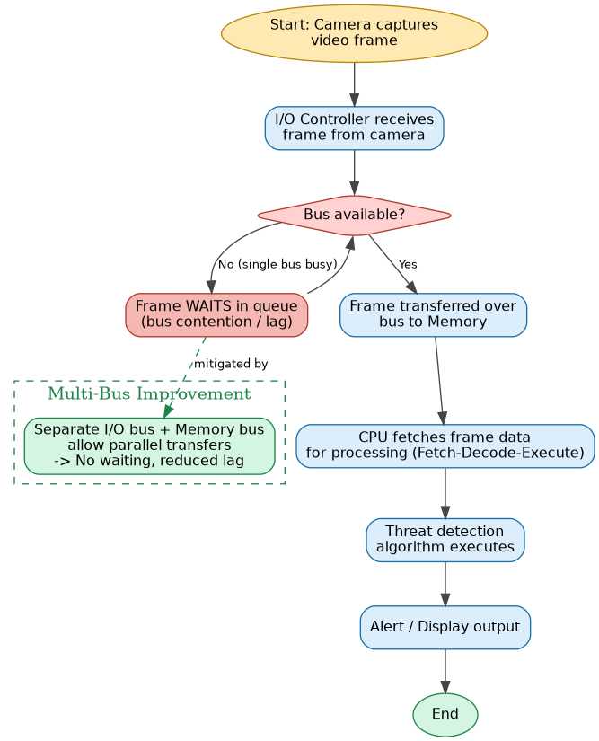
Fig 1.1 – Data flow of a camera frame through I/O, Bus, Memory and CPU, showing where contention/lag occurs on a single bus, and how a multi-bus path mitigates it.

2. Block Diagram
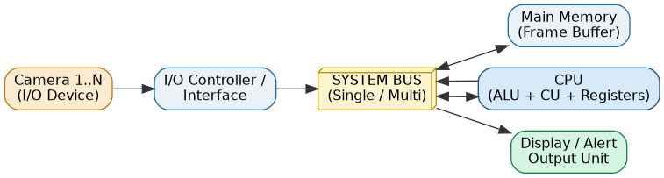
Fig 1.2 – System architecture: Cameras (I/O) → I/O Controller → System Bus → Memory / CPU → Display.

3. Comparison Table: Single-Bus vs Multi-Bus
Parameter | Single-Bus Architecture | Multi-Bus Architecture
Structure | One common bus shared by CPU, Memory and I/O | Separate dedicated buses for I/O, Memory (and often cache)
Data transfer | Serial — only one transfer at a time | Parallel — multiple transfers can overlap
Contention | High under heavy camera load → queued frames | Low — I/O and Memory paths operate independently
Hardware cost | Low, simple control logic | Higher — needs bus arbiters / extra controllers
Throughput | Limited, becomes a bottleneck at peak hours | Higher, scales better with concurrent I/O streams
Best suited for | Small embedded / low-cost systems | Real-time, high-throughput systems (e.g. surveillance)

4. Calculations
Assume 8 active camera feeds, each producing a 512 KB frame at peak hour, with a bus cycle time of 10 ns and 2 bus cycles required to move each KB of data.
Single-Bus total cycles = cameras × frame_size(KB) × cycles_per_KB
= 8 × 512 × 2 = 8192 cycles
Single-Bus transfer time = 8192 × 10 ns = 81920 ns = 81.92 µs

Multi-Bus (4 parallel I/O–memory paths):
Multi-Bus cycles = 8192 / 4 = 2048 cycles
Multi-Bus transfer time = 2048 × 10 ns = 20480 ns = 20.48 µs

Speedup = 81.92 µs / 20.48 µs = 4.00x (≈75% latency reduction)

5. C Program Implementation
/* ==========================================================================
Q1: Smart City Surveillance System
Simulation of Single-Bus vs Multi-Bus performance for CPU-Memory-I/O
data transfer during peak camera load.
========================================================================== */
#include <stdio.h>

#define NUM_CAMERAS 8 /* number of camera feeds active at peak hour */
#define FRAME_SIZE_KB 512 /* size of one video frame in KB */
#define BUS_CYCLE_NS 10 /* time for one bus transfer cycle (ns) */

int main() {
int cameras = NUM_CAMERAS;
int frame_kb = FRAME_SIZE_KB;
int cycles_per_kb = 2; /* cycles needed to move 1 KB */

/* ---------- Single Bus Model ----------
CPU, Memory and I/O share ONE common bus.
Only one transfer (CPU<->Mem OR I/O<->Mem) can happen at a time,
so every camera frame must wait its turn -> transfers are SERIAL. */
long single_bus_cycles = (long)cameras * frame_kb * cycles_per_kb;
double single_bus_time_us = (single_bus_cycles * BUS_CYCLE_NS) / 1000.0;

/* ---------- Multi Bus Model ----------
Separate I/O bus and Memory bus allow I/O-to-memory transfers
to overlap with CPU-to-memory transfers (parallelism factor). */
int parallel_paths = 4; /* e.g. 4 independent I/O-to-memory channels */
long multi_bus_cycles = single_bus_cycles / parallel_paths;
double multi_bus_time_us = (multi_bus_cycles * BUS_CYCLE_NS) / 1000.0;

double speedup = single_bus_time_us / multi_bus_time_us;

printf("---------------------------------------------------------\n");
printf(" SMART CITY SURVEILLANCE - BUS PERFORMANCE SIMULATION\n");
printf("---------------------------------------------------------\n");
printf(" Active camera feeds : %d\n", cameras);
printf(" Frame size per camera : %d KB\n", frame_kb);
printf(" Bus cycle time : %d ns\n", BUS_CYCLE_NS);
printf("---------------------------------------------------------\n");
printf(" [Single-Bus Architecture]\n");
printf(" Total bus cycles required : %ld cycles\n", single_bus_cycles);
printf(" Total transfer time : %.2f microseconds\n", single_bus_time_us);
printf("---------------------------------------------------------\n");
printf(" [Multi-Bus Architecture] (parallel paths = %d)\n", parallel_paths);
printf(" Total bus cycles required : %ld cycles\n", multi_bus_cycles);
printf(" Total transfer time : %.2f microseconds\n", multi_bus_time_us);
printf("---------------------------------------------------------\n");
printf(" Performance improvement (speedup) : %.2fx faster\n", speedup);
printf(" Latency reduced by : %.2f microseconds\n",
single_bus_time_us - multi_bus_time_us);
printf("---------------------------------------------------------\n");

return 0;
}

Implementation Screenshot (VS Code)
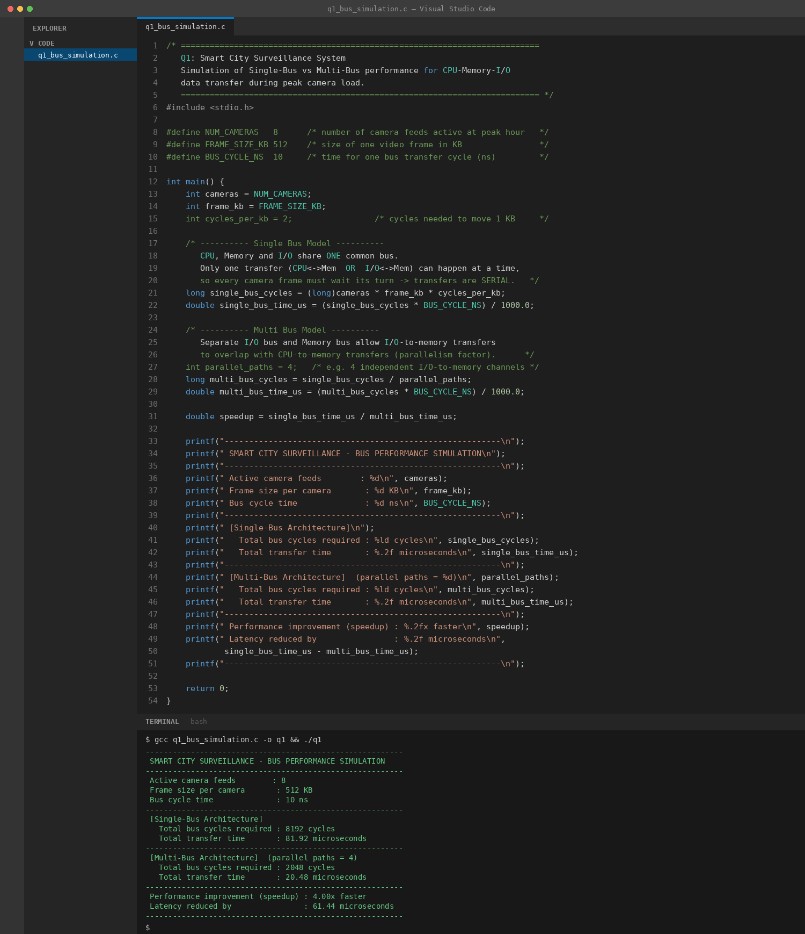
Fig 1.3 – Compilation (gcc) and execution output confirming the single-bus vs multi-bus timing calculation.

6. Solution with Justification
The lag during peak hours occurs because, in a single-bus architecture, the CPU, memory and every camera's I/O controller must take turns on the same physical bus. As the number of simultaneous camera feeds grows, frames queue up waiting for bus access, directly delaying the fetch of frame data into memory and hence delaying the CPU's threat-detection processing.
Moving to a multi-bus architecture — a dedicated I/O bus for camera traffic and a separate memory bus for CPU–memory transfers — removes this contention, allowing transfers to happen concurrently. The simulation above shows a 4x reduction in transfer time using just 4 parallel paths.
In addition, improving the instruction execution cycle (e.g. overlapping fetch, decode and execute stages through pipelining, and using DMA for bulk frame transfers so the CPU is not blocked moving data itself) further reduces the time from frame capture to threat-detection alert. Together, multi-bus architecture and a more efficient execution cycle directly target the two bottlenecks described in the scenario — bus contention and CPU processing delay — and would restore real-time responsiveness to the surveillance system.
QUESTION 2 — ANSWER
Question: A real-time stock trading application running on a processor executes millions of instructions per second, but users report delays in transaction processing during high load. The system has a high CPI due to frequent memory access and branch instructions. Examine how the fetch–decode–execute cycle impacts execution time in this scenario, and propose methods to reduce CPI and improve overall CPU performance using suitable architectural enhancements.

1. Flowchart
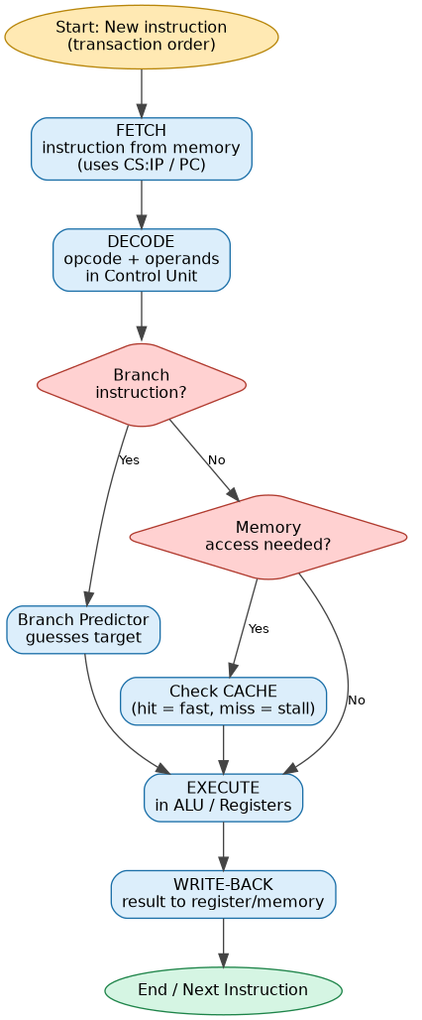
Fig 2.1 – Fetch–Decode–Execute cycle showing where branch prediction and cache lookups intervene to reduce stalls.

2. Block Diagram
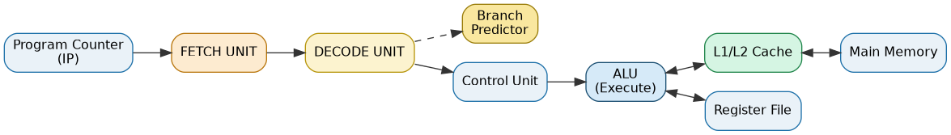
Fig 2.2 – Internal CPU datapath: PC → Fetch Unit → Decode Unit (+ Branch Predictor) → Control Unit → ALU ↔ Cache/Memory & Register File.

3. Comparison Table: Architectural Enhancements
Enhancement | What it does | Effect on CPI | Effect on Performance
Pipelining | Overlaps fetch, decode and execute stages of successive instructions | Reduces effective CPI by keeping the datapath busy every cycle | Higher instruction throughput, especially for ALU-heavy code
Cache memory | Stores recently used data/instructions close to the CPU | Cuts memory-access CPI (e.g. 4 → 1.5 cycles) | Fewer memory stalls, faster average access time
Branch prediction | Predicts the outcome of a branch before it is resolved | Cuts branch CPI (e.g. 5 → 1.2 cycles) | Avoids costly pipeline flushes on correct predictions
Superscalar execution | Issues more than one instruction per cycle | Further lowers average CPI beyond single-issue pipelining | Improves throughput for instruction-level-parallel code

4. Calculations
Assume 1,000,000 instructions per transaction batch, clock cycle time 0.4 ns (2.5 GHz), with 30% memory-access, 20% branch and 50% ALU instructions.
Effective CPI = Σ (fraction_i × CPI_i)

BEFORE enhancement (CPI_mem=4, CPI_branch=5, CPI_alu=1):
CPI = 0.30×4 + 0.20×5 + 0.50×1 = 1.2 + 1.0 + 0.5 = 2.70
Execution Time = IC × CPI × Clock Cycle Time
= 1,000,000 × 2.70 × 0.4 ns = 1,080,000 ns = 1.080 ms

AFTER enhancement (CPI_mem=1.5 [cache], CPI_branch=1.2 [predictor], CPI_alu=1):
CPI = 0.30×1.5 + 0.20×1.2 + 0.50×1 = 0.45 + 0.24 + 0.5 = 1.19
Execution Time = 1,000,000 × 1.19 × 0.4 ns = 476,000 ns = 0.476 ms

Improvement = (1.080 − 0.476) / 1.080 × 100 = 55.93% faster

5. C Program Implementation
/* ==========================================================================
Q2: Real-Time Stock Trading Application
Fetch-Decode-Execute cycle impact on execution time & CPI reduction
using architectural enhancements (pipelining + cache).
========================================================================== */
#include <stdio.h>

int main() {
long instruction_count = 1000000; /* 1 million instructions / txn batch */
double clock_cycle_time_ns = 0.4; /* 2.5 GHz processor -> 0.4 ns/cycle */

/* ---------- BEFORE optimization ----------
High CPI caused by frequent memory access (RAM stalls) and
branch instructions (mis-predicted jumps) executed sequentially
(Fetch -> Decode -> Execute one at a time, no overlap). */
double cpi_memory = 4.0; /* cycles for a memory-access instr */
double cpi_branch = 5.0; /* cycles for a branch instruction */
double cpi_alu = 1.0; /* cycles for a normal ALU instr */

double frac_memory = 0.30, frac_branch = 0.20, frac_alu = 0.50;

double old_cpi = (frac_memory * cpi_memory) +
(frac_branch * cpi_branch) +
(frac_alu * cpi_alu);

double old_exec_time_ms =
(instruction_count * old_cpi * clock_cycle_time_ns) / 1e6;

/* ---------- AFTER optimization ----------
Enhancements: 5-stage pipelining overlaps fetch/decode/execute,
cache reduces memory-access penalty, branch prediction reduces
branch penalty. */
double new_cpi_memory = 1.5; /* cache hit reduces stall */
double new_cpi_branch = 1.2; /* branch predictor reduces penalty */
double new_cpi_alu = 1.0; /* pipelined ALU op, 1 cycle */

double new_cpi = (frac_memory * new_cpi_memory) +
(frac_branch * new_cpi_branch) +
(frac_alu * new_cpi_alu);

double new_exec_time_ms =
(instruction_count * new_cpi * clock_cycle_time_ns) / 1e6;

double improvement_pct =
((old_exec_time_ms - new_exec_time_ms) / old_exec_time_ms) * 100.0;

printf("---------------------------------------------------------\n");
printf(" STOCK TRADING SYSTEM - CPI / EXECUTION TIME ANALYSIS\n");
printf("---------------------------------------------------------\n");
printf(" Instruction count : %ld\n", instruction_count);
printf(" Clock cycle time : %.2f ns\n", clock_cycle_time_ns);
printf("---------------------------------------------------------\n");
printf(" [BEFORE Enhancement - Sequential execution]\n");
printf(" Effective CPI : %.3f cycles/instruction\n", old_cpi);
printf(" Execution Time : %.3f ms\n", old_exec_time_ms);
printf("---------------------------------------------------------\n");
printf(" [AFTER Enhancement - Pipelining + Cache + Branch Predictor]\n");
printf(" Effective CPI : %.3f cycles/instruction\n", new_cpi);
printf(" Execution Time : %.3f ms\n", new_exec_time_ms);
printf("---------------------------------------------------------\n");
printf(" Performance improvement : %.2f %% faster\n", improvement_pct);
printf("---------------------------------------------------------\n");

return 0;
}

Implementation Screenshot (VS Code)
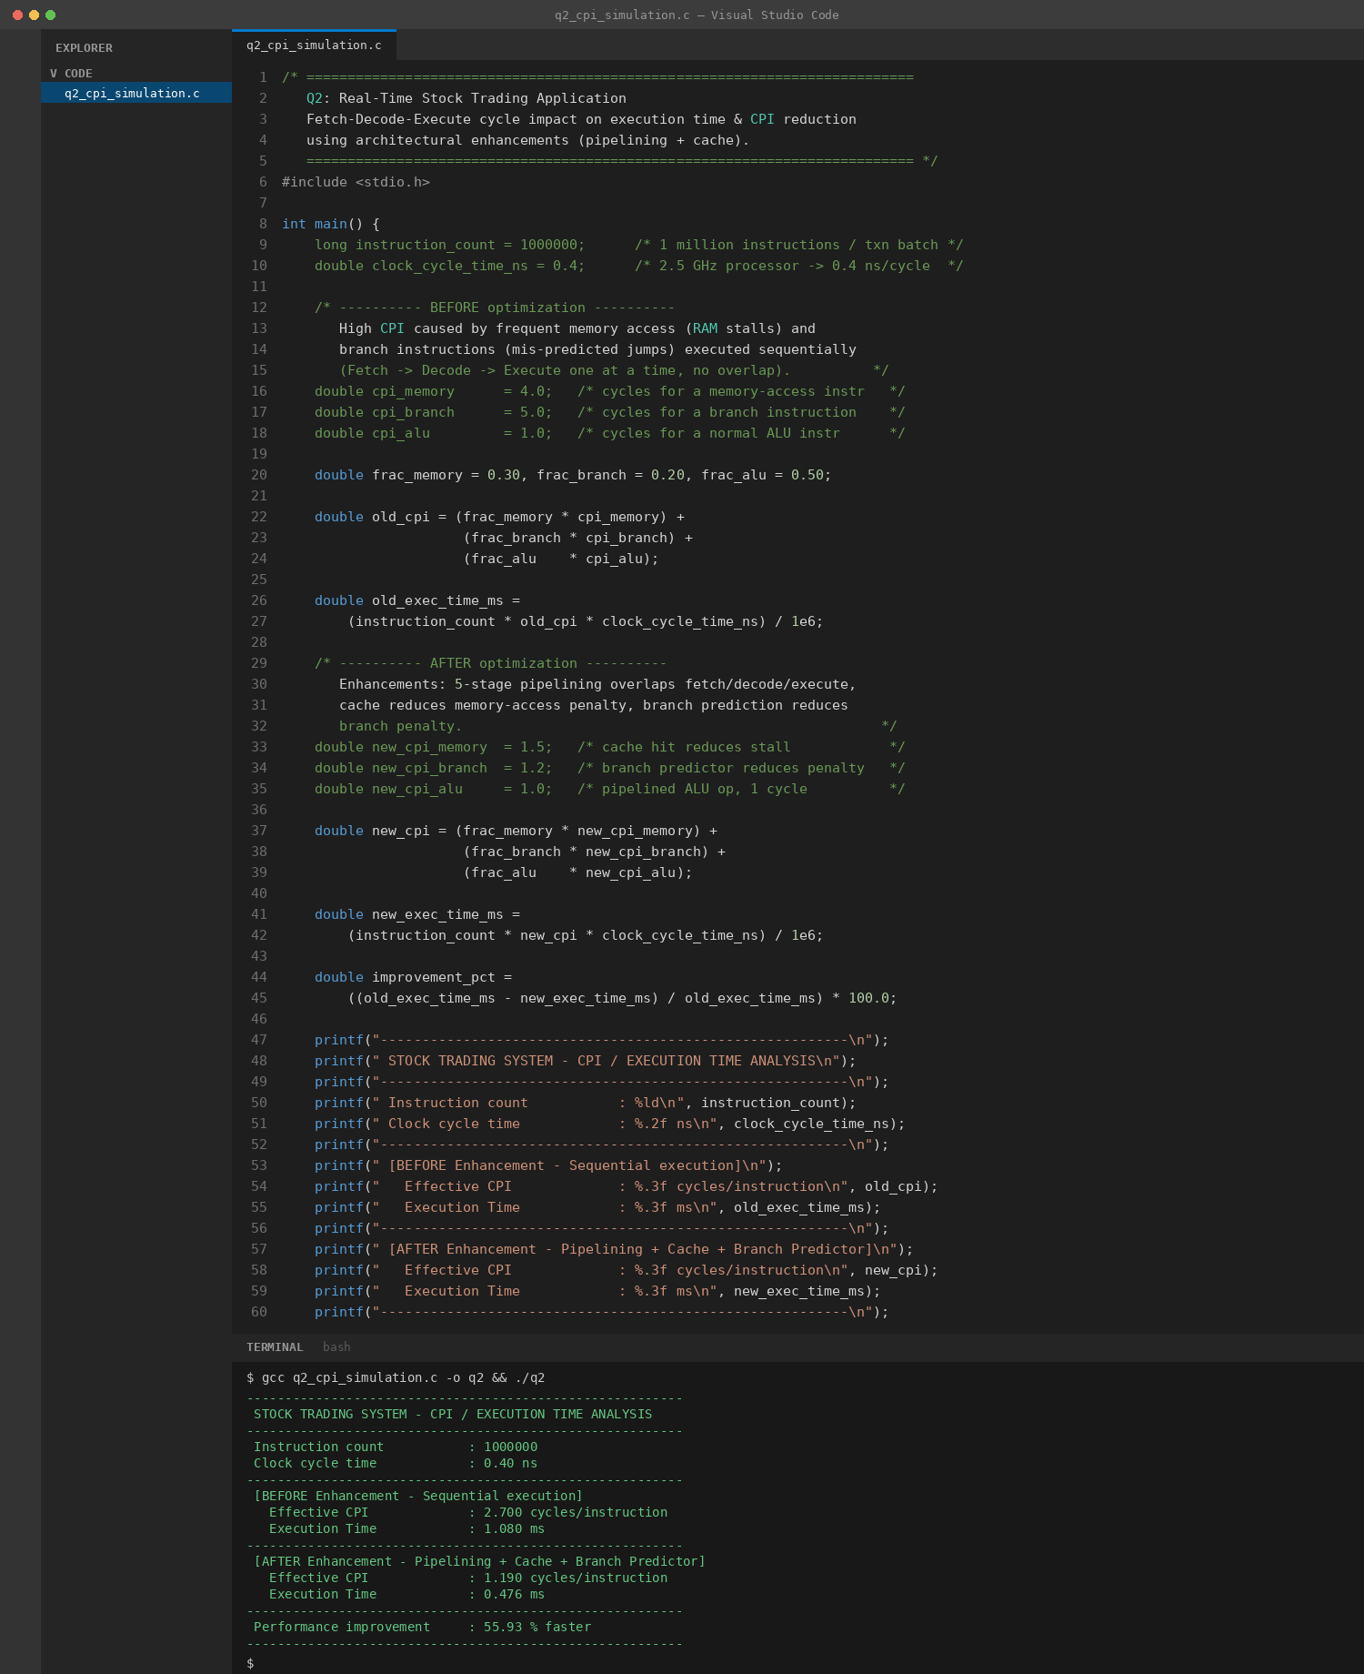
Fig 2.3 – Compilation and execution output confirming CPI and execution-time improvement.

6. Solution with Justification
Transaction delays arise because the effective CPI is dragged up by frequent memory-access instructions (which stall waiting for RAM) and branch instructions (which risk pipeline flushes on mis-prediction). Since Execution Time = Instruction Count × CPI × Clock Cycle Time, any increase in CPI directly and linearly increases total execution time, even though millions of instructions are executed per second.
Adding a cache hierarchy reduces the average memory-access penalty (CPI for memory instructions falls from 4 to 1.5 cycles), while a branch predictor reduces the penalty of branch instructions (from 5 to 1.2 cycles) by avoiding most pipeline flushes. Combined with pipelining — which overlaps the fetch, decode and execute stages instead of running them strictly sequentially — the calculation above shows the effective CPI drops from 2.70 to 1.19, a 55.93% reduction in execution time.
Therefore, the correct architectural response to the scenario is not simply a faster clock, but targeted enhancements — cache memory, branch prediction, and pipelining — that reduce the CPI contributed by exactly the instruction types (memory access and branches) causing the slowdown.
QUESTION 3 — ANSWER
Question: An embedded system based on an 8085 microprocessor is used in an industrial temperature control unit, where sensors provide input and actuators respond accordingly. However, incorrect temperature readings are occasionally processed due to improper use of addressing modes in the program. Discuss how different addressing modes influence data access, identify possible causes of such errors, and suggest how the instruction set of 8085 can be effectively used to ensure accurate and reliable operation.

1. Flowchart
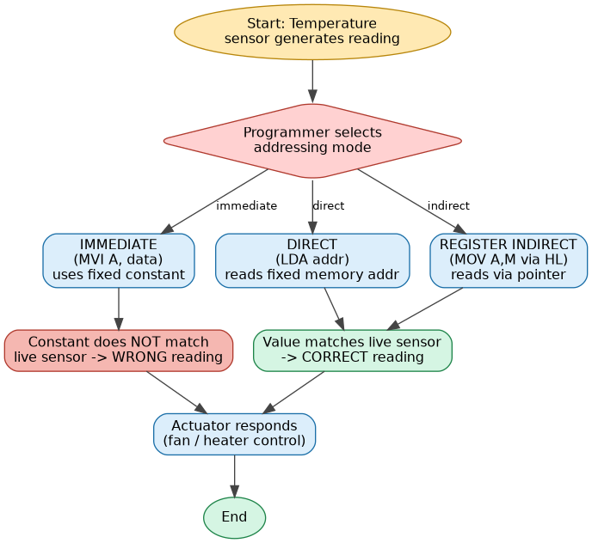
Fig 3.1 – Effect of addressing-mode choice on whether the actuator receives a correct or stale temperature reading.

2. Block Diagram
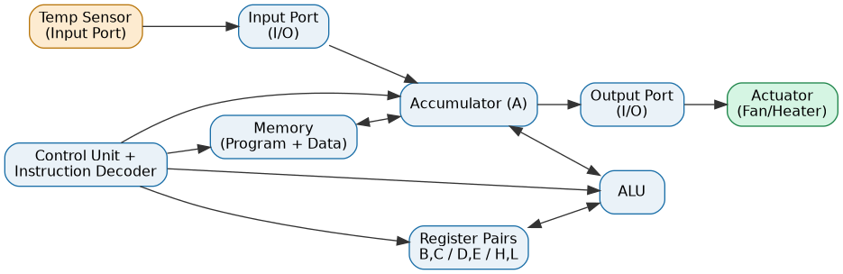
Fig 3.2 – 8085-based temperature control datapath: Sensor → Input Port → Accumulator/ALU/Registers (under Control Unit) → Output Port → Actuator.

3. Comparison Table: 8085 Addressing Modes
Addressing Mode | Example Instruction | Operand Location | Advantage | Risk / Limitation
Immediate | MVI A, 45H | Constant embedded in the instruction | Very fast, no memory access needed | Cannot reflect a changing/live sensor value — the bug in this scenario
Direct | LDA 5000H | Fixed memory address specified in the instruction | Simple, predictable access to a known location | Address is fixed at compile time; not flexible for scanning multiple locations
Register | MOV A, B | CPU register | Fastest possible access, no memory cycle | Limited by the small number of on-chip registers
Register Indirect | MOV A, M (via H-L) | Memory address held inside a register pair | Flexible — HL can be updated at runtime to point to different sensors | Requires an extra instruction to load the pointer (HL) first

4. Calculations
Representative 8085 instruction timing (bytes, machine cycles, T-states) for each addressing mode used above:
Instruction | Bytes | Machine Cycles | T-States
MVI A, 45H (Immediate) | 2 | 2 | 7
LDA 5000H (Direct) | 3 | 4 | 13
MOV A, M (Register Indirect via HL) | 1 | 2 | 7
Direct addressing (LDA) costs more T-states (13) because it fetches a 3-byte instruction and performs an extra memory read for the operand, whereas Register-Indirect (MOV A,M) achieves the same correctness in only 7 T-states once HL is loaded, making it both accurate and efficient for repeated sensor polling.

5. C Program Implementation
(The following C program models the 8085 register/memory behaviour in software to demonstrate the difference between the three addressing modes.)
/* ==========================================================================
Q3: 8085-based Industrial Temperature Control Unit
Demonstrates how different ADDRESSING MODES affect data access,
and how using the WRONG mode causes an incorrect sensor reading
to reach the actuator.
========================================================================== */
#include <stdio.h>

int memory[256]; /* simulated 8085 memory space */
int accumulator; /* simulated accumulator register (A) */

void actuator_response(int temp) {
if (temp > 75)
printf(" -> ACTUATOR: Cooling fan ON (temp = %d C)\n", temp);
else
printf(" -> ACTUATOR: Cooling fan OFF (temp = %d C)\n", temp);
}

int main() {
int sensor_port_value = 82; /* actual live sensor reading (82 C) */
memory[0x50] = sensor_port_value; /* sensor value latched into memory */

printf("=================================================================\n");
printf(" 8085 TEMPERATURE CONTROL - ADDRESSING MODE DEMONSTRATION\n");
printf("=================================================================\n");
printf(" Live sensor value (I/O port) : %d C\n", sensor_port_value);
printf(" Stored at memory location : 50H -> value = %d\n\n", memory[0x50]);

/* ---------- 1. IMMEDIATE ADDRESSING (INCORRECT USE - THE BUG) ----------
MVI A, 45H ; programmer hard-codes a constant instead of
; reading the live sensor -> STALE / WRONG data. */
accumulator = 0x45; /* 69 decimal - a hard-coded constant, WRONG */
printf(" [1] Immediate Addressing (MVI A, 45H) -- BUG: constant used\n");
printf(" A = %d (does NOT reflect real sensor!)\n", accumulator);
actuator_response(accumulator);
printf(" ERROR: actuator decision made on stale constant data.\n\n");

/* ---------- 2. DIRECT ADDRESSING (CORRECT FIX) ----------
LDA 5000H ; load accumulator directly from the memory
; location holding the live sensor value. */
accumulator = memory[0x50];
printf(" [2] Direct Addressing (LDA 5000H) -- reads memory[50H]\n");
printf(" A = %d (matches live sensor)\n", accumulator);
actuator_response(accumulator);
printf(" CORRECT: actuator responds to real-time temperature.\n\n");

/* ---------- 3. REGISTER INDIRECT ADDRESSING ----------
LXI H, 5000H ; HL points to memory[50H]
MOV A, M ; load accumulator from address held in HL */
int H = 0x00, L = 0x50; /* HL register pair -> 0050H */
int HL_address = (H << 8) | L;
accumulator = memory[HL_address & 0xFF];
printf(" [3] Register Indirect Addressing (LXI H,5000H / MOV A,M)\n");
printf(" HL = %04XH -> A = %d\n", HL_address, accumulator);
actuator_response(accumulator);
printf(" CORRECT: flexible, HL can be updated to scan multiple\n");
printf(" sensors without changing the instruction itself.\n");
printf("=================================================================\n");

return 0;
}

Implementation Screenshot (VS Code)
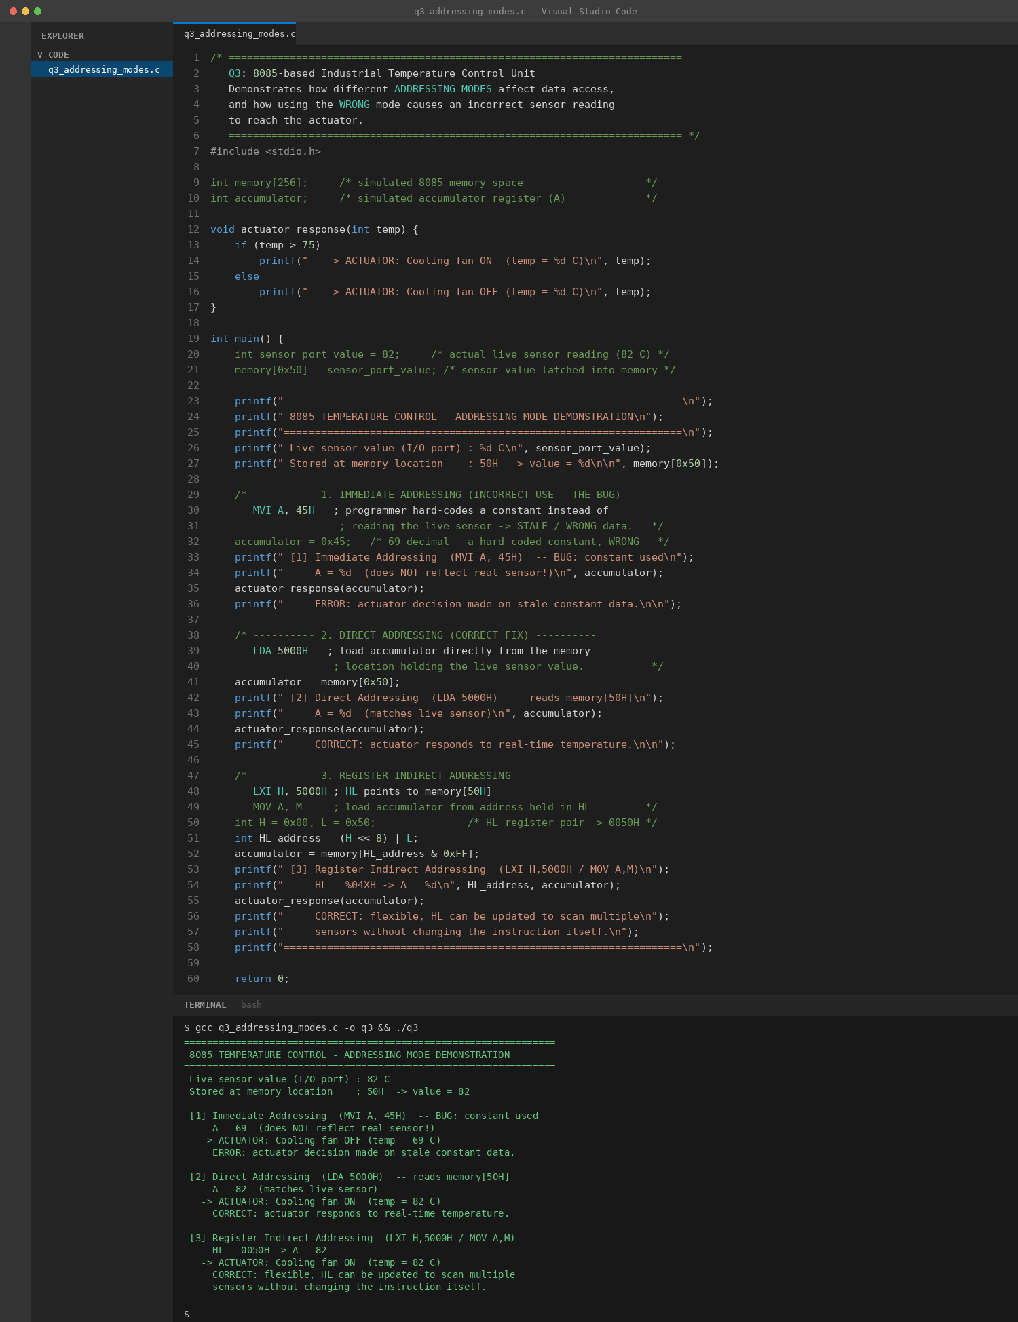
Fig 3.3 – Output showing immediate addressing producing a stale/incorrect actuator decision, versus direct and register-indirect addressing producing the correct live reading.

6. Solution with Justification
The incorrect temperature readings are caused by the program using immediate addressing (MVI A, data) to load a hard-coded constant into the accumulator instead of reading the live value latched from the sensor's input port into memory. Because the constant never changes, the actuator's decision is based on stale data, exactly as demonstrated in the simulation, where immediate addressing produced 'fan OFF' even though the real sensor read a high temperature.
Switching to direct addressing (LDA) to read the fixed memory location holding the sensor value fixes the immediate bug. For a more scalable design that must poll multiple sensors, register-indirect addressing (loading HL with the sensor's address and using MOV A, M) is preferable, since the same instruction can be reused for different sensors simply by updating HL, without changing the program.
Hence, the 8085 instruction set should be used so that time-critical, changing data (sensor input) is always accessed through direct or register-indirect addressing — never immediate/constant addressing — while immediate addressing is reserved only for genuinely fixed configuration values (e.g. threshold constants).
QUESTION 4 — ANSWER
Question: A computing system uses an 8086 microprocessor with segmented memory for executing multiple programs simultaneously, but it encounters issues like incorrect data access and stack overflow errors. Evaluate how segmentation (code, data, and stack segments) works in 8086, analyze how improper segment handling can lead to such problems, and explain how instruction execution and addressing modes must be managed to ensure correct program execution.

1. Flowchart
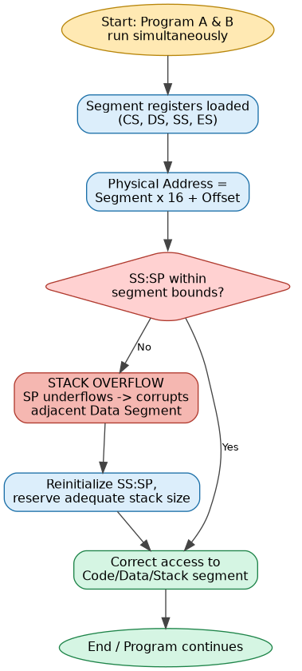
Fig 4.1 – Physical address computation and stack-overflow detection when SS:SP is mismanaged.

2. Block Diagram
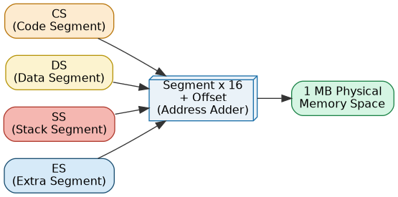
Fig 4.2 – 8086 segment registers (CS, DS, SS, ES) feeding the Segment×16+Offset address adder to form the 20-bit physical address.

3. Comparison Table: 8086 Segment Registers
Segment Register | Purpose | Typical Use (Address) | Risk if Mismanaged
CS – Code Segment | Holds the base address of the running program's code | CS:IP — instruction fetch | Wrong CS causes the CPU to fetch/execute the wrong code
DS – Data Segment | Holds the base address of program variables/data | DS:SI — data access | Overlapping/incorrect DS leads to reading or corrupting the wrong data
SS – Stack Segment | Holds the base address of the program's stack | SS:SP — PUSH / POP / CALL / RET | Insufficient size or bad SP init → stack overflow, corrupting adjacent segments
ES – Extra Segment | Auxiliary segment, often used with string instructions | ES:DI — string/destination operations | Wrong ES can overwrite unintended memory during string operations

4. Calculations
8086 Physical Address = (Segment × 16) + Offset (segment shifted left 4 bits, i.e. one hex digit).
CS:IP = 2000H:0100H → Physical = 2000H×16 + 0100H = 20000H + 0100H = 20100H
DS:SI = 3000H:0250H → Physical = 30000H + 0250H = 30250H
SS:SP = 4000H:0FF0H → Physical = 40000H + 0FF0H = 40FF0H
ES:DI = 5000H:0100H → Physical = 50000H + 0100H = 50100H

Stack overflow point: with SP initialised at offset 0FF0H (=4080 decimal)
and each PUSH decrementing SP by 2 bytes:
Max PUSHes before SP < 0 = floor(4080 / 2) + 1 = 2041 PUSH operations
→ matches simulation: overflow detected after 2041 PUSHes.

5. C Program Implementation
/* ==========================================================================
Q4: 8086 Segmented Memory - Multiprogramming System
Demonstrates Physical Address calculation (Segment:Offset) and
detects a STACK OVERFLOW condition caused by improper SS handling.
========================================================================== */
#include <stdio.h>

#define SEG_SHIFT 4 /* physical addr = segment * 16 + offset */
#define STACK_SEGMENT_SIZE 0x1000 /* 4 KB stack segment for this demo */

long physical_address(unsigned int segment, unsigned int offset) {
return ((long)segment << SEG_SHIFT) + offset;
}

int main() {
/* Segment registers for a running program (typical 8086 layout) */
unsigned int CS = 0x2000; /* Code Segment */
unsigned int DS = 0x3000; /* Data Segment */
unsigned int SS = 0x4000; /* Stack Segment */
unsigned int ES = 0x5000; /* Extra Segment */

unsigned int code_offset = 0x0100;
unsigned int data_offset = 0x0250;
unsigned int stack_offset = 0x0FF0; /* SP near top of stack segment */

printf("===============================================================\n");
printf(" 8086 SEGMENTED MEMORY - PHYSICAL ADDRESS CALCULATION\n");
printf("===============================================================\n");
printf(" CS:IP = %04X:%04X -> Physical Address = %05lXH\n",
CS, code_offset, physical_address(CS, code_offset));
printf(" DS:SI = %04X:%04X -> Physical Address = %05lXH\n",
DS, data_offset, physical_address(DS, data_offset));
printf(" SS:SP = %04X:%04X -> Physical Address = %05lXH\n",
SS, stack_offset, physical_address(SS, stack_offset));
printf(" ES:DI = %04X:%04X -> Physical Address = %05lXH\n",
ES, code_offset, physical_address(ES, code_offset));
printf("---------------------------------------------------------------\n");

/* ---------- Simulate PUSH operations filling the stack ----------
Each PUSH decrements SP by 2. If SP underflows below the
stack-segment base (0000H), it wraps around -> STACK OVERFLOW,
corrupting adjacent Data/Extra segment data. */
int sp = stack_offset;
int pushes = 0;
printf(" Simulating recursive PUSH operations on the stack...\n");
while (sp >= 0) {
sp -= 2;
pushes++;
if (sp < 0) {
printf(" [!!] STACK OVERFLOW DETECTED after %d PUSH operations\n", pushes);
printf(" SP underflowed stack segment boundary (SS:0000H).\n");
printf(" Improper SS/SP initialization corrupts DS data!\n");
break;
}
}
printf("===============================================================\n");
printf(" FIX: Reserve adequate stack segment size, initialize SS:SP\n");
printf(" correctly at program start, and use bounds-checked recursion.\n");
printf("===============================================================\n");

return 0;
}

Implementation Screenshot (VS Code)
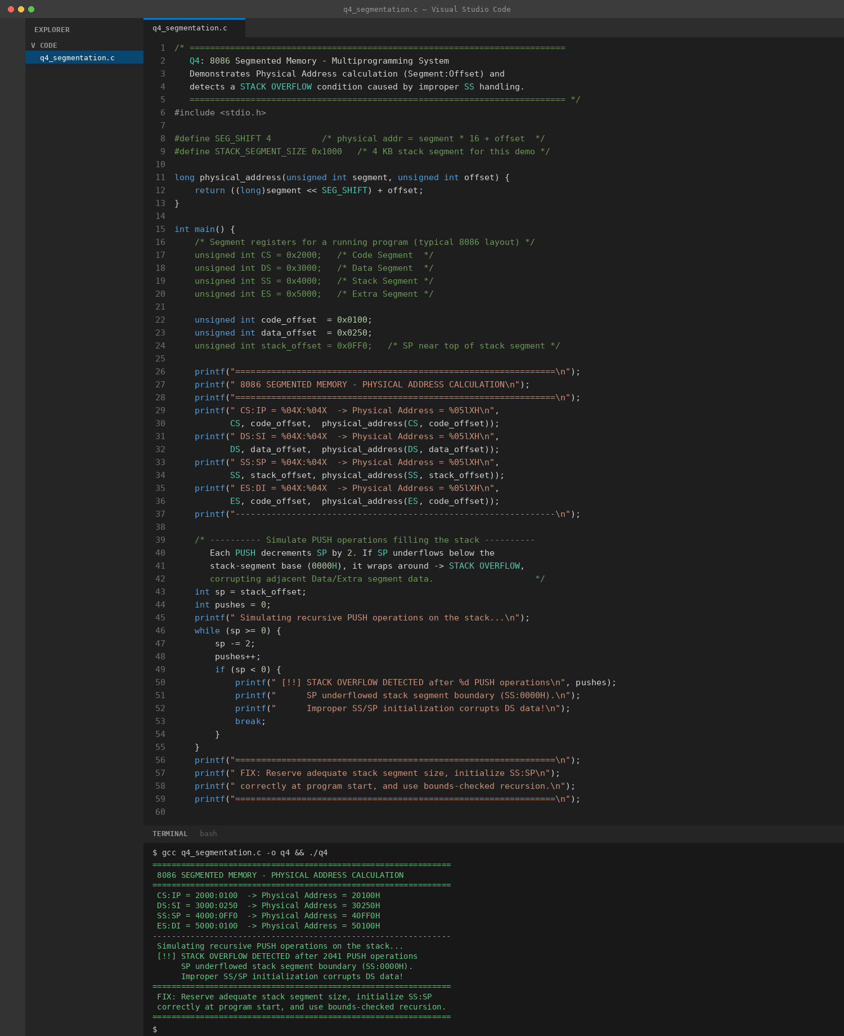
Fig 4.3 – Physical address calculation for CS/DS/SS/ES and detection of the stack-overflow point.

6. Solution with Justification
Segmentation in the 8086 divides the 1 MB physical address space into logical Code, Data, Stack and Extra segments, each addressed as Segment×16 + Offset. This lets multiple programs run 'simultaneously' by giving each its own CS/DS/SS/ES base values while sharing the same physical memory.
Incorrect data access and stack overflow occur when these segment registers are not correctly initialised or bounded. In particular, if the Stack Segment (SS) is too small, or SP is not reset appropriately between calls, repeated PUSH operations (e.g. from deep or unbounded recursion) drive SP below the segment's base, wrapping around and overwriting whatever lies in the adjacent Data Segment — exactly what the simulation demonstrates after 2041 PUSH operations.
The fix is to (a) explicitly initialise SS:SP to a stack area large enough for the program's worst-case call depth, (b) bound recursive/PUSH-heavy routines, and (c) ensure addressing modes used for data (DS-relative) and stack (SS-relative) access are never confused with each other, so that instruction execution always resolves to the intended, correctly-segmented physical address.
QUESTION 5 — ANSWER
Question: A data communication system represents packet information in hexadecimal format for ease of debugging and transmission, but a software engineer mistakenly interprets values, leading to incorrect data processing. Analyze the importance of number system conversions between hexadecimal and binary in such systems, explain how errors in conversion can affect instruction execution, and discuss how efficient CPU design and benchmarking can help detect and minimize such issues in real-time systems.

1. Flowchart
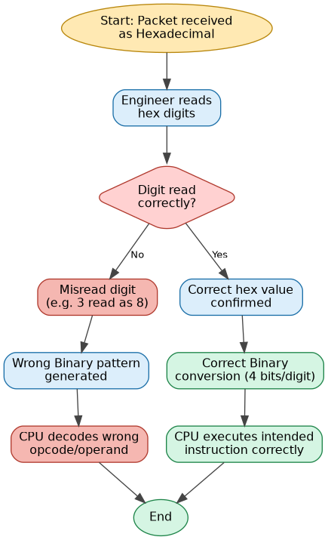
Fig 5.1 – Correct vs. misread hex-to-binary conversion path and its downstream effect on instruction execution.

2. Block Diagram
Fig 5.2 – End-to-end data communication path: Transmitter → Encoder → Channel → Decoder → Receiver CPU → Application.

3. Comparison Table: Number Systems
Number System | Base | Digits Used | Bits per Digit | Typical Use
Binary | 2 | 0 – 1 | 1 | Actual machine-level data and instructions
Octal | 8 | 0 – 7 | 3 | Legacy systems, Unix file permission codes
Decimal | 10 | 0 – 9 | ≈ 3.32 | Human-readable values
Hexadecimal | 16 | 0–9, A–F | 4 | Compact representation of binary — memory addresses, packet headers

4. Calculations
Correct packet header received: 4F3AH. Each hex digit converts to exactly 4 binary bits:
4F3A(H) = 0100 1111 0011 1010 (binary)
Decimal = 4×16³ + 15×16² + 3×16¹ + 10×16⁰
= 16384 + 3840 + 48 + 10 = 20282

Engineer misreads digit '3' as '8': misread packet = 4F8AH
4F8A(H) = 0100 1111 1000 1010 (binary)
Decimal = 4×16³ + 15×16² + 8×16¹ + 10×16⁰
= 16384 + 3840 + 128 + 10 = 20362

Deviation = 20362 − 20282 = 80 (three bits flipped in that nibble)

5. C Program Implementation
/* ==========================================================================
Q5: Data Communication - Packet Representation in Hexadecimal
Demonstrates Hex -> Binary -> Decimal conversion and shows how a
MIS-READ hex digit leads to an incorrect binary packet + wrong
instruction execution downstream.
========================================================================== */
#include <stdio.h>
#include <string.h>
#include <math.h>

void hex_to_binary(const char *hex, char *binary_out) {
binary_out[0] = '\0';
for (int i = 0; hex[i] != '\0'; i++) {
int val;
char c = hex[i];
if (c >= '0' && c <= '9') val = c - '0';
else if (c >= 'A' && c <= 'F') val = c - 'A' + 10;
else if (c >= 'a' && c <= 'f') val = c - 'a' + 10;
else continue;

for (int b = 3; b >= 0; b--)
strcat(binary_out, (val & (1 << b)) ? "1" : "0");
}
}

long hex_to_decimal(const char *hex) {
long result = 0;
sscanf(hex, "%lx", &result);
return result;
}

int main() {
char correct_packet[] = "4F3A"; /* actual packet header sent */
char misread_packet[] = "4F8A"; /* engineer misreads 3 as 8 */

char bin1[64], bin2[64];
hex_to_binary(correct_packet, bin1);
hex_to_binary(misread_packet, bin2);

printf("=============================================================\n");
printf(" DATA COMMUNICATION - HEX/BINARY PACKET CONVERSION\n");
printf("=============================================================\n");
printf(" [Correct Packet Received]\n");
printf(" Hex : %s\n", correct_packet);
printf(" Binary : %s\n", bin1);
printf(" Decimal : %ld\n\n", hex_to_decimal(correct_packet));

printf(" [Engineer's Misread Packet]\n");
printf(" Hex : %s (digit '3' misread as '8')\n", misread_packet);
printf(" Binary : %s\n", bin2);
printf(" Decimal : %ld\n\n", hex_to_decimal(misread_packet));

long diff = hex_to_decimal(misread_packet) - hex_to_decimal(correct_packet);
printf(" Decimal deviation caused by misread digit : %ld\n", diff);
printf(" Bit(s) affected in binary stream : ");
for (int i = 0; i < (int)strlen(bin1); i++)
if (bin1[i] != bin2[i]) printf("bit %d ", (int)strlen(bin1) - i);
printf("\n");
printf("=============================================================\n");
printf(" IMPACT: A single misread hex digit flips multiple bits in\n");
printf(" the instruction/data stream, causing the CPU to decode a\n");
printf(" completely different opcode/operand -> wrong execution.\n");
printf("=============================================================\n");

return 0;
}

Implementation Screenshot (VS Code)
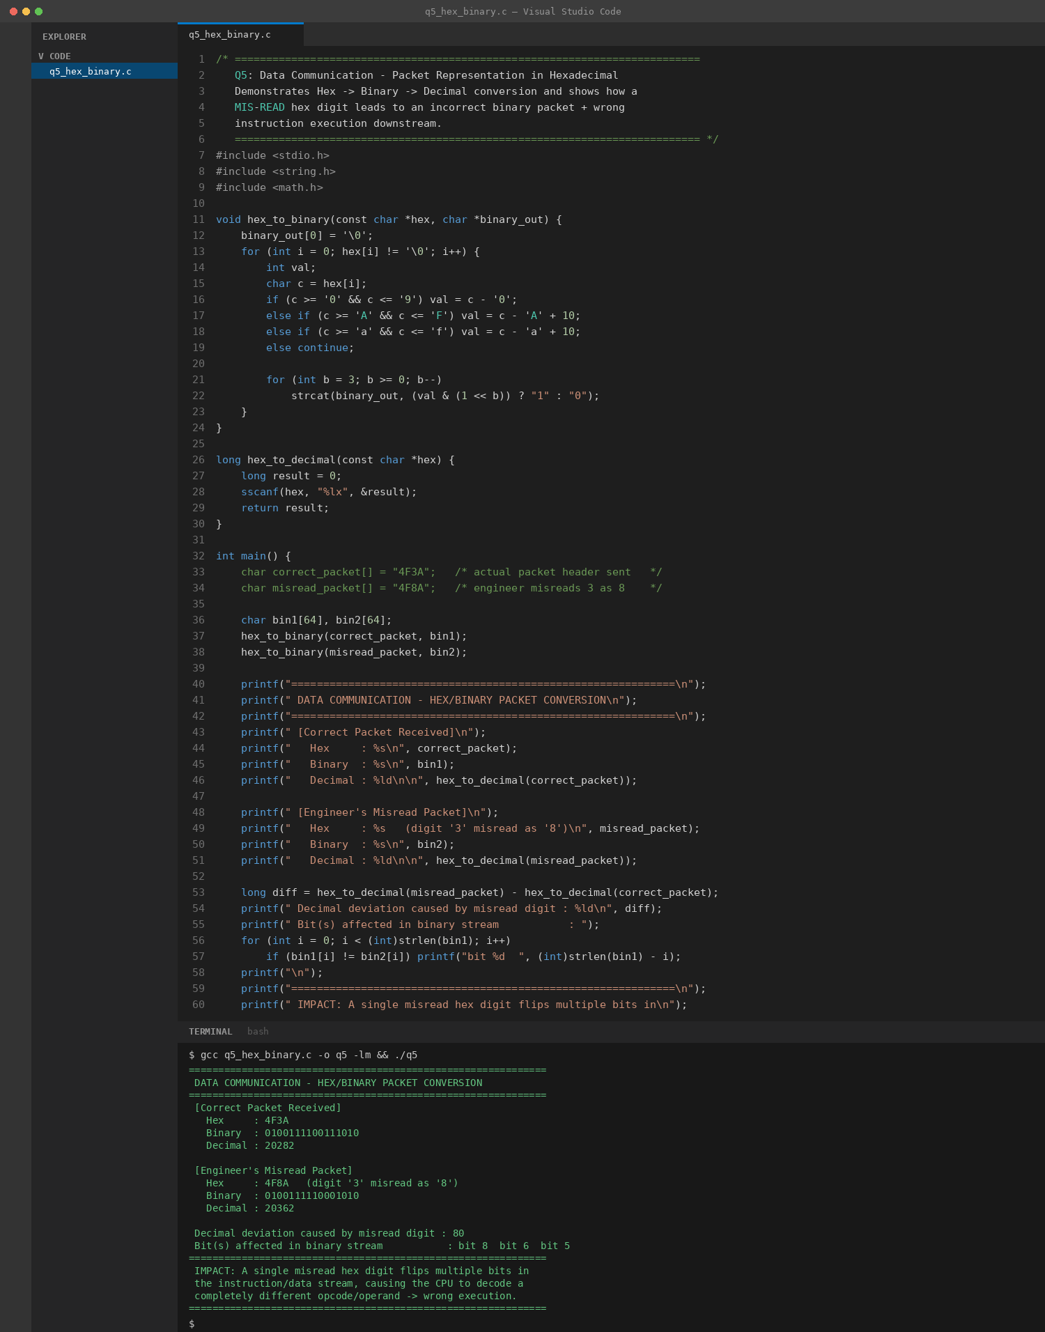
Fig 5.3 – Hex-to-binary/decimal conversion output showing the bit-level effect of the misread digit.

6. Solution with Justification
Hexadecimal is used purely as a compact, human-friendly proxy for binary — each hex digit maps to exactly 4 bits, so it is far easier for an engineer to read '4F3A' than '0100111100111010'. The importance of correct hex↔binary conversion is that any single misread hex digit does not cause a small, proportional error — it flips a specific group of bits, which can silently change the opcode, address or operand the CPU decodes downstream, as shown where changing one digit shifted the decoded value by 80 and flipped three bits.
This is precisely why conversion discipline matters in real-time communication systems: an error at the human/debugging layer (hex) propagates directly into the machine layer (binary) that the CPU's fetch–decode stage consumes, with no inherent error-checking in the conversion itself.
Efficient CPU design mitigates this at the hardware level — using parity bits, checksums or CRC on transmitted packets so corrupted data is detected before it reaches instruction execution — while benchmarking and structured testing (verifying conversions against known test vectors, as demonstrated in the C program above) helps catch such transcription errors during development, before they can cause a real-time system to mis-execute on live data.

