SIMATS ENGINEERING
COURSE CODE: CSA0304A
COURSE NAME: DATA STRUCTURES FOR STATIC AND DYNAMIC MEMORY ALLOCATION
ASSIGNMENT NO - 2 | Batch Code: CSA0304A
S.No | Reg No | Name | Topic
34 | 192511445A | Shaik Khajah Roshan | Infix → Postfix Conversion

Questions answered in this document
Q1. What is the time complexity of converting an infix expression to a postfix expression? Explain your answer.
Q2. Convert (A + B) * (C - D) to postfix and explain operator precedence handling.

Question 1: Time Complexity of Infix to Postfix Conversion
Short Answer
The time complexity is O(n), where n is the number of tokens (operands, operators and parentheses) in the infix expression. The auxiliary space complexity is also O(n) in the worst case, for the operator stack.
Each token is read exactly once, and each operator or parenthesis is pushed onto the stack at most once and popped at most once. Because push and pop are O(1), the total work is proportional to n.

1.1 Background: What the algorithm does
Infix notation places the operator between its operands (A + B), so a computer must know precedence and parentheses to evaluate it. Postfix notation (Reverse Polish Notation) places the operator after its operands (A B +) and needs neither precedence rules nor parentheses at evaluation time. The standard method for converting infix to postfix is the Shunting-Yard algorithm (Dijkstra), which uses one stack for operators and one output list.
The algorithm scans the expression from left to right and takes one of four actions on each token:
Token read | Action performed
Operand (A, B, 5 …) | Append directly to the output.
Opening parenthesis ( | Push onto the stack.
Closing parenthesis ) | Pop operators to the output until ( is found; discard both parentheses.
Operator (+ − * / ^) | While the stack top has higher or equal precedence (for left-associative operators), pop it to the output; then push the current operator.
End of input | Pop all remaining operators from the stack to the output.

1.2 Pseudocode
INFIX_TO_POSTFIX(expr):
create empty stack S, empty output list OUT
for each token t in expr (left to right): // n iterations
if t is an operand:
append t to OUT // O(1)
else if t == '(':
push t on S // O(1)
else if t == ')':
while S not empty and top(S) != '(':
append pop(S) to OUT // each pop O(1)
pop '(' from S and discard
else: // t is an operator
while S not empty and prec(top(S)) >= prec(t):
append pop(S) to OUT // each pop O(1)
push t on S // O(1)
while S not empty:
append pop(S) to OUT
return OUT

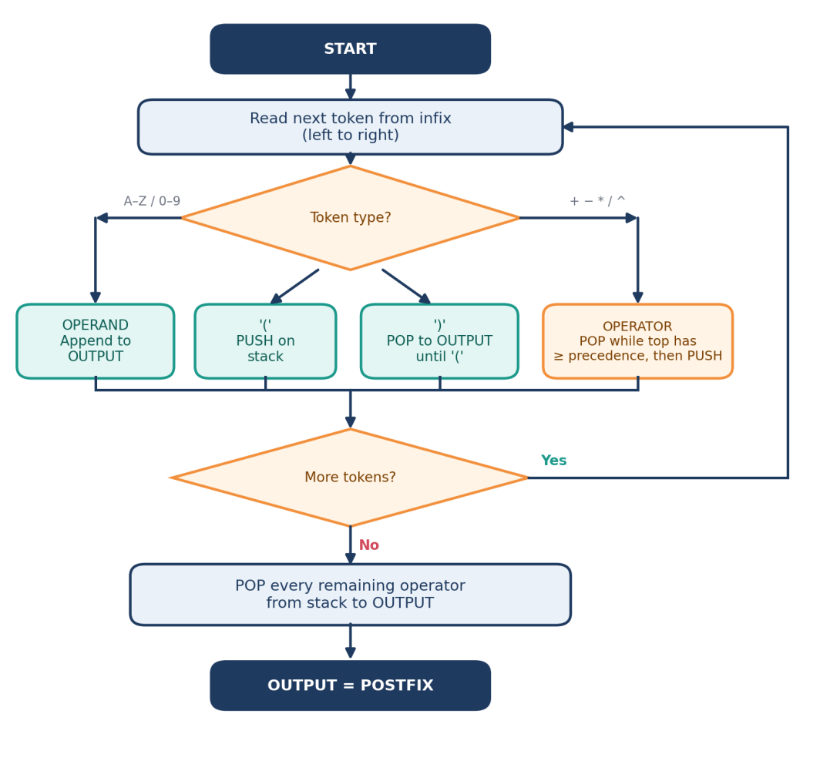
Figure 1: Flowchart of the infix-to-postfix (Shunting-Yard) algorithm

1.3 Why the complexity is O(n)
At first glance the algorithm looks quadratic: there is a for loop over n tokens, and inside it there are while loops that pop operators. If each while loop could run up to n times, the total would be O(n²). That bound is too pessimistic, as the following argument shows.

Step 1: The outer loop runs n times
Every token is examined exactly once and the scan never moves backwards. This gives n iterations of constant work for reading the token and deciding what to do with it.

Step 2: Each token is pushed at most once
Operands never go on the stack. An operator or a parenthesis is pushed exactly once, when it is read. So the total number of pushes is at most n.

Step 3: Each pushed token is popped at most once (amortized argument)
An element can only be popped if it was pushed earlier, and once popped it is gone. Therefore, summed over the entire run, the number of pops cannot exceed the number of pushes, so total pops ≤ n. A single iteration may pop many operators, but those pops are "paid for" by earlier pushes. This is called amortized analysis.

Step 4: Every individual operation is O(1)
Push, pop, peeking at the top, appending to the output and comparing two precedences (a table or switch lookup) all take constant time with an array-based stack.

Step 5: Add up the total
Operation | Max. times executed | Cost each | Total
Read / examine a token | n | O(1) | O(n)
Append operand to output | ≤ n | O(1) | O(n)
Push on stack | ≤ n | O(1) | O(n)
Pop from stack (all while-loops combined) | ≤ n | O(1) | O(n)
Precedence comparisons (each ends in a pop or exits the loop) | ≤ pops + n ≤ 2n | O(1) | O(n)
Overall |  |  | O(n)

Key inequality
Total steps ≤ n (scans) + n (operand appends) + n (pushes) + n (pops) + 2n (comparisons) = 6n = O(n)
In practice the constant is much smaller, as the worked example below shows.

1.4 Worked example: counting the operations
Take (A + B) * (C - D), which has n = 11 tokens. The full trace is given in Question 2. Counting the actual operations:
Operation | Count | Where it happens
Tokens scanned | 11 | ( A + B ) * ( C - D )
Operands appended to output | 4 | A, B, C, D
Pushes | 5 | (, +, *, (, -
Pops | 5 | + and ( at the first ); - and ( at the second ); * at the end
Total elementary steps | 25 | ≈ 2.3 × n, comfortably within the O(n) bound
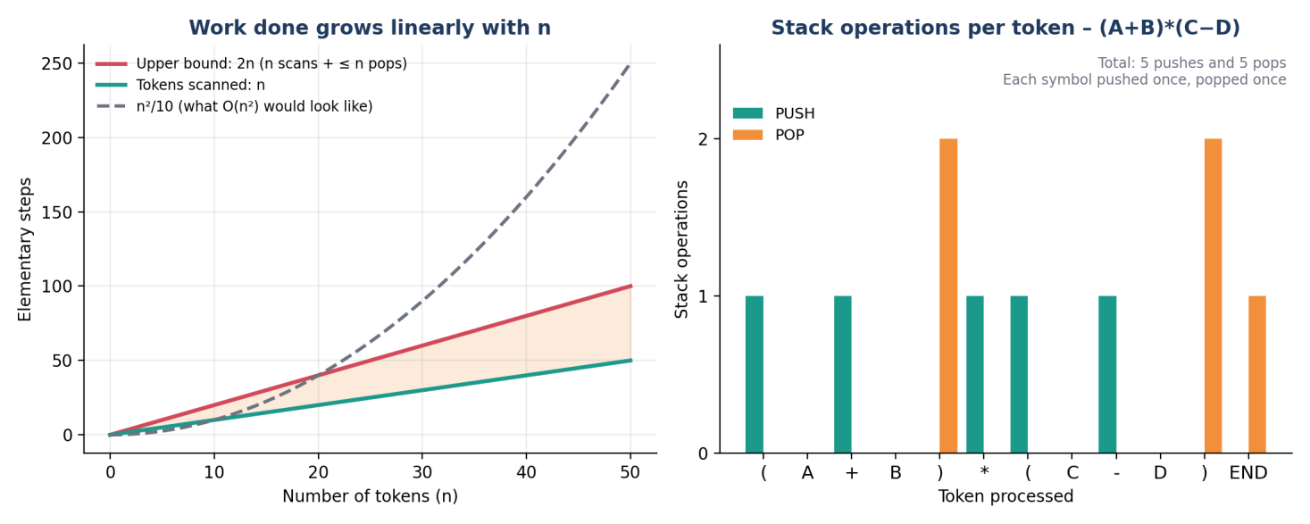
Figure 2: (left) linear growth of work with input size; (right) push/pop activity for (A+B)*(C−D)

1.5 Best, average and worst case
The conversion has no early exit: every token must be read, so the running time is Θ(n) in all cases. Only the shape of stack usage differs between inputs.
Case | Example input | Behaviour
Best | A B C D style, only operands (or one operator) | Almost no stack activity; n scans and n appends.
Average | A + B * C - D | A mix of pushes and pops; about one push and one pop per operator.
Worst (time) | A + B - C + D … (all equal precedence) | Each new operator pops the previous one; still ≤ n pops in total, so O(n).
Worst (space) | ((((A)))) or A ^ B ^ C ^ D | The stack holds up to n/2 or more symbols at once, so O(n) space.

1.6 Space complexity
- Operator stack: at most O(n) elements (worst case when many parentheses or right-associative operators are nested).
- Output list: exactly one entry per operand and operator, so O(n).
- Overall auxiliary space: O(n).

1.7 Remarks and assumptions
- The bound assumes the output is built with an O(1) append (array or buffer). Repeated string concatenation that copies the whole string each time could degrade it to O(n²).
- Precedence lookup is O(1) because the number of operators is fixed (a small constant table).
- Multi-digit numbers or variable names are treated as one token each; tokenizing the raw string is itself a single O(length) pass.
- Evaluating the resulting postfix expression is also O(n), so the whole pipeline (convert, then evaluate) is linear.

1.8 Conclusion for Question 1
Final result
Time complexity = Θ(n) (linear) | Space complexity = O(n)
Reason: single left-to-right pass, and every operator is pushed once and popped once, each in constant time.

Question 2: Convert (A + B) * (C - D) to Postfix
Short Answer
Infix: (A + B) * (C - D)
Postfix: A B + C D - *
The parentheses force + and - to be evaluated before *, which is why both appear before * in the postfix result.

2.1 Operator precedence and associativity
Precedence decides which operator is applied first when an expression has several. Associativity decides the order among operators of the same precedence. Parentheses override both.
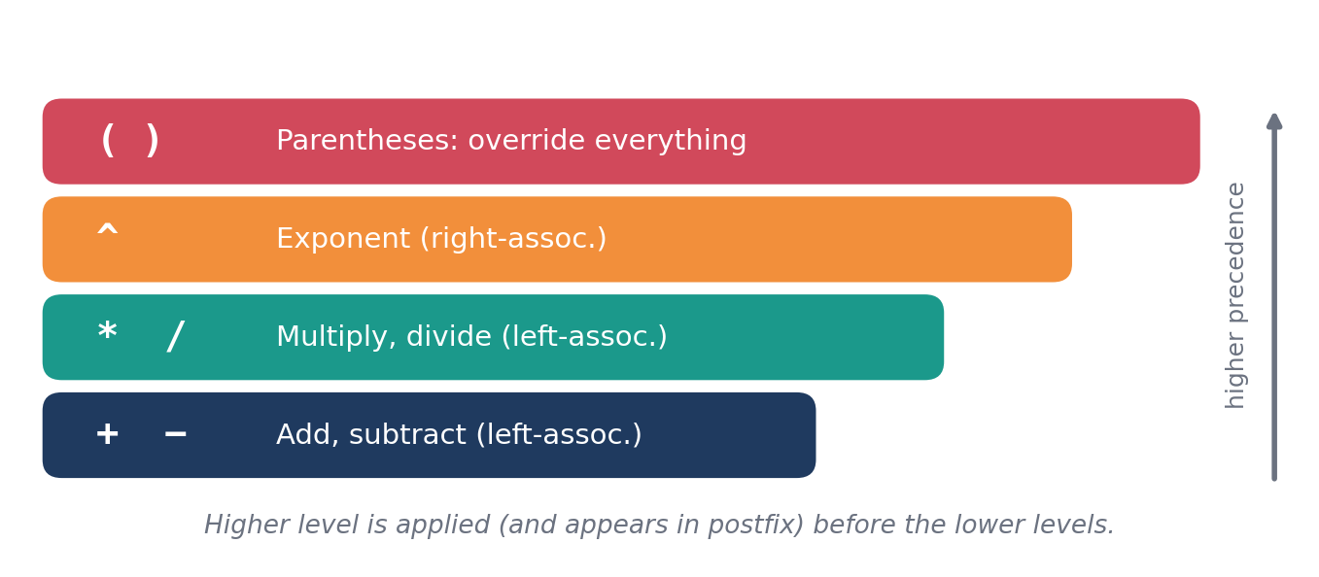
Figure 3: Precedence levels used by the conversion algorithm
Operator | Precedence | Associativity | Role in this expression
( ) | Highest (override) | n/a | Group A + B and C - D so they are done first.
* | 2 | Left → Right | Applied to the two bracketed results.
+ - | 1 | Left → Right | Each used once, inside its own pair of brackets.

Rule used for the stack: when an operator arrives, pop from the stack while the top operator has greater than or equal precedence (equal is included because the operators are left-associative). A ( on the stack is never popped by an operator; it is removed only by its matching ).

2.2 Step-by-step conversion
The expression is scanned left to right. The stack column lists contents from bottom to top.
Step | Token | Action | Stack (bottom → top) | Postfix output
1 | ( | Opening parenthesis: push | ( | (empty)
2 | A | Operand: send to output | ( | A
3 | + | Top is (, which is never popped by an operator: push + | ( + | A
4 | B | Operand: send to output | ( + | A B
5 | ) | Pop until (: pop + to output, discard ( | (empty) | A B +
6 | * | Stack empty: push * | * | A B +
7 | ( | Opening parenthesis: push | * ( | A B +
8 | C | Operand: send to output | * ( | A B + C
9 | - | Top is (: push - | * ( - | A B + C
10 | D | Operand: send to output | * ( - | A B + C D
11 | ) | Pop until (: pop - to output, discard ( | * | A B + C D -
End | — | Input finished: pop remaining * to output | (empty) | A B + C D - *

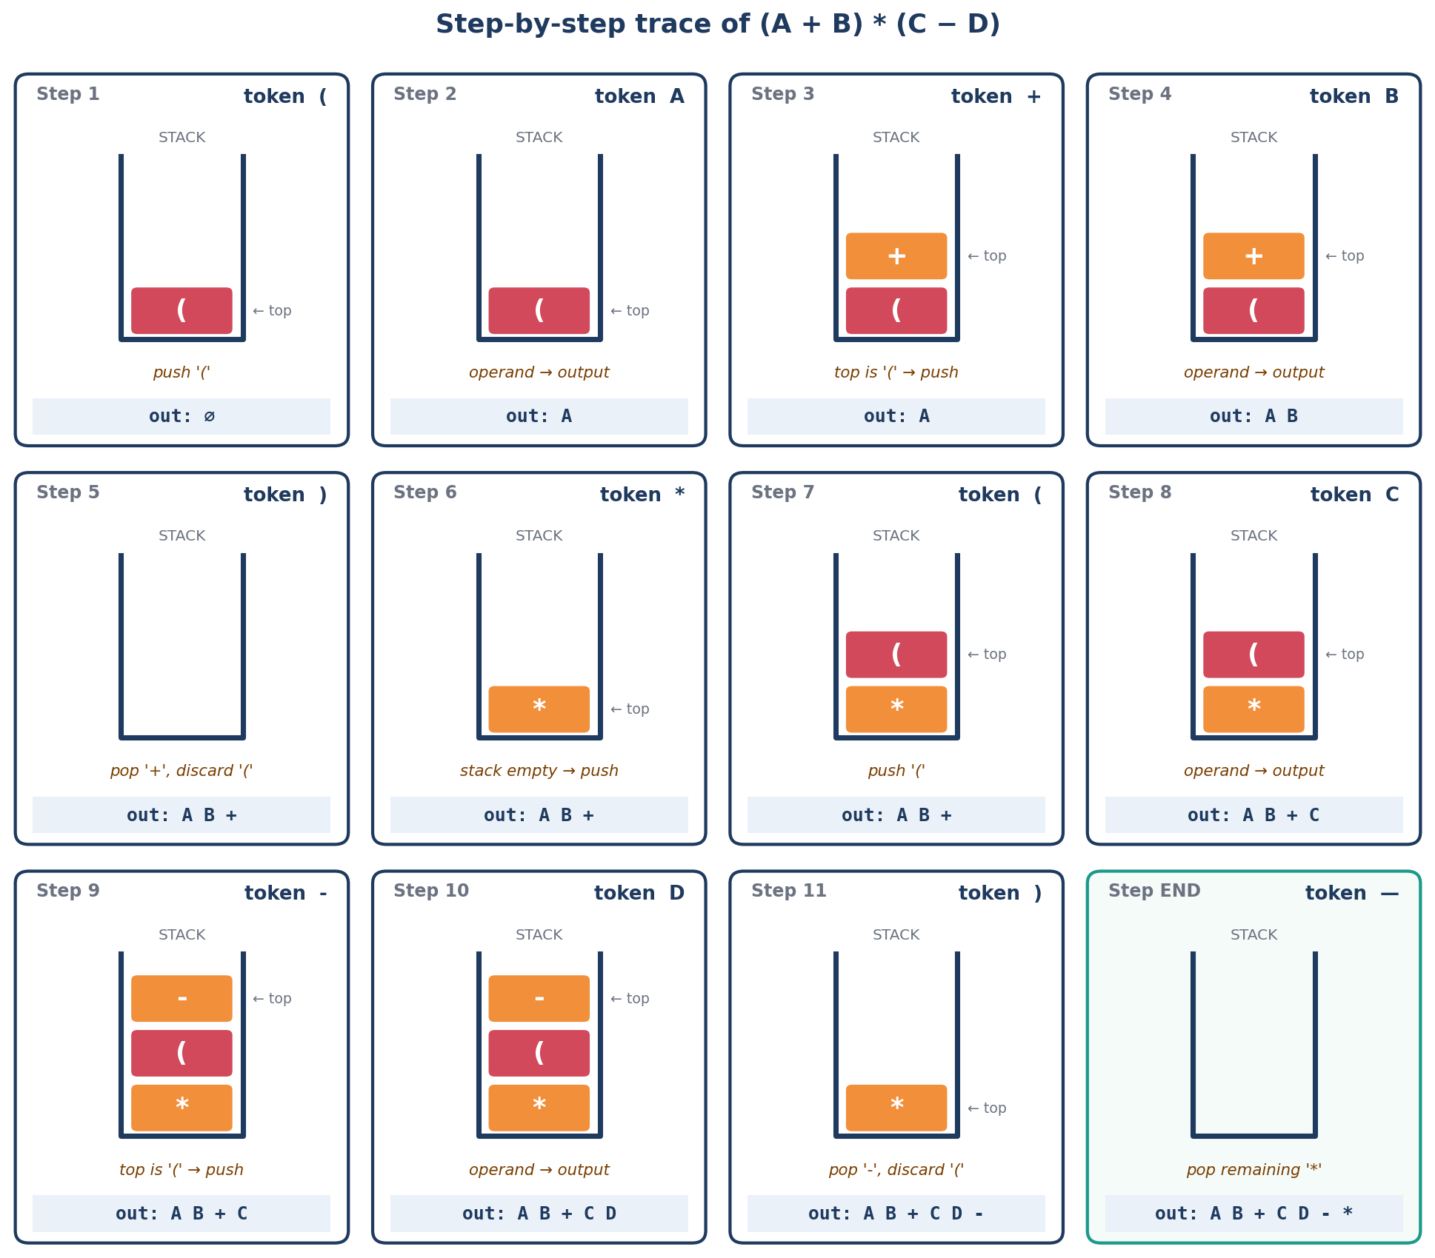
Figure 4: Stack and output after each of the 12 steps

2.3 Final answer
Result
Infix: ( A + B ) * ( C - D )
Postfix: A B + C D - *

2.4 How operator precedence and parentheses were handled

(a) Parentheses override precedence
Normally * has higher precedence than + and -, so without brackets * would bind first. Here the brackets reverse that. In steps 3 and 9 the incoming operators + and - see a ( on top of the stack. Since a ( is never popped by an operator, they are simply pushed, and they remain on the stack until their own ) arrives (steps 5 and 11).

(b) The ) token flushes a sub-expression
When ) is read, everything above the matching ( is a complete sub-expression. Popping those operators to the output gives A B + and C D - as finished blocks. This is exactly why the lower-precedence + and - come out before *.

(c) Why * waits on the stack
The operator * is pushed at step 6 and sits at the bottom of the stack while the second bracket is processed. It is only popped at the end because no operator of lower precedence arrives afterwards and no ) encloses it. This delay places * last in the output, i.e. as the last operation to be evaluated.

(d) What happens without parentheses
Removing the brackets changes the meaning completely. The expression A + B * C - D has * binding first, which yields A B C * + D -. Compare the two trees below.
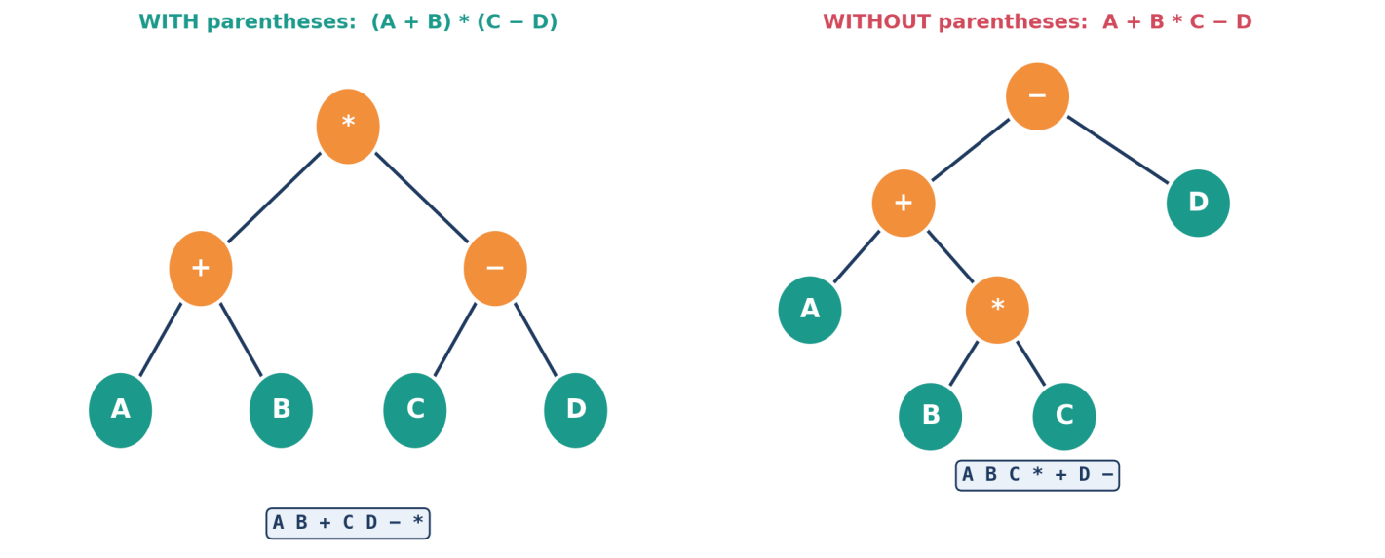
Figure 5: Parentheses change the structure of the expression tree and hence the postfix string
 | (A + B) * (C - D) | A + B * C - D
Evaluated first | A + B and C - D | B * C
Evaluated last | * | -
Postfix | A B + C D - * | A B C * + D -
With A=5, B=3, C=7, D=2 | (8) × (5) = 40 | 5 + 21 − 2 = 24

2.5 Expression tree view
A postfix string is the postorder traversal (left subtree, right subtree, root) of the expression tree. Operators with brackets around them sit lower in the tree and so are evaluated earlier; the root is the last operation performed.
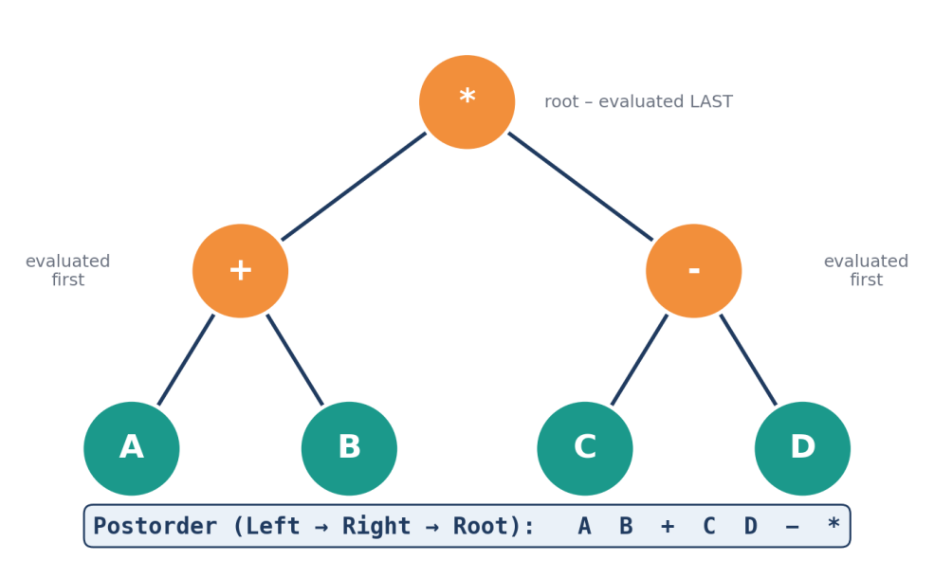
Figure 6: Expression tree of (A + B) * (C - D) and its postorder traversal

2.6 Verification by evaluating the postfix
To confirm the conversion is correct, evaluate A B + C D - * with a stack, using A = 5, B = 3, C = 7, D = 2. Operands are pushed; an operator pops two values (right operand first), applies the operation, and pushes the result.
Token | Action | Stack after | Calculation
A | Push 5 | 5 | —
B | Push 3 | 5, 3 | —
+ | Pop 3 and 5, push result | 8 | 5 + 3 = 8
C | Push 7 | 8, 7 | —
D | Push 2 | 8, 7, 2 | —
- | Pop 2 and 7, push result | 8, 5 | 7 − 2 = 5
* | Pop 5 and 8, push result | 40 | 8 × 5 = 40

Direct evaluation of the infix form gives (5 + 3) × (7 − 2) = 8 × 5 = 40, which matches. The conversion is correct.

2.7 C implementation
The following program performs the same conversion for single-letter operands.
#include <stdio.h>
#include <ctype.h>
#include <string.h>

char stack[100]; int top = -1;

void push(char c) { stack[++top] = c; }
char pop(void) { return stack[top--]; }
char peek(void) { return stack[top]; }

int prec(char op) {
if (op == '^') return 3;
if (op == '*' || op == '/') return 2;
if (op == '+' || op == '-') return 1;
return 0; /* '(' */
}

void infixToPostfix(const char *in, char *out) {
int k = 0;
for (int i = 0; in[i]; i++) {
char c = in[i];
if (isalnum(c)) out[k++] = c;
else if (c == '(') push(c);
else if (c == ')') {
while (top != -1 && peek() != '(') out[k++] = pop();
pop(); /* discard '(' */
} else if (c != ' ') {
while (top != -1 && prec(peek()) >= prec(c))
out[k++] = pop();
push(c);
}
}
while (top != -1) out[k++] = pop();
out[k] = '\0';
}

int main(void) {
char out[100];
infixToPostfix("(A+B)*(C-D)", out);
printf("Postfix: %s\n", out); /* prints: AB+CD-* */
return 0;
}

2.8 Conclusion for Question 2
Final result
(A + B) * (C - D) → A B + C D - *
Parentheses make + and - execute before *. The stack holds each operator until its sub-expression is complete, so postfix ordering reflects both precedence and grouping without needing any brackets.

