ASSIGNMENT – 1
Data Structures | Batch Code: CSA0304A
S. No | 34
Register No | 192511445A
Student Name | SHAIK KHAJAH ROSHAN
Batch Code | CSA0304A
Questions Covered
Part | Question | Marks
A | Define iterative and recursive approaches | 5
B | Write a program for finding the greatest of three numbers using if-else | 10
C | Describe use of ADTs in simulation systems | 5

Part A – Iterative and Recursive Approaches (5 Marks)

1. Introduction
Many problems in programming require a set of steps to be performed again and again – for example, adding the numbers from 1 to n, computing a factorial, or searching a list. There are two fundamental ways of expressing such repetition in a program: the iterative approach and the recursive approach. Both can solve the same problems, but they work in very different ways and have different costs in time, memory and readability.

2. Iterative Approach
Definition: An iterative approach solves a problem by repeating a block of statements using a loop construct (for, while or do-while) until a given condition becomes false. The solution is built step by step by updating variables on each pass of the loop.
Key characteristics of iteration:
- Uses loops – for, while, do-while.
- Uses a loop counter and a loop condition to control how many times the body runs.
- Constant extra memory – only a few variables are needed, so space complexity is usually O(1).
- Faster in practice – there is no overhead of function calls.
- Infinite loop risk – happens when the loop condition never becomes false.

3. Recursive Approach
Definition: A recursive approach solves a problem by letting a function call itself with a smaller (simpler) version of the same problem until a simple case, called the base case, is reached that can be answered directly.
Every recursive function has two essential parts:
- Base case – the condition that stops the recursion (e.g., n == 0). Without it the function would call itself forever.
- Recursive case – the part where the function calls itself with a smaller input (e.g., n * fact(n-1)).
Each call is stored as a stack frame in the call stack, holding the parameters, local variables and return address. The calls pile up while going down towards the base case, and the results are returned while coming back up.
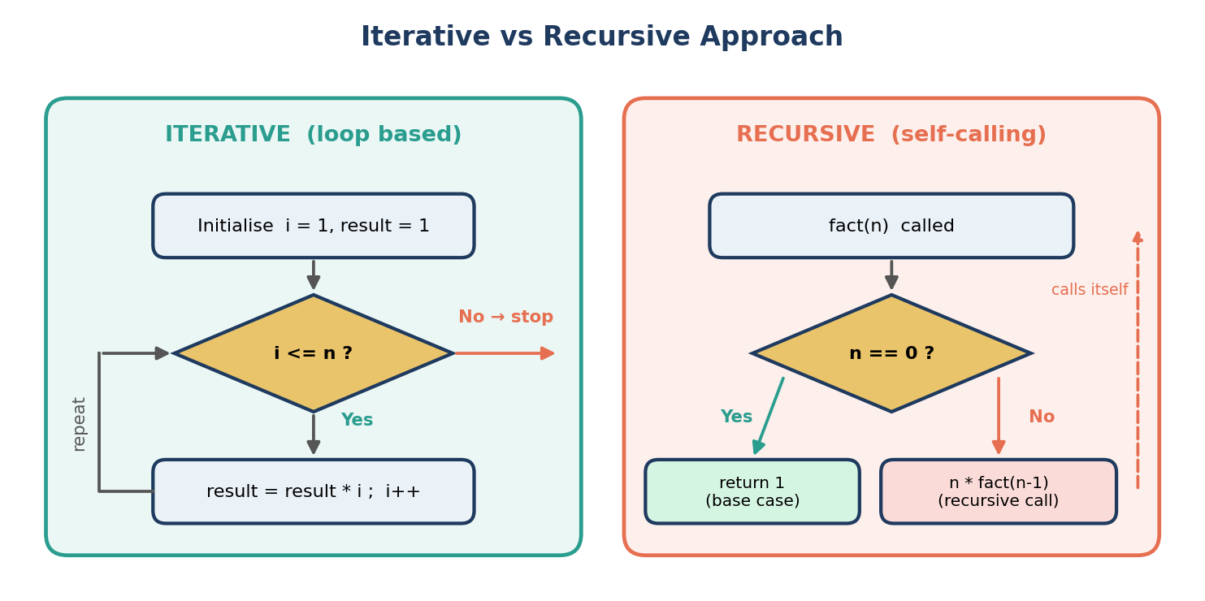
Figure A.1: Flow of the iterative and recursive approaches (factorial example)

4. Example: Factorial of a Number
The factorial of n is n! = n × (n−1) × … × 1, with 0! = 1. The same problem is solved below using both approaches.
factorial.c
#include <stdio.h>

/* Iterative approach - uses a for loop */
long fact_iter(int n) {
long result = 1;
for (int i = 1; i <= n; i++)
result = result * i;
return result;
}

/* Recursive approach - function calls itself */
long fact_rec(int n) {
if (n == 0) /* base case */
return 1;
return n * fact_rec(n - 1); /* recursive case */
}

int main() {
int n = 5;
printf("Iterative: %d! = %ld\n", n, fact_iter(n));
printf("Recursive: %d! = %ld\n", n, fact_rec(n));
return 0;
}

Output
Iterative: 5! = 120
Recursive: 5! = 120

The following diagram traces how the recursive call fact(4) works on the call stack. The calls are made from fact(4) down to fact(0) (base case), and then the values 1, 1, 2, 6 and 24 are returned one after another.
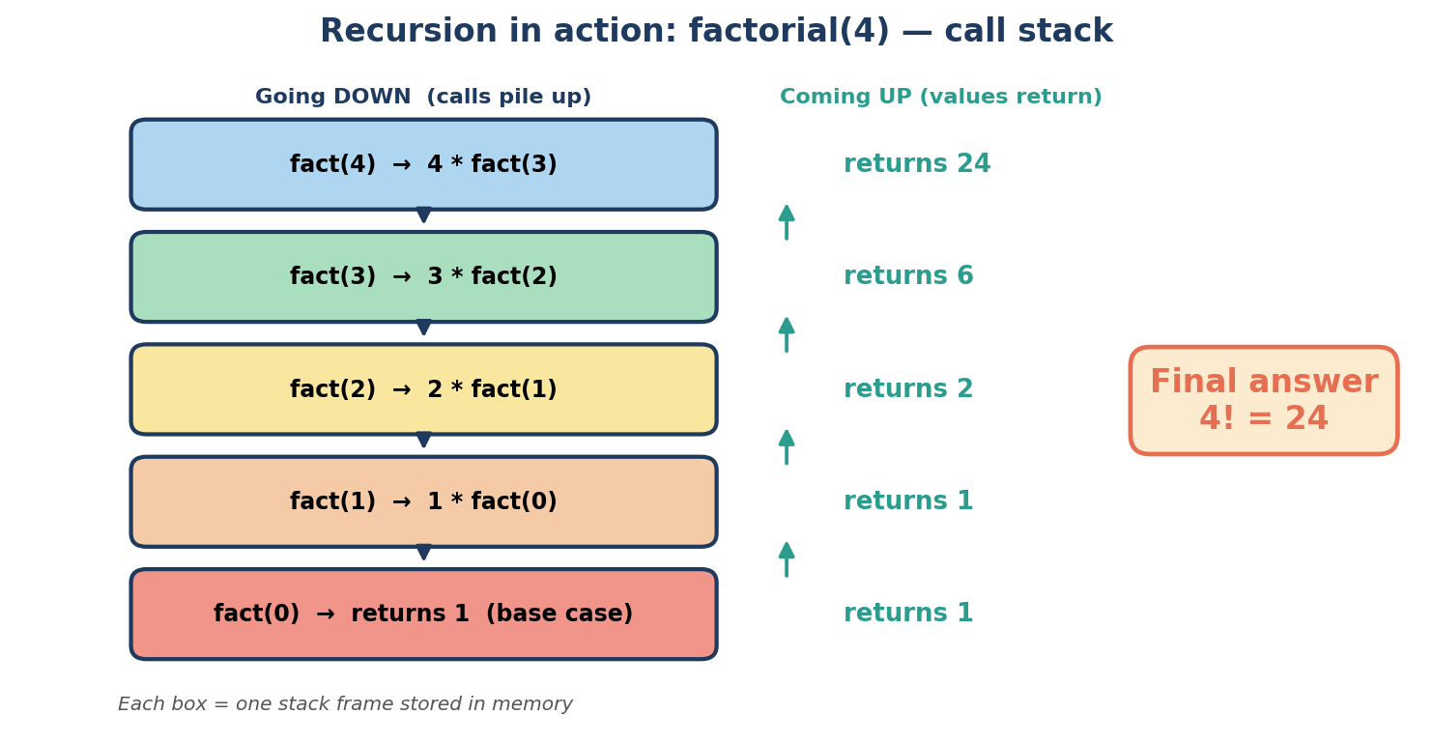
Figure A.2: Call-stack trace of the recursive function fact(4)

5. Memory Usage Comparison
An iterative solution needs only a fixed number of variables, whereas a recursive solution adds a new stack frame for every call. For an input of size n, recursion therefore needs O(n) stack space. A very deep recursion can even cause a stack overflow error.
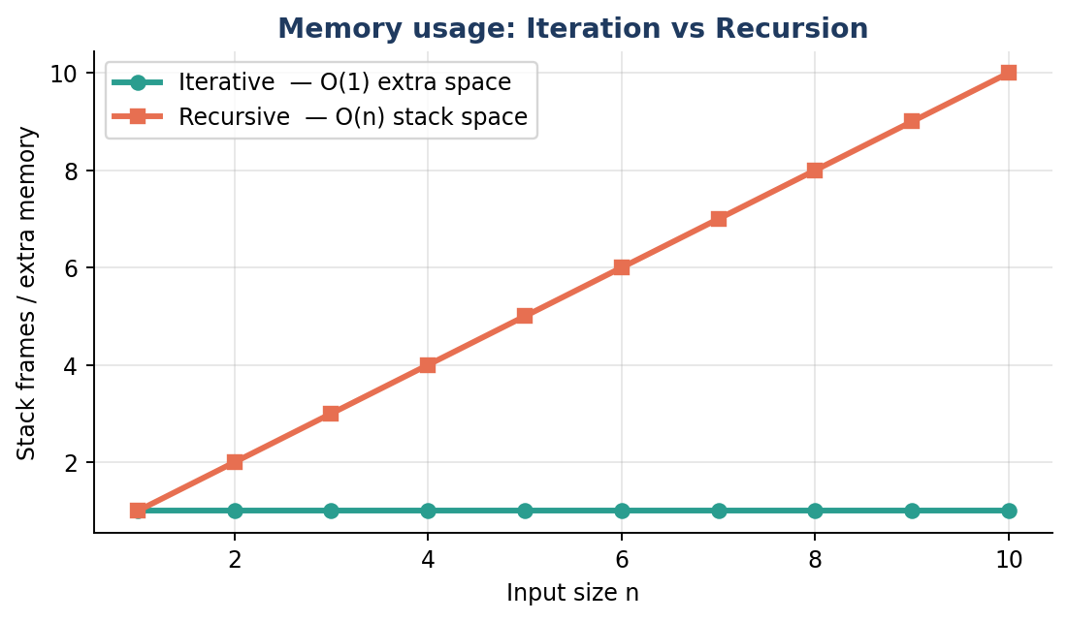
Figure A.3: Extra memory required – iteration vs recursion

6. Difference Between Iterative and Recursive Approaches
Basis | Iterative Approach | Recursive Approach
Definition | Repeats statements using loops | Function calls itself on a smaller problem
Termination | Loop condition becomes false | Base case is reached
Memory (Space) | O(1) – no stack growth | O(n) – one stack frame per call
Speed | Faster – no call overhead | Slower – function call overhead
Code size | Usually longer | Shorter and more elegant
Readability | Good for simple repetition | Very natural for tree / divide-and-conquer problems
Failure case | Infinite loop | Stack overflow (no / wrong base case)
Typical uses | Array traversal, counting, searching | Tree traversal, Tower of Hanoi, Fibonacci, quick sort

Conclusion: Iteration is preferred when speed and memory are important, while recursion is preferred when the problem is naturally defined in terms of smaller copies of itself. Every recursive program can be rewritten iteratively and vice-versa.

Part B – Greatest of Three Numbers using if-else (10 Marks)

1. Aim
To write a C program that reads three integers a, b and c from the user and finds and prints the greatest of them using if-else statements.

2. Concept
The if-else statement lets a program choose between two paths depending on whether a condition is true or false. To find the largest of three numbers we use nested if-else: first compare a with b to find the bigger of those two, and then compare that winner with c. Only two comparisons are required, so the logic is simple and efficient.
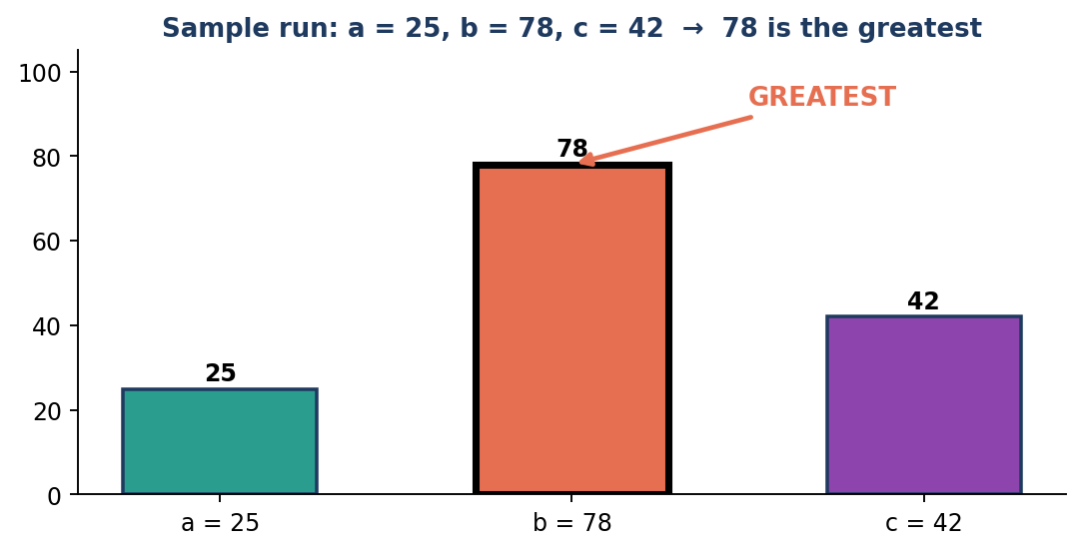
Figure B.1: Sample input a = 25, b = 78, c = 42 – the value 78 is the greatest

3. Algorithm
- START
- Declare integer variables a, b and c.
- Read the values of a, b and c.
- If a >= b then go to step 5, otherwise go to step 6.
- If a >= c then print a as the greatest; otherwise print c as the greatest. Go to step 7.
- If b >= c then print b as the greatest; otherwise print c as the greatest.
- STOP

4. Flowchart
The flowchart below shows the same logic graphically. The oval shapes are the start and end points, the parallelograms are input/output steps and the diamonds are decisions (yes / no).
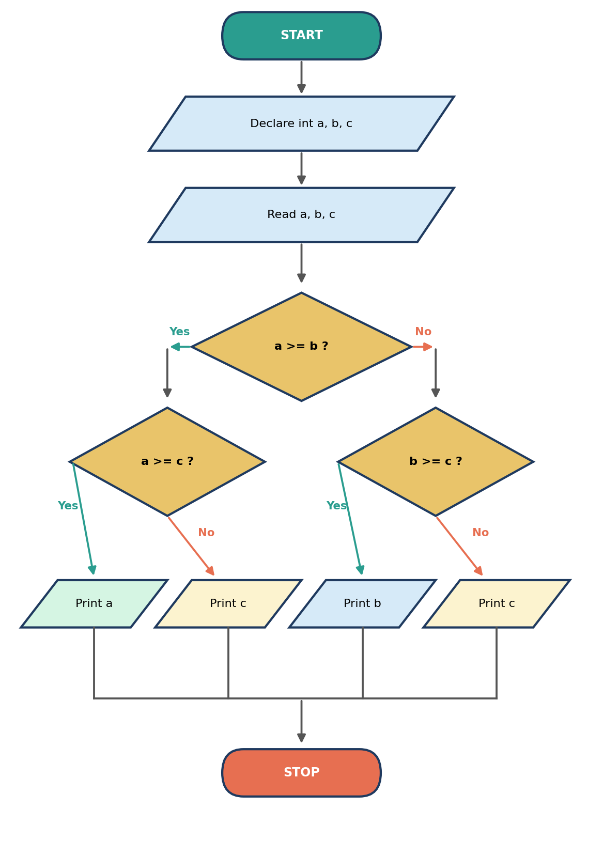
Figure B.2: Flowchart – greatest of three numbers using nested if-else

5. C Program (Nested if-else)
greatest.c
#include <stdio.h>

int main() {
int a, b, c;

printf("Enter three numbers: ");
scanf("%d %d %d", &a, &b, &c);

if (a >= b) { /* a is bigger than (or equal to) b */
if (a >= c)
printf("%d is the greatest\n", a);
else
printf("%d is the greatest\n", c);
} else { /* b is bigger than a */
if (b >= c)
printf("%d is the greatest\n", b);
else
printf("%d is the greatest\n", c);
}

return 0;
}

6. Explanation of the Program
- #include <stdio.h> – gives access to printf() and scanf().
- int a, b, c; – three integer variables to hold the user's numbers.
- scanf("%d %d %d", &a, &b, &c); – reads three integers; & passes the address of each variable.
- if (a >= b) – outer decision. If true, a is a candidate for the greatest, so it is compared with c. If false, b is the candidate.
- inner if-else – the winner of the first comparison is compared with c, and the larger one is printed.
- >= instead of > – makes the program work correctly even when two or more numbers are equal.

7. Sample Outputs
Output
Run 1: Enter three numbers: 25 78 42
78 is the greatest

Run 2: Enter three numbers: 9 9 3
9 is the greatest

Run 3: Enter three numbers: -5 -2 -9
-2 is the greatest

8. Dry Run (Trace Table)
a | b | c | a >= b ? | Second test | Greatest
25 | 78 | 42 | False | b >= c → True | 78 (b)
90 | 30 | 60 | True | a >= c → True | 90 (a)
10 | 20 | 50 | False | b >= c → False | 50 (c)
70 | 40 | 95 | True | a >= c → False | 95 (c)
9 | 9 | 3 | True | a >= c → True | 9 (a)

9. Alternative Method (else-if Ladder with Logical Operators)
The same problem can also be solved with an else-if ladder, using the logical AND operator (&&) to combine two conditions in a single test:
greatest_ladder.c
#include <stdio.h>

int main() {
int a, b, c;
printf("Enter three numbers: ");
scanf("%d %d %d", &a, &b, &c);

if (a >= b && a >= c)
printf("%d is the greatest\n", a);
else if (b >= a && b >= c)
printf("%d is the greatest\n", b);
else
printf("%d is the greatest\n", c);

return 0;
}

Basis | Nested if-else | else-if ladder with &&
Comparisons | Exactly 2 | 1 to 4 (depends on the data)
Structure | Tree of decisions | Linear chain of tests
Readability | Good for small decisions | Easier to read, longer conditions
Best use | Fewest comparisons needed | When conditions are independent

10. Complexity Analysis
- Time complexity: O(1) – a fixed number (2) of comparisons whatever the values are.
- Space complexity: O(1) – only three variables are used.

Result: The program was executed for different sets of inputs and correctly displays the greatest of the three numbers, including negative numbers and equal values.

Part C – Use of ADTs in Simulation Systems (5 Marks)

1. What is an Abstract Data Type (ADT)?
An Abstract Data Type is a mathematical model of a data structure that is defined by what it does (its operations and behaviour) and not by how it is implemented. The user of an ADT only knows the interface – for example enqueue() and dequeue() for a queue – while the internal details (array, linked list, heap) stay hidden. This hiding of details is called data abstraction and encapsulation.

2. What is a Simulation System?
A simulation system is a computer program that imitates the behaviour of a real-world system over time so that it can be studied without building or disturbing the real one. Examples are a bank counter, airport runway, traffic network, hospital emergency room, CPU scheduling, weather prediction and computer games. Such systems must manage many entities, waiting lines, events, resources and states, which makes ADTs a natural fit.
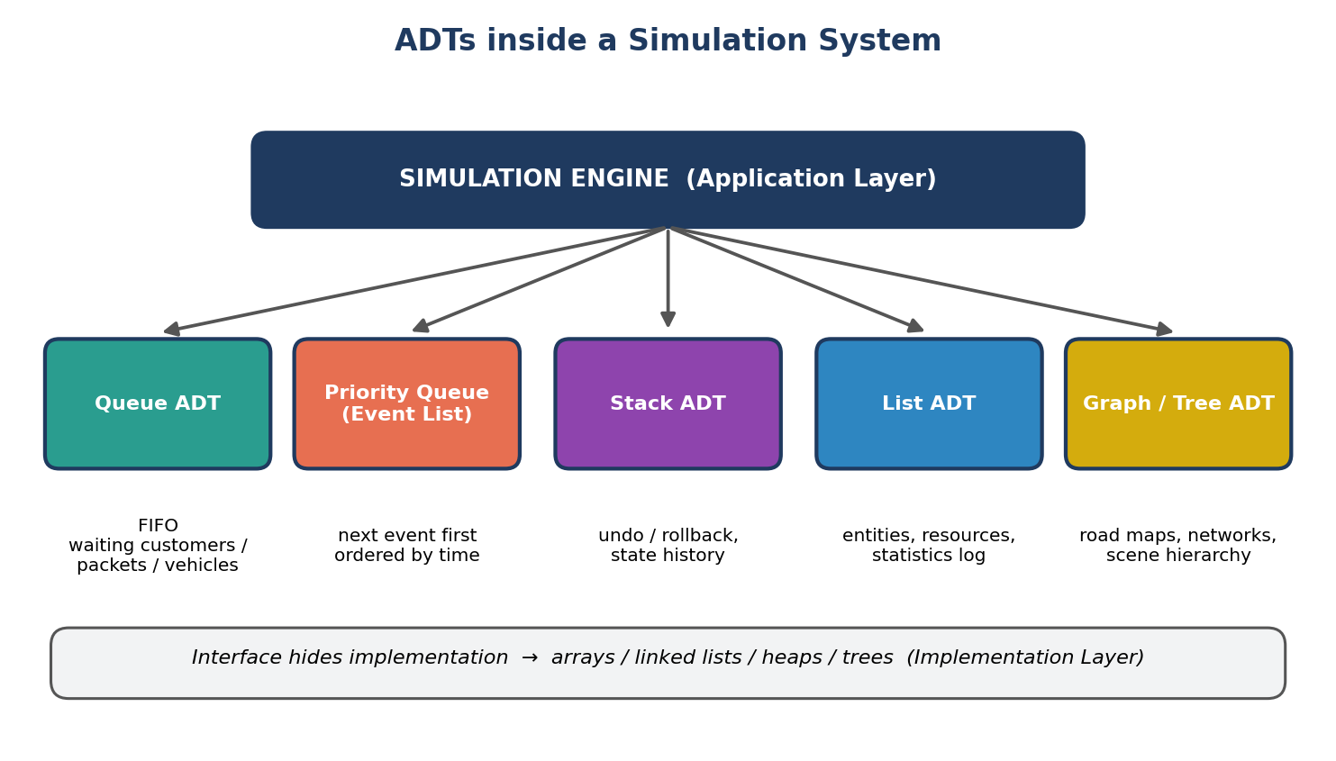
Figure C.1: Common ADTs used by a simulation engine

3. Why ADTs are Used in Simulation
- Modularity – queues, event lists and resources are separate, well-defined modules.
- Reusability – the same Queue or Priority Queue ADT can be reused in a bank, hospital or traffic simulation.
- Flexibility – the implementation (array → linked list → heap) can be changed without changing the simulation logic.
- Easier testing and maintenance – each ADT can be tested on its own.
- Efficiency – the right ADT gives fast operations, e.g. a heap-based priority queue finds the next event in O(log n).

4. ADTs and Their Role in Simulation
ADT | Role in simulation | Example
Queue (FIFO) | Holds entities waiting for service in arrival order | Customers at a bank counter, packets in a router
Priority Queue | Event list – always gives the earliest-time event first | Next arrival / departure event in discrete-event simulation
Stack (LIFO) | Stores history of states for undo / backtracking | Rollback of simulation state, function-call tracking
List | Stores the set of entities, resources and logged statistics | List of all vehicles or servers in the model
Graph / Tree | Represents connections and hierarchies | Road network in traffic simulation, network topology, scene graph in games
Array / Matrix | Stores grid-based or tabular data | Cellular automata, weather grid, game maps

5. Discrete-Event Simulation Using ADTs
Most simulations are discrete-event simulations. The program keeps a simulation clock and an event list implemented as a priority queue ordered by event time. In a loop, the earliest event is removed, the clock is moved to its time, the event is processed (which may change queues and states and may create new future events), and the process repeats until the event list is empty.
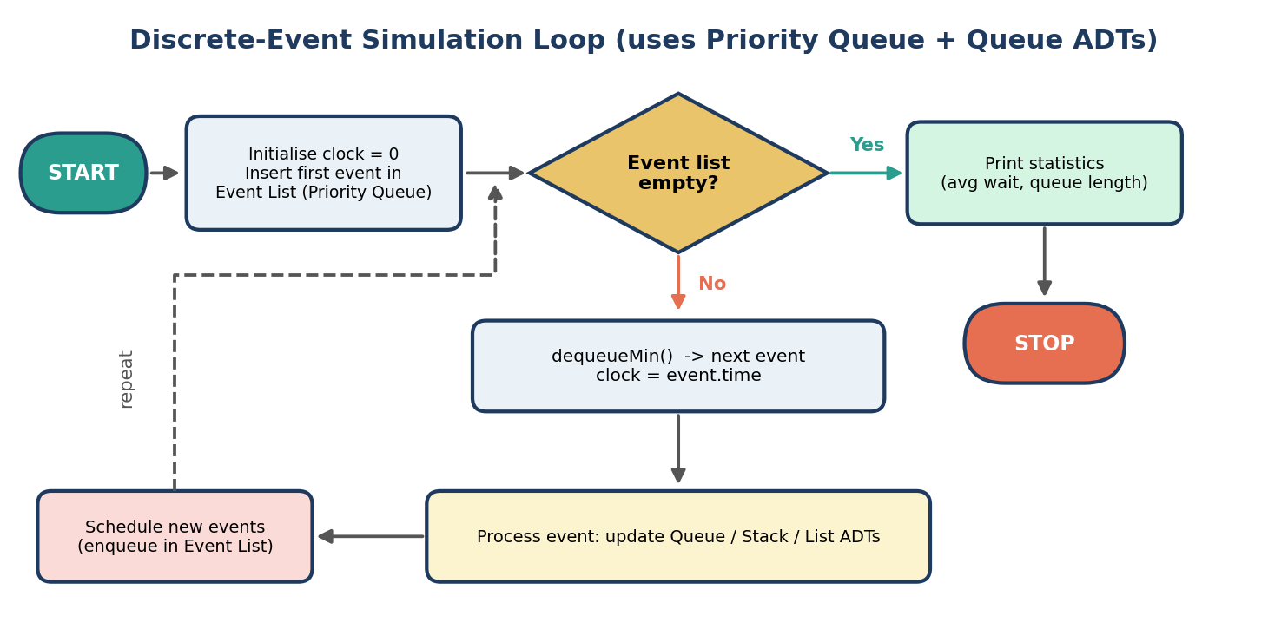
Figure C.2: Discrete-event simulation loop built on Priority Queue and Queue ADTs

6. Example: Bank Counter Simulation
In a bank, customers arrive randomly and wait in a line. The first customer to arrive is served first, which is exactly the FIFO behaviour of a Queue ADT. The simulation inserts each arriving customer with enqueue() and removes a customer for service with dequeue(). Waiting time and queue length are measured to judge whether more counters are needed.
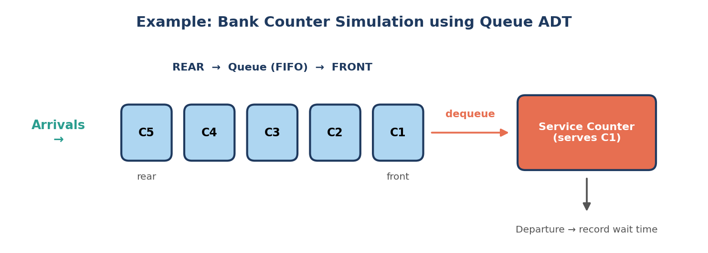
Figure C.3: Customers waiting in a Queue ADT for a service counter
A simple C implementation of this Queue ADT (circular array) is given below:
bank_queue.c
#include <stdio.h>
#define MAX 5

int q[MAX], front = 0, rear = -1, cnt = 0;

void enqueue(int id) { /* customer arrives */
if (cnt == MAX) { printf("Queue full\n"); return; }
rear = (rear + 1) % MAX;
q[rear] = id;
cnt++;
}

int dequeue() { /* customer is served */
if (cnt == 0) return -1; /* queue empty */
int v = q[front];
front = (front + 1) % MAX;
cnt--;
return v;
}

int main() {
for (int i = 1; i <= 3; i++) {
enqueue(i);
printf("Customer C%d arrives\n", i);
}
int c;
while ((c = dequeue()) != -1)
printf("Customer C%d served\n", c);
return 0;
}

Output
Customer C1 arrives
Customer C2 arrives
Customer C3 arrives
Customer C1 served
Customer C2 served
Customer C3 served

7. Real-World Applications
- Traffic simulation – graph ADT for roads and queues for vehicles at signals.
- Operating-system CPU scheduling – ready queue and priority queue of processes.
- Network simulation – queues model packet buffers in routers and switches.
- Hospital / airport management – priority queues for emergency patients and flight landing order.
- Games and physics engines – event queues, trees for scene management, stacks for state history.

8. Advantages and Limitations
Advantages | Limitations
Clean, modular design | Slight overhead from the extra interface layer
Implementation can be replaced easily | Wrong choice of ADT or implementation reduces performance
Reusable across many simulations | Needs careful design of operations at the start
Fewer bugs due to data hiding | Fixed-size array implementations may overflow

Conclusion: ADTs provide the building blocks of simulation systems. Queues model waiting lines, priority queues schedule events, stacks keep history, and graphs or trees represent structure. Because ADTs hide implementation details, simulations become modular, reusable, efficient and easy to maintain.

